<https://www.mirkosertic.de/blog/2013/04/domain-driven-design-example/>

Project : **IT Body Leasing**

* Employees
* lot of Freelancers as Subcontractors

Manual Work/Challenge:

use Excel sheets to manage their

* Customers,
* Freelancers,
* Timesheets and so on.

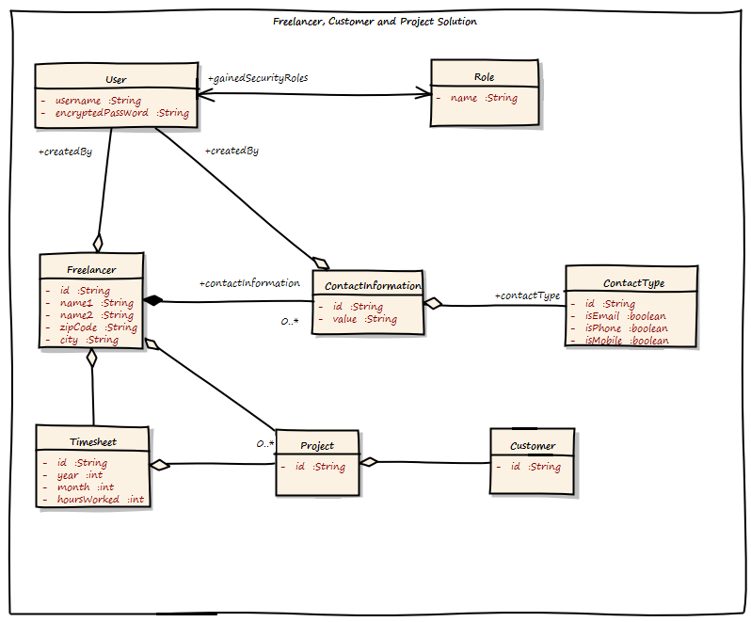

Flaws in the above design:

1. Big Object Graph , might get the issue of memory run out