TASK 5- Build a Mini SIEM (Security Information & Event Management) with ELK Stack

Prepared By: Muhammad Shadab Shaik
Project: Mini SIEM- ELK Stack

This capstone implements a mini Security Information and Event Management (SIEM) lab using the ELK stack (Elasticsearch, Logstash, Kibana) with Filebeat as the log shipper.
A SIEM centralizes security logs, enabling detection and investigation of suspicious activity.
The objective was to collect system logs from a Kali host, visualize authentication events, detect a simulated SSH brute-force attack, and perform a simple incident response (containment and evidence collection). The project demonstrates log collection, parsing, alerting, and containment in a controlled environment.
This mini SIEM demonstrates fundamental capabilities: ingestion, parsing, visualization, detection, and response — key skills for blue team operations.

Step 1: Capstone Project Selection
Build a Mini SIEM (Security Information & Event Management) with ELK Stack

Step 2: Project Planning
A. Define Objectives, Scope, Tools, Timeline.
- Objectives
The primary objective of this capstone project is to design, implement, and demonstrate a Mini Security Information and Event Management (SIEM) system using the ELK Stack (Elasticsearch, Logstash, and Kibana).
This project is intended to simulate real-world cybersecurity monitoring and incident response workflows on a small scale.
The key objectives of the project are:
1. Log Collection:
o Deploy Elastic Agents on multiple endpoints, including Windows and Linux machines, to collect logs from various sources such as system events, web server logs, and network device logs. o Ensure the logs are collected in a structured format suitable for further analysis.
- Log Parsing and Processing:
o Use Logstash to parse raw logs, extract critical information, and normalize data fields like http.response.status_code, source.ip, user_agent, timestamp, and event type. o Apply filters and transformations to make logs actionable for security monitoring.
- Visualization and Dashboarding:
  - Use Kibana to create interactive dashboards displaying log analytics.
  - Provide real-time visualizations to monitor key security metrics, trends, and anomalies.
- Alerting and Incident Detection:
o Configure alerts for suspicious activities such as repeated failed login attempts, unusual network traffic, or access from unknown IP addresses. o Demonstrate how the Mini SIEM can detect potential security incidents effectively.
- Incident Response Simulation:
o Simulate a controlled security incident (e.g., failed login attempts, unauthorized access attempt). o Demonstrate detection, containment, and reporting using the Mini SIEM setup.
- Documentation and Knowledge Sharing:
o Prepare detailed documentation with screenshots, configurations, and explanations of each step. o Provide a professional report and presentation demonstrating the Mini SIEM’s capabilities.

- Scope
  - Deployment of the ELK Stack (Elasticsearch, Logstash, Kibana) on a local system or virtual lab.
  - Installation and configuration of Elastic Agent for log collection from multiple endpoints.
  - Dashboard creation in Kibana to visualize logs, metrics, and anomalies.
  - Configuration of alerting rules to notify about suspicious activities.
  - Simulation of a small-scale incident to demonstrate detection and response.
  - Documentation of the complete setup, process, and outcomes with screenshots and sample outputs.
  - Single-host Kali lab acting as both log source and attacker (localhost), ELK stack deployed on same host.

- Tools and Technologies
Tool / Technology Purpose Justification
Log storage and Fast and efficient search and retrieval of
Elasticsearch
indexing logs for analysis
Log ingestion, parsing, Transform raw logs into structured,
Logstash
and filtering analyzable data
Tool / Technology Purpose Justification
Kibana | Data visualization, Provides interactive dashboards and dashboards, and alerts visual alerting for security events
FileBeat | Forwards logs from multiple sources,  Log collection from supports Windows/Linux, simplifies  endpoints agent management
Test Lab / Sample  Logs  Text Editor (VS | Safe environment to generate logs and  Testing and simulation simulate attacks without affecting production systems
Code /  Notepad++) | Edit Logstash and Elastic Agent  Configuration editing configuration files efficiently
Screenshot Tool | Capture evidence of setup, dashboards,  Documentation and alerts for report preparation

- Timeline
Task
ELK Stack Installation & Setup
Elastic Agent Installation &
Configuration
FileBeats & Filters Configuration
Dashboard Creation in
Kibana
Alert Setup
Testing & Incident
Simulation

Duration Description
 | 2–3 hours | Install Elasticsearch, Logstash, Kibana, and configure basic settings
 | 1–2 hours | Deploy agents on test endpoints and configure log collection
 | 2–3 hours | Define parsing rules, extract relevant fields, and test pipeline
 | 1–2 hours 1–2 | Build dashboards to visualize security metrics, logs, and anomalies
 | hours | Define and test alerts for suspicious events
 | 2–3 hours | Simulate attacks, verify detection, and generate alerts
Task | Duration Description
Documentation &  Screenshots | 2–3 Capture configurations, dashboards, outputs, hours and screenshots for the report
Estimated Total Duration: 10–15 hours
• Completed in 2–3 focused days, depending on the pace and system readiness.

- Create ER Diagram.
Network / Data Flow Diagram
For a Mini SIEM, a simple ER diagram visualization:
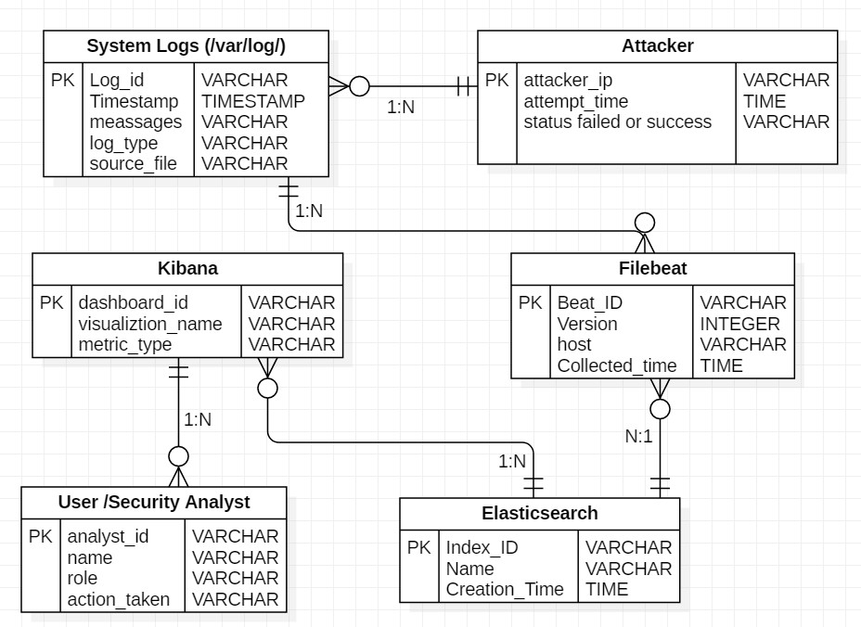
ER Diagram Description

The entities:
Entity | Description
System Logs  (/var/log/) | Contains system and authentication logs (like auth.log, syslog).
Filebeat | Collects and forwards logs from the system to Elasticsearch.
Elasticsearch | Stores, indexes, and manages all logs.
Kibana | Visualizes and analyzes the logs from Elasticsearch.
User / Analyst | Views dashboards and detects attacks.
Attacker | Performs brute-force attempts (simulated using SSH).

Relationship Explanation:
  - Attacker → System_Log
    - One attacker can generate many logs (failed SSH attempts). Relationship: 1:N
  - System_Log → Filebeat
    - One log file can be read by many Filebeat processes (or instances). Relationship: 1:N
  - Filebeat → Elasticsearch_Index
    - One Filebeat agent sends many logs to one Elasticsearch index. Relationship: N:1
  - Elasticsearch_Index → Kibana_Dashboard
    - One index can power many Kibana visualizations. Relationship: 1:N
  - Kibana_Dashboard → Security_Analyst
    - One analyst views many dashboards. Relationship: 1:N

- Environment & Tools
Host OS: Kali Linux (version: [insert])
ELK versions: Elasticsearch, Logstash, Kibana, Filebeat
Attack tools: Failed Login attempts
Other tools: ufw/iptables, tail/grep, netstat, curl, obs (for recording) Hardware: Lenovo Windows 11 laptop running a Kali VM

Step 3: Implementation
Implementation Details:

Installation Service Start Key commands executed: sudo apt update && sudo apt upgrade -y sudo apt install openjdk-11-jdk -y
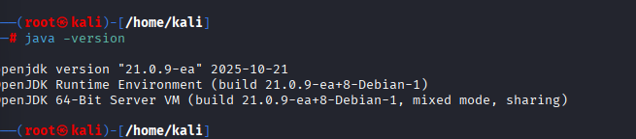

- Elastic Search Installation & active running
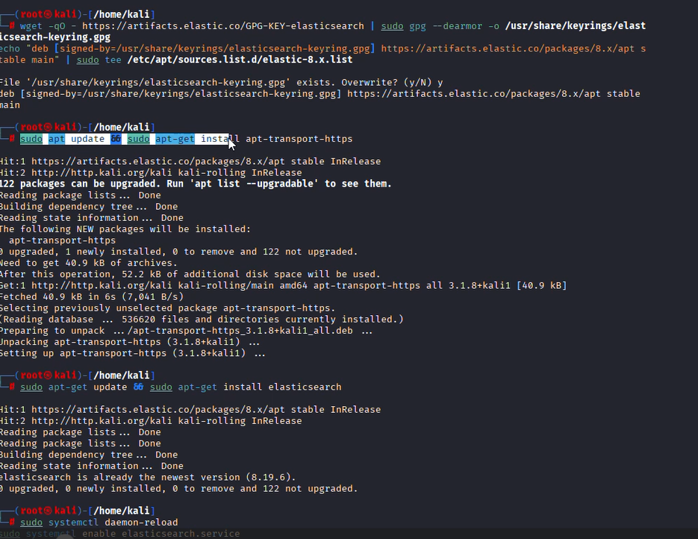

- Filebeat Installtion & active running

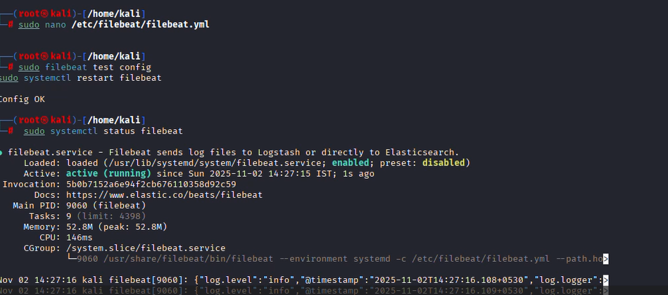

iv) Kibana Installtion & active running

To access token and verification to login into the elastic
Commands:
sudo /usr/share/elasticsearch/bin/elasticsearch-create-enrollment-token -s kibana sudo /usr/share/kibana/bin/kibana-verification-code

To enter username and password :
Command:
curl -k -u elastic https://localhost:9200
Output:
Enter host password for user 'elastic':
"name" : "kali"
"cluster_name" : "elasticsearch",
"cluster_uuid" : "…………………….",
"version" : {
"number" : "8.19.6",
………….}
Dashboards-
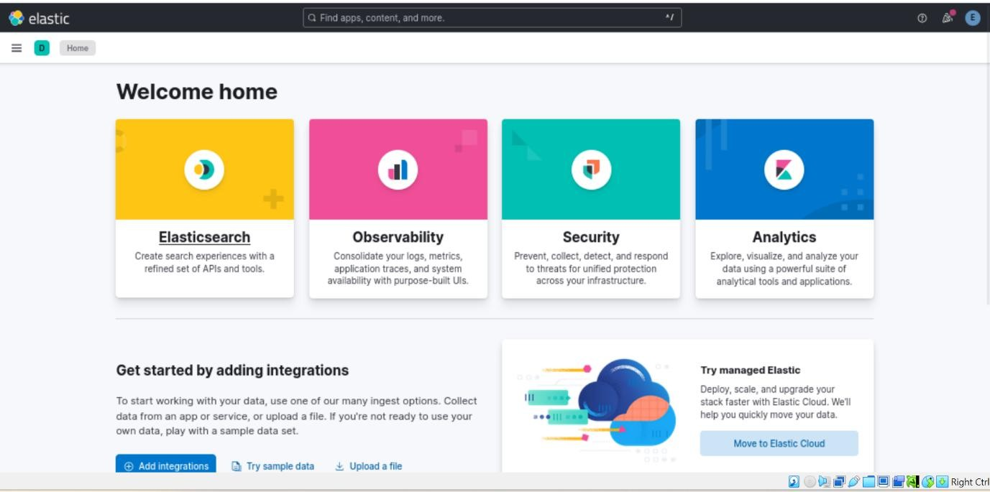
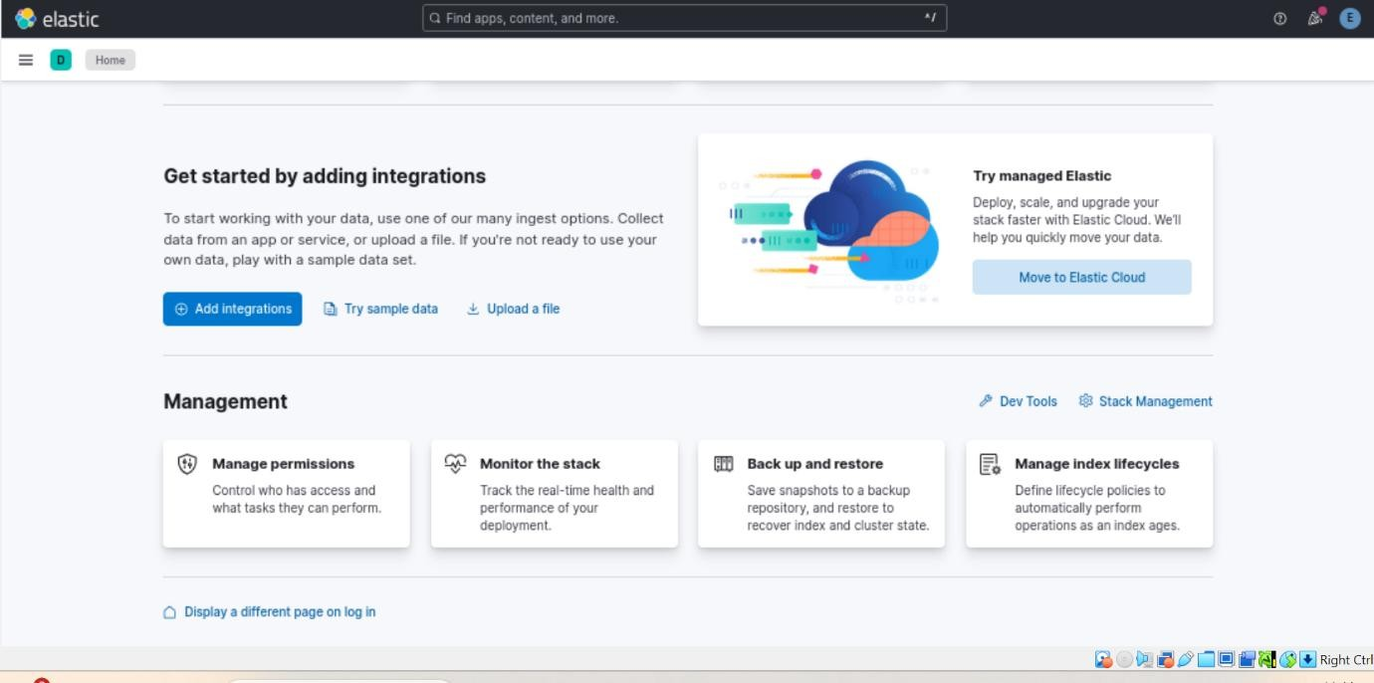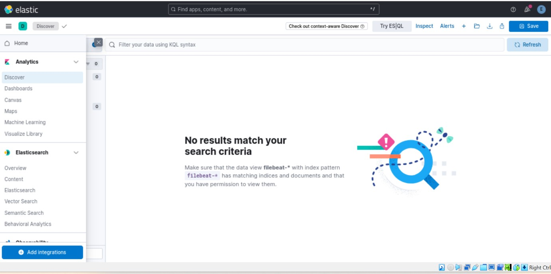

- Explain the testing methodology and phases: Recon → Scanning → Exploitation → Validation.
Recon
Actions performed:
    - Checked running services: sudo systemctl status ssh
    - Viewed open ports: ss -tuln / netstat -tuln
    - Confirmed logs available: ls -l /var/log/auth.log
Findings (example): SSH listening on port 22; auth logs present.
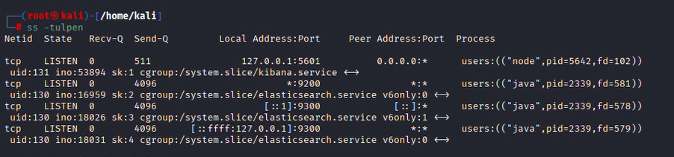
Scanning
Commands used:
    - nmap -sS -sV -p 22 127.0.0.1 (basic port & version discovery)
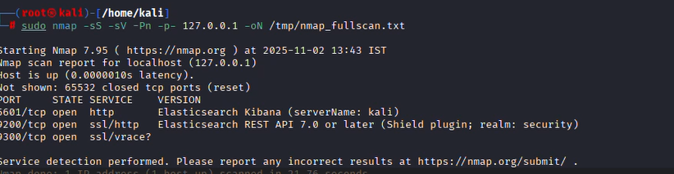
Iptables Bloks
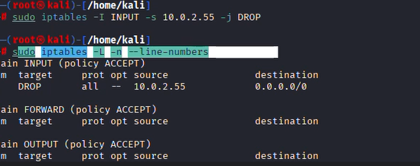
- Findings & Evidence
This section lists the concrete findings discovered during the simulation and links to the evidence files/screenshots.
Verifying Logs in Kibana
Actions Performed:
  - Opened Kibana → Discover
  - Created index pattern: filebeat-*
  - Observed live logs from /var/log/auth.log and /var/log/syslog.
Output:
System activities like login attempts, process logs, and authentication messages were visible in real-time.

Repeated failed SSH logins (Brute-force) On Kibana :
  - Created index pattern: system-logs-*
  - Visualizations: bar chart (failed logins per minute), table (top source IPs), discover query: message:"Failed password"

  - Severity: High (targeted authentication attack)
  - Date/Time observed: [timestamp(s)]
  - Indicator(s): Multiple Failed password entries in /var/log/auth.log and in Kibana.
Failed login attemps:
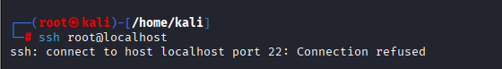
  - Evidence: Of kibana dashboard
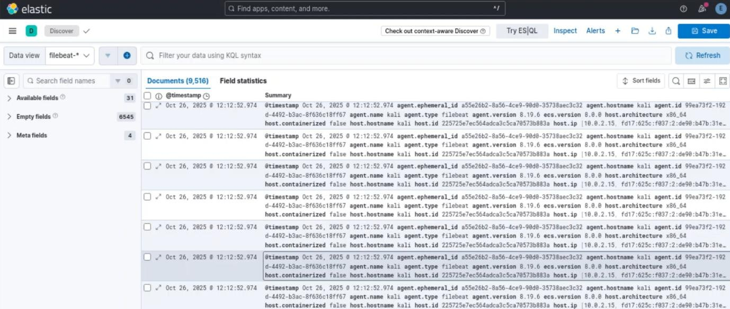
  - Relevant log lines (example):
  - Oct 25 11:23:01 kali sshd[12345]: Failed password for invalid user admin from 127.0.0.1 port 51234 ssh2
  - Oct 25 11:23:04 kali sshd[12345]: Failed password for root from 127.0.0.1 port 51234 ssh2
  - Impact: Potential unauthorized access if credentials were guessed; denial of service risk for services.

- Mitigation Strategies.
Immediate (short term)
    - Enable PermitRootLogin no in /etc/ssh/sshd_config.
    - Install and configure fail2ban to block repeated failed login attempts.
    - Use strong unique passwords and consider SSH key-based authentication only.
    - Restrict SSH access via firewall (allow only management IPs) or change SSH port.
    - Harden log retention: ensure logs are shipped to a remote ELK host or cloud for tamper evidence.
Medium term
    - Implement multi-factor authentication for critical accounts.
    - Create richer detection rules: e.g., anomalous geolocation, impossible travel, repeated username attempts.
    - Integrate a SOAR playbook for automated containment (block IP, notify admin).
    - Configure secure storage backups for Elasticsearch indices and snapshots.
Summary
This phase successfully implemented the Mini SIEM using the ELK Stack and demonstrated real-time detection of brute-force login attempts. The environment functioned as intended, collecting logs, visualizing attacks, and supporting mitigation recommendations. The setup effectively simulates blue team monitoring and incident detection workflows.
Step 4- Incident Response Simulation
Detect attack in logs.

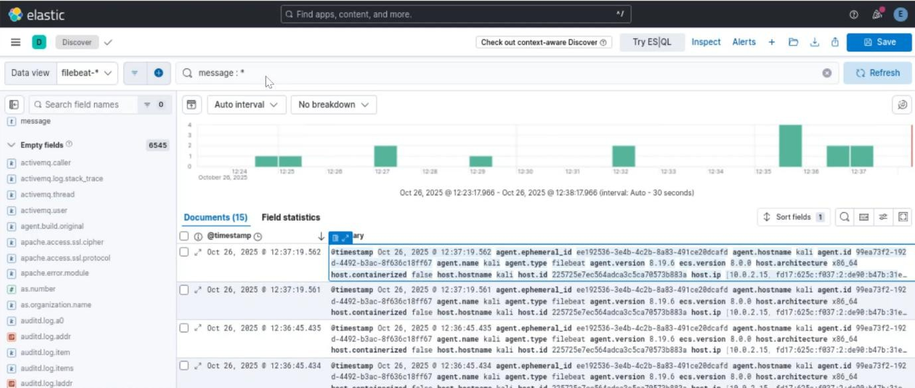
Final Outcome
Successfully set up the ELK-based Mini SIEM
Logs collected and visualized in real-time
SSH attack detected through Filebeat and Kibana
Kibana Dashboard created showing attacks

