

Functional Safety Concept Lane Assistance

**Document Version: [Version]**

**Template Version 1.0, Released on 2017-06-21**

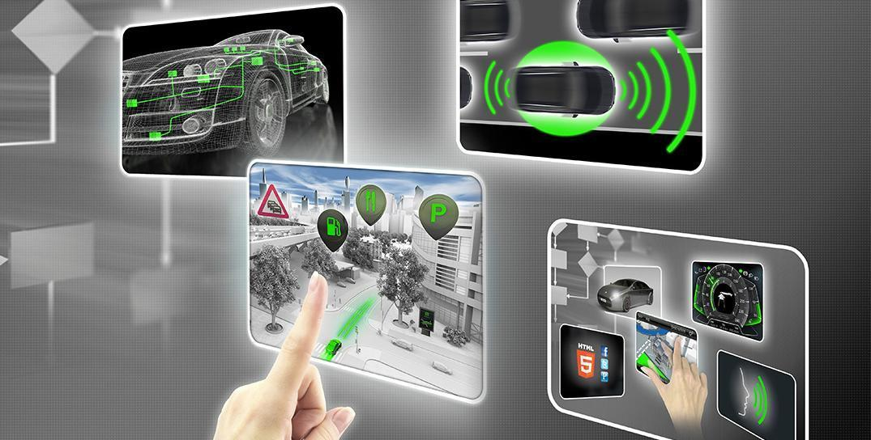

# Document history

**[Instructions: Fill in the date, version and description fields. You can fill out the Editor field with your name if you want to do so. Keep track of your editing as if this were a real world project.**

**For example, if this were your first draft or first submission, you might say version 1.0. If this is a second submission attempt, then you'd add a second line with a new date and version 2.0]**

|  |  |  |  |
| --- | --- | --- | --- |
| Date | Version | Editor | Description |
|  |  |  |  |
|  |  |  |  |
|  |  |  |  |
|  |  |  |  |
|  |  |  |  |

# Table of Contents

**[Instructions: We have provided a table of contents. If you change the document structure, please update the table of contents accordingly. The table of contents should show each section of the document and page numbers or links. Most word processors can do this for you. In** [**Google Docs**](https://support.google.com/docs/answer/116338?co=GENIE.Platform%3DDesktop&hl=en)**, you can use headings for each section and then go to Insert > Table of Contents.** [**Microsoft Word**](https://support.microsoft.com/en-us/help/285059/how-to-create-a-table-of-contents-by-marking-text-in-word) **has similar capabilities]**

Document history

Table of Contents

Purpose of the Functional Safety Concept

Inputs to the Functional Safety Analysis

Safety goals from the Hazard Analysis and Risk Assessment

Preliminary Architecture

Description of architecture elements

Functional Safety Concept

Functional Safety Analysis

Functional Safety Requirements

Refinement of the System Architecture

Allocation of Functional Safety Requirements to Architecture Elements

Warning and Degradation Concept

# Purpose of the Functional Safety Concept

**[Instructions: Answer what is the purpose of a functional safety concept?]**

# Inputs to the Functional Safety Concept

## Safety goals from the Hazard Analysis and Risk Assessment

**[Instructions:**

**REQUIRED:**

**Provide the lane departure warning and lane keeping assistance safety goals as discussed in the lessons and derived in the hazard analysis and risk assessment.**

**OPTIONAL:**

**If you expanded the hazard analysis and risk assessment to include other safety goals, include them here.**

**]**

|  |  |
| --- | --- |
| **ID** | **Safety Goal** |
| Safety_Goal_01 | The oscillating steering torque from the lane departure warning function shall be limited |
| Safety_Goal_02 | The lane keeping assistance function shall be time limited, and the additional steering torque shall end after a given time interval so that the driver cannot misuse the system for autonomous driving |

## Preliminary Architecture

**[Instructions: Provide a preliminary architecture for the lane assistance item. Hint: See Lesson 3: Item Definition]**

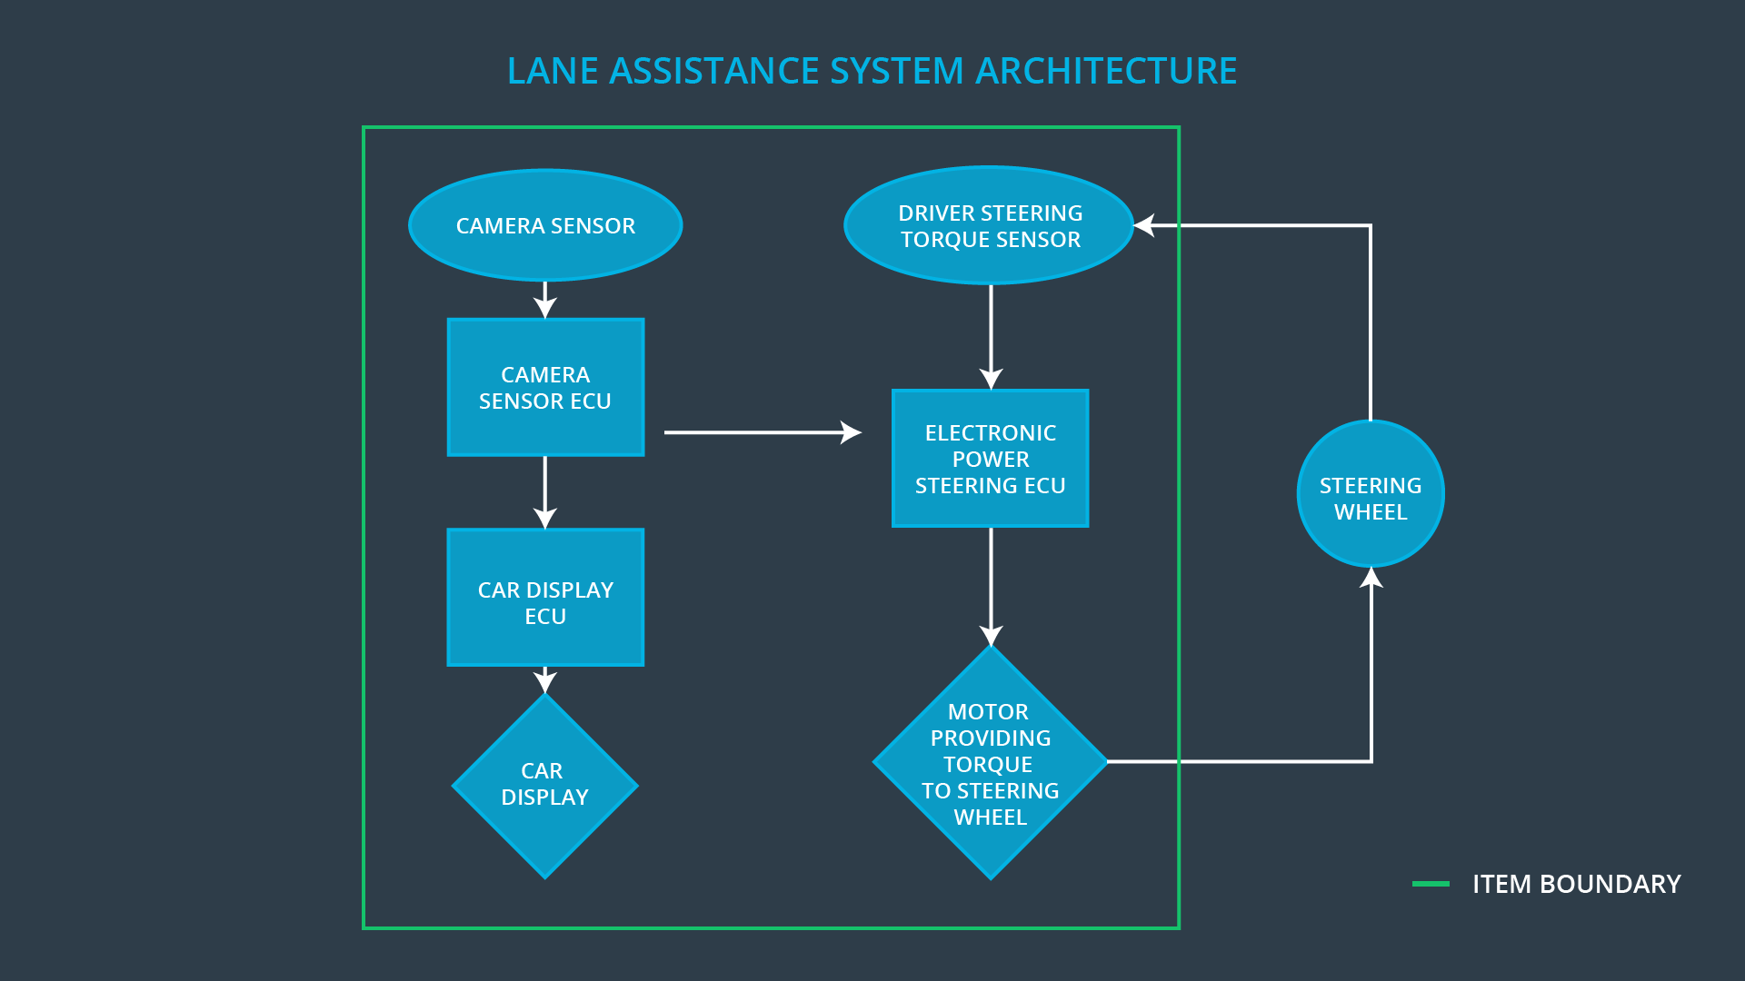

### Description of architecture elements

**[Instructions: Provide a description for each of the item elements; what is each element's purpose in the lane assistance item? ]**

|  |  |
| --- | --- |
| **Element** | **Description** |
| Camera Sensor | The camera sensor just reads in images from the road |
| Camera Sensor ECU | The camera sensor ECU identifies when the vehicle has accidentally departed its lane and sends  the appropriate messages to the Car Display ECU and the Electronic Power Steering ECU. |
| Car Display | This is the display unit where all relevant data is displayed |
| Car Display ECU | This is the systems which takes in all sensor data and gives command to display all this on Car Display |
| Driver Steering Torque Sensor | This units checks the torque applied on steering wheel by the driver |
| Electronic Power Steering ECU | This system identifies the torque requested by Camera Sensor ECU, torque measured by sensor and give command to apply the extra torque |
| Motor | This the actuator which applies the torque. |

# Functional Safety Concept

The functional safety concept consists of:

* Functional safety analysis
* Functional safety requirements
* Functional safety architecture
* Warning and degradation concept

## Functional Safety Analysis

**[Instructions: Fill in the functional safety analysis table below.]**

|  |  |  |  |
| --- | --- | --- | --- |
| **Malfunction ID** | **Main Function of the Item Related to Safety Goal Violations** | **Guidewords (NO, WRONG, EARLY, LATE, MORE, LESS)** | **Resulting Malfunction** |
| Malfunction_01 | Lane Departure Warning (LDW) function shall apply an oscillating steering torque to provide the driver a haptic feedback | More | The lane departure warning function applies an oscillating torque with very high torque amplitude (above limit) |
| Malfunction_02 | Lane Departure Warning (LDW) function shall apply an oscillating steering torque to provide the driver a haptic feedback | More | The lane departure warning function applies an oscillating torque with very high torque frequency (above limit) |
| Malfunction_03 | Lane Keeping Assistance (LKA) function shall apply the steering torque when active in order to stay in ego lane | No | The lane keeping assistance function is not limited in time duration which leads to misuse as an autonomous driving function. |

## Functional Safety Requirements

**[Instructions: Fill in the functional safety requirements for the lane departure warning ]**

Lane Departure Warning (LDW) Requirements:

|  |  |  |  |  |
| --- | --- | --- | --- | --- |
| **ID** | **Functional Safety Requirement** | **ASIL** | **Fault Tolerant Time Interval** | **Safe State** |
| Functional  Safety  Requirement  01-01 | The lane keeping item shall ensure that the lane departure oscillating torque amplitude is below Max_Torque_Amplitude | C | 50ms | LDW feature should be turned off |
| Functional  Safety  Requirement  01-02 | The lane keeping item shall ensure that the lane departure oscillating torque frequency is below Max_Torque_Frequency | C | 50ms | LDW feature should be turned off |

Lane Departure Warning (LDW) Verification and Validation Acceptance Criteria:

|  |  |  |
| --- | --- | --- |
| **ID** | **Validation Acceptance**  **Criteria and Method** | **Verification Acceptance**  **Criteria and Method** |
| Functional  Safety  Requirement  01-01 | Test how drivers react to different torque amplitudes | Inserting a fault into the system and checking how system respond to this malfunction |
| Functional  Safety  Requirement  01-02 | Test how drivers react to different torque frequency | Inserting a fault into the system and checking how system respond to this malfunction |

**[Instructions: Fill in the functional safety requirements for the lane keeping assistance]**

Lane Keeping Assistance (LKA) Requirements:

|  |  |  |  |  |
| --- | --- | --- | --- | --- |
| **ID** | **Functional Safety Requirement** | **ASIL** | **Fault Tolerant Time Interval** | **Safe State** |
| Functional  Safety  Requirement  02-01 | the electronic power steering ECU shall ensure that the lane keeping assistance torque is applied for only Max_Duration | B | 500 ms | LKA system should be turned off |

Lane Keeping Assistance (LKA) Verification and Validation Acceptance Criteria:

|  |  |  |
| --- | --- | --- |
| **ID** | **Validation Acceptance**  **Criteria and Method** | **Verification Acceptance**  **Criteria and Method** |
| Functional  Safety  Requirement  02-01 | Test that for Max_Duration LKA feature is on and driver takes of his hands from steering wheel | Run the software and see that after Max_Duration LKA system turn off |

## Refinement of the System Architecture

**[Instructions: Include the refined system architecture. Hint: The refined system architecture should include the system architecture from the end of the functional safety lesson including all of the ASIL labels.]**

## Allocation of Functional Safety Requirements to Architecture Elements

**[Instructions: Mark which element or elements are responsible for meeting the functional safety requirement. Hint: Only one ECU is responsible for meeting all of the requirements.]**

|  |  |  |  |  |
| --- | --- | --- | --- | --- |
| **ID** | **Functional Safety Requirement** | **Electronic Power Steering ECU** | **Camera ECU** | **Car Display ECU** |
| Functional  Safety  Requirement  01-01 | The lane keeping item shall ensure that the lane departure oscillating torque amplitude is below Max_Torque_Amplitude | **Yes** | **No** | **No** |
| Functional  Safety  Requirement  01-02 | The lane keeping item shall ensure that the lane departure oscillating torque frequency is below Max_Torque_Frequency | **Yes** | **No** | **No** |
| Functional  Safety  Requirement  02-01 | Test that for Max_Duration LKA feature is on and driver takes of his hands from steering wheel | **Yes** | **No** | **No** |

## Warning and Degradation Concept

**[Instructions: Fill in the warning and degradation concept.]**

|  |  |  |  |  |
| --- | --- | --- | --- | --- |
| **ID** | **Degradation Mode** | **Trigger for Degradation Mode** | **Safe State invoked?** | **Driver Warning** |
| WDC-01 | Shut down | Malfunction_01  Malfunction_02 | Yes | Indicator on Car display showing max torque/frequency |
| WDC-02 | Shut down | Malfunction_03 | Yes | Indictor on Car display turn off when LKA turned off |