



Technical Safety Concept Lane Assistance
Document Version: [Version]
Template Version 1.0, Released on 2017-06-21

Document history

Date | Version | Editor | Description
26/05/18 | 1 | Shaikh Mohammed Shadab | First attempt

Table of Contents

Document history 2
Table of Contents 2
Purpose of the Technical Safety Concept 3
Inputs to the Technical Safety Concept 3
Functional Safety Requirements 3
Refined System Architecture from Functional Safety Concept 3
Functional overview of architecture elements 4
Technical Safety Concept 4
Technical Safety Requirements 4
Refinement of the System Architecture 8
Allocation of Technical Safety Requirements to Architecture Elements 9
Warning and Degradation Concept 9

Purpose of the Technical Safety Concept

The technical safety concept shall expand upon the functional safety requirements, detailing
how each of them shall be realized, through various components and sub-systems present in
the system. Further, the technical concepts describe what a system shall do when a malfunction
violates the safety goal.

Inputs to the Technical Safety Concept

Functional Safety Requirements

ID | Functional Safety Requirement | ASIL | Fault Tolerant Time Interval | Safe State
Functional  Safety  Requirement  01-01 | The lane keeping item shall ensure that the lane departure oscillating torque amplitude is below Max_Torque_Amplitude | C | 50ms | LDW feature should be turned off
Functional  Safety  Requirement  01-02 | The lane keeping item shall ensure that the lane departure oscillating torque frequency is below Max_Torque_Frequency | C | 50ms | LDW feature should be turned off
Functional  Safety  Requirement  02-01 | The electronic power steering ECU shall ensure that the lane keeping assistance torque is applied for only Max_Duration | B | 500 ms | LKA system should be turned off

Refined System Architecture from Functional Safety Concept

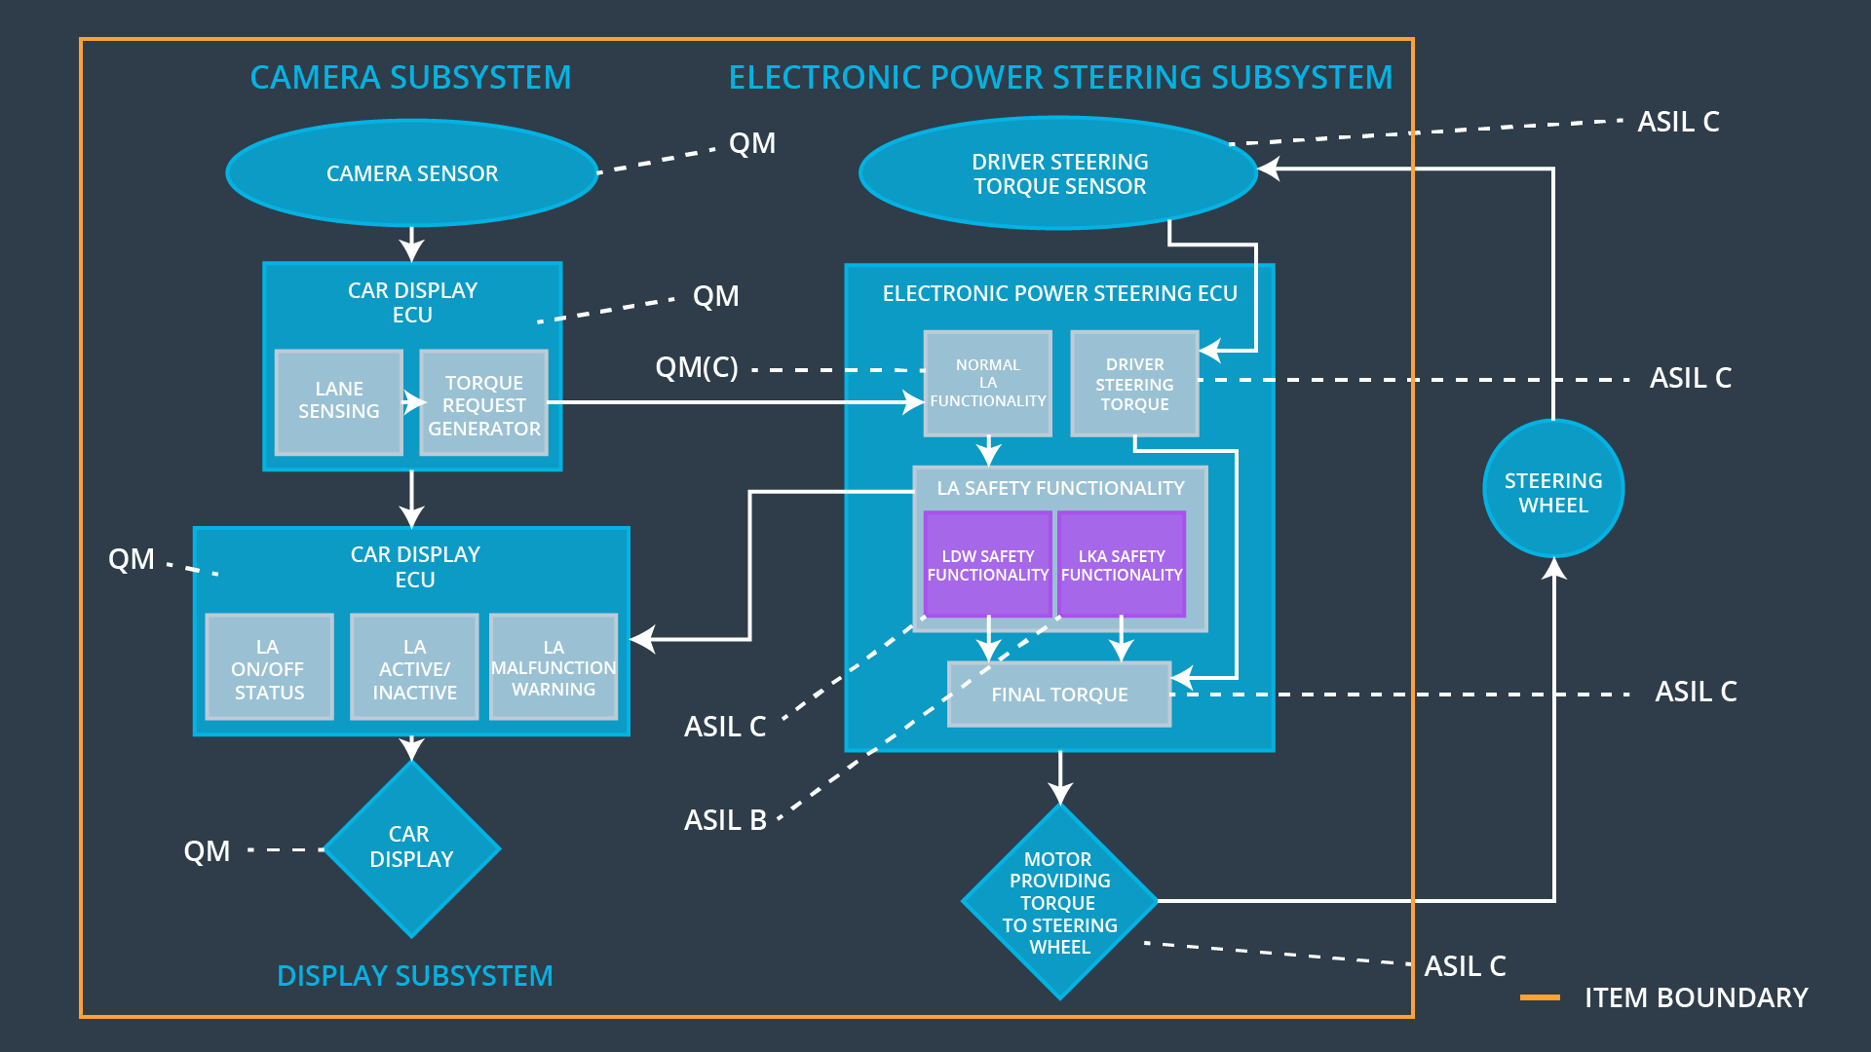

Functional overview of architecture elements

Element | Description
Camera Sensor | The camera sensor just reads in images from the road
Camera Sensor ECU - Lane Sensing | This units is computer vision system to detect lane lines
Camera Sensor ECU - Torque request generator | Generated request for torque for LDW warning
Car Display | This is the display unit where all relevant data is displayed
Car Display ECU - Lane Assistance On/Off Status | Check whether Lane assisstance system is on
Car Display ECU - Lane Assistant Active/Inactive | Check whether Lane Assisstance system is on or off
Car Display ECU - Lane Assistance malfunction warning | Check whether Lane Assisstance system is gives warning for unintentional lane change
Driver Steering Torque Sensor | This units checks the torque applied on steering wheel by the driver
Electronic Power Steering (EPS) ECU - Driver Steering Torque | Sends signal for generating torque which is restricted to a maximum limit max_torque
EPS ECU - Normal Lane Assistance Functionality | Generates oscilatory torque for alerting the driving
EPS ECU - Lane Departure Warning Safety Functionality | Check if torque to steering wheel is within limits and it is not in limit warning signal is indicated
EPS ECU - Lane Keeping Assistant Safety Functionality | Check whether LKA system applies torque for fixed duration of time
EPS ECU - Final Torque | Provide torque signal to steering after all safety checks
Motor | This the actuator which applies the torque.

Technical Safety Concept

Technical Safety Requirements
Lane Departure Warning (LDW) Requirements:

Functional Safety Requirement 01-01 with its associated system elements
(derived in the functional safety concept)
ID | Functional Safety Requirement | Electronic Power Steering ECU | Camera ECU | Car Display ECU
Functional  Safety  Requirement  01-01 | The lane keeping item shall ensure that the lane departure oscillating torque amplitude is below Max_Torque_Amplitude | X

Technical Safety Requirements related to Functional Safety Requirement 01-01 are:
ID | Technical Safety Requirement | ASIL | Fault Tolerant Time Interval | Architecture Allocation | Safe State
Technical  Safety  Requirement  01 | The LDW safety component shall ensure that the amplitude of the 'LDW_Torque_Request' sent to the 'Final electronic power steering Torque' component is below 'Max_Torque_Amplitude. | C | 50ms | LDW safety block | Set LDW_torque_amplitude to zero
Technical  Safety  Requirement  02 | As soon as the LDW function deactivates the LDW feature, the 'LDW Safety' software block shall send a signal to the car display ECU to turn on a warning light. | C | 50ms | Data Transmission Integrity Block | Lane Assistance System in turned if Data_validity is False
Technical  Safety  Requirement  03 | As soon as a failure is detected by the LDW function, it shall deactivate the LDW feature and the 'LDW_Torque_Request' shall be set to zero. | C | 50ms | LDW safety block | Lane Assistance System is turned off
Technical  Safety  Requirement  04 | The validity and integrity of the data transmission for 'LDW_Torque_Request' signal shall be ensured. | C | 50ms | LA Malfunction Warning Block | Lane Assistance System is turned off with Error_status True
Technical  Safety  Requirement  05 | Memory test shall be conducted at start up of the EPS ECU to check for any faults in memory. | A | 50ms | Memory Test Block | Lane Assistance System is turned off

Functional Safety Requirement 01-2 with its associated system elements
(derived in the functional safety concept)
ID | Functional Safety Requirement | Electronic Power Steering ECU | Camera ECU | Car Display ECU
Functional  Safety  Requirement  01-02 | The lane keeping item shall ensure that the lane departure oscillating torque frequency is below Max_Torque_Frequency | X

Technical Safety Requirements related to Functional Safety Requirement 01-02 are:
ID | Technical Safety Requirement | ASIL | Fault Tolerant Time Interval | Architecture Allocation | Safe State
Technical  Safety  Requirement  01 | The LDW safety  component shall ensure  that the amplitude of  the  ‘LDW_Torque_Request’  sent to the ‘Final EPS  Torque’ component is  below  Max_Torque_Amplitude | C | 50ms | LDW safety block | Set LDW_torque_amplitude to zero
Technical  Safety  Requirement  02 | The validity and  integrity of the  LDW_Torque_Request  signal shall be ensured | C | 50ms | Data Transmission Integrity Block | Lane Assistance System in turned if Data_validity is False
Technical  Safety  Requirement  03 | As soon as failure is  detected by the LDW  function, the  LDW_Torque_Request  shall be set to zero | C | 50ms | LDW safety block | Lane Assistance System is turned off
Technical  Safety  Requirement  04 | As soon as the LDW  function deactivates the  LDW feature, the  software block shall  send a signal to turn on  a warning light | C | 50ms | LA Malfunction Warning Block | Lane Assistance System is turned off with Error_status True
Technical  Safety  Requirement  05 | Memory tests shall be  conducted at the start  of EPS ECU to check  for any faults in memory | A | 50ms | Memory Test Block | Lane Assistance System is turned off

Lane Keeping Assistance (LKA) Requirements:

Functional Safety Requirement 02-1 with its associated system elements
(derived in the functional safety concept)

ID | Functional Safety Requirement | Electronic Power Steering ECU | Camera ECU | Car Display ECU
Functional  Safety  Requirement  02-01 | The lane keeping item shall ensure that the lane keeping assistance torque is applied for only Max_Duration | X

Technical Safety Requirements related to Functional Safety Requirement 02-01 are:
ID | Technical Safety Requirement | ASIL | Fault Tolerant Time Interval | Allocation to Architecture | Safe State
Technical  Safety  Requirement  01 | The LKA system shall stop sending LKA_Torque_Request once Max_Duration is completed | B | 500ms | LKA safety block | Shut down LKA system, as duration> Max_duration
Technical  Safety  Requirement  02 | The validity and integrity of the LKA_Torque_Request signal shall be ensured | B | 500ms | Data transmission Integrity block | Lane Assistance System is turned if Data_validity is False
Technical  Safety  Requirement  03 | As soon as failure is detected by the LKA function, the LKA_Torque_Request shall be set to zero | B | 500ms | LKA safety block | Lane Assistance System is turned off
Technical  Safety  Requirement  04 | As soon as the LKA function deactivates the LKA feature, the software block shall send a signal to turn on a warning light | B | 500ms | LA malfunction warning block | Lane Assistance System is turned off with Error_status_true
Technical  Safety  Requirement  05 | Memory tests shall be conducted at the start of EPS ECU to check for any faults in memory | A | Length of ignition cycle | Memory test block | Lane Assistance System in turned off

Refinement of the System Architecture

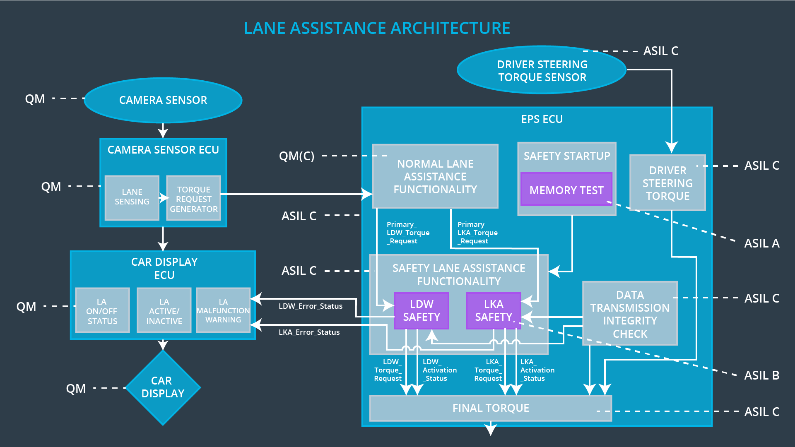

Allocation of Technical Safety Requirements to Architecture Elements

All technical safety requirements are allocated to EPS ECU.

Warning and Degradation Concept

ID | Degradation Mode | Trigger for Degradation Mode | Safe State invoked? | Driver Warning
WDC-01 | Shut down | Malfunction_01  Malfunction_02 | Yes | Indicator on Car display showing max torque/frequency
WDC-02 | Shut down | Malfunction_03 | Yes | Indictor on Car display turn off when LKA turned off

