**Certificate**

This is to certify that the thesis entitled “MRI Image Based Brain Tumor Classification using SVM and CNN” has been submitted by Roll No. 160111 in the partial fulfillment for the requirements of the degree of Bachelor of Science in Computer Science & Engineering, under the Faculty of Engineering and Technology, Jashore University of Science and Technology, Jashore-7408, Bangladesh.

I would like to clarify that the author has been completed his work under my supervision.

**Author:**

Roll No: 160111

## Supervisor

## Mustain Billah

## Lecturer

## Department of Computer Science & Engineering

## Jashore University of Science & Technology

## Jashore-7408, Bangladesh

## Chairman

## Dr. Syed Md. Galib

## Department of Computer Science & Engineering

## Jashore University of Science and Technology

## Jashore-7408, Bangladesh

**Acknowledgement**

At first, I would like to thank almighty for giving all his blessings on us to complete our task. It is my immense pleasure to express our deepest gratitude to my supervisor Jannatul Ferdush, Assistant Professor, Department of Computer Science and Engineering (CSE), Jashore University of Science & Technology and Mustain Billah, Lecturer, Department of Computer Science and Engineering (CSE), Jashore University of Science & Technology (JUST) for their continuous encouragement, constant guidance and keen supervision throughout of this study and implementation. At last, I am grateful to my parents and friends for their patience, support and encouragement during this period.

**Abstract**

Abnormal cell growth in the brain leads to the tumor which is hazardous and without proper detection and suitable treatment, it becomes life-threatening. Computer-aided diagnosis (CAD) systems have proved their worth in solving this kind of problem. Despite being a well-researched area, category-based classification of brain tumors among glioma, meningioma, pituitary and non-tumors using magnetic resonance imaging (MRI) images has always become a challenging task. Initially, a traditional machine learning approach is applied using SVM to classify tumor images. In this method, GLCM, Gabor filter and first-order derivatives are used to extract features. Then CNN is applied separately which gives a better result. Finally, a hybridization of CNN and machine learning algorithms are applied that gives the best testing accuracy. The corresponding testing accuracies are 87:44%, 92.96% and 97.24% for SVM, CNN and SVM- based CNN networks. In this proposed method, CNN is applied to extract the features from the MRI images. Then SVM is used to classify the images into 4 different categories. The traditional machine learning approach shows a significant result when the training dataset is smaller. With the increasing amount of data, its performance gets lower. In this case, the proposed method is more reliable and robust.

**Contents**

**Certificate** i

**Acknowledgment** ii

**Abstract** iii

**Contents** iv

**List of Tables** vii

**List of Figures** viii

**Chapter 1: Introduction**

1.1 Introduction 1

1.2 Classification of Brain Tumor 2

1.3 Motivation 3

1.4 Objective 4

1.5 Thesis Contribution 5

1.6 Thesis Structure 6

1.7 Summary 7

**Chapter 2 Literature Review**

2.1 Introduction 8

2.2 Works regarding Tumor Detection 8

2.3 Classification using Deep Learning 8

2.4 Classification using Hybrid of Machine & Deep Learning 9

2.5 Classification using Pretrained Model 9

2.6 Summary 10

**Chapter 3 Background** **Study**

3.1 Introduction 11

3.2 Importance of Medical Image Analysis 11

3.3 Image Processing for Brain Tumor Classification 11

3.4 Machine Learning Classifiers 12

3.5 Deep Learning 14

3.5.1 Neuron 14

3.5.2 Artificial Neural Network 15

3.5.3 Convolution Neural Network 16

3.6 Summary 19

**Chapter 4 Proposed Methodology**

4.1 Introduction 20

4.2 Proposed Architecture 20

4.2.1 Classification using SVM 21

4.2.2 Classification Using CNN 23

4.2.3 Classification Using CNN-SVM 26

4.3 Summary 27

**Chapter 5 Results** **& Discussions**

5.1 Introduction 28

5.2 Experimental Setup 28

5.3 Dataset Acquisition 28

5.4 Performance Measures 28

5.4.1 Confusion Matrix 29

5.4.2 Accuracy 31

5.4.3 Precision 31

5.4.4 Recall 31

5.4.5 F-Score 32

5.4.6 Specificity 32

5.4.7 ROC-AUC 32

5.5 Experimental Results 34

5.5.1 Performance Analysis of ML Algorithms 34

5.5.1 Performance Analysis of CNN 35

5.5.1 Performance Analysis of CNN-SVM 35

5.6 Performance Comparison with Existing Works 36

5.7 Summary 37

**Chapter 6 Conclusion**

6.1 Introduction 38

6.2 Limitations 38

6.3 Future Works 38

6.4 Summary 39

**References 40**

**List of Tables**

Table 5.1: Proposed Machine Learning Algorithm's Results 34

Table 5.2: Proposed CNN Algorithm's Results 35

Table 5.3: Proposed Hybrid Algorithm's Results 36

Table 5.4: Comparison with Existing Works 36

**List of Figures**

Figure 1.1: glioma, no-tumor, meningioma and pituitary tumor 3

Figure 1.2: New cases and survival rate caused by brain tumor [6] 5

Figure 3.1: Support Vector Machine 14

Figure 3.2: Basic Structure of a Neuron 15

Figure 3.3: A simple Artificial Neural Network 16

Figure 3.4: A simple neural network and A Convolutional Neural Network [86] 17

Figure 3.5: Convolution Operation 18

Figure 4.1: Proposed methodology for classification using SVM 22

Figure 4.2: Proposed methodology for classification using SVM 24

Figure 4.3: Proposed methodology for classification using CNN-SVM 27

Figure 5.1: The confusion matrix of proposed SVM 29

Figure 5.2: The confusion matrix of proposed CNN 30

Figure 5.3: The confusion matrix of proposed CNN-SVM 30

Figure 5.4: Multiclass ROC-AUC using SVM-CNN 33

Figure 5.5: Multiclass ROC-AUC using CNN 33

Figure 5.6: Multiclass ROC-AUC of top 3 algorithms 34

**Chapter 1**

# Introduction

* 1. **Introduction**

A brain tumor is one of the maximum mortal sorts of most cancers’ infections. It has its excessive outcomes due to the fact it's the far very clause to the principle neuronal motor of the individual wherein each small disorder can value a lot. For this reason, it's far crucial to locate techniques of early detecting or alarming the opportunity of the life of brain tumor. This significance comes from the reality that early detection will increase extensively the opportunity of curing the sickness and saving the existence of sufferers. Recently, the remedies of most cancers have substantially evolved mainly withinside the early degrees of infection. Survival opportunities are very excessive for the sufferers receiving early remedies in comparison to the ones folks that don’t have this hazard withinside the early degrees of sickness. A brain tumor is a mass or accumulation of organic cells withinside the brain. These cells are categorized as strange cells that range from abnormal cells. These cells develop and increase in length in the inflexible cranium that encloses the brain. This increase of the cells mass in the difficult shape of the cranium forces the mind cells and reasons severe pains and problems. Generally, tumors of the brain or any tumor may be categorized into sorts of tumors. The first is known as a benign tumor or noncancerous tumor; while the second one could be very risky and cancerous this is stated to be a malignant tumor. The increase of those sorts of tumors in the cranium forces the mind and may be very dangerous for the existence of an affected person. Based on the foundation of tumors, tumors also can be categorized into categories. These are the primary and secondary tumors. Primary tumors are originated withinside the brain and commonly it's far benign tumor type. Secondary tumors or additionally known as metastatic is originated in different body organs like lungs and unfold into the brain via blood or lymph. According to the location of tumors in the human brain, it may be categorized into glioma, meningioma, and pituitary The early detection of any form of sickness is a keystone withinside the therapy of the affected person that will increase the survival opportunities. This is likewise real withinside the case of brain tumors. The early detection reduces the hazard at the existence of sufferers and will increase their hopes of being cured to 90%. However, early detection of the tumor is a technique that entails the intervention of professional human beings in all assessment techniques of the affected person. This is highly priced and almost not possible to be performed for a big quantity of human beings. The aspect that will increase the significance of using computer-aided detection of brain tumors. The CAD is a technique wherein the primary level of tumor detection may be performed robotically by the use of a specialized software program. The Magnetic Resonance Imaging device generates the brain pictures whilst the software program might be accountable to locate any unique sections or regions withinside the mind like a tumor. The CAD will then help the human professional in producing the first file of tumor opportunities.

**1.2 Classification of Brain Tumor:**

According to Ilhan et al. [37], a brain tumor takes place while abnormal cells shape in the brain. Many unique styles of brain tumors exist. while a few brain tumors are cancerous (malignant) and a few are pre-malignant. Cancerous tumors may be divided into primary tumors that begin in the brain, and secondary tumors which have unfolded from someplace else called brain metastasis tumors [37]. Primary tumors can be divided into unique kinds. The most crucial kinds are glioma, meningioma, and pituitary.

**Glioma Tumor**

Glioma is a sort of tumor that happens withinside the brain and spinal cord. Gliomas start withinside the gluey supportive cells (glial cells) that surround nerve cells and assist them characteristically. Three kinds of glial cells can produce tumors. Gliomas are categorized in step with the sort of glial molecular worried withinside the tumor, in addition to the tumor's genetic features, which could assist are expecting how the tumor will behave through the years and the remedies maximum in all likelihood to work. A glioma can have an effect on your brain characteristic and be life-threatening relying on its vicinity and charge of growth. Gliomas are one of the maximum not unusual place kinds of number one mind tumors. The sort of glioma you've got allows deciding your remedy and your prognosis. In general, glioma remedy alternatives encompass surgery, radiation remedy, chemotherapy, centered remedy, and experimental medical trials.

**Meningioma Tumor**

A meningioma is a tumor that originates on membranes that cowl the mind and spinal cord simply withinside the skull. Specifically, the tumor originate at the 3 layers of membranes which can be referred to as meninges. These tumors are regularly slow-growing. As many as 90% are benign (now no longer cancerous). Most meningiomas arise withinside the mind. But they also can develop on elements of the spinal twine. Often, meningiomas purpose no signs and symptoms and require no on-the-spot treatment. But the increase of benign meningiomas can purpose critical problems. In a few cases, such increase may be fatal. Meningiomas are the maximum not unusual place kind of tumor that originates withinside the important fearful system. They arise greater regularly in girls than in men. Some meningiomas are categorized as atypical. These aren't taken into consideration both benign or malignant (cancerous). But they'll turn out to be malignant. A small wide variety of meningiomas are cancerous. They have a tendency to develop quickly. They can also unfold to different elements of the mind and beyond, regularly to the lungs.

**Pituitary Tumor**

Pituitary tumors are extraordinary growths that broaden for your pituitary gland. Some pituitary tumors result in too much of the hormones that regulate the crucial talents of your body. Some pituitary tumors can cause your pituitary gland to offer lower tiers of hormones. Most pituitary tumors are noncancerous (benign) growths (adenomas). Adenomas stay in your pituitary gland or surrounding tissues and do now no longer spread to specific factors of your body. There are several options for treating pituitary tumors, which encompass removing the tumor, controlling its increase, and handling your hormone tiers with medications.

# 

Figure 1. 1:glioma, no-tumor, meningioma and pituitary tumor

* 1. **Motivation**

The latest facts of loss of life charge because of brain tumors, we decided on brain tumor detection and class which belongs to the sector of scientific image evaluation. Tumor detection and classification in scientific images are time-ingesting because it relies upon human judgment. The professionals in this area, which include radiologists, specialized medical doctors study CT experiments, MRIs, PET experiment images and provide selections upon which the remedy relies. This entire technique is time-ingesting. Automated scientific image evaluation can assist to lessen the effort and time taken right here and the workload of a human because it can be finished through machines. Figure 1.2 suggests that loss of life because of brain most cancers is more than different kinds of cancers. Brain tumor detection to an early degree can assist to lessen the loss of life charge in this area. For assisting quicker communication, wherein affected person care may be prolonged to far off regions the use of records technology, automatic image evaluation will assist to an exceptional extent. The advanced nations of the sector had been added to the automation of scientific photo evaluation. But, in Bangladesh, it has now no longer been followed properly yet. We need to construct a version to be able to be green and viable withinside the angle of Bangladesh. If we undergo the maximum latest decade’s facts, it has been proven that there has been a predicted 14.1 million most cancers instances round the sector in 2012. Men made from 7. four million amongst them, at the same time as relaxation 6.7 million have consisted of female. This variety is predicted to grow to 24 million through 2035. Among all of the shapes of cancers, Lungs most cancers turned into the maximum not unusual place most cancers international contributing 13% of the entire variety of recent instances identified in 2012 [39]. So reading those facts, we desired to make a contribution withinside the area of scientific image million have consisted of females. This variety is predicted to grow to 24 million through 2035. Among all of the shapes of cancers, Lungs most cancers turned into the maximum not unusual place most cancers international contributing 13% of the entire variety of recent instances identified in 2012 [39]. So reading those facts, we desired to make a contribution withinside the area of scientific image evaluation.

**1.4 Objective**

The primary goal of our thesis is to construct a version that could classify tumors into glioma, meningioma, pituitary, and non-tumors. Primarily, dataset series is the primary assignment to paintings on a clinical photograph due to the fact brain tumor dataset is scarce in addition to very a whole lot complex to acquire. Most of the researchers targeted definitive workings like filtering, segmentation, characteristic choice, or cranium removing. Here we attempted to set up a version that could accomplish all of the essential and principal essential responsibilities to discover a tumor and its properties. We proposed three distinctive fashions which allow in classifying the mind tumor with no human assistance, primarily based totally on each conventional classifier and Convolutional Neural Network. Finally, we in comparison all of the experimental consequences to discover which version offers higher overall performance in phrases of accuracy, sensitivity, and different overall performance metrics.

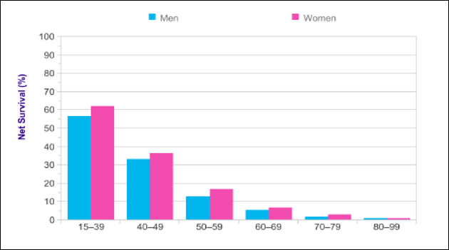

Figure 1.2:New cases and survival rate caused by brain tumor [6]

**1.5** **Thesis Contribution**

To apprehend the modern reputation of class strategies of Brain tumors, we've got carried out a statistical from a unique background. This statistical evaluation of classifying tumors consists of each picture processing and Neural Network strategy. It covers nearly all kinds of classification strategies at the side of the unique sort of pre-processing strategies. We executed 3 kinds of classifications to categorize the tumor. Tumor class the usage of Machine Learning classifiers and Convolutional Neural Network had been executed and contrast of overall performance measures became carried out among those 3 models. Initially, machine learning algorithms are implemented which includes extra feature extraction and image processing.

Later a convolutional neural network is implemented to the augmented dataset which offers a step forward result with recognition to different studies. The version is much less complicated as we detected the tumor the usage of the most effective 23 CNN.

In the end, a hybrid of CNN and SVM is applied. In phrases of education time and accuracy, the proposed CNN-SVM version offers a higher result than the maximum of today's works. The version is much less complicated as we detected the tumor the usage of the most effective 20 layer.

**1.6 Thesis Structure**

Our thesis book consists of six chapters based on our research work. Following, we will briefly discuss about the basis of the chapters**.**

**Chapter 1: Introduction**

This is the introductory chapter of the thesis book. In this chapter, we can describe shortly the objective, our goal, and contribution of our thesis. We will even symbolize Brain Tumor and its type shortly.

**Chapter 2: Literature Review**

We will describe some associated work that had been done before and describe their working approach, advantages and disadvantages.

**Chapter 3: Background Study**

This chapter includes all the prerequisite knowledge related to our thesis topic. We will discuss the Image processing techniques, Traditional Machine Learning Classifiers, and Deep Learning.

**Chapter 4: Proposed Methodology**

Our proposed methodology to classify brain tumor images will be described here.3 types of model which are proposed will be described here

**Chapter 5: Experimental Results & Evaluation**

In this chapter, we will explain the performance measures, our proposed algorithm for performance evaluation and we will discuss about the experimental results. In this division, we will also discuss the limitations of our work and future directions to work on and improve.

* 1. **Summary**

In this chapter, a short description of Brain tumor and its sub-fields are described. We have discussed different types of Brain tumor and its characteristics. We shortly explained the motivation behind our work and the objective for doing it. At last, our thesis contribution and the structure of our thesis was briefly described.

**Chapter 2**

**Literature Review**

**2.1 Introduction**

In recent years, numerous and diverse types of work have been carried out in the field of medical image processing. Researchers from the various ground such as- computer vision, image processing, machine learning came into a place in the field of Image Processing in medical sectors. We have studied some of the existing papers to find the most useful and advanced methods that were used in the existing articles in recent times. In this chapter, we will discuss thoroughly about these papers and their working procedures which are related to our work.

**2.2 Works Regarding Tumor Detection**

Machine learning tactics had been considerably employed in numerous domains which include clinical diagnostics and preventive medicine. A constrained range of studies, however, have focused prognosis of mind tumors mainly employing magnetic resonance imaging (MRI). Mostly machine learning strategies are used and quite a few works had been done simply to stumble on the tumors. Mallikarjun et al. [1] proposed a method the uses more advantageous statistical texture capabilities that can stumble on and localize tumors. It gives edge-primarily based totally Contourlet Transformation for a couple of entering photo registration, fusion, and pre-processing, for Region of Interest (ROI) of tumor region. The region-developing segmentation set of rules gives correct boundaries. Kumar et al. [2] proposed an SVM model with a characteristic choice set of rules named Particle Swarn Optimization. It used shapes, textures, and intensities as capabilities and categorized snapshots into 2 classes benign and malignant. This technique offers an accuracy of 95.23% altogether.

**2.3 Classification Using Deep Learning**

Deep learning techniques advantage extra reputation than machine learning works. Sultan et al [3] proposed a CNN model that classifies tumors into meningioma, glioma, and pituitary tumor. The data augmentation process is used right here to increase the scale of the schooling dataset and three convolution layers are used respectively. The proposed community shape achieves a giant overall performance with a pleasant common accuracy of 96.13% and 98.7%. Abiwinanda et al. [4] used an easy CNN structure this is with none earlier region-based. It classifies tumors into three classes which can be glioma, meningioma, and pituitary. It achieves a common accuracy that fluctuates between 71.39 to 94.68%. Similarly, Sunanda et al. [5] additionally proposed the identical range of convolution layers performed at the identical dataset containing 3064 pix with 3 sorts of tumor and performed an accuracy of 94.39%, common precision of 93.33%, and an average keep in mind of 93%.

**2.4 Classification Using Hybrid Of Machine & Deep Learning**

An aggregate of CNN and SVM outcomes is lots higher than the preceding ones and current research display massive outcomes. Deepak et al. [6] make use of five convolution layers to extract the functions from the snapshots after which the SVM set of rules is used to categorize the one's functions into three exceptional categories. Testing and assessment of the incorporated machine accompanied a fivefold cross-validation process and the proposed version attained a usual type accuracy of 95.82%. Similarly, Sejuti et al. [7] proposed nearly the identical sort of paintings which includes 19 layers with three convolution layers, three max-pooling layers,2 fully-connected layers, three batch-normalization layers with activation functions ‘reLu’. This manner additionally demonstrates three sorts of tumor types and offers an accuracy of 97.1%.

**2.5 Classification Using Pretrained Model**

In recent times, pre-trained networks additionally won popularity in classifying images. Some very famous pre-trained networks are VGG16, VGG19, GoogleNet, InceptionV3, Alexnet. S.deepak et al. [8] proposed a pre-trained network GoogleNet to extract features from brain MRI images. . Proven classifier fashions are incorporated to categorize the extracted capabilities. The test follows a patient-stage five-fold cross-validation technique on an MRI dataset from figshare [9]. The proposed gadget statistics an average type accuracy of 98%. Noreen et al. [10] propose a way of multi-level features extraction and concatenation for early analysis of mind tumor with pre-trained deep getting to know models i.e. Inception-v3 and DensNet201 make this version valid. With the assist of those models, distinct eventualities of brain tumor detection and its type had been evaluated. First, the features from distinct Inception modules had been extracted from the pretrained Inception-v3 version and concatenated those capabilities for brain tumor type.

**2.6 Summary**

In this chapter, we reviewed the different types of articles and discussed their working procedures. This literature study shows that a lot of research works had been introduced regarding brain tumor detection and classification. Some of the researchers applied traditional classifiers, while the others implemented deep learning and pretrained methods. Some works achieved a significant result using traditional approaches while some works did not. But after studying these works, we can claim that deep learning performs better than traditional classifiers because of their learning mechanism and use of memory in the network.

**Chapter 3**

**Background Study**

**3.1 Introduction**

Medical sectors are greatly dependent on computer-aided diagnostic. Since the enhancement of image processing techniques, the medical sector is now taking help from technology. Different algorithms are developed to identify and classify those images. These algorithms are broadly categorized. Primarily machine learning algorithms were used greatly. But in recent times Convolution Neural Network which is nothing but a subset of Artificial Neural Network gained popularity over that. This chapter will describe some basic image processing techniques along with the explanation of machine and deep learning algorithms.

**3.2 Importance of Medical Image Analysis**

Digital image processing is one of the contemporary-day and increase technology that way on the photos or videos. Nowadays x-ray is the number one important application of Digital Image Processing. Before x-ray, it modified into very difficult to check human bone. In every attitude and every lane, image processing can be carried out whether or not or now no longer it's miles for safety or for private use. From the discovery of X-ray via Roentgen in 1895 to the current imaging tools like Magnetic Resonance Imaging (MRI) and Computed Tomography (CT), the technology has advanced much. The advances in imaging technology will hold as time progresses. However, in recent times the point of interest of systems is shifting from clinical imaging popularity from the era and acquisition of pix to post-processing and manipulation of picture graph data. This is stimulated via the need to make inexperienced use of the data that already exists. Recent improvement in imaging research has demonstrated the capacity the technology can need to decorate and transform many factors of scientific medicine.

**3.3 Image Processing for Brain Tumor Classification**

The most challenging task is to extract the region of interest part from the whole image. We generally do not need the whole image. In a brain image, our region of interest is the tumor part only. We need to strip the skull part. There are different operations for it. Images must be clear in order to get the best results from it. We can use different preprocessing steps to make it possible.

**Skull Striping:**

The region of interest must be extracted from the whole image. This is called skull striping. Different types of operations like watershed algorithm, thresholding, morphological operations are performed to do so. In our paper, we’ve tried all of them. The best outcome comes from the morphological operation.

Morphology approach pixel form primarily based totally analysis. The goal of the use of morphological operations is to do away with the imperfections withinside the shape of the image [40]. The most simple morphological operations are dilation and erosion. Dilation provides pixels to the limits of objects in an image, even as erosion eliminates pixels on item boundaries. Morphological operations additionally consist of opening, closing, hit, and miss rework, etc.

**Preprocessing:**

A proper image is needed in order to identify and differentiate it from other images. Pre-processing is the prerequisite for gaining a clear and smooth image. Generally filtering is used to preprocess a large amount of image. Image filtering is beneficial for lots of applications, which includes smoothing, polishing, eliminating noise, and aspect detection. A clear out is described through a kernel, which is a small array implemented to every pixel and its neighbors inside a photo. The system used to use filters to a photo is referred to as convolution and can be implemented in both the spatial and frequency area. Spatial area filtering may be categorized into types- smoothing and sharpening filters, in keeping with their outputs. In our paper, we’ve used a simple smoothing filter named median filter.

**3.4 Machine Learning Classifiers**

Evaluation of our proposed model is performed by making use of a typical algorithm. So constructing up a model which could stumble on or phase the tumor is 1/2 of the undertaking that we've performed. Justification of the model is performed through model assessment or evaluation of the proposed version. We have performed a technique that implemented three conventional machine learning algorithms. To justify our model we've used those numerous sorts of classifiers. Here in this paper, we have used three conventional machine learning classifiers which might be Logistic Regression, Random Forest, and Support Vector Machine for getting the acquired result.

**Logistic Regression**

Like other regression analyses, the logistic regression is a predictive analysis. Logistic regression is used to explain records and to provide an explanation for the connection among one established binary variable and one or greater nominal, ordinal, c language or ratio-degree impartial variables.

Logistic regression makes use of an equation because of the representation, very similar to linear regression. Input values (x) are mixed linearly the usage of weights or coefficient values (called the Greek capital letter Beta) to are expecting an output fee (y). A key distinction from linear regression is that the output fee being modeled is a binary value (zero or 1) in preference to a numeric fee. Below is the logistic regression equation [43]: in which y is the anticipated output, b0 is the unfairness or intercept time period and b1 is the coefficient for the single input value (x).

**Random Forest**

Random forest is a sort of supervised machine learning set of rules primarily based totally on ensemble learning. Ensemble learning is a sort of mastering wherein we be part of distinctive sorts of algorithms or equal set of rules more than one instance to shape a greater effective prediction version. The random forest set of rules combines more than one set of rules of the equal kind i.e. more than one choice tree. Random choice forests are accurate for choice trees’ addiction of over-becoming to their training set [44]. It operates through building a mess of choice timber at training time and out- placing the elegance this is the mode of the classes (type) or imply prediction (regression) of the character trees [44].

**Support Vector Machine**

Support vector machines are supervised learning models with related learning algorithms that examine facts used for type and regression analysis. Given a fixed of training examples, every marked as belonging to 1 or the opposite of classes, an SVM training set of rules builds a version that assigns new examples to 1 class or the opposite, making it a non-probabilistic binary linear classifier [97]. An SVM version is an illustration of the examples as factors in the area, mapped in order that the examples of the separate classes are divided through a clean hole this is as extensive as possible. New examples are then mapped into that equal area and anticipated to belong to a class primarily based totally on which aspect of the distance they fall. In addition to appearing linear type, SVM can correctly carry out a non-linear type the usage of what's referred to as the kernel trick, implicitly mapping their inputs into high-dimensional function spaces.

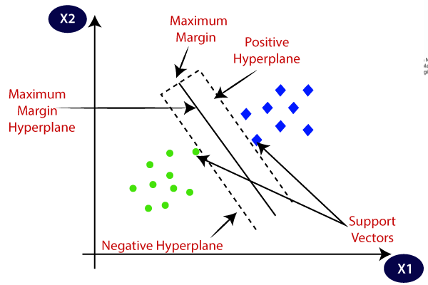

Figure 3.1: Support Vector Machine

**3.5 Deep Learning**

Deep learning is nothing but superset of machine learning. Machine learning is generally good for short amount of data. But when data is big the relation between them is complex, we need something more than that. We then use deep learning which consists of combination of neurons. These neurons are connected to each other like our human brain’s connectivity. Image related data can be greatly utilized using deep learning algorithms.

**3.5.1 Neuron**

The fundamental constructing unit of neural networks is artificial neurons, which imitate human brain neurons. These artificial neurons are effective computational units that have weighted enter alerts and convey an output sign by the use of an activation function. These neurons are unfolded throughout the numerous layers in a neural network. Figure 3.4 depicts the statistics of a neuron: A neuron has 3 parameters which are Weight, Bias and Activation Function. Geneally a neuron indicates connectivity of information between numbers of other neurons. The information transmits through them like a black box inside which we cannot see, but outside can be predicted.

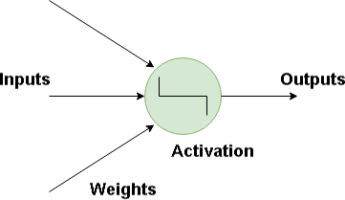

Figure 3.2: Basic Structure of a Neuron

**3.5.2 Artificial Neural Network**

Deep learning includes artificial neural networks which can be modeled on comparable networks present withinside the human brain. These neural networks paintings in more than one layer so this form of machine mastering is referred to as deep mastering. Artificial neural networks are a manner of calculating an output from an enter (a category) the use of weighted connections (“synapses") which can be calculated from repeated iterations via training statistics. Each by skip via the education statistics alters the weights such that the neural network produces the output with greater “accuracy" (decrease blunders rate). The combination of running reminiscence and pace is critical whilst we’re doing loads of lots of matrix multiplications. Figure 3.5 represents an easy synthetic neural community: An artificial neural network commonly has 3 layers. Layers are made of a few nodes which might be interconnected. The 3 layers of ANN are defined withinside the following:

• **Input Layer:** This layer includes neurons and that they simply get hold of the inputs and by skip it to the subsequent layer. The variety of layers withinside the enter layer needs to be identical to the attributes or functions withinside the dataset.

•**Hidden Layer:** In among input and output layers there are hidden layers primarily based totally on the sort of model. Hidden layers comprise a huge variety of neurons. The neurons withinside the hidden layer follow variations to the inputs earlier than passing them to the subsequent layer. As the community is trained the weights get updated, to be extra predictive. The real processing of the statistics is finished thru a gadget of weighted connections withinside the hidden layer. The hidden layers are related to the output layer.

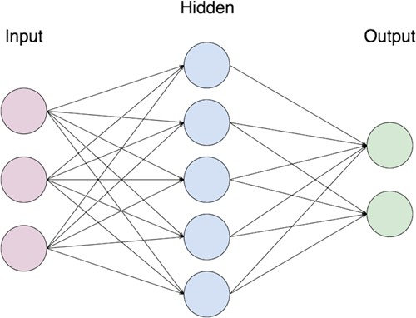

Figure 3.3: A simple Artificial Neural Network

•**Output Layer:** The output layer is the predicted feature, or elegance in a category problem, it essentially relies upon withinside the sort of the constructed model. The output layer offers the output primarily based totally on the facts surpassed from the hidden layer.

The inner shape of ANN may be modified through itself primarily based totally on the facts passing via it. This is finished through the adjustment of the weights. Every connection withinside the neural community commonly has a weight that controls the sign among the 2 neurons. If the output is good, the adjustment is not needed, however, if the output is poor, then the gadget adapts by converting the weights to enhance the output. The overall performance assessment of the output is finished through the gadget through evaluating the output with the unique output given earlier than withinside the education mode [37].

**3.5.3 Convolution Neural Network (CNN)**

The simple concept of Convolutional Neural Network become added via way of means of Kunihiko Fukushima in the 1980s [88]. Convolutional Neural Networks (ConvNets or CNNs) are a class of Neural Networks that have tested very powerfully in regions inclusive of picture reputation and classification. Computer imaginative and prescient strategies are ruled via way of means of convolutional neural networks due to their accuracy in picture classification. CNN is a category of deep, feed-ahead synthetic neural networks (wherein connections among nodes do now no longer shape a cycle) & uses a variant of multilayer perceptrons designed to require minimum pre-processing. ConvNet architectures make the specific assumption that the inputs are images, which lets us encode positive properties into the architecture. These then make the ahead characteristic extra green to put into effect and massively lessen the number of parameters withinside the community. ConvNets are made of neurons that have learnable weights and biases. Each neuron gets a few inputs, plays a dot product, and optionally follows it with a non-linearity. The complete community nevertheless expresses a single differentiable rating characteristic: from the uncooked picture pixels on one quit to elegance rankings on the other. And they have got a loss characteristic at the closing layer.

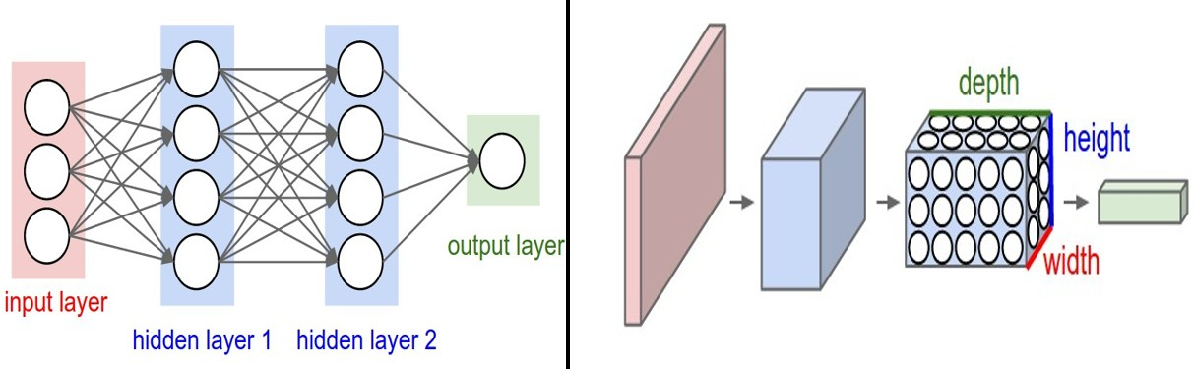

Figure 3.4: A simple neural network and A Convolutional Neural Network [86]

In the above, in determine 3.4, the left aspect represents a regular 3 Layer neural network. On the opposite hand, the proper aspect of the determine represents a CNN that arranges its neurons in 3 dimensions (width, height, intensity) [41].

Every layer of a CNN transforms the 3D enter quantity to a 3D output quantity of neuron activations. In this example, the red enter layer holds the image, so its width and height will be the dimensions of the image, and the intensity might be 3 (Red, Green, Blue channels).

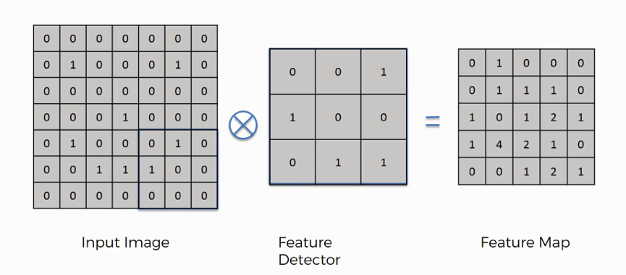

Figure 3.5: Convolution Operation

1. **Convolutional Layer**

This layer is the primary layer. This is used to extract the numerous functions from the input images. In this residue, the mathematical operation of convolution is accomplished among the input photo and a clear-out of a selected length NxN. By sliding the clear out over the input photo, the dot product is taken among the clear-out and the elements of the input photo with admire to the scale of the clear out (NxN). The output is called because the Feature map. It offers us statistics approximately the photo which includes the corners and edges. Later, this option map is fed to different layers to analyze numerous different functions of the entry photo.

1. **Pooling Layer**

In maximum cases, a Convolutional Layer is observed via way of means of a Pooling Layer. The number one intention of this residue is to lower the scale of the convolved function map to lessen the computational costs. This is accomplished via way of means of reducing the connections among layers and independently operates on every function map. Depending upon the technique used, there are numerous varieties of Pooling operations. In Max Pooling, the most important detail is taken from the function map. Average Pooling calculates the common of the factors in a predefined sized Image segment. The general sum of the factors withinside the predefined segment is computed in Sum Pooling. The Pooling Layer normally serves as a bridge between the Convolutional Layer and the FC Layer

1. **Fully Connected Layer**

The Fully Connected (FC) layer includes the weights and biases alongside the neurons and is used to attach the neurons among specific layers. These layers are normally located earlier than the output layer and shape the previous few layers of a CNN Architecture. In this, the input photo from the preceding layers is flattened and fed to the FC layer. The flattened vector then undergoes a few extra FC layers wherein the mathematical features operations normally take place. In this stage, the category method starts off evolving to take place.

1. **Dropout**

Usually, whilst all of the functions are related to the FC layer, it is able to purpose overfitting withinside the training dataset. Overfitting takes place whilst a selected version works so properly at the education records inflicting a poor effect withinside the version’s overall performance whilst used on a brand new record. To conquer this problem, a dropout layer is utilized in which some neurons are dropped from the neural community at some stage in the training method ensuing in decreased length of the version. On passing a dropout of 0.3, 30% of the nodes are dropped out randomly from the neural community.

1. **Activation Functions**

Finally, one of the maximum essential parameters of the CNN version is the activation function. They are used to analyze and approximate any type of non-stop and complicated courting among variables of the community. In easy words, it comes to a decision which statistics of the version have to hearthplace withinside the ahead route and which of them have to now no longer on the stop of the community. It provides non-linearity to the community. There are numerous normally used activation features which include the ReLU, Softmax, tanH, and the Sigmoid features. Each of those features has particular usage. For a binary category CNN version, sigmoid and softmax features are desired and for a multi-elegance category, commonly softmax is used.

**3.6 Summary**

This chapter includes a brief explanation of all the topics which are related to our thesis work along with their working procedure, their advantages and disadvantages etc. Firstly, we have tried to describe the topics of basic image processing and then we moved on to the description of the basic CNN architecture along with its different layers.

**Chapter 4**

**Proposed Methodology**

**4.1 Introduction**

There are three proposed model by which we can classify the abnormal cells in brain MRI. We have tried to detect and classify the tumor using traditional machine learning algorithms, convolutional neural network and a hybridization on both of them. In classification using machine learning step, our main concern is to train the proposed model. We have used three machine learning algorithms: Logistic Regression, Random Forest, and SVM for this purpose. Initially we will discuss the classification of the tumor using traditional machine learning algorithm. After that, we will introduce the CNN model and thoroughly describe the all the layers related to detect the brain tumor. At the end we’ll describe a hybrid model of CNN and SVM.

**4.2 Proposed Architecture**

We have proposed 3 different models with respect of finding out the proper classification of brain tumors. So our total work will be divided into 3 stages.

* Stage-1: Classification using Support Vector Machine
* Stage-2: Classification using Deep Convolution Neural Network
* Stage-3: Classification using a hybrid of SVM & CNN

The data will be break into 2 fundamental portions. They are called images and labels where images are the feature information about each individuals and labels are the corresponding class value for them. The total dataset has been divided into training and testing with a ratio of 80% to 20%. In stage-1 and stage-3,we use our leading training data without distorting any information. In stage-2, we’ve expanded our data by using data augmentation. This process is nothing but adding a few other operations on image to expand the number of images. As convolution neural network is feed on the number of training data. As the number of variations of training information increased, the output classification will be better significantly. So augmenting data will be a good solution to this.

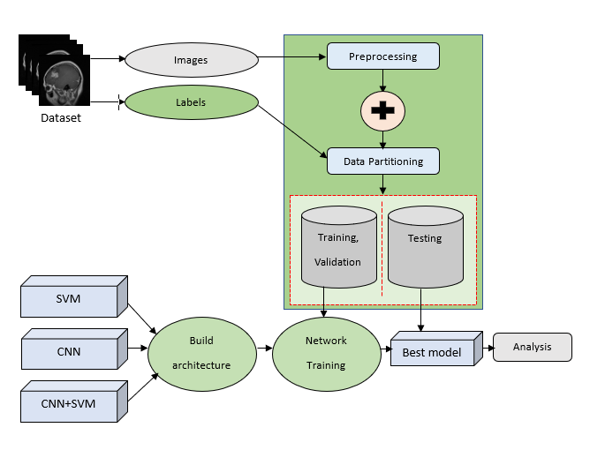

Figure 4.1 : Brain Tumor Classification System Architecture

**4.2.1 Classification using SVM**

Support Vector Machine(SVM) is a now no longer unusual place supervised set of guidelines that are used for class, regression and outliers detection [12] It is robust in times in which the amount of dimensions is greater than the number of samples. We have classified the MRI images following a number of steps that are given in figure 3. The steps follow preprocessing, filtering, features extraction, data normalization, cross-validation and hyper-tuning. In the preprocessing stage, we follow the previous steps where data is under sampled as 128 x 128. Then images are converted to grayscale and apply median filtering on it. Followed by this, skull masking [13] is done using morphological operations like erosion and dilation to reduce the dimensionality of the images. Then the images are divided into raw images and labels. The labels are further encoded from string to numbers using one-hot encoding. Additionally, a couple of features are extracted from the images. The features used in the section are GLCM features [14], Gabor2D filters, and first-order derivatives.

A GLCM (Gray Level Co-occurrence Matrix) is a matrix in which the number of rows and columns are the same as the number of gray ranges withinside the image. Total 5 sorts of GLCM features are used properly right here especially contrast, homogeneity, dissimilarity, energy, and correlation.3 orientation (0,45,90) with 3 offsets (2,3,4) is used withinside the corresponding SVM method.

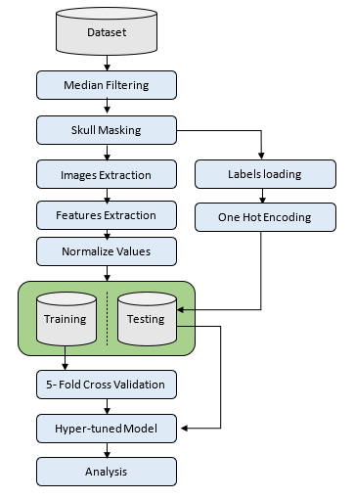

Figure 4.2: Proposed methodology for classification using SVM

**1)Contrast:** Contrast is determined through manner of a method of the pixel intensities alongside facet the adjacent pixels of a photo.

**2) Homogeneity:** It is decided by the concept of local regularity in an MRI photo. It is computed through manner of the method of the variations on textured and non-textured abilities, which can be stated as an inverse model moment.

**3) Correlation:** It is derived due to the fact the computation of spatial features between the image pixels.

**4) Energy:** Energy is considered proper right here as the quantity of reoccurring pixel pairs. It is the derivation of similarity of pixels in an MRI scan.

**5) Dissimilarity:** Here, the weights with which GLCM probabilities are increased grow linearly away from the diagonal (along which neighboring values are equal).

**4.2.2 Classification using CNN**

Convolution Neural Network(CNN) is a subset of an Artificial Neural Network that is patterned after the operation of the human brain. This procedure is significantly utilized in operations like photograph processing, photograph reputation and category. A traditional CNN version may have distinctive layers on the foundation of the operation. Initially, datasets had been augmented with the use of distinctive operations like zooming, including noise, peak shifting, width shifting, and so on to increase the variety of datasets [16] [17] Next, a great CNN version with quite a number of layers has been implemented to each characteristic extraction and classify pix. Figure four indicates the CNN structural version used on this paper to categorize pictures all alongside itself. The following parent indicates using 23 layers in general. It consists of the use of convolution filters, max-pooling layers, batch normalization, dropout and so on. After the primary characteristic extracting layers, the capabilities are then flattened and ship to the completely related layer following with the aid of using a few different layers and a ’SoftMax’ classifier is used to categorize the pictures [18].

The description of every layer is as follows: First, withinside the input layer, we've got used [128x128] images with having all of the three colorize information. Next, convolution filters are implemented. Here in this paper, general four numbers of convolution layers are used. This layer plays a dot product among matrices, in which one matrix is the set of learnable parameters in any other case known as a kernel. The kernel is spatially smaller than an photograph but is greater in-intensity. This method that, if the photograph is composed of 3 (RGB) channels, the kernel peak and width could be spatially small, however the intensity extends as much as all 3 channels. During

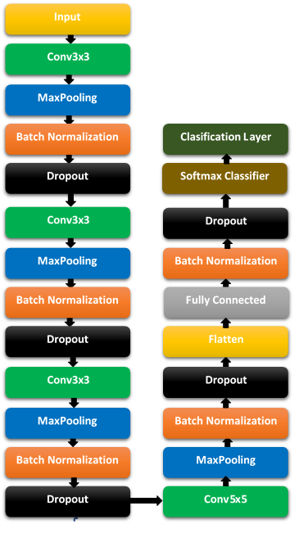

Figure 4.3: Proposed methodology for classification using SVM

the ahead by skip, the kernel slides throughout the peak and width of the photograph-generating the photograph illustration of that receptive region. This produces a two-dimensional illustration of the photograph called an activation map that offers the reaction of the kernel at every spatial role of the photograph [19].

Accordingly, a kernel length of 3 x 3 and 5 x 5 is utilized in parent four. Some variety of 64,32,32 and sixty four convolution filters are implemented corresponding with three, three, five and three kernel length. Every convolution layer is accompanied with the aid of using a non-saturated activation characteristic known as ‘RELU’ [20]. It is hooked up to each neuron and makes a decision whether or not a neuron could be activated or now no longer primarily based totally on every neuron’s relevancy for the version’s prediction [21]. This will store a number of computation time and increase the version’s flexibility.

Next, a max-pooling layer [22] with a 2x2 layer is implemented. This layer normally replaces the output of the community at sure places with the aid of using deriving a precis statistic of the nearby outputs. This allows in lowering the spatial length of the illustration, which decreases the desired quantity of computation and weights. All of the pooling layers utilized in parent four are 2x2. Followed with the aid of using this, batch normalization layers had been implemented to every convolution layer [23]. This layer allows in scaling and adjusting distinctive characteristic values into variety values. This has the impact of stabilizing the getting to know the procedure and dramatically lowering the variety of education epochs.

In each convolution layer, a dropout layer [24] is used. It is a way in which randomly decided on neurons are dropped all through training. They are “dropped-out” arbitrarily. This infers that their contribution to the activation of downstream neurons is transiently evacuated at the ahead by skip and any weight refreshes aren't implemented to the neuron at the backward by skip. Every dropout layer in parent four has a dropout price of 20% corresponding with the preceding layers.

Applying all different layers related to convolution layers, a flatten layer [25] is proposed on the quit of them to create a one-dimensional illustration of characteristic values. What happens after the pulling down step is that the procedure finally ends up with a lengthy vector of enter facts this is passing via the artificial neural community to have it processed further.

Since the characteristic extraction procedure is done, now we need to categorize the pix accordingly. Initially, a completely related dense layer is proposed because the nineteenth layer in parent four [26]. The completely related a part of the CNN community is going via its backpropagation procedure to decide the maximum accurate weights. Each neuron gets weights that prioritize the maximum suitable label. Finally, the neurons “vote” on every of the labels, and the winner of that vote is the category decision [21]. A unit of 512 is used on this version because the dimensionality of the output space. The values had been normalized the use of a batch normalization layer after this and additionally a dropout layer is initiated to lessen the undesirable values with the aid of using 20% [23] [24]. After characteristic extractions from each block, the average pooling layer and completely related layer had been used for characteristic concatenation after which exceeded those concatenated capabilities to the ’SoftMax’ classifier. SoftMax layer is used after the FC layer. SoftMax assigns decimal possibilities to every magnificence in a multi-magnificence problem. Those decimal possibilities ought to upload as much as 1.0. This extra constraint allows education converge greater quick than it in any other case would [22] [18] [26].

Finally, an optimizer named ‘Adam’ is used to optimize the work. Adam [27] is an adaptive getting to know price optimization set of rules that’s been designed in particular for training deep neural networks The algorithms leverage the electricity of adaptive getting to know fees techniques to discover person getting to know fees for every parameter. It works nicely in settings with sparse gradients, but struggles in non-convex optimization of neural networks, and RMSpropwhich tackles to remedy a number of the troubles of Adagrad and works nicely in on line settings.

**4.2.3 Classification using CNN-SVM**

Previously, the CNN version acts as each feature extractor and classifier. But on this portion, the CNN version makes use only as a feature extractor [28]. In figure 5, the entire proposal of this contemporary version has been proposed. It is just like figure four till Fig. 5. CNN Classification Approaches layer 18. Now, the concept is to apply those functions withinside the machine learning algorithms to educate the version. We’ve used ’random forest’ and ’support vector machine(SVM)’ on this version, wherein SVM offers great results. A support vector classifier tries to find a hyperplane that maximizes the gap from the individuals of every class to the most advantageous hyperplane [12]. In this research, 3 sorts of kernels are studied. These kernels are linear, polynomial, and radial foundation functions. The kernel features go back the inner product among factors in an appropriate function space. Thus with the aid of using defining a perception of similarity, with a bit computational price even in very high-dimensional spaces. We’ve used a value of fifty as a penalty parameter which is likewise described as C. It describes the set of rules how plenty we care approximately misclassified factors. SVMs, in general, are seeking to locate the most margin hyperplane. That is the road that has as plenty room on each aspects as possible [29] [30].

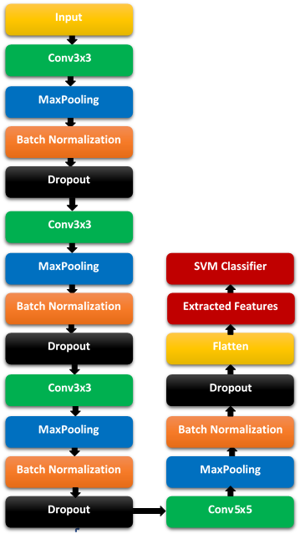

Figure 4.4: Proposed methodology for classification using CNN-SVM

**4.3 Summary**

In this chapter, the proposed methodology classification using different sets of algorithm is described. It includes Support vector Machine which is a machine learning algorithm. Later convolution Neural Network has been used. The best result comes from the hybridization of CNN and SVM.

**Chapter 5**

**Results & Discussions**

**5.1 Introduction**

we will comprehensively describe the outcomes of our proposed methodology in this chapter. We classify our model using three distinct mechanisms which are traditional machine learning, convolutional neural network and a hybridization on both of them. Following we will do the performance evaluation process and will compare the performance of the three models. Furthermore, we also analyze our model with the existing model in terms of classification.

* 1. **Experimental Setup**

We have used the Google Colab notebook and various python packages such as NumPy, Pandas, OpenCV etc. for image processing. For the traditional classifiers, we also used the Scikit-Learn. We used python version 3.7 with Anaconda. For training and testing our model through CNN, we used TensorFlow and karas framework. We used the dedicated GPU which is provided by Google Colab.

* 1. **Dataset Acquisition**

The dataset used in this study uses 3264 T1-weightedMR images and collected from the Kaggle website [11]. Four different types of classification are formed here such as glioma, meningioma, pituitary and no tumor. Here, the number of tumor images for each category contains:926 forglioma,940 for meningioma,500 for no tumor and 901 for pituitary**.**

* 1. **Performance Measures**

We have to talk about approximately the overall performance matrices that allow us to recognize in what volume our version works accurately. In this phase, we can talk approximately the overall performance degree that we keep in mind to assess our model. We want to familiarize ourselves with a few phrases concerning the overall performance measures.

**5.4.1 Confusion Matrix**

The Confusion matrix is one of the maximum intuitive metrics used to discover the correctness and accuracy of the version. It is used for Classification hassle in which the output may be of or greater sorts of classes. The Confusion Matrix includes 4 parameters which might be defined below-

* **True Positive (TP):** Number of tumor photos that might be effectively labeled.
* **True Negative (TN):** Number of non-tumor photos which might be effectively labeled.
* **False Positive (FP):** Number of non-tumor photos which might be misclassified as tumors.
* **False Negative (FN):** Number of tumor photos that might be misclassified as non-tumor .

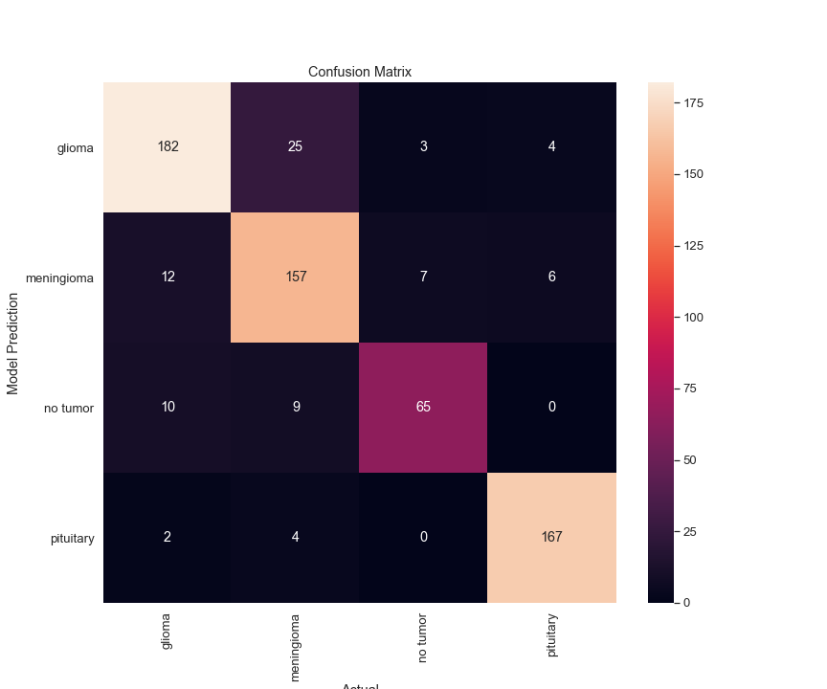

Figure 5.1: The confusion matrix of proposed SVM

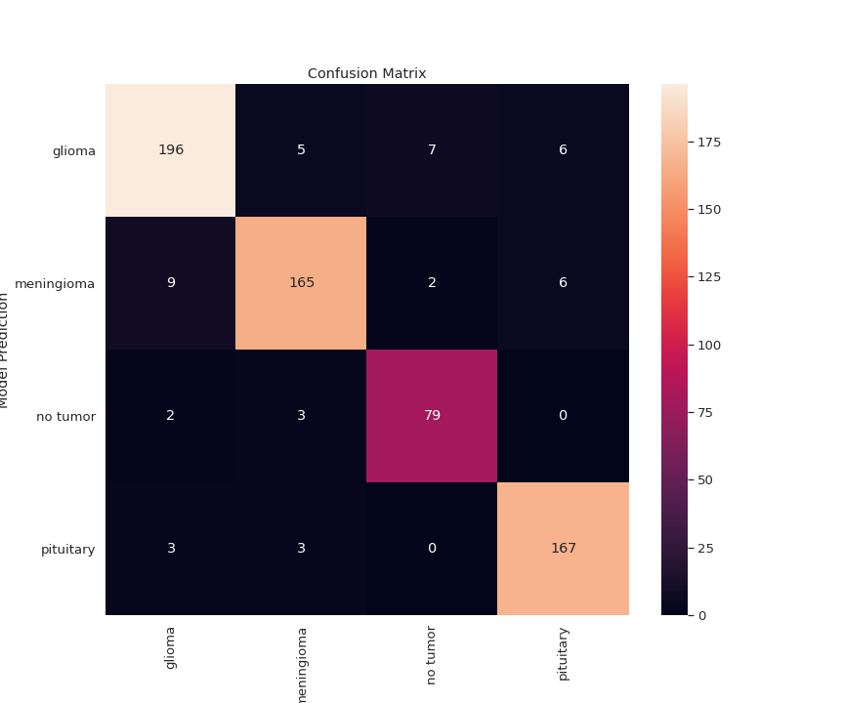

Figure 5.2: The confusion matrix of proposed CNN

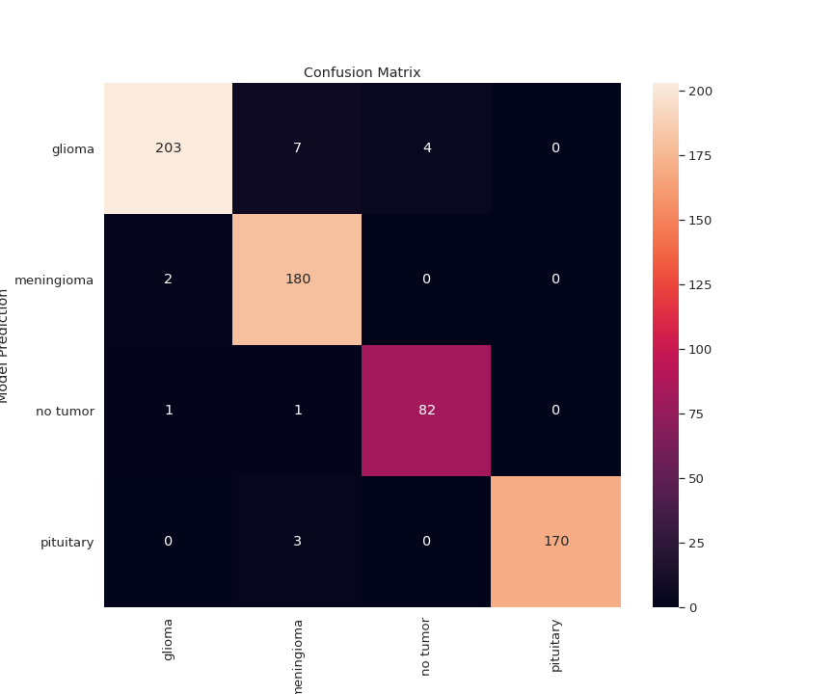

Figure 5.3: The confusion matrix of proposed CNN-SVM

**5.4.2 Accuracy**

It’s the maximum famous overall performance matrix that measures how regularly the classifier produces the right prediction. Mathematically Accuracy is described because the ratio of the variety of correct anticipated photos and the overall variety of photos and symbolically represented as-

*Accuracy = $\frac{Correct Predictions}{Total Number of Images}=\frac{TP+TN}{TP+TN+FP+FN} (5.1)$*

**5.4.3 Precision**

It is the retrieved facts that might be applicable to the version. Precision is the ratio of the variety of tumor photos that might be effectively labeled (TP) and the variety of photos labeled or misclassified as tumor (TP + FP). The decrease the FP the better the Precision. The model is greater powerful in case of a better precision rate.

*Precision = $\frac{TP}{TP+FP} (5.2)$*

**5.4.4 Recall**

It is the fraction of the photos which might be efficiently retrieved. The recall is the ratio of the variety of tumor photos that might be effectively labeled and the variety of photos that might be to be anticipated. Sensitivity, Hit Rate, True Positive Rate is the opposite names of Recall. The lower the False-negative the higher the recall.

*Recall = $\frac{TP}{TP+FN} (5.3)$*

**5.4.5 F-Score**

It is the harmonic imply of Precision and Recall and is a degree of taking a look at accuracy. F-score reaches its quality value at 1 (100% precision and recall) and worst value at 0. F-Score may be described as-

*F -Score= $2*\frac{Precision*Recall}{Precision+Recall}=\frac{2TP}{2TP+FP+FN} (5.4)$*

**5.4.6 Specificity**

Specificity is the True Negative Rate (TNR) of the version and the statistical degree of the binary category test. As we're managing a binary category (tumor or non-tumor) so we are able to use this because of the overall performance evaluation. It is the ratio of the variety of non-tumor photos which might be effectively labeled (TN) and the variety of photos that might be labeled or misclassified as non-tumor (TN + FP). The decrease the fake positive (FP) the better the specificity or selectivity.

*Specificity=TNR $=\frac{TN}{TN+FP} (5.5)$*

**5.4.7 ROC-AUC**

ROC-AUC curve is an overall performance dimension for the category issues at diverse threshold settings. ROC is an opportunity curve and AUC represents the diploma or degree of separability. It tells how a good deal the model is able to distinguish among classes. Higher the AUC, the higher the version is at predicting 0s as 0s and 1s as 1s. By analogy, the Higher the AUC, the higher the version is at distinguishing among sufferers with the ailment and no ailment.

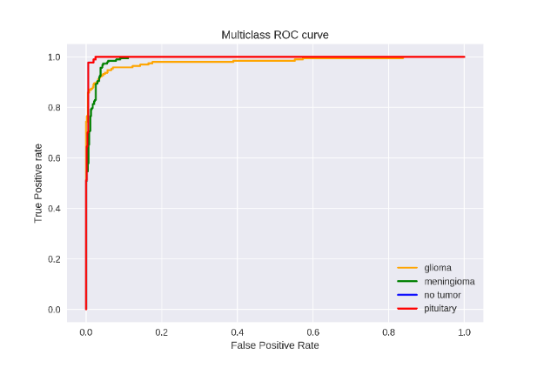

Figure 5.4: Multiclass ROC-AUC using SVM-CNN

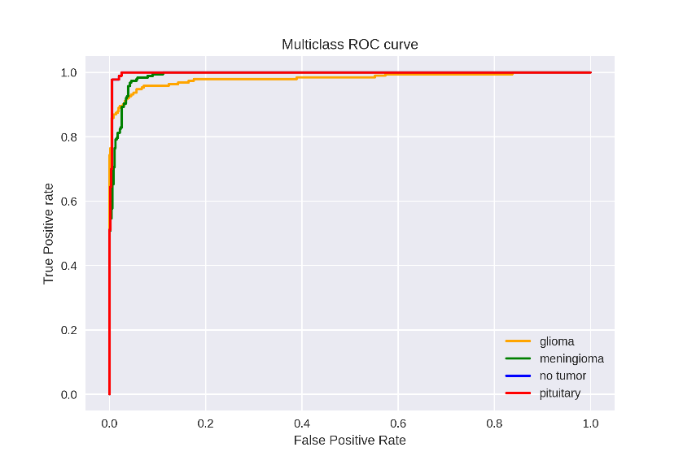

Figure 5.5: Multiclass ROC-AUC using CNN

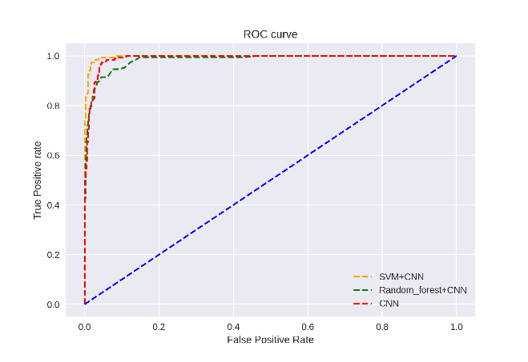

Figure 5.6: Multiclass ROC-AUC of top 3 algorithms

* 1. **Experimental Results**

We will discuss our corresponding results which come from not only our best 3 models but with other used models too.

* + 1. **Performance Analysis of ML Algorithms**

Three different machine learning algorithms are used primarily. They are called support vector machine, random forest and logistic regression.

Table 5.1:Proposed Machine Learning Algorithm's Results

|  |  |  |  |  |  |
| --- | --- | --- | --- | --- | --- |
| **Methods** | **Classes** | **Precision** | **Recall** | **F1-Score** | **Average Accuracy** |
|  | Glioma | 0.88 | 0.85 | 0.87 |  |
|  | Meningioma | 0.81 | 0.86 | 0.83 | **87.44%** |
| **SVM** | No Tumor | 0.87 | 0.77 | 0.82 |  |
|  | Pituitary | 0.94 | 0.97 | 0.95 |  |
| **Random** | Glioma | 0.83 | 0.71 | 0.77 |  |
| **Forest** | Meningioma | 0.70 | 0.79 | 0.74 | **79.94%** |
|  | No Tumor | 0.85 | 0.76 | 0.81 |  |
|  | Pituitary | 0.86 | 0.93 | 0.89 |  |
|  | Glioma | 0.82 | 0.66 | 0.73 |  |
| **Logistic** | Meningioma | 0.61 | 0.69 | 0.65 | **73.04%** |
| **Regression** | No Tumor | 0.74 | 0.68 | 0.71 |  |
|  | Pituitary | 0.77 | 0.88 | 0.82 |  |

From Table-5.1, we can clearly see that support vector machine gives the best result. It’s average accuracy is 87.44%.

* + 1. **Performance Analysis of CNN**

Convolution Neural Network is an updated version of Machine Learning Algorithms. The outcome comes better than previous with much less effort. From table 5.2 we can see that, the average accuracy is 92.96%.

Table 5.2: Proposed CNN Algorithm's Results

|  |  |  |  |  |  |
| --- | --- | --- | --- | --- | --- |
| **Methods** | **Classes** | **Precision** | **Recall** | **F1-Score** | **Average Accuracy** |
|  | Glioma | 0.93 | 0.92 | 0.92 |  |
| **CNN** | Meningioma | 0.94 | 0.91 | 0.92 | **92.96%** |
|  | No Tumor | 0.90 | 0.94 | 0.92 |  |
|  | Pituitary | 0.93 | 0.97 | 0.95 |  |

Convolution Neural Network is an updated version of Machine Learning Algorithms. The outcome comes better than previous with much less effort. From table 5.2 we can see that, the average accuracy is 92.96%.

* + 1. **Performance Analysis of CNN-SVM**

CNN is good for automatic feature extraction which is automatic. SVM is a great classification algorithm. We have combined both of them where CNN acts as a feature extractor and SVM as a classification algorithm. We have used other machine learning algorithm like Random Forest with CNN too. The best outcome of this paper come from a hybrid of CNN and SVM. The average accuracy from this comes as 92.24%.

Table 5.3: Proposed Hybrid Algorithm's Results

|  |  |  |  |  |  |
| --- | --- | --- | --- | --- | --- |
| **Methods** | **Classes** | **Precision** | **Recall** | **F1-Score** | **Average Accuracy** |
| **CNN** | Glioma | 0.99 | 0.95 | 0.97 |  |
| **+** | Meningioma | 0.94 | 0.99 | 0.97 | **91.73%** |
| **RF** | No Tumor | 0.95 | 0.98 | 0.96 |  |
|  | Pituitary | 1.00 | 0.98 | 0.99 |  |
| **CNN** | Glioma | 0.95 | 0.86 | 0.91 |  |
| **+** | Meningioma | 0.86 | 0.92 | 0.89 | **97.24%** |
| **SVM** | No Tumor | 0.92 | 0.92 | 0.92 |  |
|  | Pituitary | 0.94 | 0.98 | 0.96 |  |

* 1. **Performance Comparison with Existing Works:**

In this section, we in comparison the overall performance of the present fashions to the proposed fashions. Though we used dataset to degree the overall performance of the proposed version, we can think about the outcomes of the BRATS dataset.

Table 5.4: Comparison with Existing Works

|  |  |  |  |
| --- | --- | --- | --- |
| **Model** | **Accuracy** | **Classification Type** | **Method** |
| P Satish et al. [31] | 89.52% | Multi 3 | RBNN |
| Ayadi et al. [32] | 90.27% | Multi 3 | SVM |
| Kaplan et al. [33] | 95.56% | Multi 3 | KNN |
| Rajini et al. [34] | 95% | Multi 3 | CNN |
| Begum et al. [35] | 95% | Binary 2 | RNN |
| David et al. [36] | 93.75% | Binary 2 | SVM |
| Sultan et al. [3] | 96.13% | Multi 3 | CNN |
| Deepak et al. [6] | 95.82% | Multi 3 | CNN-SVM |
| Sejuti et al. [7] | 97.1% | Multi 3 | CNN-SVM |
| **Proposed Structure** | **97.24%** | **Multi 4** | **CNN-SVM** |

We in comparison with the proposed version of type, the use of Machine Learning set of rules and the CNN version relying on a distinct splitting ratio. In conventional gadget getting to know version, we compare the version primarily based totally on splitting techniques. Among them 80:20 splitting ratio offers us the high-quality end result of 97.24% for the hybrid of CNN and SVM. For the proposed CNN-SVM version, the average accuracy is 97.24% which beat the previous records.

* 1. **Summary**

We have shown the performance matrices with a short description and the value of the hyper-parameters for which we got the best result for the proposed CNN-SVM model. After that, the output of each step in the classification of the tumor is depicted. Later, we have shown all the experimental and empirical results with proper justification. At the end, we have done a comparison between our proposed models and between the existing models.

**Chapter 6**

**Conclusion**

**6.1 Introduction:**

This paper discussed the automatic classification of MRI brain tumor images using various machine learning algorithms in comparison with deep learning algorithm CNN and hybridization on both of them. The classification process classifies the tumors into 4 different categories namely glioma, meningioma, pituitary, and no-tumor. Initially, handcrafted features got its extraction from the images and then trained using machine learning algorithms. The results come good and the highest accuracy is 87.44% for SVM. Then, the deep learning algorithm CNN is used to classify them. Data Augmentation is used in this method to first increment the size of data. Then different layers including a fully-connected dense layer are applied. The accuracy comes better than the previous one and it is 92.96%. Finally, a hybridization of both of these processes is applied. The best result comes from this process, which is approximately 97.24%. This is better than most of the works related to this term. One important thing is, we’ve classified not binary or 3 kinds of tumor classification only. We have added both tumors and non-tumor portions to the dataset. So,4 different types of classification have been applied and the results are followed in this paper.

* 1. **Limitations**

There are some limitations of our thesis work that we have listed in this section which we are leaving to improve in our future works.

1.The BRATS dataset has only 3264 images.

2.Worked only on 2D images.

3.We could have tried more traditional classifiers to increase the accuracy. Types of the tumor could not be classified.

* 1. **Future Works**

There are more opportunities for improvement or research on our work in the future.

Firstly, images number should be increasing in number. The bigger the number of images is, the better the model is trained.

Secondly, we want to work on 3D images in the future.

Thirdly, more traditional classifiers can be applied to get more increased accuracy.

Fourthly, we will try to sectionize the tumor if its benign or malignant after the detection of the tumor.

Last but not the least, more variations of deep learning methods can be tested in the future.

**6.4 Summary**

We have shown the performance matrices with a short description and the value of the hyper-parameters for which we got the best result for the proposed CNN-SVM model. After that, the output of each step in the classification of the tumor is depicted. Later, we have shown all the experimental and empirical results with proper justification. At the end, we have done a comparison between our proposed models and between the existing models.

**References**

[1] Mallikarjun Mudda, R Manjunath, and N Krishnamurthy. Brain tumor classification using enhanced statistical texture features. IETE Journal of Research, pages 1–12, 2020.

[2] Arun Kumar, Alaknanda Ashok, and MA Ansari. Brain tumor classification using hybrid model of pso and svm classifier. pages 1022–1026, 2018.

[3] Hossam H Sultan, Nancy M Salem, and Walid Al-Atabany. Multiclassification of brain tumor images using deep neural network. IEEE Access, 7:69215–69225, 2019.

[4] Nyoman Abiwinanda, Muhammad Hanif, S Tafwida Hesaputra, Astri Handayani, and Tati Rajab Mengko. Brain tumor classification using convolutional neural network. In World congress on medical physics and biomedical engineering 2018, pages 183–189. Springer, 2019.

[5] Sunanda Das, O. F. M. Riaz Rahman Aranya, and Nishat Nayla Labiba. Brain tumor classification using convolutional neural network. In 2019 1st International Conference on Advances in Science, Engineering and Robotics Technology (ICASERT), pages 1–5, 2019.

[6] S Deepak and PM Ameer. Automated categorization of brain tumor from mri using cnn features and svm. Journal of Ambient Intelligence and Humanized Computing, 12(8):8357–8369, 2021. [7] Zarin Anjuman Sejuti and Md Saiful Islam. An efficient method to classify brain tumor using cnn and svm. In 2021 2nd International Conference on Robotics, Electrical and Signal Processing Techniques (ICREST), pages 644–648. IEEE, 2021.

[8] S Deepak and PM Ameer. Retrieval of brain mri with tumor using contrastive loss based similarity on googlenet encodings. Computers in Biology and Medicine, 125:103993, 2020.

[9] Figshare brain tumor dataset. 2018.

[10] Neelum Noreen, Sellappan Palaniappan, Abdul Qayyum, Iftikhar Ahmad, Muhammad Imran, and Muhammad Shoaib. A deep learning model based on concatenation approach for the diagnosis of brain tumor. IEEE Access, 8:55135–55144, 2020.

[11] Sartaj Bhuvaji, Ankita Kadam, Prajakta Bhumkar, Sameer Dedge, and Swati Kanchan. Brain tumor classification (mri), 2020.

[12] Onuwa Okwuashi and Christopher E Ndehedehe. Deep support vector machine for hyperspectral image classification. Pattern Recognition, 103:107298, 2020.

[13] A Gokulalakshmi, S Karthik, N Karthikeyan, and MS Kavitha. Icm-btd: improved classification model for brain tumor diagnosis using discrete wavelet transform-based feature extraction and svm classifier. Soft Computing, 24(24):18599–18609, 2020.

[14] Dharmender Kumar et al. Feature extraction and selection of kidney ultrasound images using glcm and pca. Procedia Computer Science, 167:1722–1731, 2020.

[15] Shubham Kumar Baranwal, Krishnkant Jaiswal, Kumar Vaibhav, Abhishek Kumar, and R Srikantaswamy. Performance analysis of brain tumour image classification using cnn and svm. In 2020 Second International Conference on Inventive Research in Computing Applications (ICIRCA), pages 537–542. IEEE, 2020.

[16] Alex Krizhevsky, Ilya Sutskever, and Geoffrey E Hinton. Imagenet classification with deep convolutional neural networks. Advances in neural information processing systems, 25:1097–1105, 2012.

[17] Sebastien C Wong, Adam Gatt, Victor Stamatescu, and Mark D Mc- Donnell. Understanding data augmentation for classification: when to warp? In 2016 international conference on digital image computing: techniques and applications (DICTA), pages 1–6. IEEE, 2016.

[18] Muhammad Aamir, Nazri Mohd Nawi, Fazli Wahid, and Hairulnizam Mahdin. A deep contractive autoencoder for solving multiclass classification problems. Evolutionary Intelligence, pages 1–15, 2020.

[19] Jun-e Liu and Feng-Ping An. Image classification algorithm based on deep learning-kernel function. Scientific programming, 2020, 2020.

[20] Afnan M Alhassan and Wan Mohd Nazmee Wan Zainon. Brain tumor classification in magnetic resonance image using hard swish-based relu activation function-convolutional neural network. Neural Computing and Applications, pages 1–13, 2021.

[21] Jamal Khamis El-Mahelawi, Jinan Usama Abu-Daqah, Rasha Ibrahim Abu-Latifa, Bassem S Abu-Nasser, and Samy S Abu-Naser. Tumor classification using artificial neural networks. International Journal of Academic Engineering Research (IJAER), 4(11), 2020.

[22] FM Javed Mehedi Shamrat, Md Al Jubair, Md Masum Billah, Sovon Chakraborty, Md Alauddin, and Rumesh Ranjan. A deep learning approach for face detection using max pooling. In 2021 5th International Conference on Trends in Electronics and Informatics (ICOEI), pages 760–764. IEEE, 2021.

[23] Xianwei Jiang, Liang Chang, and Yu-Dong Zhang. Classification of alzheimer’s disease via eight-layer convolutional neural network with batch normalization and dropout techniques. Journal of Medical Imaging and Health Informatics, 10(5):1040–1048, 2020.

[24] Adam P Piotrowski, Jaroslaw J Napiorkowski, and Agnieszka E Piotrowska. Impact of deep learning-based dropout on shallow neural networks applied to stream temperature modelling. Earth-Science Reviews, 201:103076, 2020.

[25] Harsh Sharma, Jai Sethia Jain, Priti Bansal, and Sumit Gupta. Feature extraction and classification of chest x-ray images using cnn to detect pneumonia. In 2020 10th International Conference on Cloud Computing, Data Science & Engineering (Confluence), pages 227–231. IEEE, 2020.

[26] Minghua Liu, Lu Sheng, Sheng Yang, Jing Shao, and Shi-Min Hu. Morphing and sampling network for dense point cloud completion. In Proceedings of the AAAI conference on artificial intelligence, volume 34, pages 11596–11603, 2020.

[27] Utkarsh Mahadeo Khaire and R Dhanalakshmi. High-dimensional microarray dataset classification using an improved adam optimizer (iadam). Journal of Ambient Intelligence and Humanized Computing, 11(11):5187–5204, 2020.

[28] Arun Gopal Govindaswamy, Enid Montague, Daniela Stan Raicu, and Jacob Furst. Cnn as a feature extractor in gaze recognition. In 2020 3rd Artificial Intelligence and Cloud Computing Conference, pages 31–37, 2020.

[29] K Shankar, SK Lakshmanaprabu, Deepak Gupta, Andino Maseleno, and Victor Hugo C De Albuquerque. Optimal feature-based multikernel svm approach for thyroid disease classification. The Journal of Supercomputing, 76(2):1128–1143, 2020.

[30] O¨ mer Karal. Performance comparison of different kernel functions in svm for different k value in k-fold cross-validation. In 2020 Innovations in Intelligent Systems and Applications Conference (ASYU), pages 1–5. IEEE, 2020.

[31] P Sathish and NM Elango. Gaussian hybrid fuzzy clustering and radial basis neural network for automatic brain tumor classification in mri images. Evolutionary Intelligence, pages 1–19, 2020.

[32] Wadhah Ayadi, Imen Charfi, Wajdi Elhamzi, and Mohamed Atri. Brain tumor classification based on hybrid approach. The Visual Computer, pages 1–11, 2020.

[33] Kaplan Kaplan, Yılmaz Kaya, Melih Kuncan, and H Metin Ertunc¸. Brain tumor classification using modified local binary patterns (lbp) feature extraction methods. Medical hypotheses, 139:109696, 2020.

[34] N Hema Rajini. Automatic classification of mr brain tumor images using knn, ann, svm and cnn.

[35] S Salma Begum and D Rajya Lakshmi. Combining optimal wavelet statistical texture and recurrent neural network for tumour detection and classification over mri. Multimedia Tools and Applications, 79(19):14009–14030, 2020.

[36] DS David and L Arun. Classification of brain tumor type and grade using mri texture and shape in a machine learning scheme. Artech J. Eff. Res. Eng. Technol, 1:57–63, 2020.

[37]“General Information About Adult Brain Tumors”. NCI. Last Accessed Date: May 10, 2019.

[38] https://www.cancerresearchuk.org/sites/default/files/cstream-node/surv 5yr age brain 0.pdf, Last Accessed Date: March 05, 2019.

[39] https://www.wcrf.org/int/cancer-facts-figures/worldwide-data,World Cancer Research

Fund, Worldwide cancer data, Last Accessed Date: May 10, 2019.

[40] Ravi Srisha, Am Khan, “Morphological Operations for Image Processing : Understanding

and its Applications”, National Conference on VLSI, Signal processing & Communications, December 2013.

[41]https://medium.com/machine-learning-for-humans/neural-networks-deep-learning-cdad8aeae49b,Last Accessed Date: May 10, 2019.

[42] Mehrotra, Kishan & Mohan, Chilukuri & Ranka Preface, “Elements of Artificial Neural

Nets”, 1997.

[43] https://www.medcalc.org/manual/logistic_regression.php , Last Accessed Date: June

15, 2019.

[44] Hastie, Trevor; Tibshirani, Robert; Friedman, Jerome (2008). The Elements of StatisREFERENCEStical Learning (2nd ed.). Springer. ISBN 0-387-95284-5.

[45] Ho TK (1998). “The Random Subspace Method for Constructing Decision Forests”,

IEEE Transactions on Pattern Analysis and Machine Intelligence. 20 (8): 832-844.