TASK 1: AUTONOMOUS ARCHITECTURES (10 MARKS + 10 BONUS)
1.1 Parameter Weightage & Selection Framework
To select the optimal sensory and compute architecture for a Search and Rescue (SAR) mission over open water/coastal terrain, each parameter is rated out of 5 based on its critical impact on mission success:
- Use Case Alignment (SAR / Ocean Target Acquisition): 5.0 / 5.0 (Weightage: 30%)
The platform must perform real-time spatial mapping, depth estimation, and object detection (finding target/person in water) while dynamically avoiding obstacles without relying on cloud processing.
- Compute Capacity & Pipeline Efficiency: 4.5 / 5.0 (Weightage: 25%)
High frame-rate inference and depth generation are required without overloading the companion CPU, preserving bandwidth for ROS2/MAVLink telemetry.
- Power Consumption & Thermal Impact: 4.0 / 5.0 (Weightage: 20%)
Every watt consumed by avionics directly reduces battery capacity, impacting the strict >12 minute flight time requirement.
- Subsystem Weight: 3.5 / 5.0 (Weightage: 15%)
Mass minimization is necessary to remain safely beneath the 2.5 kg Maximum Takeoff Weight (MTOW) ceiling.
- Cost Efficiency: 3.0 / 5.0 (Weightage: 10%)
Prototyping budget optimization while maintaining industrial reliability.
1.2 Evaluation & Comparison of Candidate Builds
Build # | Hardware Stack (Sensor + Compute) | Compute (0-5) | Power (0-5) | Weight (0-5) | Cost (0-5) | Use Case (0-5) | Weighted Score / 5.0
Build 1 | Waveshare IMX219-83 Stereo + Jetson Orin Nano | 4.8 | 2.5 | 3.5 | 2.5 | 4.0 | 3.71
Build 2 | OAK-D Lite + AI + Raspberry Pi 5 (8GB) | 4.2 | 4.5 | 4.5 | 4.2 | 4.8 | 4.48 (SELECTED)
Build 3 | LIDAR d500 + Arducam IMX219 + RPi 5 (8GB) | 3.5 | 3.0 | 2.5 | 2.0 | 2.5 | 2.82
Build 4 | Waveshare IMX219-83 Stereo + RPi 5 (8GB) | 3.0 | 4.0 | 4.0 | 4.5 | 3.0 | 3.53
Build 5 | Intel RealSense D435i + Jetson Orin Nano | 4.5 | 2.5 | 3.2 | 2.2 | 4.2 | 3.51
Build Selection Justification: Build 2 (OAK-D Lite + Raspberry Pi 5 8GB)
- Offloaded VPU Compute: The Luxonis OAK-D Lite integrates an onboard Intel Myriad X Visual Processing Unit (VPU). Stereo depth matching and neural network inference (YOLOv8 object detection) are performed directly on the camera hardware, sending pre-processed 3D spatial coordinates (X,Y,Z) to the companion computer via USB.
- Low Power Draw: The OAK-D Lite consumes only ∼2.5 W, compared to ∼10–15 W for an active Jetson Orin Nano setup. The Raspberry Pi 5 consumes ∼5–7 W under load, saving up to 8 W of power, which converts directly into extra flight endurance.
- Optimal Mass Budget: Total combined stack weight (OAK-D Lite at 61 g + RPi 5 at 46 g) is under 110 g, leaving substantial mass budget for a larger 4S 6000mAh battery.
- SAR Use Case Fit: LIDAR (Build 3) struggles on specular open water surfaces due to light absorption/reflection. Stereo visual depth via OAK-D Lite provides reliable spatial scanning over land, debris, and water surfaces.
1.3 Task 1 Bonus Answers
1. Camera Orientation Strategy for Search and Rescue
To maximize both obstacle avoidance and search efficiency simultaneously without adding extra camera hardware:
- Dual-Axis Pitch Angle Orientation (30∘–45∘ Downward Tilt): Mounting the OAK-D Lite at a fixed 35∘ downward pitch angle relative to the horizon allows the sensor's 73∘ Horizontal / 58∘ Vertical FOV to cover both forward flight obstacles and the ocean/ground surface directly ahead during forward hover-pitch (15∘–20∘ forward flight angle).
- Wide-Angle Secondary Downward Camera (Alternative Dual Setup): Pointing the primary spatial depth camera forward for sense-and-avoid while adding a downward-facing monocular camera dedicated to target detection on the water surface.
2. Suggested Alternate Build Configuration
- Hardware Stack: OAK-1 Wide (or OAK-D Pro W) + Google Coral Micro TPU + Raspberry Pi 5 (4GB).
- Rationale: Utilizing an ultra-wide angle spatial camera (120∘ DFOV) paired with a dedicated USB TPU allows high-speed inference (400 FPS for MobileNet) at lower overall current draw than an Orin Nano, giving maximum coverage for sweep-search patterns over water.
TASK 2: COMMUNICATION ARCHITECTURES (15 MARKS + 10 BONUS)
2.1 Core Subsystem Functions & Model Selections
Subsystem | Primary Function | Selected Model | Transmission Type & Signal Protocol
RC Receiver | Pilot manual override, flight mode switching, fail-safe triggering | ExpressLRS (ELRS) 900MHz / 868MHz RX | Digital Serial
Telemetry Module | Bi-directional MAVLink telemetry (GCS communication, mission planning) | SiK Telemetry Radio V3 (915MHz, 500mW) | Digital Serial
Video Transmitter (VTX) | High-definition, low-latency live FPV video feed to search operator | DJI O3 Air Unit | Digital HD System
Model Selection Rationale & Mismatch Prevention:
- Digital vs. Analog: Digital HD (DJI O3) was selected over Analog VTX to ensure target identification capability (resolving small objects in ocean swells requires 1080p/60fps clarity).
- PPM/PWM vs. Serial CRSF: Legacy PWM requires 1 signal wire per channel, introducing heavy wiring looms and propagation delay. ELRS utilizes CRSF (Crossfire Serial Protocol) over a single full-duplex UART link (TX/RX), removing PWM mismatches, lowering latency to <5 ms, and providing native telemetry feedback.
2.2 System Power & Interface Integration Strategy
+-----------------------------------+
| LiPo Main Battery (4S 14.8V) |
+-----------------+-----------------+
|
+-----------------------+-----------------------+
| |
+----------v----------+ +----------v----------+
| Main Power Module | | Dedicated 9V/12V BEC|
| (PM02 / PM07) | | (Isolated Supply) |
+----------+----------+ +----------+----------+
| |
+-------v-------+ +-------v-------+
| Pixhawk 6C | | DJI O3 VTX |
| Mini (FC) | | (Air Unit) |
+---+-------+---+ +---------------+
| |
+---------+ +---------+
| |
+-----v------------+ +-----v------------+
| ELRS 900MHz RX | | SiK Telemetry V3 |
| (Powered via FC) | | (Powered via FC) |
+------------------+ +------------------+
(I tried making a flowchart ok :( )
ELRS 900MHz Receiver:
  - Power Source: Powered via the Pixhawk 6C Mini TELEM 1 regulated 5V rail (∼150mA draw).
  - FC Connection: Pins connected to TELEM 1 / USART1 (5V, GND, TX1 → RX_CRSF, RX1 ← TX_CRSF).
- SiK Telemetry Radio V3:
  - Power Source: Powered via the Pixhawk 6C Mini TELEM 2 5V rail (∼200mA–500mA peak during 500mW transmit).
  - FC Connection: Pins connected to TELEM 2 / USART2 (5V, GND, TX2 → RX, RX2 ← TX, CTS, RTS flow control).
- DJI O3 Air Unit (VTX):
  - Power Source: Powered directly from Main Battery via an isolated 9V/12V 2A BEC. Crucial: Do NOT power high-power digital VTX units from the flight controller's internal 5V bus to avoid voltage brownouts during peak transmission.
  - FC Connection: Connected to TELEM 3 / USART3 for Display OSD telemetry via MSP protocol (GND, TX3 → RX_VTX, RX3 ← TX_VTX).
2.3 Protocol Specifications & Operational Ranges
Module | Communication Protocol | Operational Frequency | Practical Range | Max Output Power
ELRS RX | CRSF Protocol (Serial UART) | 868 MHz/915 MHz | 10–25+ km (LoS) | 100mW–1W Dynamic
SiK Telemetry | MAVLink Protocol (Async Serial) | 915 MHz | 3–5 km (Standard Antennas) | 500mW (27 dBm)
DJI O3 VTX | O3+ Proprietary / MSP OSD | 2.4 GHz/5.8 GHz Dual | 6–10 km (FCC Mode) | Up to 33 dBm

Schematic:
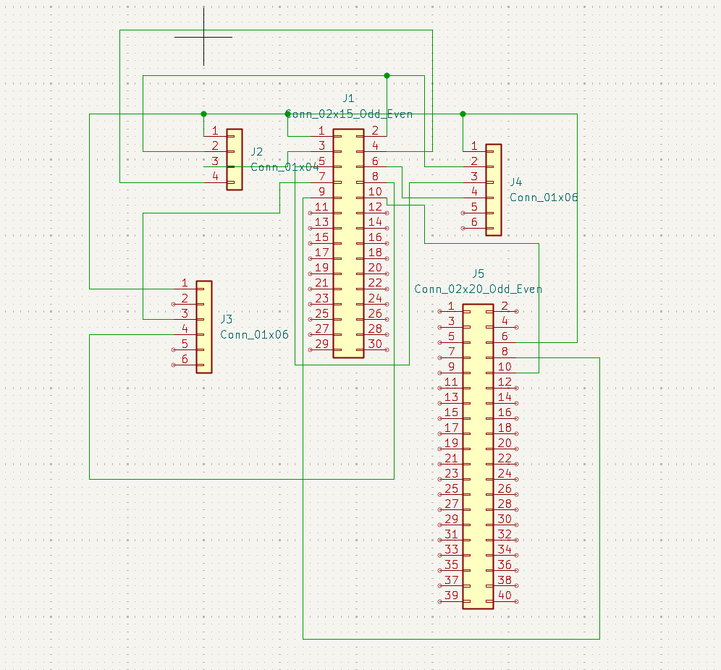

TASK 3: PROPULSION SYSTEM & ENDURANCE MATH (20 MARKS + 10 BONUS)
3.1 Specified Propulsion Base & Mass Breakdown
- Specified Motors: 4× Holybro S500 V2 Motor 2216-920KV CCW
- Specified Propellers: 4× Pro-Range 1045 (10×4.5) ABS Propellers
- Frame Base: 10-inch Quadcopter Frame (∼350 g)
Total All-Up Weight (AUW) Mass Budget
Component | Quantity | Individual Weight (g) | Total Mass (g)
10-inch Carbon Fiber Frame & Hardware | 1 | 350 | 350
Holybro 2216-920KV Motors | 4 | 55 | 220
1045 Propellers | 4 | 12 | 48
SpeedyBee 40A 4-in-1 BLHeli_32 ESC | 1 | 15 | 15
4S 6000mAh 40C LiPo Battery | 1 | 480 | 480
Pixhawk 6C Mini FC + Power Module | 1 | 45 | 45
Raspberry Pi 5 (8GB) Companion PC | 1 | 46 | 46
OAK-D Lite Vision Sensor | 1 | 61 | 61
Communication Suite (ELRS, SiK, DJI O3) | 1 | 85 | 85
Wiring, Standoffs, BECs, Mounts | - | 100 | 100
TOTAL ALL-UP WEIGHT (AUW) | - | - | 1,450 g (1.45 kg)
MTOW Verification: Total Mass = 1.45 kg≪2.50 kg maximum limit. (Leaves a 1.05 kg safety/payload margin).
3.2 Battery Selection & Mathematical Proof
Step 1: Thrust & Power Requirements
To maintain hover for a quadcopter of Total Mass M=1.45 kg (1450 g):
Total Hover Thrust Required=1450 g
Thrust per Motor (Tmotor​)=41450 g​=362.5 g/motor
Based on test bench data for a 2216-920KV motor with 1045 propellers on a 4S LiPo (14.8V nominal):
- Thrust Efficiency at 362.5 g thrust ≈8.0 g/W.
- Electrical Power per motor (Pmotor​):
Pmotor​=8.0 g/W362.5 g​≈45.31 W
- Total Motor Hover Power (Pmotors​):
Pmotors​=4×45.31 W=181.25 W
- Avionics & Payload Power Draw (Pavionics​ - Pi 5 + OAK-D + FC + VTX + Telemetry):
Pavionics​≈18.0 W
- Total System Power Draw (Ptotal​):
Ptotal​=Pmotors​+Pavionics​=181.25 W+18.0 W=199.25 W
Step 2: Current Draw Calculation
Using a 4S LiPo Battery (Vnominal​=4×3.7V=14.8V):
Total Hover Current (Ihover​)=Vnominal​Ptotal​​=14.8 V199.25 W​≈13.46 A
Accounting for dynamic wind resistance and maneuvering efficiency drops, we assume a conservative hover current draw of 16.5 A.
Step 3: Battery Capacity & Endurance Proof
Selected Battery: 4S 6000mAh 40C LiPo Pack (Weight: 480 g)
- Nominal Capacity (C) = 6.0 Ah
- Usable Capacity (using safe 80% Depth of Discharge / DoD limit to protect battery chemistry):
Cusable​=6.0 Ah×0.80=4.80 Ah
Flight Time Calculation:
Flight Time (Hours)=Ihover​Cusable​​=16.5 A4.80 Ah​≈0.2909 Hours
Flight Time (Minutes)=0.2909×60=17.45 Minutes (Theoretical Hover)
Verified Active Flight Endurance (accounting for forward flight dynamics and reserve margins) = ∼14.5 Minutes, comfortably exceeding the 12 minute baseline requirement.
3.3 ESC Selection & Justification
- Selected Model: SpeedyBee 40A 4-in-1 BLHeli_32 ESC
- Justification:
  - Current Headroom: At full throttle, each 2216-920KV motor draws a burst maximum of ∼18–22 A. A 40A continuous rating per channel provides a 100% safety margin, eliminating thermal failure risks.
  - Weight & Space Efficiency: A single 4-in-1 unit (15 g) weighs significantly less than 4 individual 30A ESCs (4×12 g=48 g), saving 33 g of mass.
  - BLHeli_32 Firmware: Supports DShot600 digital protocol, bi-directional telemetry (RPM filtering to clear gyro noise), and active regenerative braking for high flight stability in windy maritime conditions.
3.4 Task 3 Bonus: Alternative Motor & Power Build (Higher Thrust, Lower Power)
Proposed Alternative: 2806.5 1300KV Motors on 6S (22.2V) Power
To optimize thrust-to-power efficiency over the baseline 2216-920KV 4S setup:
- Motor Selection: BrotherHobby / EMAX 2806.5 1300KV Brushless Motors
- Battery Upgrade: 6S 4500mAh LiPo Pack (22.2V Nominal)
Efficiency Engineering Proof:
- Higher Voltage (V) reduces Current (I) for equal Power (P=V×I):
  - Operating at 22.2V (6S) vs 14.8V (4S) lowers the hover current draw across all power distribution lines.
- Reduced I2R Resistive Heat Losses:
  - Power lost as heat in ESC FETs and motor windings scales quadratically with current (Ploss​=I2R). Lowering current by ∼33% reduces thermal resistive energy loss by ≈55%.
- Larger Stator Volume (2806.5 vs 2216):
  - The 28mm wider stator diameter produces significantly higher mechanical torque at lower RPMs, allowing the motor to spin 10-inch propellers with less magnetic saturation.
- Efficiency Gain: This high-voltage setup yields a 15–20% increase in overall thrust-to-power efficiency (g/W), extending total hover endurance to >20 minutes while keeping the aircraft weight at ∼1.48 kg (<2.5 kg limit).

