Initializing Inserv Steps(OOTB)

July 25, 2013

# Step by step procedure to OOTB an Inserv

**Steps:**

1. **Execute the steps 2-4 for the links below as show in screenshot**

[**http://engweb.3pardata.com/twiki/bin/view/Main/Fieldconfig**](http://engweb.3pardata.com/twiki/bin/view/Main/Fieldconfig)

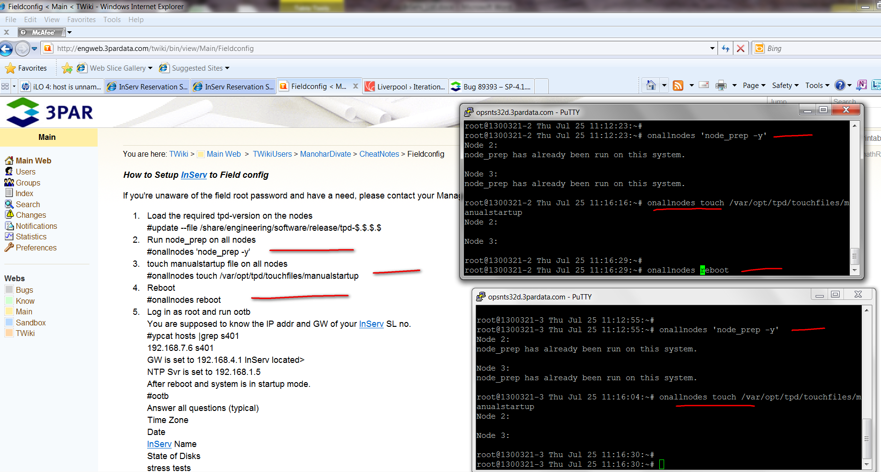

1. **Execute the command 4 only on one node. And it will reboot both the node. Rebooting screenshot below.**

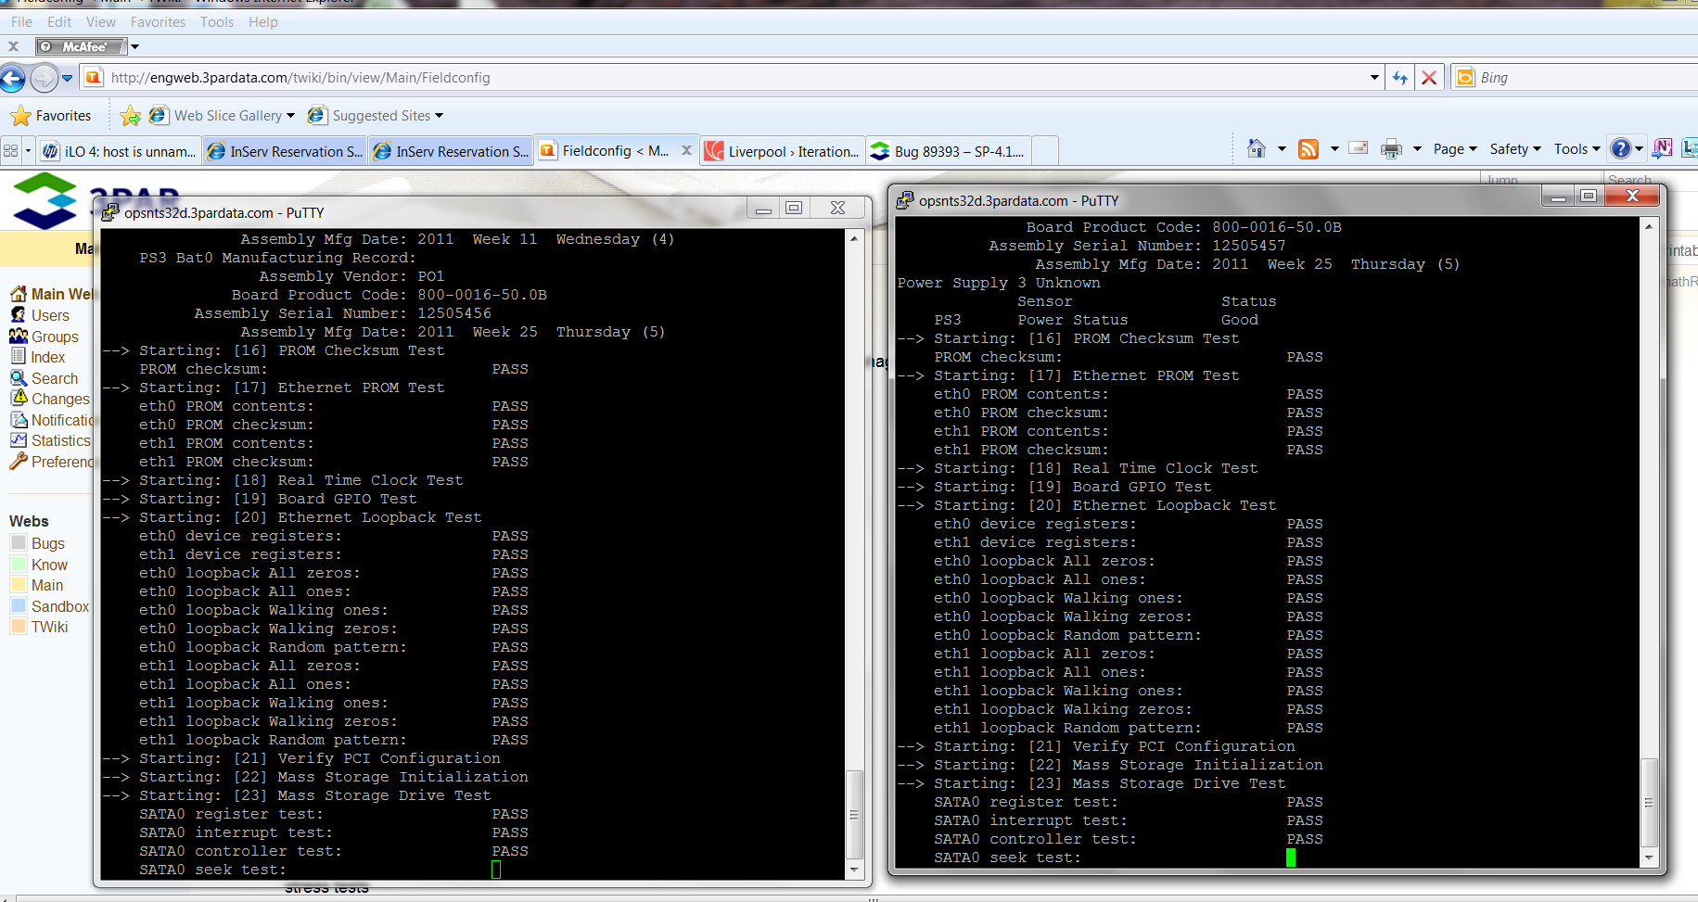

1. **Login as root . You will find the root password for Inserv in /share/st/init_files/pw**

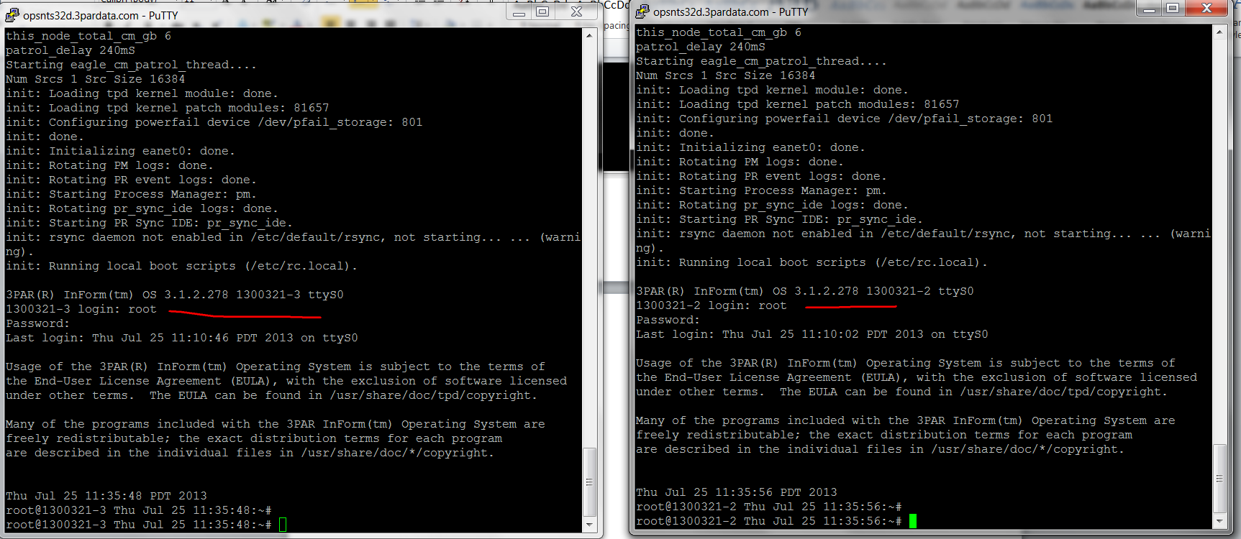

1. **On one of the node run OOTB and keep continuing as show in the screenshot below.**

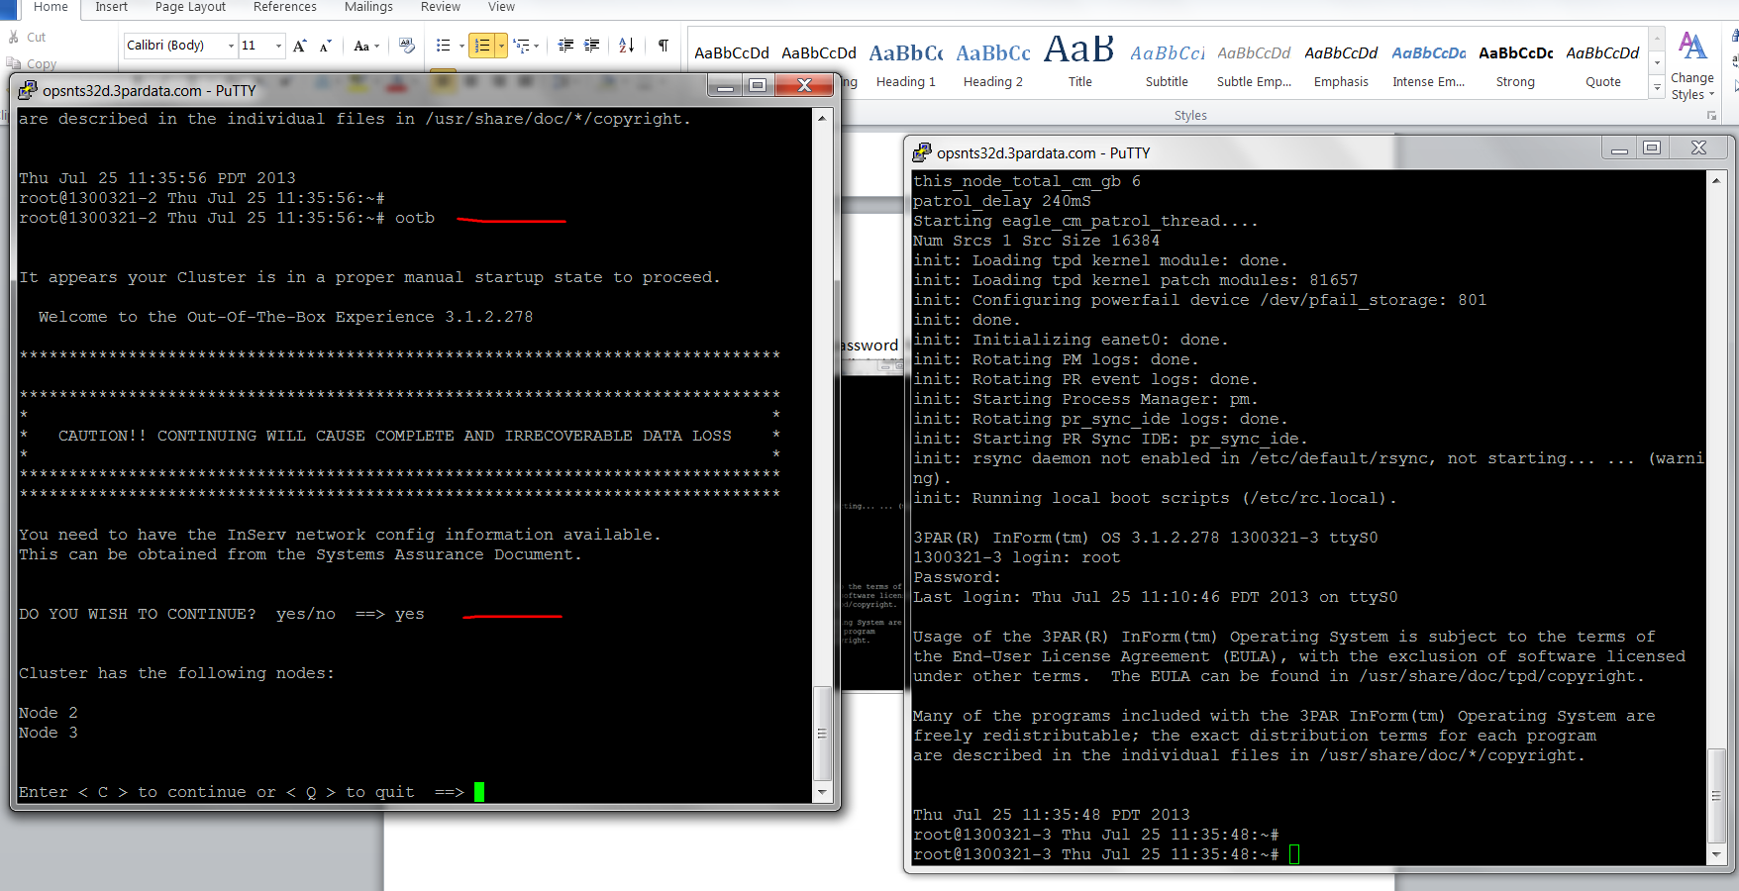

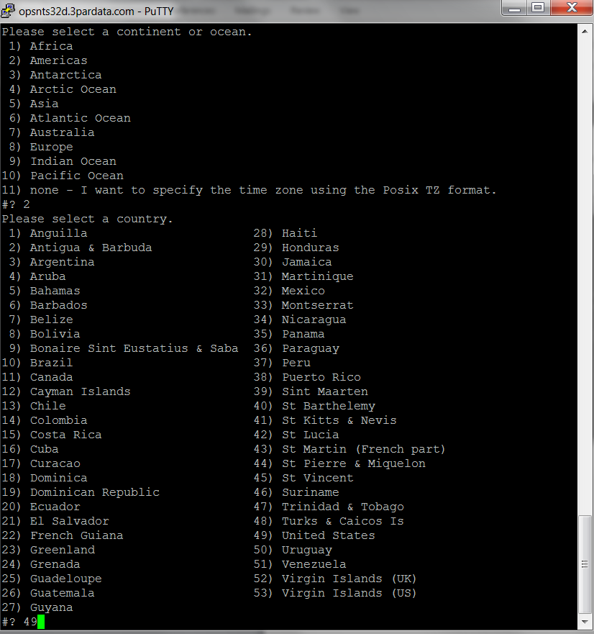

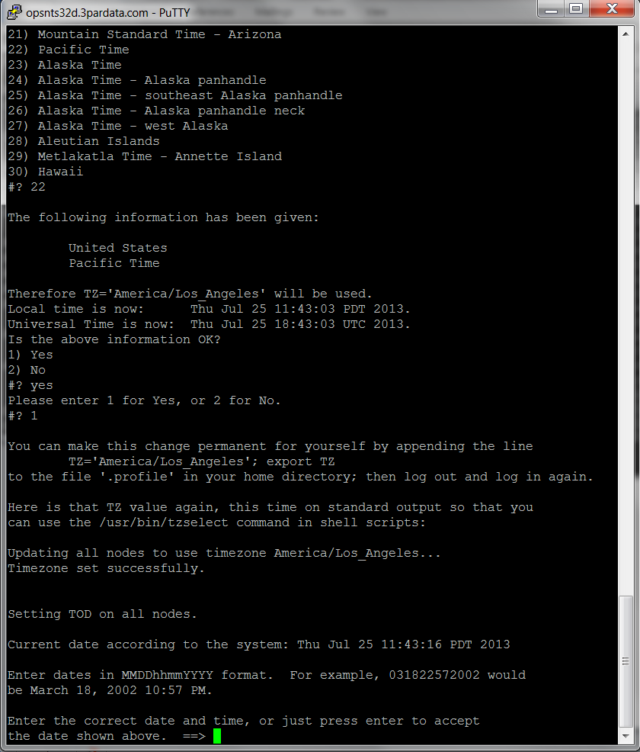

**7.**

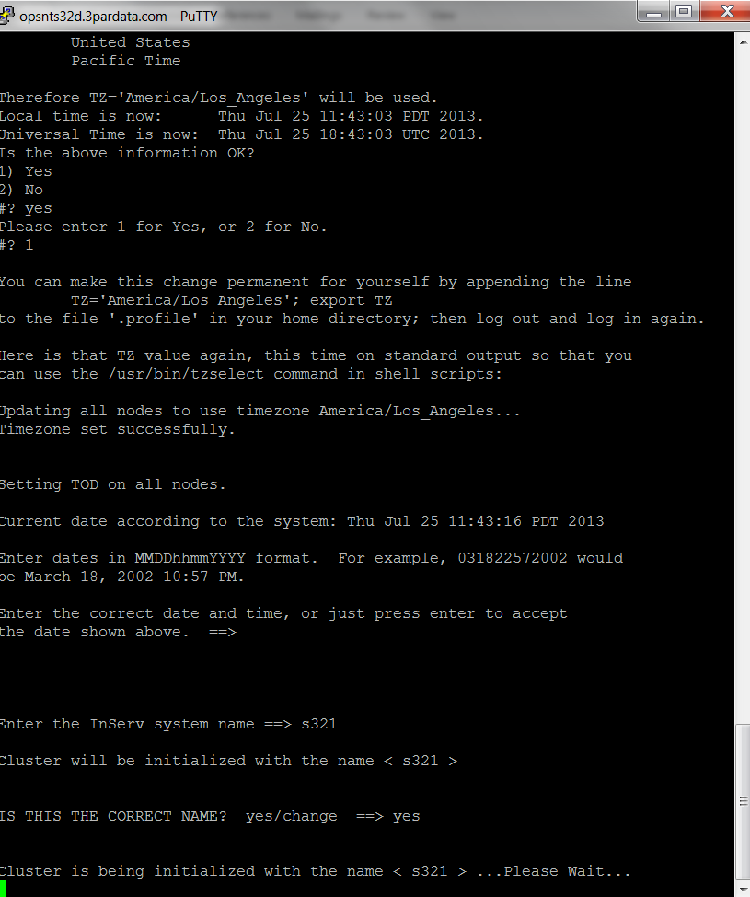

**8.**

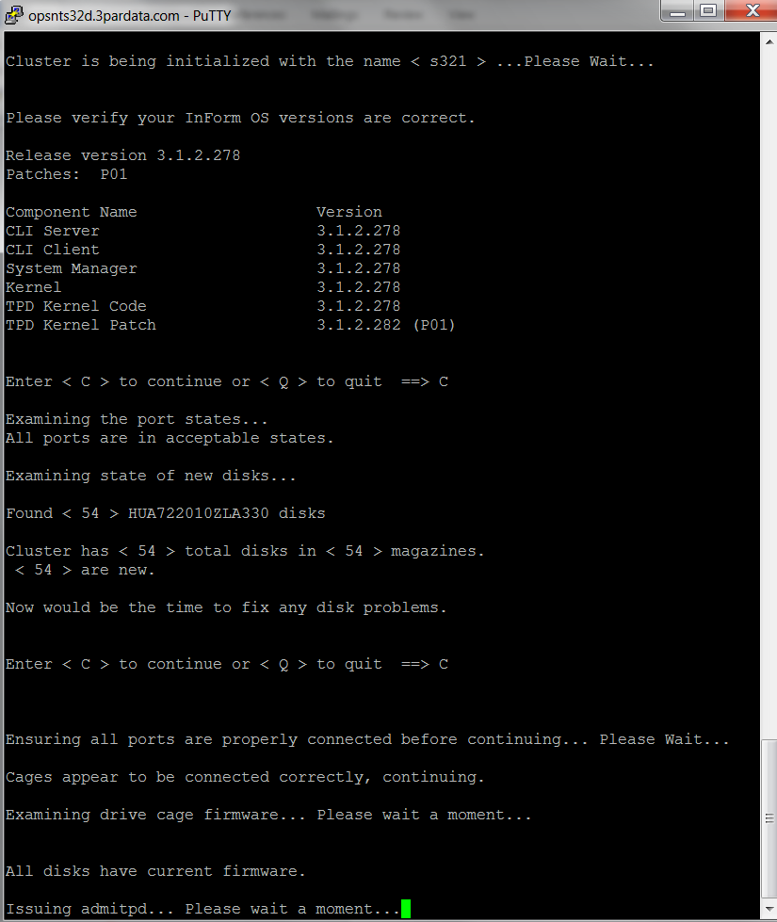

**9. Say “n”, which will not undergo stress test. For a faster OOTB**

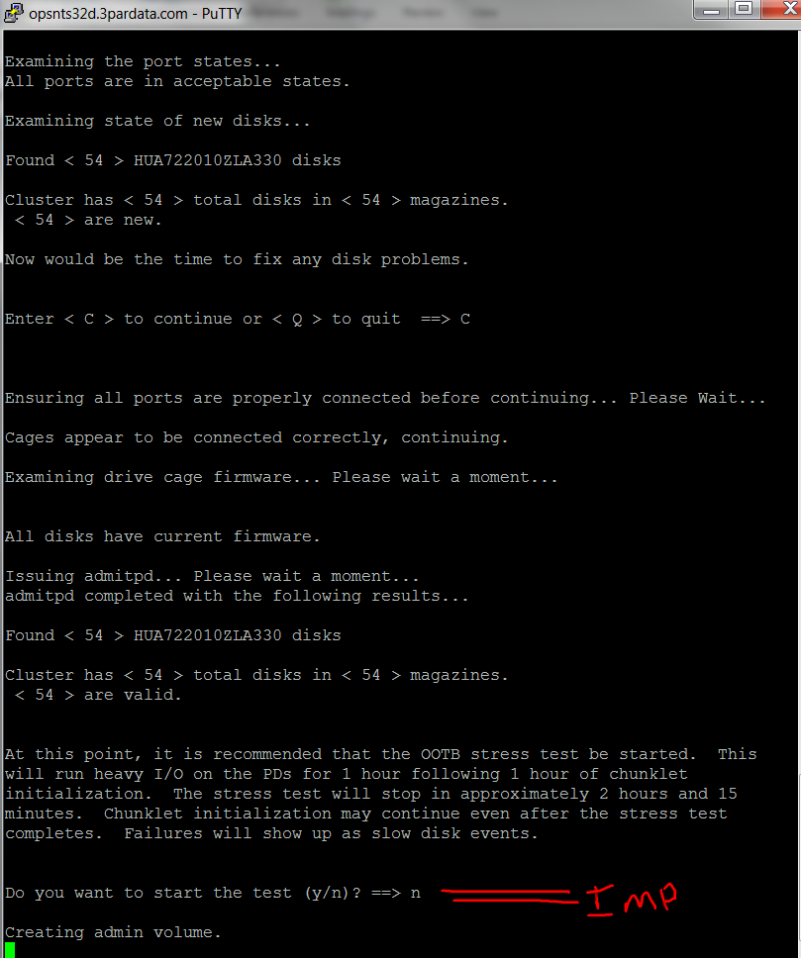

**10. This is the important step to provide all the network details.**

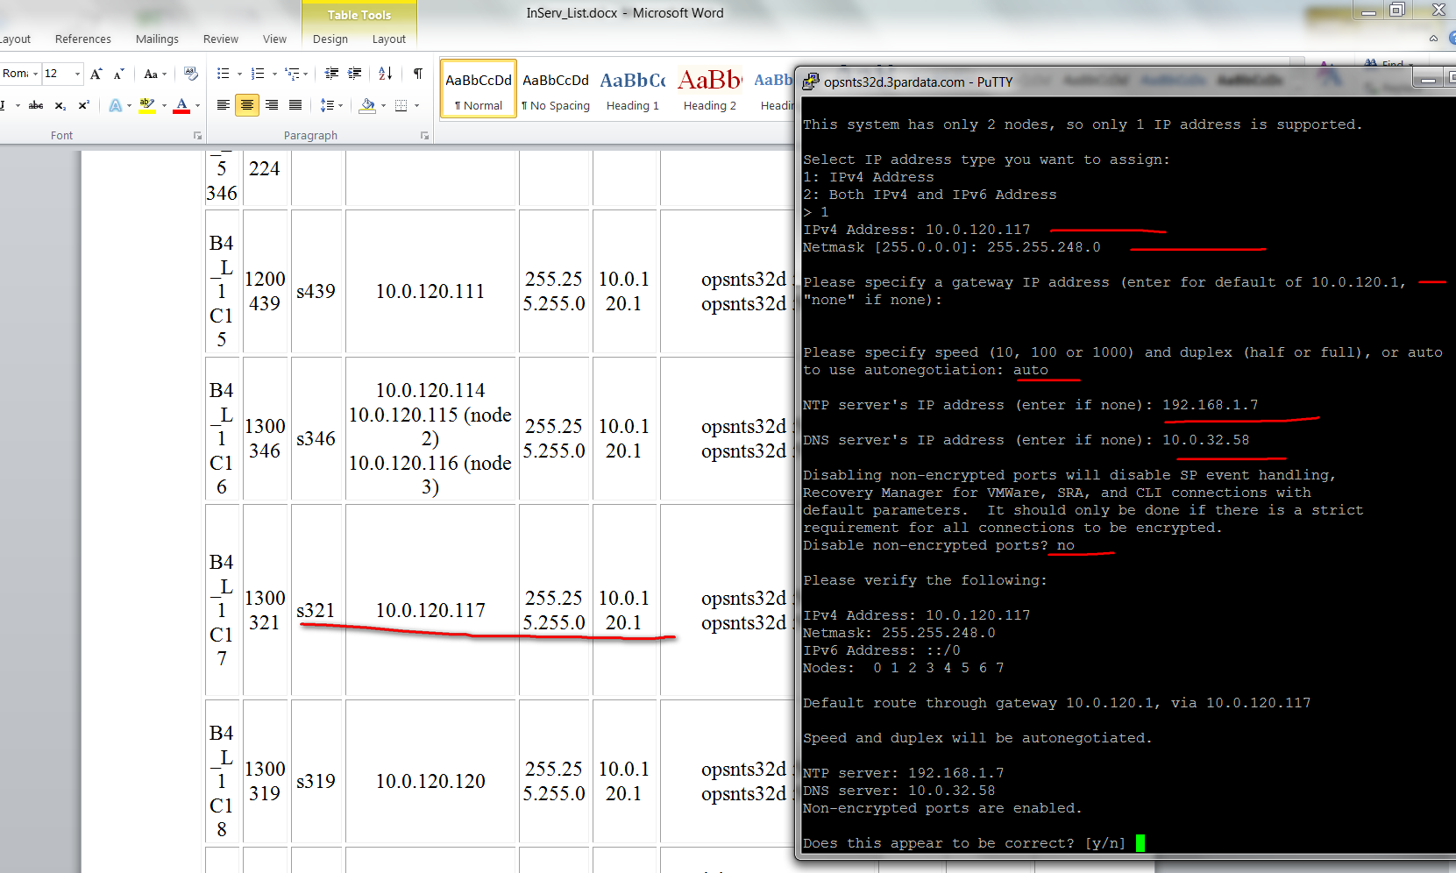

**11.**

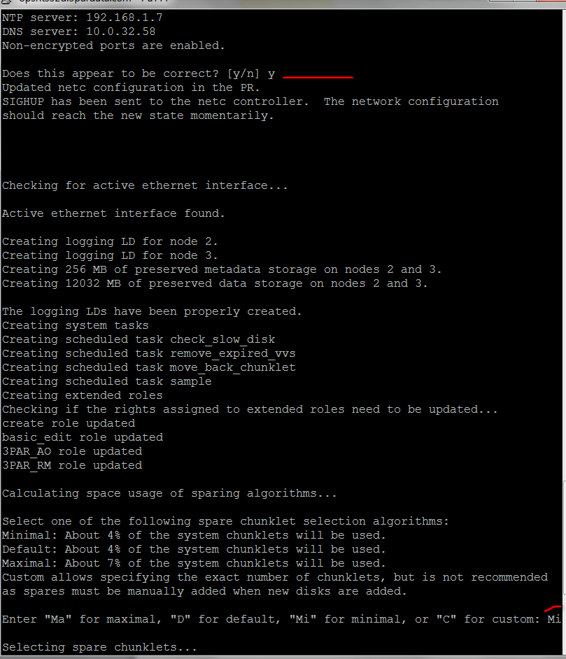

**12.**

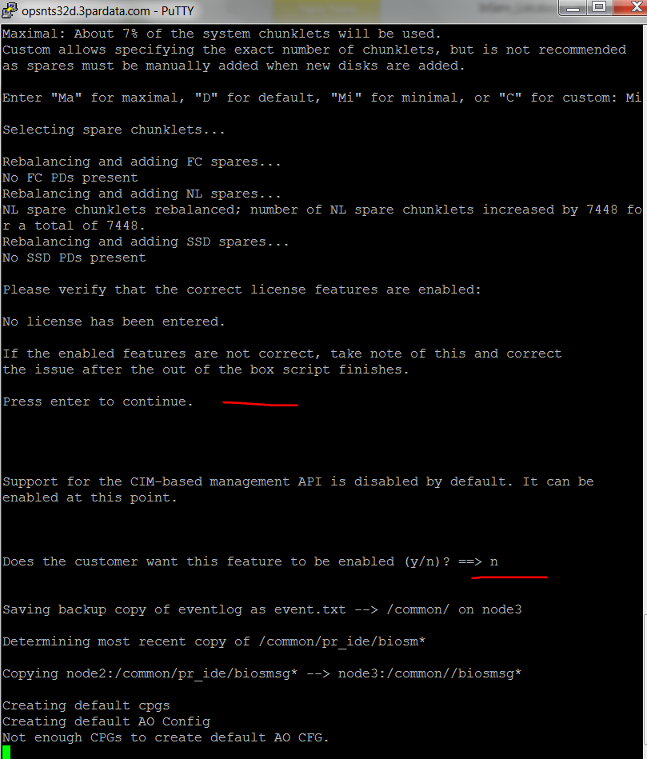

**13. OOTB completed! Meaning Inserv is initialized.**

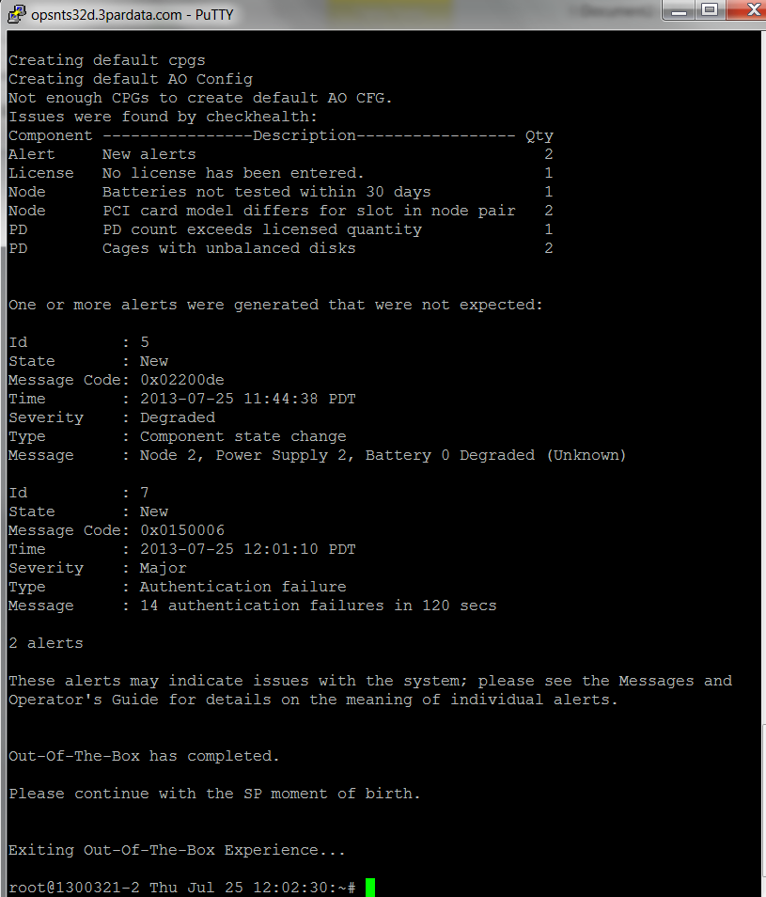

**14. Once initialized, the Inserv can be connected to the SPOCC.**

