HelpDesk Prototype
20/11/17 09:05
Author:
File name: JustInMind_HelpDeskPrototype.vp, created with JustInMind
Version 1.0

01. Screens / JustInMind_HelpDeskPrototype 
Login
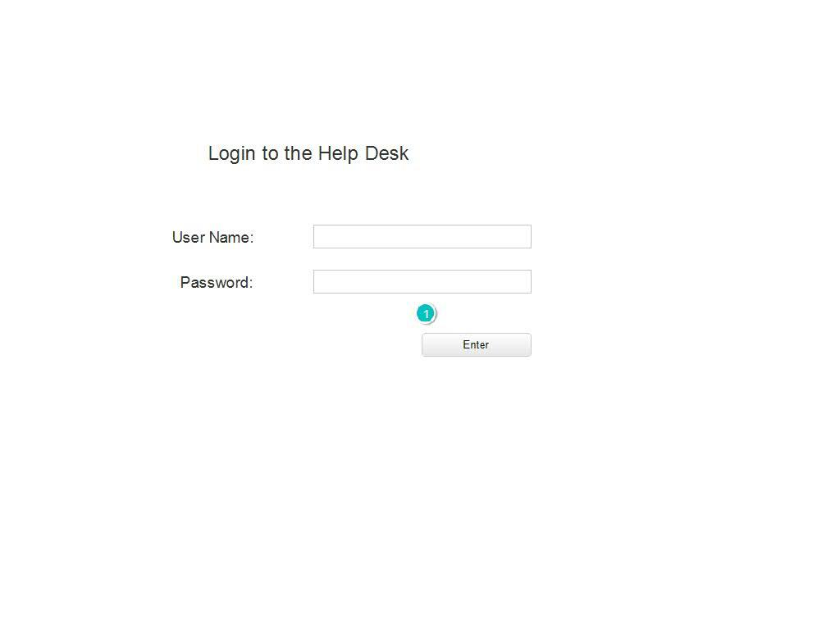

Interactions

1 | on Click:goes to 'AllTickets'🡪

01. Screens / JustInMind_HelpDeskPrototype 
AllTickets
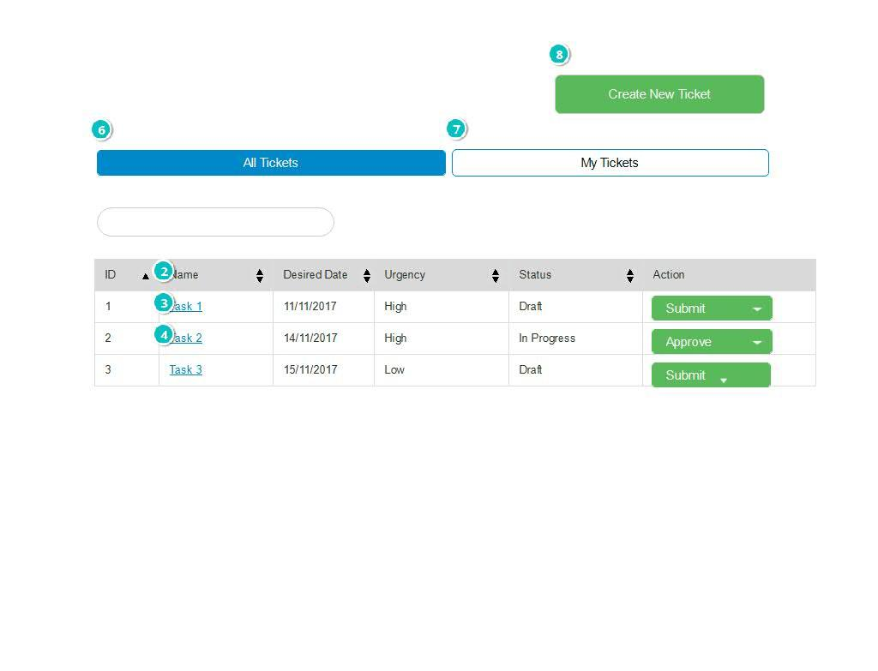

Interactions

2 | on Click:goes to 'TicketOverview'🡪
3 | on Click:goes to 'TicketOverview'🡪
4 | on Click:goes to 'TicketOverview'🡪
6 | on Click:goes to 'AllTickets'🡪
7 | on Click:goes to 'MyTickets'🡪
8 | on Click:goes to 'CreateTicket'🡪

01. Screens / JustInMind_HelpDeskPrototype 
MyTickets
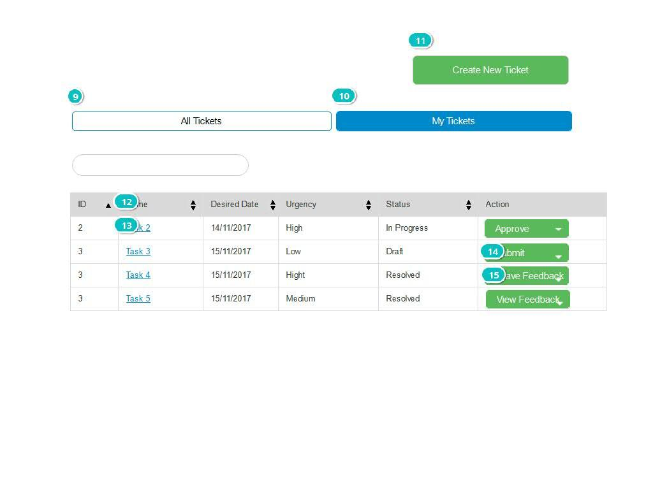

Interactions

9 | on Click:goes to 'AllTickets'🡪
10 | on Click:goes to 'MyTickets'🡪
11 | on Click:goes to 'CreateTicket'🡪
12 | on Click:goes to 'TicketOverview'🡪
13 | on Click:goes to 'TicketOverview'🡪
14 | on Click:goes to 'LeaveFeedback'🡪
15 | on Click:goes to 'ViewFeedback'🡪

01. Screens / JustInMind_HelpDeskPrototype
CreateTicket
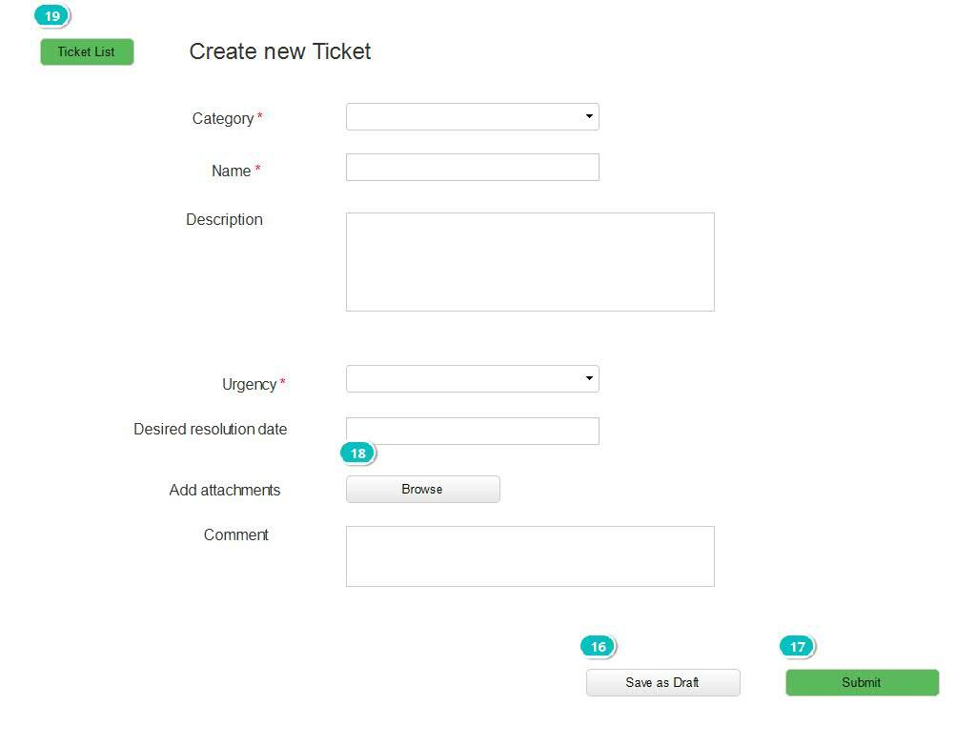

Interactions

16 | on Click:goes to 'TicketOverview'🡪
17 | on Click:goes to 'MyTickets'🡪
18 | on Click:goes to 'TicketOverview'🡪
19 | on Click:goes to 'AllTickets'🡪

01. Screens / JustInMind_HelpDeskPrototype
EditTicket
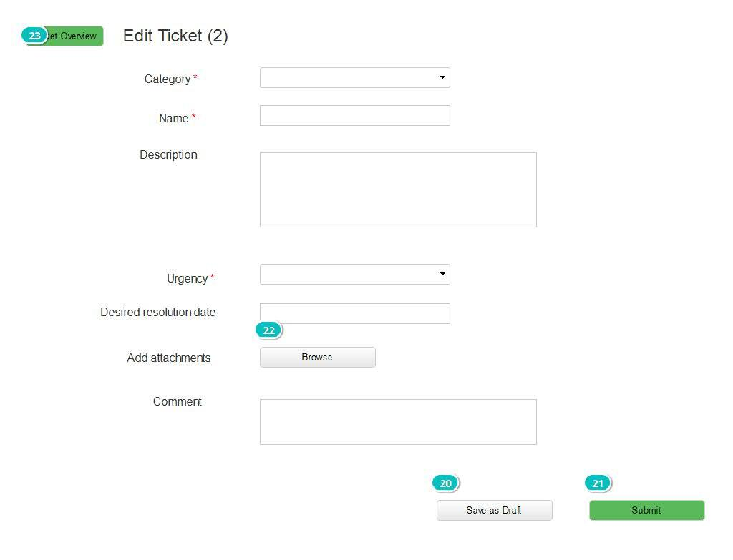

Interactions

20 | on Click:goes to 'TicketOverview'🡪
21 | on Click:goes to 'MyTickets'🡪
22 | on Click:goes to 'TicketOverview'🡪
23 | on Click:goes to 'TicketOverview'🡪

01. Screens / JustInMind_HelpDeskPrototype
TicketOverview
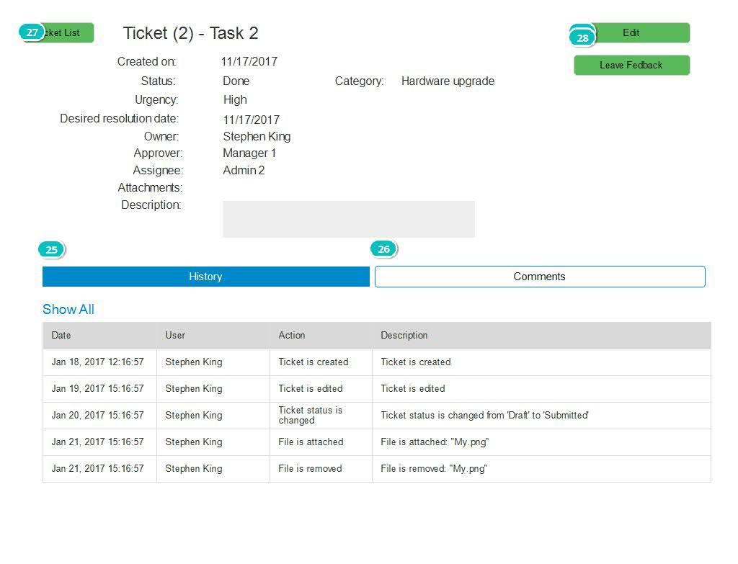

Interactions

24 | on Click:goes to 'EditTicket'🡪
25 | on Click:goes to 'TicketOverview'🡪
26 | on Click:goes to 'TicketOverviewComments'🡪
27 | on Click:goes to 'AllTickets'🡪
28 | on Click:goes to 'LeaveFeedback'🡪

01. Screens / JustInMind_HelpDeskPrototype
TicketOverviewComments
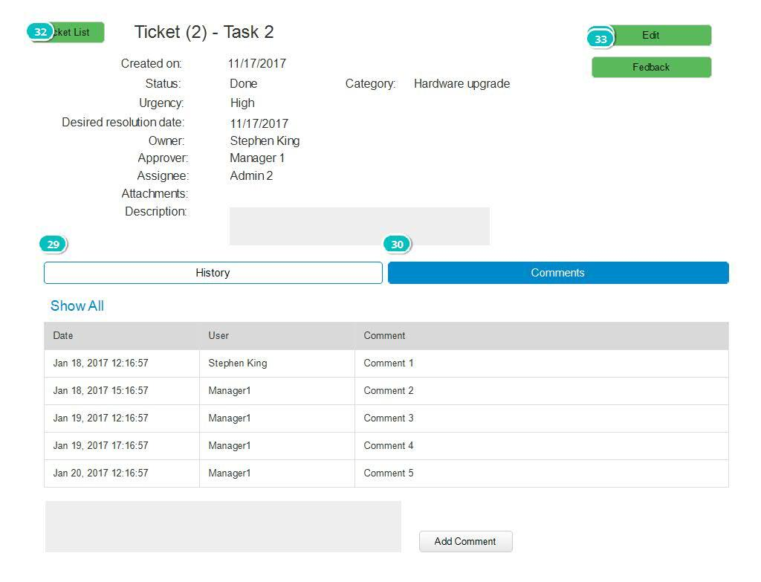

Interactions

29 | on Click:goes to 'TicketOverview'🡪
30 | on Click:goes to 'TicketOverviewComments'🡪
31 | on Click:goes to 'EditTicket'🡪
32 | on Click:goes to 'AllTickets'🡪
33 | on Click:goes to 'ViewFeedback'🡪

01. Screens / JustInMind_HelpDeskPrototype
LeaveFeedback
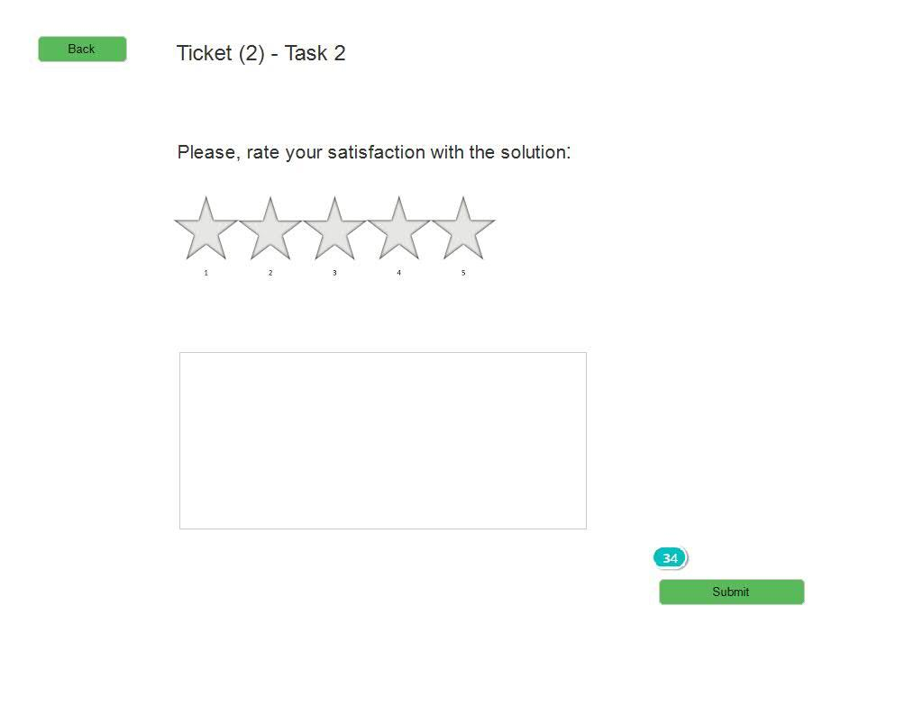

Interactions

34 | on Click:goes to 'AllTickets'🡪

01. Screens / JustInMind_HelpDeskPrototype
ViewFeedback
