Shade Alabsa

CS 7455

HW 02

Mignon Kang

<https://github.com/shade34321/CS_7455/hw03>

For this project I ran your linead_model.m file to generate the coeffiencents, though I used every sample rather than the first one thousand. I then added these csv files to my android project, though they really aren’t csv files since they only have one value per line and new lines separate each value.

Inside my java code I created a method which reads a CSV file, readCSV, though for this project it wasn’t really needed. In here I cast each value to a double which is what I need. For a general purpose function this should be taken out. I store each value as an element in a array list. I call this method from within initializeOpenCVDependencies along with the classifier file. I’m not a fan of sticking a bunch of stuff into one method unless I need to which is why I broke out the readCSV method.

Within onCameraFrame is where I call a new method I created, guessGenderAndAge. Within onCameraFrame I assign the return value from that method to a list called guess and print out these values. The first value inside this list is the gender and the second value is the age. To get the correct gender I use .5 as the cutoff and anything over .5 is a male and below .5 is a female. The method guessGenderAndAge takes in a Rect, face: which is the face we’re currently working on, and a Mat, aInputFrame: which is the current frame. I couldn’t figure out how to take out this dependency just yet and honestly it might be better to split this method into two but I’ll work on that later. Inside guessGenderAndAge I create a temp matrix where I take a submatrix from the aInputFrame where face is the ROI. Then I create a greyscale matrix and use cvtColor to convert temp to a greyscale image. I also create greyFaceResize and use Imgprox.resize to resize this matrix to a 10x10 matrix. I think go through the list of coefficients and multiple the current pixel by the current coefficient and store them in age_y and gender_y. I then add these to a list but I round the age to decimal places and return them. Then I print them on screen.

I was also able to get this working in the emulator and on my tablet. Though I ran into an issue where the emulator was only in greyscale and wasn’t printing anything out to logcat which made debugging hard.

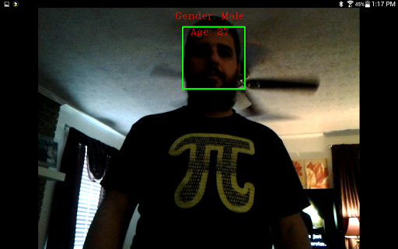

Tablet Screenshot above and emulator screenshot below.

