Lab 8

Task 1

1. Navigate to the yolov7 project directory

2. Create a new Conda environment with Python 3.9
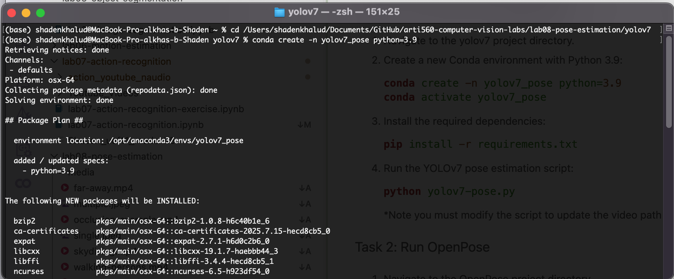

3. Activate Conda environment

4. Install the required dependencies
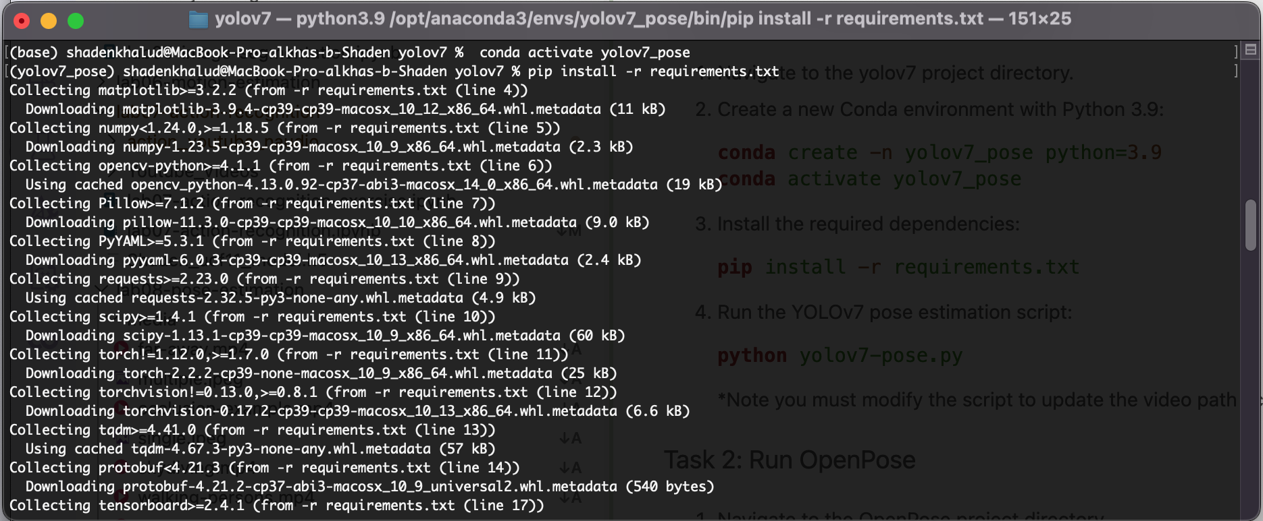

5. Modify the script to update the video path accordingly
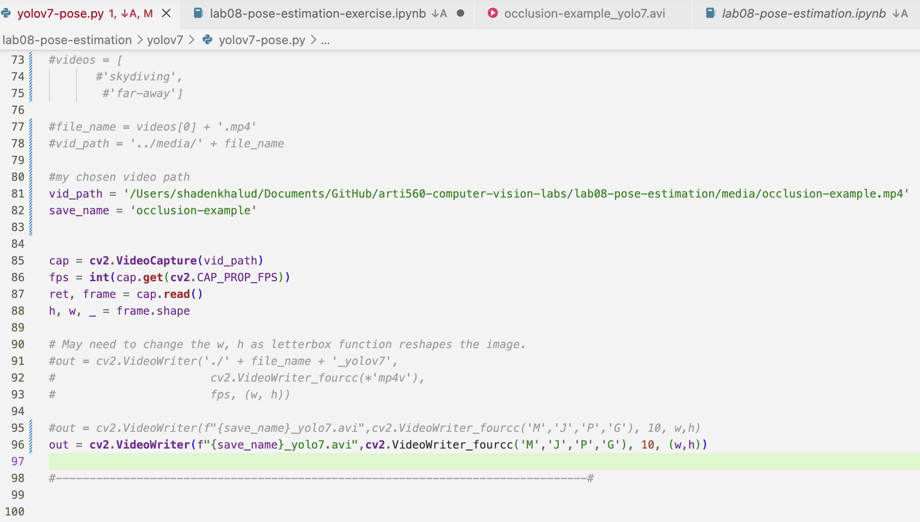

6. Run the YOLOv7 pose estimation script: python yolov7-pose.py
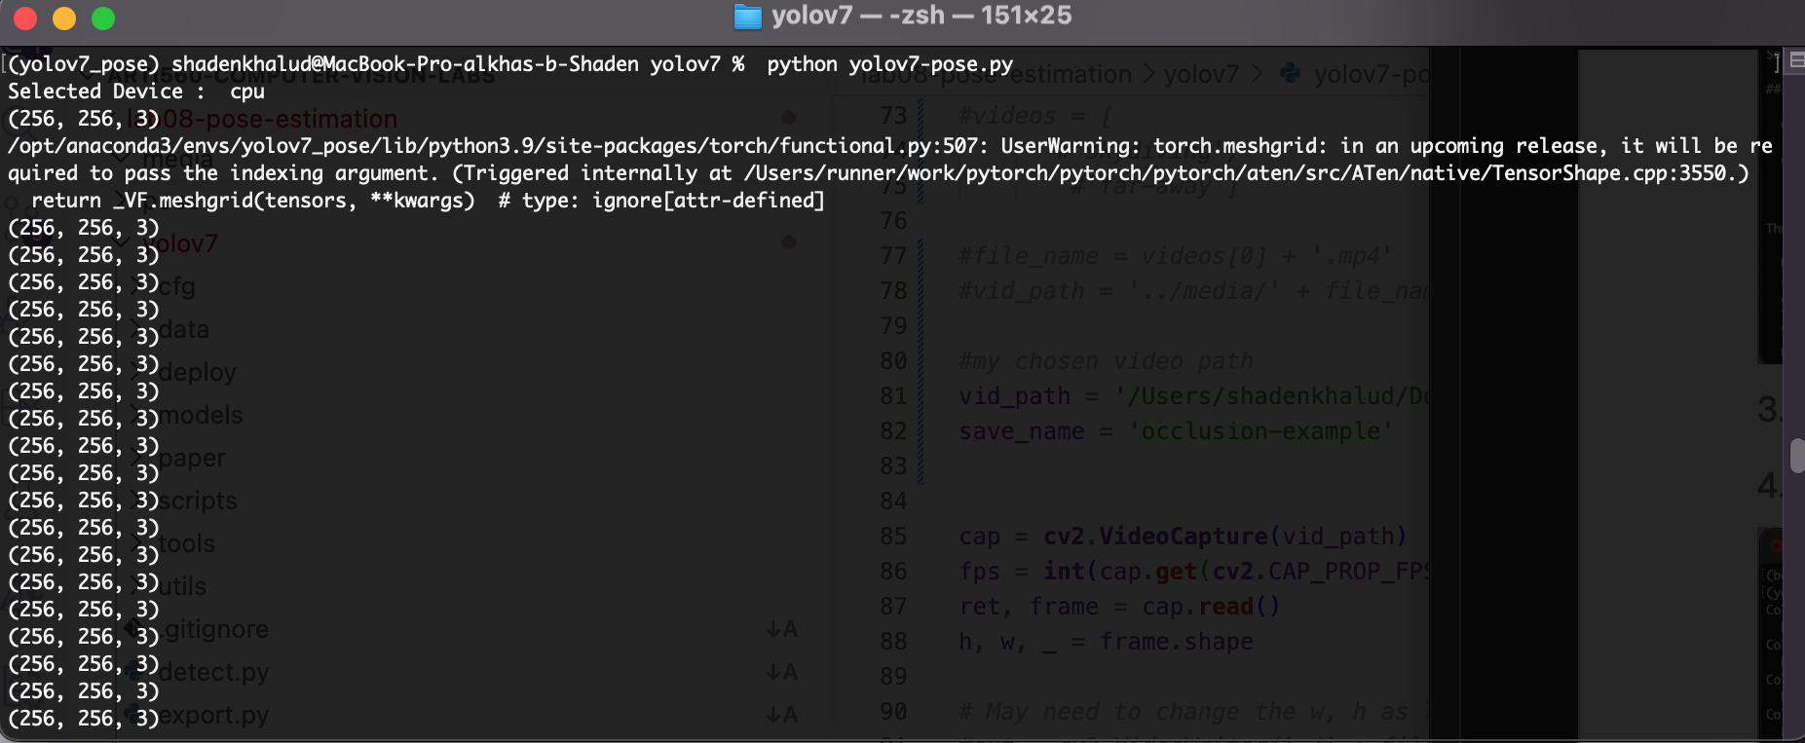
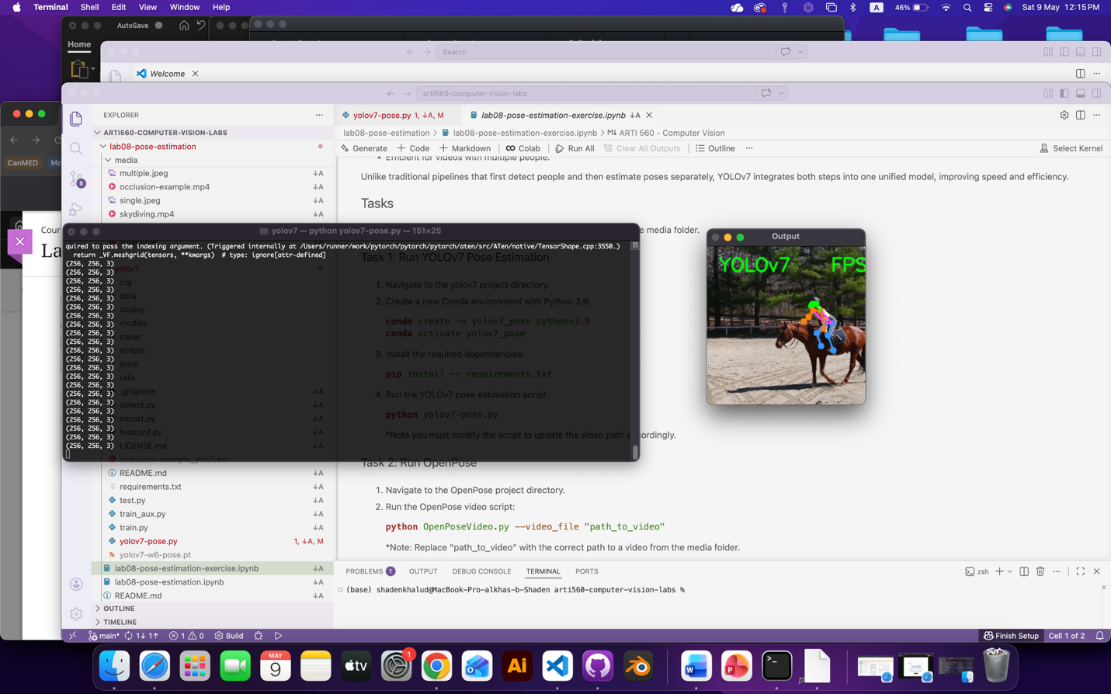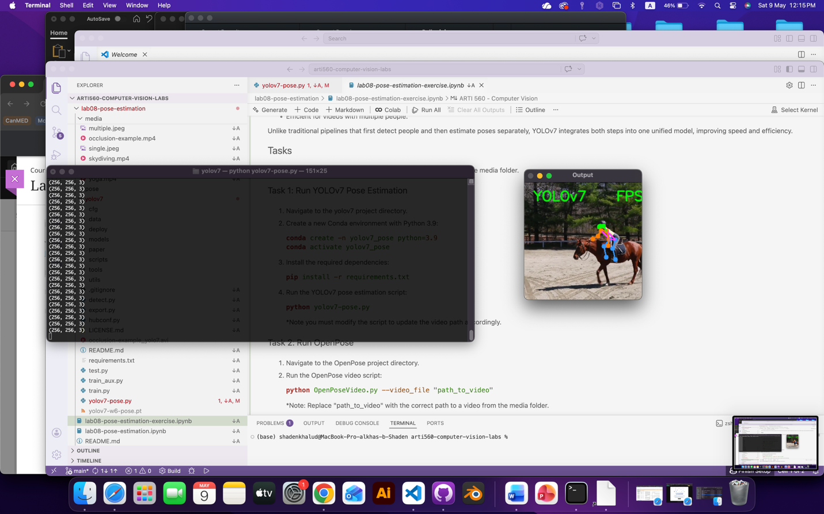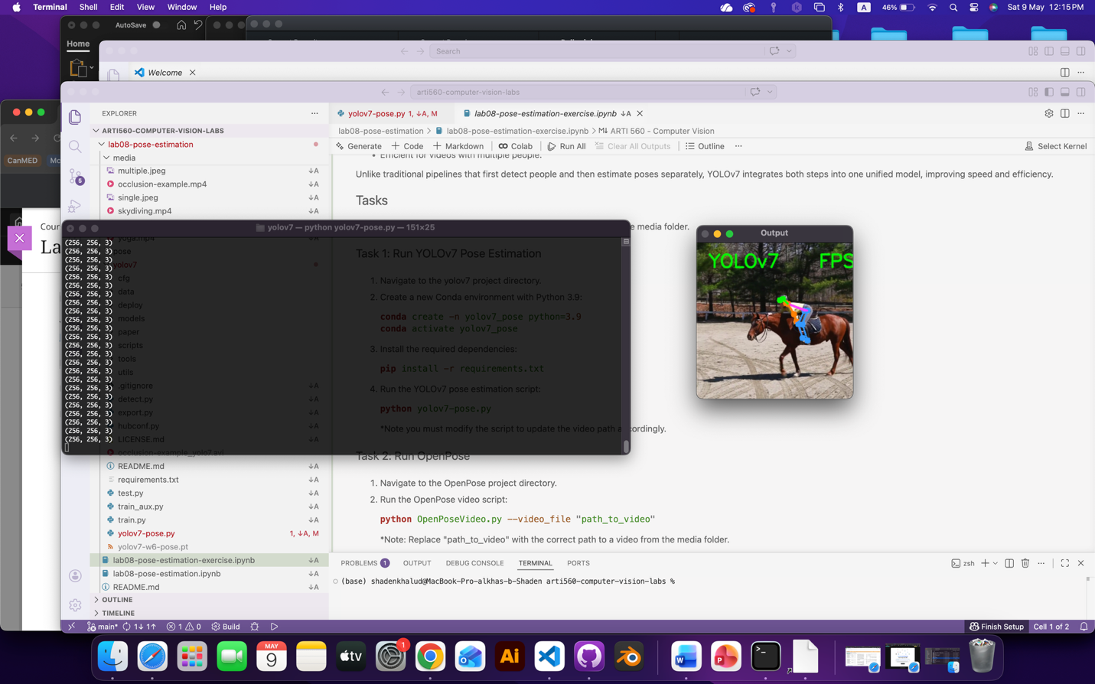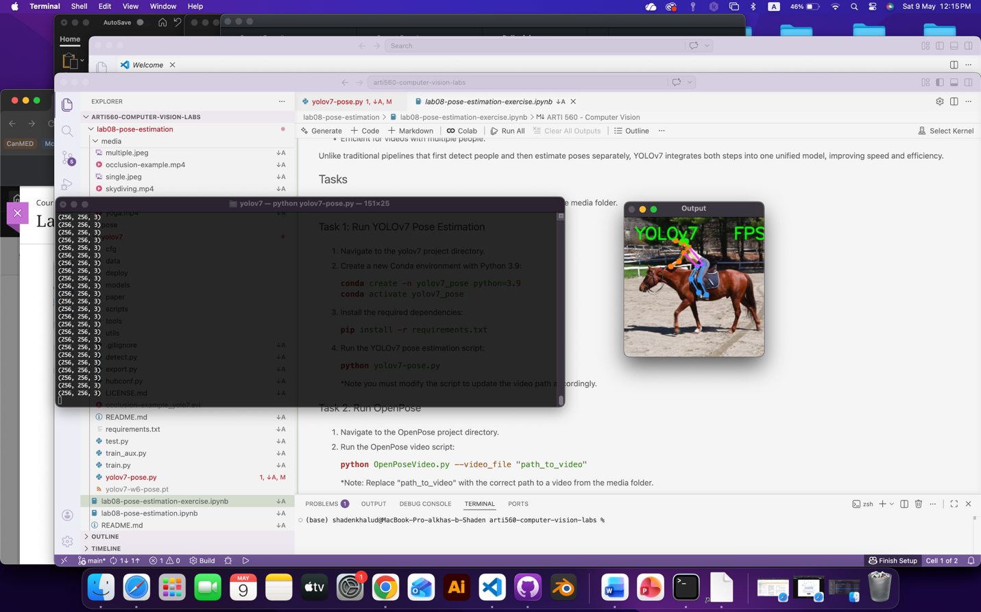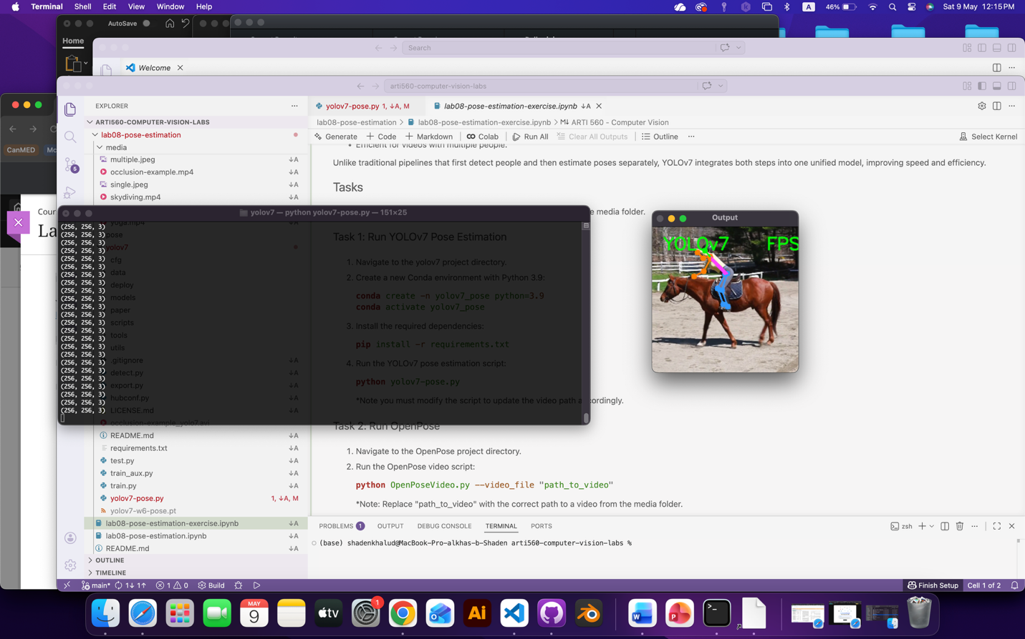

Task 2

1. Navigate to the yolov7 project directory

2. Create a new Conda environment with Python 3.9
