Day 1 Review Note
C4 Context Diagram: Notation Used for People
While reviewing the Day 1 Systems Thinking materials, I noticed a small inconsistency in the notation used to represent people in a C4 context diagram.
Observation
1. Tutorial example
The tutorial C4 context diagram represents the Rider, Driver, and Ops Agent using rounded rectangles.
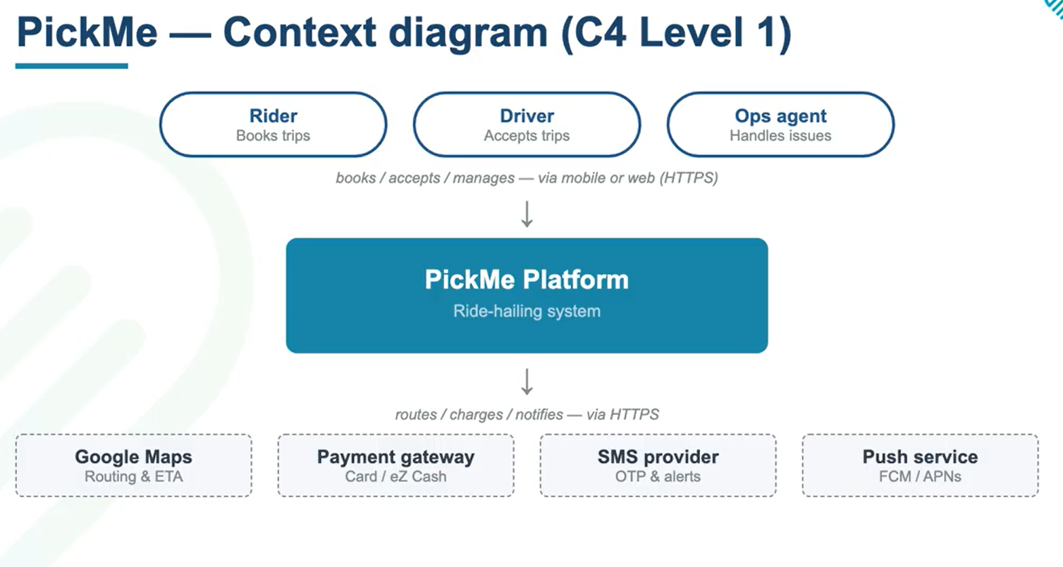
2. Slide deck guidance
A later slide in the session deck states that people should be represented using stick figures.
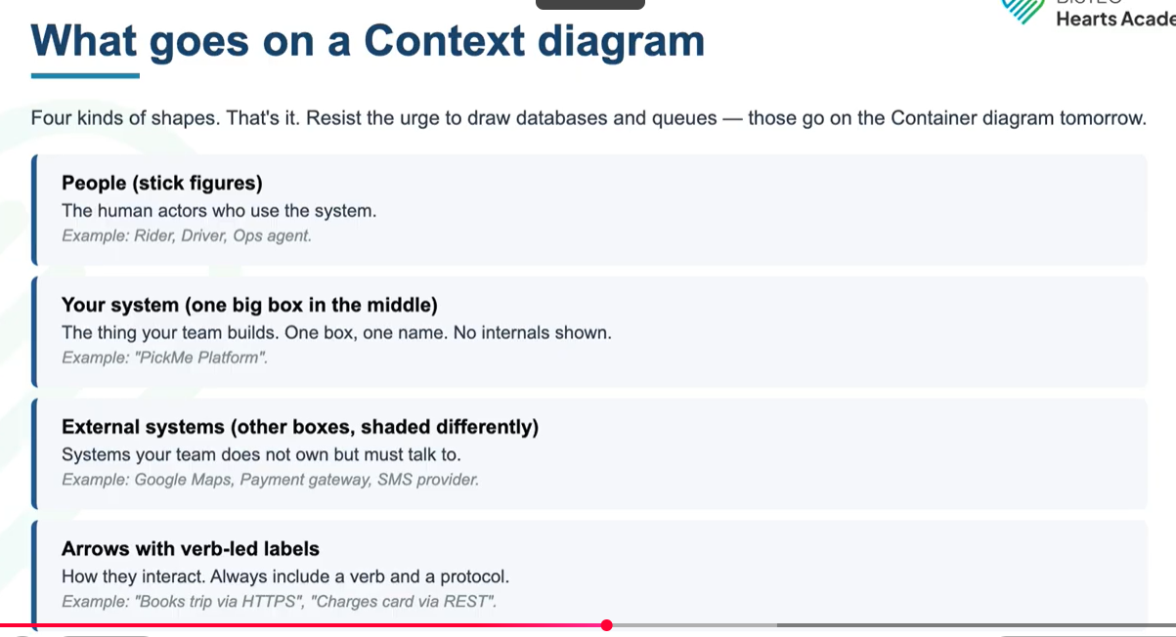

3. Session challenge requirement
The session challenge also specifies a “stick figure with role label” as the required notation for each person.
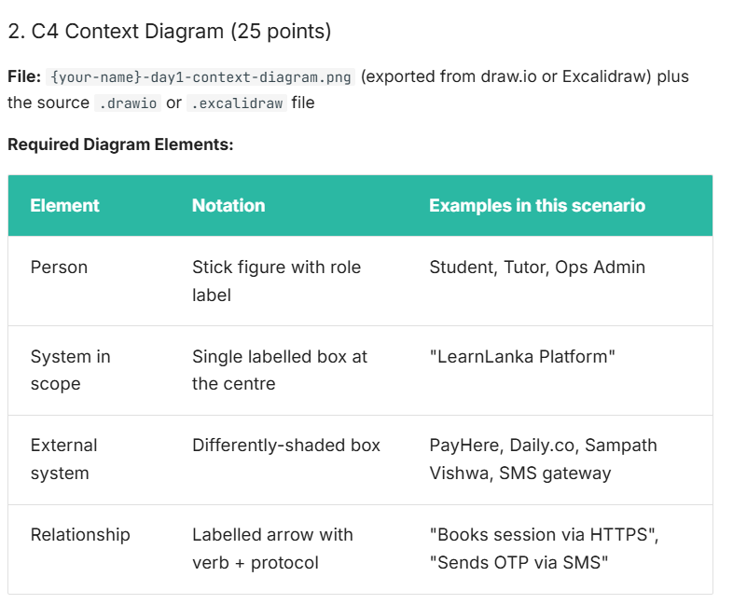
Decision
Because the challenge instructions were the most specific requirements for the submission, I followed them and represented each person as a stick figure with a role label. This ensured that my diagram remained consistent with the stated assessment requirements.

