GEOSMILE · KINGSTON UPON HULL
Evaluation of the Area-Data Geo Branch
ATT fidelity, ATT accuracy against expert-highlighted regions, ATT faithfulness, ATT stability and ATT consistency for ten candidate models
Item | Setting
Prediction task | Next-month crime count per LSOA (Kingston upon Hull)
Spatial units | 168 LSOAs (ONS 2021 boundaries)
Candidate models | XGBoost, LightGBM, CatBoost, SVR, GP, MLP, DL, ANN, CNN, Transformer
Geo perturbations | N = 4,000, seed 42 (5–10 LSOAs masked per perturbation)
Expert reference | 56 LSOAs inside four expert-highlighted regions
Test period | January–March 2026

Contents

1. Executive summary
This report evaluates the Geo branch of GeoSMILE under the area-data design, in which masking an LSOA replaces all of the data the 30-feature model receives from that location. Attribution accuracy is measured against the regions an expert highlighted as the areas whose crime events inform their assessment of Hull's crime situation. All five attribution-evaluation criteria used for SMILE are reported.
- ATT fidelity. The weighted-Ridge surrogate reproduces the perturbation responses closely for every model: held-out R² 0.945–0.948.
- ATT accuracy. Every model's most sensitive LSOAs fall in the expert regions far more often than chance (0.333): accuracy@20 0.80–0.85 and accuracy@42 0.548–0.643, all with hypergeometric p < 0.001.
- ATT faithfulness. Across the ten models, agreement with the expert regions does not rise significantly with predictive R² (ATT-AUC: r = +0.12, p = 0.73). Without the two non-reproducible Keras models the correlation is strong (r = +0.87, p = 0.005); this is a sensitivity result only.
- ATT stability (XGBoost). Adding a neighbouring LSOA outside Hull in any compass direction leaves the top 20 unchanged (Jaccard 1.00) and the ranking almost identical (Spearman 0.9998).
- ATT consistency (XGBoost). Across five perturbation seeds the ranking is highly consistent (mean rank Spearman 0.963, score Pearson 0.997); the largest coefficient SD is 2.8% of that LSOA's mean.
Table 1. Summary of the five evaluation criteria under the area-data Geo design.
Criterion | Measure | Models | Result
ATT fidelity | Held-out R² of the weighted-Ridge surrogate | All 10 | 0.945–0.948
ATT accuracy | Share of top-k LSOAs in expert regions (chance 0.333) | All 10 | @20: 0.80–0.85; @42: 0.548–0.643
ATT faithfulness | Pearson r (predictive R², ATT-AUC) across models | All 10 | r = +0.12 (p = 0.73); not demonstrated
ATT stability | Top-20 Jaccard / rank Spearman after adding a neighbour LSOA | XGBoost | 1.00 / 0.9998
ATT consistency | Mean pairwise rank Spearman over 5 seeds | XGBoost | 0.963
Stability and consistency were run for the final XGBoost explanation only (as in Chapter 4); they do not depend on the expert reference.

2. The area-data Geo design
In the earlier Geo branch, a coordinates-only model was explained and masking an LSOA replaced only its easting and northing. Under the area-data design the Geo branch explains the same fitted 30-feature model as the Feature branch, and masking an LSOA replaces all of its model inputs with the training median. Each Geo coefficient therefore measures how sensitive the model is to the data it takes from that location.
Because every masked row receives the same inputs, the masked prediction is one typical-area value, and the per-LSOA response orders LSOAs by how far their predictions sit from it. The signed coefficient preserves that ordering, while its absolute value would fold it, so all rankings use the signed coefficient. Coefficients describe model sensitivity, not causal effects of places on crime.
Table 2. Settings of the area-data Geo branch.
Component | Setting
Explained model | The same 30-predictor model as the Feature branch, one per candidate model (seed 42)
Players | 168 Hull LSOAs
Perturbation | 5–10 randomly chosen LSOAs; all of their inputs replaced by the training median
Response | First Wasserstein distance between original and masked predictions on the affected LSOA-month rows
Surrogate | Kernel-weighted Ridge (α = 1); kernel (RBF, Laplace, inverse) chosen on a validation split
Pool size | N = 4,000 perturbations; 60/20/20 train/validation/test split of the pool
Ranking | Signed Geo-SMILE coefficient

3. Expert reference regions
The expert marked on street maps the areas whose crime events inform their assessment of Hull's crime situation. The drawings were georeferenced on street landmarks (The Deep, MKM Stadium, the Hedon Road roundabouts and Marfleet Lane, and the edge of the Bransholme estate) and intersected with the ONS 2021 LSOA boundaries. After reviewing the first selection the expert removed north-east Bransholme and added a strip west of the River Hull between Beverley Road and Oak Road.
Inclusion rule: an LSOA belongs to the reference if at least 20% of its area, or at least 0.1 km² of it, lies inside a drawn region, and less than 50% of it lies inside the excluded north-east Bransholme area. The reference contains 56 of the 168 LSOAs, so a randomly chosen LSOA is a reference LSOA with probability 1/3. It includes 17 of the 20 LSOAs in the earlier expert top-20 list. The full list is in Appendix A.
Table 3. Expert reference LSOAs by region.
Region | LSOAs | In earlier expert top 20 | In top 50 of all 10 models
Beverley Road – Oak Road | 6 | 0 | 0
Bransholme | 14 | 0 | 1
Sculcoates – City Centre – Dairycoates | 22 | 15 | 15
Southcoates – Marfleet | 14 | 2 | 3
Total | 56 | 17 | 19
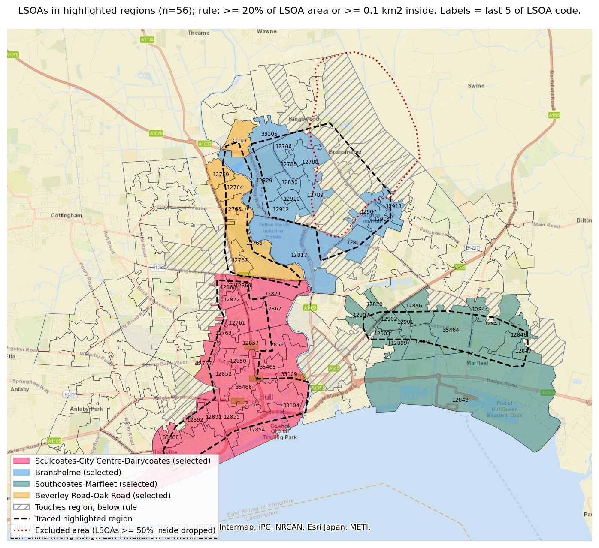
Figure 1. Reference LSOAs by region (shaded), traced expert outlines (dashed), the excluded north-east Bransholme area (red dotted), and LSOAs touching a region but below the inclusion rule (hatched).

4. ATT fidelity
ATT fidelity measures how well the kernel-weighted Ridge surrogate reproduces the model's perturbation responses on held-out perturbations. It is reported as R², weighted R², and the mean absolute and root-mean-square errors, unweighted and kernel-weighted (MAE, WMAE, RMSE, WRMSE; in crimes per month).
Table 4. Geo fidelity of the weighted-Ridge surrogate for all ten models (N = 4,000, held-out 20% of the pool).
Model | Family | Predictive R² | Fidelity R² | Weighted R² | MAE | WMAE | RMSE | WRMSE | Kernel
xgboost | Boosting | 0.896 | 0.948 | 0.946 | 0.785 | 0.801 | 1.355 | 1.400 | inverse
lightgbm | Boosting | 0.897 | 0.948 | 0.946 | 0.795 | 0.811 | 1.378 | 1.424 | inverse
catboost | Boosting | 0.896 | 0.948 | 0.946 | 0.800 | 0.815 | 1.378 | 1.423 | inverse
svr | Kernel | 0.863 | 0.948 | 0.946 | 0.771 | 0.782 | 1.500 | 1.551 | inverse
gp | Kernel | 0.899 | 0.948 | 0.946 | 0.858 | 0.874 | 1.521 | 1.572 | inverse
mlp | Neural | 0.853 | 0.947 | 0.945 | 1.101 | 1.111 | 1.918 | 1.973 | inverse
dl | Neural | 0.666 | 0.945 | 0.944 | 0.562 | 0.573 | 0.816 | 0.840 | inverse
ann | Neural | 0.866 | 0.948 | 0.946 | 0.942 | 0.953 | 1.766 | 1.821 | inverse
cnn | Neural | 0.635 | 0.948 | 0.946 | 1.197 | 1.212 | 2.430 | 2.513 | inverse
transformer | Neural | 0.873 | 0.948 | 0.946 | 0.713 | 0.729 | 1.231 | 1.273 | inverse
Fidelity is uniformly high (R² 0.945–0.949) and barely differs between models, so differences in accuracy or faithfulness below are not explained by surrogate quality. Error scales differ because the models' predictions and responses have different ranges.

4.1 Surrogate comparison
The full Chapter-4 surrogate menu was fitted to each model's pool and scored on the same held-out split. Linear surrogates (weighted and unweighted Ridge, OLS, Bayesian ridge) all reach R² ≈ 0.95; tree ensembles are lower and the GLMs and kernel ridge fit poorly. The permutation null row gives the standard deviation of R² when responses are shuffled.
Table 5. Held-out R² of each surrogate for each model (N = 4,000).
Surrogate | xgboost | lightgbm | catboost | svr | gp | mlp | dl | ann | cnn | transformer
Weighted Ridge | 0.948 | 0.948 | 0.948 | 0.948 | 0.948 | 0.947 | 0.945 | 0.948 | 0.948 | 0.948
Weighted OLS | 0.947 | 0.947 | 0.947 | 0.948 | 0.947 | 0.946 | 0.944 | 0.947 | 0.947 | 0.947
Ridge (α = 0) | 0.947 | 0.947 | 0.947 | 0.948 | 0.947 | 0.946 | 0.944 | 0.947 | 0.947 | 0.947
Bayesian ridge | 0.948 | 0.948 | 0.947 | 0.948 | 0.947 | 0.946 | 0.945 | 0.948 | 0.947 | 0.948
Linear regression | 0.948 | 0.948 | 0.948 | 0.949 | 0.948 | 0.948 | 0.946 | 0.949 | 0.948 | 0.948
Unweighted OLS | 0.948 | 0.948 | 0.948 | 0.949 | 0.948 | 0.948 | 0.946 | 0.949 | 0.948 | 0.948
Ridge (unweighted) | 0.949 | 0.948 | 0.948 | 0.949 | 0.948 | 0.948 | 0.946 | 0.949 | 0.948 | 0.948
Hist. grad. boosting | 0.905 | 0.905 | 0.906 | 0.920 | 0.912 | 0.889 | 0.839 | 0.915 | 0.936 | 0.894
Random forest | 0.829 | 0.825 | 0.822 | 0.865 | 0.841 | 0.798 | 0.712 | 0.856 | 0.896 | 0.817
Shallow tree | 0.733 | 0.733 | 0.726 | 0.818 | 0.751 | 0.723 | 0.466 | 0.800 | 0.853 | 0.724
Kernel ridge (RBF) | 0.618 | 0.618 | 0.619 | 0.614 | 0.617 | 0.625 | 0.630 | 0.618 | 0.612 | 0.616
Elastic net (weak) | 0.559 | 0.560 | 0.560 | 0.582 | 0.573 | 0.577 | 0.444 | 0.588 | 0.615 | 0.543
Poisson GLM | 0.503 | 0.504 | 0.500 | 0.493 | 0.512 | 0.595 | 0.440 | 0.532 | 0.586 | 0.490
Tweedie GLM | 0.193 | 0.192 | 0.191 | 0.182 | 0.192 | 0.218 | 0.192 | 0.191 | 0.195 | 0.191
Null, SD | 0.017 | 0.017 | 0.016 | 0.017 | 0.016 | 0.015 | 0.016 | 0.016 | 0.017 | 0.018

4.2 Fidelity across perturbation budgets (XGBoost)
Table 6. XGBoost Geo fidelity by number of perturbations N.
N | Fidelity R² | Weighted R²
1,000 | 0.931 | 0.930
2,000 | 0.923 | 0.937
3,000 | 0.944 | 0.941
4,000 | 0.948 | 0.946
5,000 | 0.942 | 0.943
7,500 | 0.942 | 0.943
10,000 | 0.946 | 0.946
Fidelity stabilises at about 0.94–0.95 from N = 3,000; N = 4,000 gives the highest value of the sweep.

5. ATT accuracy
ATT accuracy measures how many of a model's most sensitive LSOAs fall in the expert-highlighted regions. Accuracy@k is the share of the model's top-k LSOAs (by signed coefficient) that are reference LSOAs. A random ranking would score 56/168 = 0.333 at every k. Lift is accuracy divided by that chance rate, and p is the one-sided hypergeometric probability that a random set of k LSOAs contains at least as many reference LSOAs. ATT-AUC scores the whole signed ranking of all 168 LSOAs against reference membership and needs no cut-off; its chance value is 0.5.
Accuracy is reported at k = 20 (the size of the earlier expert list), 42 and 50 (the cut-offs requested for this study) and 56 (the size of the reference, where accuracy equals recall).
Table 7. ATT accuracy of all ten models against the expert regions, sorted by accuracy@42 (best values in colour).
Model | Predictive R² | Hits@20 | Acc@20 | Hits@42 | Acc@42 | Hits@50 | Acc@50 | Acc@56 | ATT-AUC
transformer | 0.873 | 17 | 0.850 | 27 | 0.643 | 30 | 0.600 | 0.554 | 0.695
catboost | 0.896 | 17 | 0.850 | 26 | 0.619 | 27 | 0.540 | 0.518 | 0.704
gp | 0.899 | 17 | 0.850 | 26 | 0.619 | 28 | 0.560 | 0.536 | 0.693
svr | 0.863 | 16 | 0.800 | 26 | 0.619 | 30 | 0.600 | 0.554 | 0.684
lightgbm | 0.897 | 17 | 0.850 | 25 | 0.595 | 28 | 0.560 | 0.554 | 0.711
dl | 0.666 | 17 | 0.850 | 25 | 0.595 | 28 | 0.560 | 0.518 | 0.708
xgboost | 0.896 | 17 | 0.850 | 25 | 0.595 | 28 | 0.560 | 0.536 | 0.700
ann | 0.866 | 16 | 0.800 | 24 | 0.571 | 26 | 0.520 | 0.518 | 0.681
cnn | 0.635 | 16 | 0.800 | 23 | 0.548 | 26 | 0.520 | 0.500 | 0.676
mlp | 0.853 | 16 | 0.800 | 23 | 0.548 | 25 | 0.500 | 0.482 | 0.659
Chance | – | 6.7 | 0.333 | 14.0 | 0.333 | 16.7 | 0.333 | 0.333 | 0.500
Table 8. Lift over chance and hypergeometric significance of the top-k overlap.
Model | Lift@20 | p@20 | Lift@42 | p@42 | Lift@50 | p@50 | Lift@56 | p@56
transformer | 2.55× | <0.0001 | 1.93× | <0.0001 | 1.80× | <0.0001 | 1.66× | <0.0001
catboost | 2.55× | <0.0001 | 1.86× | <0.0001 | 1.62× | 0.0003 | 1.55× | 0.0004
gp | 2.55× | <0.0001 | 1.86× | <0.0001 | 1.68× | <0.0001 | 1.61× | <0.0001
svr | 2.40× | <0.0001 | 1.86× | <0.0001 | 1.80× | <0.0001 | 1.66× | <0.0001
lightgbm | 2.55× | <0.0001 | 1.79× | <0.0001 | 1.68× | <0.0001 | 1.66× | <0.0001
dl | 2.55× | <0.0001 | 1.79× | <0.0001 | 1.68× | <0.0001 | 1.55× | 0.0004
xgboost | 2.55× | <0.0001 | 1.79× | <0.0001 | 1.68× | <0.0001 | 1.61× | <0.0001
ann | 2.40× | <0.0001 | 1.71× | 0.0002 | 1.56× | 0.0009 | 1.55× | 0.0004
cnn | 2.40× | <0.0001 | 1.64× | 0.0008 | 1.56× | 0.0009 | 1.50× | 0.001
mlp | 2.40× | <0.0001 | 1.64× | 0.0008 | 1.50× | 0.003 | 1.45× | 0.004
Every model is significantly better than chance at every cut-off (largest p = 0.0035, MLP at k = 56).

5.1 Where the agreement comes from
Breaking the hits down by region shows that the city-centre corridor carries most of the agreement: 16–19 of its 22 LSOAs are in every model's top 50. Bransholme contributes far less, and MLP ranks almost none of the Bransholme or Beverley Road–Oak Road LSOAs highly.
Table 9. Reference LSOAs in each model's top 50, by region.
Model | Corridor (22) | Bransholme (14) | Southcoates–Marfleet (14) | Beverley Rd–Oak Rd (6) | Total (56) | Share of top k | Also in top 20
xgboost | 16 | 5 | 4 | 3 | 28 | 56.0% | 17
lightgbm | 17 | 4 | 4 | 3 | 28 | 56.0% | 17
catboost | 17 | 4 | 3 | 3 | 27 | 54.0% | 17
svr | 17 | 5 | 5 | 3 | 30 | 60.0% | 16
gp | 18 | 3 | 4 | 3 | 28 | 56.0% | 17
mlp | 19 | 1 | 5 | 0 | 25 | 50.0% | 16
dl | 18 | 3 | 4 | 3 | 28 | 56.0% | 17
ann | 18 | 2 | 5 | 1 | 26 | 52.0% | 16
cnn | 18 | 3 | 3 | 2 | 26 | 52.0% | 16
transformer | 16 | 7 | 4 | 3 | 30 | 60.0% | 17
Table 10. Reference LSOAs in each model's top 42, by region.
Model | Corridor (22) | Bransholme (14) | Southcoates–Marfleet (14) | Beverley Rd–Oak Rd (6) | Total (56) | Share of top k | Also in top 20
xgboost | 16 | 3 | 3 | 3 | 25 | 59.5% | 17
lightgbm | 16 | 3 | 3 | 3 | 25 | 59.5% | 17
catboost | 17 | 3 | 3 | 3 | 26 | 61.9% | 17
svr | 16 | 3 | 4 | 3 | 26 | 61.9% | 16
gp | 18 | 3 | 4 | 1 | 26 | 61.9% | 17
mlp | 18 | 1 | 4 | 0 | 23 | 54.8% | 16
dl | 18 | 1 | 4 | 2 | 25 | 59.5% | 17
ann | 18 | 1 | 5 | 0 | 24 | 57.1% | 16
cnn | 16 | 3 | 3 | 1 | 23 | 54.8% | 16
transformer | 16 | 5 | 3 | 3 | 27 | 64.3% | 17
“Also in top 20” counts reference LSOAs within the model's top 20. Moving from k = 50 to k = 42 removes 1–3 hits per model, almost all outside the corridor, so the overlap rate rises.
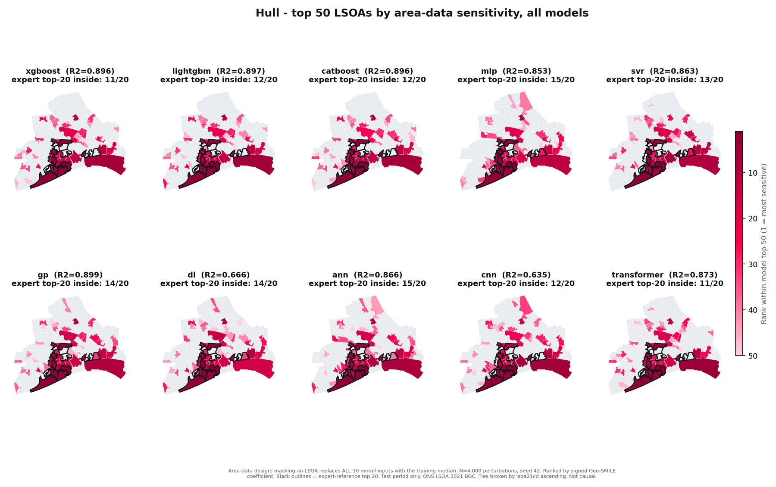
Figure 2. Each model's top 50 LSOAs coloured by rank (darker = more sensitive). Black outlines mark the earlier expert top-20 list.

5.2 XGBoost in detail
Table 11. XGBoost ATT accuracy metrics against the expert regions (N = 4,000).
k | Hits | Accuracy | Lift | p | Recall | F1 | ATT-Acc | Jaccard
20 | 17 | 0.850 | 2.55× | <0.0001 | 0.304 | 0.447 | 0.750 | 0.288
42 | 25 | 0.595 | 1.79× | <0.0001 | 0.446 | 0.510 | 0.714 | 0.342
50 | 28 | 0.560 | 1.68× | <0.0001 | 0.500 | 0.528 | 0.702 | 0.359
56 | 30 | 0.536 | 1.61× | <0.0001 | 0.536 | 0.536 | 0.690 | 0.366
XGBoost (predictive R² 0.896, ATT-AUC 0.700) places 17 of its top 20 in the reference: 13 in the corridor, 3 in Southcoates–Marfleet and 1 in Bransholme. Two of its top-20 misses are informative. E01012805 (rank 6) lies just outside the Southcoates strip, with under 10% of its area inside. E01012787 (rank 10) lies in the north-east Bransholme area the expert explicitly excluded: the model depends on it, but the expert does not treat it as informative. Several reference LSOAs sit near the bottom of its ranking (ranks 147–165), which is why the threshold-free ATT-AUC is only moderate.
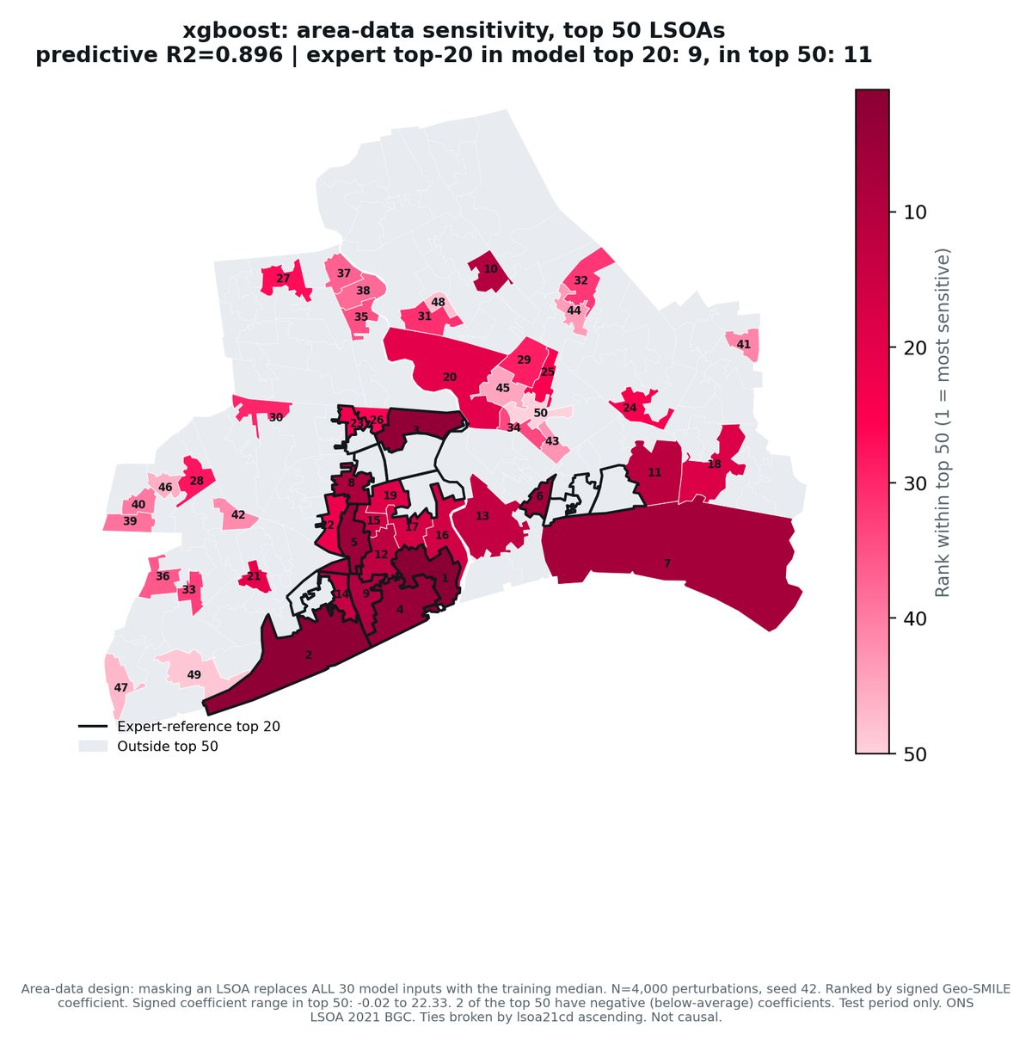
Figure 3. XGBoost top 50 LSOAs by signed area-data Geo-SMILE coefficient, with rank labels.

6. ATT faithfulness
ATT faithfulness follows the performance–attribution correspondence defined for the Hull study, adapted from KG-SMILE: the Pearson correlation, across the candidate models, between predictive competence (held-out predictive R²) and attribution quality. A strong positive correlation means that better predictors also produce explanations that agree more with the expert. ATT-AUC against the expert regions is the primary attribution-quality measure and hits@k the secondary one. Because the Geo branch explains the 30-feature model, each model's Geo score is paired with that model's own predictive R².
The two-sided p of the Pearson correlation is the primary test; the one-sided p (H₁: r > 0) and Spearman's ρ with its p are reported beside it. A sensitivity analysis excludes the two Keras models (DL and CNN), whose training is not reproducible under a fixed seed and whose predictive R² values are therefore unstable.
Table 12. ATT faithfulness: correlation between predictive R² and Geo attribution quality against the expert regions.
Model set | Attribution measure | M | Pearson r | p (two-sided) | p (one-sided) | Spearman ρ | p (Spearman)
All models | ATT-AUC (primary) | 10 | +0.12 | 0.732 | 0.366 | +0.49 | 0.150
All models | Hits@20 | 10 | +0.26 | 0.461 | 0.231 | +0.64 | 0.046
All models | Hits@42 | 10 | +0.48 | 0.164 | 0.082 | +0.55 | 0.096
All models | Hits@50 | 10 | +0.24 | 0.500 | 0.250 | +0.31 | 0.386
All models | Hits@56 | 10 | +0.46 | 0.185 | 0.092 | +0.55 | 0.101
Excl. DL, CNN | ATT-AUC (primary) | 8 | +0.87 | 0.005 | 0.003 | +0.74 | 0.037
Excl. DL, CNN | Hits@20 | 8 | +0.88 | 0.004 | 0.002 | +0.85 | 0.008
Excl. DL, CNN | Hits@42 | 8 | +0.43 | 0.286 | 0.143 | +0.37 | 0.369
Excl. DL, CNN | Hits@50 | 8 | +0.20 | 0.632 | 0.316 | +0.20 | 0.641
Excl. DL, CNN | Hits@56 | 8 | +0.40 | 0.321 | 0.161 | +0.27 | 0.515
Result. Across all ten models, ATT faithfulness is not demonstrated: every correlation is positive, but none reaches significance, and the primary ATT-AUC correlation is r = +0.12 (p = 0.73). The direction differs from the earlier reference: against the earlier expert top-20 list the same area-data Geo branch gave r = −0.00 for ATT-AUC and r = −0.48 for top-20 overlap. DL (R² 0.666) and CNN (R² 0.635) predict worst yet match the other models on attribution quality, which flattens the correlation. Without them, ATT-AUC (r = +0.87, p = 0.005) and hits@20 (r = +0.88, p = 0.004) correlate strongly with R², while hits@42 and hits@50 remain non-significant.
The ten-model result should be reported as the primary finding and the eight-model result only as a sensitivity analysis: the exclusion is motivated, but it was examined after seeing the data, and the remaining eight models span a narrow R² range (0.853–0.899).
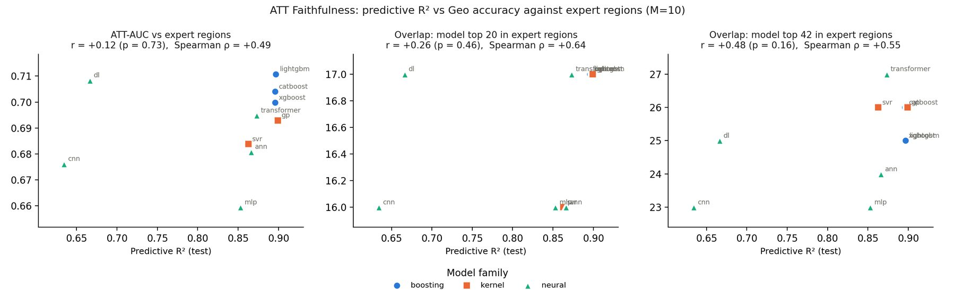
Figure 4. Predictive R² against ATT-AUC, hits@20 and hits@42 for all ten models, with Pearson r and Spearman ρ in each panel title.

6.1 Intervention impact (XGBoost, supplementary)
ATT faithfulness is a cross-model statistic and has no value for a single model. For the final XGBoost explanation, an intervention analysis tests a related but different property: whether masking the highest-ranked LSOAs changes the model's predictions more than masking random LSOAs. It uses the model's own ranking and does not involve the expert regions.
Table 13. Intervention impact for the XGBoost area-data Geo explanation (N = 4,000, k = 20).
Measure | Value
Top-20 response (W₁) | 37.84
Bottom-20 response (W₁) | 1.42
Random-set mean (W₁) | 11.61
Random-set 95% interval | 7.12 – 21.36
Top − random | 26.22
Top − bottom | 36.42
Empirical p (top vs random) | 0.0010
Random sets | 1000
The top-20 response lies far above the random-set 95% interval and p = 0.001 is the smallest value attainable with 1,000 random sets: the Geo ranking reflects the model's real dependence on each location.

7. ATT stability
ATT stability tests whether the explanation changes when the spatial context is slightly extended. For each compass direction, the nearest LSOA outside the Hull boundary is added to the panel as an extra player, the Geo pool is rebuilt, and the new ranking of the 168 Hull LSOAs is compared with the base ranking: the Jaccard index of the two top-20 sets, the Spearman correlation of the rankings, and where the added LSOA itself ranks. Stability was run for XGBoost at N = 4,000.
Table 14. XGBoost ATT stability after adding one neighbouring LSOA in each direction.
Direction | Added LSOA | Top-20 Jaccard | Top-20 retained | Rank Spearman | Rank of added LSOA | Added coefficient
North | E01012953 | 1.00 | 20/20 | 0.9998 | 82 of 169 | -0.390
East | E01013094 | 1.00 | 20/20 | 0.9998 | 57 of 169 | -0.112
South | E01013009 | 1.00 | 20/20 | 0.9998 | 101 of 169 | -0.694
West | E01013112 | 1.00 | 20/20 | 0.9998 | 53 of 169 | -0.065
Mean | – | 1.00 | – | 0.9998 | – | –
The top 20 is identical in all four directions, rank correlations exceed 0.9997, and no added LSOA enters the top 20 (their coefficients are small and negative): the explanation is robust to extending the study area.
Table 15. XGBoost ATT stability by number of perturbations N.
N | Top-20 Jaccard (mean) | Rank Spearman (mean)
1,000 | 1.00 | 0.9991
2,000 | 1.00 | 0.9996
3,000 | 1.00 | 0.9997
4,000 | 1.00 | 0.9998
5,000 | 1.00 | 0.9998
7,500 | 1.00 | 0.9999
10,000 | 1.00 | 0.9998

8. ATT consistency
ATT consistency tests whether repeated explanations of the same model agree when only the random perturbations change. The XGBoost Geo pool was rebuilt with five seeds (100–104) at N = 4,000. For each LSOA the variance and standard deviation of its coefficient across the five runs were computed, and every pair of runs was compared by rank Spearman, coefficient Pearson and the Jaccard index of their top-20% sets (the 34 highest-scoring LSOAs).
Table 16. XGBoost ATT consistency over five perturbation seeds (N = 4,000).
Measure | Value
Seeds | 100, 101, 102, 103, 104
Mean coefficient variance | 0.0154
Median coefficient variance | 0.0109
Mean coefficient SD | 0.1105
Median coefficient SD | 0.1043
Largest coefficient SD | 0.6507 (E01033104)
Mean coefficient of that LSOA | 22.98
Largest SD as % of its mean | 2.83%
Mean pairwise rank Spearman | 0.9635
Mean pairwise coefficient Pearson | 0.9972
Mean pairwise top-20% Jaccard | 0.7728
Coefficient noise is small relative to the coefficients (largest SD under 3% of its LSOA's mean). The top-20% sets agree less (Jaccard 0.77) because many mid-ranked LSOAs have near-identical coefficients; the leading LSOAs are stable.
Table 17. XGBoost ATT consistency by number of perturbations N.
N | Mean variance | Mean SD | Rank Spearman
1,000 | 0.0597 | 0.2263 | 0.8774
2,000 | 0.0251 | 0.1493 | 0.9341
3,000 | 0.0195 | 0.1232 | 0.9525
4,000 | 0.0154 | 0.1105 | 0.9635
5,000 | 0.0181 | 0.1106 | 0.9682
7,500 | 0.0083 | 0.0833 | 0.9779
10,000 | 0.0058 | 0.0697 | 0.9834
Consistency improves steadily with N (rank Spearman 0.877 at N = 1,000 to 0.983 at N = 10,000); N = 4,000 reaches 0.963.

9. Limitations
- Tracing uncertainty. The regions were traced from hand-drawn screenshots with a positional error of about 100–300 m. LSOAs with small overlaps, and the large dock and industrial LSOAs admitted by the 0.1 km² rule, are borderline and could change a model's hit count by one or two.
- Choice of k. Accuracy depends on the cut-off. Results at k = 20, 42, 50 and 56 all lead to the same conclusions.
- Small number of models. Faithfulness rests on ten models (eight in the sensitivity analysis), so the correlations have wide uncertainty.
- Scope of stability and consistency. Both were run for XGBoost only; the other nine models were explained with one pool each (seed 42).
- Keras reproducibility. The predictive R² of DL and CNN varies between runs under a fixed seed, which affects the faithfulness correlation directly.
- Sensitivity, not causation. Coefficients measure how much the fitted model depends on each location's data, not the causal effect of places on crime.

10. Reproduction
- hull_geo_area_data_models.py — fits the ten models and builds each area-data Geo pool (N = 4,000); fidelity and surrogate menu.
- hull_geo_area_data_eval.py — XGBoost N sweep: fidelity, intervention impact, stability and consistency.
- map_area_data_top50.py — signed rankings and per-model top-50 maps.
- select_highlighted_region_lsoas.py — traced expert regions, inclusion and exclusion rules, reference list and region overlap tables.
- eval_expert_region_accuracy.py — accuracy@k, lift, hypergeometric p, ATT-AUC and ATT faithfulness.
Outputs are in outputs/geo_area_data_models/ (top50_maps/, expert_region_accuracy/) and outputs/geo_area_data_eval/.

Appendix A. Expert reference LSOAs
The 56 LSOAs of the expert reference, with the share of each LSOA's area inside its region, the number of models that rank it in their top 50, and whether it is in the earlier expert top-20 list.
Table 18. Expert reference LSOAs.
Region | LSOA | Name | Area inside | Models (top 50) | Earlier top 20
Beverley Road–Oak Road | E01012767 | Kingston upon Hull 012B | 99% | 0 | –
Beverley Road–Oak Road | E01012765 | Kingston upon Hull 005B | 82% | 9 | –
Beverley Road–Oak Road | E01012766 | Kingston upon Hull 012A | 75% | 0 | –
Beverley Road–Oak Road | E01012764 | Kingston upon Hull 005A | 73% | 8 | –
Beverley Road–Oak Road | E01012769 | Kingston upon Hull 005D | 23% | 7 | –
Beverley Road–Oak Road | E01033107 | Kingston upon Hull 035E | 22% | 0 | –
Bransholme | E01012907 | Kingston upon Hull 007C | 100% | 0 | –
Bransholme | E01012788 | Kingston upon Hull 002E | 100% | 0 | –
Bransholme | E01012785 | Kingston upon Hull 002B | 100% | 0 | –
Bransholme | E01012910 | Kingston upon Hull 006D | 100% | 3 | –
Bransholme | E01012789 | Kingston upon Hull 002F | 100% | 0 | –
Bransholme | E01012830 | Kingston upon Hull 006B | 100% | 2 | –
Bransholme | E01012786 | Kingston upon Hull 002C | 99% | 0 | –
Bransholme | E01012912 | Kingston upon Hull 006E | 88% | 9 | –
Bransholme | E01012904 | Kingston upon Hull 007B | 63% | 1 | –
Bransholme | E01012813 | Kingston upon Hull 013B | 59% | 8 | –
Bransholme | E01012829 | Kingston upon Hull 006A | 43% | 0 | –
Bransholme | E01012911 | Kingston upon Hull 007E | 39% | 4 | –
Bransholme | E01033105 | Kingston upon Hull 035D | 21% | 0 | –
Bransholme | E01012817 | Kingston upon Hull 016D | 12% | 10 | –
Sculcoates–City Centre–Dairycoates | E01035466 | Kingston upon Hull 029H | 100% | 10 | –
Sculcoates–City Centre–Dairycoates | E01012761 | Kingston upon Hull 015A | 100% | 8 | Yes
Sculcoates–City Centre–Dairycoates | E01012852 | Kingston upon Hull 024B | 100% | 10 | Yes
Sculcoates–City Centre–Dairycoates | E01012850 | Kingston upon Hull 024A | 100% | 10 | –
Sculcoates–City Centre–Dairycoates | E01012857 | Kingston upon Hull 024D | 99% | 10 | –
Sculcoates–City Centre–Dairycoates | E01012872 | Kingston upon Hull 015E | 96% | 0 | Yes
Sculcoates–City Centre–Dairycoates | E01012891 | Kingston upon Hull 030C | 87% | 10 | Yes
Sculcoates–City Centre–Dairycoates | E01033104 | Kingston upon Hull 029E | 85% | 10 | Yes
Sculcoates–City Centre–Dairycoates | E01012892 | Kingston upon Hull 030D | 83% | 5 | Yes
Sculcoates–City Centre–Dairycoates | E01012855 | Kingston upon Hull 029D | 73% | 10 | Yes
Sculcoates–City Centre–Dairycoates | E01012763 | Kingston upon Hull 018C | 70% | 10 | Yes
Sculcoates–City Centre–Dairycoates | E01012868 | Kingston upon Hull 015B | 67% | 10 | Yes
Sculcoates–City Centre–Dairycoates | E01012869 | Kingston upon Hull 015C | 48% | 10 | –
Sculcoates–City Centre–Dairycoates | E01035468 | Kingston upon Hull 031I | 48% | 2 | –
Sculcoates–City Centre–Dairycoates | E01012854 | Kingston upon Hull 029C | 44% | 10 | Yes
Sculcoates–City Centre–Dairycoates | E01012867 | Kingston upon Hull 024E | 41% | 0 | Yes
Sculcoates–City Centre–Dairycoates | E01033109 | Kingston upon Hull 029F | 36% | 10 | –
Sculcoates–City Centre–Dairycoates | E01012889 | Kingston upon Hull 030B | 33% | 10 | Yes
Sculcoates–City Centre–Dairycoates | E01035465 | Kingston upon Hull 029G | 33% | 10 | –
Sculcoates–City Centre–Dairycoates | E01012757 | Kingston upon Hull 025B | 27% | 9 | Yes
Sculcoates–City Centre–Dairycoates | E01012856 | Kingston upon Hull 024C | 21% | 0 | Yes
Sculcoates–City Centre–Dairycoates | E01012871 | Kingston upon Hull 015D | 17% | 10 | Yes
Southcoates–Marfleet | E01012902 | Kingston upon Hull 022D | 96% | 0 | –
Southcoates–Marfleet | E01035464 | Kingston upon Hull 017G | 83% | 10 | –
Southcoates–Marfleet | E01012901 | Kingston upon Hull 020E | 81% | 0 | –
Southcoates–Marfleet | E01012843 | Kingston upon Hull 021B | 70% | 10 | –
Southcoates–Marfleet | E01012846 | Kingston upon Hull 021D | 67% | 1 | –
Southcoates–Marfleet | E01012903 | Kingston upon Hull 022E | 58% | 0 | –
Southcoates–Marfleet | E01012847 | Kingston upon Hull 021E | 55% | 0 | –
Southcoates–Marfleet | E01012896 | Kingston upon Hull 020D | 41% | 1 | –
Southcoates–Marfleet | E01012894 | Kingston upon Hull 020C | 40% | 5 | Yes
Southcoates–Marfleet | E01012807 | Kingston upon Hull 016C | 31% | 0 | –
Southcoates–Marfleet | E01012899 | Kingston upon Hull 022B | 27% | 0 | Yes
Southcoates–Marfleet | E01012820 | Kingston upon Hull 022A | 23% | 4 | –
Southcoates–Marfleet | E01012844 | Kingston upon Hull 017B | 20% | 0 | –
Southcoates–Marfleet | E01012848 | Kingston upon Hull 020B | 3% | 10 | –

