|  |
| --- |
| **COMP-232**  **MATHEMATICS FOR COMPUTER SCIENCE Fall 2019**  Assignment #3  **Shadi Jiha**  **#** **40131284** |

**PROBLEM 1: Let A and B be sets. Prove that A ⊆ B if and only if P(A) ⊆ P(B).**

Let and . Let’s define and :

We can see here that is a subset of , because contains which is equal to . Also, is a subset of because contains . Therefor it is a proof that

**PROBLEM 2: Let A, B, C, and D be sets. Prove or disprove the following:**

Let

So here we can see that the statement is only true if and only if and . In other words, the set D has no common elements with neither C nor A. For this reason, we can conclude that the whole statement is not always true, because D can be something like so,

Will be,

Which is not true. Therefor the statement if false.

**PROBLEM 3: Give an example of two uncountable sets A and B such that A – B is:**

1. Countably Infinite.
2. Uncountable.

**PROBLEM 4:**

1. Let . Always possible since if then .

Proof by cases:

* + Case n = 0:
  + Case n = 2:

* + Case n = 4:

1. Let . Proof by cases:
   * Case
   * Case
   * Case

**PROBLEM 5:**

Floor(Ceiling)…

PAGE 45 solution to a problem

**PROBLEM 6:**

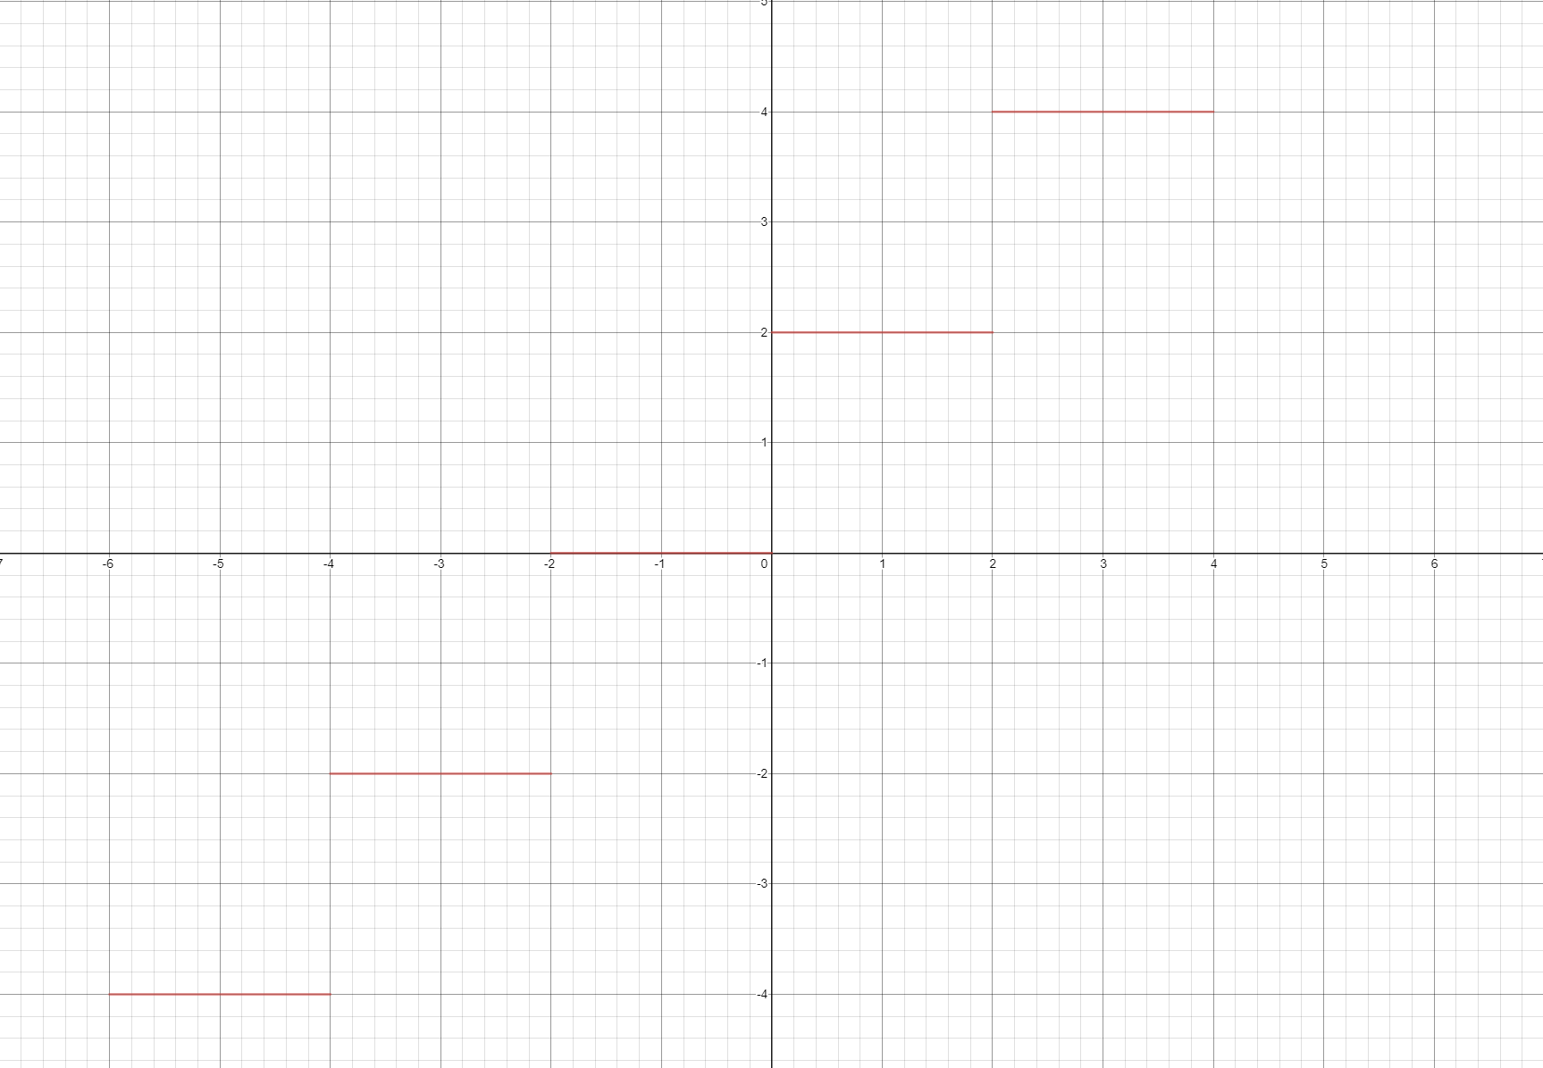

**PROBLEM 7:**

A and B are integers:

* Case and m = 3:

Let a = 4, b = 2:

So, is true

* Case and m = 3:

Let a = 2, b = 4:

So, is true

* Case and m = 3:

Let a = 4, b = 4:

So, is false

**PROBLEM 8:**

**PROBLEM 9:**