|  |
| --- |
| **COMP-232**  **MATHEMATICS FOR COMPUTER SCIENCE Fall 2019**  Assignment #4  **Shadi Jiha**  **#** **40131284** |

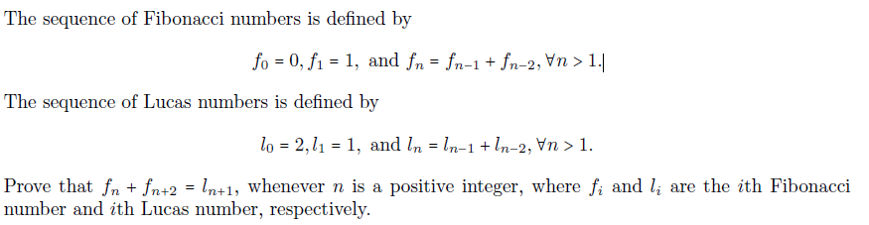**PROBLEM 2:**

*Basic step:*

Let

So, it is true for n = 2

Let n = 3

So, it is true for n = 3

*Inductive step:*

Assume that is true for , where

Now for

We can still decompose them further:

Now replace with :

By the induction hypothetic is this true because for being . And the statement above every and is not greater than .