Lab Taks-1

Question-
Draw the object-

Graph Plot (Picture)-
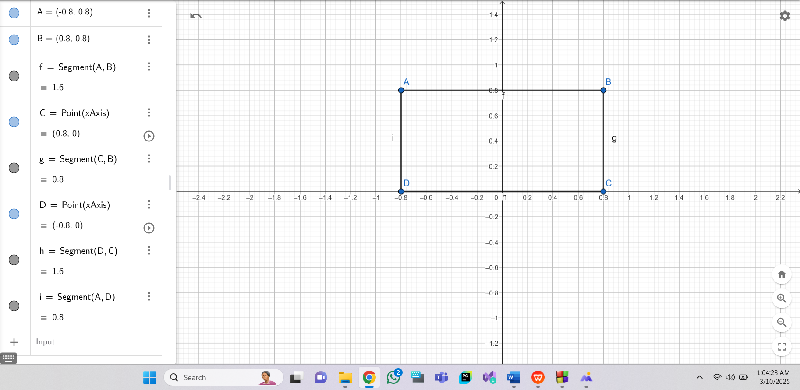

Code-
#include <windows.h>
#include <GL/glut.h>

void display() {
glClearColor(1.0f, 1.0f, 1.0f, 1.0f);
glClear(GL_COLOR_BUFFER_BIT);

glLineWidth(5.0);

glBegin(GL_LINE_LOOP);
glColor3f(1.0f, 0.0f, 0.0f);

glVertex2f(-0.8f, 0.8f);
glVertex2f(0.8f, 0.8f);
glVertex2f(0.8f, 0.0f);
glVertex2f(-0.8f, 0.0f);
glEnd();

glFlush(); // Render now
}

// Main function
int main(int argc, char** argv) {
glutInit(&argc, argv);
glutCreateWindow("OpenGL Setup Test");
glutInitWindowSize(320, 320);
glutInitDisplayMode(GLUT_SINGLE | GLUT_RGB);
glutDisplayFunc(display);
glutMainLoop();
return 0;
}
Output Screenshot (Full Screen)-
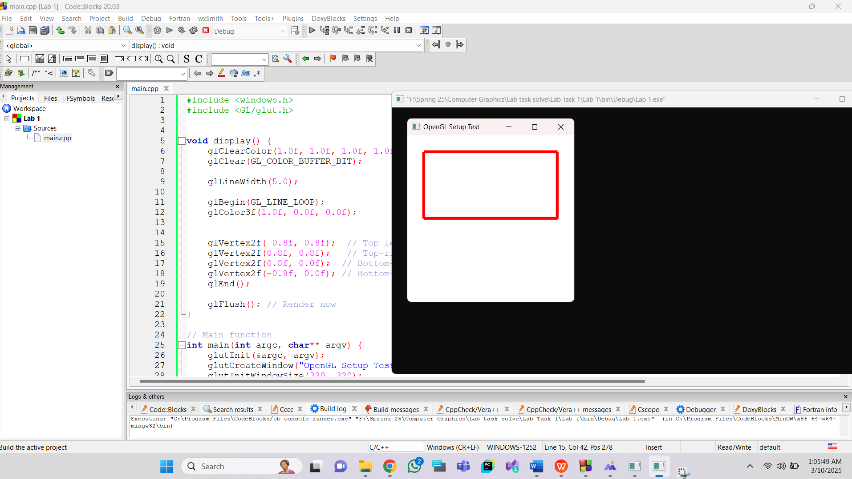

Question-
Draw the object-

Graph Plot (Picture)-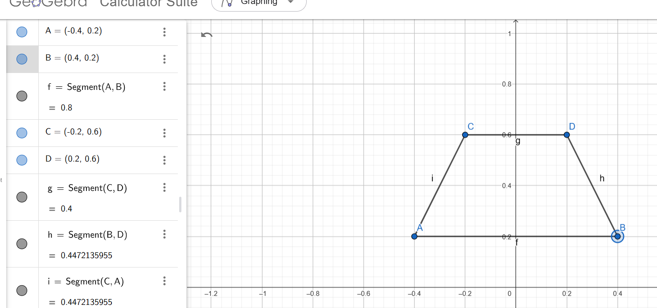

Code-#include <windows.h>
#include <GL/glut.h>

void display() {
glClearColor(1.0f, 1.0f, 1.0f, 1.0f);
glClear(GL_COLOR_BUFFER_BIT);

glColor3ub(246, 82, 80); // Set polygon color

glBegin(GL_POLYGON);
glVertex2f(-0.4, 0.2);
glVertex2f(0.4, 0.2);
glVertex2f(0.2, 0.6);
glVertex2f(-0.2, 0.6);
glEnd();

glutSwapBuffers(); // Use double buffering for smooth rendering
}

int main(int argc, char** argv) {
glutInit(&argc, argv);
glutInitDisplayMode(GLUT_DOUBLE | GLUT_RGB);
glutInitWindowSize(320, 320);
glutCreateWindow("OpenGL Polygon");

glutDisplayFunc(display);

glutMainLoop();
return 0;
}

Output Screenshot (Full Screen)-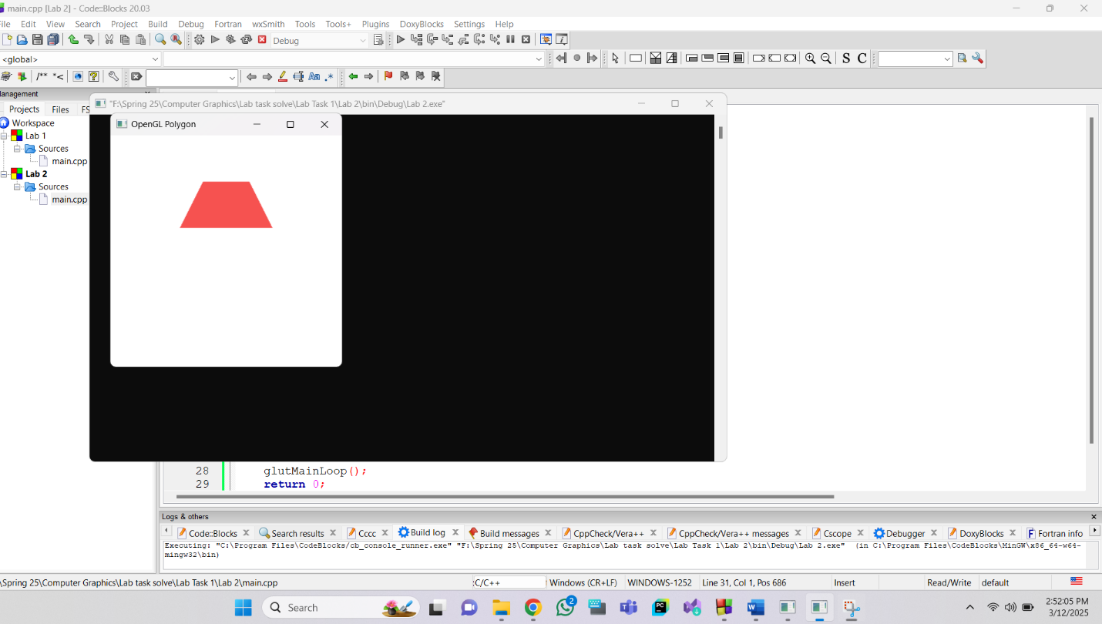

Question-
Draw the object-

Graph Plot (Picture)-
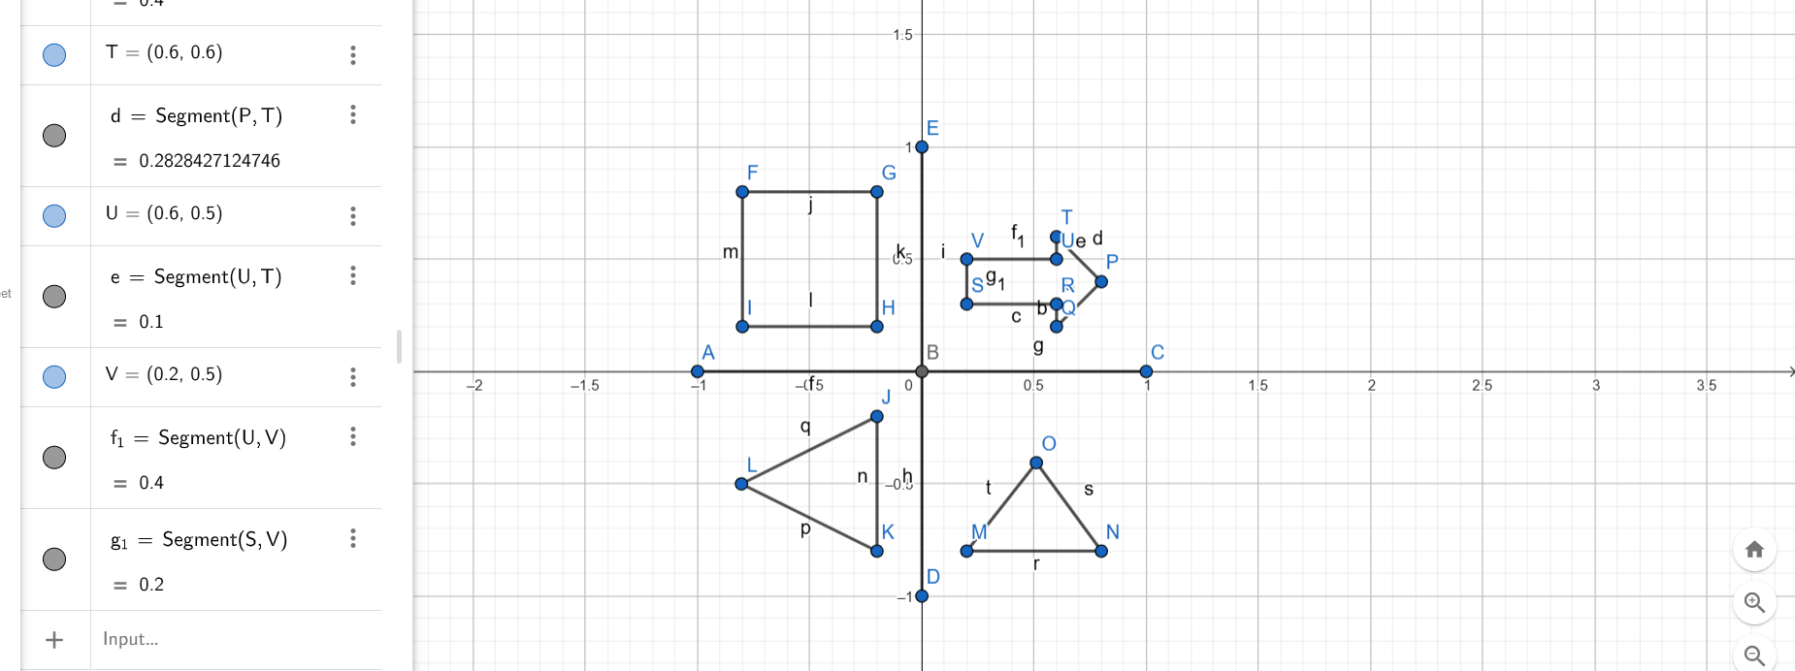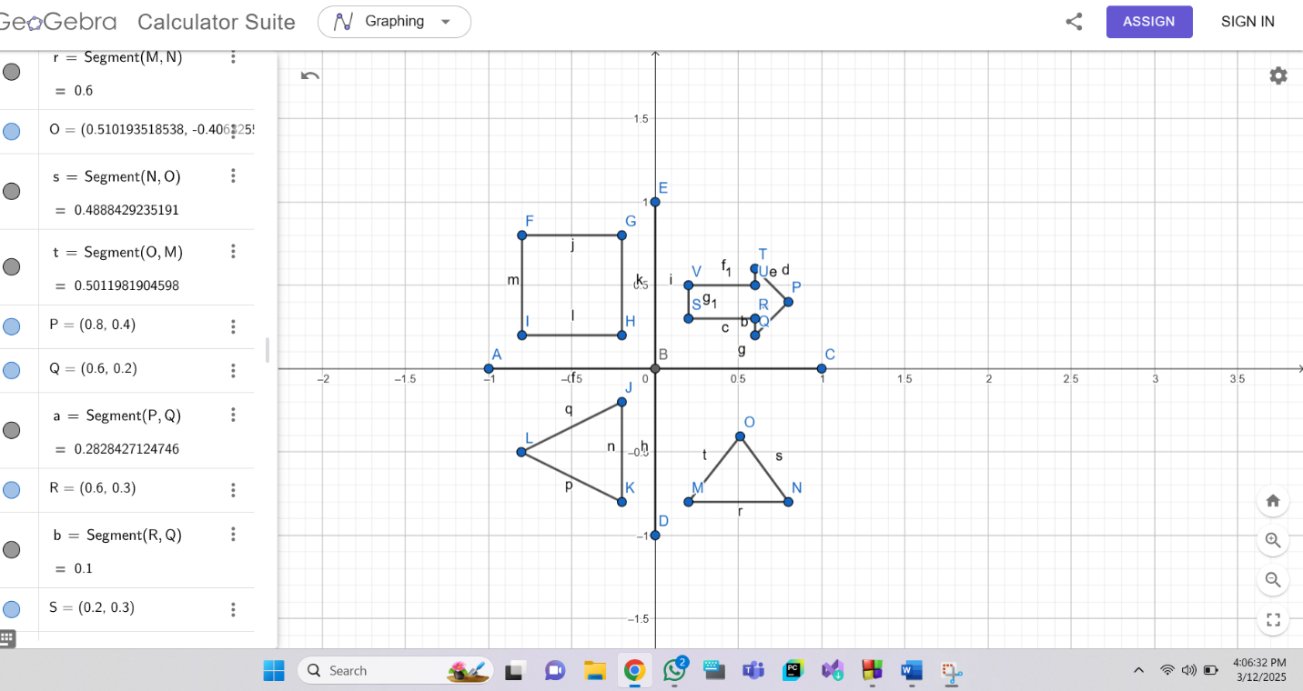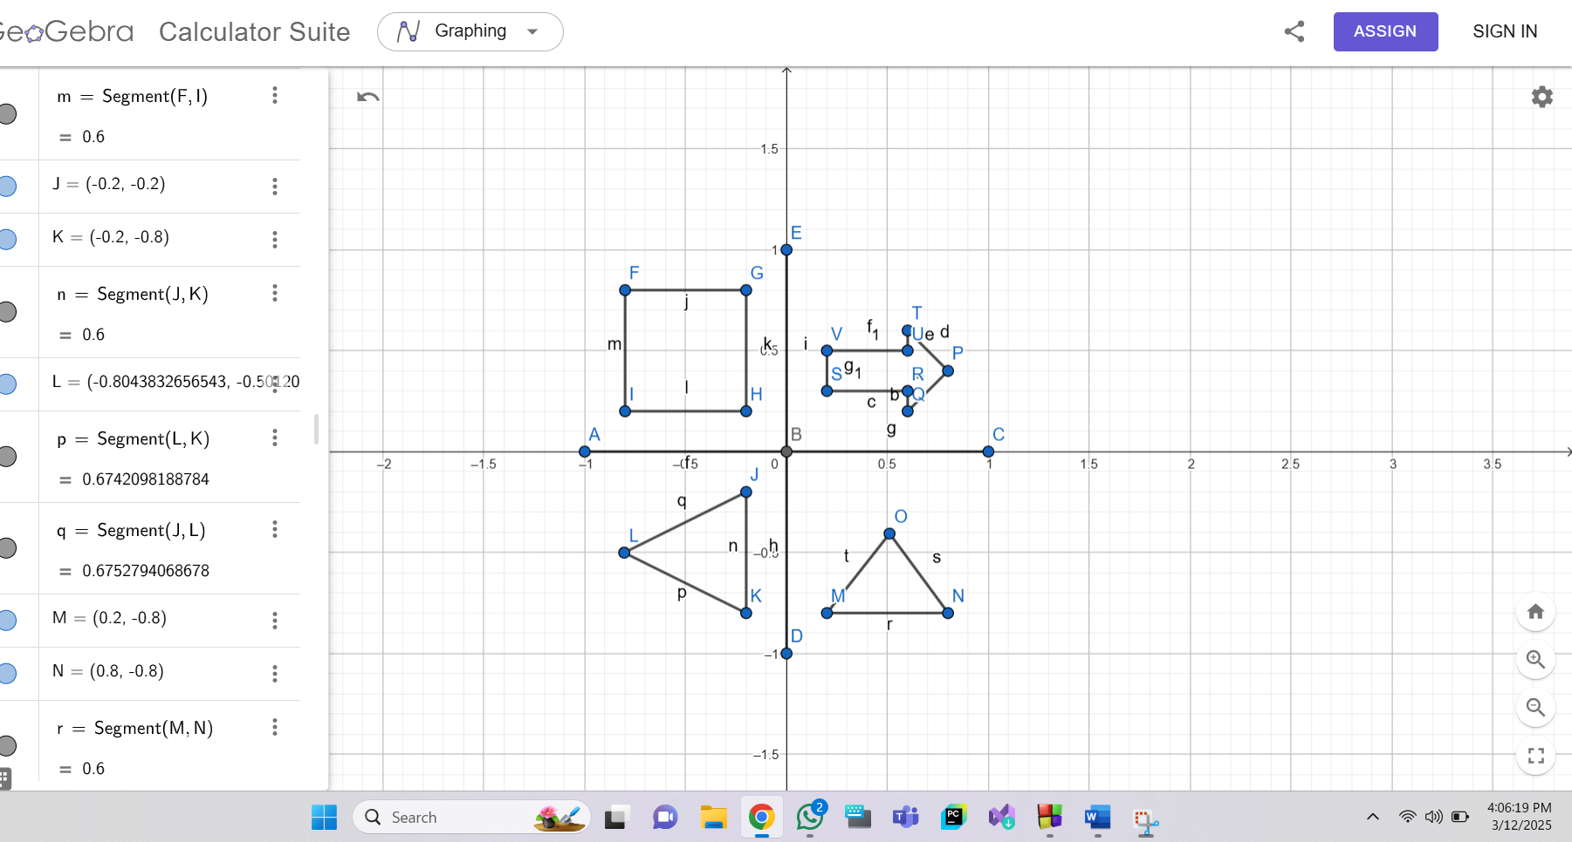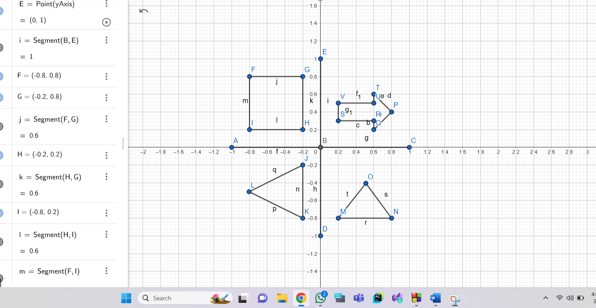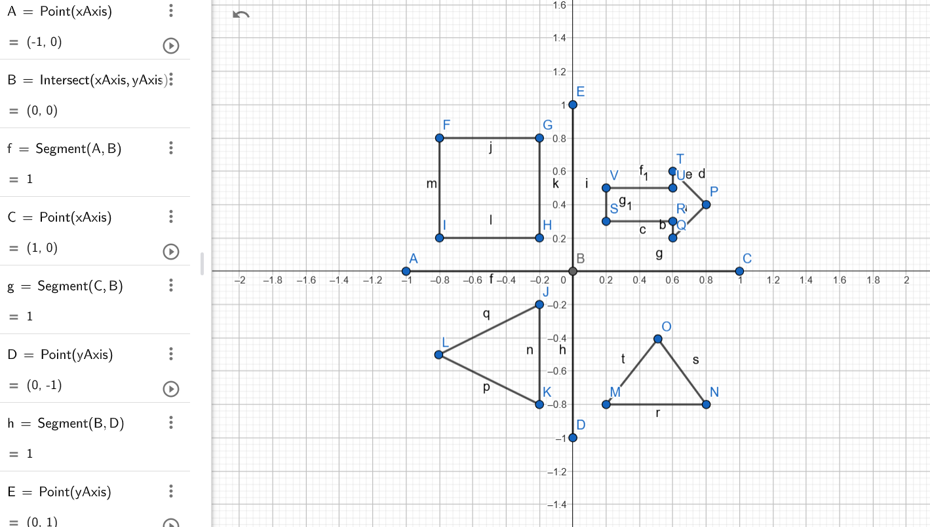

Code- #include <windows.h>
#include <GL/glut.h>

void initGL() {
glClearColor(0.0f, 0.0f, 0.0f, 1.0f); // Black background
}

void display() {
glClear(GL_COLOR_BUFFER_BIT);

// XY Axis
glLineWidth(2.0);
glBegin(GL_LINES);
glColor3f(1.0f, 1.0f, 1.0f);

// X-Axis
glVertex2f(-1.0f, 0.0f);
glVertex2f(1.0f, 0.0f);

// Y-Axis
glVertex2f(0.0f, -1.0f);
glVertex2f(0.0f, 1.0f);
glEnd();

// 2nd Shape: Square

glBegin(GL_QUADS);
glColor3f(1.0f, 0.0f, 0.0f); // Red
glVertex2f(-0.8f, 0.8f); // Bottom-left
glVertex2f(-0.2f, 0.8f); // Bottom-right
glVertex2f(-0.2f, 0.2f); // Top-right
glVertex2f(-0.8f, 0.2f); // Top-left
glEnd();

//3rd Shape: TRIANGLES

glBegin(GL_TRIANGLES);
glColor3f(0.56f, 0.0f, 1.0f); // Violet
glVertex2f(-0.2f, -0.2f); // x, y
glVertex2f(-0.804f, -0.501f);
glVertex2f(-0.2f, -0.8f);

glEnd();

// 4th Shape: TRIANGLES

glBegin(GL_TRIANGLES);
glColor3f(1.0f, 1.0f, 0.0f); // Yellow
glVertex2f(0.8f, -0.8f); // x, y
glVertex2f(0.2f, -0.8f);
glVertex2f(0.510f, -0.406f);

glEnd();

// 1st Shape: Arrow
glBegin(GL_POLYGON);
glColor3f(0.0f, 1.0f, 0.0f); // Green
glVertex2f(0.8f, 0.4f); //P
glVertex2f(0.6f, 0.2f); //Q
glVertex2f(0.6f, 0.3f); //R
glVertex2f(0.2f, 0.3f); //S
glVertex2f(0.2f, 0.5f); //V
glVertex2f(0.6f, 0.5f); //U
glVertex2f(0.6f, 0.6f); //T

glEnd();

glFlush(); // Render now
}

int main(int argc, char** argv) {
glutInit(&argc, argv);
glutCreateWindow("Vertex, Primitive & Color");
glutInitWindowSize(320, 320);
glutDisplayFunc(display);
initGL();
glutMainLoop();
return 0;
}

Output Screenshot (Full Screen)-
