Lab Taks-2

Submission Guidelines-
- Rename the file with your serial number only.
- Must submit within time that will be discussed in class VUES to the section named Lab Tak-2
- Must include resources for all the section in the table
Question- 1

Draw a Rainbow Flag

Graph Plot (Picture)-
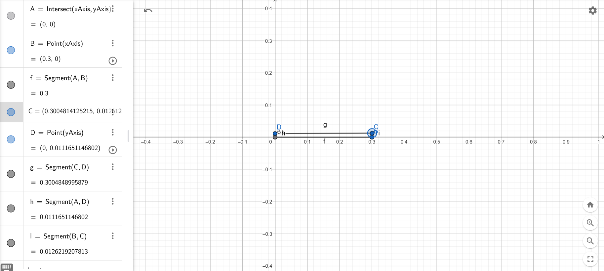

Code- #include <GL/glut.h>

float width = 0.3f;
float height = 0.12f;
int numStripes = 6;

// Rainbow colors (RGB)
float colors[6][3] = {
{228/255.0f, 3/255.0f, 3/255.0f}, // Red
{255/255.0f, 140/255.0f, 0/255.0f}, // Orange
{255/255.0f, 237/255.0f, 0/255.0f}, // Yellow
{0/255.0f, 128/255.0f, 38/255.0f}, // Green
{0/255.0f, 77/255.0f, 255/255.0f}, // Blue
{117/255.0f, 7/255.0f, 135/255.0f} // Violet
};

void drawRectangle(float x, float y, float width, float height, float color[3]) {
glColor3fv(color);
glBegin(GL_QUADS);
glVertex2f(x, y);
glVertex2f(x + width, y);
glVertex2f(x + width, y + height);
glVertex2f(x, y + height);
glEnd();
}

void display() {
glClear(GL_COLOR_BUFFER_BIT);

float stripeHeight = height / numStripes;
for (int i = 0; i < numStripes; i++) {
float y = i * stripeHeight;
drawRectangle(0, y, width, stripeHeight, colors[i]);
}
glColor3f(0, 0, 0);
glLineWidth(2);
glBegin(GL_LINE_LOOP);
glVertex2f(0, 0);
glVertex2f(width, 0);
glVertex2f(width, height);
glVertex2f(0, height);
glEnd();

glFlush();
}
void init() {
glClearColor(1.0f, 1.0f, 1.0f, 1.0f); // White background
glMatrixMode(GL_PROJECTION);
glLoadIdentity();
gluOrtho2D(0.0, 0.3, 0.0, 0.12); // Set the coordinate system
}
int main(int argc, char** argv) {
glutInit(&argc, argv);
glutInitDisplayMode(GLUT_SINGLE | GLUT_RGB);
glutInitWindowSize(500,300);
glutCreateWindow("Rainbow Flag");

init();
glutDisplayFunc(display);
glutMainLoop();

return 0;
}

Output Screenshot (Full Screen)-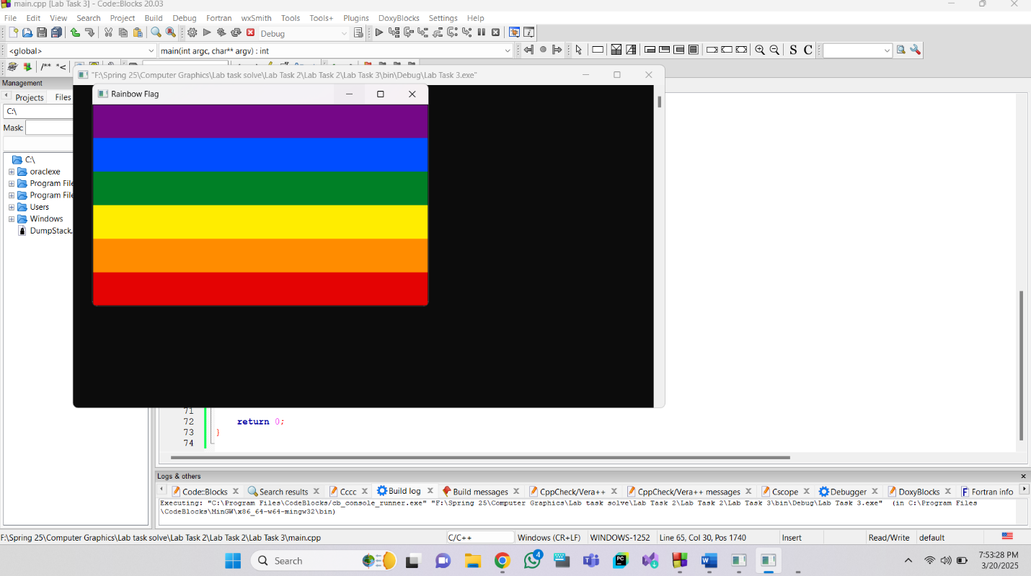

Question- 2

Flag of 5 different countries as per your choice.

Graph Plot (Picture)-
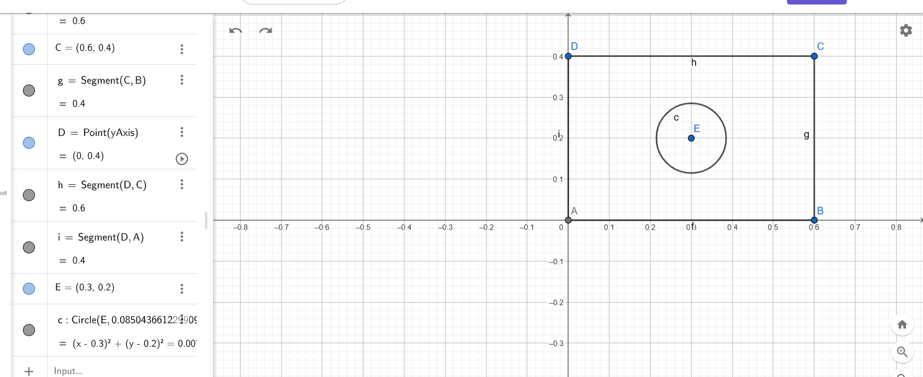

Code-
BANGLADESH FLAG

#include <GL/glut.h>
#include <cmath>

// Define flag dimensions
float flagWidth = 0.6f;
float flagHeight = 0.4f;
float circleRadius = 0.085f; // Adjusted for proper scaling
float circleCenterX = 0.3f; // Center of the circle
float circleCenterY = 0.2f; // Center of the circle

// Function to draw a filled circle
void drawCircle(float cx, float cy, float r, int numSegments) {
glBegin(GL_TRIANGLE_FAN);
glVertex2f(cx, cy);
for (int i = 0; i <= numSegments; i++) {
float angle = 2.0f * 3.1416f * float(i) / float(numSegments);
float x = r * cos(angle);
float y = r * sin(angle);
glVertex2f(cx + x, cy + y);
}
glEnd();
}

// Display function
void display() {
glClear(GL_COLOR_BUFFER_BIT);

// Draw the green rectangle (flag background)
glColor3f(0.0f, 0.42f, 0.24f); // Dark green color
glBegin(GL_QUADS);
glVertex2f(0.0f, 0.0f);
glVertex2f(flagWidth, 0.0f);
glVertex2f(flagWidth, flagHeight);
glVertex2f(0.0f, flagHeight);
glEnd();

// Draw the red circle
glColor3f(0.84f, 0.0f, 0.0f); // Red color
drawCircle(circleCenterX, circleCenterY, circleRadius, 100);

glFlush();
}

// Initialize OpenGL
void init() {
glClearColor(1.0f, 1.0f, 1.0f, 1.0f); // White background
glMatrixMode(GL_PROJECTION);
glLoadIdentity();
gluOrtho2D(0.0, 0.6, 0.0, 0.4); // Set the coordinate system
}

// Main function
int main(int argc, char** argv) {
glutInit(&argc, argv);
glutInitDisplayMode(GLUT_SINGLE | GLUT_RGB);
glutInitWindowSize(600, 400);
glutCreateWindow("Bangladesh Flag");

init();
glutDisplayFunc(display);
glutMainLoop();

return 0;
}

Gayana Flag
//Guyana
#ifdef __APPLE__
#include <GLUT/glut.h>
#else
#include <GL/glut.h>
#endif

#include <stdlib.h>

void display()
{
glClearColor(1.0f,1.0f,1.0f,1.0f);
glClear(GL_COLOR_BUFFER_BIT);
glLineWidth(1);

glBegin(GL_QUADS);
glColor3f(0.0f,0.592f,0.22f);
glVertex2f(0,0);
glVertex2f(400,0);
glVertex2f(480,240);
glVertex2f(0,240);
glEnd();

glBegin(GL_TRIANGLES);
glColor3f(1,1,1);
glVertex2f(0,0);
glVertex2f(400,120);
glVertex2f(0,240);

glEnd();

glBegin(GL_TRIANGLES);
glColor3f(1,0.82,0);
glVertex2f(0,15);
glVertex2f(360,120);
glVertex2f(0,225);

glEnd();

glBegin(GL_TRIANGLES);
glColor3f(0,0.0,0);
glVertex2f(0,0);
glVertex2f(200,120);
glVertex2f(0,240);

glEnd();

glBegin(GL_TRIANGLES);
glColor3f(0.93,0.2,0.25);
glVertex2f(0,15);
glVertex2f(160,120);
glVertex2f(0,225);

glEnd();

glFlush();

}
void myInit (void){
glClearColor(0.5, 0.5, 0.5, 0.0);
glColor3f(0.0f, 0.0f, 0.0f);
//glPointSize(4.0);
glMatrixMode(GL_PROJECTION);
glLoadIdentity();
gluOrtho2D(0.0, 400.0, 0.0, 240.0);
}
int main(int argc, char** argv){
glutInit(&argc, argv);
glutInitDisplayMode (GLUT_SINGLE | GLUT_RGB);
glutInitWindowSize (400, 240);
glutInitWindowPosition (80, 30);
glutCreateWindow ("my first attempt");
glutDisplayFunc(display);
myInit ();
glutMainLoop();
}

Kuwait Flag
//Kuwait
#ifdef __APPLE__
#include <GLUT/glut.h>
#else
#include <GL/glut.h>
#endif

#include <stdlib.h>

void display()
{
glClearColor(1.0f,1.0f,1.0f,1.0f);
glClear(GL_COLOR_BUFFER_BIT);
glLineWidth(1);

glBegin(GL_QUADS);
glColor3f(0.807f,0.0667f,0.149f);
glVertex2f(0,0);
glVertex2f(480,0);
glVertex2f(480,80);
glVertex2f(0,80);

glEnd();

glBegin(GL_QUADS);
glColor3f(1.0f,1.0f,1.0f);
glVertex2f(0,80);
glVertex2f(480,80);
glVertex2f(480,160);
glVertex2f(0,160);

glEnd();

glBegin(GL_QUADS);
glColor3f(0.0f,0.478f,0.239f);
glVertex2f(0,160);
glVertex2f(480,160);
glVertex2f(480,240);
glVertex2f(0,240);

glEnd();

glBegin(GL_QUADS);
glColor3f(0.0f,0.0f,0.0f);
glVertex2f(0,0);
glVertex2f(120,80);
glVertex2f(120,160);
glVertex2f(0,240);

glEnd();

glFlush();

}
void myInit (void){
glClearColor(0.5, 0.5, 0.5, 0.0);
glColor3f(0.0f, 0.0f, 0.0f);
//glPointSize(4.0);
glMatrixMode(GL_PROJECTION);
glLoadIdentity();
gluOrtho2D(0.0, 480.0, 0.0, 240.0);
}
int main(int argc, char** argv){
glutInit(&argc, argv);
glutInitDisplayMode (GLUT_SINGLE | GLUT_RGB);
glutInitWindowSize (430, 200);
glutInitWindowPosition (80, 30);
glutCreateWindow ("my first attempt");
glutDisplayFunc(display);
myInit ();
glutMainLoop();
}

Norway Flag

Output Screenshot (Full Screen)-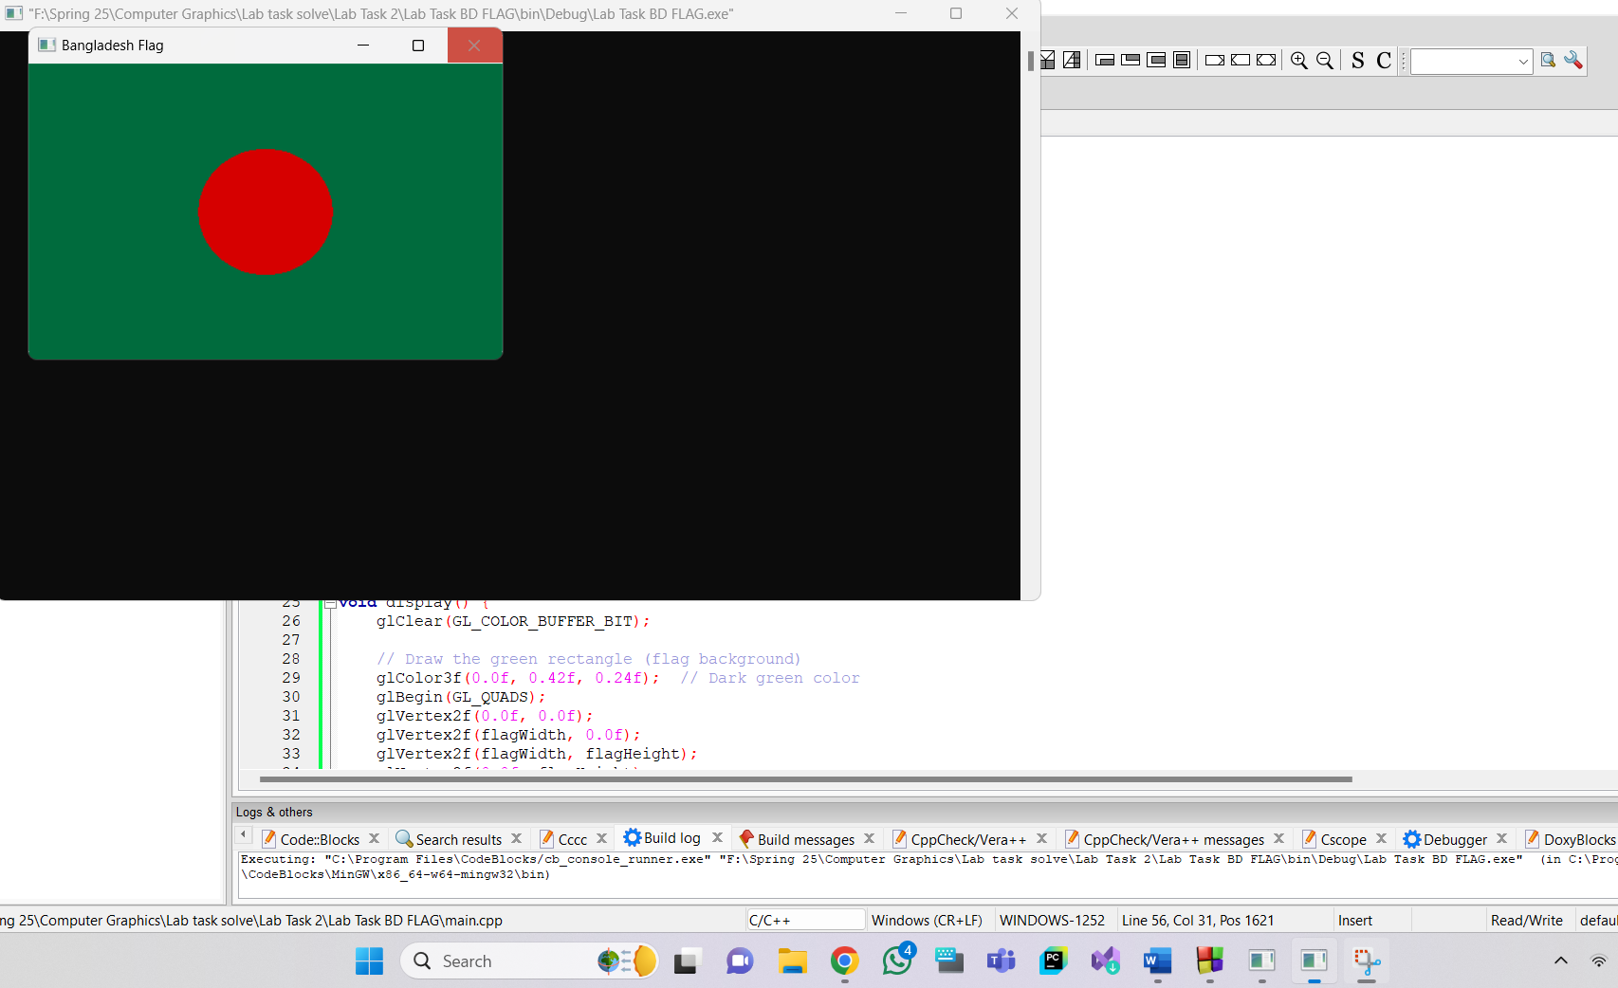
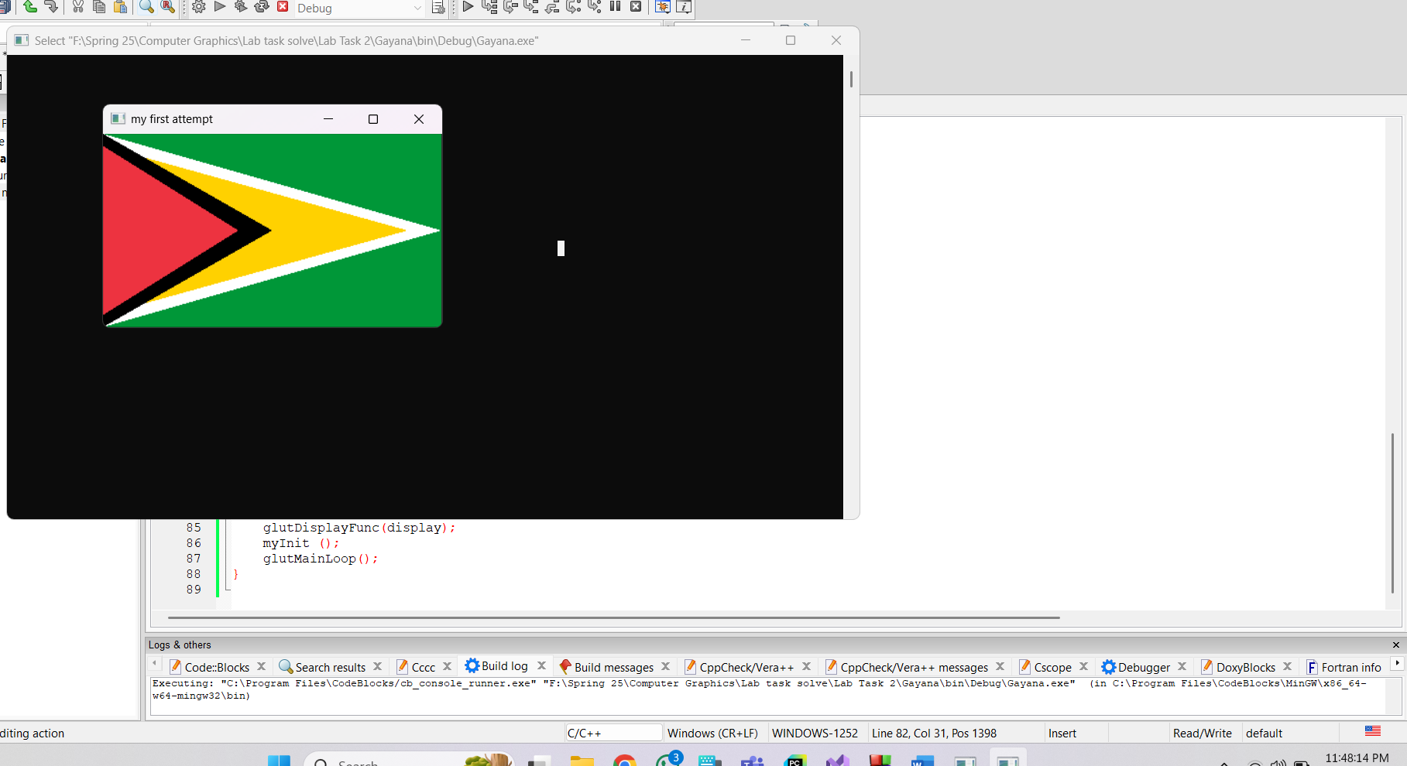
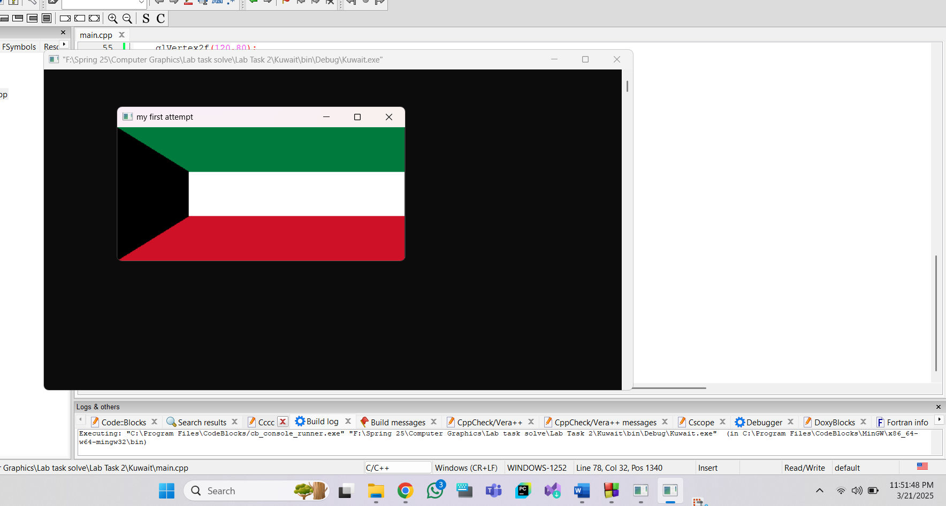

Question- 2

Draw 4X4 Chess Board

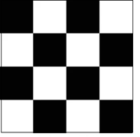

Graph Plot (Picture)-
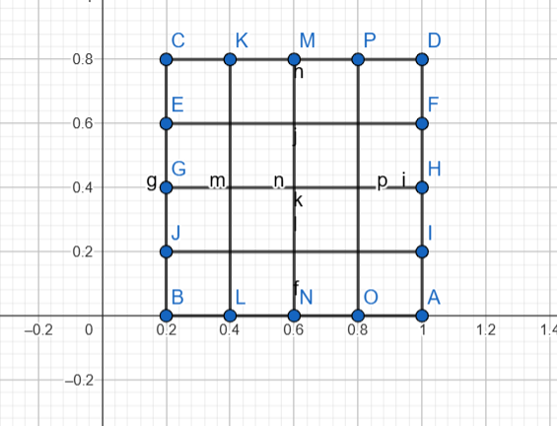

Code-
#include <GL/glut.h>

void drawSquare(float x, float y, float size, bool isBlack) {
if (isBlack) glColor3f(0.0f, 0.0f, 0.0f); // Black square
else glColor3f(1.0f, 1.0f, 1.0f); // White square

glBegin(GL_QUADS);
glVertex2f(x, y);
glVertex2f(x + size, y);
glVertex2f(x + size, y + size);
glVertex2f(x, y + size);
glEnd();
}

void display() {
glClear(GL_COLOR_BUFFER_BIT);
float size = 0.5f; // Size of each square
for (int i = 0; i < 4; i++) {
for (int j = 0; j < 4; j++) {
bool isBlack = (i + j) % 2 == 0;
drawSquare(-1.0f + j * size, 1.0f - (i + 1) * size, size, isBlack);
}
}
glFlush();
}

void init() {
glClearColor(1.0f, 1.0f, 1.0f, 1.0f);
glMatrixMode(GL_PROJECTION);
glLoadIdentity();
gluOrtho2D(-1.0, 1.0, -1.0, 1.0);
}

int main(int argc, char** argv) {
glutInit(&argc, argv);
glutInitDisplayMode(GLUT_SINGLE | GLUT_RGB);
glutInitWindowSize(270, 270);
glutCreateWindow("4x4 Chess Board");
init();
glutDisplayFunc(display);
glutMainLoop();
return 0;
}

Output Screenshot (Full Screen)-
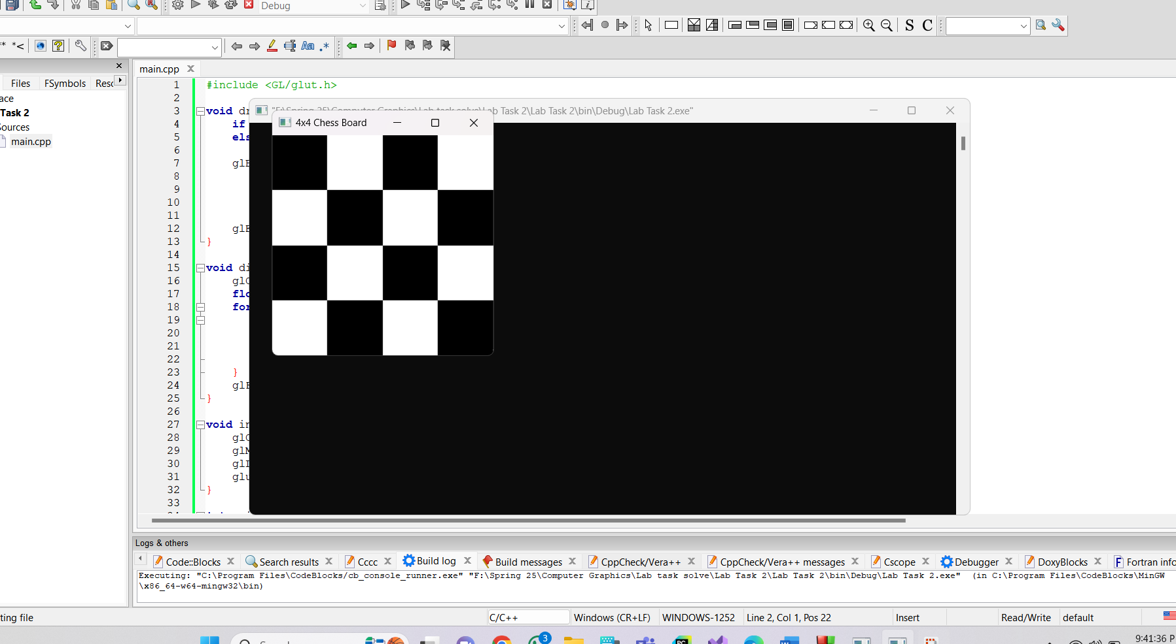

Question- 3


Implement the given picture

Graph Plot (Picture)-

Code-
#include <windows.h>
#include <GL/glut.h>
#include <math.h>
void circle(float r, float g, float b, float radius,float xc, float yc)
{
glBegin(GL_POLYGON);// Draw a Red 1x1 Square centered at origin
for(int i=0;i<200;i++)
{
glColor3ub(r,g,b);
float pi=3.1416;
float A=(i*2*pi)/200;
float r=radius;
float x = r * cos(A);
float y = r * sin(A);
glVertex2f(x+xc,y+yc);
}

//glVertex2f(0.3f,0.4f);
//glVertex2f(0.1f,0.4f);

glEnd();
}
void display() {
glClearColor(0.0f, 0.0f, 0.0f, 1.0f);
glClear(GL_COLOR_BUFFER_BIT);
glLineWidth(7.5);
circle(4, 238, 241,0.5,-0.3,0);
circle(4, 238, 241,0.5,0.3,0);
circle(4, 238, 241,0.5,-0.3,-0.6);
circle(4, 238, 241,0.5,0.3,-0.6);
glFlush(); // Render now
}

int main(int argc, char** argv) {
glutInit(&argc, argv);
glutCreateWindow("OpenGL Setup Test");
//gluOrtho2D(-0.1,0.7,-0.1,0.3);
glutInitWindowSize(320, 320);
glutDisplayFunc(display);
gluOrtho2D(-2,2,-2,2);
glutMainLoop();
return 0;
}

Output Screenshot (Full Screen)-