DIGITAL SIGNAL PROCESSING LABORATORY

EE321

# EXPERIMENT – 3

Z-Transform

# Name – Shaik Shadiq Roll no.- 1701EE44

**AIM- To understand the Z-transform and solve the differential equations**

1-Let X1(z)= 2+ 3z-1+4z-2 and X2= 3+ 4z-1+5z-2+6z-3. Determine X3(z) = X1(z)X2(z).

**Code**

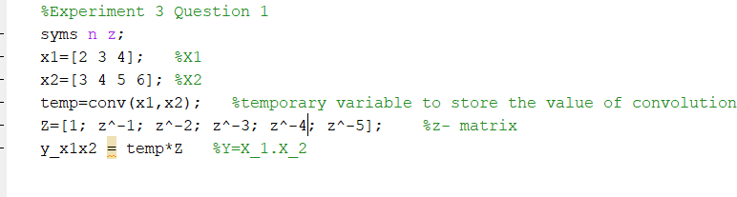

**Output**

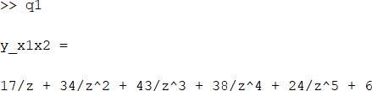

1. **Determine the inverse z-transform of**

**X(z)=** 𝟏+𝟎.𝟒√𝟐𝒛−𝟏

𝟏−𝟎.𝟖√𝟐𝒛−𝟏+𝟎.𝟔𝟒𝒛−𝟐

So that the resulting sequence is casual and contains no complex numbers.

**Code**

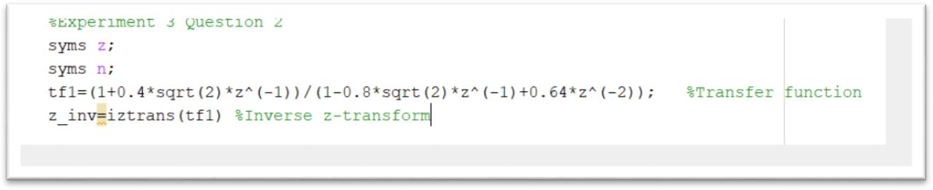

**Output**

z_inv =

((-1)^n*2^(1/2)*25^(1 - n)*(2^(1/2)*(- 10 - 10i))^(n - 1)*4i)/5 - ((-1)^n*2^(1/2)*25^(1 - n)*(2^(1/2)*(- 10 + 10i))^(n - 1)*4i)/5 + 3*(-1)^n*16^n/20^n*cos((3*pi*n)/4)

1. **Given a casual system y(n) =0.9y(n-1)+x(n)**
   1. **Determine H(z) and sketch its pole zero plot.**

**Code**

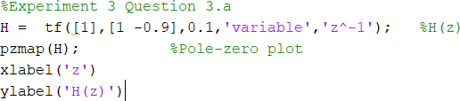

**Output**

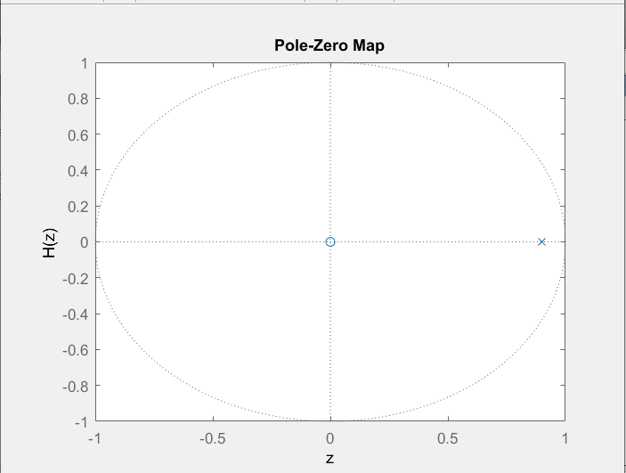

* 1. **Plot |H(ejω)| and phase of H(ejω).**
  2. **Determine the impulse response h(n).**

**Code**

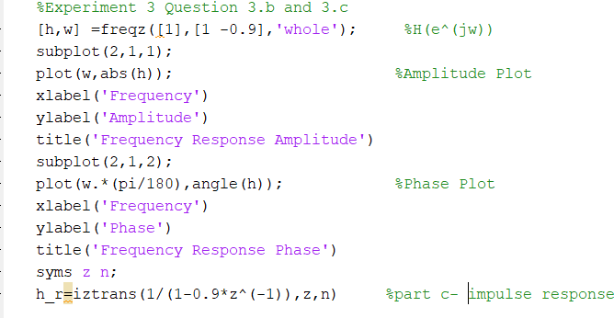

**Output(b)**

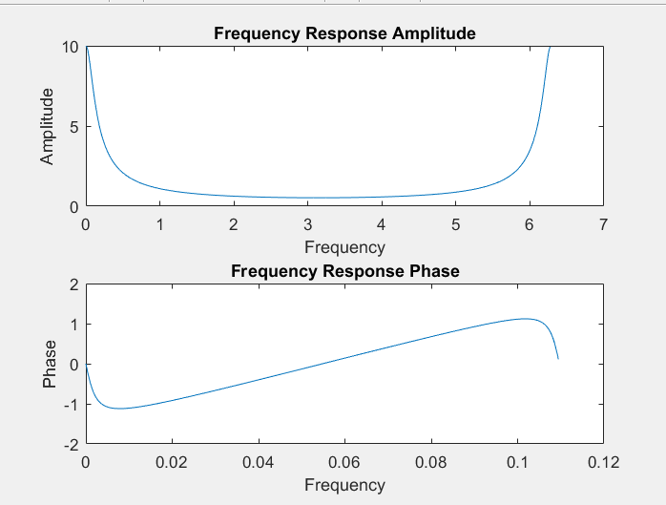

**Output(c)**

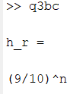

1. **Solve the difference equation**

Y(n) =(1/3)[x(n)+x(n-1)+x(n-2)]+ 0.95y(n-1)-0.9025y(n-2), n ≥0

Where x(n) = cos(πn/3)u(n) and

Y(-1) = -2, y(-2)=-3: x(-1) = 1, x(-2) =1

First determine the solution analytically and then by using MATLAB

**Code**

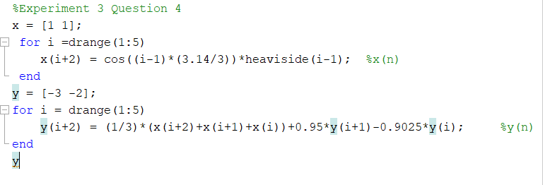

**Output**

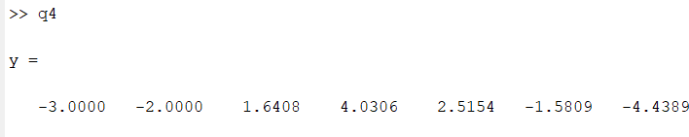

**Conclusion**

In this experiment we have learned about the z-transform and its properties. We have also learned the method to solve a difference equation in MATLAB. These methods can be used in further solving higher problems of DSP.