1. Created Test1 project to call main method in CreateCustomerMain class

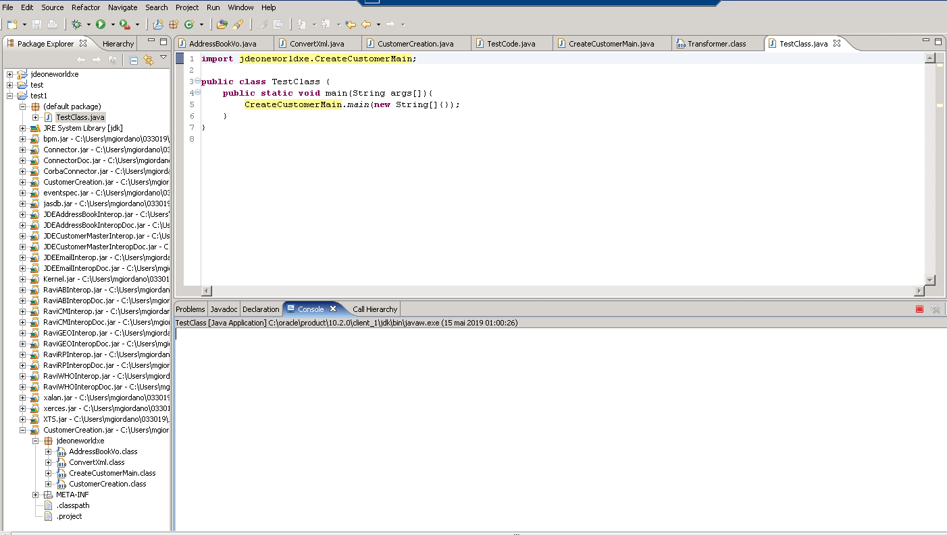

1. To configure VMarguments (-Dconfig_file=C:\Users\mgiordano\033019\Jar_Files\jdeinterop.ini)

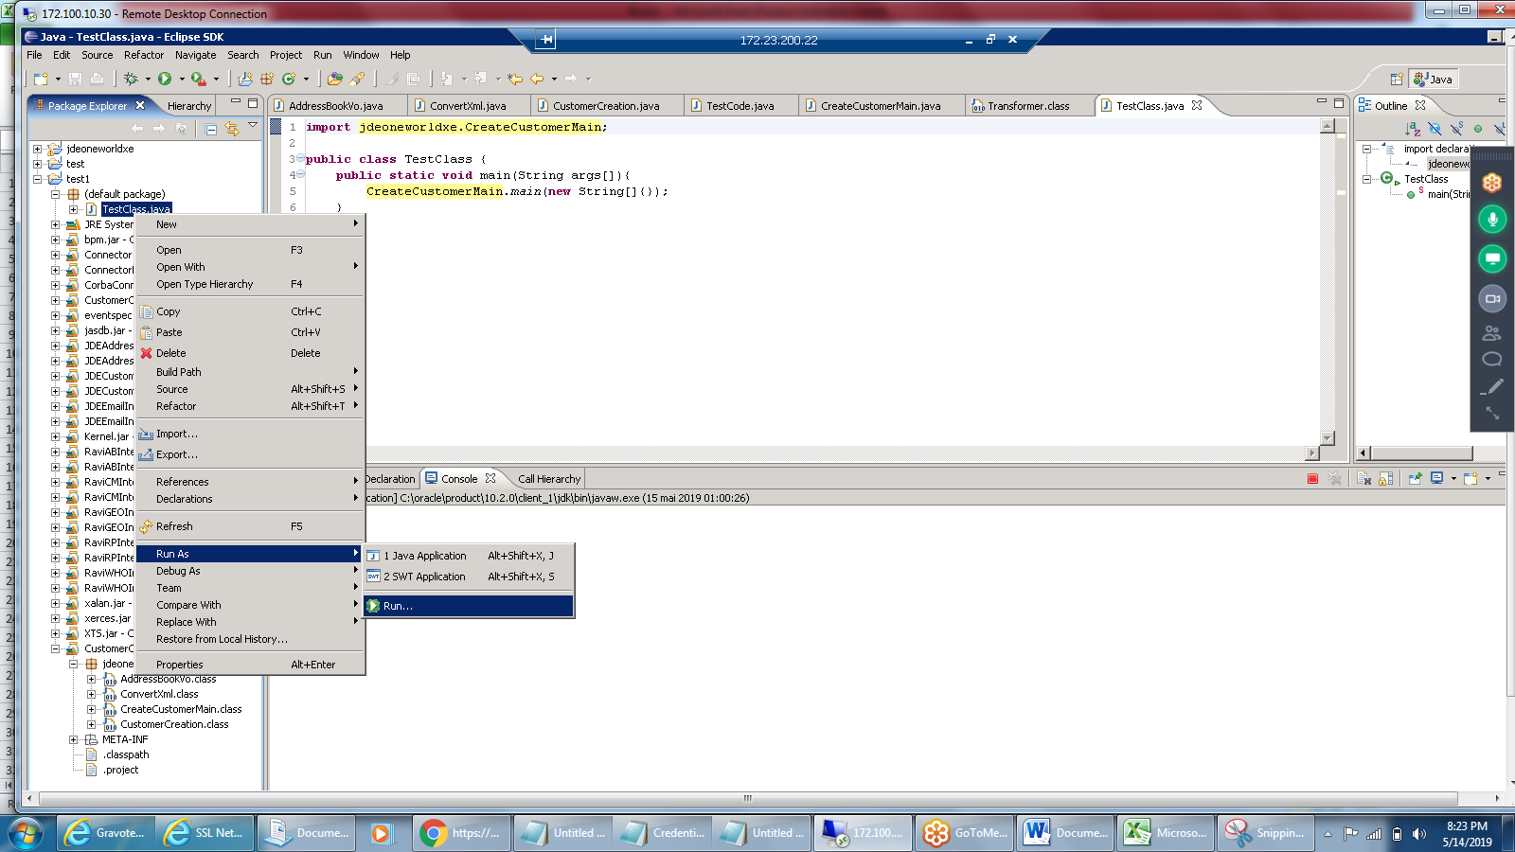

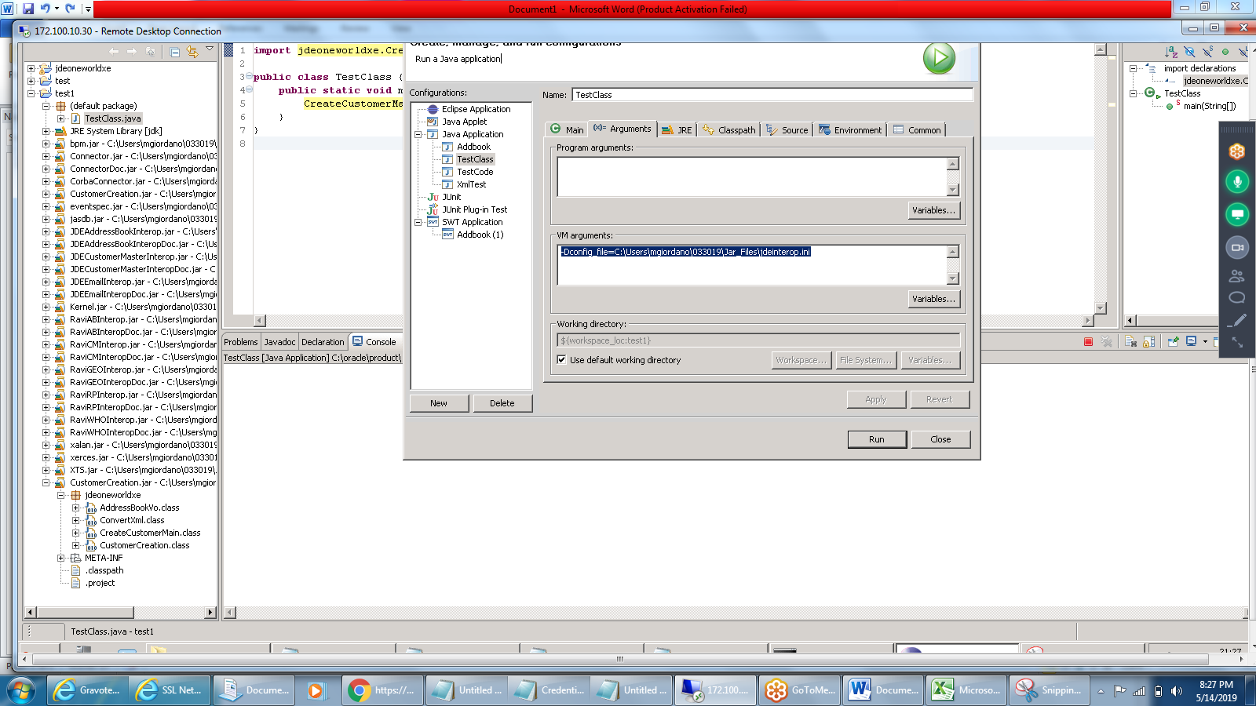

1. Click on Run button to execute the main method.
2. Output in eclipse console

