
Department of Electrical and Computer Engineering
North South University

Senior Design Project
My Farm

Group Members
ID | Name
MD shadman sakib | 1911357042
Jamil Kabir Hridoy | 1931032642
Kazi Nawmin Binte Rahman | 1931911042
Fardin Alam | 2031795642

Faculty Advisor:
Dr. Shazzad Hosain (SZZ)
Professor & Dean
ECE Department

Winter, 2024

APPROVAL
MD Shadman Sakib (ID 1911357042), Kazi Nawmin Binte Rahman (ID 1931911042), Fardin Alam (ID 2031795642) from Electrical and Computer Engineering Department of North South University, have worked on the Senior Design Project titled “My Farm” under the supervision of Dr. Shazzad Hosain partial fulfillment of the requirement for the degree of Bachelors of Science in Engineering and has been accepted as satisfactory.

Supervisor’s Signature

…………………………………….
Dr. Shazzad Hosain (SZZ)
Professor & Dean

Chairman’s Signature

…………………………………….
Dr. Rajesh Palit
Professor
Department of Electrical and Computer Engineering
North South University
Dhaka, Bangladesh.

DECLARATION

This is to declare that this project is our original work. No part of this work has been submitted elsewhere partially or fully for the award of any other degree or diploma. All project related information will remain confidential and shall not be disclosed without the formal consent of the project supervisor. Relevant previous works presented in this report have been properly acknowledged and cited. The plagiarism policy, as stated by the supervisor, has been maintained.

Students’ names & Signatures

1. MD shadman sakib

_ _ _ _ _ _ _ _ _ _ _ _ _ _ _ _ _
2. Jamil Kabir Hridoy

_ _ _ _ _ _ _ _ _ _ _ _ _ _ _ _ _
3. Kazi Nawmin Binte Rahman

_ _ _ _ _ _ _ _ _ _ _ _ _ _ _ _ _
4. Fardin Alam

_ _ _ _ _ _ _ _ _ _ _ _ _ _ _ _ _

ACKNOWLEDGEMENTS

The authors would like to express their heartfelt gratitude towards their project and research supervisor, Dr. Shazzad Hosain, Professor, Department of Electrical and Computer Engineering, North South University, Bangladesh, for his invaluable support, precise guidance and advice pertaining to the start-up expertise , knowledge and theoretical studies carried out during the course of the current project and also in the preparation of the current report.
Furthermore, the authors would like to thank the Department of Electrical and Computer Engineering, North South University, Bangladesh for facilitating the porject. The authors would also like to thank their loved ones for their countless sacrifices and continual support.

ABSTRACT
MY FARM

Agriculture is a vital sector in Bangladesh, yet farmers often face challenges in accessing fair markets due to intermediaries, leading to reduced profits and higher consumer prices. To address this issue, My Farm introduces an e-commerce platform that connects farmers directly with consumers, enabling a streamlined and transparent marketplace.

The project has successfully developed a fully compiled application, utilizing Dart with Flutter for the front-end interface, Node.js for backend services, and MongoDB for database management. The development process followed agile methodologies, emphasizing iterative testing, feature enhancements, and user-centric design principles.

The resulting application provides an intuitive user interface for farmers to list their products and for consumers to browse and purchase items seamlessly. Backend scalability and database optimization ensure reliable performance, even with increasing user demand.

The platform’s impact is significant, offering farmers better profit margins while enabling consumers to access fresh produce at competitive prices. By reducing dependency on intermediaries, My Farm promotes economic empowerment for farmers and contributes to the digital transformation of Bangladesh's agricultural sector.

TABLE OF CONTENTS
APPROVAL 2
DECLARATION 3
ACKNOWLEDGEMENTS 4
ABSTRACT 5
LIST OF FIGURES 8
Chapter 1 Introduction 10
1.1 Background and Motivation 10
1.2 Purpose and Goal of the Project 10
1.3 Organization of the Report 10
Chapter 2 Research Literature Review 11
2.1 Existing Research and Limitations 11
Chapter 3 Methodology 12
3.1 System Design 12
3.2 Hardware and/or Software Components 12
3.3 Hardware and/or Software Implementation 12
Chapter 4 Investigation/Experiment, Result, Analysis and Discussion 13
Chapter 5 Impacts of the Project 14
5.1 Impact of this project on societal, health, safety, legal and cultural issues 14
5.2 Impact of this project on environment and sustainability 14
Chapter 6 Project Planning and Budget 15
Chapter 7 Complex Engineering Problems and Activities 16
7.1 Complex Engineering Problems (CEP) 16
7.2 Complex Engineering Activities (CEA) 16
Chapter 8 Conclusions 18
8.1 Summary 18
8.2 Limitations 18
8.3 Future Improvement 18
References 19

LIST OF FIGURES
Figure 1. Gantt chart.
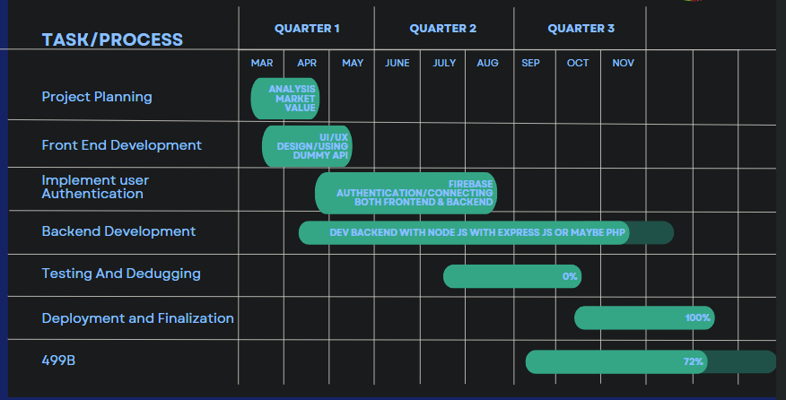
Figure 2. Use Case Diagram
15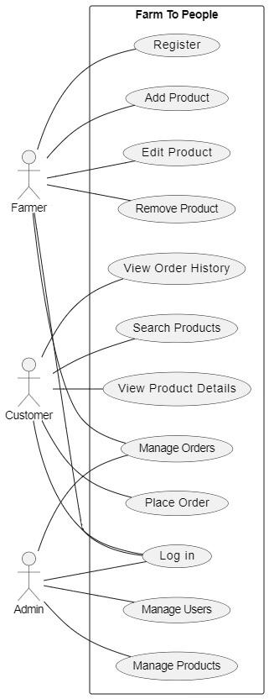

LIST OF TABLES

TABLE I. SOFTWARE TOOLS TABLE
Tool name | Purpose | Category
Dart | Frontend development | Programming Language
Flutter | UI/UX design and frontend framework | Framework
Node.js | Backend development and API handling | Runtime Environment
Postman | API testing and debugging | Testing Tool
Visual Studio Code | Code editor and IDE | Development Tool
Git/GitHub | Version control and code collaboration | Version Control Too
Firebase | Authentication and cloud services | Cloud Service
Android Studio | Mobile app testing and debugging | IDE/Testing Tool
npm (Node Package Manager) | Package management for Node.js | Dependency Manager
Docker | Containerization for backend services | Deployment Tool
14

Chapter 1 Introduction

Background and Motivation

Agriculture is one of the most vital sectors in Bangladesh, contributing significantly to the country's economy and employment. Despite its importance, farmers often face challenges in accessing fair markets, resulting in reduced profits and inefficient supply chains. Currently, farmers primarily rely on two distribution systems: the Public Food Distribution System (PFDS) and the Private Distribution System (PDS). While PFDS offers stability, it imposes restrictive regulations, leading many farmers to opt for PDS despite higher losses due to intermediaries. In the PDS model, multiple middlemen—such as Local Paddy Assemblers (LPA) and Local Paddy Brokers (LPB)—are involved before produce reaches consumers. This process inflates costs, reduces profitability for farmers, and raises prices for consumers.
Recent trends in agricultural technology highlight the growing role of e-commerce platforms in streamlining supply chains. Notable examples include solutions like "iFarmers," which has facilitated over 2.7 billion BDT in transactions with 265,000 tons of produce sold and engagement from over 100,000 farmers and retailers. These successes demonstrate the potential of digital platforms to empower farmers and reduce inefficiencies.
Motivated by the need for a sustainable and fairer agricultural ecosystem, this project introduces My Farm, an e-commerce application designed to directly connect farmers with consumers. By eliminating unnecessary intermediaries, the app aims to lower costs, increase farmers' profits, and ensure fresh, high-quality produce reaches consumers. This project envisions fostering sustainable agriculture while promoting economic growth and reducing food waste through efficient logistics and technology-driven solutions. In an era where convenience and health consciousness are increasingly growing in our country, our app redefines the fresh produce shopping experience by delivering farm-fresh fruits and vegetables directly to customer’s doorsteps. Leveraging a robust network of local farmers and advanced logistics, “My Farm” app ensures the highest quality produce reaches consumers swiftly, preserving nutritional value and freshness. The app features a user-friendly interface, allowing customers to effortlessly browse, select, and schedule deliveries. By fostering direct relationships between consumers and farmers, “My Farm” promotes sustainable agriculture, reduces food waste, and supports local economies. This innovative solution not only caters to the modern demand for convenience but also champions a healthier lifestyle and a more resilient food system.

Purpose and Goal of the Project

The primary objective of My Farm is to streamline the supply chain between farmers and consumers through a user-friendly mobile application. The app facilitates direct transactions, eliminating the need for multiple intermediaries. It leverages modern technology to:
- Provide farmers with a digital marketplace to showcase and sell their produce at fair prices.
- Enable consumers to access fresh, high-quality fruits and vegetables conveniently.
- Optimize transportation and logistics to minimize delivery costs and time.
- Promote sustainable farming practices by offering farmers higher returns on their produce.
The project’s novelty lies in its integration of a robust network of farmers with an e-commerce model, ensuring affordability for consumers and profitability for farmers. It combines cutting-edge technologies such as Dart with Flutter for the frontend, Node.js for the backend, and MongoDB for database management. Additionally, testing tools like Postman ensure the reliability and performance of the application.
By leveraging scheduled delivery systems, the project minimizes logistical inefficiencies, making it a scalable and replicable solution for Bangladesh’s agricultural sector.

Organization of the Report
This report is organized into multiple chapters, each addressing a key aspect of the project:
- Chapter 2: Literature Review—Discusses existing solutions and technologies related to agricultural e-commerce platforms and their impact.
- Chapter 3: Methodology—Describes the technical architecture, tools, and frameworks used in the development process.
- Chapter 4: Results and Discussion—Presents the outcomes, testing results, and performance evaluation of the system.
- Chapter 5: Impacts of the Project—Analyzes the economic, social, and technological impacts of the project on farmers, consumers, and the agricultural supply chain.
- Chapter 6: Project planning
- Chapter 6: Conclusion and Future Work—Summarizes findings, highlights limitations, and provides directions for future improvements.

Chapter 2 Research Literature Review

2.1 Existing Research and Limitations
Research: “The Marketing System of Agricultural Products in Bangladesh: A Case Study from Sylhet District”
Authors Md Mizanur RahmanShahnaz, Begum Neena
This research is on how much are farmers dependent are on the traders for their produce to reach a market. We can see that there exist two main ways for farmers to make their produce reach market PFDS(public food distribution system) and PDS(private distribution system). Due to constraints such as the lack of government information on PFDS and getting information of PFDS timely. PFDS’s strict requirements in paddy procurement is also another reason cited in the research. Farmers are suffering from poor facilities and sufficient money to access better marketing of PFDS. As a result, farmers tend to rely much on PDS, especially LPA, because it is much easier and convenient for them to access even if they make an economical loss in their paddy business. The smaller farmers who can not afford to meet the requirements of PFDS suffer the most.
Similar projects: IFARMERS
They are similar project to us who aim to ensure farmers financially, loan to farmers, work with agriculture companies, and supply to wholesale markets.
From their website:
“We enable individuals and institutions to fund the capital requirement of the farmers. iFarmer bundles finance with agriculture inputs, advisory services, insurance and market access for the farmers.”
“We empower Agri input retailers by offering a one stop solution for all Agri input supply, offering omni channel presence, doorstep delivery and buy now pay later solutions.”
“We use our tech-enabled supply chain network to aggregate fresh produce, directly from farming communities.”

Chapter 3 Methodology

3.1 System Design
- System architectural design
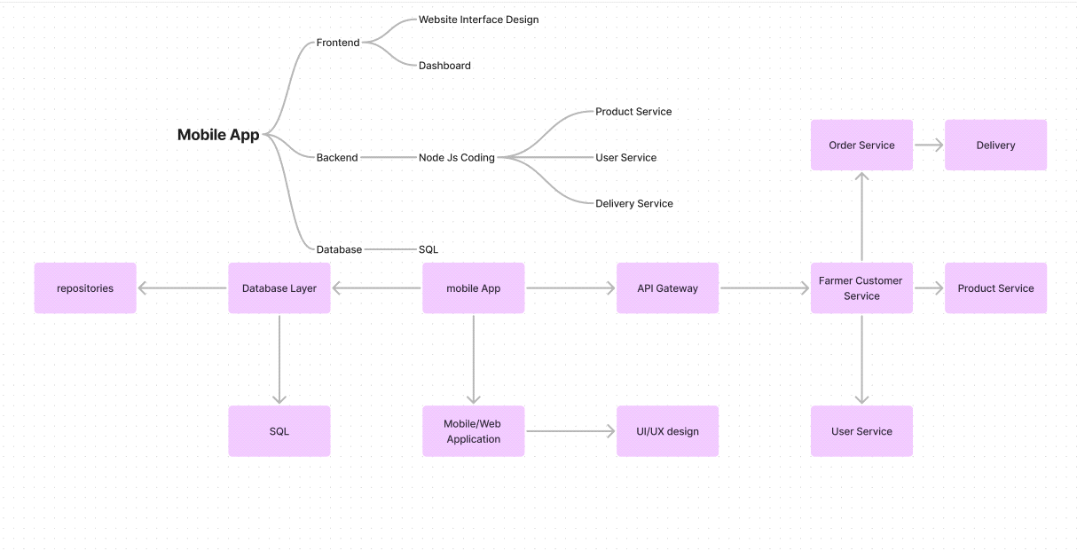

- Sub-component design

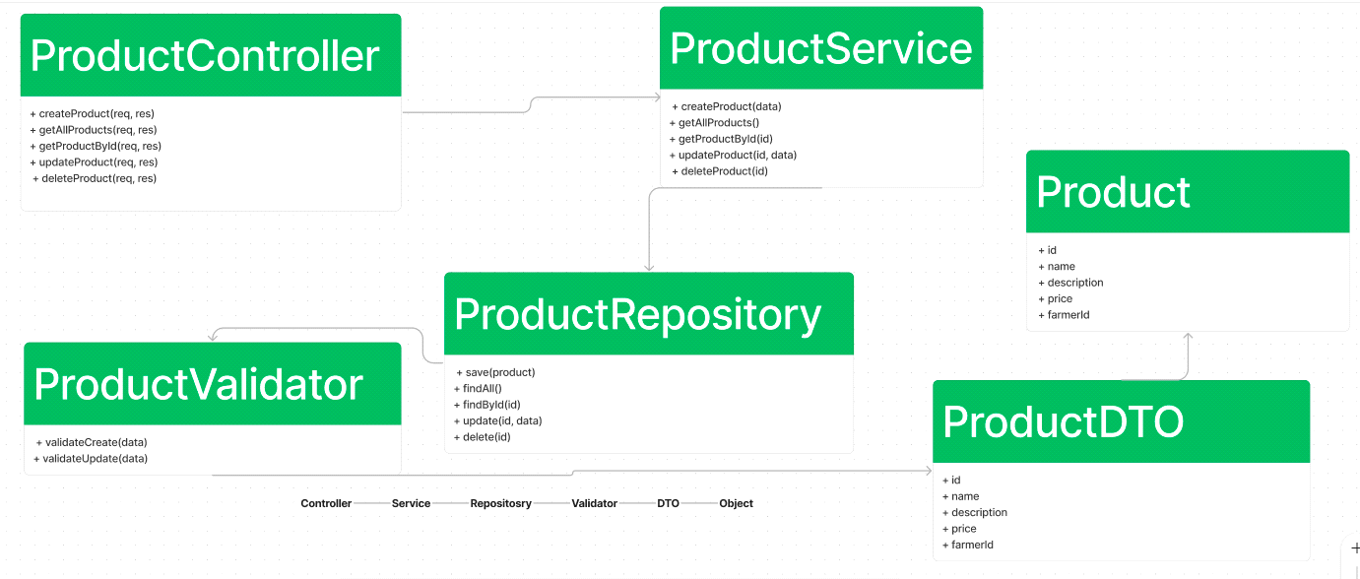

- System design and implementation challenges and how they have been addressed
We brainstormed the design and implementation and opted to utilise flutter as front end and node js as backend, connecting the two and getting it to work. The API gateway routes all the request and handles it. The system appropriately handles all request such as order, products and deliveries by routing the services to each class.

3.2 Database design Description
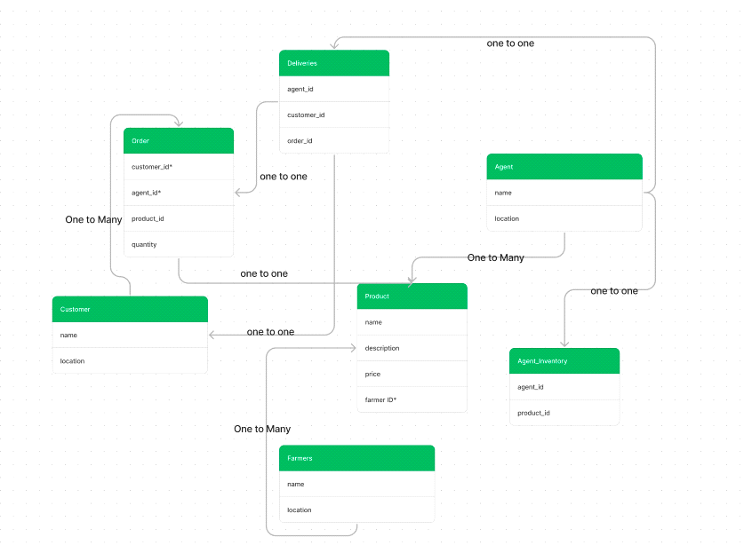

3.3 Class diagram

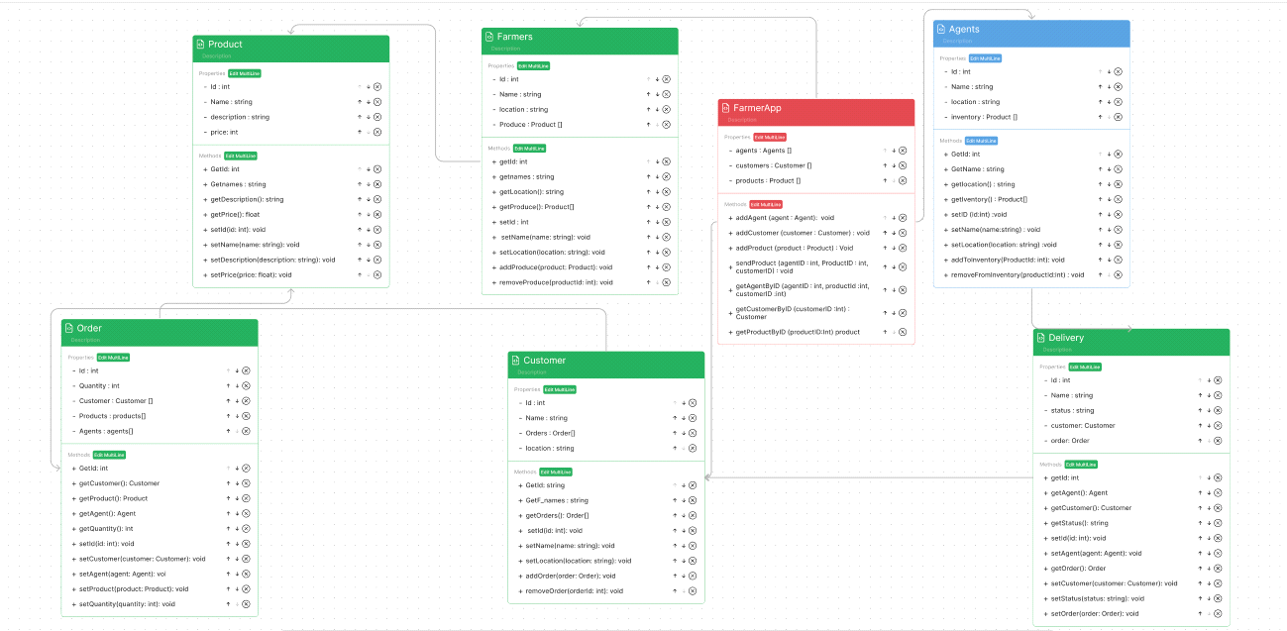3.4 Software Components

Tool name | Purpose | Category
Dart | Frontend development | Programming Language
Flutter | UI/UX design and frontend framework | Framework
Node.js | Backend development and API handling | Runtime Environment
Postman | API testing and debugging | Testing Tool
Visual Studio Code | Code editor and IDE | Development Tool
Git/GitHub | Version control and code collaboration | Version Control Too
Firebase | Authentication and cloud services | Cloud Service
Android Studio | Mobile app testing and debugging | IDE/Testing Tool
npm (Node Package Manager) | Package management for Node.js | Dependency Manager
Docker | Containerization for backend services | Deployment Tool

Chapter 4 Result, Analysis and Discussion

4.1 System Testing and Performance

The application underwent rigorous testing using tools like Postman for API validation and debugging, ensuring seamless communication between the frontend and backend systems. Performance tests were conducted to assess database query speeds, server response times, and scalability under simulated high-traffic conditions.

4.2 User Interface Evaluation

User feedback was gathered to evaluate the intuitiveness and accessibility of the app’s interface. Test users provided insights into navigation ease, feature usability, and design clarity. Adjustments were made based on this feedback to improve the overall user experience.

4.3 Results from Simulated Transactions

Simulated transactions were carried out to analyze the time taken from order placement to confirmation, highlighting the efficiency of the system’s order management and logistics handling. These tests demonstrated the platform’s capability to streamline the supply chain while maintaining accuracy in data processing.

4.4 Some UI components of our APP
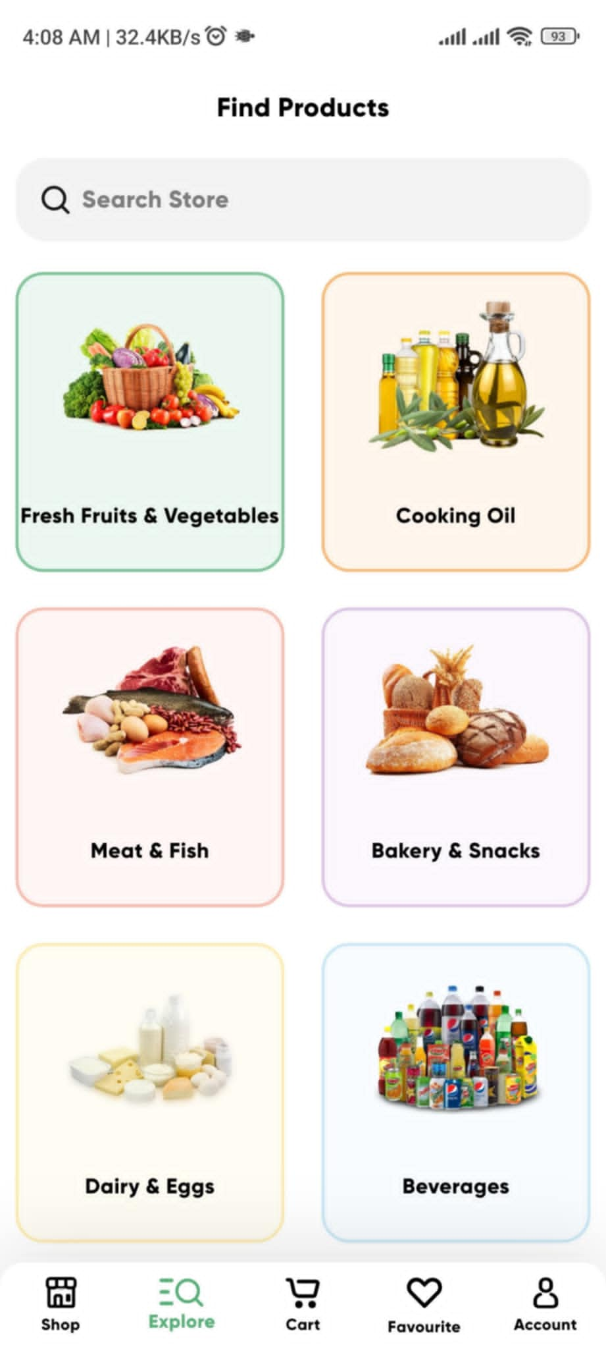
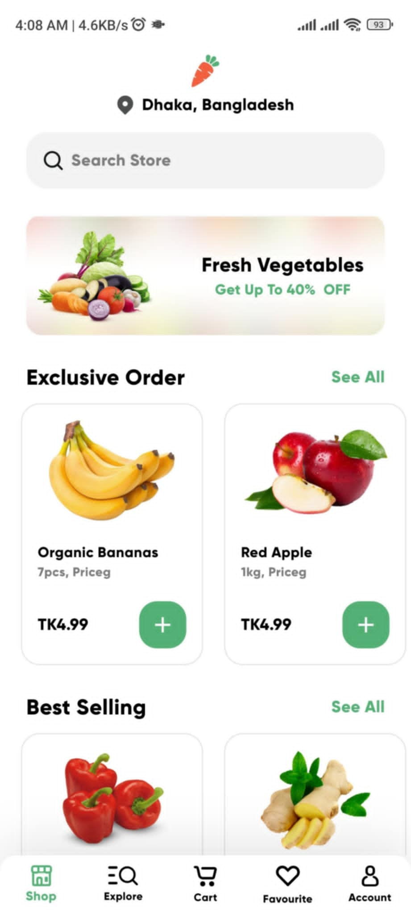
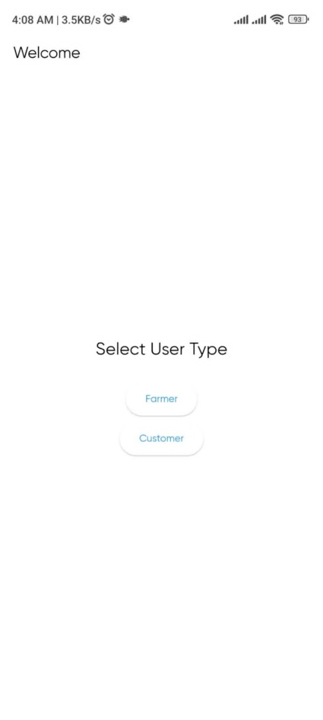

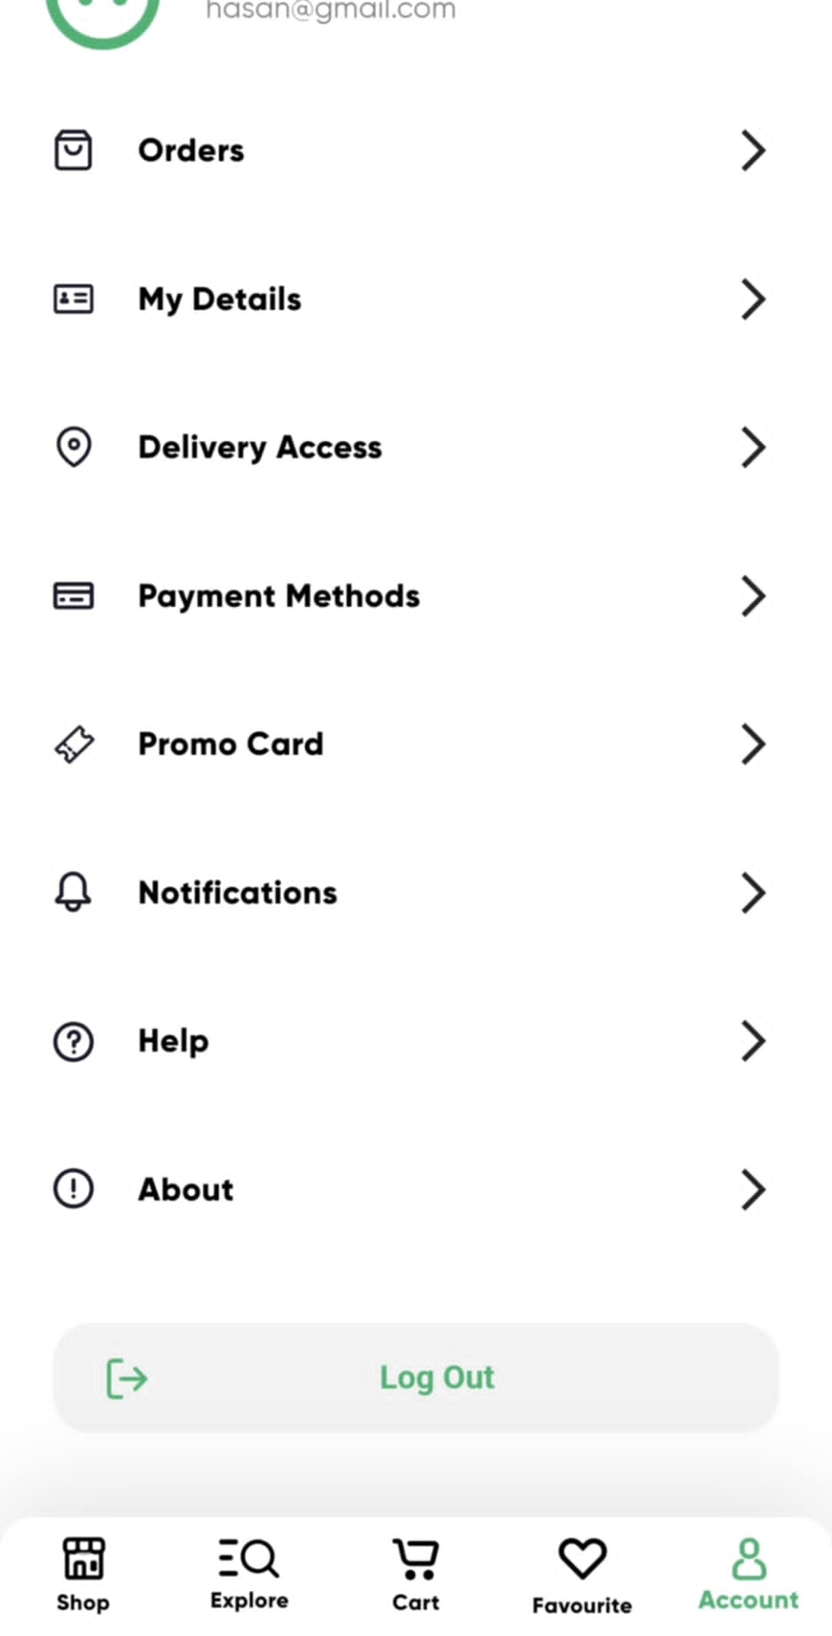
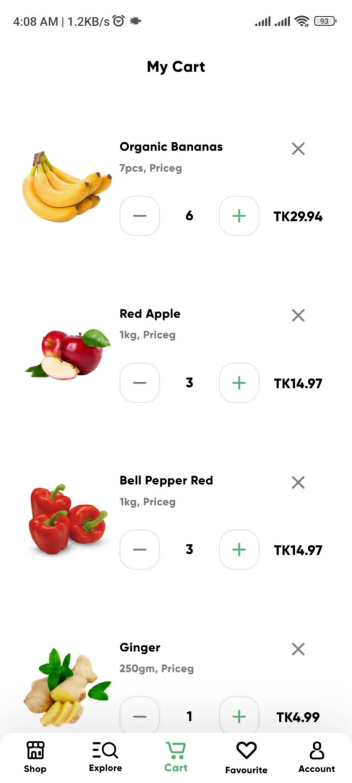
Login Shop Explore

Cart Account Management

4.4 Discussion of Observations
The results highlight the effectiveness of My Farm in reducing intermediaries and transaction costs for farmers, allowing them to secure better prices. Consumers also benefited from lower prices and improved product quality due to reduced handling time. The platform’s scalability and performance indicate its potential to support larger networks of farmers and consumers as the user base grows.

Chapter 5 Impacts of the Project

5.1 Economics (cost) impact:

i. Tax Incentives
Implementing My Farm offers the potential to leverage various tax incentives, which can reduce the final product cost. Examples include:
- Renewable Energy and Energy-Efficient Products: By using renewable energy for app servers and promoting sustainable farming practices, farmers and the app might qualify for tax credits and deductions.
- Carbon Footprint Reduction: Encouraging local consumption and reducing transportation distances lowers carbon emissions, possibly making My Farm eligible for carbon reduction incentives.

ii. Environmental Aspects and Market Vulnerability

The cost and pricing of My Farm products are influenced by:
- Availability of Resources: Local resource availability affects the cost of production. For example, regions with abundant water and fertile soil will have lower production costs.
- Market Vulnerability: The dependency on specific agricultural products can make the market susceptible to environmental changes (droughts, floods) affecting prices.

5.2 Environmental impact of the product

i. Greenhouse Gas Emissions

My Farm can lead to a reduction in GHG emissions through:
• Local Distribution: Reducing the need for long-distance transportation decreases fossil fuel consumption and emissions.
• Sustainable Practices: Encouraging farmers to adopt eco-friendly practices can further reduce emissions.

ii. Consumption Patterns
The app promotes positive environmental impacts by:
• Reduced Waste: Direct sales from farmers to consumers minimize food waste and spoilage.
• Efficient Resource Use: Farmers can better manage inventory and resources, reducing water and energy consumption.

Chapter 6 Conclusions

6.1 Summary
The My Farm project aims to revolutionize the agricultural supply chain in Bangladesh by creating a digital platform that connects farmers directly with consumers. Through this e-commerce application, farmers can bypass multiple intermediaries, ensuring better profits while providing consumers with fresher and more affordable produce.
The project was developed using Dart and Flutter for the frontend, Node.js for the backend, and MongoDB for database management. The development process spanned from January to November, with a focus on creating a user-friendly interface, robust API integration, and scalable database management.
Testing and debugging were conducted using tools like Postman and Android Studio, ensuring the platform's performance and reliability. The successful deployment of the application demonstrates its potential to promote sustainable agriculture, reduce food waste, and support local farmers economically.

8.2 Limitations

Despite its success, the My Farm application has a few limitations that need to be addressed:
Logistical Challenges:
The delivery process currently depends on scheduled transports, which may cause delays in certain areas, especially rural regions with poor infrastructure.
Scalability Concerns:
Although the application supports a moderate user base, further optimization may be required to handle a larger number of users and transactions efficiently.
Payment Gateway Limitations:
The application lacks integration with multiple payment gateways, restricting payment options for consumers.
Internet Dependency:
The platform requires stable internet access, which may limit accessibility for farmers in remote areas.
Farmer Digital Literacy:
Adoption may be slower among farmers unfamiliar with smartphone technologies or digital platforms.

8.3 Future Improvement
To overcome the identified limitations and enhance the platform’s capabilities, the following improvements are proposed:
Logistics Optimization:
Introduce dynamic delivery scheduling and route optimization algorithms to reduce delays and improve delivery efficiency.
Scalability Enhancements:
Upgrade server infrastructure and optimize database queries to handle increased user activity as the platform grows.
Payment Gateway Expansion:
Integrate multiple payment options, including mobile financial services (e.g., bKash, Nagad) and bank transfers to accommodate diverse user preferences.
Offline Mode Support:
Develop an offline mode for farmers to upload product details or orders, which syncs with the system once internet access is available.
Training Programs for Farmers:
Organize workshops and training sessions to improve farmers’ digital literacy, enabling wider adoption and effective usage of the platform.
AI-Driven Insights and Recommendations:
Implement machine learning algorithms to provide farmers with insights into market trends, pricing, and demand forecasts.

References
1. Md Mizanur RahmanShahnaz, Begum Neena (2021) Farmers' Dependency on Traders in the Paddy Marketing. The united graduate of Agricultural sciences, Kagoshima university https://www.jstage.jst.go.jp/article/fmsj/58/4/58_69/_pdf/-char/ja
2. IFarmer website

