SpectrumU
Official URL: https://services.smsu.edu/TDClient/180/Portal/KB/Article/8838/SpectrumU
Category: Knowledge Base > Information Technology Services > Software and Applications > SpectrumU
Tags: tv, Streaming, LiveTV, SpectrumU, Television
_____________________________________________________
SpectrumU TV is a video streaming service that delivers live TV with news, sports, and entertainment, in addition to on-demand television shows and movies, to iOS and Android mobile devices, tablets, laptops, and desktops over the SMSU campus network.
Authentication
SpectrumU uses your SMSU email account to access over 200 channels, along with a wide selection of on-demand shows and movies. When connected to the University’s wired or wireless network, SpectrumU allows on-campus residents to access an expanded channel lineup and stream on-demand content. Before downloading and logging into SpectrumU on a device, make sure you are connected to the campus network.
Sign in:
- For Students:
Log in with your StarID@go.minnstate.edu and StarID password.
Example: ab1234cd@go.minnstate.edu
- Log in with your StarID@go.minnstate.edu and StarID password.
- Example: ab1234cd@go.minnstate.edu
- For Employees:
Log in with your StarID@minnstate.edu and StarID password.
Example: ab1234cd@minnstate.edu
- Log in with your StarID@minnstate.edu and StarID password.
- Example: ab1234cd@minnstate.edu
Getting Started
Students can visit the Apple App Store®, Google Play Store®, Amazon Appstore, and Roku Channel Store to download the SpectrumU® app.

Figure 1: Apple App Store, Google Play Store, Amazon Appstore, and Roku channel store image.
To view SpectrumU on a computer or laptop, students can visit SpectrumUTV.com while connected to your campus network.
Supported Devices
- Android: all major Android™ smartphones and tablets running Android™ 7 or above.
- iOS: running iOS® 13 or above.
- Kindle Fire Phone: all Kindle Fire models except the first generation.
- Mac: Safari 11 or newer, Firefox 63 or newer, or Chrome 69 or newer.
- PC: IE 11, Chrome 69 or newer, Firefox 63 or newer, or MS Edge 16 or newer.
- Roku: All third-generation players and TVs.
- Apple TV: all fourth- and fifth-generation devices and TV OS version 13.0 or newer.
- Chromecast: first, second and third generation devices.
Watch on Your Computer or Laptop using a Web Browser
- Launch SpectrumU
- Use the University Student sign in option.
- Enter SMSU.EDU and Submit.
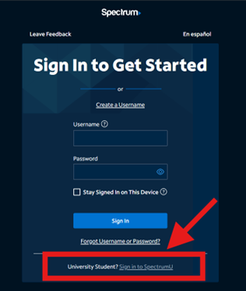
Figure 2: Use the University Student sign in option image.
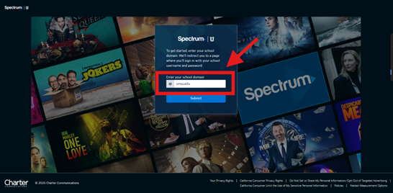
Figure 3: Enter school domain dialog image, enter SMSU.edu and click on “Submit”.
- Sign in
For Students:
- For Students:
Log in with your StarID@go.minnstate.edu and StarID password.
Example: ab1234cd@go.minnstate.edu
- For Employees:
Log in with your StarID@minnstate.edu and StarID password.
Example: ab1234cd@minnstate.edu
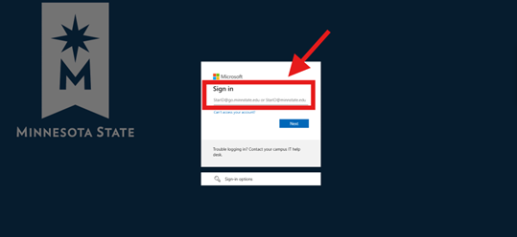
Figure 4: Single Sign On portal image

- After signing on, you will be redirected back to spectrumUTV.com. Select “Continue” to open SpectrumU.
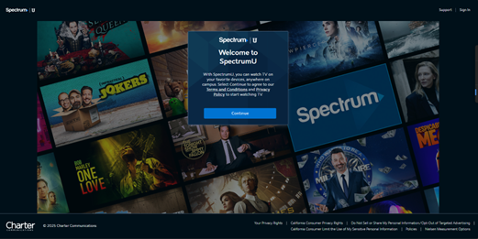
Figure 5: Welcome to SpectrumU image

- After signing on, you will be redirected back to the SpectrumU app. Select “Watch TV” to open SpectrumU.
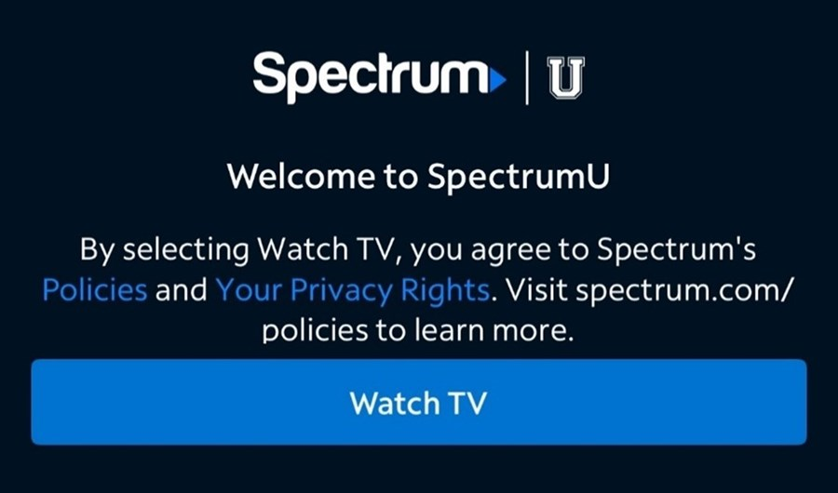
Figure 6: Page Confirming Successful Activation

Mobile (iOS and Android)

Figure 7: SpectrumU image
- Go to the Apple App Store or Google Play Store and download the SpectrumU app. Open the app to display the “Let’s Find Your School” screen. Enter SMSU.edu and click "Submit".
If prompted for a username and password, ensure you have downloaded the SpectrumU app, not the Spectrum TV app.
Ensure you have the most recent version of the app if it is not working.
- If prompted for a username and password, ensure you have downloaded the SpectrumU app, not the Spectrum TV app.
- Ensure you have the most recent version of the app if it is not working.
- You will be redirected to SMSU’s email login. Enter your username and password (as shown above), then select "Login".
- After signing on, you will be redirected back to the SpectrumU app. Select "Watch TV" to open SpectrumU.
After your first sign-on, SpectrumU will automatically authenticate the next time it is launched, so you will not need to sign-on again until the authentication token expires in 14 days.
Roku
- Go to the Roku Channel Store and download the SpectrumU app.
- Launch the app to display the SpectrumU Let’s Get Started activation screen.
If prompted for a User ID, ensure you have downloaded the SpectrumU app, not the Spectrum TV app.
- If prompted for a User ID, ensure you have downloaded the SpectrumU app, not the Spectrum TV app.
- From a computer or smartphone, visit watch.spectrumutv.com/activate, enter the activation code displayed on the Roku, and click “Submit.”
- In the "Enter your school domain" dialog, enter SMSU.edu and click “Submit.”
- You will be redirected to SMSU’s email login. Enter your username and password (as shown above), then select "Login".
- After signing on, you will be redirected back to the activation page.
- The Roku will change from the activation screen to an End User License Agreement (EULA). Select "Accept".
- The Welcome to SpectrumU screen will appear. Select "Watch TV" to open SpectrumU.
After activation, the SpectrumU app will automatically authenticate the next time it is launched, so you will not need to sign-on again until the authentication token expires in 60 days.
Kindle Fire Tablet
- Go to the Amazon Appstore and download the SpectrumU app. Open the app to display the “Let’s Find Your School” screen. Enter SMSU.edu and click "Submit".
If prompted for a username and password, ensure you have downloaded the SpectrumU app, not the Spectrum TV app.
Ensure you have the most recent version of the app if it is not working.
- If prompted for a username and password, ensure you have downloaded the SpectrumU app, not the Spectrum TV app.
- Ensure you have the most recent version of the app if it is not working.
- You will be redirected to SMSU’s email login. Enter your username and password (as shown above), then select "Login".
- After signing on, you will be redirected back to the SpectrumU app. Select "Watch TV" to open SpectrumU.
After your first sign-on, SpectrumU will automatically authenticate the next time it is launched, so you will not need to sign-on again until the authentication token expires in 14 days.
Apple TV
- Go to the Apple TV App Store and download the SpectrumU app.
- Open the app to display the Let’s Get Started activation screen.
- From a computer or smartphone, visit watch.spectrumutv.com/activate and enter the activation code displayed. Click "Submit".
- In the "Enter your school domain" dialog, enter SMSU.edu and click "Submit".
- You will be redirected to SMSU’s email login. Enter your username and password (as shown above), then select "Login".
- After signing on, you will be redirected back to the activation page.
- The app will update from the activation screen and show live TV.
After activation, the SpectrumU app will automatically authenticate the next time it is launched, so you will not need to sign-on again until the authentication token expires in 60 days.
Channel Lineup
- Note that not all channels are available to SMSU.
Live TV Channels
A&E Network
Great American Family
SEC Network
ABC (KGTV-DT)
GSN
SEC Overflow
ACC Network
Hallmark Channel
Smithsonian Channel
American Heroes Channel
Hallmark Movie & Mysteries
Spectrum Deportes LA Dodgers
American Movie Classics
HBO
Spectrum SportsNet
Animal Planet
HBO 2
Sundance Channel
Antenna TV (KSWB-DT2)
HBO Comedy
Syfy
Bally Sports San Diego
HBO Family
TBS Superstation
Bally Sports West
HBO Latino
TCM - Turner Classic Movies
Bally Sports West
HBO Signature
TeenNick HD
Bally Sports West (San
Diego)
HBO Zone
Telefutura
BBC America
History
Telemundo (KUAN-LD)
BBC World News
HLN
TeleXitos (KUAN-LD2)
beIN SPORTS
Home & Garden Television
Tennis Channel
BET - Black Entertainment
Television
Home Shopping Network
The Weather Channel
BET HERHD
Impact
TLC
BET Soul
Independent Film Channel
TNT - Turner Network Television
Big 10 Network
Inspirational Network
Travel Channel
Bloomberg
Investigation Discovery
truTV
Boomerang
KGTV 10 News Channel
TV Land
BRAVO
LATV (XHAS-DT2)
TVONE
BYU TV
Lifetime Television
TWC SportsNet LA HDTV
(Dodgers)
Cartoon Network
LMN
UCSD TV
CBS (KFMB-DT)
Logo
Universal Kids
CBS Sports Network
Magnolia
Univision (KBNT)
CMT - Country Music
Television
MeTV (KGTV-DT2)
Univision Deportes Network
CNBC
Milenio TV (XDTV)
UP (Gospel Music Channel)
CNN - Cable News Network
MLB Network
USA Network
CNN - Cable News Network
en Espanol
MLB Network Strike Zone
VH1
Comedy Central
MOTORTREND
Viceland
Cooking Channel
MSNBC
Willow Cricket
Cozi TV (KNSD-DT2)
MTV
Willow TV
CSPAN
MTV Classic
Women's Entertainment
Network
CW (KFMB DT2)
MTV Live

Destination America
MTV2
Discovery Channel
MTV-U
Discovery Family Channel
NatGeo WILD
Discovery Life
National Geographic Channel
Discovery Life Channel
NBA TV
Disney Channel
NBC (KNSD-DT)
Disney Junior
News 9 (KUSI-DT)
Disney XD
NEWSMAX TV
E! Entertainment Television
NFL Network
ESPN
NFL RedZone
ESPN Deportes
NHL Network
ESPN News
Nick Jr
ESPN2
Nickelodeon
ESPNU
Nicktoons Network
Estrella News (KSDX-LD)
Outdoor Channel
Estrella TV (XHAS)
Ovation
EVINE Live
OWN - The Oprah Winfrey
Network
EWTN - Eternal Word
Television Network
Oxygen
FanDuel TV
Pac-12 Az
Food Network
Pac-12 Bay
Fox - Business Network
Pac-12 LA
Fox - Deportes en Espanol
Pac-12 Mtn
Fox - News Channel
Pac-12 Nat'l
FOX (KSWB-DT)
Pac-12 Oreg
Fox Sports 1
Pac-12 Wash
Fox Sports 2
Padres
Freeform
Paramount Network
Fuse
PBS (KPBS-DT)
FX
PBS World (KPBS-DT2)
FX Movie Channel
Pop
FXX
QVC - Quality Value
Convenience Network
FYI
Revolt
Golf Channel
Science
Video On Demand (VOD) Networks
A&E
FOX Deportes
OWN
ABC
Fox Sports 1
Oxygen
AMC
Freeform
Paramount Network
American Heroes Channel
FUSE
PBS
Animal Planet
FX
PBS Kids
BBC America
FX Movie Channel (FXM)
POP
BBC World News
FXX
Revolt
beIN SPORTS
FYI
Science Channel
BET
Golf Channel
Smithsonian Channel
Big Ten Network
GSN
SundanceTV
Boomerang
Hallmark Channel
SYFY
Bravo
HBO
TBS
Cartoon Network
HGTV
Telemundo
CBS
History
TLC
CMT
HLN
TNT
CNBC
IFC
Travel Channel
CNN
Investigation Discovery
truTV
Comedy Central
Lifetime
Turner Classic Movies (TCM)
Cooking Channel
Lifetime Movie Network
TV Land
CW
Logo
TV One
Destination America
MLB Network
UniMas
Discovery Channel
MotorTrend
Universal Kids
Discovery Family
MSNBC
Univision
Discovery Life
MTV
Univision Deportes Network
Disney Channel
MTV Classic
UP
Disney Junior
MTV Live
USA Network
Disney XD
MTV2
VH1
DIY Network
Nat Geo Wild
Viceland
E! Entertainment Television
National Geographic Channel
Weather Channel
El Rey
NBC
Womens Entertainment TV (WE)
ESPN
NBCSN

ESPN Deportes
NFL Network
ESPNU
Nick Jr
Food Network
Nickelodeon
FOX
Ovation TV
Authentication Token Lengths
After you sign-on for the first time to a SpectrumU app an authentication token is issued so you will not have to sign-on again until it expires. This table lists the token lengths for the devices that are supported by SpectrumU.
Device
Token Length
Roku
60 Days
Apple TV
60 Days
iOS
14 Days
Android
14 Days
Web Browsers
14 Days
Kindle Tablets
14 Days
Accessibility Review & Update Log:
- [x] Content accuracy and link integrity verified
- [x] High-contrast visual hierarchy implemented (Inter and Calibri)
- [x] Image alt-text captions verified (all screenshots captioned)
- [x] Outline headers and standard list sequences optimized for screen readers

