|  |  |  |
| --- | --- | --- |
| **Name** | **ID** | **STUDENT SIGN** |
|  |  |  |

**Instructions:**

* **Make sure to write your Name, ID and Signature on this document.**
* **First write your signature on a paper then take photo of that signature and use it for signing this document.**
* **After completing the requirements of the midterm assignment by editing this document, upload this document in the link provided in your VUES Student Account.**
* **Submission Deadline: 18th August 2025, 11:59pm.**

**Midterm Assignment**

1. **Below a scenario has been given draw the ER Diagram.**

***Draw with proper annotations (use DIA, VISIO, MS WORD etc.).***

***For reference see ERDiagramTutorial.***

In a Juice Bar Management System, one Juice Bar may have many staff. But one staff can work in one Juice Bar only. Each staff has a unique identification number, name, age, address, date of birth and phone number. Juice Bar has a unique identification number, address, and phone. One Juice Bar maybe rented by exactly one owner. One owner may rent exactly one Juice Bar. Owner is defined by name, address, email and phone. A Juice Bar may have many customers. Each customer has a unique identification number, name, address, email, phone. Each customer can have more than one email address and phone number. A Juice Bar must pay the utility bill which has a unique identification number, payment_type and amount.

Answer Box 1:

1. **Below an ER Diagram has been given write the scenario.**

***For reference see ERDiagramTutorial.***

Answer Box 2:

1. **Normalize the ER Diagram given below up to 3rd Normal Form and finalize the tables that needs to be created. Then (in Oracle using SQL) write down the queries that are required to create all the tables with necessary constraints. Also insert at least 3 rows of data in each created table.**

***For reference see NormalizationTutorial and BasicSQLTutorial.***

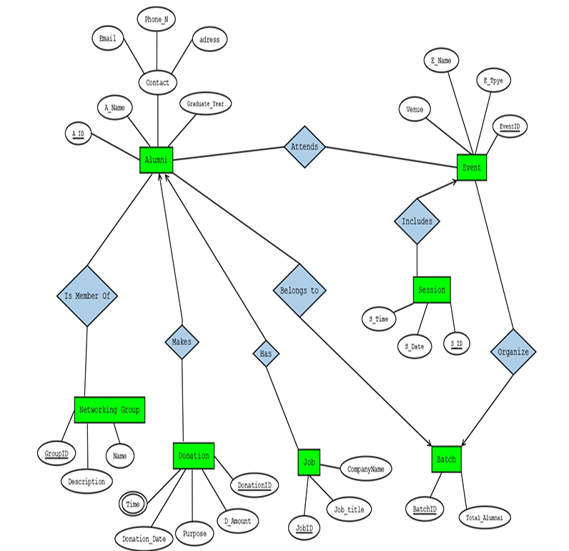

Answer Box 3 (Normalization steps in detail as shown in Normalization Tutorial Slide + all the queries required to create the tables and insert data after Normalization):

1. **Query Writing (continuation of Question 3) (Write down the question and the answer. Give full screenshot of the Oracle 10g Homepage that contains the answer and result)**

**-All screenshots MUST include the DATE and TIME feature from the screen of the machine (PC, Laptop etc.) used**

**SQL**

**-2 single-row function**

**-2 group function**

**-2 subquery**

**-2 joining**

***For reference see BasicSQLTutorial and AdvanceSQLTutorial.***

Answer Box 4:

1. **Query Writing (continuation of Question 4) (Write down the answer only. Give full screenshot of the Oracle 10g Homepage that contains the answer and result)**

**-All screenshots MUST include the DATE and TIME feature from the screen of the machine (PC, Laptop etc.) used**

**PL/SQL**

1. **Convert the SQLs of Question 4 into equivalent PL/SQL code**
2. **For this part, 8 PL/SQL code must be submitted**

Answer Box 5: