**2Class Test 04**

**PL/SQL**

**Part 01:**

*To solve the following use the scott schema*

1. Write a query that can display the salary of employee JONES three times using basic loop.

declare

v_salary number;

begin

-- Fetching the salary of employee 'JONES' from the emp table

select SAL into v_salary

from emp

where ename = 'JONES';

-- Basic FOR loop to display the salary of JONES three times

for i in 1..3 loop

dbms_output.put_line('Salary of JONES: ' || v_salary);

end loop;

end;

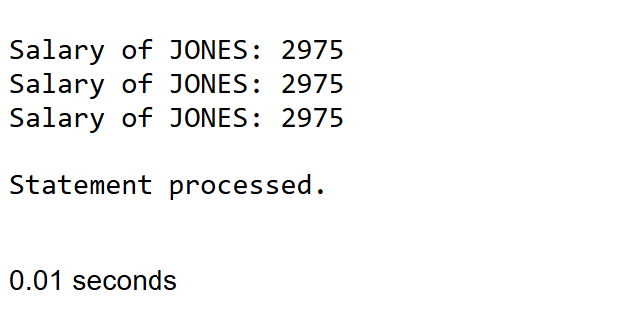

1. Write a query that can display the salary of employee JONES three times using while loop.

declare

v_salary number;

v_count number:=1;

begin

-- Fetching the salary of employee 'JONES' from the emp table that is predefined in the scott table

select SAL into v_salary

from emp

where ename = 'JONES';

-- Using WHILE loop to display the salary of JONES three times

while v_count <= 3 loop

dbms_output.put_line('Salary of JONES: ' || v_salary);

v_count := v_count + 1;

end loop;

end;

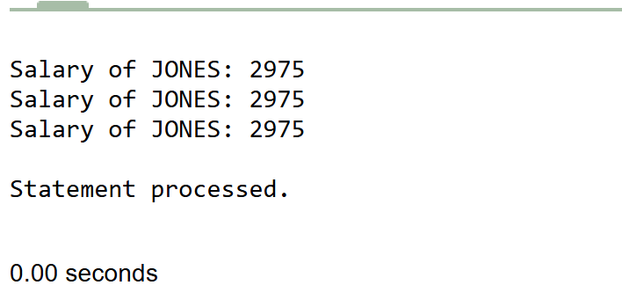

1. Write a query that can display the salary of employee JONES three times using for loop.

declare

v_salary number;

begin

-- Fetching the salary of employee 'JONES' from the emp table

select SAL into v_salary

from emp

where ename = 'JONES';

-- Basic FOR loop to display the salary of JONES three times

for i in 1..3 loop

dbms_output.put_line('Salary of JONES: ' || v_salary);

end loop;

end;

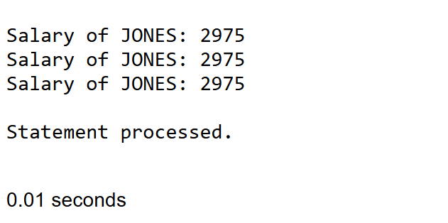

**Part 02:**

*To solve the following use the scott schema*

1. Create a procedure to update the salary of employee Allen to 100.

CREATE OR REPLACE PROCEDURE update_salary_allen IS

BEGIN

-- Update the salary of employee Allen to 100

UPDATE emp

SET sal = 100

WHERE ename = 'ALLEN';

-- Commit the transaction to save the changes

COMMIT;

END;

/

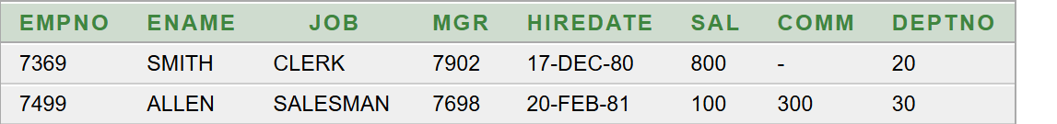

1. Create a function that returns the total number of departments.

CREATE OR REPLACE FUNCTION total_departments RETURN NUMBER IS

v_count NUMBER;

BEGIN

-- Counting the total number of departments in the dept table

SELECT COUNT(*) INTO v_count

FROM dept;

-- Returning the count

RETURN v_count;

END;

/

SELECT total_departments FROM dual;

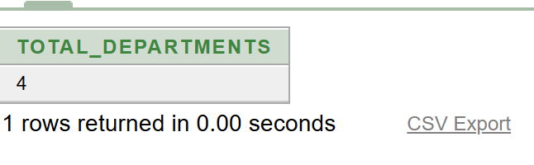

1. Create a package that contains a procedure which can display the grade whose losal and hisal is passed as its parameter.

**\*\*After solving the above questions using Oracle 10g, write the PL/SQLs in a MS Word document (Write down the answer and give screenshot of the result of the query. The name of the document MUST be your ID and the PL/SQLs MUST be numbered accordingly) and upload it in the provided link in your VUES account**