Class Test 05
PL/SQL
To solve the following use the scott schema

- Create a cursor that can output all the data from salgrade table.
DECLARE
CURSOR c_sal IS
SELECT * FROM salgrade;
v_sal c_sal%ROWTYPE;
BEGIN
OPEN c_sal;
LOOP
FETCH c_sal INTO v_sal;
EXIT WHEN c_sal%NOTFOUND;
DBMS_OUTPUT.PUT_LINE('Grade: ' || v_sal.grade ||
', Losal: ' || v_sal.losal ||
', Hisal: ' || v_sal.hisal);
END LOOP;
CLOSE c_sal;
END;
/
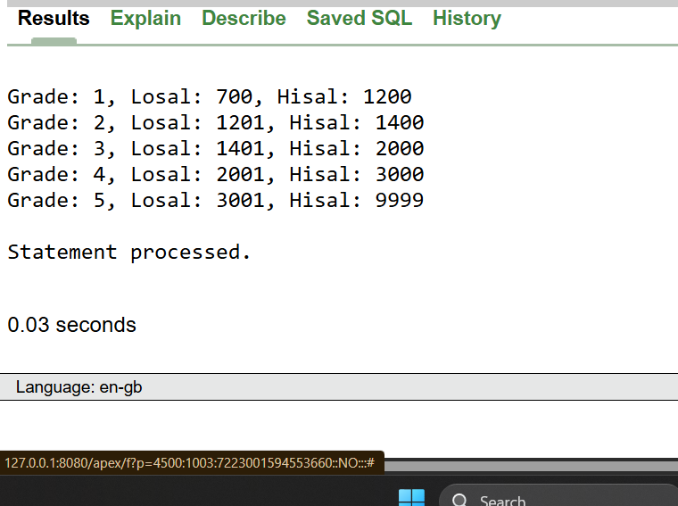
- Create a record that can output the id, name, job, and hiredate of the employee whose Id is 7654.
DECLARE
v_emp_record EMP%ROWTYPE;
BEGIN
SELECT *
INTO v_emp_record
FROM emp
WHERE empno = 7654;
DBMS_OUTPUT.PUT_LINE(
'ID: ' || v_emp_record.empno ||
', Name: ' || v_emp_record.ename ||
', Job: ' || v_emp_record.job ||
', Hiredate: ' || TO_CHAR(v_emp_record.hiredate, 'DD-MON-YYYY')
);
END;
/
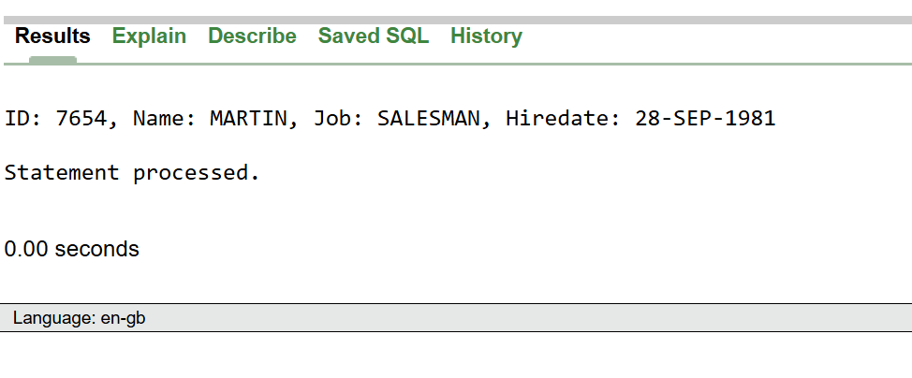

- Create a trigger in such a way that whenever a new row is inserted into the salgrade table an output ‘New Row Added’ is generated.
CREATE OR REPLACE TRIGGER trg_salgrade_insert
AFTER INSERT ON salgrade
FOR EACH ROW
BEGIN
DBMS_OUTPUT.PUT_LINE('New Row Added');
END;
/
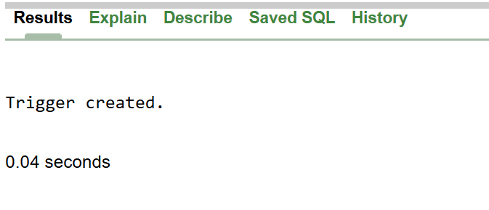

INSERT INTO salgrade (grade, losal, hisal) VALUES (6, 5000, 7000);
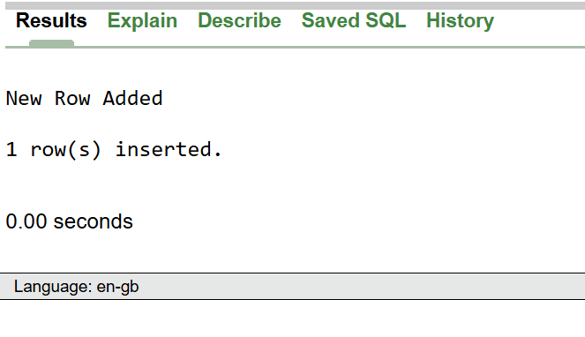

**After solving the above questions using Oracle 10g, write the PL/SQLs in a MS Word document (Write down the answer and give screenshot of the result of the query. The name of the document MUST be your ID and the PL/SQLs MUST be numbered accordingly) and upload it in the provided link in your VUES account

