Name | ID | STUDENT SIGN
Md. Shadman Shakib Alam | 22-46262-1 | 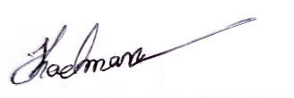
Instructions:
- Make sure to write your Name, ID and Signature on this document.
- First write your signature on a paper then take photo of that signature and use it for signing this document.
- After completing the requirements of the midterm assignment by editing this document, upload this document in the link provided in your VUES Student Account.
- Submission Deadline: 18th August 2025, 11:59pm.
Midterm Assignment
- Below a scenario has been given draw the ER Diagram.
Draw with proper annotations (use DIA, VISIO, MS WORD etc.).
For reference see ERDiagramTutorial.
In a Juice Bar Management System, one Juice Bar may have many staff. But one staff can work in one Juice Bar only. Each staff has a unique identification number, name, age, address, date of birth and phone number. Juice Bar has a unique identification number, address, and phone. One Juice Bar maybe rented by exactly one owner. One owner may rent exactly one Juice Bar. Owner is defined by name, address, email and phone. A Juice Bar may have many customers. Each customer has a unique identification number, name, address, email, phone. Each customer can have more than one email address and phone number. A Juice Bar must pay the utility bill which has a unique identification number, payment_type and amount.
Answer Box 1:
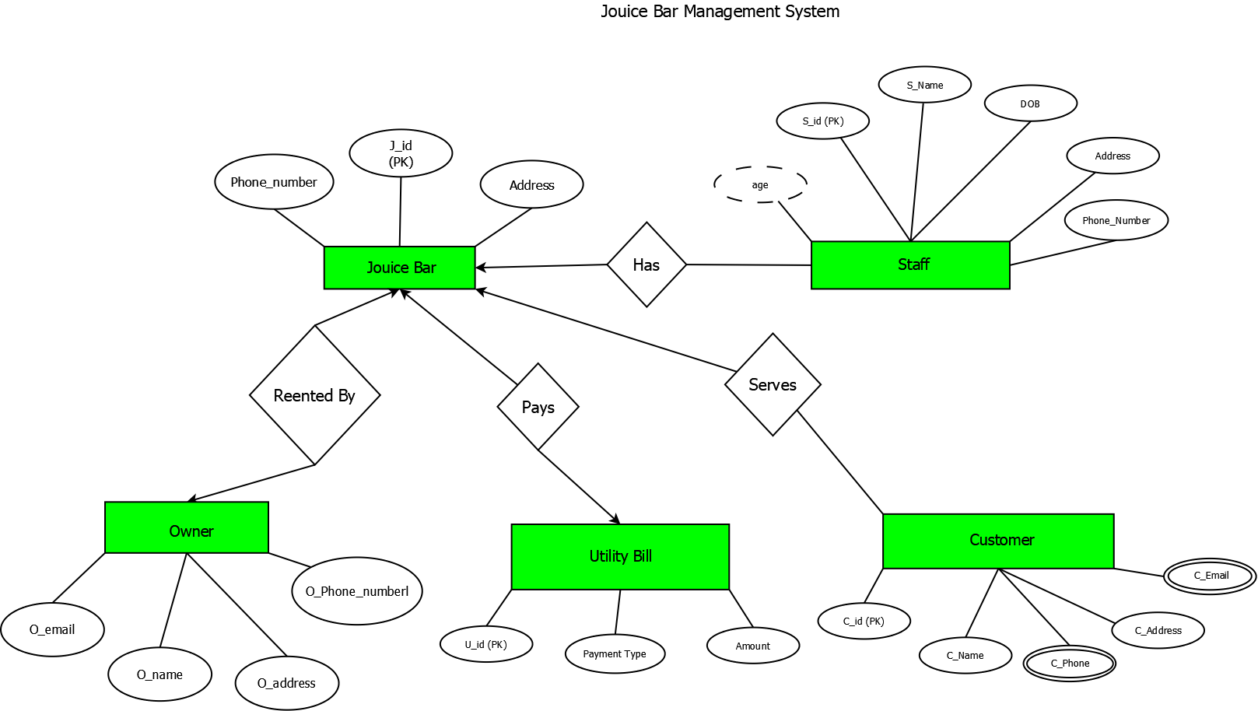

- Below an ER Diagram has been given write the scenario.
For reference see ERDiagramTutorial.

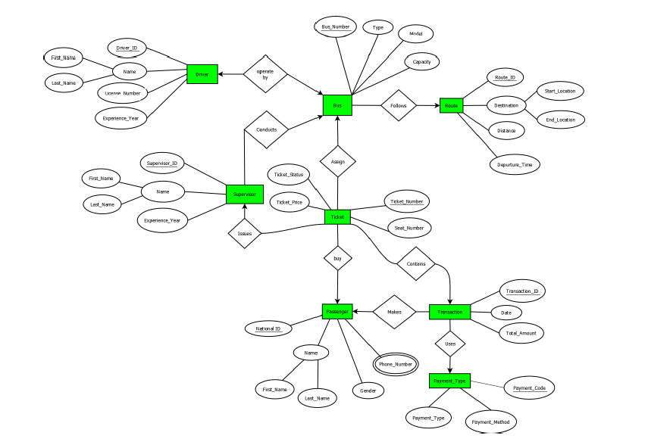

Answer Box 2:
In a Bus Ticketing System, One Driver can operate only one Bus. Each Driver has a unique identification number, Name, license number, Experience year, and Phone Number. A Name is composed of First Name, Last Name. A Bus has a unique identification number, Type, Model, and Capacity. One Bus may follow one Route, but a Route can be followed by many Buses. Each Routes has a unique identification Number, Destination, Distance, and Departure Time. A Destination is composed of Start Location and End Location. Many Supervisor manages One Bus. Each Supervisor has a unique identification number, Name, and Experience years. A Name is composed of First Name, Last Name. One Supervisor can issue many Tickets and Many tickets can be assign by One Bus. Each Ticket has a unique identification number or it is ticket number, Ticket price, Seat number, ticket status, and ticket price. A Passenger can buy one or more Tickets. Each Passenger has a unique identification number that is base on their National Id, Name, Gender, and Phone number. A Name is composed of First Name, Last Name. A Passenger can make multiple Transactions, and each Transaction is associated with one Payment Type. Each Transaction has a unique identification number named Transaction id, date, and total amount. Many Transactions can use the same Payment Type. Each of that payment type it has it's own unique Payment code, Payment Method, and payment type.

- Normalize the ER Diagram given below up to 3rd Normal Form and finalize the tables that needs to be created. Then (in Oracle using SQL) write down the queries that are required to create all the tables with necessary constraints. Also insert at least 3 rows of data in each created table.
For reference see NormalizationTutorial and BasicSQLTutorial.

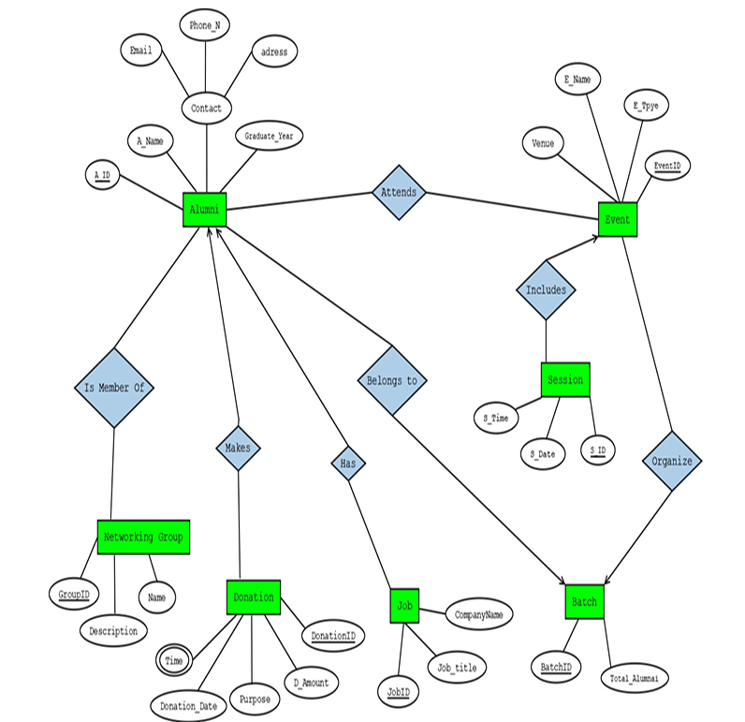

Analyzing the ER Diagram
From diagram, we can identify the following entities and their attributes:
Alumni:
- Attributes: A_ID (PK), A_Name, Email, Phone_N, Address, Graduation_Year
Job:
- Attributes: Job_ID (PK), Job_Title, Company_Name, Alumni_ID (FK)
Donation:
- Attributes: Donation_ID (PK), Donation_Amount, Purpose, Donation_Date, Donation_Time, A_ID (FK)
Networking Group:
- Attributes: Group_ID (PK), Name, Description
Alumni Membership (Junction Table for Many-to-Many between Alumni and Networking Group):
- Attributes: A_ID (FK), Group_ID (FK)
Batch:
- Attributes: Batch_ID (PK), Total_Alumni
Event:
- Attributes: Event_ID (PK), E_Name, E_Type, Venue, Batch_ID (FK)
Session:
- Attributes: Session_ID (PK), Session_Date, Session_Time, Event_ID (FK)
Event Attendance (Junction Table for Many-to-Many between Alumni and Event):
- Attributes: A_ID (FK), Event_ID (FK)

Relation 1: Attends (Alumni Attends Event)
UNF:
Attends(A_ID, A_Name, Contact, Graduate_Year, EventID, E_Name, Venue, E_Type)
1NF:
No multivalued attributes, so it remains
1. A_ID, A_Name, Contact, Graduate_Year, EventID, E_Name, Venue, E_Type
2NF:
Alumni details depend on A_ID.
Event details depend on EventID.
1. A_ID, A_Name, Contact, Graduate_Year
2. EventID, E_Name, Venue, E_Type
3. A_ID, EventID
3NF:
No Transitive dependencies.
1. A_ID, A_Name, Contact, Graduate_Year
2. EventID, E_Name, Venue, E_Type
3. A_ID, EventID
Table Creation:
Alumni(A_ID, A_Name, Contact, Graduate_Year)
Event(EventID, E_Name, Venue, E_Type)
Attends(A_ID, EventID)

Relation 2: Belongs To (Alumni Belongs to Batch)
UNF:
BelongsTo(A_ID, A_Name, Graduate_Year, BatchID, BatchNo, Total_Alumni)
1NF:
A_ID, A_Name, Graduate_Year, BatchID, BatchNo, Total_Alumni

2NF:
Alumni details depend on A_ID.
Batch details depend on BatchID.
1. A_ID, A_Name, Graduate_Year
2. BatchID, BatchNo, Total_Alumni
3. A_ID, BatchID

3NF:
No Transitive dependencies:
1. A_ID, A_Name, Graduate_Year
2. BatchID, BatchNo, Total_Alumni
3. A_ID, BatchID

Table Creation:
Alumni(A_ID, A_Name, Graduate_Year)
Batch(BatchID, BatchNo, Total_Alumni)
BelongsTo(A_ID, BatchID)

Relation 3: Includes (Event Includes Session)
UNF:
Includes(EventID, E_Name, Venue, E_Type, S_ID, S_Date, S_Time)

1NF:
Already atomic.
EventID, E_Name, Venue, E_Type, S_ID, S_Date, S_Time
2NF:
Event details depend on EventID.
Session details depend on S_ID.
1. EventID, E_Name, Venue, E_Type
2. S_ID, S_Date, S_Time
3. EventID, S_ID

3NF:
No Transitive dependencies
1. EventID, E_Name, Venue, E_Type
2. S_ID, S_Date, S_Time
3. EventID, S_ID

Table Creation:
Event(EventID, E_Name, Venue, E_Type)
Session(S_ID, S_Date, S_Time)
Includes(EventID, S_ID)

Relation 4: Is Member Of (Alumni – Networking Group)
UNF:
IsMemberOf(A_ID, A_Name, GroupID, GroupName, Description)

1NF:
Already atomic.
A_ID, A_Name, GroupID, GroupName, Description

2NF:
Alumni details depend on A_ID.
Networking Group details depend on GroupID.
1. A_ID, A_Name
2. GroupID, GroupName, Description
3. A_ID, GroupID

3NF:
No Transitive dependencies.
1. A_ID, A_Name
2. GroupID, GroupName, Description
3. A_ID, GroupID

Table Creation:
Alumni(A_ID, A_Name)
NetworkingGroup(GroupID, GroupName, Description)
IsMemberOf(A_ID, GroupID)

Relation 5: Makes (Alumni – Donation)
UNF:
Makes(A_ID, A_Name, DonationID, Donation_Date, D_Amount, Purpose)
1NF:
Time is a multivalued attributes. So, have to split
1. A_ID, A_Name
2. DonationID, Donation_Date, D_Amount, Purpose
3. DonationID, Time
4. A_ID, DonationID
2NF:
No partial dependencies remain.
1. A_ID, A_Name
2. DonationID, Donation_Date, D_Amount, Purpose
3. DonationID, Time
4. A_ID, DonationID
3NF:
No transitive dependencies remain.
1. A_ID, A_Name
2. DonationID, Donation_Date, D_Amount, Purpose
3. DonationID, Time
4. A_ID, DonationID
Table Creation:
Alumni(A_ID, A_Name)
Donation(DonationID, Donation_Date, D_Amount, Purpose)
DonationTime(DonationID, Time)
Makes(A_ID, DonationID)

Relation 6: Has (Alumni – Job)
UNF:
Has(A_ID, A_Name, JobID, Job_Title, CompanyName)
1NF:
Already atomic.
A_ID, A_Name, JobID, Job_Title, CompanyName

2NF:
Alumni details depend on A_ID.
Job details depend on JobID.
1. A_ID, A_Name
2. JobID, Job_Title, CompanyName
3. A_ID, JobID

3NF:
No Transitive dependencies.
1. A_ID, A_Name
2. JobID, Job_Title, CompanyName
3. A_ID, JobID
Table Creation:
Alumni(A_ID, A_Name)
Job(JobID, Job_Title, CompanyName)
Has(A_ID, JobID)

Relation 7: Organize (Batch – Event)
UNF:
Organize(BatchID, BatchNo, Total_Alumni, EventID, E_Name, Venue, E_Type)
1NF:
Already atomic.
BatchID, BatchNo, Total_Alumni, EventID, E_Name, Venue, E_Type

2NF:
No partial dependencies.
1. BatchID, BatchNo, Total_Alumni
2. EventID, E_Name, Venue, E_Type
3. BatchID, EventID

3NF:
No Transitive dependencies.
1. BatchID, BatchNo, Total_Alumni
2. EventID, E_Name, Venue, E_Type
3. BatchID, EventID
Table Creation:
Batch(BatchID, BatchNo, Total_Alumni)
Event(EventID, E_Name, Venue, E_Type)
Organize(BatchID, EventID)

Final Tables:
Alumni(A_ID, A_Name, Contact, Graduate_Year, Email, Phone_No, Address)
Event(EventID, E_Name, Venue, E_Type)
Session(S_ID, S_Date, S_Time)
Batch(BatchID, BatchNo, Total_Alumni)
NetworkingGroup(GroupID, GroupName, Description)
Donation(DonationID, Donation_Date, D_Amount, Purpose)
DonationTime(DonationID, Time)
Job(JobID, Job_Title, CompanyName)

Table Creation:
- Alumni Table:
CREATE TABLE Alumni (
A_ID INT PRIMARY KEY,
A_Name VARCHAR(100),
Contact VARCHAR(15),
Graduate_Year INT,
Email VARCHAR(100),
Phone_No VARCHAR(15),
Address VARCHAR(255)
);

-- Insert 3 rows of data
INSERT INTO Alumni (A_ID, A_Name, Contact, Graduate_Year, Email, Phone_No, Address) VALUES (1, 'John Doe', '9876543210', 2022, 'john.doe@email.com', '9876543210', '123 Main St')
INSERT INTO Alumni (A_ID, A_Name, Contact, Graduate_Year, Email, Phone_No, Address) VALUES
(2, 'Jane Smith', '9876543211', 2021, 'jane.smith@email.com', '9876543211', '456 Elm St')
INSERT INTO Alumni (A_ID, A_Name, Contact, Graduate_Year, Email, Phone_No, Address) VALUES
(3, 'Alex Johnson', '9876543212', 2023, 'alex.johnson@email.com', '9876543212', '789 Oak St')

- Event Table:
CREATE TABLE Event (
EventID INT PRIMARY KEY,
E_Name VARCHAR(100),
Venue VARCHAR(100),
E_Type VARCHAR(50)
);

-- Insert 3 rows of data
INSERT INTO Event (EventID, E_Name, Venue, E_Type)
VALUES (1, 'Annual Alumni Meet', 'Convention Center', 'Networking')
INSERT INTO Event (EventID, E_Name, Venue, E_Type)
VALUES (2, 'Ai talk', 'Auditorium', 'Workshop')
INSERT INTO Event (EventID, E_Name, Venue, E_Type)
VALUES (3, 'Job Fair', 'Annex-1 and Annex-2', 'Recruitment')

- Session Table:
CREATE TABLE Sessionforthetable (
S_ID INT PRIMARY KEY,
S_Date DATE, -- Stores both date and time in Oracle
EventID INT,
FOREIGN KEY (EventID) REFERENCES Event(EventID)
);

-- Insert sample data
INSERT INTO Sessionforthetable (S_ID, S_Date, EventID)
VALUES
(1, TO_DATE('2025-09-15 10:00:00', 'YYYY-MM-DD HH24:MI:SS'), 1)
INSERT INTO Sessionforthetable (S_ID, S_Date, EventID)
VALUES
(2, TO_DATE('2025-09-16 14:00:00', 'YYYY-MM-DD HH24:MI:SS'), 2)
INSERT INTO Sessionforthetable (S_ID, S_Date, EventID)
VALUES
(3, TO_DATE('2025-09-17 09:00:00', 'YYYY-MM-DD HH24:MI:SS'), 3)
- Batch Table:
CREATE TABLE Batch (
BatchID INT PRIMARY KEY,
BatchNo INT,
Total_Alumni INT
);

INSERT INTO Batch (BatchID, BatchNo, Total_Alumni)
VALUES
(1, 101, 200)
INSERT INTO Batch (BatchID, BatchNo, Total_Alumni)
VALUES
(2, 102, 150)
INSERT INTO Batch (BatchID, BatchNo, Total_Alumni)
VALUES
(3, 103, 180)

- Networking Group table:
CREATE TABLE NetworkingGroup (
GroupID INT PRIMARY KEY,
GroupName VARCHAR(100),
Description VARCHAR(255)
);

-- Insert sample data
INSERT INTO NetworkingGroup (GroupID, GroupName, Description)
VALUES (1, 'Tech Innovators', 'Group for tech enthusiasts and entrepreneurs')
INSERT INTO NetworkingGroup (GroupID, GroupName, Description)
VALUES (2, 'Marketing Professionals', 'Networking for marketing experts')
INSERT INTO NetworkingGroup (GroupID, GroupName, Description)
VALUES (3, 'Business Leaders', 'Group for business professionals and entrepreneurs')

- Donation Table:
CREATE TABLE Donation (
DonationID INT PRIMARY KEY,
Donation_Date DATE,
D_Amount DECIMAL(10, 2),
Purpose VARCHAR(255),
A_ID INT,
FOREIGN KEY (A_ID) REFERENCES Alumni(A_ID)
);
INSERT INTO Donation (DonationID, Donation_Date, D_Amount, Purpose, A_ID)
VALUES
(1, TO_DATE('2025-08-01', 'YYYY-MM-DD'), 1000.00, 'Scholarship Fund', 1)
INSERT INTO Donation (DonationID, Donation_Date, D_Amount, Purpose, A_ID)
VALUES
(2, TO_DATE('2025-08-05', 'YYYY-MM-DD'), 500.00, 'Event Sponsorship', 2)
INSERT INTO Donation (DonationID, Donation_Date, D_Amount, Purpose, A_ID)
VALUES
(3, TO_DATE('2025-08-10', 'YYYY-MM-DD'), 750.00, 'Community Development', 3)
- Donation Time Table:
CREATE TABLE DonationTimeMAINs (
DonationID INT,
Time VARCHAR(8), -- Store time as a string (HH:MI:SS)
PRIMARY KEY (DonationID, Time),
FOREIGN KEY (DonationID) REFERENCES Donation(DonationID)
);

-- Insert sample data
INSERT INTO DonationTimeMAINs (DonationID, Time)
VALUES
(1, '10:00:00')
INSERT INTO DonationTimeMAINs (DonationID, Time)
VALUES
(2, '14:30:00')
INSERT INTO DonationTimeMAINs (DonationID, Time)
VALUES
(3, '09:45:00');
- Job Table:
CREATE TABLE Job (
JobID INT PRIMARY KEY,
Job_Title VARCHAR(100),
CompanyName VARCHAR(100),
A_ID INT,
FOREIGN KEY (A_ID) REFERENCES Alumni(A_ID)
);
INSERT INTO Job (JobID, Job_Title, CompanyName, A_ID)
VALUES
(1, 'Software Engineer', 'TechCorp', 1)
INSERT INTO Job (JobID, Job_Title, CompanyName, A_ID)
VALUES
(2, 'Marketing Manager', 'MarketPro', 2)
INSERT INTO Job (JobID, Job_Title, CompanyName, A_ID)
VALUES
(3, 'Data Scientist', 'DataWorks', 3)
- Attends Table:
CREATE TABLE Attends (
A_ID INT,
EventID INT,
PRIMARY KEY (A_ID, EventID),
FOREIGN KEY (A_ID) REFERENCES Alumni(A_ID),
FOREIGN KEY (EventID) REFERENCES Event(EventID)
);
INSERT INTO Attends (A_ID, EventID)
VALUES
(1, 1)
INSERT INTO Attends (A_ID, EventID)
VALUES
(2, 2)
INSERT INTO Attends (A_ID, EventID)
VALUES
(3, 3)

- IsMemberof Table:
CREATE TABLE IsMemberOf (
A_ID INT,
GroupID INT,
PRIMARY KEY (A_ID, GroupID),
FOREIGN KEY (A_ID) REFERENCES Alumni(A_ID),
FOREIGN KEY (GroupID) REFERENCES NetworkingGroup(GroupID)
);
INSERT INTO IsMemberOf (A_ID, GroupID)
VALUES
(1, 1)
INSERT INTO IsMemberOf (A_ID, GroupID)
VALUES
(2, 2)
INSERT INTO IsMemberOf (A_ID, GroupID)
VALUES
(3, 3)
- Organize Table:
CREATE TABLE Organize (
BatchID INT,
EventID INT,
PRIMARY KEY (BatchID, EventID),
FOREIGN KEY (BatchID) REFERENCES Batch(BatchID),
FOREIGN KEY (EventID) REFERENCES Event(EventID)
);
INSERT INTO Organize (BatchID, EventID)
VALUES
(1, 1)
INSERT INTO Organize (BatchID, EventID)
VALUES
(2, 2)
INSERT INTO Organize (BatchID, EventID)
VALUES
(3, 3)

- Query Writing (continuation of Question 3) (Write down the question and the answer. Give full screenshot of the Oracle 10g Homepage that contains the answer and result)
-All screenshots MUST include the DATE and TIME feature from the screen of the machine (PC, Laptop etc.) used
SQL
-2 single-row function
-2 group function
-2 subquery
-2 joining
For reference see BasicSQLTutorial and AdvanceSQLTutorial.
Answer Box 4:
SQL
- Single Row Function
- Retrieve the Donation Date for each donation and display it in the DD-Mon-YYYY format.
SELECT DonationID, TO_CHAR(Donation_Date, 'DD-Mon-YYYY') AS Formatted_Date
FROM Donation;
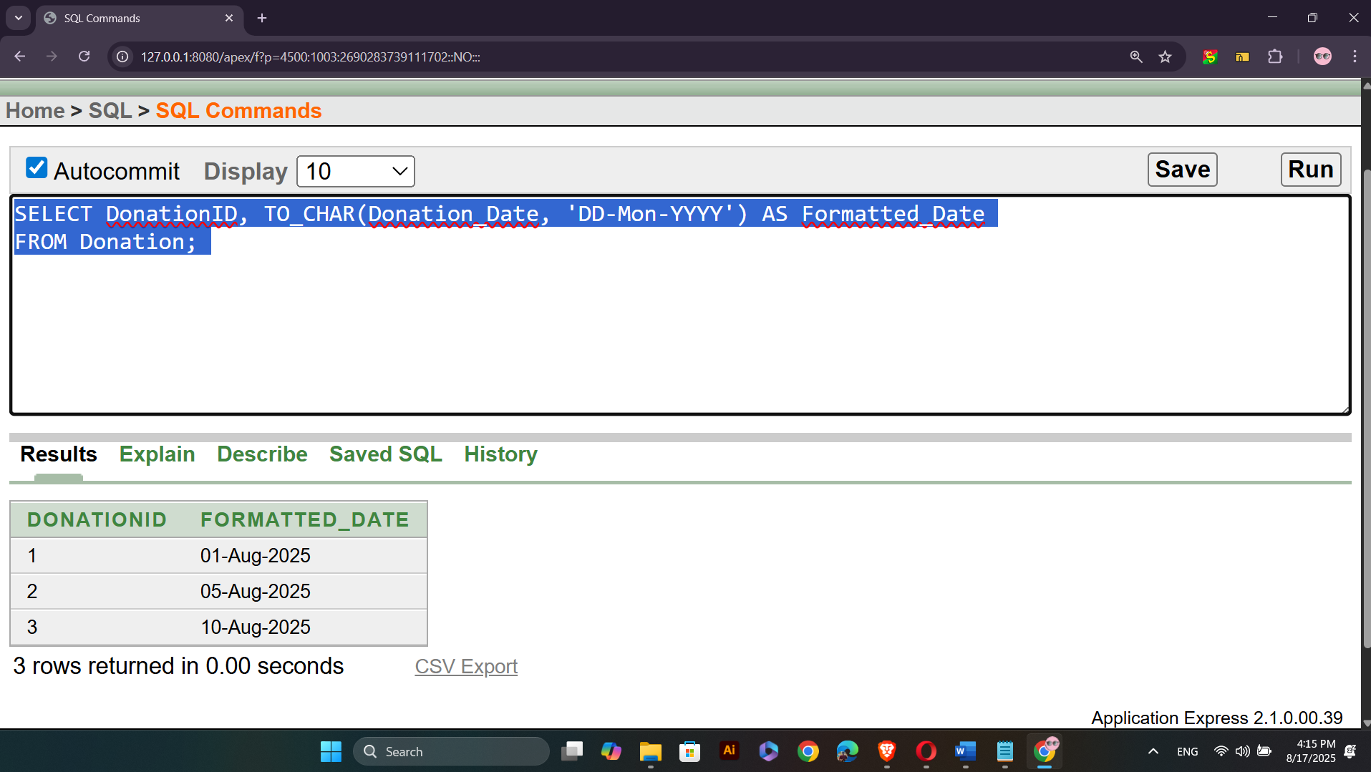

SQL
Single Row Function
- Retrieve the Alumni Name and display it in uppercase
SELECT DonationID, TO_CHAR(Donation_Date, 'DD-Mon-YYYY') AS Formatted_Date
FROM Donation;
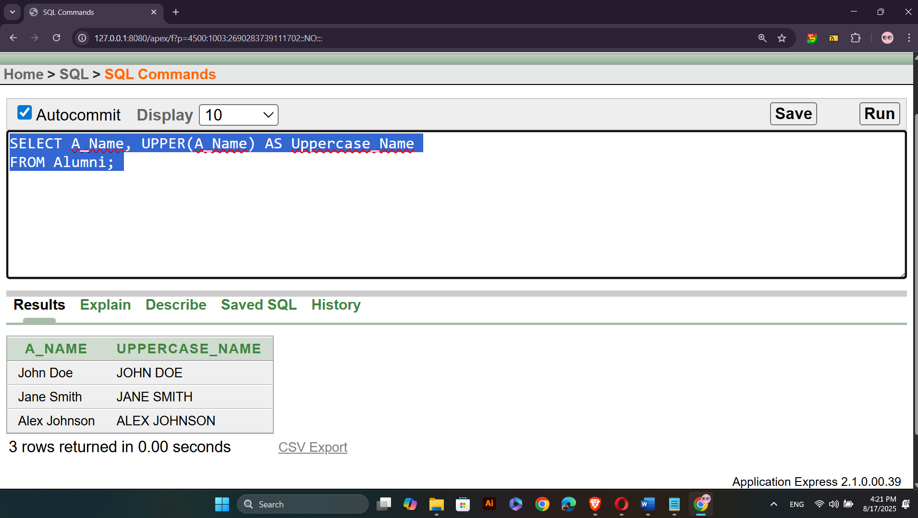

Group Functions:
- Retrieve the average donation amount from the Donation table.
SELECT AVG(D_Amount) AS Average_Donation
FROM Donation;
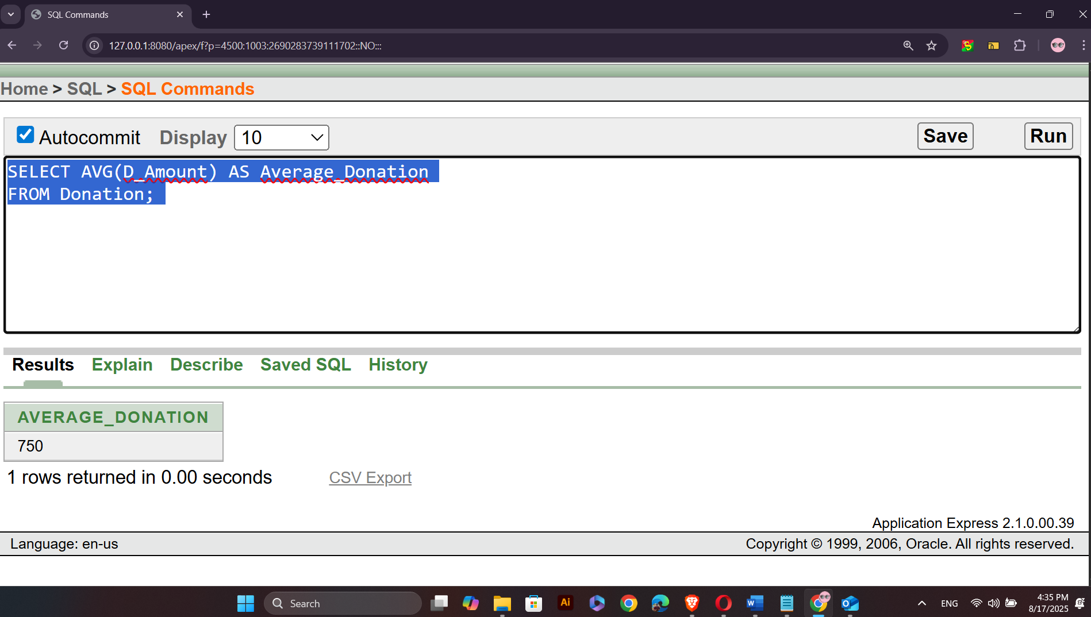

SQL
- Retrieve the total number of donations made in the system
SELECT COUNT(DonationID) AS Total_Donations
FROM Donation;
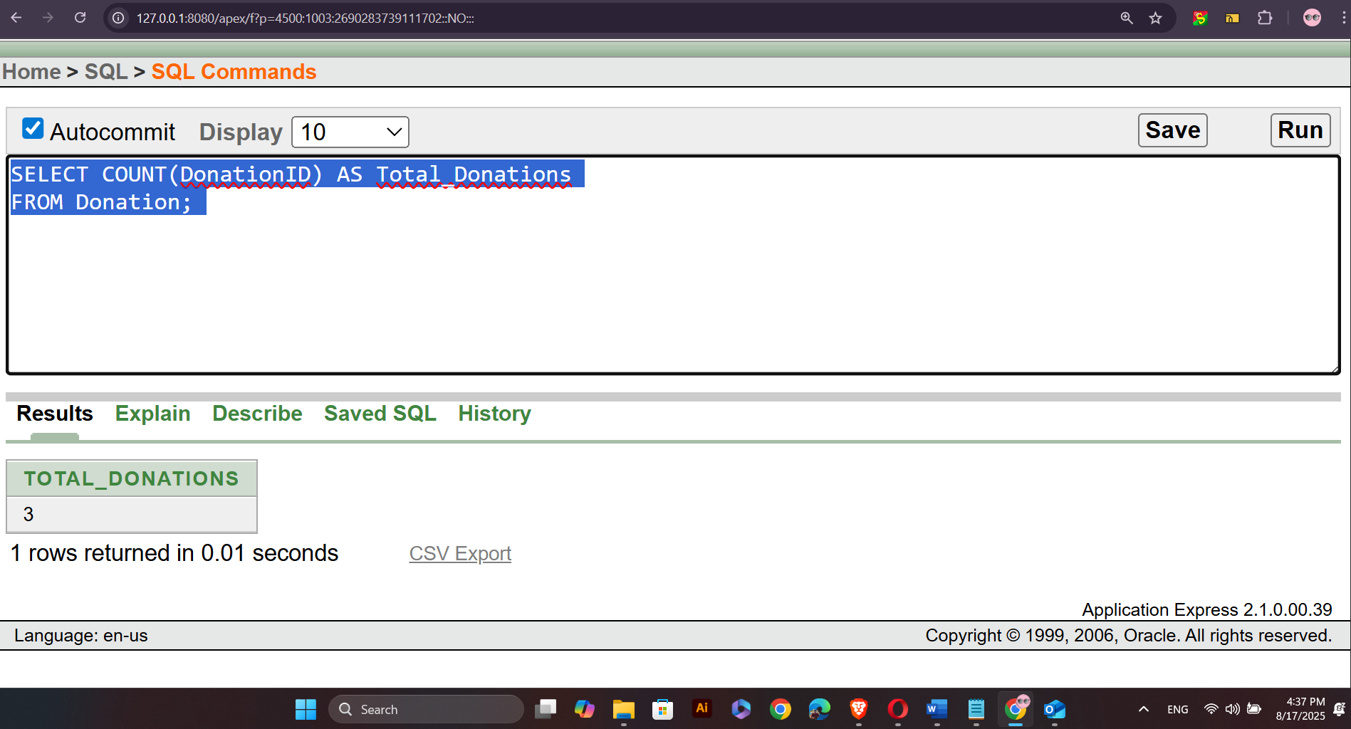
Subqueries Functions:
- Retrieve the Alumni Name of all alumni who have donated more than the average donation amount..
SELECT A_Name
FROM Alumni
WHERE A_ID IN (
SELECT A_ID
FROM Donation
WHERE D_Amount > (SELECT AVG(D_Amount) FROM Donation)
);
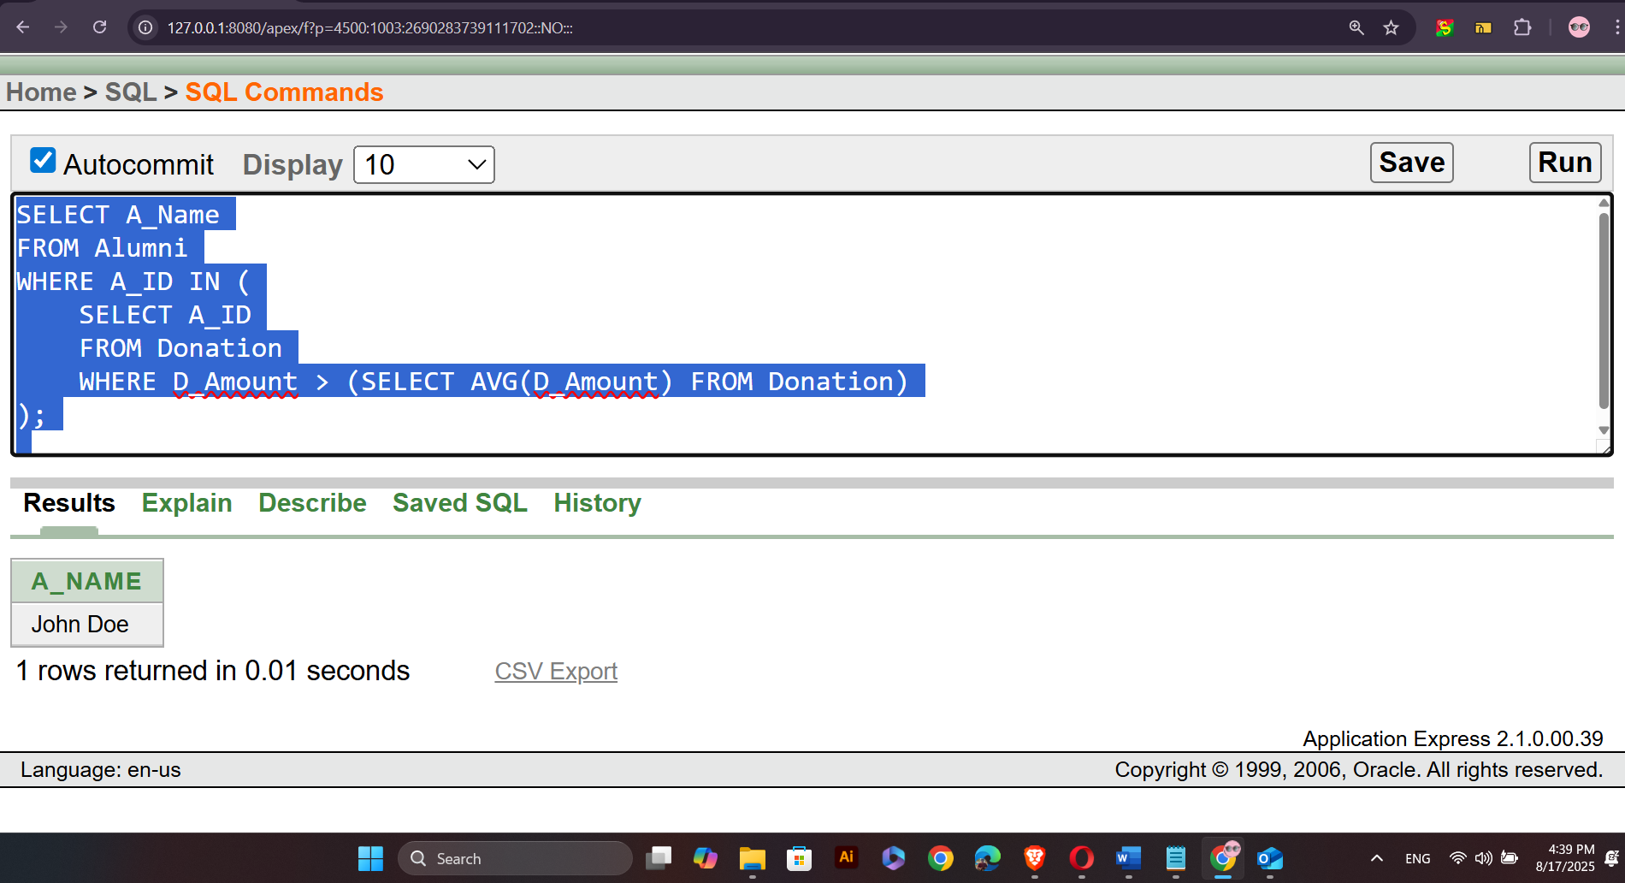

SQL
- Retrieve the Alumni Name for those who have donated for the purpose of 'Scholarship Fund'.
SELECT A_Name
FROM Alumni
WHERE A_ID IN (
SELECT A_ID
FROM Donation
WHERE Purpose = 'Scholarship Fund'
);
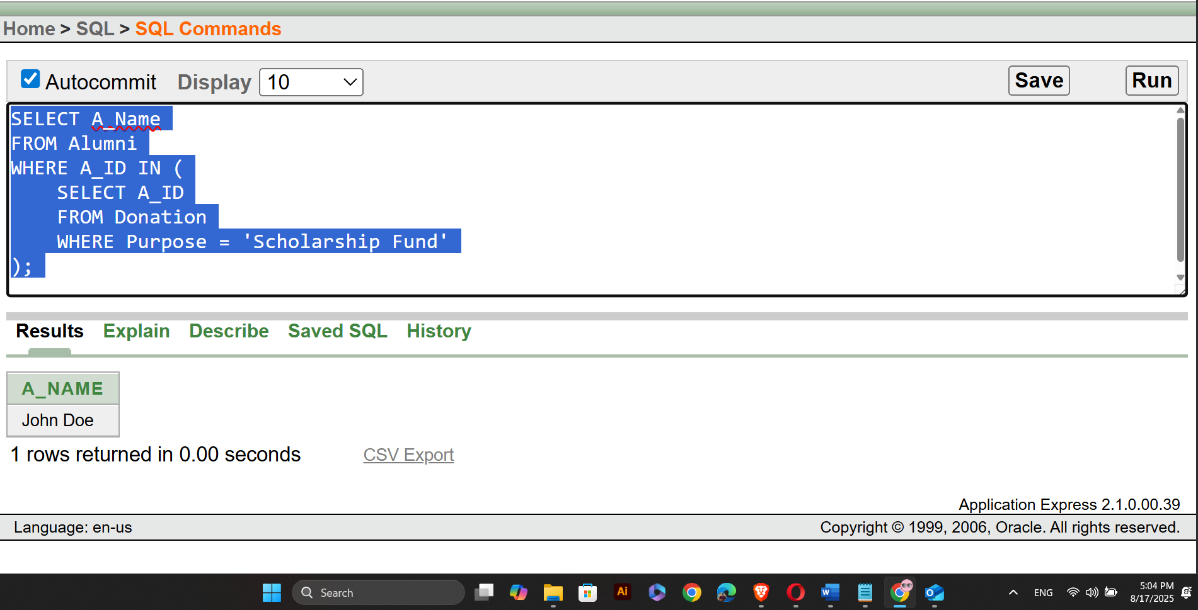
Join Functions:
- Retrieve the Alumni Name and Job Title for all alumni who have a job
SELECT Alumni.A_Name, Job.Job_Title
FROM Alumni
INNER JOIN Job ON Alumni.A_ID = Job.A_ID;
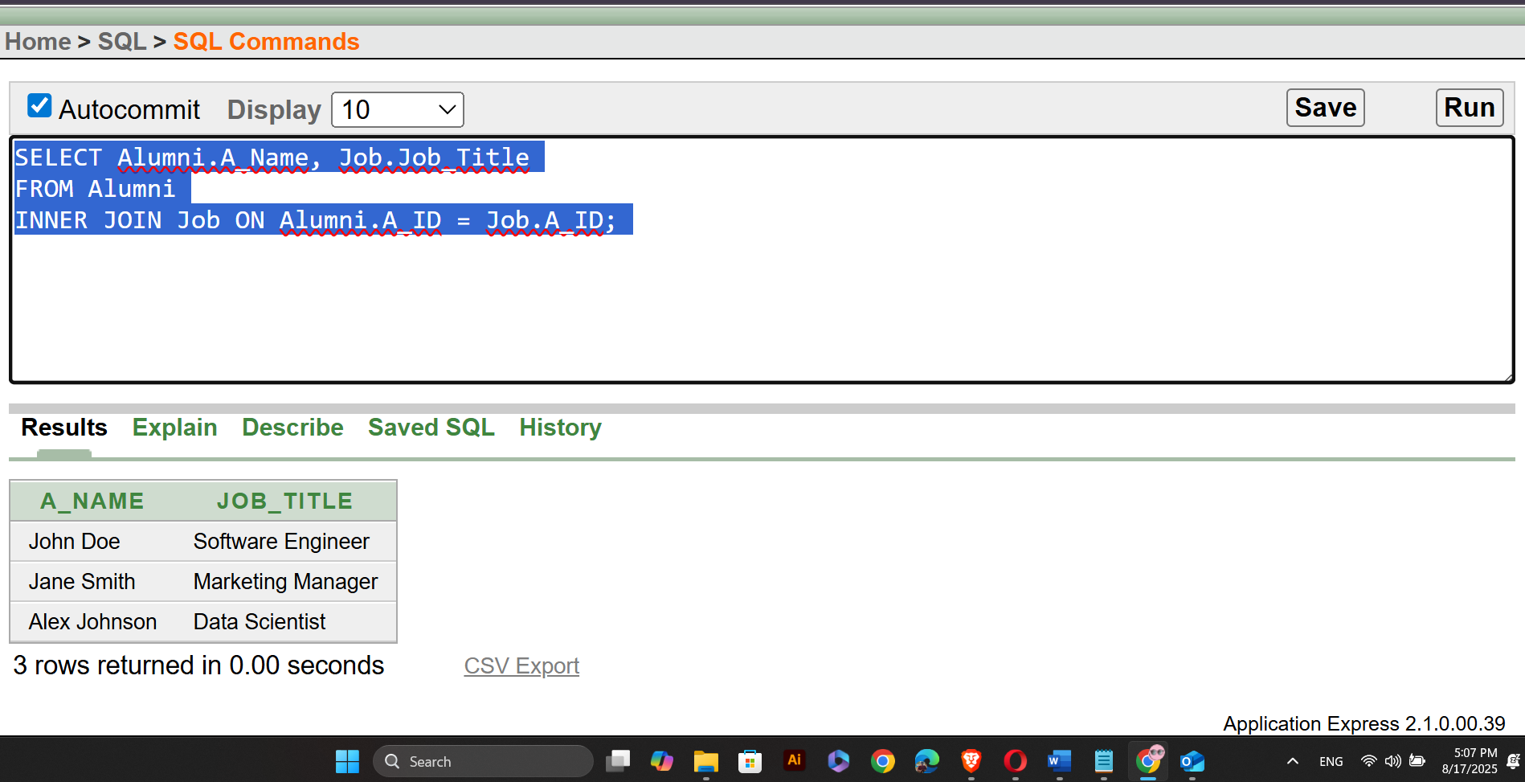

SQL
- Retrieve the Alumni Name and Job Title for all alumni, including those who do not have a job.
SELECT Alumni.A_Name, Job.Job_Title
FROM Alumni
LEFT JOIN Job ON Alumni.A_ID = Job.A_ID;
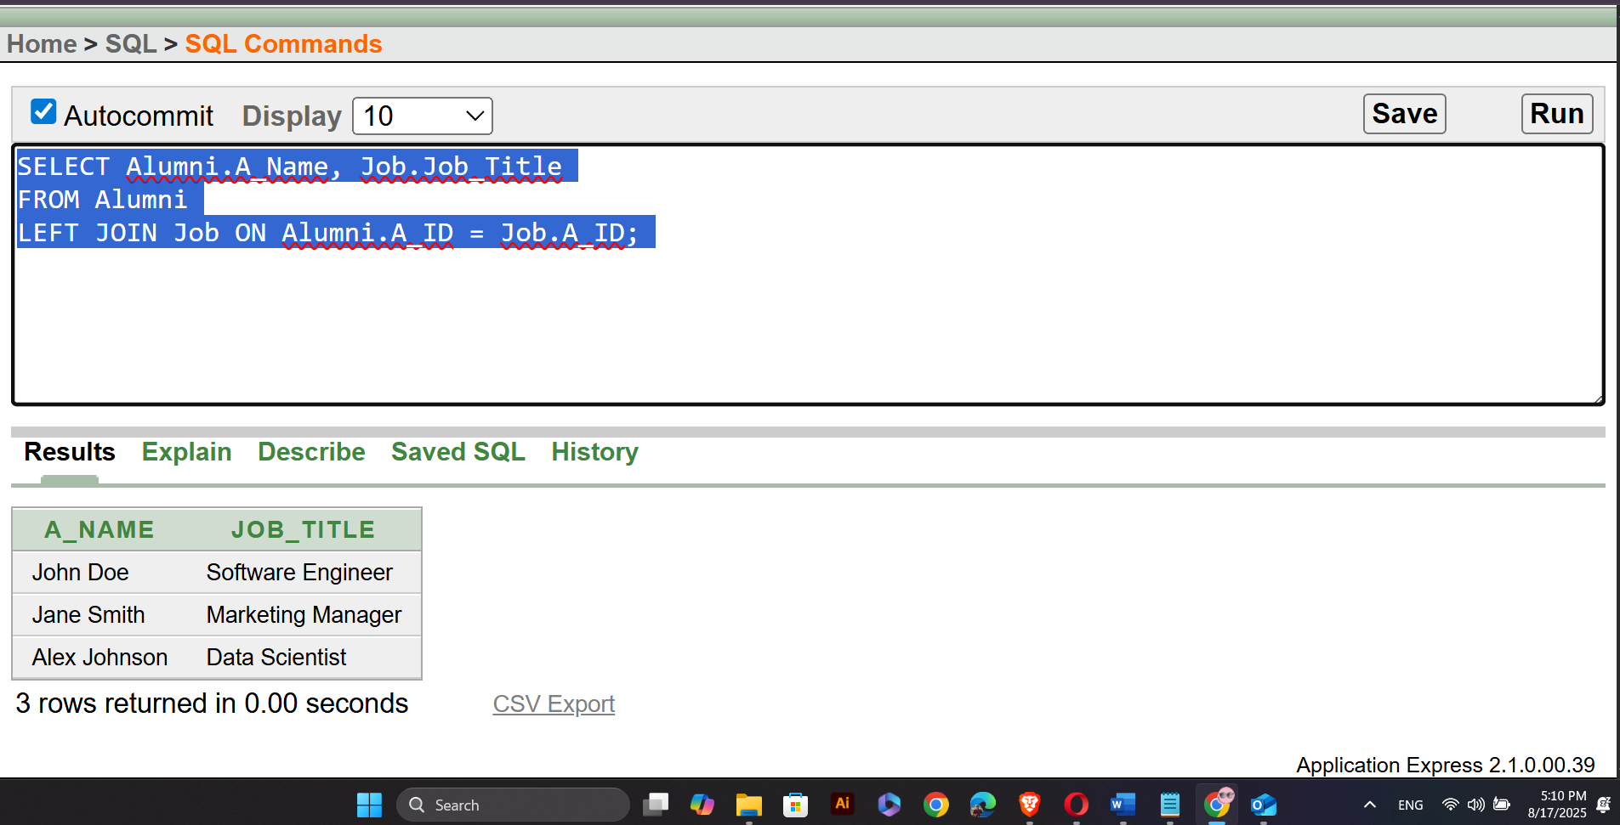

- Query Writing (continuation of Question 4) (Write down the answer only. Give full screenshot of the Oracle 10g Homepage that contains the answer and result)
-All screenshots MUST include the DATE and TIME feature from the screen of the machine (PC, Laptop etc.) used

PL/SQL
- Convert the SQLs of Question 4 into equivalent PL/SQL code
- For this part, 8 PL/SQL code must be submitted
Answer Box 5:
The PL/SQL:

DECLARE
v_DonationID INT;
v_Formatted_Date VARCHAR(20);
BEGIN
FOR rec IN (SELECT DonationID, Donation_Date FROM Donation) LOOP
v_DonationID := rec.DonationID;
v_Formatted_Date := TO_CHAR(rec.Donation_Date, 'DD-Mon-YYYY');
DBMS_OUTPUT.PUT_LINE('DonationID: ' || v_DonationID || ', Formatted Date: ' || v_Formatted_Date);
END LOOP;
END;

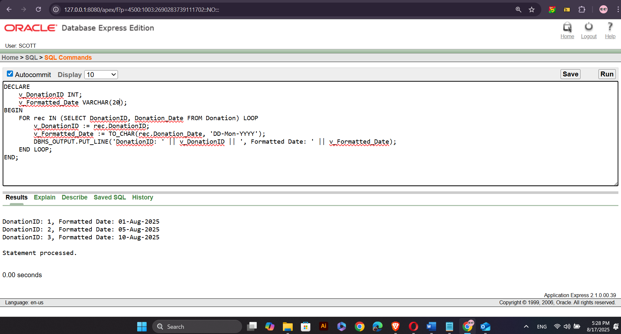

The PL/SQL:

DECLARE
v_A_Name VARCHAR(100);
v_Uppercase_Name VARCHAR(100);
BEGIN
FOR rec IN (SELECT A_Name FROM Alumni) LOOP
v_A_Name := rec.A_Name;
v_Uppercase_Name := UPPER(v_A_Name);
DBMS_OUTPUT.PUT_LINE('Alumni Name: ' || v_A_Name || ', Uppercase Name: ' || v_Uppercase_Name);
END LOOP;
END;

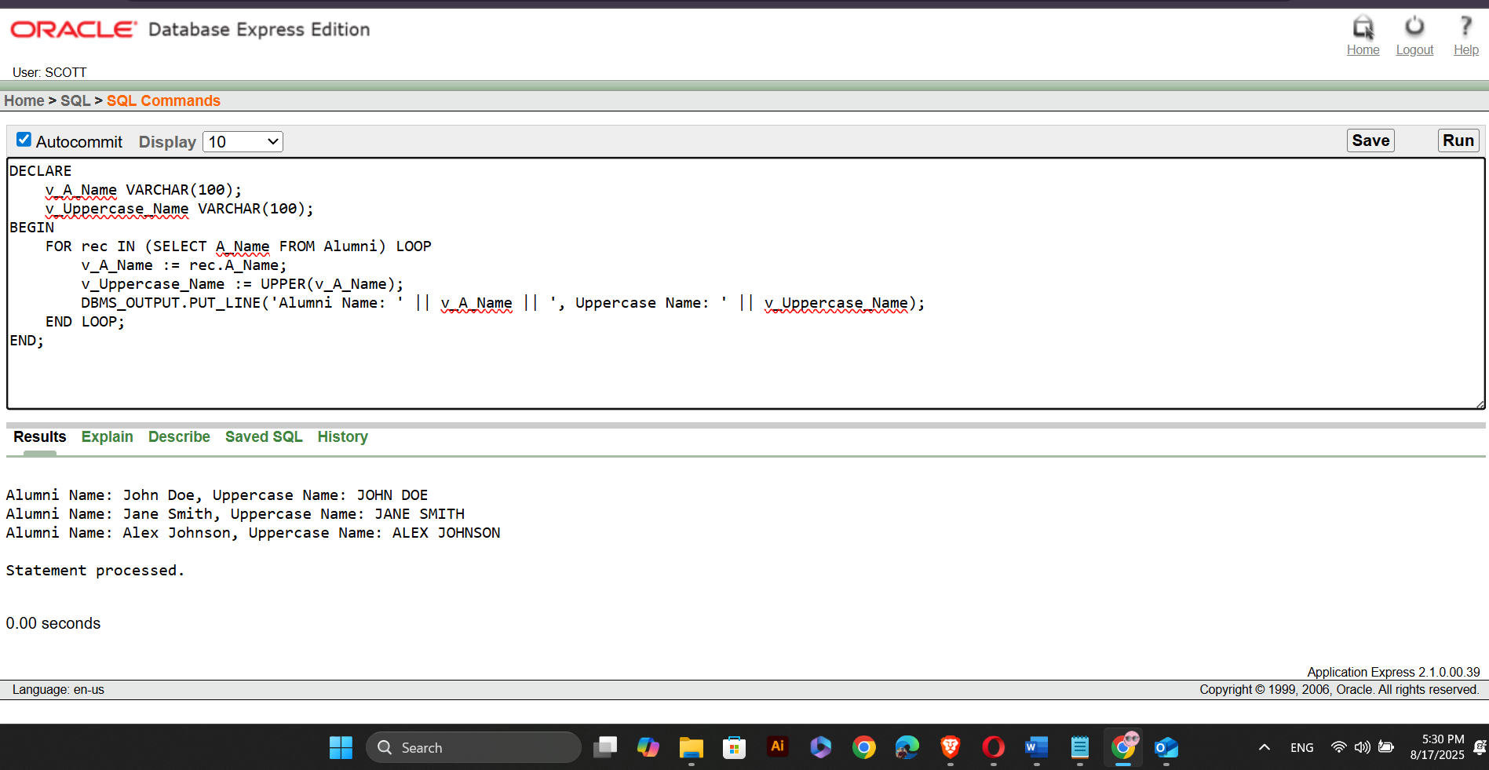

DECLARE
v_Avg_Donation DECIMAL(10,2);
BEGIN
SELECT AVG(D_Amount) INTO v_Avg_Donation FROM Donation;
DBMS_OUTPUT.PUT_LINE('Average Donation: ' || v_Avg_Donation);
END;
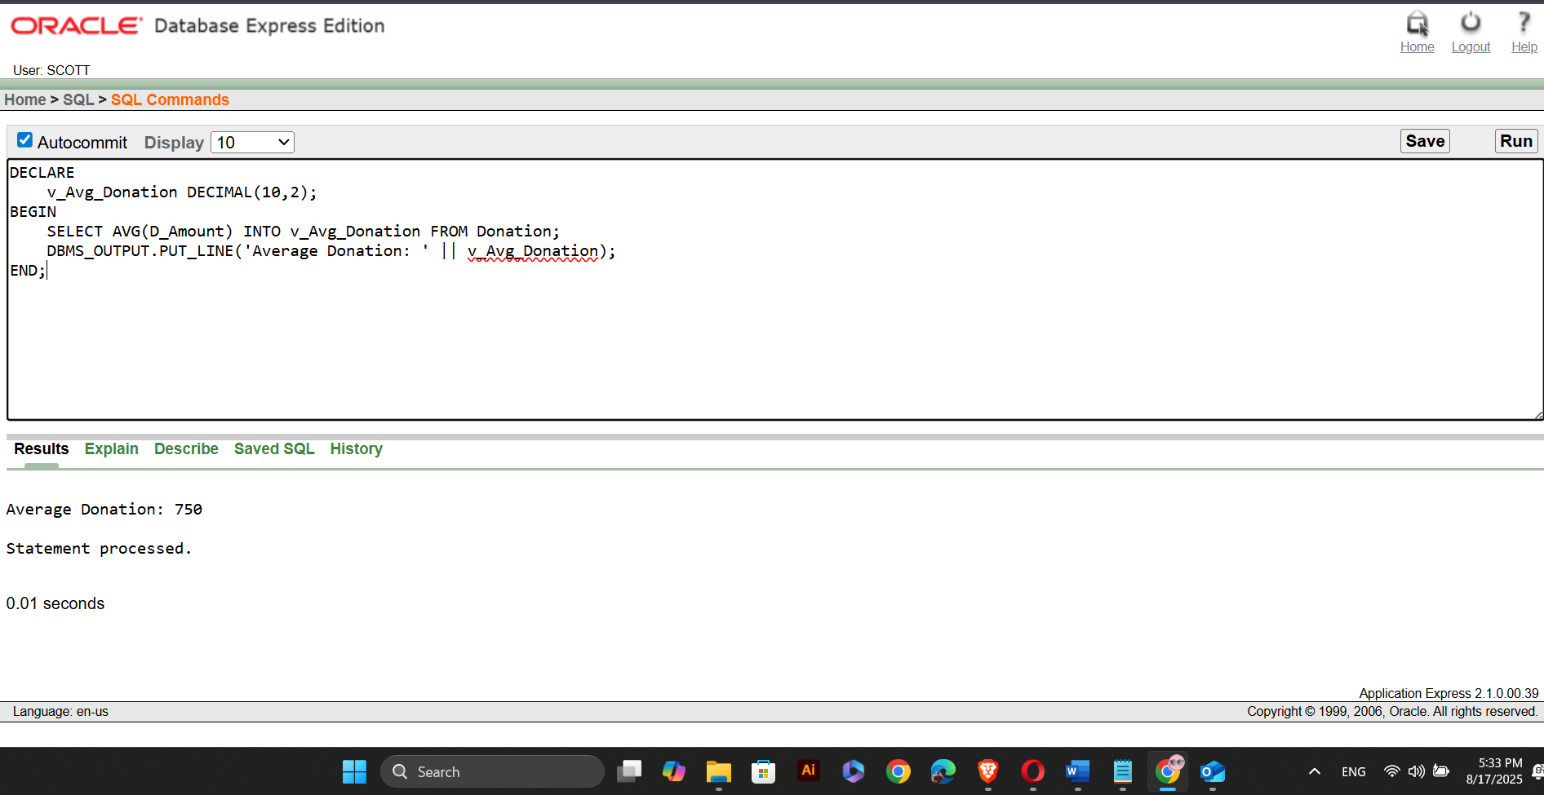

The PL/SQL:

DECLARE
v_Total_Donations INT;
BEGIN
SELECT COUNT(DonationID) INTO v_Total_Donations FROM Donation;
DBMS_OUTPUT.PUT_LINE('Total Donations: ' || v_Total_Donations);
END;
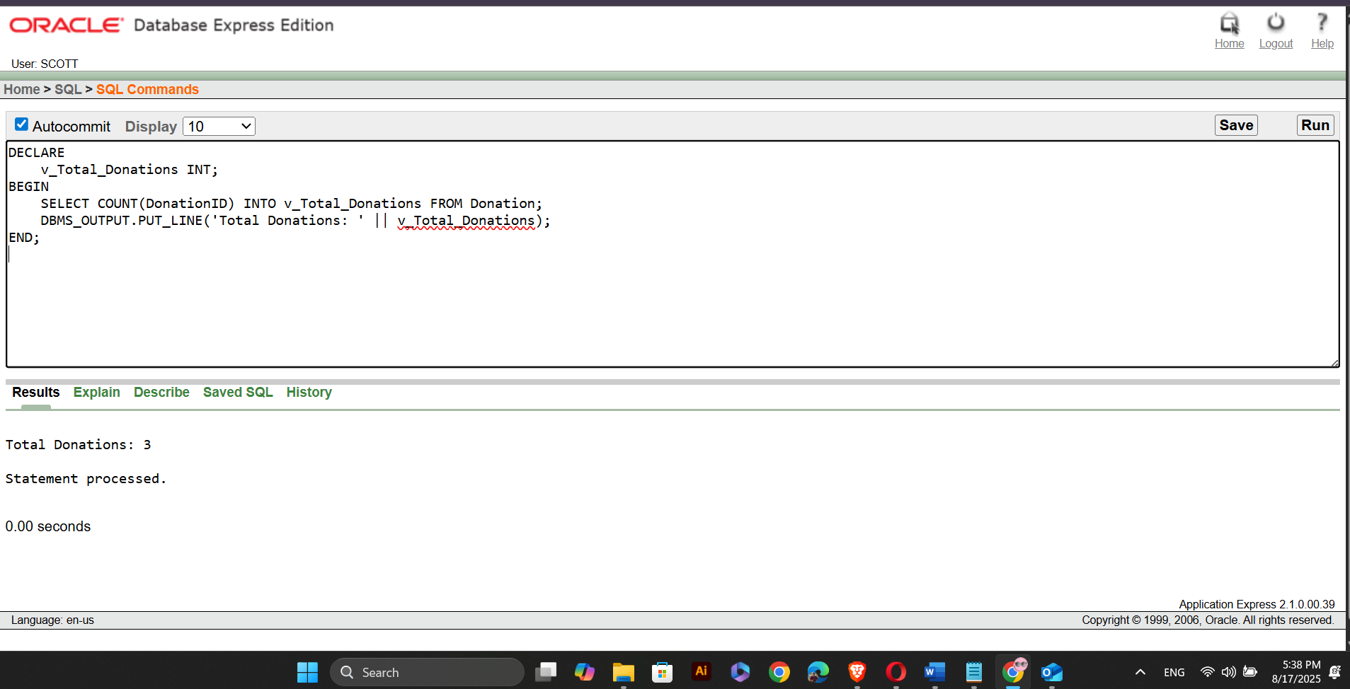

DECLARE
v_A_Name VARCHAR(100);
BEGIN
FOR rec IN (SELECT A_Name FROM Alumni WHERE A_ID IN (SELECT A_ID FROM Donation WHERE D_Amount > (SELECT AVG(D_Amount) FROM Donation))) LOOP
v_A_Name := rec.A_Name;
DBMS_OUTPUT.PUT_LINE('Alumni Name: ' || v_A_Name);
END LOOP;
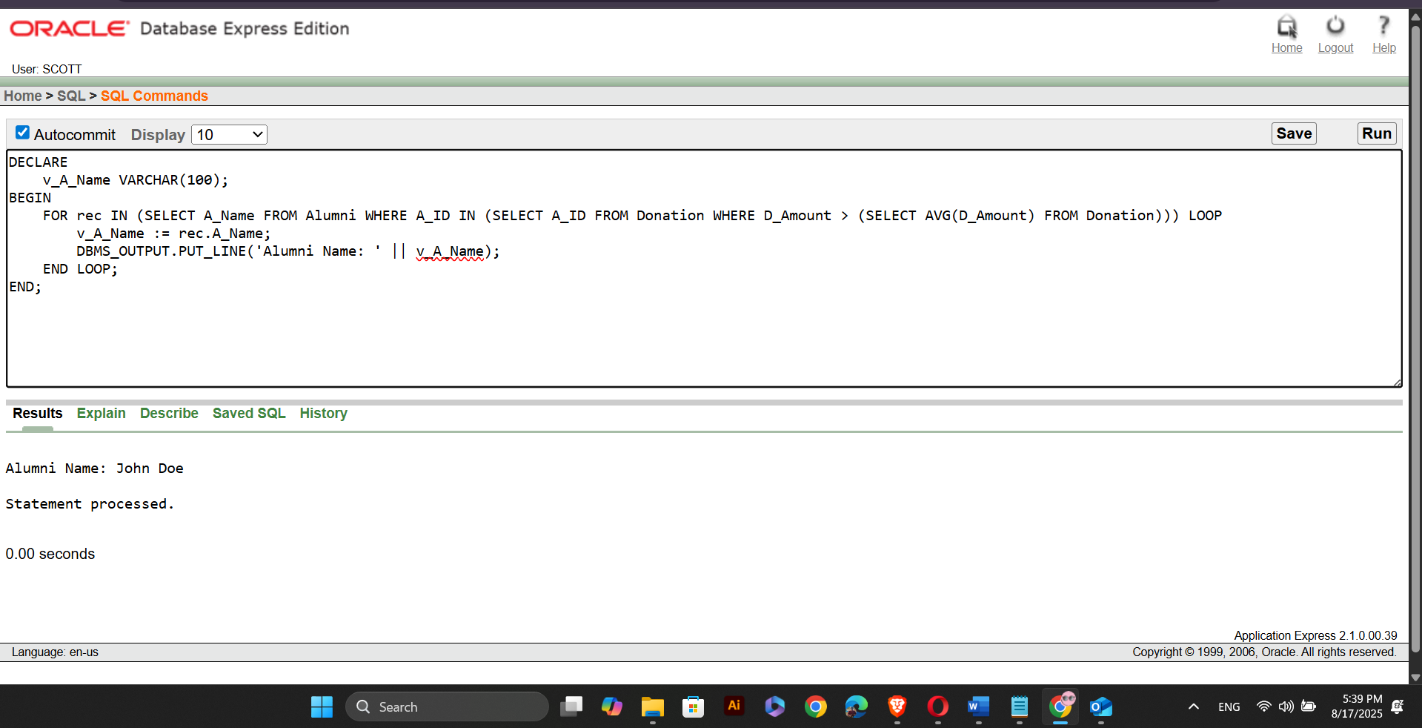

The PL/SQL:

DECLARE
v_A_Name VARCHAR(100);
BEGIN
FOR rec IN (SELECT A_Name FROM Alumni WHERE A_ID IN (SELECT A_ID FROM Donation WHERE Purpose = 'Scholarship Fund')) LOOP
v_A_Name := rec.A_Name;
DBMS_OUTPUT.PUT_LINE('Alumni Name: ' || v_A_Name);
END LOOP;
END;
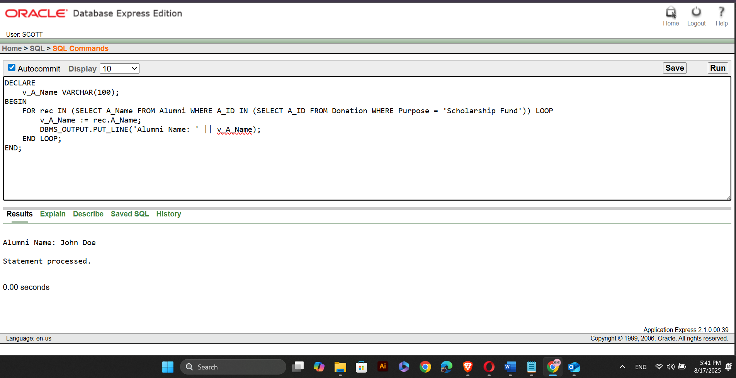

DECLARE
v_A_Name VARCHAR(100);
v_Job_Title VARCHAR(100);
BEGIN
FOR rec IN (SELECT Alumni.A_Name, Job.Job_Title FROM Alumni INNER JOIN Job ON Alumni.A_ID = Job.A_ID) LOOP
v_A_Name := rec.A_Name;
v_Job_Title := rec.Job_Title;
DBMS_OUTPUT.PUT_LINE('Alumni: ' || v_A_Name || ', Job Title: ' || v_Job_Title);
END LOOP;
END;
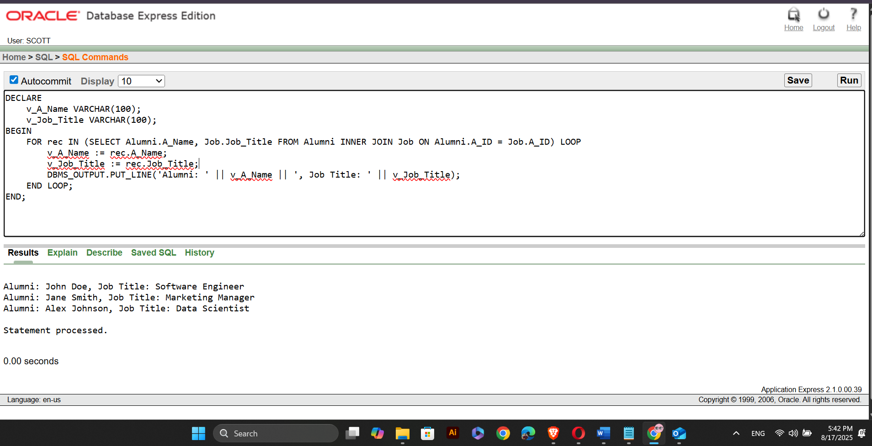

The PL/SQL:

DECLARE
v_A_Name VARCHAR(100);
v_Job_Title VARCHAR(100);
BEGIN
FOR rec IN (SELECT Alumni.A_Name, Job.Job_Title FROM Alumni LEFT JOIN Job ON Alumni.A_ID = Job.A_ID) LOOP
v_A_Name := rec.A_Name;
v_Job_Title := rec.Job_Title;
DBMS_OUTPUT.PUT_LINE('Alumni: ' || v_A_Name || ', Job Title: ' || NVL(v_Job_Title, 'No Job'));
END LOOP;
END;
