Project Plan Report
Identity and Access Management (IAM) System Deployment for Cybersecurity Enhancement

Document control
Item | Detail
Institution | Victorian Institute of Technology (VIT)
Unit code and name
Assessment | Assessment Item 3 – Project Report (Group), 20%
Project chosen | Project 2 – Identity and Access Management (IAM) System Deployment for Cybersecurity Enhancement
Client organisation | Coastal Credit Union Ltd (a fictional APRA-regulated mutual bank used as the case scenario)
Unit facilitator
Submission date
GitHub repository

Group members
Student name | Student ID | Project role | Signature

Version history
Version | Date | Author | Change summary
0.1 |  |  | Initial outline and section owners agreed
0.5 |  |  | Draft of all sections; peer review round 1
0.9 |  |  | Gantt, risk register and RACI baselined; review round 2
1.0 |  |  | Final version submitted (tag v1.0 in GitHub)

Table of Contents
Executive summary
1. Project overview and objectives
2. Project charter and scope statement
3. Work breakdown structure (WBS)
4. Project schedule and Gantt chart
5. Resource allocation and responsibility matrix
6. Risk identification, analysis and mitigation
7. Issue management strategy
8. Change request and change management process
9. Communication management plan
10. Quality management approach
11. Configuration management using GitHub
12. Conclusion
References
Appendices

Executive summary
Coastal Credit Union will deploy a cloud-based Identity and Access Management (IAM) platform over 32 weeks (1 February to 13 September 2027) for a budget of AUD 869,000, including a 10% contingency reserve. The project replaces three disconnected user directories and manual account handling with a single identity source, single sign-on (SSO), phishing-resistant multi-factor authentication (MFA), automated joiner-mover-leaver provisioning and a privileged access management (PAM) vault.
The main drivers are regulatory and security exposure. As an APRA-regulated entity, the credit union must meet Prudential Standard CPS 234 Information Security (APRA, 2019), and its 2026 internal audit found orphaned accounts, shared administrator passwords and no MFA on core banking access. The project targets Essential Eight Maturity Level 2 for the two identity-related strategies (MFA and restricting administrative privileges) in the Essential Eight Maturity Model (ASD, 2023).
This plan sets out the scope, a work breakdown structure of 6 phases and 22 activities, a dependency-linked schedule with its critical path, a RACI matrix, a risk register of 12 risks, issue and change control processes, a communication plan, a quality approach and configuration management using GitHub. The project is run with a hybrid approach: a predictive phase-gate lifecycle for governance and budget, with two-week build sprints inside Phase 3.

1. Project overview and objectives

1.1 Organisation background
Coastal Credit Union Ltd (CCU) is a customer-owned authorised deposit-taking institution in New South Wales with about 95,000 members, 620 staff and 28 branches. It is regulated by the Australian Prudential Regulation Authority (APRA) and runs a core banking platform, a CRM, Microsoft 365, an HR system and about 40 smaller business applications. CCU is a fictional organisation created for this assessment; its figures are illustrative.

1.2 Problem statement
CCU’s 2026 internal audit identified the following identity weaknesses:
- Three separate directories (on-premises Active Directory, the core banking user store and a legacy LDAP for branch systems), each managed by hand.
- 312 active accounts belonging to staff who had left; leaver access took an average of 9 business days to remove.
- 41 shared or generic administrator accounts with passwords stored in spreadsheets.
- No MFA on core banking or remote access; password resets made up 34% of service desk tickets.
- Access reviews done once a year in spreadsheets, with no evidence trail for auditors.
These gaps fall short of CPS 234 expectations (APRA, 2019) that roles, controls and testing are commensurate with the threat, and they leave CCU exposed to credential-based attacks such as phishing, password spraying and misuse of leftover accounts.

1.3 Business case
The IAM platform reduces security risk, supports compliance and cuts operating cost. Expected annual benefits once in steady state are: about 1,900 fewer password-reset tickets (roughly AUD 57,000 at AUD 30 per ticket), about 600 hours of manual provisioning work removed, and audit-ready evidence for CPS 234 and Essential Eight assessments. The largest benefit, avoiding a credential-driven breach and the regulatory consequences that follow, is not quantified here but is the primary reason for approval.

1.4 Project objectives (SMART)
# | Objective | Measure of success | Target date
O1 | Consolidate all workforce identities into one authoritative cloud directory fed by the HR system | 100% of 620 staff and 85 contractor identities sourced from HR; zero orphaned accounts in the go-live audit | 18 Aug 2027
O2 | Enforce phishing-resistant MFA for all staff on remote, cloud and core banking access | 100% MFA enrolment; MFA events centrally logged | 18 Aug 2027
O3 | Automate joiner-mover-leaver provisioning | Leaver access removed within 4 hours (from 9 days); joiner access ready on day 1 for 95% of starters | 18 Aug 2027
O4 | Bring all privileged accounts under a PAM vault | 41 shared admin accounts retired; 100% of admin sessions brokered and recorded | 11 May 2027 (build), 18 Aug 2027 (live)
O5 | Integrate the 12 highest-risk applications with SSO | 12 applications live on SSO, including core banking, CRM and Microsoft 365 | 18 Aug 2027
O6 | Deliver within approved time and cost | Closure by 13 Sep 2027; spend within AUD 869,000 | 13 Sep 2027

2. Project charter and scope statement

2.1 Project charter
Charter item | Detail
Project title | IAM System Deployment for Cybersecurity Enhancement
Project sponsor | Chief Information Officer (CIO), Coastal Credit Union
Project manager | Group member assigned the PM role (see Section 5)
Purpose | Reduce identity-related cyber risk and meet CPS 234 and Essential Eight expectations
Duration | 32 weeks: 1 Feb 2027 to 13 Sep 2027
Approved budget | AUD 869,000 (AUD 790,000 baseline + AUD 79,000 contingency)
Delivery approach | Hybrid: phase gates for governance, two-week sprints within the build phase
Authority | PM may approve changes up to 2 days of schedule and AUD 10,000; larger changes go to the Change Control Board (CCB)
Success criteria | Objectives O1 to O6 met; sponsor sign-off on the closure report

2.2 In scope
- Selection and configuration of a cloud identity provider (IdP), identity governance (IGA) and PAM solution.
- HR-system integration as the single source of truth for workforce identities (staff and contractors).
- SSO for 12 priority applications and phishing-resistant MFA (FIDO2 security keys and number-matching authenticator app) for all staff.
- Role-based access control (RBAC) model for 14 job families and quarterly automated access reviews.
- PAM vault for all administrator and service accounts, with session recording.
- Testing (SIT, UAT, penetration testing), training, pilot, phased rollout to 28 branches and decommissioning of the legacy LDAP.
- Handover documentation, runbooks and BAU support model.

2.3 Out of scope
- Customer (member) identity for internet banking; covered by a separate CIAM program.
- Integration of the remaining 28 low-risk applications (planned for a Phase 2 project).
- Replacement of the core banking platform or the HR system.
- Physical access control (building swipe cards).
- Network segmentation and endpoint security changes, except where needed for IAM agents.

2.4 Major deliverables
ID | Deliverable | Acceptance criteria
D1 | Approved project charter and management plans | Signed by sponsor
D2 | Current-state audit and CPS 234 gap analysis report | Reviewed by CISO and internal audit
D3 | Vendor selection report and signed contract | Procurement and legal approval
D4 | Solution architecture and RBAC role model | Approved at design gate (M1) by Architecture Review Board
D5 | Configured IAM platform (IdP, IGA, PAM) in production | Passes SIT, UAT and penetration test with no open critical or high findings
D6 | 12 applications integrated with SSO and MFA | Each passes its UAT script
D7 | Trained users and support staff | 95% of staff complete training module; service desk runbook signed off
D8 | Legacy LDAP decommissioned | Server shut down; no authentication traffic for 10 days
D9 | BAU handover pack and closure report | Signed by operations manager and sponsor

2.5 Constraints
- Budget is capped at AUD 869,000 for this financial year.
- No production changes during the end-of-financial-year freeze (21 June to 2 July 2027) except approved emergency changes; testing in that period runs only in the test environment, and production cut-over starts with the pilot on 8 July.
- Core banking changes can only be deployed in the Sunday 10 pm to 4 am maintenance window.
- The solution must keep identity data hosted in Australian data centres.

2.6 Assumptions
- The HR system data is at least 95% accurate after a one-off clean-up in the audit activity.
- The chosen vendor’s platform supports SAML 2.0 and OpenID Connect for the 12 priority applications.
- Key client staff (CISO, HR systems lead, service desk manager) are available for at least 20% of their time.
- Two-week sprints in Phase 3 are supported by an integration partner with certified engineers.

2.7 Key stakeholders
Stakeholder | Interest | Influence | Engagement strategy
Board and Risk Committee | CPS 234 accountability | High | Monthly status via CIO; risk register highlights
CIO (sponsor) | Delivery on time and budget | High | Weekly one-to-one; chairs steering committee
CISO | Security outcomes, audit findings closed | High | Member of steering committee and CCB
HR manager | Accurate staff data, onboarding speed | Medium | Workshops in design; UAT participation
Branch managers | Minimal disruption to member service | Medium | Branch briefings, rollout schedule, floor-walkers
Staff (620) | Easy login, no lockouts | Low | Training, intranet updates, help guides
Service desk | Support load during rollout | Medium | Runbooks, early training, hypercare roster
IAM vendor and integration partner | Contract delivery | Medium | Weekly technical stand-up; contract milestones
Internal audit and APRA | Evidence of controls | High | Audit trail, test reports, closure evidence pack

2.8 Milestones
Milestone | Date | Gate criteria
Charter approved | 5 Feb 2027 | Sponsor signature
M1 – Design approval gate | 12 Apr 2027 | Architecture and role model approved; vendor contracted
Build complete | 8 Jun 2027 | All 12 integrations configured in test
M2 – Go-live approval (CAB) | 7 Jul 2027 | No open critical/high defects or pen-test findings; UAT signed
Rollout complete | 18 Aug 2027 | All 28 branches live
M3 – Project closed | 13 Sep 2027 | Closure report signed

2.9 Budget estimate
Cost item | AUD
IAM platform licences, year 1 (IdP and MFA, IGA, PAM) | 300,000
Integration partner services | 210,000
Internal staff backfill | 170,000
FIDO2 security keys (600 at AUD 80) | 48,000
Independent penetration test | 35,000
Training and change management | 27,000
Baseline total | 790,000
Contingency reserve (10%) | 79,000
Total approved budget | 869,000

3. Work breakdown structure (WBS)
The scope is decomposed into 6 deliverable-oriented phases and 22 work packages, with three gate milestones. Project management (status reporting, risk, change and quality control) runs across all phases and is costed within internal staff backfill.
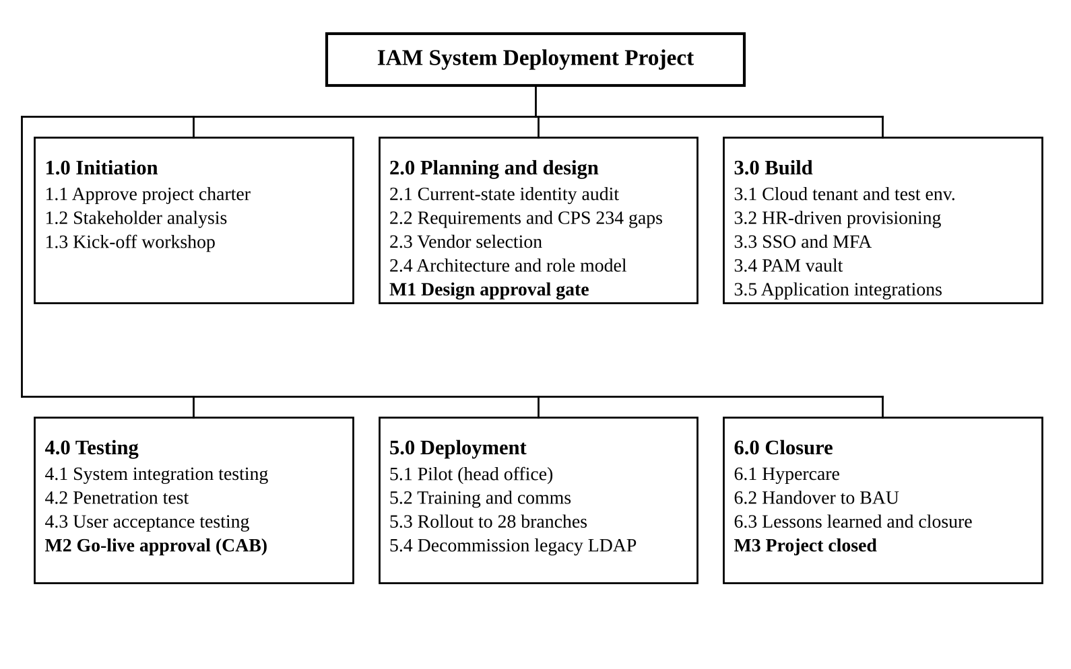
Figure 1: Work breakdown structure (WBS) of the IAM project

3.1 WBS dictionary
WBS ID | Work package | Description and output | Owner
1.1 | Approve project charter | Charter, budget and governance approved by the sponsor | Project Manager
1.2 | Stakeholder analysis | Stakeholder register and engagement plan | Project Manager
1.3 | Kick-off workshop | Shared plan, roles and ways of working agreed | Project Manager
2.1 | Current-state identity audit | Inventory of all accounts, directories and applications; orphaned and privileged accounts listed | IAM Architect
2.2 | Requirements and CPS 234 gap analysis | Functional and security requirements; gap report against CPS 234 and Essential Eight | Security Analyst
2.3 | Vendor evaluation and selection | Weighted scoring of 3 shortlisted vendors, proof of concept, contract | IAM Architect
2.4 | Solution architecture and role model | High-level and detailed design; RBAC model for 14 job families | IAM Architect
3.1 | Provision cloud tenant and test environment | Production and test tenants in Australian region; baseline hardening | Integration Lead
3.2 | HR-driven provisioning | Joiner-mover-leaver workflows from the HR system to the directory | Integration Lead
3.3 | SSO and MFA | SSO policies, FIDO2 and authenticator app enrolment, conditional access | IAM Architect
3.4 | PAM vault | Vault deployed; 41 shared admin accounts replaced with named, brokered access | Security Analyst
3.5 | Application integrations | 12 priority applications connected via SAML or OIDC | Integration Lead
4.1 | System integration testing | End-to-end test of all integrations and workflows | Test Lead
4.2 | Penetration test and security review | Independent test; findings remediated or risk-accepted | Security Analyst
4.3 | User acceptance testing | Business users sign off scripted scenarios | Test Lead
5.1 | Pilot rollout | 150 head office users live for 2 weeks; feedback captured | Change and Comms Lead
5.2 | Training and communications | E-learning module, quick guides, branch briefings | Change and Comms Lead
5.3 | Phased rollout | 28 branches in 3 waves of about 9 branches | Project Manager
5.4 | Decommission legacy authentication | Legacy LDAP retired after 10 days with no traffic | Integration Lead
6.1 | Hypercare | Two weeks of enhanced support and daily defect triage | Integration Lead
6.2 | Handover to BAU | Runbooks, support model and knowledge transfer accepted by operations | Project Manager
6.3 | Lessons learned and closure | Lessons learned log, benefits baseline and closure report | Project Manager

4. Project schedule and Gantt chart
The project runs 157 working days, from Monday 1 February to Monday 13 September 2027, with 18 of the 25 activities and milestones on the critical path. Durations are in working days (Monday to Friday), excluding NSW public holidays (Good Friday, Easter Monday, Anzac Day observed and the King’s Birthday). All dependencies are finish-to-start.
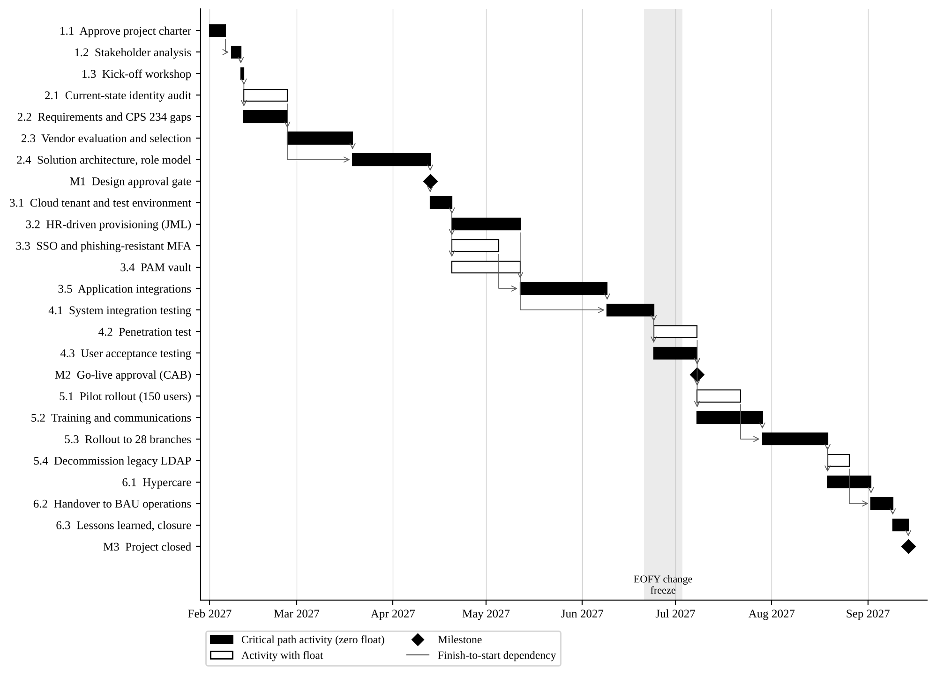
Figure 2: Gantt chart showing activities, dependencies and the critical path (1 February to 13 September 2027)

4.1 Activity list and dependencies
ID | Activity | Duration (days) | Predecessors | Start | Finish | Total float (days)
1.1 | Approve project charter | 5 | – | 1 Feb | 5 Feb | 0
1.2 | Stakeholder analysis and register | 3 | 1.1 | 8 Feb | 10 Feb | 0
1.3 | Kick-off workshop | 1 | 1.2 | 11 Feb | 11 Feb | 0
2.1 | Current-state identity audit | 10 | 1.3 | 12 Feb | 25 Feb | 15
2.2 | Requirements and CPS 234 gap analysis | 10 | 1.3 | 12 Feb | 25 Feb | 0
2.3 | Vendor evaluation and selection | 15 | 2.2 | 26 Feb | 18 Mar | 0
2.4 | Solution architecture and role model | 15 | 2.1, 2.3 | 19 Mar | 12 Apr | 0
M1 | Design approval gate | 0 | 2.4 | 12 Apr | 12 Apr | 0
3.1 | Provision cloud tenant and test environment | 5 | M1 | 13 Apr | 19 Apr | 0
3.2 | HR-driven provisioning (joiner-mover-leaver) | 15 | 3.1 | 20 Apr | 11 May | 0
3.3 | SSO and phishing-resistant MFA | 10 | 3.1 | 20 Apr | 4 May | 5
3.4 | PAM vault | 15 | 3.1 | 20 Apr | 11 May | 20
3.5 | Application integrations | 20 | 3.2, 3.3 | 12 May | 8 Jun | 0
4.1 | System integration testing | 10 | 3.4, 3.5 | 9 Jun | 23 Jun | 0
4.2 | Penetration test and security review | 10 | 4.1 | 24 Jun | 7 Jul | 5
4.3 | User acceptance testing | 10 | 4.1 | 24 Jun | 7 Jul | 0
M2 | Go-live approval (CAB) | 0 | 4.2, 4.3 | 7 Jul | 7 Jul | 5
5.1 | Pilot rollout (head office, 150 users) | 10 | M2 | 8 Jul | 21 Jul | 5
5.2 | Training and communications | 15 | 4.3 | 8 Jul | 28 Jul | 0
5.3 | Phased rollout to 28 branches | 15 | 5.1, 5.2 | 29 Jul | 18 Aug | 0
5.4 | Decommission legacy authentication | 5 | 5.3 | 19 Aug | 25 Aug | 5
6.1 | Hypercare | 10 | 5.3 | 19 Aug | 1 Sep | 0
6.2 | Handover to BAU operations | 5 | 6.1, 5.4 | 2 Sep | 8 Sep | 0
6.3 | Lessons learned and closure report | 3 | 6.2 | 9 Sep | 13 Sep | 0
M3 | Project closed | 0 | 6.3 | 13 Sep | 13 Sep | 0

4.2 Critical path
The critical path is 1.1 → 1.2 → 1.3 → 2.2 → 2.3 → 2.4 → M1 → 3.1 → 3.2 → 3.5 → 4.1 → 4.3 → 5.2 → 5.3 → 6.1 → 6.2 → 6.3 → M3. Any delay to these activities moves the closure date day for day. Float was calculated with a forward and backward pass using the critical path method (Schwalbe, 2019).
Three schedule decisions protect the critical path:
- Vendor selection (2.3) depends on requirements, not on the identity audit, so the audit (2.1) runs in parallel with 15 days of float.
- HR-driven provisioning (3.2) is on the critical path because application integrations need clean identities; it is staffed first in Sprint 1.
- Training (5.2) starts as soon as UAT finishes, in parallel with the pilot, so the branch rollout waits on whichever finishes last.
The schedule is maintained in GitHub Projects (roadmap view) and exported to Microsoft Project for steering committee reports. The baseline is frozen at the M1 gate; variance is reported weekly against it.

5. Resource allocation and responsibility matrix
The project is delivered by a core team of 6 roles (the four student group members take the first four), supported by client staff, the vendor and an integration partner. Allocation is highest in the build and test phases, from April to July 2027.

5.1 Project roles and allocation
Role | Filled by | Key responsibilities | Allocation
Project Manager (PM) | Group member 1 | Plan, schedule, budget, risks, issues, change control, reporting | 100%, whole project
IAM Architect | Group member 2 | Architecture, role model, SSO and MFA design, vendor evaluation | 100%, Feb to Jul; 50% Aug to Sep
Integration and Test Lead | Group member 3 | Provisioning, application integrations, SIT and UAT coordination, cut-over | 100%, Apr to Sep
Change, Comms and Configuration Lead | Group member 4 | Training, communications, GitHub repository, document control | 50% Feb to Jun; 100% Jul to Sep
Security Analyst (client) | CCU cyber team | CPS 234 gap analysis, PAM vault, pen test coordination | 60%, Feb to Jul
Integration engineers (2) | Integration partner | Configuration and connector build in Phase 3 sprints | 100%, Apr to Jul
Project sponsor | CIO | Funding, gate approvals, escalations | About 2 hours per week
HR systems lead | CCU HR | HR data clean-up, provisioning workflow design, UAT | 20%, Feb to Jun
Service desk manager | CCU IT operations | Support model, runbooks, hypercare roster | 20% Jun to Sep

5.2 Other resources
- Cloud IAM tenancy (production and test) hosted in an Australian region, licensed for 750 identities.
- 600 FIDO2 security keys (500 staff plus 100 spares and admins); remaining staff use the authenticator app.
- Independent CREST-accredited penetration testing firm (10 days).
- GitHub Team organisation for repositories, Projects board, issues and pull requests.
- Training room at head office and an e-learning module on the existing learning platform.

5.3 RACI matrix
R = Responsible (does the work), A = Accountable (one per row, signs off), C = Consulted, I = Informed. Column headings are short forms: Architect = IAM Architect, Test Lead = Integration and Test Lead, Config Lead = Change, Comms and Config Lead, Security = Security Analyst, HR = HR systems lead, Desk = Service desk manager.
Work package | Sponsor | PM | Architect | Test Lead | Config Lead | Security | HR | Desk
1.1 Project charter | A | R | C | C | C | C | I | I
1.2 Stakeholder analysis | I | A/R | C | C | R | C | C | C
2.1 Identity audit | I | A | R | C | I | R | C | C
2.2 Requirements and CPS 234 gaps | I | A | C | C | I | R | C | C
2.3 Vendor selection | A | R | R | C | I | C | I | I
2.4 Architecture and role model | I | C | A/R | C | I | C | C | I
3.2 HR-driven provisioning | I | C | C | A/R | I | I | R | I
3.3 SSO and MFA | I | C | A/R | R | I | C | I | C
3.4 PAM vault | I | C | C | C | I | A/R | I | I
3.5 Application integrations | I | C | C | A/R | I | C | I | I
4.1–4.3 Testing | I | A | C | R | I | R | R | C
M2 Go-live approval | A | R | C | C | C | C | I | C
5.1–5.3 Pilot, training, rollout | I | A | C | R | R | I | I | R
5.4 Legacy shutdown | I | A | C | R | I | C | I | I
6.1–6.2 Hypercare and handover | I | A | C | R | C | I | I | R
6.3 Closure report | A | R | C | C | C | C | I | I
GitHub configuration management | I | A | C | C | R | I | I | I

5.4 Resource levelling
The IAM Architect is over-allocated in Sprint 1 (20 April to 4 May), when SSO and MFA (3.3) and support for provisioning design overlap. The PAM vault (3.4) has 20 days of float, so the Security Analyst leads it with the architect consulting only, and the architect’s SSO work uses 2 of its 5 float days if needed. No critical-path activity moves.

6. Risk identification, analysis and mitigation
Twelve risks were identified, nine of them rated High before mitigation; the top two are poor HR data quality (R2) and core banking integration (R1). Risks are managed under CCU’s enterprise risk framework, aligned with ISO 31000 (ISO, 2018).

6.1 Risk management process
- Identify – risk workshops at kick-off and at each phase gate, plus any team member raising a risk as a GitHub issue labelled risk.
- Analyse – score likelihood and impact from 1 to 5; score = L × I. Impact considers schedule, cost, security and member service.
- Evaluate – Low (1–4) accept and monitor; Medium (5–9) mitigate within the team; High (10–16) mitigation plan with a named owner, reported to steering committee; Extreme (20–25) escalate to sponsor within 24 hours.
- Respond – choose a strategy: avoid, mitigate, transfer or accept; assign an owner and a trigger.
- Monitor – the register is reviewed weekly by the PM and monthly by the steering committee; closed risks are kept for lessons learned.
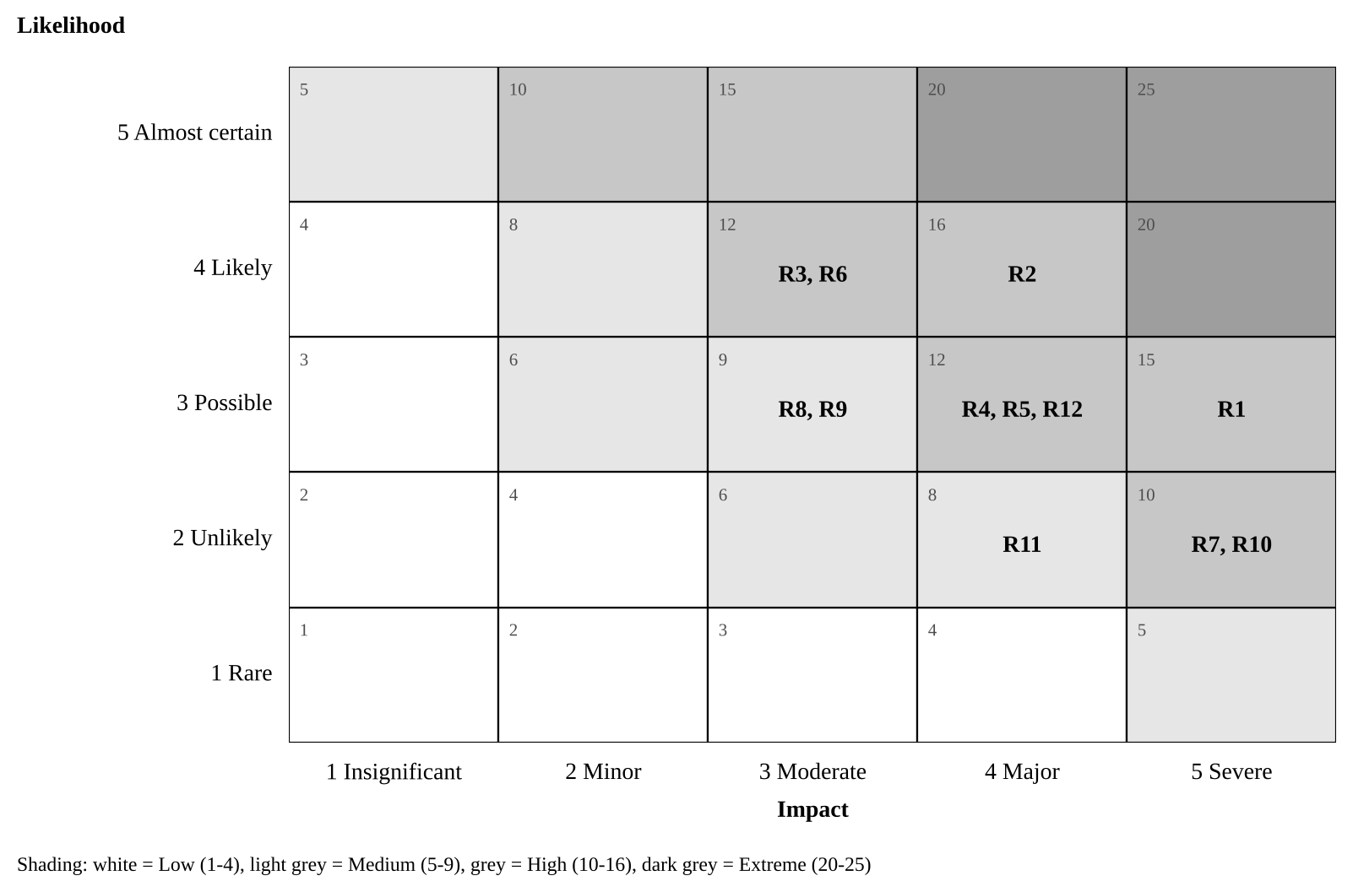
Figure 3: Risk matrix showing inherent risk of the 12 identified risks

6.2 Risk register
ID | Risk (cause → effect) | Score (L × I) | Strategy | Mitigation, contingency and trigger | Owner
R1 | Core banking supports only legacy authentication → SSO cannot be applied to the highest-risk system | 3 × 5 = 15 High | Mitigate | Core banking SSO must be shown in the vendor proof of concept (2.3); fallback is an access gateway with MFA in front of core banking. Trigger: PoC fails the core banking scenario. | IAM Architect
R2 | HR records are inaccurate or incomplete → wrong access granted or leavers missed | 4 × 4 = 16 High | Mitigate | Data clean-up during audit (2.1); run provisioning in report-only mode for 2 weeks and reconcile daily before enforcing. Trigger: Reconciliation error rate above 2%. | HR systems lead
R3 | Staff find MFA unfamiliar → lockouts and slower member service in branches | 4 × 3 = 12 High | Mitigate | Pilot first, 15-minute e-learning, branch floor-walkers on go-live days, self-service recovery. Trigger: Lockout tickets above 30 per day. | Change, Comms and Config Lead
R4 | Key client staff are pulled into BAU work → design and testing delays | 3 × 4 = 12 High | Mitigate | Backfill budget (AUD 170,000); named deputies; time commitments agreed in charter. Trigger: Two missed workshops in a row. | PM
R5 | Pen test finds critical issues late → go-live postponed | 3 × 4 = 12 High | Mitigate | Security design review at M1; configuration scanning during build; 5 days float on 4.2. Trigger: Any critical finding open at 30 June. | Security Analyst
R6 | Business units request extra applications → scope creep | 4 × 3 = 12 High | Avoid | Strict change control (Section 8); extra applications go to a Phase 2 backlog. Trigger: Change requests that add applications. | PM
R7 | Break-glass or admin access lost during PAM cut-over → systems cannot be administered | 2 × 5 = 10 High | Mitigate | Two sealed break-glass accounts tested before cut-over; staged onboarding by system; rollback plan. Trigger: Failed break-glass test. | Security Analyst
R8 | Licence procurement or vendor resourcing slips → build starts late | 3 × 3 = 9 Medium | Transfer | Contract with delivery milestones and penalties; purchase order raised during 2.3. Trigger: Contract not signed by 18 Mar. | PM
R9 | Integrations need more effort than estimated → cost overrun | 3 × 3 = 9 Medium | Transfer, mitigate | Fixed-price statement of work for the 12 integrations; 10% contingency held by sponsor. Trigger: Earned value CPI below 0.95. | PM
R10 | Cloud IdP outage → staff cannot log in to any system | 2 × 5 = 10 High | Mitigate | 99.9% availability SLA; cached credentials and offline MFA for core banking; outage runbook in BCP (APRA, 2023). Trigger: Vendor incident alert. | Integration and Test Lead
R11 | Identity data stored offshore or over-collected → privacy or contractual breach | 2 × 4 = 8 Medium | Avoid | Australian region written into contract; privacy impact assessment before build. Trigger: PIA raises a high finding. | Security Analyst
R12 | Attackers send repeated MFA prompts during rollout → account takeover | 3 × 4 = 12 High | Mitigate | Number matching and FIDO2 keys for admins; rate limiting; awareness message in every rollout email. Trigger: Unusual MFA denial spikes. | Security Analyst
After mitigation, every High risk is expected to fall to Medium or Low; residual scores are re-assessed at each gate and recorded in the register on GitHub.

7. Issue management strategy
An issue is a problem that is already affecting the project, unlike a risk, which may happen. Every issue is logged as a GitHub issue within one business day, given a priority and an owner, and tracked on the project board until closed.

7.1 Issue lifecycle
- Raise – anyone on the team opens a GitHub issue using the Issue report template (description, impact, date found, affected work packages).
- Triage – the PM reviews new issues daily and sets priority, owner and target resolution date.
- Analyse – the owner finds the root cause and options, and records them in the issue thread.
- Resolve – the agreed action is carried out. If the fix changes scope, schedule or cost, the owner raises a change request (Section 8) and links it.
- Verify and close – the person who raised it confirms the fix; the PM closes the issue and records any lesson learned.

7.2 Priority and escalation
Priority | Definition | Target resolution | Escalation path
P1 Critical | Blocks a critical-path activity, causes a security exposure or affects member service | 1 business day | PM informs sponsor and CISO immediately
P2 High | Delays a non-critical activity by more than its float, or affects a milestone | 3 business days | PM reports at weekly steering update
P3 Medium | Workaround exists; no milestone impact | 10 business days | Managed within the team
P4 Low | Minor or cosmetic | Next sprint or backlog | Managed within the team
An unresolved issue escalates one level when it passes its target date. Issues that turn out to be recurring are added to the risk register as risks for the rest of the project.

7.3 Issue log (GitHub)
The issue log is the filtered GitHub view label:issue, with fields for ID, title, priority, owner, status (Open, In progress, Blocked, Resolved, Closed), date raised, target date and linked change request. The PM reports open P1 and P2 issues and the average age of open issues in the weekly status report. A blank issue log entry form is in Appendix B.

7.4 Example issues
ID | Issue | Priority | Owner | Action
I-01 | HR system API rate limit stops full identity sync in test | P2 | Integration and Test Lead | Vendor raises limit; sync batched overnight
I-02 | Two branches have no FIDO2-compatible USB ports on teller PCs | P2 | Change, Comms and Config Lead | Those tellers use the authenticator app; PCs listed for refresh
I-03 | UAT testers from lending unavailable in week 1 of UAT | P3 | PM | Lending scripts moved to week 2; within float

8. Change request and change management process
No change to the approved scope, schedule baseline, budget or design is made without an approved change request (CR). The PM can approve small changes (up to 2 working days of schedule impact on non-critical activities and AUD 10,000); anything larger, or any change to the critical path, security controls or a milestone, goes to the Change Control Board (CCB).
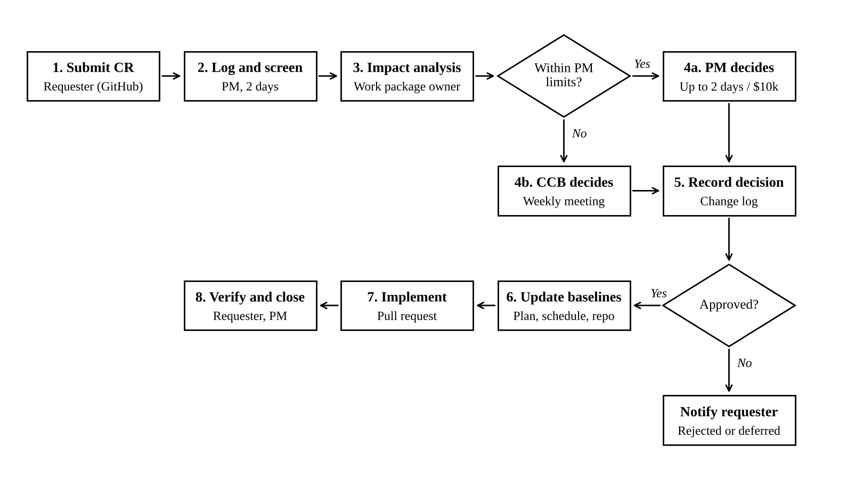
Figure 4: Change request process flow

8.1 Process steps
- Submit – the requester opens a GitHub issue using the Change request template (Appendix A): what, why, urgency and the benefit of doing it.
- Log and screen – within 2 business days the PM gives it a CR number, checks it is complete and rejects duplicates or out-of-scope ideas, which go to the Phase 2 backlog.
- Impact analysis – the work package owner assesses impact on scope, schedule (including critical path and float), cost, quality, risk, security and compliance, within 5 business days.
- Decide – the PM decides changes within delegated limits; others go to the weekly CCB. Outcomes are approve, reject, defer or request more information.
- Record – the decision, conditions and approvers are recorded in the CR issue and the change log.
- Update baselines – for approved CRs, the PM updates the schedule, budget, risk register and affected documents; document changes are made through a pull request so the repository keeps the history.
- Implement and verify – the change is delivered and tested; the requester confirms it meets the need and the PM closes the CR.
- Communicate – approved changes are summarised in the weekly status report; rejected or deferred CRs are explained to the requester.

8.2 Change Control Board
Member | Role on CCB
CIO (sponsor) | Chair; final decision on budget and milestone changes
CISO | Approves any change to security controls or risk acceptance
Project Manager | Presents impact analysis; secretary
IAM Architect | Technical and design impact
Operations manager | BAU and service impact
The CCB meets weekly during the project (Wednesday, 30 minutes) and can be convened within 24 hours for urgent changes. A quorum is the chair, CISO and PM. Production changes approved by the CCB still pass CCU’s IT Change Advisory Board (CAB) before deployment, so project change control and operational change control are linked rather than duplicated.

8.3 Change classification
Class | Example | Approver | Target decision time
Minor | Reword a training guide; move a non-critical task within its float | PM | 2 business days
Major | Add an application to SSO scope; use contingency; change a milestone | CCB | Next weekly CCB
Emergency | Urgent fix to a security weakness found in testing | CCB chair and CISO | 24 hours, ratified at next CCB

8.4 Organisational change management
Because staff will log in differently, the project also manages the people side of change using the ADKAR model (Hiatt, 2006): Awareness (CEO message and intranet articles from May), Desire (“why MFA protects our members” stories), Knowledge (e-learning and quick guides), Ability (pilot, floor-walkers and a practice environment) and Reinforcement (MFA enrolment dashboards by branch and recognition of early adopters).

9. Communication management plan
The plan gives each stakeholder group the information it needs, at a set frequency, through one owned channel. GitHub is the single source of truth for project artefacts; Microsoft Teams is used for conversations and meetings; email is used only for formal approvals and organisation-wide notices.

9.1 Communication matrix
Item | Audience | Purpose | Frequency | Channel | Owner
Daily stand-up | Core team, integration partner | Progress, plans, blockers | Daily, 15 min (build and test phases) | Teams call; GitHub board | PM
Weekly status report | Sponsor, CISO, steering committee | Schedule and cost variance, top risks, P1/P2 issues, decisions needed | Weekly, Friday | Email (PDF from GitHub wiki) | PM
Steering committee | CIO, CISO, CFO, HR manager, PM | Gate decisions, escalations, budget | Monthly and at each gate | Meeting with minutes | PM
Change Control Board | CCB members | Decide change requests | Weekly, Wednesday | Teams meeting; CR issues | PM
Sprint review and demo | Core team, business representatives | Show completed build items, gather feedback | Every 2 weeks (Phase 3) | Teams demo | IAM Architect
Board risk update | Board Risk Committee | CPS 234 progress and residual risk | Monthly | Paper via CIO | CIO with PM input
Staff updates | All 620 staff | What is changing, when and what to do | Fortnightly from May; weekly during rollout | Intranet, email, branch huddles | Change, Comms and Config Lead
Branch rollout pack | Branch managers | Wave dates, checklist, support contacts | 2 weeks before each wave | Email and briefing call | Change, Comms and Config Lead
Service desk briefing | Service desk | Known issues, runbooks, escalation | Before pilot and each wave; daily in hypercare | Teams; knowledge base | Integration and Test Lead
Vendor stand-up | Vendor, integration partner, IAM Architect | Technical progress and defects | Weekly | Teams | IAM Architect
Lessons learned | All stakeholders | Improve future projects | At each gate and at closure | Workshop; GitHub wiki | PM

9.2 Escalation path
Team member → work package owner → Project Manager → Sponsor (CIO) → Steering committee. Security incidents bypass this path and go straight to the CISO under CCU’s incident response plan, which includes the CPS 234 requirement to notify APRA within 72 hours of a material information security incident (APRA, 2019).

9.3 Communication principles
- One message, one owner: staff communications are approved by the Change, Comms and Config Lead and the HR manager before release.
- Plain language, no jargon in staff messages (“security key” rather than “FIDO2 authenticator”).
- Meeting minutes and decisions are stored in the GitHub wiki within 24 hours (template in Appendix C).
- Every status report uses the same RAG (red, amber, green) definitions so trends are comparable.

10. Quality management approach
Quality is defined as meeting the acceptance criteria in Section 2.4 and the security standards CCU is held to. The approach follows the plan–do–check–act cycle: quality planning sets standards and metrics, quality assurance checks that the process is followed, and quality control tests the deliverables.

10.1 Quality standards applied
- APRA CPS 234 – information security roles, controls, testing and incident notification.
- ACSC Essential Eight – Maturity Level 2 for multi-factor authentication and restricting administrative privileges.
- NIST SP 800-63B-4 – authentication assurance; administrators and core banking users at AAL3 (hardware-bound phishing-resistant keys), other staff at AAL2 (Temoshok et al., 2025).
- ISO/IEC 27001:2022 – access control controls (Annex A 5.15 to 5.18 and 8.2 to 8.5) used as the design checklist (ISO & IEC, 2022).
- PMBOK Guide – project management practice for scope, schedule, risk and quality (PMI, 2025).

10.2 Quality metrics
Metric | Target | Measured by | When
Requirements traced to test cases | 100% | Traceability matrix in GitHub | Before SIT
SIT test pass rate | 95% first run; 100% before UAT exit | Test management log | 4.1
Open defects at go-live | 0 critical, 0 high, ≤ 10 medium with workarounds | GitHub issues label:defect | M2
Penetration test findings | 0 critical or high unresolved | Pen test report | 4.2
SSO login success rate in pilot | ≥ 99% | IdP sign-in logs | 5.1
Leaver de-provisioning time | ≤ 4 hours for 100% of leavers | IGA audit report | Weekly from 5.3
MFA enrolment | 100% of staff | IdP dashboard | 18 Aug 2027
User satisfaction after rollout | ≥ 4 out of 5 | Pulse survey | 6.1
Documents peer-reviewed before approval | 100% | Pull request approvals | Ongoing

10.3 Quality assurance activities
- Peer review of every plan and design document through GitHub pull requests (at least one reviewer who is not the author).
- Architecture Review Board review at the M1 design gate.
- Independent security review by CCU internal audit before go-live, focused on CPS 234 control evidence.
- Process audit by the PM at each gate: are risks, issues and CRs logged and current?
- Lessons learned captured at every gate, not only at closure.

10.4 Quality control activities
Test level | What is tested | Who | Exit criteria
Unit and configuration checks | Each policy, connector and workflow as built | Integration engineers | Configuration checklist complete; automated policy checks pass
System integration testing (SIT) | End-to-end flows: HR joiner to app access, mover, leaver, SSO, MFA, PAM checkout | Integration and Test Lead | 100% of SIT cases passed or deferred by CCB
Penetration test | IdP, PAM, admin interfaces, MFA bypass attempts | CREST-accredited third party | No critical or high findings open
User acceptance testing (UAT) | 45 business scenarios across 6 departments | Business testers, Test Lead | Signed UAT certificate from each department head
Operational acceptance | Backup, monitoring, break-glass, runbooks | Service desk and operations | Operations manager sign-off
Defects are logged as GitHub issues with a severity label and linked to the failed test case. A defect review is held daily during SIT and UAT.

11. Configuration management using GitHub
All project documents, the IAM configuration-as-code and the trackers live in one private GitHub repository, ccu-iam-project. Git gives a full version history, branch protection stops unreviewed changes reaching the approved baseline, and tags mark each approved baseline so the team can always show auditors exactly what was approved and when.

11.1 Why GitHub
The team compared GitHub, GitLab and Bitbucket. GitHub was chosen because it combines version control with Issues (risk, issue, defect and change logs), Projects (Kanban board and roadmap view of the schedule), pull requests (peer review and approval evidence), a wiki (minutes and status reports) and Actions (automated checks) in one place, and GitHub’s free plan, which includes private repositories with collaborators, covers the group’s needs.

11.2 Configuration items (CIs)
Configuration item | Location in repository | Baseline at | Change approval
Project charter and this plan | /docs/plan/ | Charter approval (v1.0) | CCB
Requirements and traceability matrix | /docs/requirements/ | M1 | CCB
Solution architecture and RBAC role model | /docs/design/ | M1 | CCB with Architecture Review Board
Schedule and budget | /docs/plan/schedule/ and GitHub Projects | M1 | CCB
Risk, issue and change registers | GitHub Issues with labels risk, issue, change-request | Live | PM
IAM policies and connector configuration (as code) | /config/ (Terraform and JSON exports) | M2 | CCB and CAB
Test plans, scripts and results | /tests/ | M2 | Test Lead
Training materials and runbooks | /docs/training/, /docs/runbooks/ | M2 | Change Lead and Ops manager
Secrets (API keys, passwords, certificates) are never committed. They are stored in the PAM vault; a .gitignore and GitHub secret scanning with push protection block accidental commits.

11.3 Repository structure
The repository is organised into the following folders:
Folder or file | What it contains
README.md | Purpose of the repository, how to contribute, contacts
CONTRIBUTING.md | Branching, commit and review rules
CHANGELOG.md | Summary of each tagged baseline
.github/CODEOWNERS | Who must review which folders
.github/ISSUE_TEMPLATE/ | Forms for risks, issues, change requests and defects
.github/pull_request_template.md | Checklist shown on every pull request
.github/workflows/docs-check.yml | Automatic markdown and link checks
docs/ | Sub-folders: plan, requirements, design, training, runbooks, meetings
config/ | IAM policy and connector configuration exports
tests/ | SIT and UAT test scripts and results

11.4 Branching and review workflow
The team uses GitHub Flow, a simple trunk-based model suited to a small team:
- main holds the approved version of every item and is protected: no direct pushes, at least one approving review, required status checks and linear history (GitHub, n.d.).
- Each piece of work gets a short-lived branch named by type and issue number, for example docs/42-risk-register-update, config/57-mfa-policy or cr/63-add-payroll-app.
- Commits use clear messages that reference the issue (Update R2 mitigation after data audit (#42)).
- A pull request is opened early as a draft; CODEOWNERS automatically requests the right reviewer (for example the PM for /docs/plan/, the IAM Architect for /docs/design/ and /config/).
- The GitHub Actions check runs on every pull request; the PR is merged only when checks pass and the reviewer approves. Merging closes the linked issue.
- At each gate, the PM creates an annotated tag and a GitHub Release (v1.0-charter, v2.0-design-baseline, v3.0-go-live, v4.0-closure) with release notes copied into CHANGELOG.md.
The basic Git commands used by the team are shown below:
git checkout main && git pull
git checkout -b docs/42-risk-register-update
# edit files
git add docs/plan/risk-register.md
git commit -m “Update R2 mitigation after data audit (#42)”
git push -u origin docs/42-risk-register-update
# open pull request on GitHub, request review, merge after approval
git tag -a v2.0-design-baseline -m “Design baseline approved at M1, 12 Apr 2027”
git push origin v2.0-design-baseline

11.5 Configuration status accounting and audit
- Status accounting – the GitHub Projects board shows every work item as Backlog, In progress, In review or Done, and the Insights tab shows commit and PR activity by member, which also serves as evidence of each member’s contribution to this assessment.
- Configuration audit – before each gate the Change, Comms and Config Lead checks that every CI in Section 11.2 is at its expected version, that no unmerged branches touch baselined items and that the release notes match the CCB decisions.
- Traceability – each change request issue links to its pull request, commits and tag, so any change can be traced from request to approved baseline.
- Access control – repository access uses CCU’s SSO and MFA once live; members have Write access, the PM and Config Lead have Maintain, and branch protection rules apply to administrators too.

12. Conclusion
This plan gives Coastal Credit Union a controlled, 32-week path to replace fragmented, manual identity management with a single IAM platform, closing the audit findings that put it at odds with CPS 234. The schedule is built on explicit dependencies and a calculated critical path, so the team knows which 18 activities cannot slip and where float can absorb problems.
The largest threats, HR data quality and core banking integration, are addressed early through the audit and the vendor proof of concept, before money is committed to build. Change control, issue escalation, defined quality gates and GitHub-based configuration management together ensure that every decision and every version of a deliverable is recorded and can be shown to auditors. Delivered as planned, the project brings CCU to Essential Eight Maturity Level 2 for identity controls and removes leaver access within hours instead of days.

References
Australian Prudential Regulation Authority. (2019). Prudential Standard CPS 234 Information Security. https://www.apra.gov.au/sites/default/files/cps_234_july_2019_for_public_release.pdf
Australian Prudential Regulation Authority. (2023). Prudential Standard CPS 230 Operational Risk Management. https://handbook.apra.gov.au/standard/cps-230-final-not-force
Australian Signals Directorate. (2023). Essential Eight maturity model. Australian Cyber Security Centre. https://www.cyber.gov.au/business-government/asds-cyber-security-frameworks/essential-eight/essential-eight-maturity-model
GitHub. (n.d.). About protected branches. GitHub Docs. Retrieved October 23, 2026, from https://docs.github.com/en/repositories/configuring-branches-and-merges-in-your-repository/managing-protected-branches/about-protected-branches
Hiatt, J. M. (2006). ADKAR: A model for change in business, government and our community. Prosci Research.
International Organization for Standardization. (2018). ISO 31000:2018 Risk management – Guidelines. ISO.
International Organization for Standardization & International Electrotechnical Commission. (2022). ISO/IEC 27001:2022 Information security, cybersecurity and privacy protection – Information security management systems – Requirements. https://webstore.iec.ch/publication/79694
Project Management Institute. (2025). A guide to the project management body of knowledge (PMBOK guide) (8th ed.). Project Management Institute. https://www.pmi.org/standards/pmbok
Schwalbe, K. (2019). Information technology project management (9th ed.). Cengage Learning.
Temoshok, D., Fenton, J. L., Choong, Y.-Y., Lefkovitz, N., Regenscheid, A., Galluzzo, R., & Richer, J. P. (2025). Digital identity guidelines: Authentication and authenticator management (NIST Special Publication 800-63B-4). National Institute of Standards and Technology. https://doi.org/10.6028/NIST.SP.800-63B-4

Appendices

Appendix A – Change request form
This form is also set up as the GitHub issue template change-request.md.
Field | Entry
CR number | CR-___ (assigned by PM)
Title
Requested by / date
Description of change
Reason and benefit
Urgency | Minor / Major / Emergency
Affected WBS items and documents
Scope impact
Schedule impact (days; critical path Y/N)
Cost impact (AUD)
Risk, security and compliance impact
Options considered
Recommendation
Decision | Approved / Rejected / Deferred / More information
Decided by / date
Linked pull request and baseline tag

Appendix B – Issue log entry form
Field | Entry
Issue ID | I-__
Title
Date raised
Raised by
Priority | P1 / P2 / P3 / P4
Owner
Status | Open / In progress / Blocked / Resolved / Closed
Target date
Resolution
Linked change request

Appendix C – Meeting minutes template
Field | Entry
Meeting
Date, time, location
Attendees / apologies
Agenda items
Decisions made
Actions (owner, due date, GitHub issue)
Risks or issues raised
Next meeting

Appendix D – Group contribution record
Group member | Sections led | Sections reviewed | GitHub commits / PRs | Signature

