1. Project overview and objectives

1.1 Organisation background
Coastal Credit Union Ltd (CCU) is a customer owned Authorised Deposit-taking Institution operating within New South Wales. They have approximately 95,000 members, 620 employees and run 28 branches. They are regulated by the Australian Prudential Regulation Authority (APRA) and have a core banking solution, Customer Relationship Management (CRM), Microsoft 365, HR system and approximately 40 small business applications. CCU is a fictional company created for this assessment and the numbers represent an example.

1.2 Problem statement
- During their 2026 internal audit, CCU highlighted the following issues around their identity:
- Three separate manual-on-prem Active Directory, the core banking user store and a legacy LDAP for branch systems), each managed by hand.
- 312 active userbelonging to staff who had left; leaver access took an average of 9 business days to remove.
- 41 shared or generic admin accounts with passwords stored in spreadsheets.
- No MFA on core banking &remote aaccess solutions. 34% of service desk tickets were for password resets.
- Access reviews done once a year in spreadsheets, with no evidence trail for auditors.

This gap does not meet CPS 234 requirements (APRA, 2019). This leaves CCU vulnerable to attacks that target credentials such as phishing, password spraying and orphaned accounts.
1.3 Business Case
The IAM platform will reduce risk, increase compliance and reduce cost. In the first year, after being in a steady state it will reduce the amount of tickets raised by approximately 1900 (at a rate of $30 per ticket this will save us around $57,000), reduce manual provisioning by 600 hours. It will also provide audit ready proof that we have complied with CPS 234 and Essential Eight. However, the biggest benefit, reducing the risk of us having a breach due to credentials will not be quantified. This is the main reason why it was approved.

1.4 Project objectives (SMART)
# | Objective | Measure of success | Target date
O1 | Consolidate all workforce identities into one authoritative cloud directory fed by the HR system | 100% of 620 staff and 85 contractor identities sourced from HR; zero orphaned accounts in the go-live audit | 18 Aug 2027
O2 | Enforce phishing-resistant MFA for all staff on remote, cloud and core banking access | 100% MFA enrolment; MFA events centrally logged | 18 Aug 2027
O3 | Automate joiner-mover-leaver provisioning | Leaver access removed within 4 hours (from 9 days); joiner access ready on day 1 for 95% of starters | 18 Aug 2027
O4 | Bring all privileged accounts under a PAM vault | 41 shared admin accounts retired; 100% of admin sessions brokered and recorded | 11 May 2027 (build), 18 Aug 2027 (live)
O5 | Integrate the 12 highest-risk applications with SSO | 12 applications live on SSO, including core banking, CRM and Microsoft 365 | 18 Aug 2027
O6 | Deliver within approved time and cost | Closure by 13 Sep 2027; spend within AUD 869,000 | 13 Sep 2027

2. Project charter and scope statement

2.1 Project charter
Charter item | Detail
Project title | IAM System Deployment for Cybersecurity Enhancement
Project sponsor | Chief Information Officer (CIO), Coastal Credit Union
Project manager | Group member assigned the PM role (see Section 5)
Purpose | Reduce identity-related cyber risk and meet CPS 234 and Essential Eight expectations
Duration | 32 weeks: 1 Feb 2027 to 13 Sep 2027
Approved budget | AUD 869,000 (AUD 790,000 baseline + AUD 79,000 contingency)
Delivery approach | Hybrid: phase gates for governance, two-week sprints within the build phase
Authority | PM may approve changes up to 2 days of schedule and AUD 10,000; larger changes go to the Change Control Board (CCB)
Success criteria | Objectives O1 to O6 met; sponsor sign-off on the closure report

2.2 In scope
Solution selection and implementation:
- Set up Cloud IdP, IGA and PAM solution
- Integration with HR system to provide source of truth for staff and contractors.
- Single Sign On to 12 key applications. Phishing proof MFA implemented for all staff using FIDO2 security keys and number matching authenticator app.
- Role based access control (RBAC) implemented using 14 job families and quarterly automated access reviews.
- PAM vault for all admin/service accounts. Sessions recorded.
- Solution tested (SIT, UAT, Penetration). Training provided. Piloted and rolled out in phases. 28 branches impacted. Legacy LDAP decommissioned.
- Implementation documents, run books and BAU support model provided.

2.3 Out of scope

Customer (member) identification for internet banking. This will be addressed separately as part of the CIAM programme.

Integration of the remaining 28 low risk applications as part of a Phase 2 project.

Replacement of core banking platform or HR system.

Physical access control (swipe cards).

Changes to network segmentation and endpoint security (excluding any changes required for IAM agents)

2.4 Major deliverables
ID | Deliverable | Acceptance criteria
D1 | Approved project charter and management plans | Signed by sponsor
D2 | Current-state audit and CPS 234 gap analysis report | Reviewed by CISO and internal audit
D3 | Vendor selection report and signed contract | Procurement and legal approval
D4 | Solution architecture and RBAC role model | Approved at design gate (M1) by Architecture Review Board
D5 | Configured IAM platform (IdP, IGA, PAM) in production | Passes SIT, UAT and penetration test with no open critical or high findings
D6 | 12 applications integrated with SSO and MFA | Each passes its UAT script
D7 | Trained users and support staff | 95% of staff complete training module; service desk runbook signed off
D8 | Legacy LDAP decommissioned | Server shut down; no authentication traffic for 10 days
D9 | BAU handover pack and closure report | Signed by operations manager and sponsor

2.5 Constraints

The budget is limited to a maximum of AUD 869,000 this financial year.

No changes to production can be made during the end of financial year freeze period between 21 June and 2 July 2027. Testing can only take place in the test environment and cut over to production will commence with pilot from 8 July.

Only core banking changes can be implemented during the core maintenance period (Sunday 10pm-4am).

The solution must ensure that identity data is stored in Australian data centres

.2.6 Assumptions

Data accuracy within the HR system will be at least 95% once one off clean up activity has been completed.

The vendor selected will have support for SAML 2.0 and OpenID Connect for the priority 12 applications.

Key stakeholder time from clients will be available for the CISO, HR systems lead and service desk manager for at least 20%.

Two week sprints will be supported during phase 3 through integration partner with certified engineers.

2.7 Key stakeholders
Stakeholder | Interest | Influence | Engagement strategy
Board and Risk Committee | CPS 234 accountability | High | Monthly status via CIO; risk register highlights
CIO (sponsor) | Delivery on time and budget | High | Weekly one-to-one; chairs steering committee
CISO | Security outcomes, audit findings closed | High | Member of steering committee and CCB
HR manager | Accurate staff data, onboarding speed | Medium | Workshops in design; UAT participation
Branch managers | Minimal disruption to member service | Medium | Branch briefings, rollout schedule, floor-walkers
Staff (620) | Easy login, no lockouts | Low | Training, intranet updates, help guides
Service desk | Support load during rollout | Medium | Runbooks, early training, hypercare roster
IAM vendor and integration partner | Contract delivery | Medium | Weekly technical stand-up; contract milestones
Internal audit and APRA | Evidence of controls | High | Audit trail, test reports, closure evidence pack

2.8 Milestones
Milestone | Date | Gate criteria
Charter approved | 5 Feb 2027 | Sponsor signature
M1 – Design approval gate | 12 Apr 2027 | Architecture and role model approved; vendor contracted
Build complete | 8 Jun 2027 | All 12 integrations configured in test
M2 – Go-live approval (CAB) | 7 Jul 2027 | No open critical/high defects or pen-test findings; UAT signed
Rollout complete | 18 Aug 2027 | All 28 branches live
M3 – Project closed | 13 Sep 2027 | Closure report signed

2.9 Budget estimate
Cost item | AUD
IAM platform licences, year 1 (IdP and MFA, IGA, PAM) | 300,000
Integration partner services | 210,000
Internal staff backfill | 170,000
FIDO2 security keys (600 at AUD 80) | 48,000
Independent penetration test | 35,000
Training and change management | 27,000
Baseline total | 790,000
Contingency reserve (10%) | 79,000
Total approved budget | 869,000

3. Work breakdown structure (WBS)
The scope is decomposed into 6 deliverable-oriented phases and 22 work packages, with three gate milestones. Project management (status reporting, risk, change and quality control) runs across all phases and is costed within internal staff backfill.
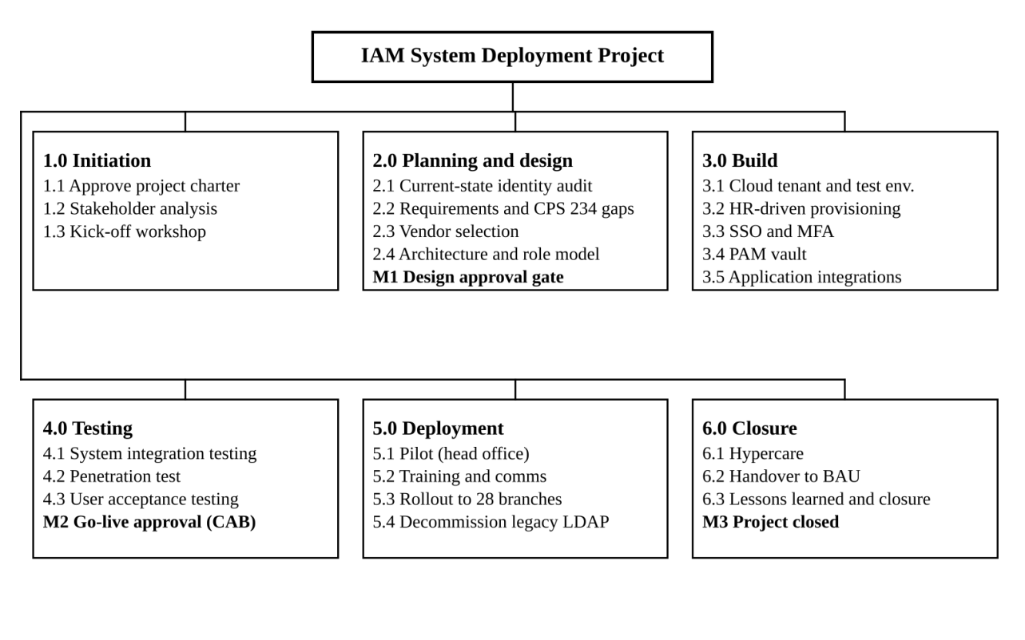
Figure 1: Work breakdown structure (WBS) of the IAM project

3.1 WBS dictionary
WBS ID | Work package | Description and output | Owner
1.1 | Approve project charter | Charter, budget and governance approved by the sponsor | Project Manager
1.2 | Stakeholder analysis | Stakeholder register and engagement plan | Project Manager
1.3 | Kick-off workshop | Shared plan, roles and ways of working agreed | Project Manager
2.1 | Current-state identity audit | Inventory of all accounts, directories and applications; orphaned and privileged accounts listed | IAM Architect
2.2 | Requirements and CPS 234 gap analysis | Functional and security requirements; gap report against CPS 234 and Essential Eight | Security Analyst
2.3 | Vendor evaluation and selection | Weighted scoring of 3 shortlisted vendors, proof of concept, contract | IAM Architect
2.4 | Solution architecture and role model | High-level and detailed design; RBAC model for 14 job families | IAM Architect
3.1 | Provision cloud tenant and test environment | Production and test tenants in Australian region; baseline hardening | Integration Lead
3.2 | HR-driven provisioning | Joiner-mover-leaver workflows from the HR system to the directory | Integration Lead
3.3 | SSO and MFA | SSO policies, FIDO2 and authenticator app enrolment, conditional access | IAM Architect
3.4 | PAM vault | Vault deployed; 41 shared admin accounts replaced with named, brokered access | Security Analyst
3.5 | Application integrations | 12 priority applications connected via SAML or OIDC | Integration Lead
4.1 | System integration testing | End-to-end test of all integrations and workflows | Test Lead
4.2 | Penetration test and security review | Independent test; findings remediated or risk-accepted | Security Analyst
4.3 | User acceptance testing | Business users sign off scripted scenarios | Test Lead
5.1 | Pilot rollout | 150 head office users live for 2 weeks; feedback captured | Change and Comms Lead
5.2 | Training and communications | E-learning module, quick guides, branch briefings | Change and Comms Lead
5.3 | Phased rollout | 28 branches in 3 waves of about 9 branches | Project Manager
5.4 | Decommission legacy authentication | Legacy LDAP retired after 10 days with no traffic | Integration Lead
6.1 | Hypercare | Two weeks of enhanced support and daily defect triage | Integration Lead
6.2 | Handover to BAU | Runbooks, support model and knowledge transfer accepted by operations | Project Manager
6.3 | Lessons learned and closure | Lessons learned log, benefits baseline and closure report | Project Manager

4. Project schedule and Gantt chart
The project will run for 157 working days between 1 Feb 2027 (Mon) and 13 Sep 2027 (Mon). There are 18 activities/milestones out of 25 that lie along the critical path. The duration is calculated in working days (Mon-Fri) excluding Public Holidays in NSW (Good Friday, Easter Monday, Anzac Day and King's Birthday). All relationships are finish to start.
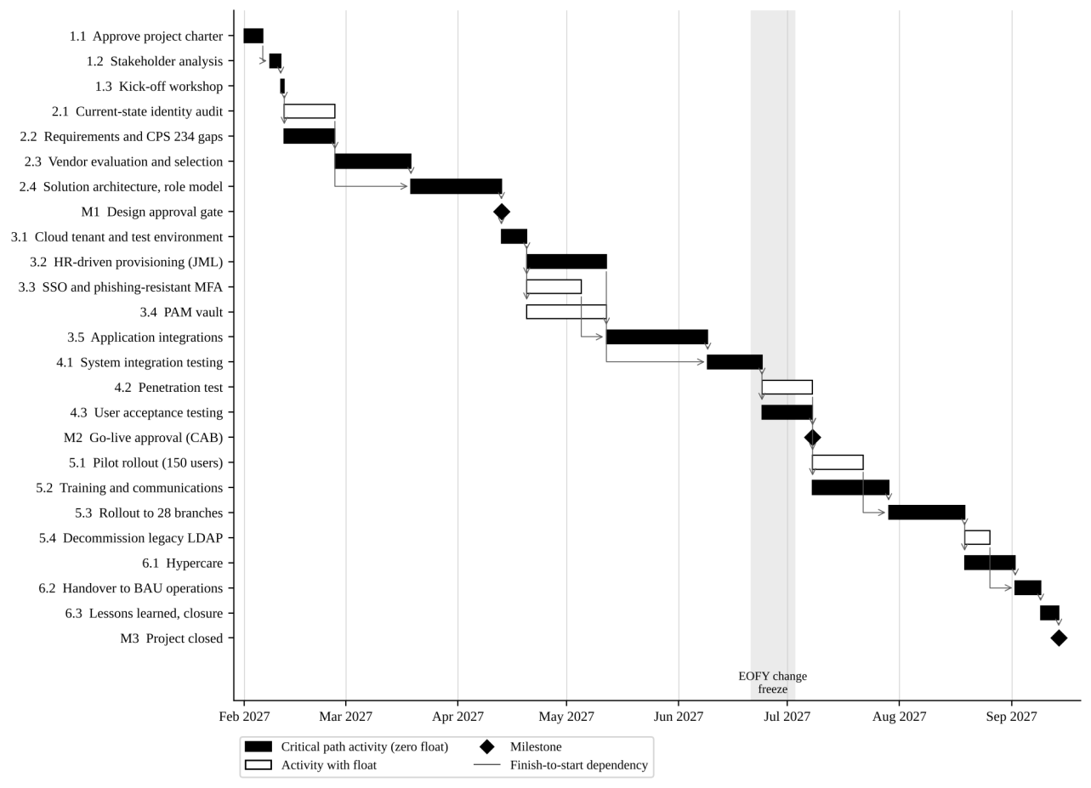
Figure 2: Gantt chart showing activities, dependencies and the critical path (1 February to 13 September 2027)

4.1 Activity list and dependencies
ID | Activity | Duration (days) | Predecessors | Start | Finish | Total float (days)
1.1 | Approve project charter | 5 | – | 1 Feb | 5 Feb | 0
1.2 | Stakeholder analysis and register | 3 | 1.1 | 8 Feb | 10 Feb | 0
1.3 | Kick-off workshop | 1 | 1.2 | 11 Feb | 11 Feb | 0
2.1 | Current-state identity audit | 10 | 1.3 | 12 Feb | 25 Feb | 15
2.2 | Requirements and CPS 234 gap analysis | 10 | 1.3 | 12 Feb | 25 Feb | 0
2.3 | Vendor evaluation and selection | 15 | 2.2 | 26 Feb | 18 Mar | 0
2.4 | Solution architecture and role model | 15 | 2.1, 2.3 | 19 Mar | 12 Apr | 0
M1 | Design approval gate | 0 | 2.4 | 12 Apr | 12 Apr | 0
3.1 | Provision cloud tenant and test environment | 5 | M1 | 13 Apr | 19 Apr | 0
3.2 | HR-driven provisioning (joiner-mover-leaver) | 15 | 3.1 | 20 Apr | 11 May | 0
3.3 | SSO and phishing-resistant MFA | 10 | 3.1 | 20 Apr | 4 May | 5
3.4 | PAM vault | 15 | 3.1 | 20 Apr | 11 May | 20
3.5 | Application integrations | 20 | 3.2, 3.3 | 12 May | 8 Jun | 0
4.1 | System integration testing | 10 | 3.4, 3.5 | 9 Jun | 23 Jun | 0
4.2 | Penetration test and security review | 10 | 4.1 | 24 Jun | 7 Jul | 5
4.3 | User acceptance testing | 10 | 4.1 | 24 Jun | 7 Jul | 0
M2 | Go-live approval (CAB) | 0 | 4.2, 4.3 | 7 Jul | 7 Jul | 5
5.1 | Pilot rollout (head office, 150 users) | 10 | M2 | 8 Jul | 21 Jul | 5
5.2 | Training and communications | 15 | 4.3 | 8 Jul | 28 Jul | 0
5.3 | Phased rollout to 28 branches | 15 | 5.1, 5.2 | 29 Jul | 18 Aug | 0
5.4 | Decommission legacy authentication | 5 | 5.3 | 19 Aug | 25 Aug | 5
6.1 | Hypercare | 10 | 5.3 | 19 Aug | 1 Sep | 0
6.2 | Handover to BAU operations | 5 | 6.1, 5.4 | 2 Sep | 8 Sep | 0
6.3 | Lessons learned and closure report | 3 | 6.2 | 9 Sep | 13 Sep | 0
M3 | Project closed | 0 | 6.3 | 13 Sep | 13 Sep | 0

4.2 Critical path
The critical path is 1.1 → 1.2 → 1.3 → 2.2 → 2.3 → 2.4 → M1 → 3.1 → 3.2 → 3.5 → 4.1 → 4.3 → 5.2 → 5.3 → 6.1 → 6.2 → 6.3 → M3. Any delay to these activities moves the closure date day for day. Float was calculated with a forward and backward pass using the critical path method (Schwalbe, 2019).

There are 3 schedule decisions that ensure the critical path:

Vendor selection (2.3) does not depend on the requirement but on the requirements. This means the audit (2.1) can happen in parallel with 15 days of float.

HR driven provisioning (3.2) is a critical path activity as clean identities are needed for application integrations. This means we staff this first in Sprint 1.

Training (5.2) can start as soon as UAT is complete meaning it will happen in parallel to the pilot. As such rollout to the branch will be dependent on whichever is complete last.

Scheduling is managed using GitHub Projects (roadmap view). Microsoft Project is used to report to the steering committee. The baseline is set at the M1 gate and any variances are reported on a weekly basis.

