Thesis Proposal
Modern Yield Curve Modeling with Dynamic Macroeconomic Factors:
An Econometric Extension Benchmarked Against Hull-White Stochastic Methods

1. Research Motivation & Background
The modeling of yield and interest rate curves remains central to asset pricing, monetary policy, and risk management. Traditional frameworks such as the Nelson–Siegel family and the Hull–White stochastic short-rate model provide robust foundations for yield curve fitting and simulation. However, recent research highlights the limitations of purely market-based or static models in capturing macro-financial dynamics. This thesis seeks to bridge econometric yield curve modeling and stochastic interest rate modeling by incorporating time-varying macroeconomic factors (GDP growth, inflation, policy rates, equity indices, and exchange rates) into the yield curve estimation process, and benchmarking their explanatory and forecasting power against the Hull–White model.

2. Research Objectives
1. To extend the classical Nelson–Siegel yield curve model by integrating dynamic macroeconomic variables and potential regime-switching behavior.
2. To calibrate and simulate the Hull–White one-factor stochastic model as a benchmark for yield dynamics.
3. To compare both approaches in terms of:
- In-sample fit to observed yield curves
- Out-of-sample forecasting accuracy
- Economic interpretability and response to macro shocks

3. Methodology
Step 1: Yield Curve Estimation
Fit the Nelson–Siegel–Svensson curve to daily or monthly sovereign bond yield data to extract level, slope, and curvature factors.
Step 2: Econometric Extension
Model the extracted factors using Dynamic Factor Models (DFM) or Vector Autoregression (VAR) with macroeconomic indicators. Explore regime-switching (Markov-switching VAR) to capture structural shifts in yield curve behavior.
Step 3: Stochastic Benchmark
Calibrate the Hull–White one-factor model to the same yield curve data. Simulate future yield paths under stochastic interest rate dynamics.
Step 4: Comparative Evaluation
Compare model performance via RMSE, forecast error metrics, and macro sensitivity analysis. Evaluate economic interpretability and robustness across market regimes.

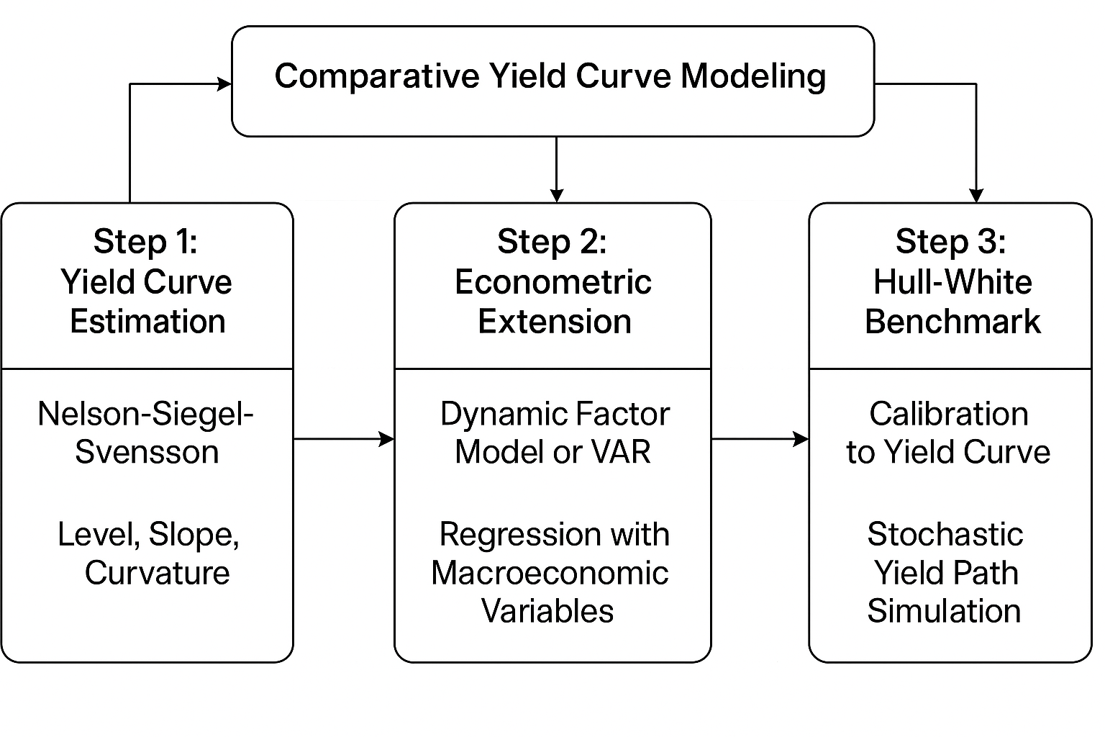

4. Data Sources
- Bond yields: U.S. Treasury, European Government Bonds (Bloomberg, FRED, ECB, BIS, or OECD databases).
- Macroeconomic indicators: GDP growth, CPI/inflation, policy rates, equity indices, and FX rates (IMF, FRED, OECD, World Bank).
- Frequency: monthly or quarterly (to align with macro data).
- Period: at least 10–15 years to capture multiple market cycles.

5. Expected Deliverables
- Econometric model integrating macro-financial factors into yield curve dynamics.
- Calibrated Hull–White stochastic rate model for benchmark comparison.
- Quantitative comparison of model fit and forecasting accuracy.
- Discussion on implications for monetary policy and financial risk management.
- Fully documented code and reproducible data pipeline (Python/R).

6. Expected Contribution
This research aims to modernize yield curve modeling by fusing econometric and stochastic frameworks. It contributes to the literature by:
- Quantifying the role of macroeconomic factors in explaining yield curve evolution.
- Benchmarking traditional short-rate models against macro-augmented econometric alternatives.
- Providing practical insights for policymakers, risk managers, and quantitative analysts in a post-zero-rate world.

