Interactivity:

Interactivity is the term that we gave to a statistic comments divided by upvotes. It is designed to measure the engagement of the Reddit users who look that the top posts, and to quantify how engaging each of the top posts were. We anticipated a near-linear trendline for the number of comments/upvotes, and (comments/upvotes)/upvotes, using upvotes as the x axis. I thought the metric for interactivity would be constant for all numbers of upvotes.

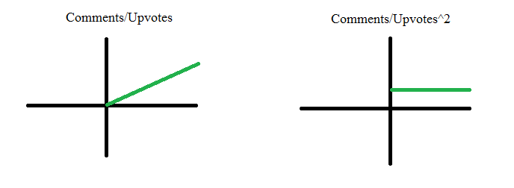

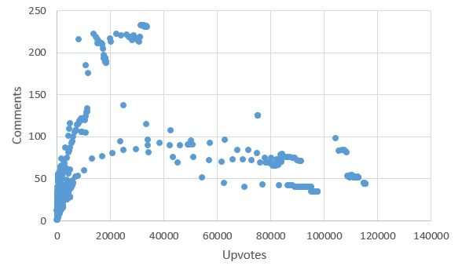 After collecting the data, and using excel to compute comments/upvotes and (comments/upvotes^2) for each of the datapoints, there were two clear trends. First of all, the comments/upvotes graph revealed that there appeared to be two different trajectories for popular posts: Those which have a lot of upvotes, and such soar to the top of the reddit page, and those which are no where near as popular, but have way more comments. Our hypothesis for this is the nature of the post itself. If the post is a cat meme, or something that only needs to be seen once, it could get very popular, but If the post elicits emotion or a discussion, it is statistically more likely for it to be somewhat popular, but get many more comments. Also, the interactivity vs upvotes graph, looked very much like the positive component of the 1 1/(n\*x) graph, which is 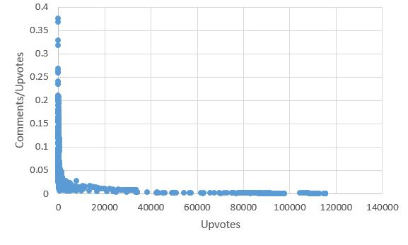tangential to both the x and y axis. We thought that this was because as long as posts made the high-ranking post numbers on an individual subreddit, even if it’s upvotes were not very high, it could still get a Comments/Upvotes rating of .2 or higher.