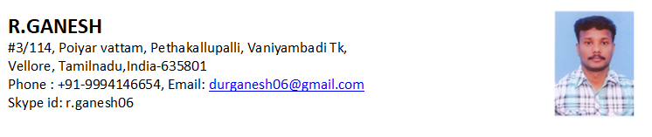

R E S U M E

Objective:-

Self-motivated and career minded professional with over 10 years of experience in Hotel & Restaurant

Education:

Academic Qualification:-
Post-Graduation : M.A – (Master of Arts) 2006 (Thiruvalluvar university)
Graduation : B.A –Economics (Bachelor of Arts) 2004 (Madras university)
Other Qualification : B. Ed – (Bachelor of Education) 2012
Advance Qualification : (DCA) Diploma Computer Application

Application Software:-
Knowledge in : MS- Office, Word, Excel, Power point.

Experience:

Business Manager : Sri Durga Restaurant

Duration: Feb 2016 – Aug 2022 Organizational Experience - (6 Years)

Rolls & Responsibilities:-

- Organizing food materials from the market. (vegetables, fruits, & general stores)
- Ensure food service and quality control
- Maintain records of stock, sales and wastage,
- Getting bulk orders from customers & organizing it for delivery.
- Co-coordinating with cooking staffs for the customer requirements.
- Supervise and check delivery of food trolleys
- Establish work schedules for the housekeeping.
- Planning, organizing , directing, & controlling daily operations,
- Cashier
- Daily Balance cash and complete balance sheets, cash reports Preparation.
- Responsible for Stock maintenance,
- Handling customer complaints, understand their needs and problems, delivering them the best of service.
- Supervise and guide staff towards maximum performance
- Inspect the areas in the store and resolve any issues that might arise
- Ensuring health and safety regulations are followed
- Providing customer service with quality.

Designation: SUPERVISOR – SARAVANA BAVAN HOTEL& RESTAURANT
From March 2013 -2016 Organizational Experience - (3 Years)
Rolls & Responsibilities:-
- Training & developing housekeeping staffs
- Ensuring work Areas are kept clean throughout the day
- Responding to all guest requests
- Responding to telephone and in-person inquiries regarding reservations, hotel information and guest concerns in a timely fashion
- Resolving customer issues, complaints and problems in a quick, efficient manner to maintain a high level of customer satisfaction and quality service
- Allocates rooms to expected arrivals after checking the guests preferences and special requests
- Cross checks all billing instructions are correctly updated
- Ensures Front desk log book and hotel log book is always updated and acted upon
- Informing floor works of any check out rooms to be cleaned.

Personal Information:-
Name : R. Ganesh.
Father’s name : V. Ramesh. (late)
Date of Birth : 26/03/1984
Gender / Age : Male / 37
Marital Status : Married
Nationality &Religion : Indian / Hindu
Languages Known : English, Tamil, Kannada and Telugu
Total Experience : 10 years
Notice period : open to work immediately

Declaration:-
I hereby declare that the above data furnished is true and correct to the best of my knowledge.
Place: Vaniyambadi Regards
Date: R.GANESH.

