# Flows

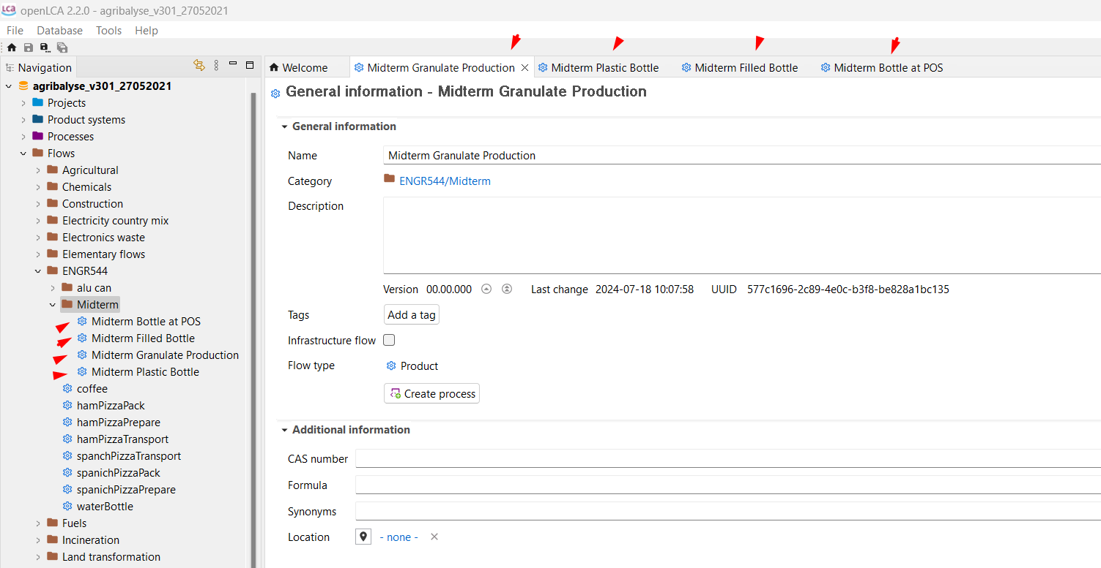

# Processes

Midterm Granulate Production Process

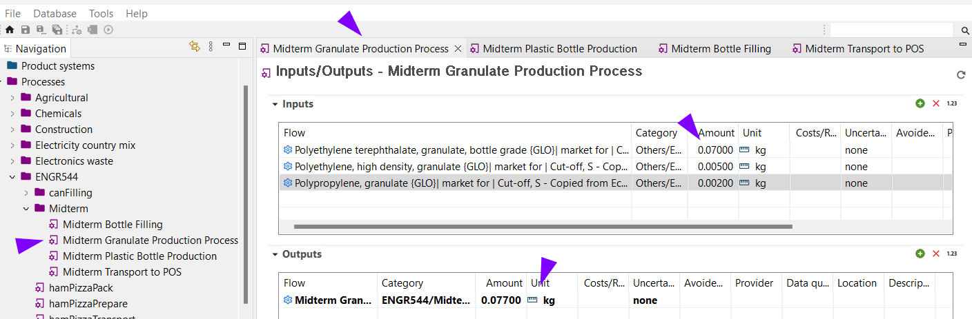

Midterm Plastic Bottle Production

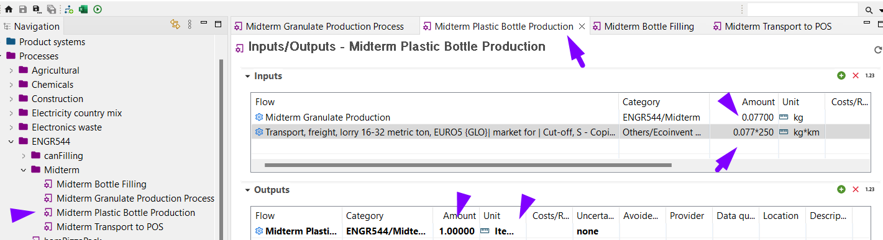

Midterm Bottle Filling

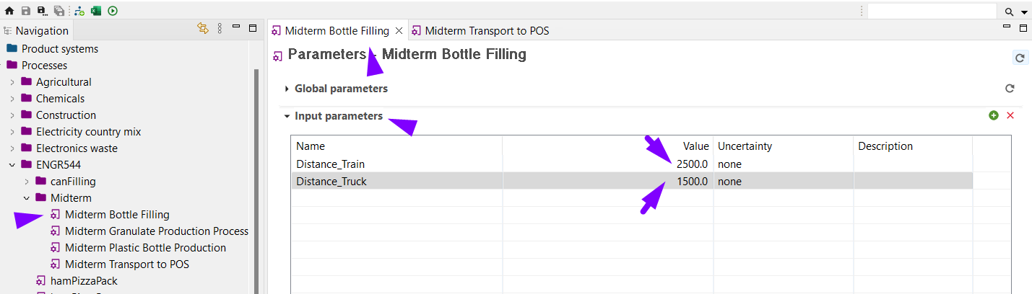

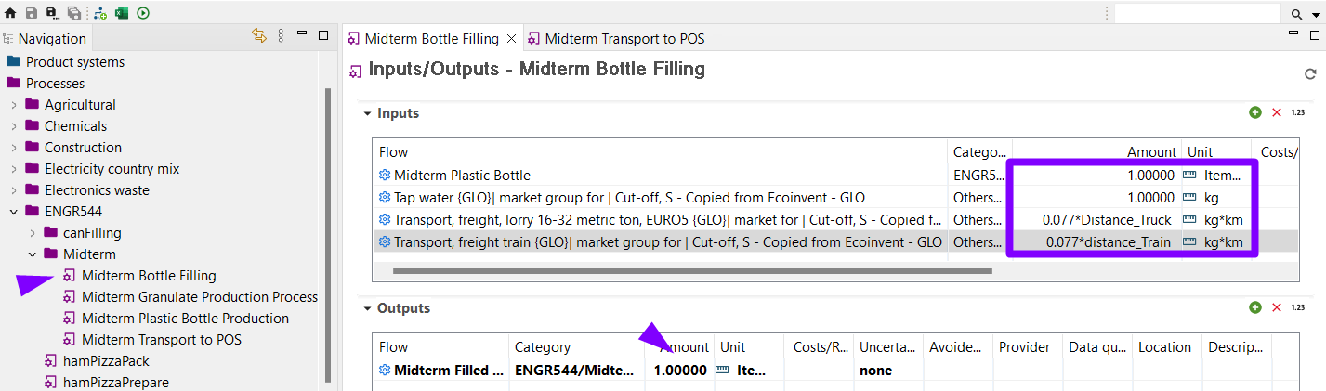

Midterm Transport to POS

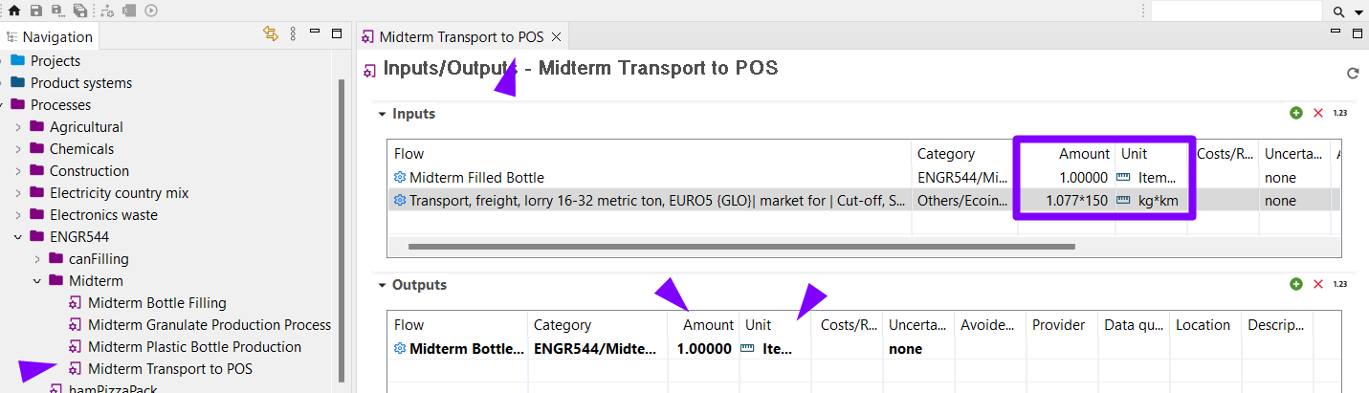

# Product System

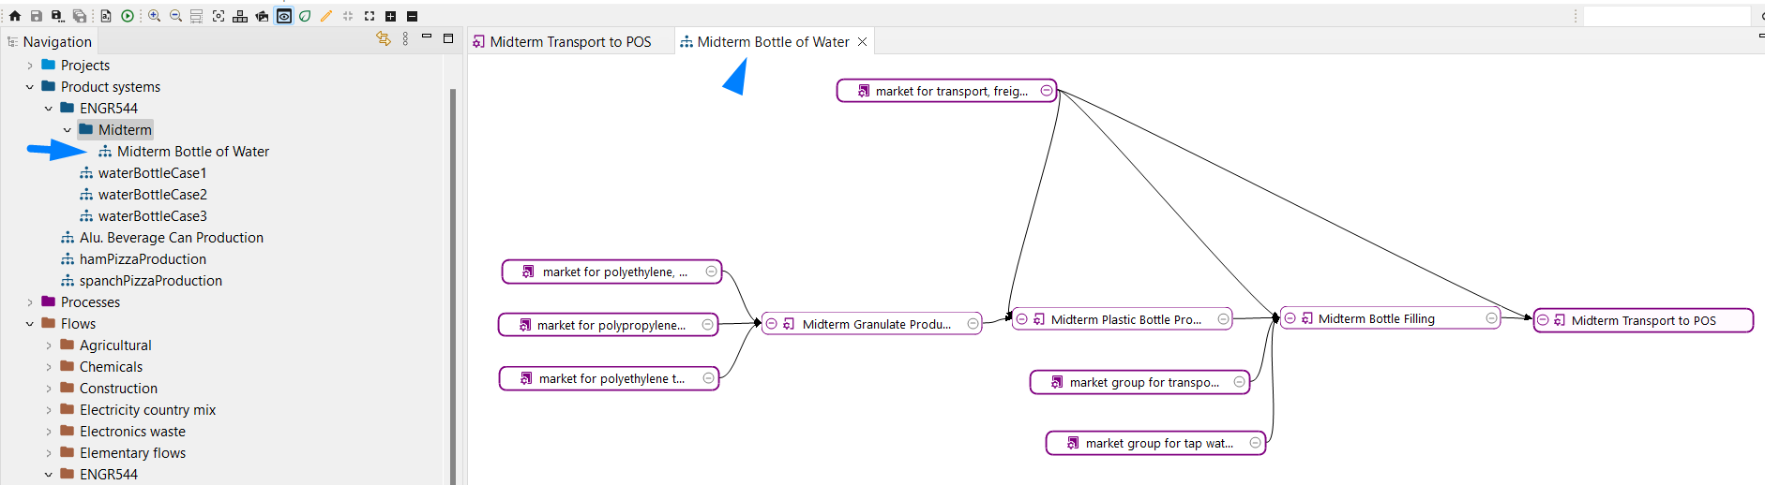

# Project

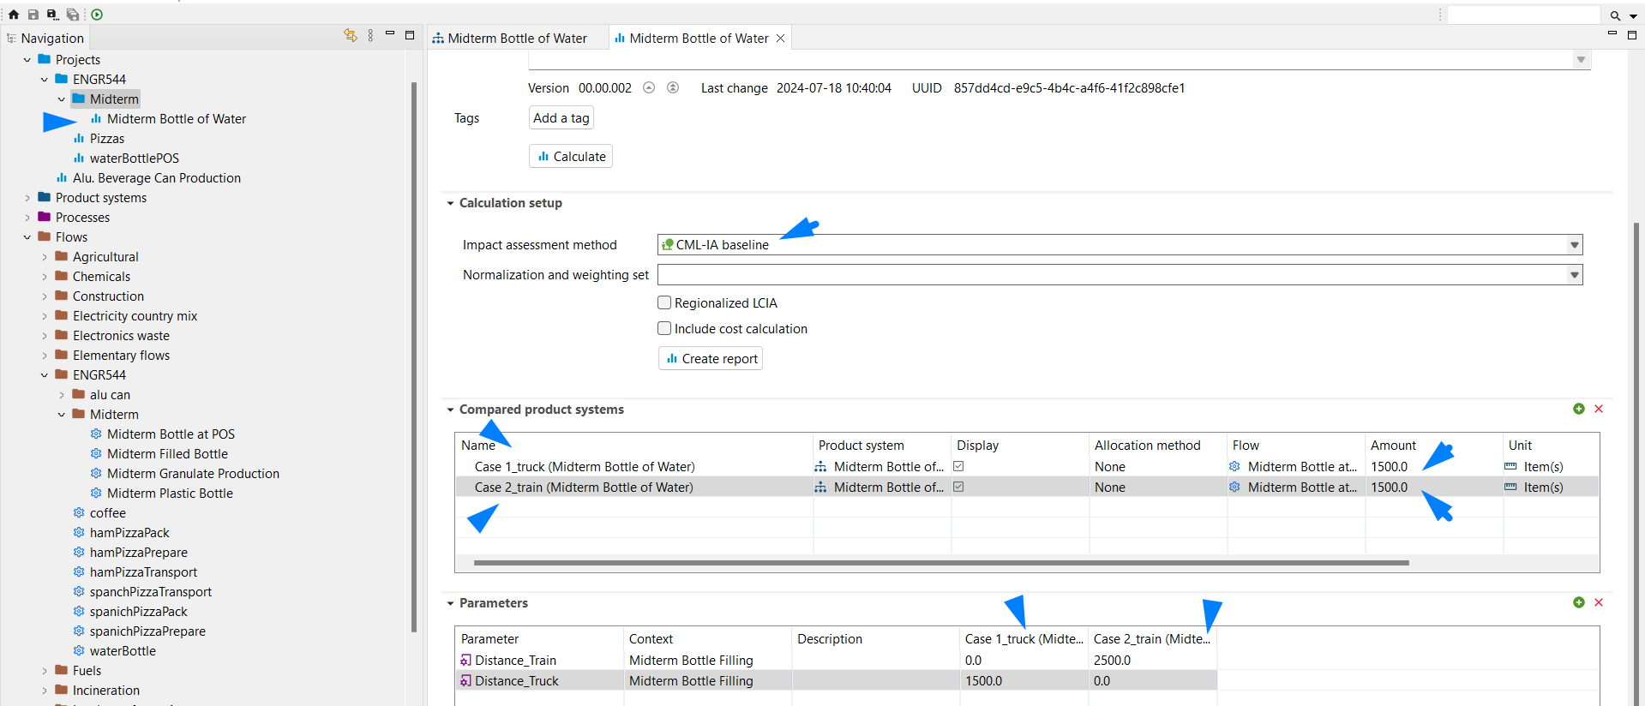

Report Configuration

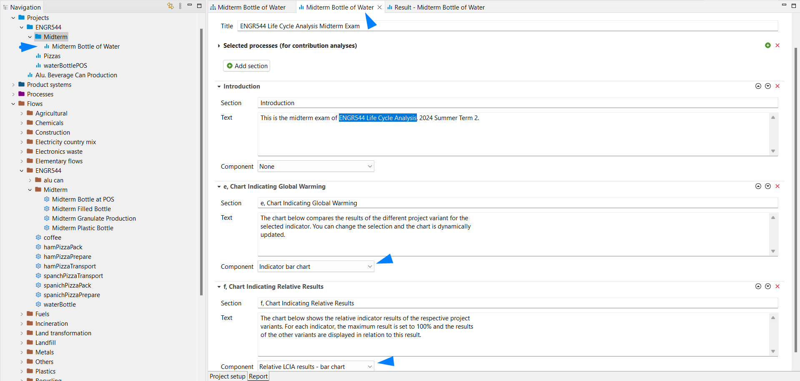

Analysis Result

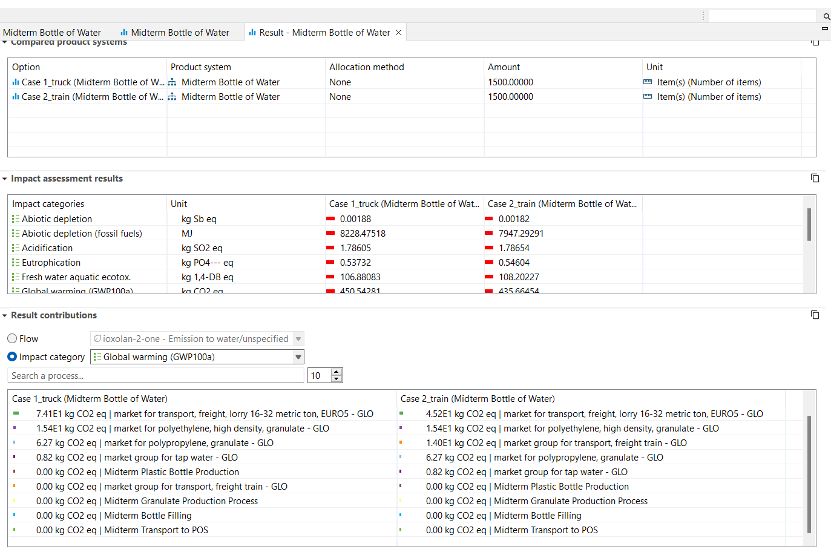

# Chart indicating global warming

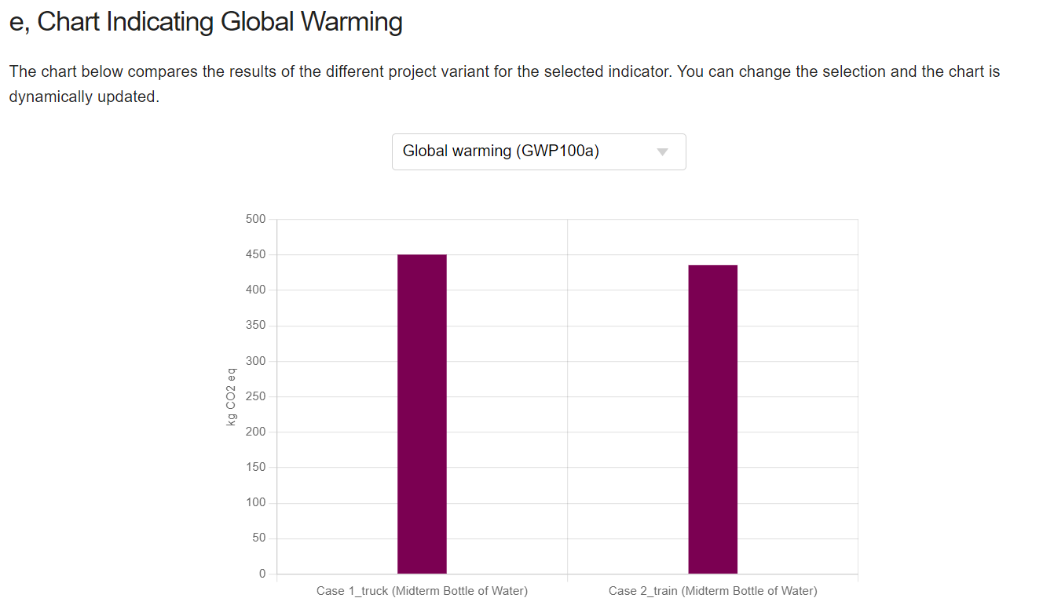

# Chart indicating relative results

