ENGR580 Project Proposal

**Background**

I bought a drone development board last year, which is equipped with an ESP32-S3 microcontroller, a barometer, a compass, an accelerometer and a gyroscope, Figure 1. I was planning to develop a controller firmware, yet found it was too complicated for me. This is one of the reasons why I selected this course.

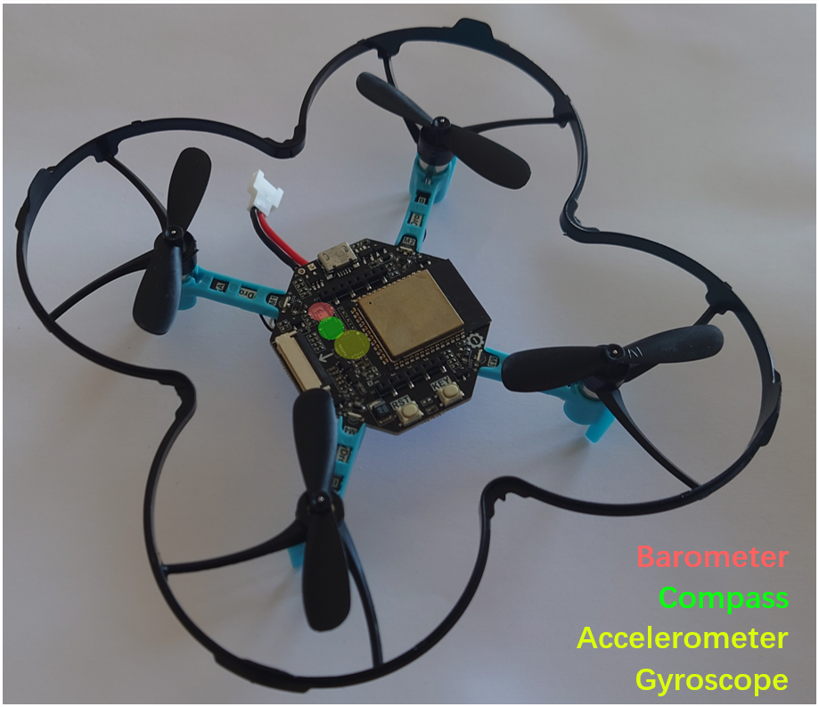

Figure The Drone with 4 DC motors with varieties of sensors.

**Method**

The mathematical model will be constructed according to the master thesis by Francesco Sabatino[1]. The states will be defined as translational and angular positions and velocities in 3 directions. The input will be defined as pulling force generated by 4 propellers. The translational and angular positions will be defined as output. Therefore, the system will have 4 inputs and 6 outputs.

A nonlinear feedback controller will be developed to maintain the stability of the drone. The physical parameters of the drone, including mass, inertia, propeller lifting force, and physical dimensions, will be measured for simulation.

**Project Goals**

The controller property will be examined by altering the parameters.

The performance of the controller will also be tested under noise.

The stability of the drone in wind will be simulated and tested.

Finally, the possibility of constructing a feedback controller only using the measurable variables, e.g., readings from barometer/compass/accelerometer/gyroscope will be tested.

**Reference**

[1] Sabatino, Francesco. "Quadrotor control: modeling, nonlinear control design, and simulation." (2015).