

Social-Oriented Philosophy

Worldview Mindset of Horizon Project

Written By: Mahyar Esteki

Document Version: 1.1

Release Date: October 10, 2025

The wrong norm creates the wrong culture.
And the wrong culture will be the architect of great crises.
Contents
1 Abstract 4
2 Keywords 4
3 Authoritarian Socialism 4
4 What is the Social-Oriented Philosophy? 7
5 The Root of the Word “Social-Oriented” 8
6 Advantages of Social-Oriented 9
7 Social-Oriented vs Authoritarian Socialism 9
8 What warranty is there for this one? 10
9 Conclusion 11
10 References 11
11 Appendix I: About Author 13
12 Appendix II: About Horizon Research Project 13

Abstract
Basically, the solutions of human societies to solve problems are based on specific philosophies and social theories that have been formed over time. This structure is completely understandable. Because past experiences show that changing approaches suddenly without improving the level of knowledge in managerial and social behaviors can have unpleasant consequences. Instability in the process of scientific progress of social affairs can cause irreparable damage to the society. But at some points in history, human beings may have come to the conclusion that the philosophy they have followed has serious flaws and should make significant changes in it. This wrong approach can exist even in the most humane and social philosophies presented in human history. For example, one of the most humane ideologies in history is “socialism”, which is a part of the anti-human actions in history based on this philosophy, and even today it is a suitable propaganda tool for capitalist governments to suppress any kind of political criticism or suggestion of social changes.
It is definitely not possible to question an ancient and great idea, such as socialism, with a simple article, or to deny humanitarian services based on it. But it is possible to learn from its historical mistakes and optimize approaches. As long as the current social approaches in various fields are faced with government propaganda labels, traditional methods cannot be used to solve managerial and social problems. In many cases, the problem is: “Many of the social solutions presented throughout history are not based on political contexts, motivations, or goals. But in public opinion, they fall victim to the unfavorable records of old ideologies.” In this article, an attempt is made to propose a suitable and alternative basic method for raising non-political social issues to the audience so that social changes based on it can be designed, followed and implemented.

Keywords
Social Approach, Philosophy, Social Management

Authoritarian Socialism
Although the roots of socialism go back to the ideas of Plato, many researchers consider the peak of maturity of the philosophy of socialism to be the period of Karl Marx. Socialism in this period becomes a political philosophy from a sociological approach. Its purpose is to create a social and economic order based on equality, meaning that all strata and classes of society have an equal share in the popular benefit.[1][2][3] This political philosophy has had tremendous effects on the advancement of human social consciousness. The founding of the International Women's Day, the fight against dictatorial governments in South America, environmental campaigns, the fight against the apartheid government of South Africa, and efforts to create economic justice in the Scandinavian countries can be mentioned as part of the effects of socialism on the world. But along with all the positive efforts of this political attitude, the traces of socialism can be seen in many anti-human tragedies of history.
 | Maximilian Francois Marie Isidore de Robespierre: During the period of terror, at least 300,000 accused were arrested, of which 17,000 were executed and probably 10,000 died in prison or without trial. [4][5][6][7]
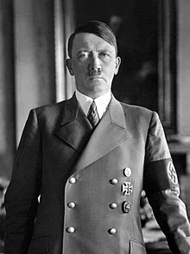 | Adolf Hitler: World War II was by far the deadliest conflict in history, resulting in 70–85 million fatalities. Millions died due to genocides, including the Holocaust, as well as starvation, massacres, and disease. [8][9][10][11][12][13]
 | Joseph Vissarionovich Stalin: His regime has been widely condemned for overseeing mass repression and man-made famine which resulted in the suffering and deaths of millions of Soviet citizens. [14][15][16]
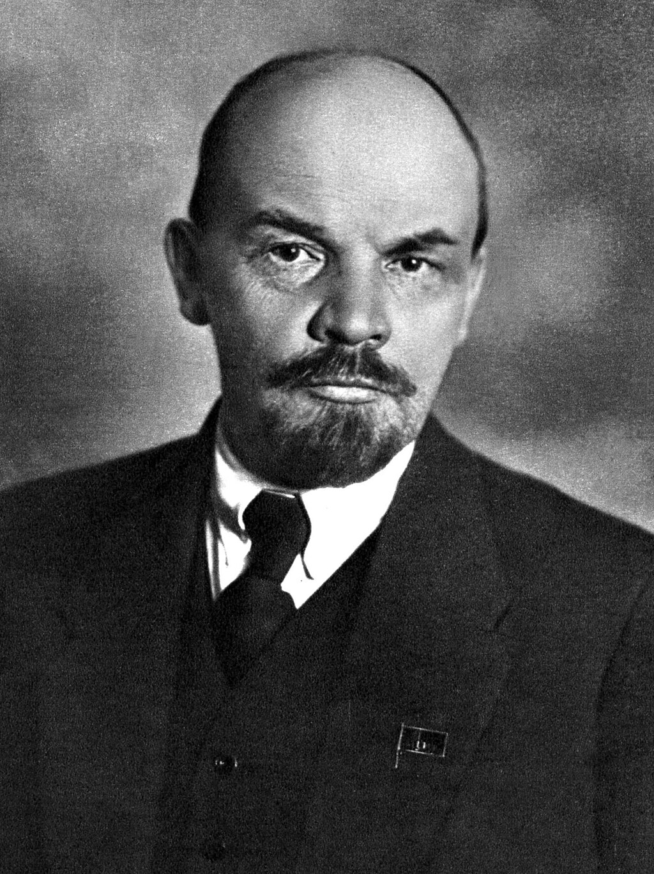 | Vladimir Ilyich Ulyanov, Most historians attribute the violent execution of the Romanov family to the Moscow government, specifically Vladimir Lenin and Yakov Sverdlov, who wanted to prevent the Czechoslovak Legion from rescuing the Russian Imperial Family during the Russian Civil War. His critics condemn him for establishing a dictatorship which oversaw mass killings and political repression. [17][18][19][20]
 | Saddam Hussein: He formed a highly authoritarian government and was able to maintain power during the Iran-Iraq War (1988-1988) and the Persian Gulf War (1991 AD), both of which caused a decline in living standards and human rights in Iraq. Saddam's government suppressed all the movements that it believed to be threatening, especially those that arose from religious or ethnic groups and had the idea of independence or autonomy. The Economist weekly has described him as one of the greatest dictators of the late 20th century, and the New York Times has described him as one of the most brutal dictators in modern history. [21][22][23]
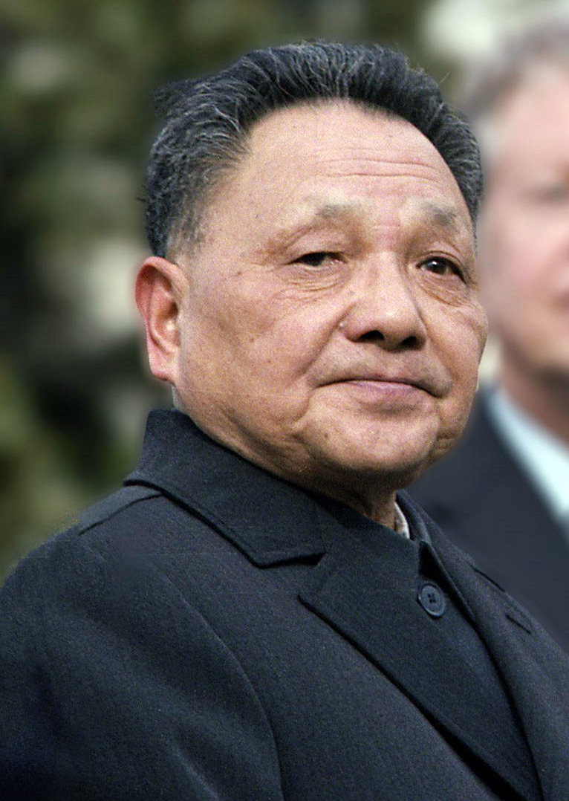 | Deng Xiaoping: In 1989, during the movement towards free market capitalism, he crushed the protests of Chinese pro-democracy students in Tiananmen Square and launched a massive crackdown. [24][25][26]
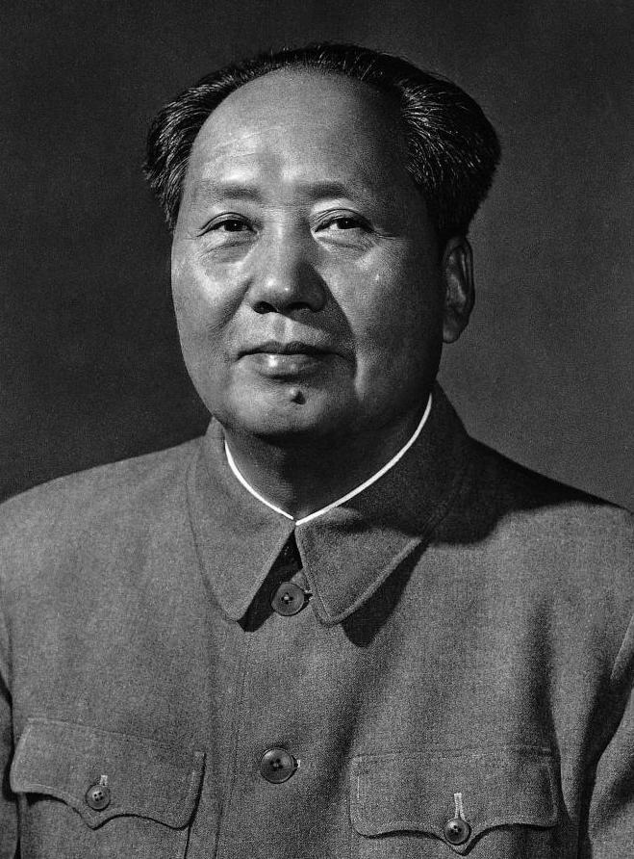 | Mao Zedong: Mao's policies resulted in a vast number of deaths, with tens of millions of victims of famine, political persecution, prison labour and executions, and his regime has been described as totalitarian. [27][28][29][30][31]
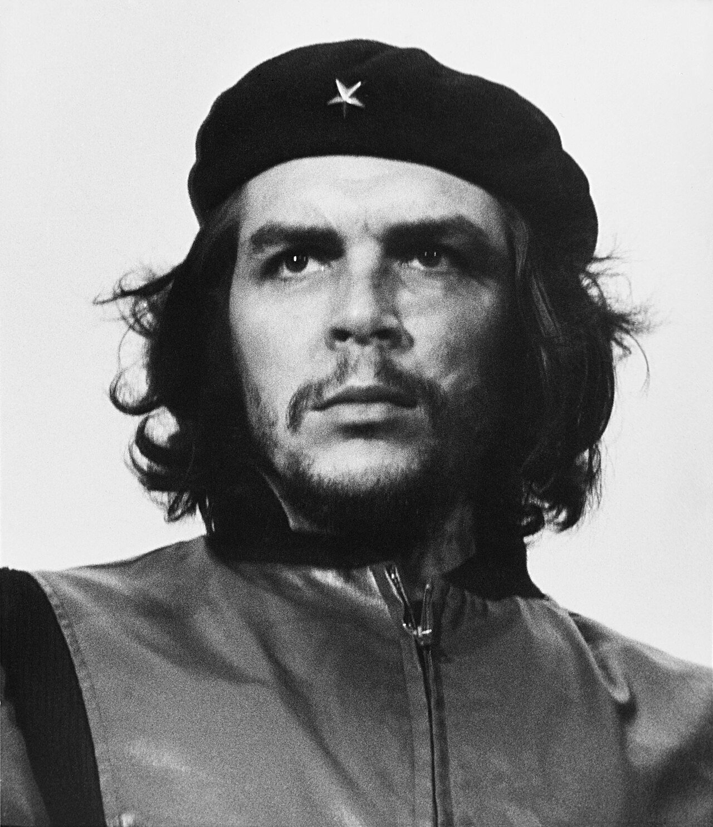 | Che Guevara: By the time Guevara arrived in Cuba the United States had already discovered the Soviet troops in Cuba via U-2 spy planes. A few weeks after the crisis, during an interview with the British communist newspaper the Daily Worker, Guevara was still fuming over the perceived Soviet betrayal and told correspondent Sam Russell that, if the missiles had been under Cuban control, they would have fired them off. While expounding on the incident later, Guevara reiterated that the cause of socialist liberation against global “imperialist aggression” would ultimately have been worth the possibility of “millions of atomic war victims”. [32][33][34]

What is discussed above is only a fraction of those who have seized power exclusively by claiming socialism and who easily decide for freedom and even human life. As explained, heroes like Che Guevara also value humanity less when they are in power. Governments formed based on the thoughts of such people are called “authoritarian socialism”, which shows a set of economic-political systems that describe themselves as socialist and they reject concepts such as liberal-democracy, multi-party politics, freedom of assembly, summons to arrest and freedom of speech because of the fear of counter-revolution or as a means for socialist goals. Absolutism is the essence of power. When the seizure of power is introduced as a tool to realize social ideals, justice will lose its way like a derailed train.
The realization of social ideals is possible through the passage of fair laws and their correct implementation. No matter what government is at work. If it is possible to monitor the functioning of governments by implementing laws, then the realization of social justice will not be far from expected. In such a situation, seizing power cannot be the only way to reach the goal. When governments dominate the judiciary and interpret the law as they please, even in the best parts of the world, the possibility of a dictatorship will increase. As a result, for the people who fight for the realization of social justice, the main goal should not be to seize power. Rather, the first principle should be based on the “development of law and the strengthening of just laws”. Creating an independent judiciary and not concentrating the power of the armed forces in the hands of a specific person is the solution to create a governance that can gradually bring social justice.

What is the Social-Oriented Philosophy?
If the main goal in challenging autocratic governments is to reduce the limits of the authority of statesmen, this means that every person who relies on the first position of the government must have a limited authority. As a result, the appeal of power in the first place will be lost for protesters. This approach reduces the deviation of public protests regarding social justice towards deceitful revolutions. Revolutions that transfer power from a dictator to a more dangerous dictatorship as a result of a series of violent actions. As a result, the goal of all public demands in a society should be to strengthen the law against the institutions of power in order to achieve social justice. Even if fundamental changes are to be made in the main institutions of power, this transformation should be carried out through public demands. Society is the main axis of all social movements. Individuals or specific parties cannot exclusively represent the opinion of society. Leaders should only promote public demands and cannot add issues to the list of society's needs with their personal opinion. At all times, they should try to hold the current government accountable to society.
It is the community that decides on the transformation at the top of the power pyramid, and the leaders should only support the decision of the community without wanting to impose their personal opinions on this matter. This is the basis of a nascent philosophy called “social-oriented” in which, instead of complex ideologies, the provision of the basic needs of society and social justice is the priority of civil demands. Advancing an ideology or defeating a philosophy is no longer the goal of a social-oriented approach. When society focuses on the victory or defeat of the rulers, the conditions are created for the seizure of power by self-interested individuals. This will be the starting point of a bloody revolution. But the goal of the society should always be to improve the conditions without blindly seeking to undermine the foundations of power. Changing the foundations of power without knowing the real purpose and needs of society will only lead to more disastrous dictatorships.
In the philosophy of socialism, there is a belief that society is a colony of people who do not necessarily have the same tastes and views. But because of a set of goals, they cooperate with each other and have a common life. It is not possible for two people to exist in the same colony with the same interests, desires, abilities and thoughts. As long as the wishes of a person do not conflict with the law and human principles, that person cannot be prohibited from reaching his/her wishes in an extra-legal way. One person may want to teach and another person may want to be an entrepreneur. In this scenario, it is never possible to label the second person as a supporter of capitalism simply by having a fighting and challenging spirit.
The philosophy of social-oriented draws its own rules, which clearly distinguish it from previous approaches. These rules are a set of ideas that simultaneously recognize both individual and social interests and try to determine criteria for the gradual improvement of justice at the level of society without the use of coercive forces. These rules will be discussed below.
- Improving social conditions is a gradual process: This law reminds people that establishing social justice is not a process that can be outlined in a short or even specific period of time. As a result, the use of coercive and extralegal forces to achieve this goal will only pave the way for authoritarian individuals to dominate the throne of power.
- Society is not a flat earth: This law reflects the acceptance of different classes in society and the existence of a plurality of opinions among people. Any insistence on homogenizing different individuals and classes is only a tool for creating a different kind of slavery within society.
- Society is a ladder: the class gap in society must be such that the path of advancement from one class to another is possible for all people in the lower class.
- Society is not a marathon: This law states that knowingly standing at the bottom of the ladder (the lower rungs of society) should not be a factor in being pressured or humiliated. Progress and movement towards progress and the upper rungs of society should never be forced upon individuals.
- The path of progress in society is like climbing Everest: on Everest, people climb within certain limits based on their abilities, goals, and interests. Some people may only climb to Camp 1, while others may even conquer the summit. As a result, capable people in a society should not be considered a source of inspiration because of their ambitions.
- Society is not like a development project of the Triple Pyramid: if individuals are striving to achieve continuous and incremental progress, this decision should not become a factor in enslaving or oppressing a large segment of society.
These six laws clearly state that accepting the diversity of classes and views of a society is inevitable and that humans never act in the same way. Different people in a colony do not choose different paths in life according to their views. As a result, no ideology can impose a single solution on all members of a society. The main issue is to establish relative justice among all classes of society and its continuous improvement. The path of progress should never be blocked for the advanced people in a colony. On the other hand, it must be ensured that the efforts of this social class to achieve their goals do not disrupt the safety, welfare and comfort of other classes.

The Root of the Word “Social-Oriented”
In information technology, sometimes when referring to the centrality of a type of architecture, design and management of the structure, the suffix "oriented" is used. such as object-oriented or service-oriented architectures. Since the origin of sociological thinking was an information technology specialist, this name was chosen for this philosophy of social management. In fact, this word emphasizes the centrality of desire and collective interests without ignoring individual interests and human desires.

Advantages of Social-Oriented
Social-oriented philosophy tries to prevent the emergence of vampire dictatorships with flashy social slogans while helping society move towards social justice. The advantages of the social-oriented approach compared to the socialism philosophy are listed below.
- Reducing the greed of political activists to seize power.
- Increasing the focus of civil movements on improving the level of social justice.
- Empowerment of judicial and parliamentary institutions in order to monitor power institutions.
- Prioritizing collective interests over individual interests.
- Reducing the unconditional dominance of social movement leaders in order to prevent the imposition of their personal opinions on the list of civil requests.
- Reducing the possibility of sudden and out-of-control changes in society.
- Replacing the evolution approach instead of revolution to achieve social goals.
- Focusing on raising collective awareness before making any changes in society.

Social-Oriented vs Authoritarian Socialism
In authoritarian socialism, humans are the cells that make up the main colony. All of them must take steps towards the goals of the colony. In such a situation, when the colony encounters different opinions and critical views, it considers those people as cancer cells and starts to eliminate them. When asked what the main goal of the colony is, to the surprise of the proponents of socialism, they answer: “Peace and exaltation of the people!!!” This is despite the fact that in historical moments prominent socialist figures like Guevara are not afraid of sacrificing the people for their ideals. They advocate a nuclear war to defeat imperialism. Even if it does not lead to the death of millions of people. They look at human societies like ant colonies and imagine themselves as soldier ants who must defend the worker ants against predators. If there are no similarities between these two societies. One can never find the pluralism and breadth of goals that exist in human societies in an ant colony.
It may be claimed that this type of attitude is related to classical socialism, and today there are many examples in European countries that refute this claim. It should be noted that the European socialists, according to what they learned from World War II, realized that the expression of traditional views causes the young generation to distance themselves more and more from them. Because the historical memory of societies does not show a positive reaction to such ideas. As a result, the new approaches in the left-wing parties only caused some surface changes and reduced unbridled violence.
The main issue is to focus on solving social problems. When the seizure of power is presented as a means to this end, attention will be diverted from the main issue to the broad margins. Because the seizure and control of power is itself a complex issue. That is, people who claim to solve a major social problem unintentionally involve themselves in far more complex and intricate situations. As a result, the likelihood of deviation from the main issue will increase significantly. On the other hand, power is inherently associated with corruption, and it requires additional energy to control it. Basically, human societies do not need people who seek to eliminate discrimination and corruption by taking power. Rather, the main need is for people who are willing to monitor those in power outside the circle of power.
When the real focus is on solving social problems, it will be understood that without accepting the opinions of all classes of a society, a comprehensive solution cannot be proposed. No group throughout history has been able to institutionalize its solutions among the people by threatening one class of society. Because sooner or later, collective intelligence comes to the conclusion that if there is a threat to a certain class, there is no guarantee that this threat will not spread to other sectors. Therefore, by distancing itself from threatening certain segments of society and focusing on creating appropriate opportunities for all classes, the social-oriented ideology attempts to spread justice and prosperity fairly (rather than equally) in society.

What warranty is there for this one?
The question may be asked, what is the guarantee that this attitude and ideology will not suffer the dark fate of socialism? The answer is that it is really impossible to provide a guarantee in this regard. Thoughts, attitudes and ideologies are known through their followers throughout history, not their creators. When extreme and radical tendencies emerge in a philosophy, that ideology will move towards transformation over time. The only way to maintain an ideology is to avoid radical attitudes. When Lenin entered the circle of Bolsheviks with extreme slogans, he could not tolerate the moderate ideas of the Mensheviks. Today, most people remember the Russian revolution with the face of the extreme Bolsheviks and not the moderate Menshevik figures.
Extremists such as Lenin, Stalin, Mao and Adolf Hitler with their charismatic personalities have transformed the ideas of Karl Marx so powerfully that it is as if the Marxist attitude was this way from the beginning. Although Germany, Norway, Switzerland, and Sweden in 2024 are more similar to Marx's ideas, the people of the world compare him with people like Lenin or Stalin. Therefore, how well one can theorize is of secondary importance. The main issue is to protect an ideology against radicalism so that it can continue to survive for many years without its image being distorted in public opinion.
To achieve this goal, two principles must be accepted. First, no ideology can issue general and definitive rulings to make decisions about human lives. Second, a desirable ideology cannot selfishly impose a method on people that has a negative impact on the macroeconomics of society. In order to avoid providing a destructive solution in macroeconomics, the principle of the existence of different social classes and different attitudes should be accepted. What is important is that the increasing distance between the social classes and the growing poverty in the lower classes should be prevented. This approach is an undeniable principle in the philosophy of social-oriented.

Conclusion
In summary, it can be concluded that the paths to improving the life of human society do not lead solely to classical and well-known solutions. With the growth of awareness in societies, it can be hoped that in the future new and improved solutions will be used by decision-making institutions and organizations to resolve the long-standing conflicts of old ideologies. What can make the future pleasant for humanity is to learn from past mistakes and strive to continuously improve existing conditions.

References
[1] The Knowledge Book: Everything You Need to Know to Get by in the 21st Century. National Geographic Society. 2009.
[2] Busky, Donald F. (2000). Democratic Socialism: A Global Survey. Praeger. p. 2. ISBN 978-0-275-96886-1. Socialism may be defined as movements for social ownership and control of the economy. It is this idea that is the common element found in the many forms of socialism.
[3] Arnold, N. Scott (1998). The Philosophy and Economics of Market Socialism: A Critical Study. Oxford University Press. p. 8. “What else does a socialist economic system involve? Those who favor socialism generally speak of social ownership, social control, or socialization of the means of production as the distinctive positive feature of a socialist economic system.”
[4] O'Brien, James Bronterre (1837). The Life and Character of Maximilian Robespierre. Proving... thaourt that Much Calumniated Person was One of the Greatest Men ... pp. 415–421.
[5] "Maximilien Robespierre | Biography, French Revolution, Reign of Terror, Facts, & Death | Britannica". 2 May 2023.
[6] "Reign of Terror | History, Significance, & Facts | Britannica". www.britannica.com. Retrieved 2022-12-31.
[7] Jordan, David P. (2013). Revolutionary Career of Maximilien Robespierre. Simon & Schuster. ISBN 978-1-4767-2571-0.
[8] Kershaw, Ian (2000b). Hitler, 1936–1945: Nemesis. New York; London: W. W. Norton & Company. ISBN 978-0-393-32252-1.
[9] Kershaw, Ian (2008). Hitler: A Biography. New York: W. W. Norton & Company. ISBN 978-0-393-06757-6.
[10] Kershaw, Ian (2012). The End: Hitler's Germany, 1944–45 (Paperback ed.). London: Penguin. ISBN 978-0-14-101421-0.
[11] Shirer, William L. (1960). The Rise and Fall of the Third Reich. New York: Simon & Schuster. ISBN 978-0-671-62420-0.
[12] Overy, Richard (2005). The Dictators: Hitler's Germany, Stalin's Russia. London: Penguin Books. ISBN 978-0-393-02030-4.
[13] Bullock, Alan (1999) [1952]. Hitler: A Study in Tyranny. New York: Konecky & Konecky. ISBN 978-1-56852-036-0.
[14] Conquest, Robert (1991). Stalin: Breaker of Nations. Penguin. ISBN 978-0-1401-6953-9.
[15] Brent, Jonathan; Naumov, Vladimir (2004). Stalin's Last Crime: The Plot Against the Jewish Doctors, 1948–1953. HarperCollins. ISBN 978-0-0620-1367-5.
[16] Service, Robert (2004). Stalin: A Biography. Macmillan. ISBN 978-0-3337-2627-3.
[17] Sebestyen, Victor (2017). Lenin the Dictator: An Intimate Portrait. London: Weidenfeld & Nicolson. ISBN 978-1-47460-044-6.
[18] Fischer, Louis (1964). The Life of Lenin. London: Weidenfeld and Nicolson.
[19] Rice, Christopher (1990). Lenin: Portrait of a Professional Revolutionary. London: Cassell. ISBN 978-0-304-31814-8.
[20] Service, Robert (2000). Lenin: A Biography. London: Macmillan. ISBN 978-0-333-72625-9.
[21] Con Coughlin, Saddam: The Secret Life Pan Books, 2003 (ISBN 978-0-330-39310-2).
[22] Karsh, Efraim; Rautsi, Inari (2002). Saddam Hussein: A Political Biography. Grove Press. ISBN 978-0-8021-3978-8.
[23] Coughlin, Con (2005). Saddam: His Rise and Fall. Harper Perennial. ISBN 978-0-06-050543-1.
[24] Faison, Seth (20 February 1997). "Deng Xiaoping is Dead at 92; Architect of Modern China". The New York Times. ISSN 0362-4331. Archived from the original on 23 January 2017. Retrieved 19 April 2021.
[25] "Deng Xiaoping: Architect of modern China". China Daily. 2014. Archived from the original on 23 June 2024.
[26] Wu, Wei (4 June 2015). "Why China's Political Reforms Failed". The Diplomat. Archived from the original on 13 April 2023. Retrieved 3 May 2020.
[27] Carter, Peter (1976). Mao. London: Oxford University Press. ISBN 978-0192731401.
[28] Clisson, Tim (2014). Chinese Rules: Mao's Dog, Deng's Cat, and Five Timeless Lessons from the Front Lines in China. New York: Harper. ISBN 978-0062316578.
[29] Pottinger, Jesse (26 August 2019). "Explainer: Mao Zedong or Mao Tse-tung? We Have the Answer". That's Online. Retrieved 24 April 2020.
[30] Perry, Elizabeth J. (14 January 2013). "Anyuan: Mining China's Revolutionary Tradition". The Asia-Pacific Journal. 11 (1). ISBN 978-0520271890. reprinting Ch 2 of Elizabeth J. Perry. Anyuan: Mining China's Revolutionary Tradition. Berkeley: University of California Press, 2012.
[31] Marquis, Christopher; Qiao, Kunyuan (2022). Mao and Markets: The Communist Roots of Chinese Enterprise. New Haven: Yale University Press. ISBN 978-0-300-26883-6. OCLC 1348572572.
[32] Crompton, Samuel (2009). Che Guevara: The Making of a Revolutionary. Gareth Stevens. ISBN 978-1433900532.
[33] Anderson, Jon Lee (1997). Che Guevara: a revolutionary life. New York: Grove Press. ISBN 0802116000.
[34] Guevara, Ernesto; Deutschmann, David (1997). Che Guevara Reader: Writings by Ernesto Che Guevara on Guerrilla Strategy, Politics & Revolution. Ocean Press. ISBN 1875284931.

Appendix I: About Author
Mahyar Esteki is an Iranian system analyst who pursues his research in the field of improving and upgrading banking, fintech, and e-commerce systems. He holds a bachelor's degree in software engineering from Staffordshire University. Esteki conducts separate research to improve the software development process. He has created Horizon Research Project (HRP) to centralize his range of activities.
LinkedIn Profile: https://www.linkedin.com/in/mahyaresteki/

Appendix II: About Horizon Research Project
Horizon is a research project to find new solutions in the field of information technology project management, which tries to ensure the health of the developers' work environment and the existence of social justice in technology companies in addition to providing consumer opinion.
Objectives:
- Is it possible to use a methodology in the software development process that in addition to improving the development process and product implementation, the interests of all project stakeholders are fairly provided, and social principles are observed throughout the project?
- Is it possible to ensure the human rights of the employees during the project without interfering with the project obligations?
- Can this model become a permanent culture in the organization?
GitHub Page of the Project: https://github.com/mahyaresteki/Horizon

