

Theory of Endurance Software Development Methodology

Mindset for the Solution in Horizon Project

Written by: Mahyar Esteki

Document Version: 1.1

Release Date: September 11, 2025

The wrong norm creates the wrong culture.
And the wrong culture will be the architect of great crises.
Contents
1 Abstract 5
2 Keywords 5
3 Philosophy of Endurance Development 5
3.1 Rapid or Endurance? This is a Problem! 5
3.2 Main Problems of Rapid Development 7
3.2.1 The First Problem: Culture of “Scissors and Red Ribbon” 7
3.2.2 The Second Problem: The Illusion of a Fast World 8
3.3 Reality of Agile Methodologies 10
3.4 New System of Slavery 11
3.5 Disadvantages of Agile Methodologies 14
3.6 Why is agile methodology ineffective? 15
3.6.1 United States: Great Depression between 2008 and 2012 16
3.6.2 Iran: Hyperinflation between 2018 and present 17
3.6.3 Compression between examples 18
3.7 Real Social Justice 18
4 About Endurance Methodology 20
4.1 What is ESDM?‌ 20
4.2 Advantages of ESDM 23
4.3 When does ESDM not work? 24
4.4 Examples of Endurance Projects in Real World 24
4.4.1 Joint Strike Fighter (JSF) Program 24
4.4.2 Competition between Windows and Linux 25
4.4.3 Competition between Symbian, iOS and Android 25
4.4.4 Falcon 9 27
4.5 Criticism against ESDM 27
5 Best Project Types to Use 28
5.1 Project Management Perspective 28
5.2 Production Perspective 28
5.3 Software Engineering Perspective 29
5.4 ‌Business Perspective 29
6 Principles of ESDM 30
6.1 Economic Model 30
6.2 Rules for Business Contracts 34
6.2.1 Project Contract 35
6.2.2 Employement Contract 36
6.2.3 Freelancing, Outsourcing and Project Based Contracts 38
6.2.4 Personal Projects 38
6.2.5 Startups and Accelerators 39
6.3 Rights of Staff 39
6.4 Roles and Responsibilities 40
6.5 Project Management Based on ESDM 42
6.5.1 Analysis and Requirement Gathering 42
6.5.2 Project Scope Adjustment 44
6.5.3 ESDM Fishbone Model 46
6.5.4 Task Schedule Balancing 49
6.5.5 Change Management 51
6.5.6 Iteration Management 52
6.5.7 Project Controlling 53
6.6 Meetings 54
6.6.1 Technical Meetings 56
6.6.1.1 Analysis Meeting (AM) 56
6.6.1.2 Project Control Daily Chat (PCDC) 57
6.6.1.3 Weekly Review Meeting (WRM) 58
6.6.1.4 DevOps Meeting (DOM) 59
6.6.2 Product Delivery Meetings 59
6.6.2.1 Sprint Cabinet Meeting (SCM) 59
6.6.2.2 Millstone Delivery Meeting (MDM) 60
6.6.3 Management Meetings 61
6.6.3.1 Feasibility Study Meeting (FSM) 61
6.6.3.2 Project Management Office Meeting (PMOM) 62
6.6.3.3 Corrective and Preventive Actions Meeting (CAPAM) 62
6.6.4 General Rules of Meetings 63
6.7 Project Documentation 63
6.8 Project Modeling 64
6.9 Managers' Responsibility about Risks 65
7 Conclusion 67
8 References 68
9 Appendix I: About Author 73
10 Appendix II: About Horizon Research Project 73

Abstract
Faulty economic systems create faulty production cycles. A monopoly economic system can create methods and mechanisms in production cycles that exploit the labor force and difficult economic conditions of that class to increase its wealth. The workforce in the IT industry is no exception to this rule and has always been exploited using various management methods. This abuse of IT professionals has created the conditions for the growing monopoly of large technology companies. Today, with various tricks such as those used in agile methodology, employees' time is used illegally for the benefit of organizations. In most cases, specialists have to work more than office hours to deliver a product or service quickly. It has been instilled in human societies that the benefits of rapid development progress will be evenly distributed in society. But studies show that not only has this trend increased and accumulated wealth in the capitalist class, but it has also led to environmental degradation. Rapid development methods reduce the quality of software products and services and consequently lead to user dissatisfaction. This production model is the cause of the semi-completion of many attractive and applied projects in the IT industry, which are led by small software teams. In this research, the theory of the possibility of creating a new methodology has been explored while maintaining the interests of the customer, employer, and employee to try to create “social justice in the information technology industry” and economic structures more beneficial to human societies. The methodology also helps small software teams figure out how to advance huge projects with limited financial resources and manpower.

Keywords
Project Management, Software Engineering, Software Development Methodology, Social Justice, HSE, Anti-monopoly.

Philosophy of Endurance Development

Rapid or Endurance? This is a Problem!
The best example to better understand the philosophy of "endurance projects" is to compare the 100-meter with the marathon sprint. No one can run a 100-meter in less than 10 seconds with the techniques of a marathon runner, and it is impossible to run the entire 42 kilometers without drinking water and at the speed of Usain Bolt! Every competition requires its techniques and no one can manage all projects in the same way with the same pattern.
The capabilities of the group, the type and volume of resources available, scheduling, requirements, and specific security sensitivities are influential in determining the techniques required for project management. Usain Bolt is a legendary man in the 100 meters and 400 meters. But he has no place in endurance competitions. This is not a reason for his inability. It reflects the different needs in an endurance competition such as the marathon.
Spending time, patience, perseverance and good materials are the keys to achieving the desired quality in making some products. A kitchen knife may be made using recycled spring-loaded steel in a matter of days or even hours. But a katana (the famous sword of the Japanese samurai) with the best type of steel requires at least 6 months of time and 15 manpower to produce.[1] A fire-fighting station cannot be managed with endurance patterns and gradual development. In the field of emergency services, responses must be prompt and effective in accordance with the events that have occurred. In such services, time is considered determining element. But do all services and products need to be managed with a fire-fighting culture? Should all activities manage according to a rapid response pattern?
It is undeniable that rapid development patterns serve only the interests of a limited segment of society. That is why this method of development is so popular among private sector investors. With the slogan of profitability for the company and survival in the labor market, all private sector managers force employees to follow their desired development patterns, claiming that this method serves the interests of all parties involved in the business. But when these companies become super companies, the profits of their owners and shareholders from the business have multiplied, but the salaries of their employees have not changed much. Many people who are hired by these companies are at risk of physical and mental illness due to the stress of rapid development patterns. Often even the social risks of high workloads, such as the breakdown of family and marital relationships, threaten these people.
In other words, rapid development can never fairly serve the interests of society, and as usual, capitalists will reap the greatest possible benefit from a rapid change. Implementing the rapid development method does not even have much collective benefit and may even cause harm to communities. The best example is the development of the Windows operating system. It could be argued that Microsoft's operating system has helped the global community expand its use of computers. But certainly, this operating system was the source of many security intrusions in developing countries from 1990 to 2009. The fact is that the development program of the Windows operating system from version 3.0 to Vista is based on the pattern of rapid development. This haste in the development of an operating system reduced the quality and caused numerous security holes in its various parts.
It remains to be seen whether it is possible to provide a way to develop software that literally serves the interests of all three sides of the human resources triangle involved in a project (customer, employer, and employee). Is it possible to deliver a software project in a reasonable time without putting unreasonable pressure on the staff? Will it be possible to advance personal projects without enduring irrational pressures? Can sensitive projects implemente with limited human resources without putting unnecessary pressure?
John Stephen Akhwari represented Tanzania in the marathon at the 1968 Summer Olympics in Mexico City. At the 19-km point during the 42-km race, there was jockeying for position between some runners and he was hit. He fell badly wounding his knee and dislocating that joint plus his shoulder hit hard against the pavement. He however continued running, finishing last among the 57 competitors who completed the race (75 had started). The winner of the marathon, Mamo Wolde of Ethiopia, finished at 2:20:26. Akhwari finished at 3:25:27 when there were only a few thousand people left in the stadium, and the sun had set.[2] When interviewed later and asked why he continued running, he said, “My country did not send me 5000 miles to start the race; they sent me 5000 miles to finish the race.”[3]
Interestingly, after many years, almost no one remembers the three medal winners of the 1968 Summer Olympics, but Akhwari has become one of the great symbols of all Olympic times because of his endurance. This incident clearly showed that the quick completion of a task can in no way guarantee its immortality. This may contradict the theory that it is never possible for the same thing to happen in sprints such as the 100-meter dash. At 105, Hidekichi Miyazaki – AKA the Golden Bolt – has become the world’s oldest competitive sprinter, breaking his own 100 m record into the bargain at an athletics meeting in 2015.[4] In 2019, a 102-year-old Japanese man competed in the 100-meter dash and was applauded despite being the last to cross the finish line. The Japanese man's contest video quickly went viral on social media. He is more famous than the winners of that contest.[5]
In “The Prince”, Niccolo Machiavelli emphasizes that a tree that grows gradually can withstand strong winds and that its trunk grows strong over time. Here Machiavelli directly addresses the fact that the more time spent on improvement and growth, the better the performance in critical situations. Perhaps comparing the rapid production of Microsoft Windows and the endurance of Linux development can be considered the best concrete example in the world of software based on Machiavelli’s words in “The Prince”. This example will be discussed in detail in Section 3.1.2.

Main Problems of Rapid Development

The First Problem: Culture of “Scissors and Red Ribbon”
According to some reports, the number of Iranian knowledge-based companies has reached 6035 in 2021.[6] Many of these companies obtain a license to operate as a knowledge-based organization only through certain legal measures and use this license to reduce tax costs. Such companies do not do any research activities.[7][8] Software companies in the field of banking systems in Iran are the best example of these types of companies. The development of business intelligence systems is only part of the actions of such companies, which can be considered to some extent a research activity. But the fact is that no innovative output of this research cycle has been created, and in fact, the experiences gained in other developed countries are incompletely implemented in these companies. The biggest factor in the theatrical growth of Iranian software companies in the field of banking systems is the existence of a culture of “scissors and red ribbon” among the senior managers of Iranian banks.
The culture of “scissors and red ribbon” is greatest is the biggest threat to real improving the progress of catastrophic, critical and research projects. In developing countries, the desire of managers to pretend to achieve economic, industrial, and technological success makes popular shows such as the opening of the event with scissors and red ribbons welcomed by such managers. In 2020 and 2021 alone, the then government of Iran has inaugurated about 280 government projects in various fields to restore its public image.[9] Sometimes the government even promises to open a large number of future projects completely unplanned and very hastily, without a proper understanding of the technical workload to be done.
In many developing countries, it is customary that at the time of opening a service center or product, a memorial plaque with the text about the time of entry into service of that product or service center and the “name of the governmental senior manager” that is installed at the entrance gate. This is done to increase the credibility of the resumes of state senior managers to hold higher positions and even participate in the election of political positions. Many governments are also working on more projects to get more votes in the upcoming elections. This excessive rush in the governments and their senior managers of many organizations to develop various projects is the main reason for the significant decline in the quality of products and services that are the output of those projects.

The Second Problem: The Illusion of a Fast World
Unfortunately, the idea has spread in the world that if a car can be assembled in 5 days or a highway can be set up in less than 6 months, then any software with any dimensions can be completed in 6 months! Apart from how baseless it is to compare software with car production and highway construction, it must be said that these rapid developments do not properly examine. It may be possible to assemble a car on a mechanized production line in less than 48 hours. But certainly, the process of creating a new platform for the products of a car factory and creating a suitable production line for it, will not be done in such a short period.
However, evidence shows that the rapid development of construction projects is also in doubt. Because the rapid development of a construction project will either severely reduce the quality of output or will cause serious injuries to the workers of that project. According to a report by the Guardian in August 2014, the Athens Olympic sports complex, which hosted the 2004 Summer Games, has been in ruins for 10 years.[10] Greece is one of the weakest economies in the European Union and has never had enough infrastructure to host the Olympics. Greece heavily borrowed from other European countries at that time, and they had lots of show off about rapid development. It would take years if Greece tried to provide the right infrastructure in a real and principled way.
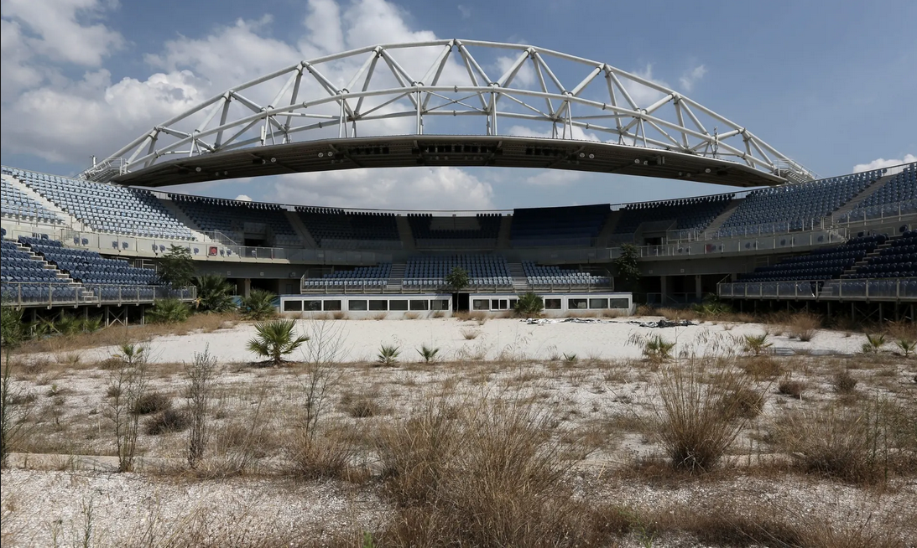
Figure 1: The ruins of the Athens Olympic sports complex [10]
Even the damage caused by rapid development is seen in developed countries. According to the Guardian, by February 2021, at least 6,500 workers had died in projects to build stadiums for the 2022 World Cup in Qatar.[11] In another case, the number of work-related suicides in Japan from 2011 to 2020 remains worrying, despite the decline. [12] A significant part of these suicides is due to the pressures of the rapid development process.
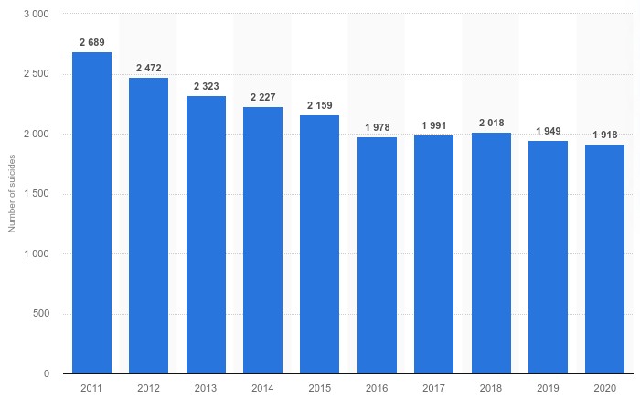
Figure 2: Number of suicides related to problems at work in Japan from 2011 to 2020 [12]
Surveys in 2016 show that even forcibly turning off company lights can not prevent the overload of work in Japanese companies. [13] In an article, Dr. Kitanaka describes overwork suicide as follows:
“It has been well documented that some middle-aged workers in Japan are committing suicide in part due to work-related stress as well as the economic recession. The term karo jisatsu, or overwork suicide, refers to people who are driven to take their own lives after excessive overwork.” [14]
It can be concluded that there is almost no rapid development without serious damage. On the other hand, no reliable infrastructure can be achieved through rapid development. Rapid development can also cause serious physical and psychological damage to development team members.

Reality of Agile Methodologies
The roots of agile methodologies go back to lean manufacturing. Lean manufacturing is a production method aimed primarily at reducing times within the production system as well as response times from suppliers to customers. The spark for this mindset came from Ford. Fredrick Taylor and Henry Ford documented their observations relating to these topics, and Shigeo Shingo and Taiichi Ohno applied their enhanced thoughts on the subject at Toyota in the 1930s. ‌‌Companies employ the strategy to increase efficiency. Receiving goods only as they need them for the production process, reduces inventory costs and increases productivity and profit. In appearance, everything looks good. But the first resource depleted by lean production was “time”. No one can finish what needs to be done in 6 years, pass in one year in the IT world. Except through two methods.
- Reducing quality and increasing the error rate in the system.
- Using staff personal time to advance the project quickly.
Both of the above would be completely unethical and detrimental to the project development team. But today these two methods are widely used in implementing the agile methodology. In defense of agile methodology, it emphasized that: “There has been injustice in its criticism and the flaws in this methodology magnified. However, there are many successful examples of it.” It should be asked: which project stakeholder endorsed successful examples of agile methodology? Employer, product owner, project manager, employees, customer, or “all”? An approach that is based on immoral principles and aims to make unconventional and unbalanced astronomical profits can never have the positive opinion of all the stakeholders of a project at the same time. As long as an employer believes that by paying wages he can look at his employees as “24-hour slaves” and tries to make all his profit from the location of only one business, the maximum work pressure and The highest level of dissatisfaction will belong to the staff.
If a person wants to make a lot of money, he/she can not make such a profit just by investing irrationally and putting unconventional pressure on others in an IT business. Successful examples in the IT industry have often been personal projects, and their owners have put the most pressure on their development. They have not started a business with a lot of investment and have expanded it gradually. Microsoft and Apple have developed a home garage. Facebook has been a student project. These are just some obvious examples of the gradual development of the IT industry. But today, agile methodology assures capitalists who lack scientific and technical knowledge that they can make a lot of money in a short period of time by creating a “system of slavery” in the IT industry.
Advocates of agile methodology emphasize that: “If a person wants to start his own business in the future and can have his own company, he must first learn how to be agile as a team. Launch the product. So it is better for the employees to serve the team manager instead of making excuses.” The paradox of this text is to do agile activities for another company and start a personal business. Working according to agile methods If a manager wants to complete a 6-month project in less than 2 months, he must use various tools such as threats, bribes, small rewards, telecommuting systems, and full-time communication with staff through Social networks should work to force team members to use their free time to develop projects. How can a specialist start his business in agile working conditions? As a result, the proponents of agile methodology are fundamentally wrong. The fact is that if people spend their time doing other things, they will not be able to start their own businesses.

New System of Slavery
Bertrand Russell explains in a series of articles entitled “In Praise of Idleness and Other Essays” that employers and capitalists are reluctant to reduce working hours or offer workers time off. Because they think that when workers have more free time for themselves, their growth of capital and wealth will decrease. [15] To better understand the unfair exploitation of labor by large corporations, instead of addressing the baseless theories of “conspiracy illusion”, one should look scientifically at the state of wealth distribution in the world between 2013 and 2021.
According to the Global Wealth Report 2013 [16], 91.6% of the world's population had a wealth of less than $100,000. Assets of 68.7% of the total land population are estimated less than $1. This low-income class is estimated at 3207 million people. Surprisingly, 0.7 percent of the world's population is worth more than $10 million, with a combined wealth of about $98.7 trillion, which is actually 41 percent of the world's total wealth.
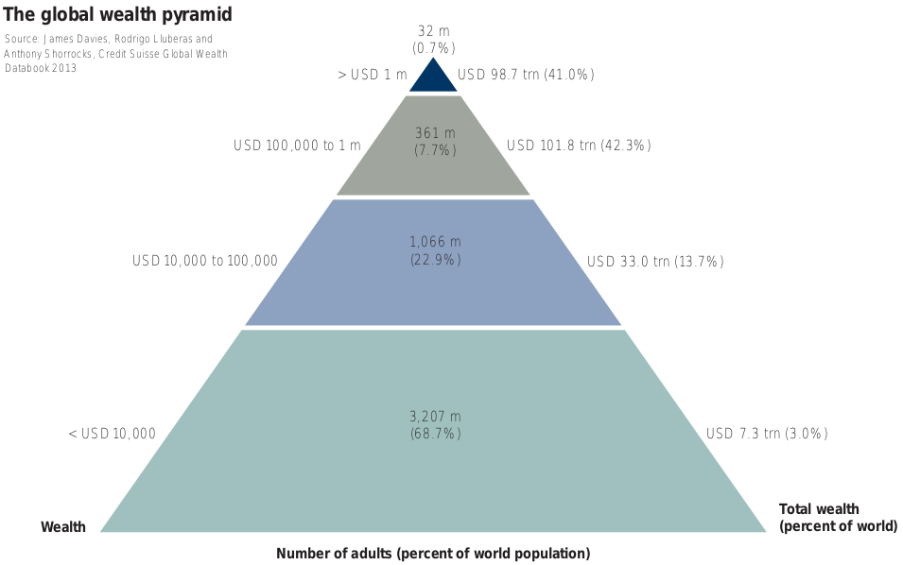
Figure 3: Wealth Distribution Pyramid in 2013 [16]
According to the 2021 report [17], there is a noticeable shift between the third and fourth floors. 34% of the world's adult population has a capital of between $10,000 and $100,000 and 53% has a capital of less than $1,000. It should be noted that such reports do not address the growth of society's liquidity and the amount of money printed by governments. Therefore, it cannot be understood that this growth has been a healthy social trend in the distribution of wealth or that global inflation has increased the capital of the upper three classes of the pyramid. If the second case is correct, the lowest floor of the pyramid will be in a worrying position.
In the 2013 report, the study population was 4666 million adults worldwide. According to worldometer.info [18], the total population of the world at that time was estimated at more than 7102 million people. But in the 2020 report, the world's adult population is estimated at 5163.9 million. The total population of the world at that time was estimated at more than 7794 million people. The missing link in all these reports is the impact of poverty on families, children, and minors.
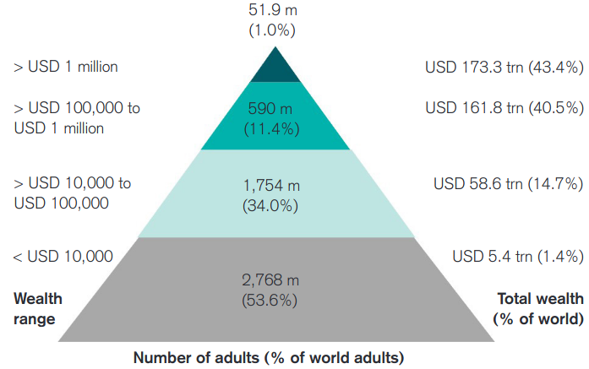
Figure 4: Wealth Distribution Pyramid at the end of 2019 [17]
It should be noted that the researchers of this study do not believe in the illusion of conspiracy and do not consider the new system of slavery to have originated from such assumptions. The problem is very simple. People who have wealth and power are reluctant to distribute it in communities and try to use others to expand their power. This is a proven principle in sociology. A comparison of the wealth distribution pyramid and the food chain shows that the development of technology has not contributed to the growth and excellence of humanity. The foundation of the wealth pyramid is based on primitive patterns such as the food chain.
The unfortunate fact is that a huge population of the world's people work only for a small group of this global village to move a large collection of world wealth to top of the pyramid. In less than seven years, 2.3 percent added to capital accumulation at the top of the pyramid. However, only 0.3% of the world’s population was able to reach the top of the pyramid.
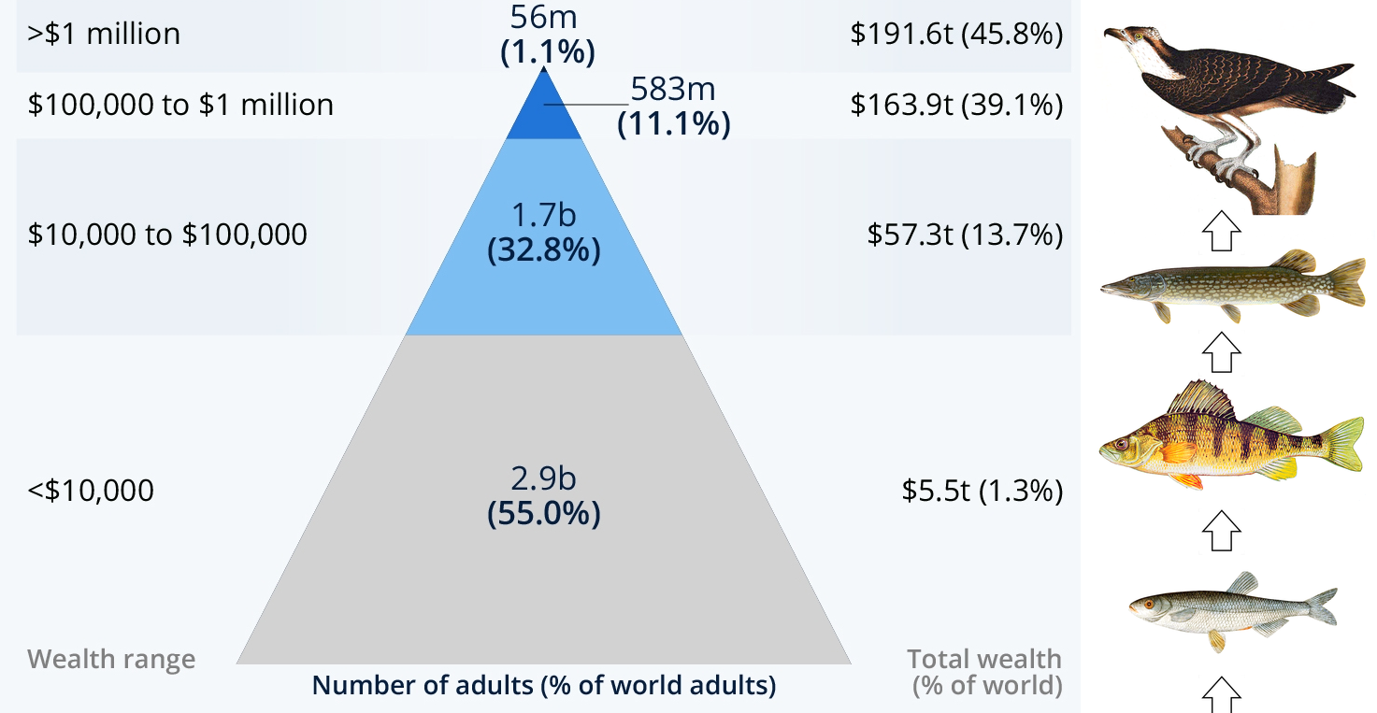
Figure 5: The similarity of the wealth distribution pyramid with an example of a food chain
That is, the rate of accumulation of wealth at the top of the pyramid is faster than the rate of distribution of capital among the people of the world. Even with the growth of capital at the bottom of the pyramid, it cannot be said that this distribution has been done fairly throughout the world. For example, the population of the third layer of the pyramid in 2013 was estimated at 1066 million people, and the population of the same class in 2020 is estimated at about 1754 million people. This figure is largely consistent with middle-class growth data in China. In other words, this growth has occurred only in certain parts of the world and regions such as the Middle East, Africa and Central Asia are deprived of this growth of wealth in the lower classes of society.

Disadvantages of Agile Methodologies
In extensive research on agile methodology [19], Company LucidChart has found the teams get easily sidetracked due to a lack of processes in projects that have used this methodology. This research also shows that long-term projects suffer from incremental delivery and the level of collaboration can be difficult to maintain. However, some solutions have been suggested to solve these problems. But there are other drawbacks. Rachaelle Lynn [20] lists the five key flaws of Agile Methodology in her article as follows.
- Poor resource planning
- Limited documentation
- Fragmented output
- No finite end
- Difficult measurement
In addition to all these technical and management disadvantages, a phenomenon called “Zombie Scrum” has recently attracted the attention of researchers, which seems to be one of the psychological effects of the pressures resulting from the implementation of the Scrum framework and agile methodology. Zombie scrum can exacerbate depression and numbness among team members.
Barry Overeem, Christiaan Verwijs and Johannes Schartau [21][22] provide a good definition of zombie scrum in "Zombie Scrum Survival Guide". According to this definition, At first sight, Zombie Scrum seems to be a normal Scrum. But it lacks a beating heart. The Scrum teams do all the Scrum events but a potentially releasable increment is rarely the result of a Sprint. The team also doesn't have any intention to improve their situation. Nobody cares about this team. The stakeholders have forgotten the existence of this team a long time ago. David Rutter [23] lists some other disadvantages of agile methodologies in his article as follows.
- Unrealistic Expectations of Management
- Agile Frameworks are Open to Interpretation
He explicitly emphasizes that “agile doesn’t suit all types of projects”. Based on his research, It seems that a lot of the frustration leveled at Agile is reality directed at management, and poor management at that. Despite all the available information and statistics on how to treat your staff, poor management is still prevalent and making a bad name for Agile.
But, that's a pretty feeble excuse for defects in a development methodology to control, guide, and lead project managers and product owners to improve the appropriate behavior with software development staff. In other words:
“A development method must be able to determine and implement appropriate behavioral patterns for all three sides of the manpower triangle involved in a project. Product owners, project managers, and employees.”

Why is agile methodology ineffective?
The inefficiency of the agile methodology and its related frameworks (such as Scrum) becomes apparent in times of macroeconomic crises. Agile methodology in the event of an economic crisis, instead of adopting a rational and patient approach, like its great ancestor (lean manufacturing), adopts an aggressive strategy to fill the financial gaps by speeding things up and delivering the product quickly. Employers are trying to reduce the economic pressure on their organizations by increasing the speed of work. This increase in development speed will put double pressure on employees. This trend will be erosive for employees in a long-term economic crisis, and therefore their motivation to continue working will show a significant decline.
Rolf Dobelli explains in Chapter 43 of The Art of Thinking Clearly that one of the most common mistakes in decision making is “Action Bias”. In short, Action Bias is the tendency to think that value can only be realized through action. In other words, we feel compelled to do something in new or shaky circumstances rather than wait and make a more rational decision.[24] Agile methodology in times of economic crisis forces organizations to act quickly and recklessly. Employers prioritize their interests and capital and avoid considering the requirements of other project stakeholders (especially employees). They immediately take corrective action without considering all aspects of the work. Patience is the greatest action in the event of a crisis. But employers prefer to take action to change the situation in favor of their capital. Most of these actions in the medium term cause severe fatigue and frustration in the workforce.

United States: Great Depression between 2008 and 2012
As a result of the financial crisis, the Great Depression swept the world economy, especially the United States, between 2008 and 2012. Stock markets around the world have shrunk. In many areas, the housing market also went into crisis, leading to layoffs, disenfranchisement, and long-term unemployment. But the point is that after the crisis, the United States largely lost its leading position in technology, and China was able to introduce itself as a new economic power in the world. Certainly, a wide range of factors can cause such changes in the world economy. But managerial mistakes are not ineffective in such a global change. One of these mistakes is the use of methodologies that either fails to advance the goals in critical times or their implementation, in the long run, causes irreparable social damage.
After the crisis subsided, the big tech companies underwent serious management changes. The CEO of Microsoft changed in 2014 and the CEO of Google changed in 2015. Preliminary investigations show that both companies were experiencing financial crises due to the Great Depression at the time.[25] The policies of both companies changed significantly. Both companies shut down many of their low-efficiency services.[26][27] In separate interviews, Satya Nadella and Sundar Pichai stated that their policy will focus on providing applied services rather than on the edge of technology. Both companies entered the field of artificial intelligence for public show-offs.[28] But with a cursory glance at the market for the two companies based on the Pareto principle, it is easy to see that 80% of their revenue is based on services and advertising, and both companies have significantly reduced their technology leadership in the world.[29]
There are almost no official statistics on the migration of skilled workers and their dissatisfaction with the environment and work patterns in the United States. Efforts have always been made to introduce this country as the cradle of technology and the utopia of specialists in the world. For this reason, it is not possible to assess the extent of social harm caused by the implementation of rapid development patterns in the United States through direct census methods. But by examining some events and analyzing them, it can be seen that this method of development has caused some damage.
After the change of CEOs of Microsoft and Google, the development and presentation of the major version of Windows and Android operating systems was done in longer and more targeted periods. For example, there is a gap of 6 years between the release of Windows 10 and 11. Since 2015, there is a year gap between the release of each major version of Android. Interestingly, both companies have eliminated many of their unsuccessful products and increased their focus on more productive products and services. Changing strategy and slowing down the presentation of new products in these two technology companies proves the least possible way that the general idea of rapid development was fundamentally wrong. Likely, implementation of agile methodology in these companies has also had devastating social consequences. But to objectively understand the extent of the social ills of development in an agile style, it suffices to study the following example.
In Stack Overflow’s 2020 Developer Survey (a research project that included participation from over 65K developers) 15% of respondents admitted having some type of mental issue, with anxiety and depression being the most common ones. [30] According to the statistics in the same report in 2019, 1 in five U.S. programmers suffered from work-related mental illnesses and disorders. [31] This shows that the destructive effects of rapid development threaten the US information technology community for more than a decade after the 2008 economic crisis. Even though tech companies have moved away from their fast-paced past.

Iran: Hyperinflation between 2018 and present
On 8 May 2018, the United States officially withdrew from the agreement after US President Donald Trump signed a Presidential Memorandum ordering the reinstatement of harsher sanctions. [32] Immediately after the withdrawal of the United States from JCPOA, hyperinflation hit the Iranian economy. [33] The government sought to compensate for the severe budget shortfall caused by the sanctions by raising taxes and overflowing the workload left on skilled workers in various fields. For this reason, many technology companies in Iran have resorted to high-pressure and rapid development methods such as agile methodology to prevent the backlog of ongoing projects.
Although the existence of a strong currency and economic backing led to the cover of technology management disasters during the 2008 US economic crisis, human resource management shortcomings in the field of technology quickly became apparent due to the sharp decline in the value of the Iranian currency. Salaries did not rise in line with inflation, and the pressure on skilled labor increased so much that the migration process accelerated frantically. Senior managers of Abararvan Company (one of the leading companies in the field of cloud computing in Iran) believe the existence of public frustration in the society, along with the availability of job opportunities for IT professionals around the world, has increased the chances of immigration in the country's IT professionals. [34]
The Secretary-General of the Association of Knowledge-Based Organizations in Iran announced that the United Arab Emirates, seeking to attract 100,000 programmers, has put special support for idea owners and startups on the agenda, which has led to an increase in the demand for immigration among Iranian elites and programmers. [35] In an interview, the secretary of the Fintech Association of Iran announced that neighboring countries are attracting Iranian programmers and startups as quickly as possible. Not only do they give work visas to elites, but these countries also invest in Iranian elites' schemes and give work visas to several family members. The situation has become so alarming and migrations are so rapid that they will lose millions of dollars of human capital by the end of the year. [36] Information obtained from Iran's labor market in October 2021 shows that maintaining the workforce is one of the problems of all software companies. After a while, software professionals leave work in domestic companies and turn to telecommuting with foreign companies or migrate completely. [37]

Compression between examples
Although at first glance comparing the two examples above seems incomprehensible considering the economic size of Iran and the United States, it can be found that the effects of these two economic events on the state of the IT industry and its experts have astonishing similarities. By comparing these two examples, it can be easily concluded that the inefficiency of high-pressure working methods such as agile methodology is determined in times of economic crises. Because this type of work causes a lot of pressure on a limited set of labor forces, resulting in a loss of proportionality between the earned income and the work done. When a skilled worker feels that his income is less than what he/she does, his/her efficiency is reduced and he/she will not have the former vitality. As a result, the level of creativity in the business is significantly reduced in a short period.
In a large economy like the United States, the psychological pressures of rapid development on manpower may never be measured. Because financial backing compensates for management deficiencies and creates incentives, albeit small ones, for the workforce. But in vulnerable economies like Iran, the side effects of rapid development pressures are visible. In such an economy, a managerial error is magnified strangely. The workforce will be extremely tired, motivation will decrease and creativity will reach its lowest level. Although many managers try to instill a sense of progress in the media and public opinion by performing some show-offs, in practice the skilled workforce loses hope for the future and is extremely tired of the pressures caused by overload work. This process will eventually lead to the migration of specialists. Sometimes the destructive effects of rapid development practices remain in society for more than a decade.

Real Social Justice
The Democratic Party submitted the social safety net bill to the house of representatives for approval in December 2021 with a budget of about $3.5 trillion. This strategy prevents poor families from falling below the poverty line. Undoubtedly, in a civilized society, people in need must be given immediate help. But in the long run, this assistance must be done in such a way that the society is on the path of social justice instead of moving towards receiving a pension. Sooner or later, the opposition parties will come to power and can cut the allocated budgets. A large budget cannot develop a culture of solidarity in a society.
It takes a lot of time and money to train a specialist. Therefore, expert manpower is a valuable asset for any country. But the wrong management, pattern, or methodology can destroy these resources in a short time. A skilled worker does not need to pension. Because it can change the situation in its favor by changing its strategy or changing its living country. At this level of society, allocating large budgets for financial aid cannot be untied. This part of society needs respect and social justice, which can only be achieved through the government’s continuous control over the behavior and performance of capitalists.
Perhaps the best kind of social justice is enabling competition between start-ups and enterprise companies. Confronting monopolies is the first step to distributing equitable wealth. Start-ups should have the chance to compete with enterprise companies by offering innovative products and limited initial capital in different markets. In the summer of 2021, the US House of Representatives and Senate are considering bills that restrict the monopolies of tech giants.[38] This is only part of the story. In addition to creating justice at the level of companies and organizations, there should be a chance to compete at the level of elites with start-ups and enterprise companies. These conditions will be possible only by controlling the utilization of human resources by companies. Many elite forces are at the service of companies to earn money.
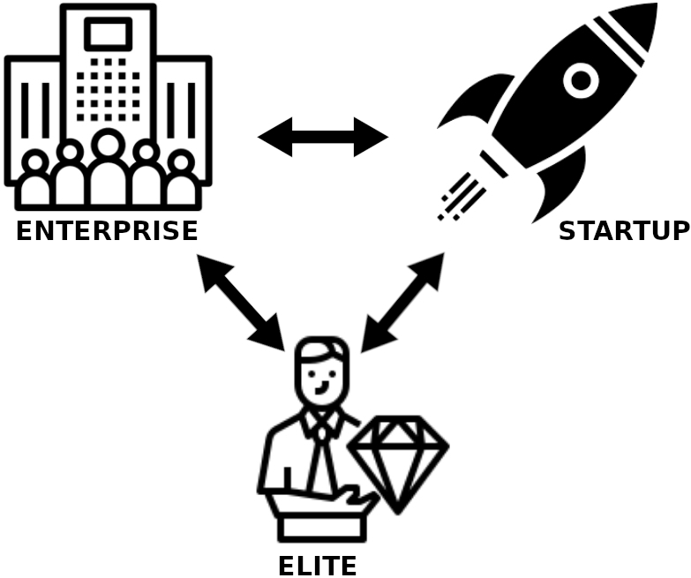
Figure 6: The best state of social justice in the field of market competitiveness
‍These people need to have conditions in the workplace so that they can use their time to develop their ideas. Today, the pressures of rapid development make it impossible for elite people to focus on cultivating their ideas after leaving the workplace. As a result, the conditions of competition will be distorted and the chain of distribution of wealth will be incomplete. All of this will eventually lead to the formation of new monopolies. In simpler terms, the market competition mechanism should be such that an enterprise, a start-up, or an elite can come up with new ideas and gain market share. Enterprise companies have a stronger presence in the market with more energy and financial strength. Start-ups can use accelerators to develop products and services. But the only source of an elite is enough peace and free time for the gradual development of new ideas.
Bertrand Russell [15] believes that for all the talents of society to flourish, the legal working time must be reduced so that the elite and talented people have more time to cultivate their talents. As a result, it must be monitored that company owners do not eliminate the possibility of elite competition in the market by unfairly exploiting the personal time of their employees. It must be acknowledged that paying subsidies to poor people during financial crises will only lead to heavy debts for governments in the years to come. Conditions must be created so that the low-income classes of society have the power to participate and compete in commercial markets. These conditions must be provided in such a way that all classes of society can continue to participate in this competition, even in times of financial crisis.

About Endurance Methodology

What is ESDM?‌
Endurance software development methodology (ESDM) is exactly the opposite of agile methodology. Agile methods for developing software and services that are widely used and need to provide updated services to users regularly are a good model for rapid and optimal development. But they will not be considered a good choice for catastrophic, critical, research, and infrastructure projects. ESDM is based on three important principles.
- Prevent erosion and fatigue of the specialist force in the long run: Unnecessary pressures on the IT community through the implementation of agile methodologies for the development of self-interest will, in the long run, lead to its disintegration. Disappointment, depression, lack of motivation, stress, a sense of machine life in the workplace, and many other mental illnesses are just some of the destructive intellectual effects on the IT community because of the excessive demand of managers to implement agile methodologies.
- Reduce management weaknesses and adjust the scope of projects to suit needs: According to Standish Group’s Annual CHAOS report, 66% of technology projects (based on the analysis of 50,000 projects globally) end in partial or total failure. [39] The failure of many technology projects has been due to the following reasons:
  - Most of projects are simply too large – the “big bang” approach and waterfall project methodology limited and in most cases punished change
  - Due to the prolonged nature of projects, staff turnover caused disruption and a loss of key legacy systems understanding
  - Lack of sponsor buy-in
  - Weak outsourcing governance
  - Poor project planning and “political in-fighting”
It must be acknowledged that the ambitions of customers and employers and the contradiction of these goals with market realities cause many problems for technology projects. Scopes of projects are considered too large. This puts double pressure on development teams. If adequate financial resources are not provided for these projects, in the long run, the expert forces will lose their motivation and leave the project. Today, thanks to the agile methodology, the scope of software projects is so large and endless that sometimes it feels like a start-up company with 5 employees is trying to send a spacecraft to the International Space Station!!! In today's world, all employers want to reach the first level of Silicon Valley from their home garage! These extravagances will eventually lead to the collapse of manpower in the large IT community. Because the pressure of large goals on limited manpower can cause despair and depression among professionals. Many of these goals are not achieved due to mismanagement. By keeping the scope of projects balanced, ESDM prevents the spread of employers' delusions to work environments and ensures the mental health of employees while working on projects. ESDM regularly monitors the goals and scope of the project, and project managers make sure that its implementation is within the staff and time frame. ESDM teaches employers how to progress gradually.
- Paying attention to the interests of all stakeholders: In terms of ESDM, the beneficiaries of a software project are as follows:
  - Customer or User: Customers or users are the end consumers of products tailored to their needs. Customers are the center of gravity of any business. Their needs are the source of the emergence of businesses. In addition to ensuring that there is a proper understanding of a customer's needs in the development team, the managers of a technology company are responsible for making sure that the customer understands its needs correctly and conveys them to the development team in appropriate detail. Many customers do not have the necessary focus when explaining their needs and can not convey their requests to the development team properly. The total customer benefits are summed up by meeting the needs of the product, decreasing the cost of the product, quality of the final product, and responsible support.
  - Employer or Project Conductor: Business owners and people who hired labor are all classified within the employer. These people produce products or provide services by investing in specific businesses and establishing companies. They will accept the risks of investment. Therefore, these people will expect a good income from their business. But in many cases, this level of satisfaction with income generation sometimes contradicts the values, criteria, and standards of society. Thus, uncontrolled income generation increases the class gap and the accumulation of unconventional wealth. ESDM strives to ensure the profitability of businesses, while ensuring that this profitability is not contrary to the human and moral values of society.
  - Employee (Managers and Staff): According to ESDM, all roles that operate according to the ITIL standard in an IT project are considered level 1 employees of the organization. In addition to the specialized staff, other people in the administrative, financial, service, and logistics departments are also classified in the circle of level 2 employees of the organization. Staff classification in ESDM is only for identifying the effectiveness of people in the project and has nothing to do with determining the extent of their human rights. ESDM never believes in the equality of employees' technical value and their effectiveness. But undoubtedly, all technology company employees are considered beneficiaries of projects in the development or execution. Therefore, the employer must respect their rights. The rights of this section of stakeholders mainly focus on the workload proportional to the scope of the project and the salary tailored to the assigned work.
  - Government: One of the clever slogans of the capitalist system in the world is: “Manpower is the most valuable asset of organizations and companies”. But behind the respect given to the working class in this slogan, the capitalists' sense of ownership over manpower is rippling. In this slogan, the assets of the employers are introduced. This beautiful slogan is the first creepy step to labor exploitation. But in ESDM, skilled manpower is defined as follows:
“Since the most time, energy, and management costs for the development of skilled labor are provided by the governments and people of a society, then skilled manpower is the most valuable executive arm of a nation and its government. Given that the only way to preserve this valuable tool is to respect the human rights of this segment of society, as a result, companies and organizations can only cooperate with these people through agreement and benefit from their expertise. Specialists are also required to provide services within the framework of regulated contracts. Provided that the provisions of the contract do not violate human rights and occupational health standards.”

Therefore, governments need to ensure that this valuable executive arm did not fail due to unauthorized exploitation by closely monitoring the behavior of companies and organizations with skilled labor.
Unlike rapid development methodologies, ESDM is not based solely on the profitability of the employer or entrepreneurs. This is a Stone Age strategy to support the populist policies of governments. ESDM promotes technology companies to collective profitability. For example, a software project must serve the interests of all stakeholders and be usable in the long run. Such a project must also be considered profitable within the framework of the international community and have the least possible damage to human beings during their lifetime. Thus, instead of creating unnecessary needs for users and insisting on competing in saturated markets, endurance methodology encourages governments, technology companies, and professionals to develop products, software, and services that meet the real needs of consumers. This type of methodology ensures that environmental degradation is minimized by the consumerist lifestyle. It also prevents the accumulation of capital at the disposal of employers and ensures a more equitable distribution of wealth in society.
The word “endurance” in the name of ESDM refers to the fact that to develop a business and extend its lifetime, all stakeholders involved must show patience and perseverance. Therefore, it is not possible to put the progress of a business on the shoulders of a specific stakeholder with all the pressure and stress. In simpler terms: “To develop businesses or produce successful products, all sections of society must take responsibility so that the masters do not whip the slaves.”

Advantages of ESDM
- Unlike other methodologies, ESDM does not use the term “best practice” and has replaced the word “rule” to prevent any abuse by customers and employers. Endurance methodologies are fundamentally opposed to any freedom of action that allows for moral abuse of one or more specific stakeholders of a project.
- ESDM increases the possibility of competition between enterprise companies and small software development teams. Accordingly, enterprise companies can not create a monopoly in the market by exploiting a large group of employees. Instead, small software teams and start-ups will have more leeway to compete in the marketplace by spending the personal time of business owners or product creators.
- ESDM ensures that the rate of physical illnesses such as “lumbar and neck disc protrusion” and mental illness among programmers such as “night owl” is reduced in the long run by balancing workload and division of tasks.
- ESDM has a fairer economic model and a more equitable division of labor. From ESDM's point of view, a business is an opportunity for the economic growth of all its stakeholders. The employer will benefit from the expertise of the employees to invest and will make a significant profit. But that does not mean it can own the whole cake! ESDM helps employees receive a share of a business's net income. Therefore, there will be the necessary incentives to continue and improve professional activities. This method will significantly contribute to the survival and sustainability of technology companies.
- ESDM tries to prevent unconventional workload and abuse of skilled labor. These stresses cause many physical and mental illnesses for programmers and developers that shorten their professional life.
- ESDM contributes to the development of non-polluting systems in the field of information technology. This trend is reinforced by the avoidance of hasty development. Providing the best possible solutions to create systems that work with minimum hardware resources and consume less energy for their activities will be a priority.

When does ESDM not work?
ESDM is an explicit methodology that addresses the main issue directly. It does not offer solutions to the wishes of inefficient managers. If the main problem of the organization is due to the poor performance of a top manager, ESDM easily reflects the cause of the problem in its reports and reviews. ESDM does not hide the social realities and problems of the organization for the satisfaction of the capitalists. Therefore, this methodology can not be implemented in countries that are dealing with deep and widespread administrative and economic corruption.

Examples of Endurance Projects in Real World

Joint Strike Fighter (JSF) Program
One of the most famous examples of endurance projects worldwide is the Joint Strike Fighter (JSF) Program, implemented by the United States Department of Defense. The program was created in 1994 by the United States, United Kingdom, Italy, Canada, Australia, Netherlands, Denmark, Norway, and Turkey to produce a sixth-generation strike fighter to replace several tactical fighters, including the F-16, A-10, F/A-18, Tornado, and Harrier.[40] Boeing with the X-32 concept and Lockheed Martin with the X-35 concept entered the big tender. Both companies completed the signing of the bidding contract by November 1996.[41] Both concept designs completed their first test flight before the end of 2000.[42]

Figure 7: Boeing and Lockheed Martin JSF demonstrators.
The contract for System Development and Demonstration (SDD) was awarded on 26 October 2001 to Lockheed Martin.[43] The F-35, the final product of the X-35 project, successfully made its first flight on December 15, 2006. The F-35B was first officially launched on 31 July 2015, by the United States Marine Corps (USMC).[44] The F-35A was also officially launched by the United States Air Force (USAF) on 2 August 2016,[45] and the F-35C by the United States Navy (USN) on February 28, 2019.[46]
The long duration of the preliminary stages of the project clearly shows that this program has been implemented patiently and haste has been avoided to achieve the desired result. It can be said that military projects are the best and most famous type of endurance projects due to having the highest sensitivity coefficient and the absence of pressures of commercial projects.

Competition between Windows and Linux
The development of Microsoft Windows since 1992 has taken a rapid and accelerated process by releasing version 3.0. Microsoft had almost no vision infrastructural vision for Windows before the development of the .NET framework until 2005. Its executives aimed to monetize it by just selling the operating system as commercial software. The fact is that Microsoft was in fierce competition with the Linux operating system and open-source software between 1998 and 2012. For this reason, to be able to compete with the developers of free and open-source software, it launched several versions of the Windows operating system in a short period. This caused the ME, Vista, and Windows 8 not to have desired quality and to be considered among users as the most hated versions of Windows. [47] Former Microsoft CEO Steve Ballmer called the Linux operating system "cancer." [48]
After the commercial failure of Windows 8 and the appointment of Satya Nadella as CEO, Microsoft's policy changed completely. They stopped competing with open source and even tried to get the company to have a better relationship with the developers of such software. Later, even Microsoft officially regretted Ballmer's remarks. However, no official apology was announced. [49] The speed of development of the Windows operating system was adjusted. The first version of Windows 10 was released in 2015. That is 3 years after the first version of Windows 8 and 6 years after the first version of Windows 7. Windows 11 was also released in 2021, six years after Windows 10. Windows 9 was never released to the public due to the possibility of repeating the bad experiences of Windows 8.
Examining the evidence, it can be concluded that Microsoft has moved away from rapid and rapid development patterns. Since 2013, they have refused to offer weak and inefficient versions of their key products such as Windows, Azure, and Office. Strategic changes at Microsoft make it clear that the agile development approach for key infrastructure products is inefficient. On the other hand, the development of Linux and its other distributions has been very patient. For example, only 11 versions of the Debian operating system have been released between 1993 and 2021, which is an average of 2 years between the release of each version from 4.0 onwards. Also, only 5 main versions of the Linux kernel have been released between 1991 and 2021.

Competition between Symbian, iOS and Android
An examination of the smartphone market share statistics between 2009 and 2021 [50] shows that in 2009 there was a fierce battle between Symbian and iOS for dominance in the smartphone market. Symbian took the lead with the launch of low-cost handsets by Nokia in mid-2010. But with the pervasiveness of the Android operating system, this superiority will not last longer than in 2012. The lack of application and UI caused the rapid exit of this operating system from the smartphone market.[51][52] Although the strategy of offering a cheap phone was effective against iOS, Symbian could not maintain its position since Android also introduced such smartphones.
After Symbian left the market, the competition between Android and iOS reached its peak. Apple has tried to show that it is launching different and luxurious products that people are willing to pay to buy. On the other side of the story, Android phone makers continued to focus on making low-cost smartphones that included a larger community of users. Apple was proud of its flawless operating system. They offered multiple versions at short intervals. Until the iOS 7.0 disaster struck in 2014. [53] Operating system with numerous errors that also caused user dissatisfaction. Although Android followed a similar trend, finally in 2017, the accelerated process of versioning in this operating system stopped and other Linux distributions in certain periods (for Android, one year period) began to release the version.

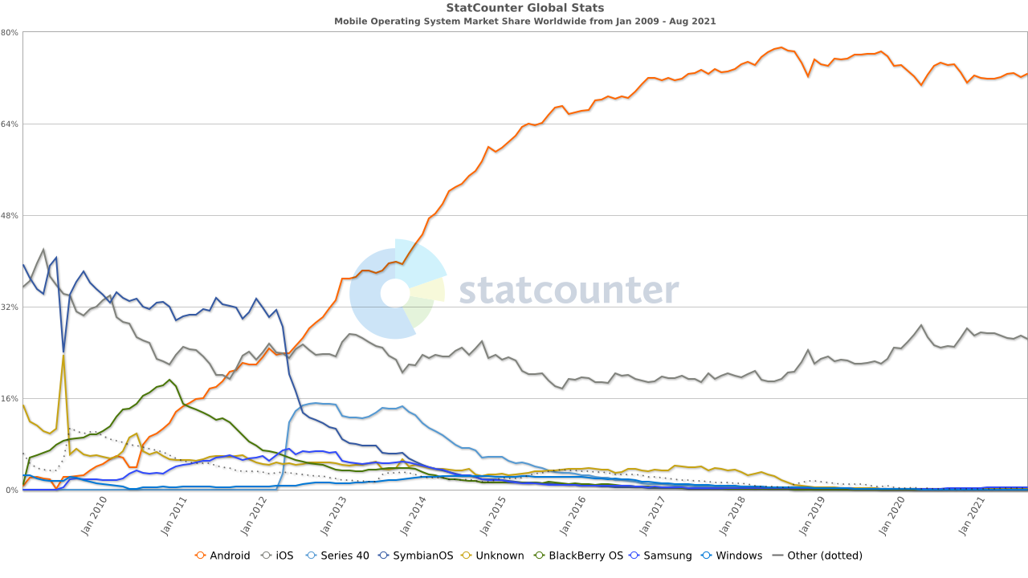
Figure 8: Smartphone market share between 2009 and 2021 [50]
But Apple continued the same rapid development policy for iOS. This trend eventually led to another mistake in 2021, when they were forced to release three main versions in less than a year. IOS was suddenly upgraded from version 10 to 15 beta and caused a great deal of confusion for its users. With the expansion of the Covid-19 pandemic and the collapse of the global economy, sales of expensive Apple products have dropped dramatically. Instead, Android gained more market share during this period.

Falcon 9
The first Falcon 9 engine test was conducted in 2006. Meanwhile, the first test flight of this commercial missile with the Dragon COST Demo 1 model took place in 2010. The Falcon 9 made only three test flights between 2010 and 2013. Later tests attempted to land the rocket precisely on an autonomous spaceport drone ship (a barge commissioned by SpaceX to provide a stable landing surface at sea) or at Landing Zone 1 (LZ-1), a concrete pad at Cape Canaveral. The first ground landing at LZ-1 succeeded in December 2015, and the first landing at sea on a drone ship in April 2016. The second landed booster, B1021, was the first to fly again in March 2017 and was recovered a second time.
The development of the Falcon 9 project shows that SpaceX aims to produce and develop a commercial rocket with exceptional capabilities. It took about 16 years to develop this advanced rocket, and more tests and updates are still underway. Therefore, speed in product delivery will not be the priority of such a project. Agile development methods can by no means be used in projects with such a wide range of research. Space projects can fail for a variety of computational, physical, and technical reasons. No one can make a definite commitment to the timely delivery of the output of complex research processes. Using an agile methodology for such projects only brings unnecessary stress. What is the main cornerstone of such scientific-commercial activities is endurance during the whole development process.

Criticism against ESDM
It may be argued that endurance methodologies reduce the income of enterprise companies and thus reduce the wages of their employees. The question that needs to be asked is what is the special benefit of rapid development for human society? Just a few dollars more for a salary ?! Today, no one denies that the environmental damage caused by rapid development reaches trillions of dollars. Rapid development is also a factor in creating economic bubbles that cause inflation in society and financial crises in capital markets. Rapid development leads to the accumulation of capital in a limited segment of society, which is considered a major cause of corruption. Rapid development is the first factor in reducing quality and violating consumer rights. Also, this method of development is the main cause of psychological pressure on employees and threatens the foundation of families. There is no way to calculate the amount of damage caused by rapid development at all. Because it is out of bounds. In addition, the rate of decline in corporate revenue can not be proven by the implementation of endurance methodologies.
Another theory suggests that ESDM originated from communist and anti-capitalist views. It should be said that ESDM is not against the capitalist class and does not deny the existence of different layers in society. But the creator of this methodology believes that if the governments of a country with any ideology want to increase market competitiveness and reduce the pressure on the working class, they should have more control over the activities of capitalists.
The other criticism about ESDM is that it will increase the cost of many IT-based services by supporting the IT community. It should be noted that ESDM emphasizes the need for organizational discipline before defending the rights of IT professionals, and believes that the lack of this discipline has put unnecessary pressure on the IT community. Now the question is whether the only way to reduce the cost of IT-based services is to violate the human rights of IT professionals?
Some people believe that endurance development methods cause laziness in the workforce. As an answer, endurance methodologies call on managers to be more agile. ESDM follows a general rule: “A big head has a big ache”. This means that managers have more responsibility for a software product or project, depending on the privileges they receive in proportion to their position. For example, It is impossible to blame a simple expert for a mistake in integrating software or system.
Another criticism leveled at ESDM is that investors and employers are unlikely to support the methodology because of their financial interests. The main point is that society should not be run based on individual interests. ESDM is a serious culture-building in the IT industry that encourages managers and professionals to protect the common good.

Best Project Types to Use

Project Management Perspective
According to the project management perspective, the endurance development methodology can be used in the development of software that has limited manpower and time allocated to work less than the existing task list. Also, if there is an obligation to complete such projects despite difficult conditions, due to the limitations of manpower, the adoption of endurance strategies will be an inevitable necessity. It should be noted that the use of endurance strategies to manage projects in which the motivation and morale of manpower have fallen sharply, will be a good option.

Production Perspective
Based on a production perspective, systems in which accuracy, quality, efficiency, and performance are of particular importance can use endurance development methodology. Depending on the type of business involved with these systems, none of these factors can be sacrificed for “delivery timing” and “commercial values”.
This does not mean that the time factor is insignificant in project management. But in such projects, a balance must be struck between delivery time, product owner expectations, and technical requirements. Catastrophic and critical software owners need to be aware of the sensitivity to security, performance, and functionality requirements and adjust their “hasty commercial pressures”. Therefore, the level of technical sensitivities and the importance of performance in the system, determine whether it is possible to use the endurance development methodology in the project or not.

Software Engineering Perspective
Based on the software engineering perspective, projects with high operational complexity can use endurance development methodology. Chidamber and Kemerer [54] proposed a set of programming complexity metrics, widely used in many measurements and academic articles. They are:
- WMC - weighted methods per class
- CBO - coupling between object classes
- RFC - response for a class
- NOC - number of children
- DIT - depth of inheritance tree
- LCOM- lack of cohesion of methods

‌Business Perspective
According to the IEEE 829-2008 standard, endurance development methodology can be used in the following two types of projects.
- Catastrophic projects
- Critical projects
Quality and accuracy are the main parameters in the development of these two types of projects. As a result, it is not possible to apply the criteria of rapid and agile development in business activities in the development of such systems. ‌Based on a business perspective, the types of projects that can be developed using the endurance development methodology are:
- Research projects
- Catastrophic civilian projects (such as air navigation systems, railway management systems, natural disaster warning systems, health systems, etc.)
- Civilian personal projects
- The back-end of banking systems
- Crisis management systems
- Operating systems development
- Data management and warehousing systems
- Telecommunication systems
- Infrastructure of emergency systems
- Infrastructure of intelligence systems
- Security systems
- Military projects
- Space projects
- Infrastructure of e-commerce systems
- Infrastructure of governance systems

Principles of ESDM
In this section, the framework, rules, and regulations of endurance development methodology will be discussed. Unlike the agile methodology, which provides employers with a free operating framework for employee abuse and exploitation, the rules of endurance methodology are completely transparent and “non-negotiable” to ensure the interests of all project stakeholders. Strict observance of these regulations will be the basis for obtaining endurance methodology certification for organizations.

Economic Model
Classical economics has always emphasized the non-interference of governments and regulatory bodies in free markets. Adam Smith believes that the “invisible hand” smoothly restores markets to equilibrium.[55] The question is, how is “equilibrium” defined in economics? Can only market equilibrium lead to an equilibrium in the economy? Can this “invisible hand” also balance the distribution of wealth (discussed in Section 3.4) fairly? Do all “stakeholders” in a business benefit fairly? Perhaps in economics, we could never reach Plato's utopia. But Socrates' economic theory could be the solution to the problem of wealth distribution. This famous Greek philosopher introduces the purpose of human life as their welfare and prosperity, but in no way does he consider the concentration of wealth as the way to achieve this prosperity and happiness. With the definition, he gives of wealth, he considers usefulness as a condition for its existence. At present, one of the differences between economic systems is their attitude towards the issue of “wealth concentration”.
The main problem is the culture that exists between capitalists and industrialists. According to this view, the employees of an organization and the government are not considered the beneficiaries of the business, and all financial payments to them are included in the category of “costs”. The question is, do employees of a company and governments not play a role in the revenue and financial advancement of a brand? But, something that falls into the category of costs when does not have a direct effect on the profitability of the organization. The capitalists' view of the large community (government) and the small community (employees of the organization) is similar to the childish game of “thief and police”. Society (police) seeks to accuse the capitalist (thief) of seizing his property and assets. In this childish culture, the successful capitalist is the one who can most likely escape the costs imposed by society. In this ideology, success is attributed to individuals, and society is introduced as a costing factor. However, the reality may be quite the opposite.
Therefore, the capitalist always considers himself/herself the owner of all the net profit obtained from a business. Karl Marx (1867) believed that the price of hiring a worker – or the value of labor-power, as Marx calls it – is lower than the value a worker can produce. The difference between the value created by a worker and the value of his or her labor power is the surplus value or profit.[56] Now, this has to be compared to the huge profits of the “six giants”. The main question is how much work has been done and what pressure has been put on the workforce to make this profit? Smith's wages-fund theory explained the short-term level of average wages by the ratio of funds for the payment of labor (the wages-fund) to the number of laborers employed. It was saved from being a tautology by the implicit condition that over moderate periods the wages fund was approximately constant in size. The uncertainty is how Smith formulated the theory. He asserted the essence of the theory, but he did not explicitly define the contents of the wages fund.[57]
The problem with most capitalist systems is that they do not recognize the effectiveness of human resources in the profitability of businesses. According to these economic systems, it is the idea that generates income and not the work done (regardless of the quality of the work done). Criticizing Smith's theories, Alfred Marshall believed that the role of manpower should be as important as money, services must be considered as important products, and the emphasis should be on human well-being, rather than there should be only an emphasis on wealth. Many contemporary economists also reject Smith's theory of the invisible hand. For example, Joseph Stiglitz, winner of the 2001 Nobel Prize in Economics, argues that there is often no evidence of an "invisible hand" in market trends and pricing because there is no invisible hand.[58] Many contemporary economists and philosophers believe that Adam Smith's favorable economic system would eventually lead to monopoly capitalism. Karl Marx, writing in the mid-nineteenth century, correctly foresaw that the structure of capitalism would change from the entrepreneurial competitive capitalism of that time with the processes of concentration and centralization leading to the emergence of domination of the economy by large firms. [59]Regarding the distribution of income from production, Karl Marx says:[60]
“The capitalist mode of production, for example, rests on the fact that the material conditions of production are in the hands of non-workers in the form of property in capital and land, while the masses are only owners of the personal conditions of production, of labor power.”
Repeated government interventions can not guarantee the dynamism of the economy, and the excessive freedom of the liberal economy can not also prevent the unbridled increase of the class divide. ESDM does not support regulatory pricing and does not call for government intervention in free markets. But the “net income” from these markets must be distributed fairly in society. In business and accounting, net income is an entity's income minus the cost of goods sold, expenses, depreciation and amortization, interest, and taxes for an accounting period. [61] Numerous studies show that income distribution in countries based on capitalist principles is completely unfair.[62][63][64] This problem has doubled in countries with crisis economies. Iran's economy has experienced an average of 40 percent annual inflation growth since the United States pulled out of the Joint Comprehensive Plan of Action in 2018.[65] The Iranian government, meanwhile, has avoided raising workers' wages until 2022. But in March 2022, it was forced to raise workers 'wages by 57 percent to balance their living conditions with possible sharp inflation in the coming months. But employers immediately threatened to cut staff.[66] Interestingly, most employers made huge profits during this period from economic instability and inflation due to sanctions, as well as the stability of workers' wages.
This example clearly shows that despite all the slogans of modern human resource management, employers and capitalists still record financial transactions with governments and workers in the expenditure line. They believe that the success of their business is based on individual capabilities. Therefore, according to this view, activities of the workforce and cooperation with governments have little effect on business success. However, ESDM believes that capitalists, employers, and financial managers need to be educated: workers and the government are not a “cost” to a business. They are the “stakeholders” of a business.
Employers must first be taught that salaries are paid to employees for routine work and employees can not give the employer any guarantee of business profit based on their salary alone. If a business is in the profitability stage, it indicates that the employees have implemented the desired strategies with perseverance, patience, and proper motivation. In other words, they have fulfilled their obligations to make the business profitable as a beneficiary. Therefore, it may be possible to put the fixed salary of an employee in the cost row. But his share of the organization's net income must be considered separately.
Moreover, items such as "income tax" or "value-added tax" should not be included in the cost line and should be paid from the net profit of the business. The question may be asked, what difference does it make under what title taxes are deducted from a company's financial resources? The answer to this question is in the field of "two-way culture building". Employers need to learn over time that the government is a stakeholder in their business and that taxes are the government's share in a business according to its assistance through public services. On the other hand, the government will learn that taxes are adjusted according to the profitability of businesses. If the government is to seek more revenue from taxes, it must be able to provide the best possible public services and reduce barriers to business development.
Accordingly, ESDM presents a very simple and fair economic model for dividing a business's net income among its stakeholders, called the “fair three-piece”. In the propaganda of capitalist systems, it has always been instilled in human societies that because the entrepreneur has accepted the greatest possible risk in a business, the ownership of the total net income is for his/her. ESDM also believes that this courage deserves a greater share of net income. But that does not mean that he/she will own all the proceeds of a collective business. ESDM qualifies the following three beneficiaries for a share of a business's net income:
- Government (external stakeholder): Ten percent of a business's net income will go to the government in the form of claims such as "income tax" or "value-added tax." In multinational corporations, this share must be paid to the government or sovereignty of each region according to the geographical areas under operation.
- Employees (internal stakeholder): Employees receive a 15 percent share of net income because of their efforts to grow the business. Indeed, they do not share in the risk of the business. But its growth is directly related to the efforts of employees. This share should be divided equally among employees. Because comparing jobs and ranking them is unprofessional. It is like asking the question: "Doctor" or "Police"? Which are more necessary for society? It is a managerial weakness that there are people among the employees who do not deserve this share due to their low effort.
- Employer (primary stakeholder): An employer or entrepreneur deserves a greater share of net income because of their risk-taking, courage in developing strategies, and responsibility. But this share must be limited and definite. In ESDM, 75% of the net income will belong to the employer.
Based on protectionist policies, a government may wish to receive a lower percentage of a business's net income in the form of taxes. In this case, the remaining share will go to the employees, not the employer. This method prevents the increase of class distance in society. Fixed salaries of employees are considered expenses and can not be included in the net income category. Therefore, it is better for all employees (from board members to simple staff) to either have fixed salaries or not receive any fixed salaries. In the “fair three-piece” model, the use of a combined method to pay a fixed salary is prohibited. This ban prevents employers from being extravagant and possible financial misconduct.
Board members cannot receive unconventional fixed salaries. Fixed salaries and bonuses of all board members can not exceed 5% of the company's net income. This ban is to prevent employers from encroaching on net income through fixed salary accounting. Accordingly, in the “fair three-piece” economic model, the fixed salaries of board members are not considered confidential information. Therefore, the financial manager is obliged to inform the public and regulatory bodies about the details of the payment of board members' salaries during the year, along with the company's annual balance sheet.
According to the fair three-piece model, the income from the sale of a company's stock on the stock exchange is not considered as part of the net income and is only the financial support of the organization for business development. Also, the interest paid to the shareholders' accounts is included in the cost line. The proceeds from the sale of a company's shares will not be owned by any of its beneficiaries. This money remains as financial reserves in the company's accounts.
In the fair three-piece economic model, the net income is the residual financial profit from the economic activity that led to the delivery of the product or service.

It is a crime to forge documents to magnify the payment of dividends to shareholders or other expenses of the company to reduce the level of net income and thus reduce the share of the large community (government) and small community (employees) based on international financial law. The question may arise as to why a methodology should have an economic model. The answer is:
One methodology cannot describe how to increase the pressure on the workforce without considering how to maintain their benefits.

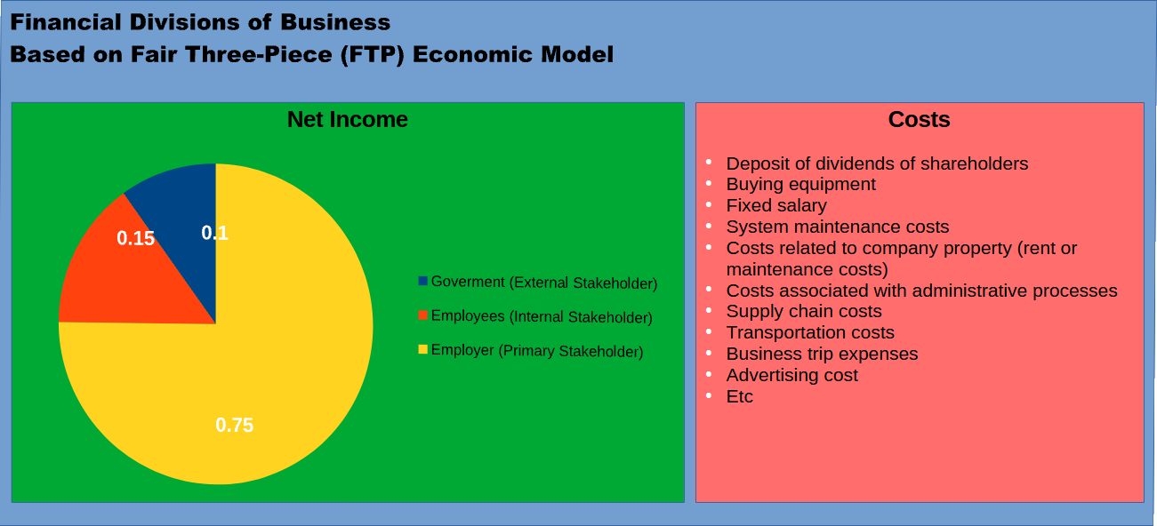
Figure 9: Financial Divisions of a Business Based on Fair Three-Piece (FTP)
This economic model does not apply to governmental organizations, institutions, and projects. Such organizations do not have any net income. If revenue generation is observed in governmental organizations, it indicates the emergence of a monopoly, corrupt and defective economy in that country.

Rules for Business Contracts
Today, most contracts at all levels of technology companies are based entirely on the interests of the customer or employer. In many cases, employee interests are ignored and conditions are created for employers to monopolize. Sometimes the status of contracts leads to the exploitation of employees. In some cases, they even lose the right to compete in the market and use their time. Contracts are structured in such a way that delivery times are considered to be very tight and impose additional pressure on IT professionals. Employee contracts are also regulated so that companies pay less for the promotion of their staff. It has even been observed that in some countries in Asia and the Middle East, IT professionals have worked for a company for more than 10 years without promotion or significant pay rise. Legal contracts are an issue that legislators and governments are allowed to intervene in. Governments and regulators can prevent the erosion of their expert and expensive workforce by monitoring the contracts of technology companies. Because a lot of money has been spent from the government budget to train such specialists. Also, by examining the legal contracts of such companies, it is possible to prevent the increase of monopolies in commercial markets.

Project Contract
The terms of a business project contract have a significant impact on the health status of its employees. Most of these are related to the provisions of the project delivery schedule. The following are “required” to control commercial software contracts based on ESDM.
- The IT project contract should include a chapter entitled “Green Computing Commitments”. This section should be in the portfolio of public products or services (such as social networks, operating systems, applications, etc.) in the field of software and communications. The production team must demonstrate in this written document how to optimize the calculations of the systems produced to prevent the improper use of servers and other equipment that increases environmental pollution.
- All customer requirements must be listed in the contract annex and signed by the parties. These requirements must be specified in the contract in at least two formats, use cases, and prototypes.
- The project contract must be arranged in such a way that it is not possible to interpret the schedule for the customer or neglect the delivery of the product by the manufacturer. Therefore, it must be ensured that both parties to the contract have the same understanding of the project schedule.
- The schedule must be approved by an independent government oversight committee in the annex to the contract. That committee should ensure, based on occupational health standards, that the project schedule is tailored to the workload and number of development staff, and that the risk of stress and work-related mental illness among production team members is minimized.
- Any request for a new change outside the agreement must be added to the contract as a new amendment and a new schedule must be updated alongside it in the contract. This is important for two reasons. In the first place, the history of frequent customer changes in the contract is recorded and the customer's aimlessness are measured. This helps prevent further financial losses to technology companies and their employees due to the customer not focusing on their needs. Second, given that all planning and scheduling changes are resubmitted to the State Oversight Committee to verify compliance with occupational health standards, customers and employers can not put employees at risk by making sudden changes to the project.
- The contract should take into account the possibility of failure of research results and failure of the proposed solutions, and the parties to the contract should consider reservation times to manage potential risks.
- No indefinitely scheduled operations should be specified in the contract, and all product delivery miles should be precisely defined in the contract. Therefore, the use of terms such as “performing task A four days after the contract” and “scheduling after the contract” in the endurance methodology is not acceptable at all.
- Overtime in contracts based on endurance methodology is unacceptable. The entire delivery schedule should be based on the number of office hours of the "development company" and the number of members of the development team. This means that in the event of outsourcing, the third-party office hours must be included in the contract schedule. In other words, the third company to which the project is to be outsourced must also be specified before concluding the contract.
- The list of project risks must be specified in the contract based on ISO 31000 standard and its solutions must be provided by the promiser. The parties must also accept this list and the possible occurrence of the risks contained in it. Compensation for non-delivery will be possible only based on unforeseen risks and non-implementation of measures announced in the list of countermeasures. In other words, the success of any project is not 100% according to the endurance methodology, and the parties must have calculated the probability of project failure correctly. The probability of project failure must also be formally included in the review and approval of the State Oversight Committee (referred to in paragraph 2).
- The failure rate of a project should not be zero. Project compensation will be based on this percentage. For example, if a project fails with a 40% chance of being approved by both parties to the contract, the promiser will pay only 60% of the number of damages. However, if the probability of failure is set at 5%, the promiser will be required to pay 95% of the damages specified in the contract. To prevent promisee abuse, the number of damages specified in the contract must be approved by the State Supervisory Committee.
All of the above indicate that a project contract in endurance methodology should be set up when all its dimensions are clearly defined for the parties And have received all government permits.

Employement Contract
Protecting the rights of IT professionals in employee contracts will benefit governments in the first place. Because companies' excessive exploitation of this segment of society leads to widespread migration of IT professionals to countries where the rights of professionals are respected. But it is interesting that this process of monitoring employee contracts will be useful even for employers. Because the salaries of employees will be determined in proportion to the duties they are responsible for and the extent of their responsibility.
- An employee's job description must be included in the contract. Excuses such as lack of manpower and large workload, which is the construction of an agile methodology for the exploitation of manpower, are not acceptable in the endurance methodology.
- A copy of the employee's contract should be sent to a government regulatory body to check whether the salary in the contract for the employee is by the governmental salary calculation table depending on the grade, work experience, and size of the job description. This means that there is no such thing as a “negotiated salary” in endurance methodology. Because the employee may be exploited because of an urgent need for money.
- The duration of the employement contract should be set between a maximum of 3 to 6 months. Short-term contracts in endurance methodology are not to reduce job security. Rather, it is necessary to ensure that the job description is added to the employee's duties after completion. In this case, the job description in the contract and its amount should be updated by the changes. As a result, an employee's salary may be reduced due to a reduction in the level of duties. Therefore, it assures employers that employees will always be willing to do more and newer things. Because contracts change in a short time, employees will always try to perform their duties well so that their job description in the contract remains at a desirable level.
- The State Supervisory Committee should ensure that software companies provide accurate job descriptions in the employee contract so that no fraud is committed and the rights of employees in the field of occupational health are respected.
- There is no clause in the employee's contract called 24-hour activity. Night shifts may be considered for some occupations, such as software customer support. For this category of jobs, there should be a special holiday during the week and alternate people in the morning shift. People should be used in rotation in the morning and night shifts. Unless the employee agrees to work only night shifts.
- The employer does not have the right to put a clause in the contract of its employees that prevents them from entering a certain market. The employer can only oblige the employees in a part of the contract so that they do not compete in the same market when cooperating with the company.
- The 30-30-40 rule should be included in the employee contract. This rule helps to reduce the dependence of employees on fixed salaries and increase their efforts to develop the business. It can also prevent the uncontrolled increase of fixed salaries and control the inflation rate in the whole society. Employees' fixed salaries and their annual remuneration according to the 30-30-40 rule should be regulated in such a way that the profitability and justification of the business model are not endangered.
- In some countries, it is common for employers to receive financial guarantees from employees at the time of employment. Receiving financial guarantees is done with the pretext of preventing the theft of property, documents, or source codes by employees at the time of resignation and leaving a company. But this is a grouse to prevent start-up companies from being found with the same field of work by their resigning employees. Financial guarantees are sometimes not returned to employees until one year after resignation. Recruitment procedures in most Iranian companies are a great example of such cases. This is considered an egregious monopoly on the market. As a result, ESDM prohibits the receipt of any financial guarantees from employees at the time of employment.

Freelancing, Outsourcing and Project Based Contracts
- It is strictly forbidden to set an unusual delivery schedule in a freelance developer contract or an outsourcing contract that may violate the human rights of those involved in the project.
- The amount of the outsourcing contract should be determined based on the standards and criteria defined by the regulatory bodies and at least 10% of the first annual net income from the performance of the product should be paid to the production team.
- Any provisions or clauses in the outsourcing contract that violate the human rights of the contractor's employees are strictly prohibited.
- The requirements of the desired product must be written in full detail in the contract appendix, and any additional request requires re-registration of the contract and new payment.

Personal Projects
Personal projects have always been the cause of the emergence of open-source software or successful startups. Although such projects do not have a specific contract, some personal commitments are required for their success and survival.
- Contributors in a personal project are required to define goals and objectives for it.
- If the set goals are commercial, contributors will be required to provide a written business model for the project.
- Participants have a moral and professional commitment to achieving the goals set for the project. Therefore, despite all the problems, they will be obliged to continue their development under any circumstances until the set goals are achieved. Unless the leader (Benevolent dictator for life) formally announces the failure of the project.

Startups and Accelerators
- Accelerator companies can not adjust their contracts with start-ups in such a way that they only share in the profit of the work. This is the cause of the corporate monopoly of big companies and allows for the indirect acquisition of start-ups through accelerators.
- The accelerator company can not expect a quick return from a software project and online services based on the initial investment it makes, and the staff of a startup company puts unreasonable pressure to achieve the desired result in the shortest possible time. Accelerator companies will be as responsible for the physical and mental health of the personnel involved in the project as the owners of the start-ups.
- It is strictly forbidden to include any provisions or clauses in the contract between the start-up company and the accelerator that cause unnecessary pressure and stress on the start-up company employees.

Rights of Staff
- A company building should be located where 70% of its employees can travel from home to work by bicycle or walk. This means that a company can not hire many people whose residence is more than 5 km away from the company building. Unless the company's managers have strong, serious, and specific plans to implement the remote work model.
- All staff should have at least 30 minutes of breakfast. This is a mandatory activity for them because it is directly related to maintaining the health of employees. A person who does not eat breakfast does not have sufficient physical and mental health and can not be an effective workforce for the organization.
- All staff should do 15 minutes of stretching and aerobic exercise. The program of these exercises should be adjusted by a sports consultant according to their type of activity.
- All staff must have 30 minutes for lunch (dinner for night shift jobs).
- All schedules announced in three items 1, 2, and 3 must be done during working hours and the employer has no right to force personnel to do them in personal time and can not delete these items.
- Overtime and high workload are meaningless in endurance methodology. As a result, one employee's day-to-day tasks need to be adjusted to ensure that they can be performed during office hours.
- Work time during the day should be between 6 to 8 hours. This period should include the times listed in Section 5.5.
- If working time is set at 8 hours during the day, 20 minutes of rest time should be provided for staff. Employees can do one of the two activities of study or relaxation at this time.
- The employer cannot communicate with its staff 24 hours a day through public social networks. Having communication tools does not mean having the right to constant contact and using the personal time of employees.

Roles and Responsibilities
Senior executives of companies have a strong desire to produce in the shortest possible time with the least cost. One of the services that agile methodologies and related frameworks (such as Scrum) provide in this regard is the elimination of specialized positions in companies and their replacement with lower-level titles with lower accountability. For example, scrum master has almost replaced the project management position and the product owner has taken over the position of product manager. It is a replacement between two specialized positions and two completely ordinary jobs that allow senior executives to replace inexperienced and obedient personnel with experienced and skilled forces.
To avoid chaos within the organization and possible criticism, such alternatives are implemented indirectly and gradually. Most of the posts defined in frameworks like Scrum are introduced as a helper. However, these helpers are gradually becoming positions to pursue the goals of senior executives and financiers to increase unfair pressure on the workforce. Substitutions often begin with the excuse of "classic positions inefficiency." But in times of crisis, the performance of senior and middle managers is never seriously reviewed. In the meantime, even practical solutions provided by frameworks such as ITIL to create a purposeful organizational structure based on specialized roles are rejected.
This structuring cannot be accused of being unscientific. But its purpose can be challenged. The question is whether this system works in the direction of human and social benefits or the direction of special interests? For example, building an atomic bomb is a purely scientific process that pursues inhumane goals. Creating new organizational positions may also be part of a purely scientific process. But it may ignore the interests of some stakeholders in a business.
But no matter how scientifically designed these structures are, due to their inability to communicate effectively with technical units, the effectiveness of some of the positions created by them in companies and organizations may be diminished in the long run. For this reason, many supporters of such methodologies are constantly justifying the weaknesses and inability of their positions. [67] The main dilemma is the relentless efforts of advocates of agile methodologies for the presence of low-skill people in key and sensitive positions of software projects. [68] For example, a person without expertise in the field of information technology can be considered who is responsible for the time management of the project. Experts are trying to make him understand that delivering the set of requests set out in the upcoming version requires more time. However, by vetoing the advice of experts, the person responsible emphasizes the CEO's schedule to reduce the time of work as long as possible.
ESDM methodology deeply believes that software production is “engineering” and not “art”. Therefore, to define the structure of the organization and determine the specialized positions, standards should be followed that the organizational structure and the division of responsibilities of each position should be carefully determined. For this reason, ESDM follows the ITIL framework for standardizing organizational structure, workflow pattern, positions, and responsibilities. ESDM does not believe in creating new positions to manage and control software projects and their sprints. Because specialized and common positions such as product manager, project manager, or technical lead, depending on their experience, can perform all tasks related to managing and controlling the status of any software project with appropriate quality.
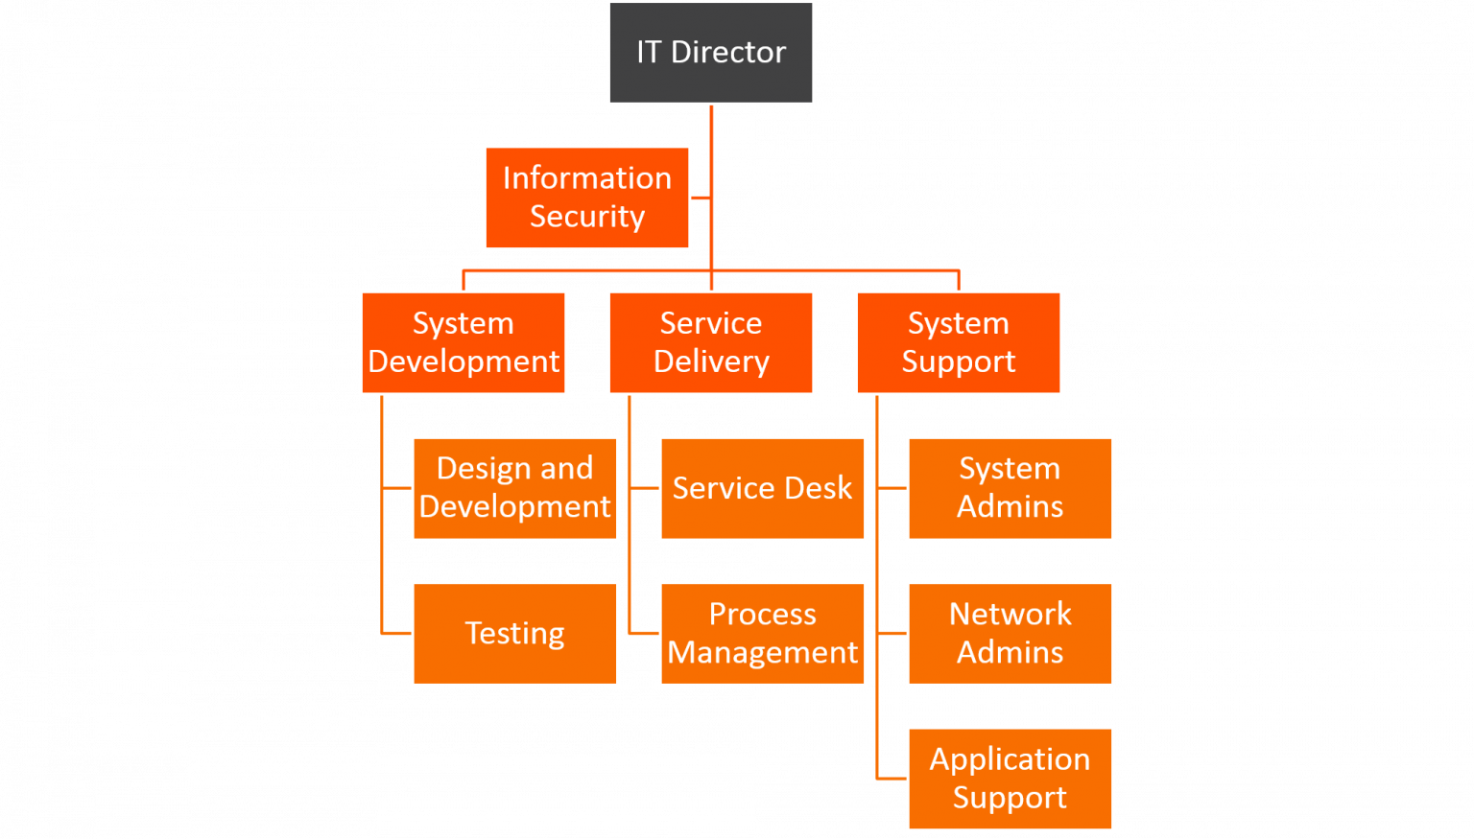
Figure 10: ITIL advice for small- and medium-size businesses [69]
ITIL standard for all three types of organizations in small, medium, and large sizes provides the organizational structure and appropriate solutions to determine the different positions for managing new projects and open issues. Examples of organizational structures proposed by ITIL can be seen in Figures 10 and 11. All the roles in an IT company and the tasks assigned to each role are listed in “ITIL Foundation”.[70] Therefore, senior executives of companies with the correct implementation of this standard in proportion to the size of their organization can ensure the performance of middle managers in controlling projects and proper execution of tasks.
ESDM supports clear responsibilities for organizational positions and believes that people should be held accountable for the results given their position in a company. Therefore, generalization for job descriptions and one-dimensional incentive and punishment systems has no place in the ESDM methodology. For this reason, instead of creating quasi-scientific jobs and positions, ESDM follows the standards tested in this field. ITIL is also the only successful and approved standard in the field of organizational structure and operational processes for IT companies.
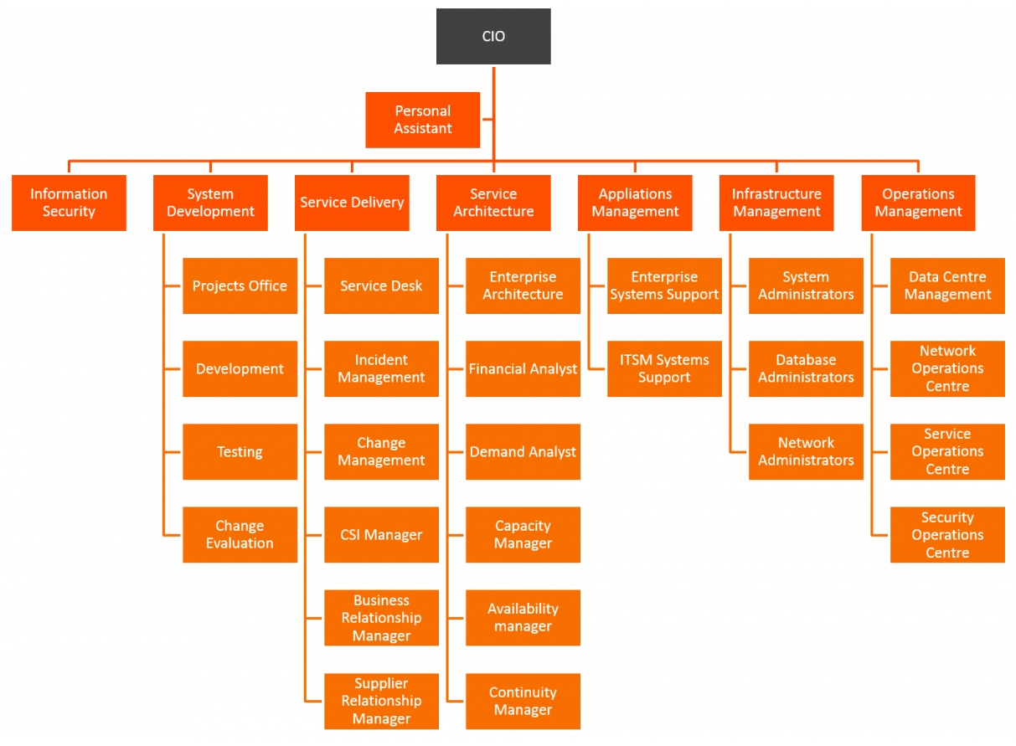
Figure 11: ITIL advice for large-size businesses [69]

Project Management Based on ESDM

Analysis and Requirement Gathering
Scrum, one of the most popular frameworks for agile methodology, extensively emphasizes the rapid determination of needs by the customer or product owner through a tool such as “user story”. Such tools lack any technical scrutiny. These techniques only work to quickly receive the needs of the customer and start the project without wasting time. Here is just one important thing: “Start a project with any level of knowledge and quality to avoid losing the market.”
The main idea is that 80% of the issues are identified along the project path and the customer doesn't need to receive high-quality products in the first step. If the output is satisfactory, it is sufficient for initial delivery and can be improved in the next steps. At first glance, this theory seems very logical, desirable, and practical. But in practice, this method does not work. The fact is that four very important points are hidden from view by the creators of the agile methodology. These four points are:
- When users of a system are faced with an imperfect and flawed environment, an unpleasant mentality of that product and the manufacturer's brand is etched in their subconscious minds. This negative mentality will eventually lead to an unbelievable resistance to product acceptance in the long run. Things like the Facebook social network can be mentioned that despite the initial success, as soon as new competitors appear, they feel the risk of being eliminated from the market. That's why Meta (formerly Facebook) is widely buying popular platforms. Because its main product has lost its initial popularity. In other words, human thoughts automatically label everything and society directs people's minds to their desired paths.
- About nine-tenths of the problems, like icebergs, are usually hidden beneath the surface. Without a comprehensive review of the dimensions and scope of a project, technical teams will certainly face unpleasant challenges. Risk management power is also taken from senior managers of organizations. Therefore, there is a possibility of increasing unnecessary costs.
- Today's consumers have a very wide experience of any type of product (especially software). They always compare new products with flagship products in the market and their pleasant experiences. Therefore, the theory of “starting a gradual development process before creating a positive mindset in users” is faced with serious doubts.
- A large portion of the net income in a software project is in the support phase. An incomplete product will put a lot of costs on the manufacturer in the support phase and the net income will be drastically reduced. In addition, the pressure of supporting a product in use on technical teams will be so great that there will be widespread delays in upgrading and improving it.
Gerald Zaltman discusses the above in detail in his book «How Customers Think».[71] He believes that the lack of careful attention to consumer experiences and their needs has become commonplace in today's methods of analysis, production, and development. Therefore, the cost of reworking the projects and the probability of product failure in the market will increase. Having an accurate understanding of the needs and experiences of the user is of particular importance in ESDM. To achieve this understanding, ESDM has four main steps based on known standards of software analysis and design. These four steps are:
- Scenario design: At this step, the product manager, with the help of the customer, prepares all the scenarios of activities considered for the desired software along with all possible business rules in it. All scenarios along with business rules must be approved in writing and formally by the customer.
- Wireframe design: The product manager together with the UI/UX team is obliged to prepare the scenarios agreed with the customer graphically in the form of specific wireframes so that the description of the operations in the scenarios becomes more objective.
- Prototyping: In this step, a complete prototype of the target system based on wireframes and scenarios will be prepared by the UI/UX team and provided to the product manager and customer. After receiving and implementing the amendments, this prototype must receive written and official approval from the customer to be provided to the development team as the final production model.
- Service (Use-case) Modeling: In this step, according to the final output of the prototype created for the system, the complete specifications of the required services should be prepared based on the use-case modeling standard provided by OMG.[72] Based on this standard, IBM has provided suitable templates for use-case specifications.[73][74] This section is related to the functional specifications of the service. Analysts can also provide a list of non-functional specifications of a service based on common templates.[75] This process may be used to specify intermediate system services such as an ESB or API Gateway. Therefore, this process can be done in parallel with steps 1, 2, and 3. But there should not be a requirement that has been approved by the customer in the previous steps, for which no service is designed for that requirement in this step.
Understanding the customer's needs and creating newer services are among the necessities of a successful project. If the project managers are not sure of the level of awareness of the development team in this regard before starting a project, working on that project is a form of group suicide for the organization. Agile methodology and its related frameworks, to buy more time for product development, consider the accurate analysis of requirements as a low-level activity that can be done with simpler techniques and tools and even without specialized knowledge in a much less time than is necessary for this task.
This type of attitude has no place in ESDM. In terms of this methodology, analysis is considered “the most important activity of a project” that the decision to start a software project and how to do it depends entirely on the output quality of the analysis phase. Therefore, in ESDM, the most expert people are responsible for implementing this phase and the full implementation of the four steps mentioned above by them is necessary without any waiver. According to ESDM, any intentional omission or negligence in the accurate implementation of the analysis process is considered a “violation of consumer rights” and can be investigated by regulatory agencies. On the other hand, the results of the analysis are widely used in project feasibility studies. Detailed analysis tells the project manager what the workload is and whether it is possible to implement the project given the existing facilities and potential of the organization. Therefore, it can be concluded that:
The output of the analysis process is also more obligatory than dinner for the project manager.

Project Scope Adjustment
One of the biggest current challenges in managing IT companies (especially start-ups) is the ambitious and unrealistic scope of the projects defined by them. Undoubtedly, innovation and ambition are necessary for the growth of technology companies. But the scope and goals of a project must be consistent with the resources available for it. Also, the scope of a business's activities should not be so wide as to include a set of unrelated topics within a project. If a company's activities expand to different areas, new departments and projects specific to them should be defined.
The biggest example of this is how Amazon operates, pursuing several ambitious projects in a variety of fields, but never overlapping the management and goals of these projects. The results of one project may be used in another, but they never merge. Unfortunately, this perspective often causes us to become overwhelmed when it's time to start a project. This heterogeneity can occur in two main ways: either the allocated resources do not match the workload at the beginning of the project, or the estimated services for that system do not match each other. The more fragile the economic situation of a country, the more likely it is that technology companies will make this managerial mistake. To better understand, one must visualize a small technology company with limited resources that initially wants to implement an e-commerce system with several different shipping models. It may seem technically successful at first and be able to run a software system with these features. But it will be impossible to support it due to limited resources and lack of sponsors.
Here the subject goes back to the philosophy of “gradual growth” in ESDM. This methodology is not opposed to innovation and calculated ambitions. What matters is the management of resources and risks in each milestone. An ambitious and ambitious goal must be achieved through the proper execution of several rational and managed miles. It is never possible to achieve big goals in the short term and maintain these achievements in the long run by putting sudden, inhuman, and non-binding pressures on the workforce. Unless the goal is individual short-term financial gain. Therefore, in ESDM, a committee will be formed before the start of each milestone to review the scope of the milestone project and the projected outputs for it. The committee will also assess the compliance of these items with the resources available in the organization. Therefore, the allocation of resources at each stage of a project must be done before the start of each milestone. This does not mean that it is not possible to add resources in the middle of a step. But it makes it clear that with the addition of resources in the middle of a phase, the milestone output status and the company's commitment to the customer will not change.
If the resources allocated to a project do not match the intended output for a milestone, the committee will be required to adjust the scope of the project in that milestone. If the committee has avoided this action or has not communicated the project scope adjustment report in a milestone to the project members in a transparent and public manner, or the result of the project scope adjustment operation is too in line with the financial interests of the organization's senior managers, employees can complain to the relevant regulatory due to unconventional pressure. The penalty for this type of violation must be equal to at least two years of the plaintiff's full salary to create the necessary deterrence.
The criterion for correctly identifying a successful project scope adjustment is that all tasks listed in a milestone can be performed by the people assigned to it without the need for overtime.

ESDM Fishbone Model
The big problem with agile methods and their dependent frameworks are that their focus has been on production only. Such methods are weak in developing innovative or research projects. They are unsuccessful in matching with the bottom-up analysis method or component-based software engineering (CBSE) development technique. The agile methodology is strongly poor in activating the minds of experts in a project and launching brainstorms. In agile methodology, specialists of a software project are seen as coding robots that a list of customer needs (backlog) can be assigned to them and after a few days the result can be tracked through an ordinary person (product owner). So the product will be ready in the shortest possible time!
On the other hand, ESDM cares about the quality of the final output. Therefore, careful consideration of innovative ideas and turning them into concrete goals in a project is one of the main concerns of ESDM. A machine checklist (product backlog) for mere production has no place in this methodology. ESDM believes that every project or product is made up of smaller components and that correctly identifying and improving the performance of these small components can lead to the creation of innovative products. As a result, ESDM uses bottom-up analysis and design techniques and the component-based software engineering (CBSE) method to further develop software projects.
The ESDM combines the Ishikawa (fishbone) diagram and the four main stages of the Rational Unified Process (RUP) to provide a model in which a software project can be easily analyzed, designed, and implemented through bottom-up methods. In this technique, a general analysis is performed on the main target to accurately identify its components and the relationships between these components. Then, each identified component is reviewed and implemented in the form of a small R&D project. Eventually, the models created for the various components will be integrated with the core infrastructure by the overall system analysis.
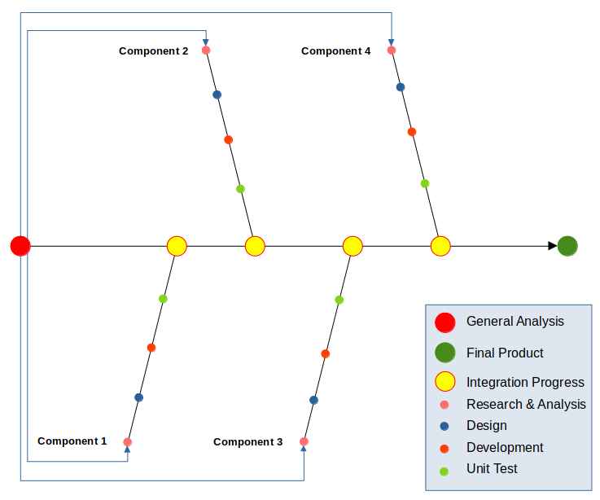
Figure 12: ESDM Fishbone Model for simple systems
This method increases the possibility of parallel development in software projects. In addition, it provides technical teams with enough time for further research to increase the quality coefficient of the final product. Through the ESDM fishbone model, periodic macro-surveys and continuous brainstorming can be utilized throughout the project. Specialists are only in constant contact with each other only in the integration process, and less expert time is spent on useless synergies and meetings. Figure 13 shows an example of an ESDM fishbone model in a software project.
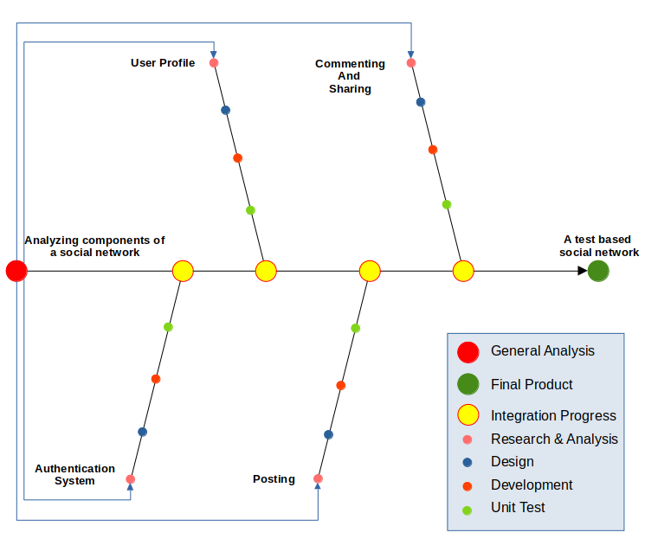
Figure 13: Developing a text based social network by ESDM Fishbone Model
This method is very suitable for designing and implementing systems that are based on microservice architecture. Because in small production teams, the system can be distributed among developers based on components. A programmer can develop a component to complete all the required items in three layers: back-end, API, and front-end alone. On the other hand, in large companies, this process is done between different teams, and one-item items are distributed among them. Provided that the project management process is implemented as a balanced matrix. The ESDM fishbone model is also used in large projects consisting of several different modules. In the initial analysis, the modules and the connections between them are identified and each module will have its fishbone diagram. The output of each diagram is returned to the parent diagram, where it will be integrated with other modules. A summary example of a fishbone model for a complex and multi-module system can be seen in Figure 14.
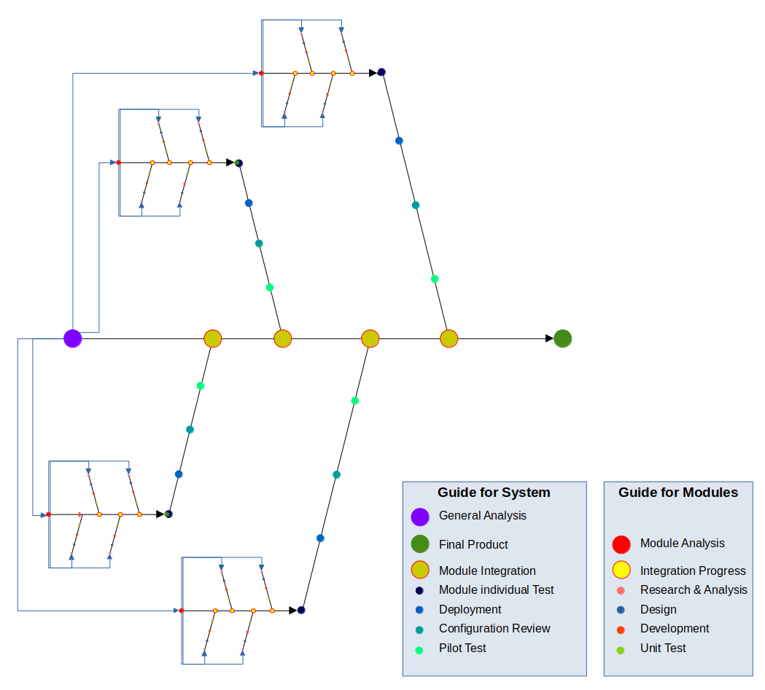
Figure 14: ESDM Fishbone Model for complex and multi-module systems

Task Schedule Balancing
Each milestone has a specific work plan for the teams involved in product development. In most cases, the weight of the milestones is not equal to each other. In many cases, even the weight of a milestone does not match the time allotted to it. As a result, the workload of employees is in most cases beyond their capacity and a project will also involve staff personal time. This phenomenon occurs in software projects for the following two reasons:
- Extravagance of capitalists and business owners to complete projects in unreasonable times.
- Low ability of middle managers to plan things in a balanced way.
In the ESDM, the to-do list will be obtained by dividing the components identified in the fishbone model into smaller tasks. For ESDM, there is no force majeure task or milestone. Unless, depending on its sensitivity, manpower and other resources are added to the project before the milestone begins. This means that planning for an emergency must be done before it occurs. Agile methodology allows senior executives of organizations and companies to include emerging issues in their current agenda whenever they wish during a milestone and even at the peak of workload. Emergency handling is normal for businesses with a sensitive or rescue nature. But in ESDM, such businesses have a definite definition and boundary. Businesses that are allowed to handle emergencies in the middle of a milestone include:
- Military systems
- Rescue systems
- Shipping systems
- Air navigation systems
- Related systems or issues to information security
- Related systems or issues to crisis management
- Maintenance of online financial transfer systems
- Maintenance of systems related to the stock exchange
- Maintenance of online service systems
According to the pattern defined in the ESDM, if the defined project is not a subset of any of the businesses listed above, the to-do list for each phase is determined before it is started, and in this to-do list during Phase execution will not change until before the milestone. Therefore, neither the customer nor the employer will be able to include new requests during the implementation of one phase, and this action will be possible only in each milestone. It is best to define milestones based on the integration sections specified in the fishbone model. But the to-do list can be created from the operational steps of a component identified in the fishbone model or the division of each of these steps. Depending on the weight of each milestone, the technical teams finally have between 2 and 5 working days to announce the to-do list and delivery time to the project management office. Technical managers are required to indicate the weight of each task in this list. The weight number of a task will be between 1 and 10 depending on its complexity. The order of this weighting will be based on Table 1.
Weight | Type of Task
1 | minor
4 | medium
7 | major
10 | complex
Table 1: Criteria for weighting tasks
A task defined in the list can have a maximum workload of a single operation without dependency (based on microservice architecture). If a task has multiple sub-operations and is more complex, it should be subdivided into smaller tasks. Therefore, the definition of a task in ESDM is as follows:
Each of creating, modifying or deleting any service from a micro-service is a single task.

Change Management
Change management is one of the most important and key activities of the software production cycle, which plays a key role in the product integration process and appropriate delivery to the customer. Excessive negligence of agile methodologies and related frameworks in documentation has caused the change management process in many technology companies to face many information deficiencies. Many problems of software development teams in product integration are due to the lack of this information. However, according to ESDM, the information produced in the change management process is directly related to controlling and improving the quality of the product and guarantees the observance of consumer rights at the time of product delivery. Therefore, ESDM has made very strict rules regarding the collection of information during the change management process. In this methodology, it is required to prepare the following documents and keep their history.
- Release Notes: Release notes are documents that are distributed with software products or hardware products, sometimes when the product is still in the development or test state (e.g., a beta release). For products that have already been in use by clients, the release note is delivered to the customer when an update is released. Another abbreviation for Release notes is Changelog or Release logs or Software changes or Revision history Updates or README file. Release notes must be prepared before delivering each copy to the customer. Also, depending on the type of product, along with other documents, it should be delivered to the customer's representative or published publicly.
- Changelog: A changelog is a log or record of all notable changes made to a project. The project is often a website or software project, and the changelog usually includes records of changes such as bug fixes, new features, etc. Some open-source projects include a changelog as one of the top-level files in their distribution. The changelog contains more detailed and specialized information for system developers. As a result, this information must be fully documented and maintained at the end of each version at least once by the DevOps Manager and the Project Manager.
- Dependency Graph: a dependency graph is a directed graph representing the dependencies of several objects on each other. The dependency graph should be periodically reviewed and updated by the technical manager and the project manager. This graph should be designed in such a way that in addition to displaying each node and its connections, a specific part of it can be separated and displayed based on a node selected as the source.
- Version History: version history gives access to old copies of files and shows the number of each version, the size of each version, as well as who created each version, and when. Version history is a complete list of all published versions of software, including version number, release date, list of changes, publisher person or unit, customer acceptance status, first installation date, and other related items. This information must always be updated by the DevOps Manager. The project manager is also required to review it.
ESDM does not accept any omission in the preparation of these four documentaries. Every organization of any size is obliged to prepare and update these four documents promptly. Any negligence in preparing these four documents is equivalent to “violating consumer rights and increasing the risk of product development and delivery”. Therefore, the employer has no right to ignore the preparation of these four documents under the pretext of speeding up the development process.

Iteration Management
An important part of the knowledge needed to complete the integration process can be extracted from change management documentation. But this does not include all the required information. Unfortunately, in most technology companies, the product integration phase is more empirical and less based on written knowledge. Try and error have become an integral part of the product integration process in such companies. The source of many of these irregularities is the constant excuse of “speeding up task". But in reality, this method only increases the costs of product development and delivery. As a result, in parallel with production, the data collection process for product integration must be ongoing and the required documentation must be prepared or updated before the process begins.
Some information about the integration process is also obtained during its implementation, which must be collected and documented during the operation. Gathering this information and writing this knowledge ensures that the components, services, and micro-services provided in a milestone are accurately assemble and that the connections between them are perfectly accurate. The documents that must be prepared in this process are:
- Configuration Identification (CI): Configuration identification is the process of identifying the attributes that define every aspect of a configuration item. A configuration item is a product (hardware and/or software) that has an end-user purpose. These attributes are recorded in configuration documentation and baselined. Baselining an attribute forces formal configuration change control processes to be affected if these attributes are changed. The analysis and design unit will be responsible for preparing these documents.
- Build and Compilation Guideline: The process of building a specific version of the software must be specifically included in the build guide. It must be explained exactly with what settings the different services and modules are connected and the final version is compiled and built based on it. The DevOps unit will be responsible for preparing these documents.
- Installation Manual: An installation manual or installation guide is a technical communication document intended to instruct people on how to install a particular product. An installation manual is usually written by a technical writer or other technical staff. The DevOps unit will be responsible for preparing these documents.
- User Guide: A user guide, also commonly known as a user manual, is intended to assist users in using a particular product, service, or application. It's usually written by a technician, product developer, or a company's customer service staff. The QA unit will be responsible for preparing these documents based on happy path or error test scenarios.
- Administrator Guide: The admin guide is a subset of the user guide that describes how to use panels or services related to system administration. The QA unit will be responsible for preparing these documents based on happy path or error test scenarios.
The above documents are prepared to step by step by different units. But they will be kept in an integrated set. Therefore, it is better to always integrate and maintain these documents in the form of knowledge management systems to protect them. ESDM does not enter into negotiations with anyone to reduce the number or change the type of these documents, and it is mandatory for any organization to provide all of the above documents.

Project Controlling
It may be best to understand what the project control does before it is understood what output is expected from the project control. James P Lweis [76] explains that monitoring and controlling the project includes the following:
- Measuring the ongoing project activities ('where we are');
- Monitoring the project variables (cost, effort, scope, etc.) against the project management plan and the project performance baseline (where we should be);
- Identifying corrective actions to address issues and risks properly (How can we get on track again);
- Influencing the factors that could circumvent integrated change control so only approved changes are implemented.
Based on the above definition, ESDM expects project managers to carefully provide the following and continue to use them.
- Determining project control criteria: Measurement criteria should be specified to control the status of the project before it starts. These criteria will be different in each project according to its nature. For example, time may be an important factor in a business project. But in research or military projects, accurate results and quality take precedence over time.
- Periodic report of ongoing activities: Periodic written reports should be prepared for current and ongoing activities and the history of these reports should be preserved. In such a way the status of the project can be checked at different time intervals.
- Periodic report of project variables: The status of project variables should be periodically reviewed and recorded in the form of written reports.
- Determining the system of recording and tracking issues: It should be possible to record, maintain, review and follow up on issues related to a project in a software system. The results of all actions related to an issue must be recorded and stored in the same system.
- Determining the CAPA management system: All corrective and preventive actions envisaged for a project along with their results must be recorded, maintained, and reviewed in a software system. This process should be such that the results of actions taken at different time intervals can be compared with each other.
- Providing annual project status report: Annual written reports on the status and results of a project should be provided to the organization's executives. These reports should also include business intelligence charts to enable executives to make better decisions.
These are the minimum requirements for project control that ESDM has required for any organization of any size. Outputs of project control processes and systems should lead to the preparation of appropriate and effective business intelligence reports for decision-making at the highest levels of the organization. Otherwise, it will be quite clear that the project control process has serious weaknesses.
Note: Wherever the term “system” is used in ESDM, it refers specifically to management software systems. For ESDM, handheld systems are mere “paperwork”. As a result, in cases 4 and 5, we mean software systems.

Meetings
ESDM strongly opposes the simultaneous presence of all members of the software development team in most project-related meetings. The agile methodology emphasizes improving the level of communication between team members. Under this pretext, the duties of low-skill managers are placed on the shoulders of other specialists. Because programmers and technical members are increasingly involved with all the technical and administrative problems of the project and have to engage in unnecessary activities to cover the weakness of their managers and get rid of unfair work pressure. But ESDM believes that:
“A professional software development team must have technical managers with product integration capabilities and great communication skills before they can have fantastic programmers.”
ESDM strictly controls that only relevant people are present in each meeting and prevents meetings with a large number of attendees. Meetings with a large number of attendees are unnecessarily long and it is not possible to examine the issues in detail. Also according to the Pareto principle, when the number of attendees in a meeting increases, a smaller percentage of them will comment on the issues raised. Therefore, more operational time will be wasted and tasks will be completed later. In terms of safety and health, if the meetings are held in person with a large number of people, the risk of infectious diseases increases. The importance of this issue has become apparent to organizations and companies during the Covid-19 pandemic.
Managers, whether they like it or not, have to accept that every meeting carries a negative psychological burden on employees. Even if the meeting is held in a completely friendly and cordial atmosphere. Because the output of each session is a set of tasks that engage the minds of employees. Therefore, the pressure caused by this stress should be carefully controlled and the presence of employees in unnecessary and irrelevant meetings should be avoided as much as possible. So:
“Rule 1: There are no public gatherings in ESDM. There should never be more than 5 people in a meeting at the same time and everyone in the meeting should be relevant.”
There are two types of managers in ESDM. A manager to coordinate, follow up and control the current status of the project, which is the responsibility of the PMO. Another for technical reviews, providing solutions to team members, and managing system integration operations that are shared between the technical manager and DevOps manager. Technical managers are not supposed to attend all meetings of the organization. ESDM ensures that relevant managers are present at the meetings and that not all technical managers attend one or more meetings at the same time. It has been seen many times in various technology organizations that the technical staff has not been able to contact the managers to investigate the problems encountered in the project. Because they all attended the meeting at the same time. [77]
“Rule 2: Meetings should never be arranged in such a way that the technical team's access to their managers is cut off and team members are forced to postpone reviewing and resolving a sensitive issue until the end of a meeting. In case of holding such meetings, the organizer of the meeting will be responsible for all damages caused by the delay.”
Therefore, it should be carefully controlled what kind of meetings and with what topics are held during a software project, and who are present in each meeting. Under the pretext of lack of coordination, a wide range of people with different specialties should not be gathered in one meeting. If there is still inconsistency in a software development team despite regular meetings and ongoing project monitoring, weakness should be sought in the organization's senior management and human resource system. For this reason, ESDM determines the exact set of meetings required to implement software development projects for IT companies and identifies who should attend each meeting. The meetings scheduled by ESDM are:
- Technical
  - Analysis Meeting (AM)
  - Project Control Daily Chat (PCDC)
  - Weekly Review Meeting (WRM)
  - DevOps Meeting (DOM)
- Product Delivery
  - Sprint Cabinet Meeting (SCM)
  - Millstone Delivery Meeting (MDM)
- Management
  - Feasibility Study Meetings (FSM)
  - Project Management Office Meeting (PMOM)
  - Corrective and Preventive Actions Meeting (CAPAM)
The organizational meetings are held to help solve problems, control the current situation, or plan for continuous improvement. Therefore, in an efficient organization, there will be no waste of time. as a result:
“Rule 3: The duration of an organizational meeting with any topic or any type that is held should not exceed 60 minutes.”

Technical Meetings

Analysis Meeting (AM)
An analysis ‌meeting (AM) is one of the most important sessions of a software development team. Because the result of these meetings is a detailed description of the relevant business requirements for the final implementation. A software development team's understanding of the target business is entirely dependent on the results and final output of the analysis team. If a system is developed based on poor analysis, the result will be nothing but project failure. For this reason, these meetings should be held during the best office hours (mornings) and the people present in these meetings should be carefully examined before holding.
If a topic requires more than 60 minutes to analyze, its content should be divided into other meetings. In such cases, the topics that can be presented in each meeting should be determined and the interval between meetings should be adjusted so that it does not exceed 48 hours. Out-of-discussion items for meetings should be strictly avoided. Contrary to popular belief, the people present at an analysis meeting are extremely limited. These individuals are mainly directly or indirectly effective in shaping the relevant business strategies. The people present in the analysis meetings are listed in Table 2.
No | Position | Responsibility
1 | Product Manager | Chairing the meeting
2 | Customer | Describe the requirements
3 | Analyst | Examine requirements and control them with current constraints and conditions
4 | Technical Manager | Be aware of the requirements and provide technical warnings if needed
Table 2: Audiences of analysis meeting
The output of these meetings should be the analyst's schedule for preparing and presenting the documentation needed to implement the requirements. The topics covered in the analysis meetings should be categorized according to the “issue concept” in ITIL. Responsible for implementing this classification is the product manager.

Project Control Daily Chat (PCDC)
In Agile Methodologies, meetings are held under the title of “Stand up” to review the latest status of items assigned to team members daily. In most cases, the reason for holding such meetings is the laziness of employees (especially programmers) in reporting. Defenders of this style of work believe that stand-up meetings do not require much time and can be held in 15 minutes. But experience has shown that at the time of many uncertainties in the project, it will not be possible to manage such meetings in 15 minutes. The question is: Are stand-up meetings held due to the laziness of programmers or the illiteracy of technical managers?
The fact is that the agile methodology makes every effort to reduce the cost of software development and employer satisfaction! To achieve this goal, two valuable positions of “Product Manager” and “Technical Manager” have been removed and replaced by two low-level positions which are called “Product Owner” and “Scrum Master”. Agile methodology allows the employer to train two low-cost, low-literate, and inexperienced pepole to take over these two positions and dominate the technical forces. The advantage of this is that the employer will be able to impose any time limit on the project without the knowledgeable and experienced people objecting to it. In the event of technical problems, the first-line culprits will be the developers, and the employer will be able to place the entire project pressure on them and minimize the technical costs by ignoring the technical needs of the development team.
The size of a technical team should be adjusted so that the technical manager can check the output and current status of all team members within a maximum of 3 hours. Therefore, if the number of software development members in a company is more than the capacity of a technical manager, that company will need more than one technical manager. The company should also check at an appropriate time whether the number of members of its development team has grown beyond need or not.
The PCDC report should be the criterion for reviewing corrective and preventive actions (CAPA) in each project. Sometimes a PCDC can be turned into a pair programming due to acute technical problems. If these issues are not resolved through consensus, the project manager and product manager should be notified at the weekly review meeting. If a PCDC leads to the discovery of a crisis, technical managers are required to raise the issue at CAPA meetings as well. The people present in the PCDC are listed in Table 3.
No | Position | Responsibility
1 | Technical Manager | Chairing the meeting, Raising question, Offering solutions
2 | Developers or IT professionals | Provide technical explanations about the results of the work done.
Table 3: Audiences of PCDC

Weekly Review Meeting (WRM)
A weekly review meeting (WRM) to review the results of the held PCDCs and check the status of the project before each sprint. This meeting should be held by middle managers and there is no need for technical staff. In these meetings, the issues will be raised by the project manager and the technical managers will answer them. If a technical manager is not able to answer the questions accurately and clearly and needs technical staff to find the answer, the project's shortcomings and delays in that area should be sought in the manager's low capabilities. Therefore, according to the principles of ESDM, the presence of any technical force in the weekly review meetings is not accepted and the manager of each department must be able to answer the questions raised by the project manager. The product manager can attend these meetings as an observer but will not have the right to comment. If the number of technical managers is more than 5 people, they can be summoned in turn in the meeting.
Meetings should be held once a week. The day and time of the meetings are chosen by the project manager. Technical managers are required to attend the meetings unless authorized to do so by the project manager. Therefore, this permit must be obtained before going on leave. The results of the meetings should be presented in the form of project management reports by the project manager to the executives of the organization. The people who should be attended the weekly review meetings are listed in Table 4.
No | Position | Responsibility
1 | Project Manager | Chairing the meeting, Raising question
2 | Technical Manager | Answering the questions
3 | Product Manager | Observer
Table 4: Audiences of weekly review meeting

DevOps Meeting (DOM)
The DevOps Meeting (DOM) is one of the most important technical sessions. In these meetings, the necessary coordination for product integration, implementation of various tests, preparation of the final version, and submission of a technical report of each milestone are reviewed and the necessary decisions are made for them. People who attend these types of meetings should have full knowledge of the details of the system. This level of awareness should be such that there is no need for technical staff to be present at the meeting. Therefore, this type of meeting is a high-level and sensitive meeting in any organization, which determines the result of their activities at the end of each milestone.
These meetings start one week before the alpha test and will continue every three days until the product is delivered to the relevant milestone. The reason for the constant repetition of these meetings is the continuous control of the integration process and checking the quality of the product being delivered. The final result of these meetings will be the product preparation reports to executives of the organization. The people who should be attended the DevOps meetings are listed in Table 5.
No | Position | Responsibility
1 | DevOps Manager | Chairing the meeting, Raising question, Reporting about Versioning Process
2 | Technical Manager | Answering the questions, Reporting about Integration Process
3 | QA Manager | Answering the questions, Reporting about Test and QA Process
4 | Project Manager | Observer
5 | Product Manager | Observer, Auditing production result
Table 5: Audiences of DevOps meeting

Product Delivery Meetings

Sprint Cabinet Meeting (SCM)
Sprint cabinet meetings (SCM) are held every two weeks. Its purpose is to continuously monitor the progress of the project with the customer. Contrary to the agile methodology, in ESDM the customer only has the right to request product delivery in the milestones, and these meetings only ensure that the project does not deviate from the requirements. In these meetings, the output of the production team is presented to the customer's representative and the product manager. If necessary, they will announce their opinions. The customer representative and the product manager are required to state in writing whether the output presented at the meeting meets the requirements considered in the analysis process. The customer or it representative can not refuse the official approval of the meeting to get more points from the contractor company and put more pressure on the production team. Even if the customer is the parent company of the holding which the contractor is a member.
If the customer or product manager refuses to comment on the results of a sprint cabinet meeting, they will be responsible for future risks. If the deviations are less than 20% of the weight of the total items set for review in the meeting, the customer representative or product manager has no right to refuse to complete the sprint. Instead, the production team must commit to completing the remaining sprints in addition to completing the next sprint. The output of the production team may cover 80% of the items assigned for review in the meeting, but there are high priority issues in the remaining 20%. Only in these cases will the customer's representative or product manager be able to refuse to complete the sprint. High priority items should not make up more than one third of the total weight of the items available in a sprint. The process of determining the weight of each task and its priority is described in Section 6.9. The output of the sprint cabinet meeting should be to approve or reject the current sprint and determine what can be considered in the next meeting. The reason for using the term “cabinet” in the name of this type of meeting is to hold it in a cabin (small room) for 4 people, which only accommodates the product manager, analyst, customer representative and a technical manager. The presentation will be done using a laptop and the relevant technical managers will enter the room one by one. This technique is used to avoid talkativeness and waste of time and on the other hand to make optimal use of minimal space. The people should be attended in the sprint cabinet meetings are listed in Table 6.
No | Position | Responsibility
1 | Product Manager | Chairing the meeting, Raising question based on Sprint Checklist
2 | Customer Representative | Raising question based on Sprint Checklist and Requirements
3 | Relative Technical Managers | Answering the questions, Presenting the Outputs
4 | Analyst | Answering the questions
Table 6: Audiences of sprint cabinet meeting

Millstone Delivery Meeting (MDM)
The milestone delivery meeting is the final review with the customer to deliver the approved outputs according to a milestone schedule. This meeting is held once at the end of each milestone. The prerequisite for this meeting is the reports of sprint cabinet meetings, DevOps meetings and UAT results. If the information obtained from the meetings, and user acceptance test confirms that 90% of the items on the milestone delivery list are successfully ready to be delivered and in the remaining 10% of cases there is no high priority item, the customer cannot reject the product in the relevant milestone. The customer may not wish to launch the product in the original environment for internal reasons. But it must pay the contractor the agreed amount in milestones.
Instead, if the deliverables fail to meet the 90% threshold, the customer can find the contractor based on the terms of the contract and deduct the milestone payment amount. Agreements may be reached between the customer and the contractor for the non-delivery of certain items, all of which must be in writing. In the final milestone, all remaining items must be delivered. The output of this meeting will be the confirmation of the product delivery by the customer and the determination of the next milestone delivery list. The people who should be attended the milestone delivery meetings are listed in Table 7.
No | Position | Responsibility
1 | Customer Representative | Chairing the meeting, Raising question based on delivery list, Confirming product delivery
2 | Product Manager | Reporting about delivery list
3 | Contractor QA Manager | Reporting about Alpha Test
4 | Customer QA Manager | Reporting about UAT Test
Table 7: Audiences of milestone delivery meeting

Management Meetings

Feasibility Study Meeting (FSM)
A feasibility study meeting (FSM) is a type of management meeting to review the results of the analysis and assess the capabilities and shortcomings of the organization in the implementation of the project. This meeting should be held with accurate and complete information from analysts. Also, all middle managers of the organization should provide accurate information about the facilities and capabilities of the organization that are suitable for use in the project in question. In this meeting, based on the information provided and the goals of the organization, it is decided whether to conclude a contract for the project under review or not. In the next step, a list of actions needed to do this should be prepared. Exceptionally, the number of people present at this meeting will be more than 5 people. But the holding time should not exceed 60 minutes. The people who should be attended the feasibility study meetings are listed in Table 8.
No | Position | Responsibility
1 | CEO | Chairing the meeting
2 | Product Manager | Questioner
3 | Project Manager | Reporting about finalizing milestone
3 | Related Technical Managers | Reporting about production abilities of the organization
4 | QA Manager | Reporting about quality assurance abilities of the organization
5 | DevOps Manager | Reporting about implementation and versioning abilities of the organization
6 | Analyst | Reporting about analysis results
Table 8: Audiences of feasibility study meeting

Project Management Office Meeting (PMOM)
The project management office meeting (PMOM) is a high-level meeting in the organization to quickly and periodically review the current status of the project each week. This meeting should not in any way interfere with the weekly review meeting. In this meeting, project progress reports will be presented by the relevant technical manager to the project manager of the CEO and it will be checked whether the expectations raised last week have been met by the Gantt chart or not. At the end of the meeting, the expected items for the next week will be reviewed. If several projects are to be considered at this meeting, it is best to invite the technical managers one by one to attend the meeting. The people who should be attended the PMOM are listed in Table 8.
No | Position | Responsibility
1 | Project Manager | Chairing the meeting, Questioner
2 | CEO | Observer
3 | Related Technical Managers | Reporting about current status of the project
Table 8: Audiences of project management office meeting

Corrective and Preventive Actions Meeting (CAPAM)
Corrective and preventive action meetings in an organization are one of the most important quarterly meetings that are held every three months between senior managers and middle managers. In this meeting, the ISO 9001 Quality Assurance Manager and Supervisor will summon the technical managers to the meeting one by one and review the problems that have occurred in the last three months. It also examines what actions have been taken to prevent similar incidents from occurring. The CEO and board members can participate in these meetings as observers. The output of this meeting is a list of reforms that must be implemented in the system of corrective and preventive actions (CAPA) in the next quarter. The people who should be attended the CAPAM are listed in Table 10.
No | Position | Responsibility
1 | QA Manager | Chairing the meeting, Questioner
2 | ISO 9001 Supervisor | Questioner
3 | All Middle Managers | Reporting about current status of the project
4 | CEO | Observer
5 | Board Members | Observer
Table 10: Audiences of CAPAM

General Rules of Meetings
- There should never be more than 5 people in a meeting at the same time and everyone in the meeting should be relevant.
- Meetings should never be arranged in such a way that the technical team's access to their managers is cut off.
- The time of a meeting should not exceed 60 minutes.
- Meetings should be held during office hours (8:00 AM until 17:00 AM). Out-of-office meetings that force employees to work overtime are prohibited and indicate poor management planning.
- The agenda of the meeting and its details must be specified before it is held and sent to the attendees.
- The meeting must have a moderator. The task of the meeting moderator is to prepare the minutes and prevent the occurrence of marginal issues.

Project Documentation
Unlike agile methodologies, ESDM is very sensitive about documenting a project and has very strict requirements in this regard. Every software that is developed in the world includes a part of the international communication and information system and a part of human knowledge in the field of technology. The neglect of recording this knowledge by agile methodologies has replaced broad social benefits with short-term and limited commercial interests. In the long run, this trend will reduce the human aristocracy to the technical experience and knowledge of its predecessors. As a result, small software declines over time, and complex systems are replaced by reduced mastery. Although the software and its documentation may have intellectual property rights, their impact on technology development is pervasive. As a result, software owners and technology companies should be required to document their products to both extend the lifetime of those software and prevent the lack of human experience and knowledge in the field of technology.
All companies must prepare some documents in the ESDM methodology. But some documents will need to be prepared according to the type of product and the size of the company. However, the minimum documentation required for a project in ESDM is mandatory for all companies that follow this methodology and can not be ignored. One of the obstacles to documenting software is that people avoid doing so. The laziness of programmers, project pressure, the hubris of specialists, low competence and expertise in writing, and many other factors are among the causes of internal conflicts for not doing documentation. [78] The ESDM methodology accurately determines what role in a software project is responsible for preparing and updating which document or documents.
No | Document Title | Size of Company | Responsible
1 | Business Requirement Specification | all | Business Analyst
2 | System Architecture | all | System Designer
3 | Data Model or Object Relational Model | all | Database Designer
4 | Product Business Model | all | Product Manager
5 | Network Model | Medium and Enterprise | System Designer and System Administrator
6 | System Security Specification | Medium and Enterprise | System Administrator
7 | Administrator Guide | Medium and Enterprise | System Administrator
8 | Developer Guide | Medium and Enterprise | Developer
9 | User Guide | all | Business Analyst
10 | In-Line Documentation (Comments on Code) | Medium and Enterprise | Developer
Table 11: List of required documents in ESDM
Table 11 displays the minimum documentation required in ESDM methodology for software projects appropriate to the size of the manufacturer. Therefore, all significant documents for a proper description and understanding of a system are required in all projects and for all companies.

Project Modeling
The modeling language approved by the ESDM methodology is UML 2.0. In some other methodologies, system modeling may be considered a time-consuming and unnecessary task. But in ESDM, modeling is an essential process for design validation and evaluation and will significantly help to record project knowledge. A hasty and unapproved design is one of the main causes of software project failure. Through the software model, the complexity of the entire software can be analyzed, and also the strategy behind the development of the software can be estimated. [79] Table 12 shows the priority of preparing UML diagrams based on the size of the software company.
No | Diagram Title | Type of Diagram | Size of Company | Responsible
1 | Class diagram | Structural | Medium and Enterprise | System Designer
2 | Component diagram | Structural | all | System Designer
3 | Composite structure diagram | Structural | Enterprise | System Designer
4 | Deployment diagram | Structural | all | System Administrator
5 | Object diagram | Structural | Medium and Enterprise | System Designer
6 | Package diagram | Structural | Medium and Enterprise | System Designer
7 | Profile diagram | Structural | Enterprise | System Designer
8 | Entity relation diagram | Structural | all | Database Designer
9 | Activity diagram | Behavioral | all | Business Analyst
10 | Communication diagram | Behavioral | Medium and Enterprise | System Designer
11 | Interaction overview diagram | Behavioral | Enterprise | System Designer and Business Analyst
12 | Sequence diagram | Behavioral | all | System Designer
13 | Collaboration diagram | Behavioral | Enterprise | System Designer
14 | State diagram | Behavioral | Medium and Enterprise | System Designer and Business Analyst
15 | Timing diagram | Behavioral | Medium and Enterprise | System Designer
16 | Use case diagram | Behavioral | all | Business Analyst
Table 12: Priority for preparing UML diagrams based on ESDM
Tables 11 and 12 help large customers know what diagrams and documentation they should expect based on the size of the contractor company if they receive the software source code from the contractor by the contract. Customers should also specify the size of the contractor company before the project tender, according to their need for software technical documentation.

Managers' Responsibility about Risks
In agile methodologies and related frameworks to prevent the appearance of weakness and lack of knowledge of middle managers, risk management pressure should be distributed to all organizational forces. For example, managerial pressures of developing and implementing a banking system or an e-commerce system easily affect the downstream forces of companies, such as developers, analysts, testers, user interface designers, and other less responsible forces. However, the income of these forces will never come from the relevant business to the extent of the responsibility imposed on them.
This is an apparent escape from responsibility in one of the most sensitive industries in the world. Where downstream technicians sometimes have to work long hours than legally and even on holidays just to develop and implement a new version of the software. However, many senior executives and even some middle managers are reluctant to accept the pressure of these responsibilities. Sometimes managers put the pressure of a project on the downstream forces by using verbal traps such as “teamwork”, “exemplary employee”, “sacrifice for business”, “do not be lazy”, “swallow your frog” etc. ESDM will never take such an approach to accept responsibility in a software development team. ESDM's view on acceptance of responsibility and its level of acceptance in software projects is quite clear:
“Any weakness, deficiency, mistake, catastrophe, shortcoming, delay, fear, worry or damage stems from poor management.”
There may be doubts about the role of poor management in all the bad events of a company or organization. But the fact is that poor management affects even the quality of the napkin placed on the staff desk! To properly understand the meaning of “poor management”, it is sufficient to examine the following examples in detail.
- If the forces of a company work overtime, it means that their managers are not able to manage time and accurately break project tasks.
- If a company's workforce has a lot of overhead tasks and repetitive tasks are delayed, it means that managers are now pursuing ambitious goals beyond the current capacity of their workforce.
- When a workforce is out of control or does not have the necessary qualifications, it means that managers have not been careful in hiring.
- When a company is faced with limited financial resources, it means that its managers have not been careful in the optimal use of resources.
- When a company is in crisis, it means that the structure and patterns of risk management are poor.
- When a new system's initial setup requires a large number of expensive hardware resources, managers are poor at selecting and implementing the right architecture.
- When software has poor documentation, it means that the infrastructure and design of the product are not properly engineered and the management of the manufacturing company has limited knowledge of technical issues.
- If a programmer has a lot of errors in their coding or an analyst produces documentation with a high error coefficient, that means it's poor to manage output reviews.
- When the forces of an organization do not care about the current state of a project, it means that the human resource management in that company is extremely poor.
- When preparing the final version of software always faces serious challenges, it means that the product integration management is poor.
- If one of the professionals is not able to perform a task properly, which means that the training management in the company is poor.
- If specialists are not able to start bold projects, it means that the research and development management in the company is poor.
- If a company's toilet paper does not fill up on time or the burned-out light bulbs are not replaced quickly, it means that procurement management, logistics management, and cost control are poor.
- And etc.
It must be admitted that a higher position equals the acceptance of more responsibility. To reduce the stress on managers, employees' responsibility cannot be increased without changing their position and salary. According to ESDM, managers are responsible for the outcome and they must be held accountable as the first person for any malpractice.
Therefore, the path of all problems in an organization will end up with its managers.

Conclusion
In methodologies based on capitalist culture, the only priority is the financial interests of the organization or company that uses it. The whole focus of such methodologies is on product development and service delivery to a wide range of customers. Therefore, quality in production, environmental issues, and human rights have no special value in their ethical models. Some critics believe that socialist methodologies hinder the growth and development of human knowledge and slow down its process. Some also accuse such methodologies of reducing the incomes of the middle and low-income classes of society.
The main goal of methodologies based on capitalist culture is economic growth. Economic growth is closely linked to increases in production, consumption, and resource use and has detrimental effects on the natural environment and human health. [80] Also, this trend will eventually lead to the accumulation of capital and the unfair distribution of wealth in society. Therefore, the result of the widespread use of these methodologies is a sharp decline in the level of social justice.
So far, the working methods in the software development process have never been criticized from a social, political, and cultural perspective. It is generally believed that technical issues and methods have nothing to do with social or political issues. But all this simplification can be true to the extent that such issues do not lead to the creation of an inclusive organizational culture. Therefore, the intellectual and ideological structure of a method will affect the economic and social situation of society. Any business strategy and work methodology include not only technical techniques but also revenue policies and organizational culture. When a work culture is used in a wide range of companies and organizations, it will ultimately lead to dramatic changes in the social structure of that community. This even creates undesirable mental paradigms in society. For example, in the long run, experts believe that their entitlement to a firm's net income is fixed and is only part of the company's direct costs.
On the other hand, socialist methodologies, along with achieving project goals and controlled economic growth, respect social values and preserve a country's strategic resources. Such methodologies try to minimize the material and moral damage caused by production and economic growth to environmental resources and manpower while developing a project and improving the process of a company's activities. They help the community in the long-term use of these resources. Socialist methodologies have no tendency to involve organizations and companies with political ideologies. But they care about the technical, industrial and commercial methods that affect society and public life. The extent of these effects must always be evaluated. Industrial and commercial activities that have destructive financial, human, psychological and environmental effects on society must also be avoided.
In capitalist methodologies, most issues are presented as “recommendations” to organizations and companies so that the capitalist is free to circumvent the law to earn more money. But socialist methodologies to prevent any misuse by capitalists and senior managers of companies from Legal gaps, provide all stakeholders with work methods and business management techniques in the form of “rules”. A socialist methodology includes a set of rules that equitably serves the interests of all project stakeholders within the framework of social ethics. But a capitalist methodology involves a set of escape routes that help capitalists earn more without considering any ethical criteria.
Perhaps a capitalist methodology can bring about favorable economic growth for governments in the short term. But this way of working will inflict irreparable psychological damage on the workforce in the long run. To the extent that it may even threaten the foundation of families. The speed of economic growth is not important today. Rather, it is sustainability in economic growth that is of particular importance. A methodology must be able to provide long-term business sustainability by eliminating the interests of all stakeholders.

References
[1] “Secret of the samurai sword – Making a masterpiece”. Nova. PBS.
[2] “Athletics at the 1968 Ciudad de México Summer Games: Men's Marathon”. Archived from the original on 2011-10-02. Retrieved 2011-08-29.
[3] Stan Isaacs (November 5, 1991). "Bud's Olympiads Are Worth Their Weight in Gold". Newsday. p. 109.
[4] Justin McCurry. “Japan's 105-year-old Golden Bolt beats his own world sprint record”. The Guardian. Sepember 15 2015.
[5] “102-Year-Old Man Runs The”. Digg.com. July 6, 2019
[6] “The number of knowledge-based companies exceeded 5,000”. MehrNews.com. June 22, 2021. (Persian Reference)
[7] “Knowledge-based license or tax evasion license ?!”. ITanalyze.ir. August 14, 2018. (Persian Reference)
[8] “Types of tax exemptions for knowledge-based companies”. Department of Evaluation of Knowledge-Based Companies and Institutions. Vice President for Science and Technology. Headquarters of the President of the Islamic Republic of Iran. (Persian Reference)
[9] “By the end of the government, another 180 projects with a credit of 25,000 billion tomans are to be inaugurated.”. I.R.I Presidential information site. December 17, 2020. (Persian Reference)
[10] Steven Bloor. “Abandoned Athens Olympic 2004 venues, 10 years on – in pictures”. The Guardian. Aguest 13, 2014.
[11] “Revealed: 6,500 migrant workers have died in Qatar since World Cup awarded”. The Guardian. Feb 23, 2021.
[12] “Number of suicides related to problems at work in Japan from 2011 to 2020”. Statista.com. March 2020.
[13] Leo Lwis. “Turning off the lights is no fix for overworked Japan”. Financial Times. October 18, 2016.
[14] Steven D. Targum and Junko Kitanaka. “Overwork Suicide in Japan, A National Crisis”. Innov Clin Neurosci. 2012 Feb; 9(2): 35–38.
[15] Bertrand Russell. In Praise of Idleness and Other Essays. George Allen & Unwin Ltd. 1935. ISBN: 978-0-04-304001-0.
[16] “Research Institute: Global Wealth Report 2013”. Credit Suisse. October 2013.
[17] “Research Institute: Global Wealth Report 2020”. Credit Suisse. October 2020.
[18] “World Population by Year”. worldometers.info. September 2021.
[19] Lucid Content Team. “3 key disadvantages of Agile methodology (and how to avoid them)”. lucidchart.com.
[20] Rachaelle Lynn. “Disadvantages of Agile”. PlanView.com.
[21] Barry Overeem, Christiaan Verwijs, and Johannes Schartau. "Zombie Scrum Survival Guide".Addison-Wesley Professional. July 16, 2020.
[22] Barry Overeem. "Zombie Scrum - Symptoms, Causes and Treatment". Scrum.org. January 26, 2017.
[23] David Rutter. “The Pros and Cons of Agile”. The Art of Teamwork. March 5, 2021.
[24] “What is Action Bias?”. My Cognitive Biases. September, 2021.
[25] Sebastian Anthony. “Microsoft will cut 18,000 jobs, 15% of its global workforce”. ExtremeTech. July 17, 2014.
[26] Chris Welch. “Google begins shutting down its failed Google+ social network”. The Verge. April 2, 2019.
[27] Tom Warren. “Microsoft finally admits Windows Phone is dead”. The Verge. October 9, 2017.
[28] “Microsoft Strategy Teardown: Cloud, AI, & Subscriptions And The Next Trillion-Dollar Company”. cbinsights.com. December 20, 2018.
[29] Samantha Subin. “Is 2021 finally the year for smart glasses? Here’s why some experts still say no”. CNBC. Jan 23 2021.
[30] “2020 Developer Survey: Mental Health and Differences”. stackoverflow.com
[31] “For Developers, Mental Health Challenges Abound”. orbitanalytics.com. October 1, 2019.
[32] Mark Landler. “Trump Abandons Iran Nuclear Deal He Long Scorned”. The New York Times. May 8, 2018.
[33] “Growing threat of hyperinflationary spiral in Iran”. Economist Intelligence. January 28, 2021.
[34] Arash Parsapour. “Migration of elites in the verse field of Iran; More critical than ever”. digiato.com. September 4, 2021. (Persian Reference)
[35] “The migration of programmers to the UAE accelerated”. eghtesaad24.ir. September 10, 2021. (Persian Reference)
[36] Shila Maleki. “Secretary of Fintech Iran Association: The position of the Central Bank in withdrawing from reducing the number of transactions is temporary”. digiato.com. Septeber 26, 2021. (Persian Reference)
[37] Mohammad Azmoon. “How does the conservation plan take over digital businesses?”. donya-e-eqtesad. October 2, 2021 (Persian Reference)
[38] Cat Zakrzewski. “Bipartisan proposals in House would mean major changes for the way tech giants operate”. The Washington Post. June 11, 2021.
[39] Simon Swords. “Why Software Projects Fail & 6 Strategies To Make Them Succeed”. Atlas Clever Software. February 4, 2020.
[40] Aaron Mehta. “Turkey officially kicked out of F-35 program, costing US half a billion dollars. Defense News”. July 17, 2019.
[41] Christopher Bolkcom. “F-35 Lightning II Joint Strike Fighter (JSF) Program: Background, Status, and Issues. Defense Tecnical Information Center”. ADA494859. Feb 17, 2009.
[42] “History page”. Joint Strike Fighter official site.
[43] “Lockheed Martin Defeats Boeing For $19 Billion Joint Strike Fighter Contract”. Inside Defense. October 26, 2001.
[44] James Drew. “First operational F-35 squadron declared ready for combat”. Flight Golbal. 31 July 2015.
[45] Valerie Insinna. “Air Force Declares F-35A Ready for Combat. Defense News”. Augest 2, 2016.
[46] Megan Eckstein. “Navy Declares Initial Operational Capability for F-35C Joint Strike Fighter”. USNI News. February 28, 2019.
[47] Ben Stegner. “The Most Hated Windows Versions (And Why They Were So Bad)”. makeuseof.com. December2, 2020.
[48] Liam Tung. “Ballmer: I may have called Linux a cancer but now I love it. ZDNet”. March 11, 2016.
[49] Tom Warren. “Microsoft: we were wrong about open source”. The Verge. May 18, 2020.
[50] “Mobile Operating System Market Share Worldwide (2009-2021)”. statcounter.com. Augest 2021.
[51] Ibrahim Abdelaziz. “Nokia Failure Story”. LinkedIn Article. May 24, 2015.
[52] Andrew Orlowski. “Why Symbian failed: developers, developers, developers”. The Register. November 9, 2010.
[53] Ram Uppugunduri. “IOS 7 MAY BE A DISASTER WAITING FOR APPLE”. mobilitydigest.com. September 19, 2013.
[54] Chidamber, S.R.; Kemerer, C.F. IEEE Transactions on Software Engineering Volume 20, Issue 6, Jun 1994 Page(s):476 – 493
[55] Adam Smith. “An Inquiry into the Nature and Causes of The Wealth of Nations”. 1997. (accessible by table of contents chapter titles). AdamSmith.org. ISBN 1-4043-0998-5.
[56] Hansjörg HerrKarl. “Marx's thoughts on functional income distribution: a critical analysis from a Keynesian and Kaleckian perspective”. Berlin School of Economics and Law and Berlin Institute for International Political Economy (IPE). Sep 2019.
[57] George J. Stigler. “What Were Adam Smith’s Biggest Failures?” Chicago Booth Review. August 02, 1976.
[58] Joseph Stiglitz. “There is no invisible hand”. The Guardians. December 20, 2002.
[59] Malcolm Sawyer. “Theories of Monopoly Capitalism”. Department of Economics and Related Studies, University of York. February 1988.
[60] Branko Milanovic. “Marx on Income Inequality Under Capitalism”. Global Policy. 14 February 2022.
[61] “IAS 1 Presentation of Financial Statements”. IFRS Foundation. 2012. Retrieved April 14, 2012.
[62] Marco Ranaldi, Branko Milanovic. “Capitalist systems and income inequality”. Elsevier. 28 July 2021.
[63] Angus Deaton. “Inequality and the future of capitalism. Inequality”. 19 May 2019.
[64] Keeley, B. (2015), “Income Inequality: The Gap between Rich and Poor”, OECD Insights, OECD Publishing, Paris.
[65] Asadolah Rezaei. “Forecast of annual and point inflation rate for the second half of 1400 Solar Year”. Statistics Research Institute of the Islamic Republic of Iran. (Persian Reference)
[66] “Protest against a 57% salary increase; Employers' opposition and downsizing”. Ensafnews. March 11, 2022. (Persian Reference)
[67] Amruta Pelapkar. “Does Scrum Master Really Have Useless Accountabilities?”. medium.com. September 7, 2021.
[68] Vinod Sharma. “Can a Non-IT Person Become a Scrum Master?”. medium.com. December 2, 2019.
[69] “ITIL & ITSM Roles and Responsibilities”. BMC.com. May 16, 2017.
[70] Axelos. “ITIL Foundation, ITIL 4 Edition”. Stationery Office. 2019. ISBN: 9780113316076.
[71] Gerald Zaltman. “How Customers Think: Essential Insights Into the Mind of the Market”. Hardvard Press. 2003. ISBN: 1-57851-826-1.
[72] Cris Kobryn. “Introduction to UML: Structural and Use Case Modeling”. OMG. 1999-2001.
[73] “Use cases”. IBM Engineering Lifecycle Management. Version 6.0.2. 2016.
[74] “Use case Template”. IBM InfoSphere Master Data Management. Version 11.5. 2021.
[75] “Sample Service Specification”. CA SERVICE MANAGEMENT Version 17.2. BOARDCOM. Last Updated February 7, 2022.
[76] James P. Lewis. “The project manager's desk reference: a comprehensive guide to project planning, scheduling, evaluation, and systems”. McGraw-Hill. 2nd edition. November 17, 1999). ISBN-13: 978-0071347501.
[77] Leslie A. Perlow. “Stop the Meeting Madness”. Harward Business Review. July 2017.
[78] Damian Wolf. “Why Developers Write Horrible Documentation and How to Solve It”. DZone. July 13, 2016.
[79] Monika Sharma. “A software model - the importance of a model in a software”. includehelp.com. October 14, 2019.
[80] “Growth without economic growth”. European Environment Agency. January 11, 2021.

Appendix I: About Author
Mahyar Esteki is a system analyst who pursues his research in the field of improving and upgrading banking, fintech, and e-commerce systems. He holds a bachelor's degree in software engineering from Staffordshire University. Esteki conducts separate research to improve the software development process. He has created Horizon Research Project (HRP) to centralize his range of activities.
LinkedIn Profile: https://www.linkedin.com/in/mahyaresteki/

Appendix II: About Horizon Research Project
Horizon is a research project to find new solutions in the field of information technology project management, which tries to ensure the health of the developers' work environment and the existence of social justice in technology companies in addition to providing consumer opinion.
Objectives:
- Is it possible to use a methodology in the software development process that in addition to improving the development process and product implementation, the interests of all project stakeholders are fairly provided, and social principles are observed throughout the project?
- Is it possible to ensure the human rights of the employees during the project without interfering with the project obligations?
- Can this model become a permanent culture in the organization?
GitHub Page of the Project: https://github.com/mahyaresteki/Horizon

Project categories based on IEEE 829-2008

