Updating global travel-time accessibility for new road developments: methods and results
Draft Methods, Results and Discussion, followed by the Supplementary Material
Status of the results. The Methods describe the full global workflow (script global_accessibility_v3.py, version 3.0). The Results come from the complete end-to-end application of that workflow to a regional test domain (1°W–4.5°E, 5.5–13.5°N: Benin, Togo and neighbouring parts of Ghana, Burkina Faso, Niger and Nigeria) for 1 January 2015, 2020 and 2026. In the test, OSM roads came from Geofabrik snapshots (option --osm-source geofabrik); the global run cuts the OSM full-history planet instead (Section 2.3), which may give slightly different road networks. All numbers marked [global] must be replaced after the global run on the 30″ Nelson et al. (2019) extent; tables and figures are generated by the same code.

2. Methods

2.1 Study design
We estimated travel time from every location to the nearest settlement and port of a range of sizes for three reference years, 1 January 2015, 2020 and 2026, and attributed the changes between them to new or newly mapped roads. The start year matches the reference year of the global accessibility indicators of Nelson et al. (2019), which we used for comparison. All years were modelled with the same method, grid, speed tables and land cover, so that differences between them arise from the transport network and, where stated, from settlement growth. The workflow (Figure 1) builds a friction surface for each year (minutes needed to cross one metre), computes least-cost travel time to 17 sets of destinations, and compares the results with Nelson et al. (2019) for every year and with an independent routing engine for 2026. Changes are reported for 2015–2020, 2020–2026 and 2015–2026.
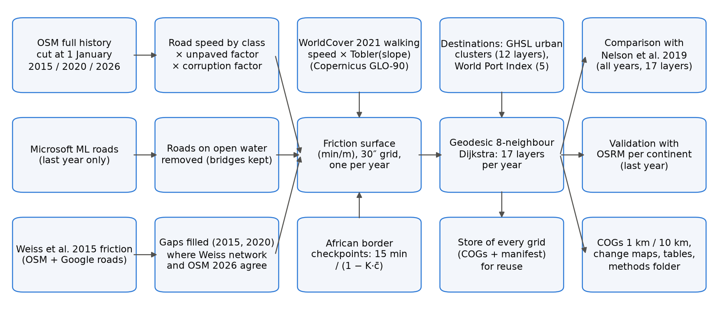
Figure 1. Workflow. Inputs (left) are combined into one friction surface per reference year, from which travel time to 12 settlement and 5 port layers is computed; outputs are compared with Nelson et al. (2019) and validated against OSRM, and every grid is kept in a store for reuse. The completion step uses the Weiss et al. (2018) 2015 friction surface for the years before the last (2015 and 2020).

2.2 Computational grid
All layers were computed on a regular geographic grid (WGS84) with a cell size of 30 arc-seconds (≈0.93 km at the equator), aligned with and covering the same extent as Nelson et al. (2019): 180°W–180°E and 60°S–85°N (43,200 × 17,400 cells). The grid wraps across the antimeridian. Cell areas and step lengths account for the convergence of meridians (Section 2.9). A light version at 300 arc-seconds (≈10 km) was derived by averaging valid 30″ cells in blocks of 10 × 10.

2.3 Road network

OpenStreetMap at 1 January of each year
Roads for all years were taken from one source, the OpenStreetMap (OSM) full-history planet file (planet.openstreetmap.org; the newest dated history-YYMMDD.osm.pbf, ≈152 GB, checked against its published MD5 sum), which contains every version of every object. For each reference year, the state of the map at 00:00 UTC on 1 January was cut out with osmium-tool (time-filter), reduced to ways tagged highway and the nodes they need (tags-filter), and split into 10° × 10° land tiles holding complete ways (extract). Road lengths were clipped to each tile so that ways crossing tile edges are counted once. Taking every year from the same file avoids differences between regional extracts and their boundaries. As an alternative, and in the regional test, the workflow uses the yearly regional snapshots of Geofabrik: for each part of the domain, the smallest region with a 1 January snapshot of that year, its parent region where the region did not yet exist, or the next yearly snapshot (at most one year later) where no ancestor has one. All ways tagged highway with a class listed in Table S2 were read; ways of other classes (paths, footways, cycleways), waterways and ferry routes were not used as travel links.

Speeds
Each road class was assigned a free-flow speed (Table S2), from 100 km/h for motorways to 15 km/h for tracks. Speeds were multiplied by 0.7 when the way was tagged with an unpaved surface, or when the surface was not tagged and the class is usually unpaved (tertiary and lower). Roads were burned into the grid with every touched cell receiving the speed of the fastest road crossing it.

Governance penalty
Travel on roads was slowed in proportion to perceived corruption, which we used as a proxy for delays from informal checkpoints and poorly maintained infrastructure. We used the World Bank Worldwide Governance Indicators Control of Corruption score (0–100, higher = better control; indicator GOV_WGI_CC.SC) for the latest year not later than the reference year, and the continental median for countries without a score. With S the score of the country containing a cell and c = 1 − S/100, road speeds were multiplied by
f_{corr} = 1 − K · c (1)
with K = 0.10, so that the road speeds of a country with the lowest score are reduced by at most 10%. Off-road walking was not penalised. Because K has no empirical basis, it is treated as a scenario parameter; values per country and year are given in Table S5.

Microsoft road detections
For the last reference year only (2026), roads detected by Microsoft from satellite imagery (Global ML Road Detections, release of 28 April 2025) were added in cells without any OSM road, at 15 km/h. They were not used for earlier years because their imagery date is not known.

Roads on open water
To exclude mapping errors and false detections, a road cell was removed when at least 90% of its area is permanent water (share computed from WorldCover 2021 at ≈185 m within each 30″ cell), unless the OSM way is tagged as a bridge, causeway, ford or embankment. Microsoft roads on such cells were always removed. Using the water share rather than the dominant class keeps roads along lake shores and coasts.

Completion of the 2015 and 2020 networks
OSM was much less complete in 2015 than today in many low- and middle-income countries. The friction surface of Weiss et al. (2018), which underlies the Nelson et al. (2019) indicators, combined OSM with Google road data for 2015; the Google data are not public, but the friction surface is (Malaria Atlas Project, CC BY 4.0). We converted it to speed (v = 60 / (1000 f), km/h) and, before any travel-time calculation, added a road in reference year Y (every year from 2015 up to the year before the last, i.e. 2015 and 2020) to every cell where (i) OSM of year Y has no road, (ii) the Weiss surface implies a transport network (v ≥ 10 km/h), (iii) OSM of the last year (2026) has a road, and (iv) the cell is not open water. Condition (iii) restricts the completion to roads that exist today and removes the rivers, sea lanes and railways that are also present in the Weiss surface; a road present in 2015 and in 2026 is assumed to have existed in 2020 as well. The added cells received the lower of the Weiss speed and the 2026 OSM speed, so that no completed road is faster than in 2026.

Completeness of OSM in 2015 and 2020
To identify areas where OSM alone was already informative, we computed, for 2° × 2° tiles (the tile size used by Weiss et al., 2018, for validation) and for each completed year, the share of Weiss 2015 network cells that are 2026 OSM roads and were already OSM roads in that year, before completion. Tiles with ≥80% completeness and ≥50 such cells were classed as complete; the OSM 2015 complete tiles form a separate subset in the comparison with Nelson et al. (2019).

2.4 Off-road travel
Off-road cells were assigned a walking speed on flat ground according to their dominant ESA WorldCover 2021 class (Table S3), multiplied by Tobler's hiking factor for the mean slope of the cell:
v_{off} = v_{lc} · exp(−3.5 · tan θ) (2)
where tan θ is the mean of the slope computed from the Copernicus GLO-90 digital elevation model at 6″ (≈185 m) within each 30″ cell. Using one land-cover map (2021) for all years ensures that the change in travel time is not driven by differences between the WorldCover 2020 (v100) and 2021 (v200) products, which were produced with different algorithm versions. Permanent water is impassable (speed 0) unless crossed by a road.

2.5 Border crossings
Crossing an international land border between two African countries (Natural Earth, 1:10 m) added a delay at official crossing points only, defined as the intersections of motorways, trunk, primary and secondary roads (and their links) with such borders. The delay applies to all travellers using these crossings. Borders elsewhere in the world, and informal crossings away from major roads, were not penalised. The delay was scaled by the mean governance score of the two countries, c̄:
D = 15 min / (1 − K · c̄) (3)
and added to the friction of the grid cell containing the crossing as D / L, where L is the cell's mean step length, so that a path through the cell accumulates approximately D.

2.6 Friction surface
The speed of each cell was the larger of the road speed (after the governance factor) and the off-road speed; friction was expressed in minutes per metre:
F = 60 / (1000 · max(v_{road} · f_{corr}, v_{off})) (4)
Cells with speed 0 (open water, no data) were impassable.

2.7 Destinations

Settlements
Settlements were delineated for each reference year from the Global Human Settlement Layer (GHSL, release R2023A) at 1 km: contiguous (8-connected) cells classified by the degree-of-urbanisation model (GHS-SMOD) as urban centre, dense or semi-dense urban cluster, or suburban cell (classes 30, 23, 22 and 21), with population summed from GHS-POP. Urban clusters have at least 5,000 inhabitants by definition. The GHSL epoch nearest to each reference year was used (2015 for 2015, 2020 for 2020, 2025 for 2026); GHSL epochs after 2020 are projections [check against the GHSL documentation]. Settlement cells were transferred to the 30″ grid by nearest-neighbour resampling.

Ports
Ports were taken from the current edition of the World Port Index (NGA Publication 150) and classified by harbour size. Ports falling on impassable cells were moved to the nearest passable cell within 5 km.

Layers
We reproduced the 17 layers of Nelson et al. (2019) (Table S4): travel time to settlements of each of nine population classes (layers 1–9, from 5–50 million to 5,000–10,000), to settlements of ≥20,000 (layer 10), 50,000–50 million (layer 11, the headline indicator used here) and ≥5,000 (layer 12), and to ports of each size (layers 1–4) and of any size (layer 5).

2.8 Least-cost travel time
Travel time from every cell to the nearest destination cell was computed with a multi-source Dijkstra algorithm over the 8-neighbour graph of the grid. The cost of a step between two adjacent cells i and j is
C_{ij} = ½ (F_{i} + F_{j}) · d_{ij} (5)
where d_{ij} is the great-circle step length on a sphere of radius 6,371,007 m: R Δφ north–south, R cos φ Δλ east–west at the latitude φ of the row, and the hypotenuse of the two (east–west length at the mean latitude of the two rows) for diagonal steps. All cells of a destination settlement are sources with time zero. Results are in minutes and were distributed as 16-bit integers (nodata 65535), as in Nelson et al. (2019), and kept in full precision (32-bit floating point) in the store for reuse. The implementation was verified against scikit-image (MCP_Geometric) near the equator (agreement within 0.02%) and against analytical distances at 60°N.

2.9 Summary indicators
Travel times were summarised as population-weighted means and as the share of population within 60 minutes, using GHS-POP of the same epoch as the settlements, re-projected to the 30″ grid while conserving population (mean density × cell area). Population in cells from which no destination can be reached was reported separately. Summaries are given for each country, continent and the whole domain; in the regional test, country values refer only to the part of each country inside the domain.

2.10 Comparison with Nelson et al. (2019)
Our layers of every reference year were compared cell by cell with the corresponding 2015 layers of Nelson et al. (2019) (figshare 10.6084/m9.figshare.7638134, version 4; the rasters are identical to version 3 cited by the R package geodata, verified by MD5 checksum). For each layer, with d = ours − Nelson per cell, we report the bias (mean d) and the mean absolute difference (mean |d|), both also relative to Nelson et al. as ratios of sums (Σd / ΣNelson and Σ|d| / ΣNelson; ratios of sums remain defined in cells inside cities where Nelson is close to 0 minutes), the median per-cell percentage difference 100 d / Nelson over cells with Nelson > 0 (the statistic Nelson et al. used against Google Maps), the share of cells within ±30 minutes, the Pearson correlation of log(1 + minutes), and population-weighted means, for all cells and for the OSM 2015 complete tiles (Section 2.3). All 17 layers are compared in the result tables; here we report the three cumulative settlement layers (≥5,000, ≥20,000 and 50,000–50 million inhabitants), and ports in the Supplementary Material. Only the 2015 comparison is like-for-like; for 2020 and 2026 the difference combines change since 2015 and method differences.

2.11 Validation against a routing engine
Travel times of the last year (2026) were validated against the free Open Source Routing Machine (OSRM; car profile on current OSM data, public servers of the OSRM project and FOSSGIS), queried at no more than one request per second in line with the servers' usage policies. In every continent we sampled up to 100 settlements of ≥50,000 inhabitants and, for each, 20 origins spread evenly over four great-circle distance bands (10–50, 50–100, 100–200 and 200–300 km), drawn within each band from populated cells with probability proportional to population; this gives about 2,000 origin–settlement pairs per continent [global] (12 settlements and 240 pairs in the regional test). Our time was obtained from a single-source least-cost run from the settlement over the 2026 friction surface, within a window of 330 km; the reference was the OSRM table duration between the same points. Pairs for which OSRM moved an origin or the settlement point by more than 1 km to reach its road network were discarded, which restricts the validation to areas covered by the routing data. Results are summarised overall, by continent, by distance band and by country (countries with at least 30 pairs). OSRM gives free-flow car times without walking segments or border delays and is therefore a lower-bound reference rather than an observed journey time.

2.12 Implementation
The workflow is a single Python script (global_accessibility_v3.py; Python 3.11–3.13) that installs missing Python packages and osmium-tool (from conda-forge, without administrator rights), checks that every data server is reachable, downloads all inputs, runs the stages above and writes Cloud Optimized GeoTIFFs at 30″ and 300″ (one 17-band file per year, change files for each pair of years, and the friction surfaces), global maps, summary tables, a store of every intermediate grid in full precision with a manifest for reuse, and a folder with all parameters, input versions, checksums and run logs (Text S1). The least-cost algorithm is compiled with Numba; OSM tiles and travel-time layers are processed in parallel with a scheduler that limits the number of concurrent tasks by their estimated memory. Stages are resumable, and downloads and intermediate files are deleted only after every stage has succeeded. The regional test ran on a GitHub-hosted runner (2 cores) in about 8 minutes; software versions are listed in Table S10.

2.13 Sensitivity analysis
Because the governance factor K and the border delay rest on assumptions, we varied them one at a time around the baseline (K = 0.10, delay = 15 minutes): K ∈ {0, 0.05, 0.10, 0.20} with the delay at 15 minutes, and delay ∈ {0, 15, 30, 60} minutes with K at 0.10, giving seven scenarios including the baseline (a full factorial design of 16 combinations is available as an option). For each scenario the friction surfaces of all years were rebuilt from the same road and off-road speeds, so that only K and the delay differ, and travel time to settlements of 50,000–50 million inhabitants (cities 11) and to ports of any size (ports 5) was recomputed and summarised as in Section 2.9, for the whole domain, each continent and each country, together with the changes between years.

3. Results
Regional test domain (1°W–4.5°E, 5.5–13.5°N). Replace with the global run where marked [global].

3.1 Road network and friction
For 2015 no country-level Geofabrik snapshots exist for the domain, so the Africa extract of 1 January 2015 was used; for 2020 and 2026, the six country extracts (Benin, Burkina Faso, Ghana, Niger, Nigeria, Togo). The length of OSM roads in the domain grew from 79,100 km in 2015 to 295,300 km in 2020 and 382,000 km in 2026 (Table S8): most of the growth happened before 2020. It was concentrated in unclassified (10,400 → 114,300 → 148,300 km), residential (18,000 → 93,000 → 118,200 km) and track roads (5,500 → 25,600 → 43,500 km), whereas the length of primary roads fell from 13,500 km in 2015 to 9,700 km in 2020 (10,800 km in 2026) while trunk roads increased from 1,500 to 6,200 km, consistent with reclassification. On the grid, OSM 2015 roads occupied 66,886 cells and the completion with the Weiss et al. (2018) surface added 79,233 cells (146,119 road cells); OSM 2020 roads occupied 182,806 cells and the completion added only 4,525 (187,331 cells). In 2026 there were 252,709 road cells, of which 29,882 were contributed by Microsoft road detections. The open-water rule removed 35, 92 and 111 OSM road cells in 2015, 2020 and 2026 and 29 Microsoft cells, and kept 9, 11 and 12 cells tagged as bridges or causeways.
OSM 2015 was far from complete: in the twelve 2° tiles assessed it contained between 14% and 73% (median 39%) of the Weiss network cells that are roads in 2026, and no tile reached the 80% threshold. By 2020 completeness had reached 93–98% (median 97%) in every tile (Table S7), so the completion mainly affects 2015. Completeness in 2015 was highest in the west of the domain (Ghana, 61–73%) and lowest in southern and central Nigeria and Benin (14–35%).
The governance factor reduced road speeds by 5.2–7.5% across countries and years (Table S5; in 2026 Nigeria 7.3%, Togo 6.6%, Benin 5.6%). Sixty-five official border crossings were identified in 2015, 73 in 2020 and 87 in 2026, mostly on the Togo–Ghana and Benin–Togo borders (25 each in 2026) and the Benin–Nigeria border (17) (Table S6); their delays ranged from 15.9 to 16.1 minutes after the governance scaling.

3.2 Accessibility in 2015, 2020 and 2026
The number of settlements rose from 1,219 in 2015 to 1,282 in 2020 and 1,369 in 2025, and those of ≥50,000 inhabitants from 186 to 191 and 198 (Table S9). The population-weighted mean travel time to the nearest settlement of ≥50,000 inhabitants was 22.0 minutes in 2015, 21.8 minutes in 2020 and 19.0 minutes in 2026, and the share of the population within 60 minutes rose from 87.1% (2015 and 2020) to 88.7% (Table 1; Figure 2). Travel time to the nearest settlement of ≥5,000 fell from 8.7 to 8.1 and 6.4 minutes (97.6% of people within 60 minutes in 2026), and to the nearest port of any size from 261 to 248 and 243 minutes. For settlements, most of the 2015–2026 reduction occurred after 2020 (−2.8 of −3.0 minutes for ≥50,000), whereas for ports most of it occurred before 2020 (−13 of −18 minutes). About 0.3% of the population (0.23–0.25 million) lived in cells from which no destination could be reached, mostly on land enclosed by water.
Table 1. Destinations, population-weighted mean travel time and share of population within 60 minutes, regional test domain [global]. Population: GHS-POP 2015 (67.1 million), 2020 (75.4 million) and 2025 (84.4 million). Destinations are counted within the domain. All 17 layers are in Table S9.
Layer | Dest. 2015 | 2020 | 2026 | Mean 2015 (min) | 2020 | 2026 | ≤60 min 2015 | 2020 | 2026
Settlements ≥ 5,000 (cities 12) | 1,209 | 1,270 | 1,352 | 8.7 | 8.1 | 6.4 | 95.8% | 96.2% | 97.6%
Settlements ≥ 20,000 (cities 10) | 373 | 388 | 413 | 14.9 | 13.5 | 11.4 | 92.1% | 92.7% | 94.2%
Settlements 50,000–50 M (cities 11) | 186 | 191 | 198 | 22.0 | 21.8 | 19.0 | 87.1% | 87.1% | 88.7%
Settlements 100,000–200,000 (cities 5) | 48 | 50 | 57 | 71.5 | 67.2 | 62.5 | 68.1% | 70.2% | 71.4%
Settlements 1–5 M (cities 2) | 6 | 7 | 9 | 160.1 | 166.3 | 155.7 | 34.1% | 37.2% | 40.8%
Any port (ports 5) | 7 | 7 | 7 | 261.5 | 248.1 | 243.3 | 36.2% | 37.2% | 37.4%
Mean and share are weighted by GHS-POP of the epoch used for the settlements.
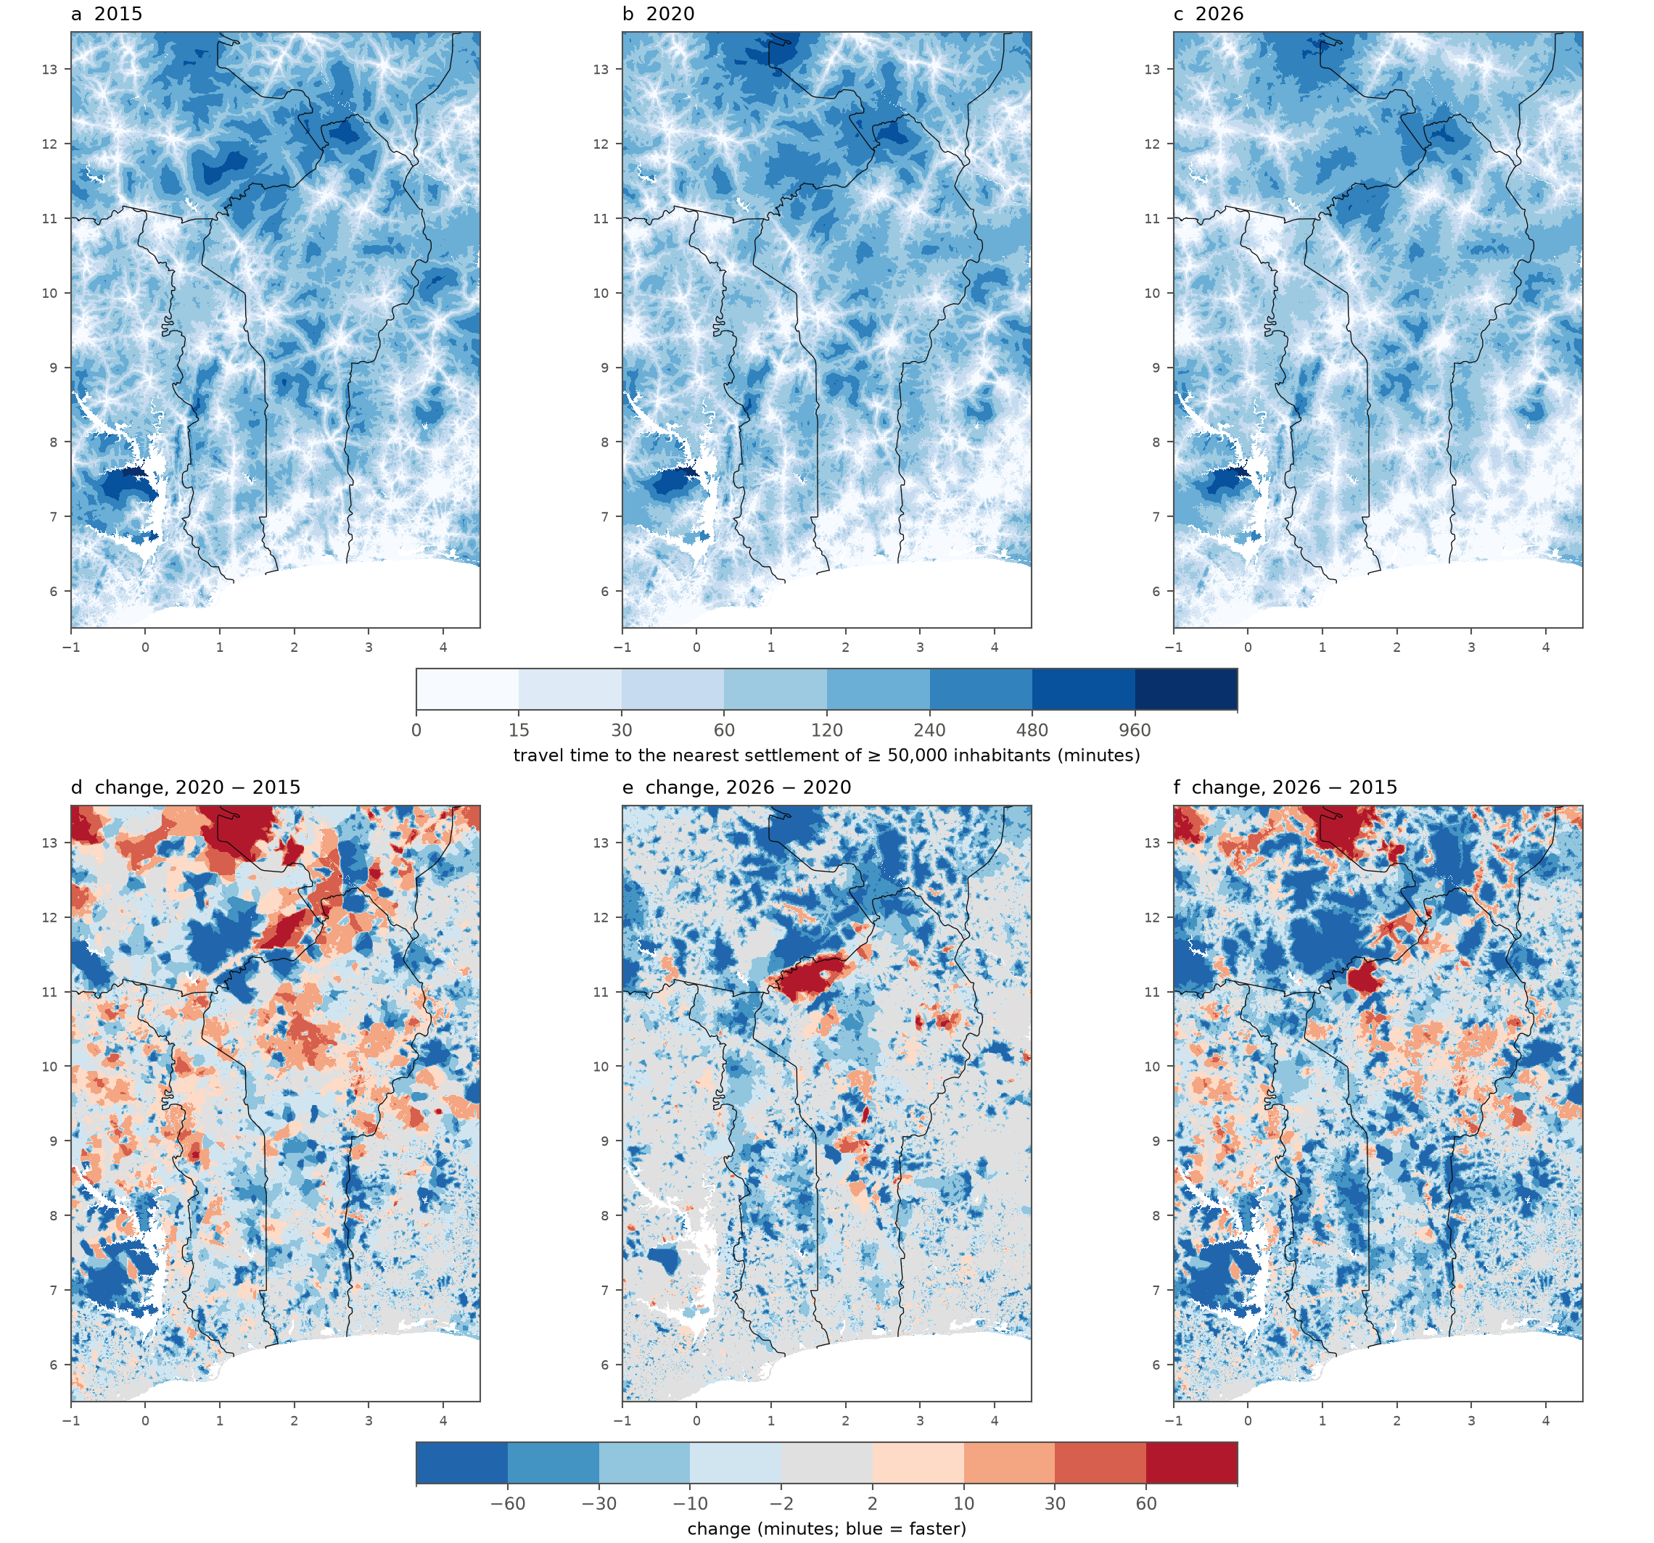
Figure 2. Travel time to the nearest settlement of 50,000–50 million inhabitants (layer cities 11) in (a) 2015, (b) 2020 and (c) 2026, and the changes (d) 2020 − 2015, (e) 2026 − 2020 and (f) 2026 − 2015 (negative = faster). Lines: African land borders. White: water or no data. Regional test domain [global].
Between 2020 and 2026 travel time fell in most of the domain, often by more than 30 minutes in rural Burkina Faso, Niger and west of Lake Volta, with a few areas of increase, the largest near the Benin–Burkina Faso border around 11°N (Figure 2e). Between 2015 and 2020, in contrast, it increased in many places, in particular in the north of the domain (Figure 2d), and the population-weighted mean rose in the Burkinabè and Nigerien parts of the domain (Table 2). We traced this to the road data rather than to the roads themselves: of the 146,119 road cells of 2015, 22,411 (15%) had a lower speed in 2020. In 18,357 of them OSM had a road in both years but tagged it with a slower class or an unpaved surface in 2020 (for example primary roads reclassified as secondary), in 2,038 the 2015 OSM road was no longer in OSM 2020, and in 1,882 the 2015 speed came from the completion step (the 2026 OSM speed) while OSM 2020 tagged the same road more slowly. Changes of settlements between GHSL epochs can also raise travel time where a 2015 destination is no longer one. The 2015–2026 change (Figure 2f) is dominated by reductions, with increases in the same northern areas. For layers restricted to one population class, growth can move settlements out of the class: the number of settlements of 50,000–100,000 inhabitants fell from 104 to 101 and 98 and the mean travel time to that class rose from 53.6 to 55.2 and 62.3 minutes, whereas it fell for the cumulative layers.

3.3 Differences between countries
Within the domain, mean travel time to settlements of ≥50,000 in 2026 ranged from 6.8 minutes in the Nigerian part to 80.2 minutes in the Burkinabè part (Table 2). Over 2015–2026 the largest absolute reductions were in Niger (−13.0 minutes) and Burkina Faso (−9.6 minutes) and the largest relative reduction in Togo (−25%, from 20.9 to 15.8 minutes); in Benin the mean fell from 22.9 to 22.6 minutes in 2020 and 20.4 minutes in 2026. In the Burkinabè and Nigerien parts the 2020 means were higher than in 2015 (94.1 against 89.8 and 84.4 against 79.2 minutes), for the reasons given above, before falling well below the 2015 values in 2026.
Table 2. Population-weighted travel time to settlements of 50,000–50 million inhabitants (cities 11) and to any port, by country, regional test domain [global: all countries in Table S13].
Country (part in domain) | Population 2025 (M) | Cities 11, 2015 (min) | 2020 | 2026 | ≤60 min 2015 | ≤60 min 2026 | Ports 5, 2026 (min)
Benin | 14.4 | 22.9 | 22.6 | 20.4 | 85.5% | 86.6% | 221
Togo | 9.4 | 20.9 | 20.3 | 15.8 | 86.7% | 91.4% | 189
Ghana (part) | 16.8 | 16.9 | 14.3 | 13.7 | 92.7% | 94.1% | 192
Nigeria (part) | 34.1 | 8.0 | 7.3 | 6.8 | 95.5% | 96.2% | 146
Burkina Faso (part) | 5.7 | 89.8 | 94.1 | 80.2 | 46.3% | 52.4% | 740
Niger (part) | 3.6 | 79.2 | 84.4 | 66.2 | 47.7% | 52.5% | 865
Only the part of each country inside the domain is included; for Ghana, Nigeria, Burkina Faso and Niger this is a small, non-representative part of the country, and destinations outside the domain (e.g. ports of Lagos, Tema and Abidjan) are not reachable.

3.4 Comparison with Nelson et al. (2019)
After completion of the 2015 network, our 2015 estimates agreed closely with Nelson et al. (2019) for settlements (Table 3). For settlements of 50,000–50 million, the population-weighted mean was 22.0 minutes against 23.1 minutes in Nelson et al. (−4%); 67% of cells were within ±30 minutes and the correlation of log travel times was 0.89. Area-weighted, our estimates were longer (bias +16.1 minutes, +16% of the Nelson mean; median cell difference +9%), with a mean absolute difference of 33.1 minutes (32%): our estimates are longer mainly in sparsely populated cells. For settlements of ≥20,000 and ≥5,000 our population-weighted means were higher (14.5 against 12.2 minutes, +18%; 8.7 against 7.9 minutes, +11%), with correlations of 0.89 and 0.87. Without the completion step, i.e. with OSM 2015 roads only, the population-weighted bias was +46% to +101% and the correlation 0.77–0.80 for the three layers. Our 2020 estimates were within −9% to +1% of the 2015 values of Nelson et al. (population-weighted), and our 2026 estimates 19–30% shorter, consistent with the network growth described above; these later comparisons mix change and method differences. Travel time to ports was spatially consistent (r = 0.97 in 2015) but longer in our estimates (262 against 203 minutes, +29%; Table S12), which we attribute at least in part to the domain boundary: Nelson et al. can reach ports outside the domain, such as Lagos, Tema and Abidjan, which our regional run cannot [global: to be verified]. No tile of the domain reached the 2015 completeness threshold, so the comparison restricted to OSM 2015 complete areas could not be made here [global]. The comparison for all 17 layers and years is in the result tables (nelson_comparison/comparison_by_layer.csv).
Table 3. Comparison with the 2015 layers of Nelson et al. (2019) for the three cumulative settlement layers, regional test domain [global]. d = ours − Nelson for each cell. Bias: mean d, and in brackets Σd / Σ Nelson (i.e. relative to the Nelson mean over the same cells). Mean abs. diff.: mean |d|, and Σ|d| / Σ Nelson. Median cell diff.: median of 100 d / Nelson over cells with Nelson > 0. Pop.-weighted: population-weighted means, bias in brackets relative to Nelson. OSM only: run without the completion step; completed: final method. The 2020 and 2026 rows compare our estimates for those years with Nelson 2015. Population weights: GHS-POP of our settlement epoch (2015, 2020 or 2025). Ports: Table S12; all 17 layers: result tables.
Layer and version | Cells | Bias, min (% of Nelson) | Mean abs. diff., min (% of Nelson) | Median cell diff. | Within ±30 min | r (log) | Pop.-weighted: ours / Nelson, min (bias)
Cities 12 (≥ 5,000), 2015, OSM only | 576,631 | +68.0 (+107%) | 73.6 (116%) | +67% | 49% | 0.77 | 15.9 / 7.9 (+101%)
Cities 12 (≥ 5,000), 2015, completed | 576,917 | +19.9 (+31%) | 27.5 (43%) | +19% | 74% | 0.87 | 8.7 / 7.9 (+11%)
Cities 12 (≥ 5,000), 2020 | 577,231 | +8.6 (+14%) | 25.2 (40%) | +7% | 75% | 0.85 | 8.1 / 8.6 (−6%)
Cities 12 (≥ 5,000), 2026 | 577,401 | −3.8 (−6%) | 25.4 (40%) | −9% | 74% | 0.82 | 6.4 / 9.1 (−30%)
Cities 10 (≥ 20,000), 2015, OSM only | 572,449 | +76.5 (+96%) | 83.2 (104%) | +61% | 45% | 0.79 | 24.3 / 12.2 (+99%)
Cities 10 (≥ 20,000), 2015, completed | 572,720 | +21.4 (+27%) | 30.7 (38%) | +19% | 69% | 0.89 | 14.5 / 12.2 (+18%)
Cities 10 (≥ 20,000), 2020 | 573,023 | +8.8 (+11%) | 28.0 (35%) | +8% | 72% | 0.87 | 13.2 / 13.1 (+1%)
Cities 10 (≥ 20,000), 2026 | 573,188 | −5.0 (−6%) | 28.5 (36%) | −7% | 71% | 0.84 | 11.1 / 13.7 (−19%)
Cities 11 (50,000–50 M), 2015, OSM only | 576,562 | +71.9 (+70%) | 83.8 (82%) | +42% | 44% | 0.80 | 33.8 / 23.1 (+46%)
Cities 11 (50,000–50 M), 2015, completed | 576,822 | +16.1 (+16%) | 33.1 (32%) | +9% | 67% | 0.89 | 22.0 / 23.1 (−4%)
Cities 11 (50,000–50 M), 2020 | 577,134 | +8.0 (+8%) | 33.4 (33%) | +2% | 66% | 0.87 | 21.8 / 23.9 (−9%)
Cities 11 (50,000–50 M), 2026 | 577,282 | −6.6 (−6%) | 33.7 (33%) | −11% | 64% | 0.85 | 19.0 / 24.4 (−22%)
The OSM-only rows come from a second pass of the same code (option --no-weiss) on identical inputs.
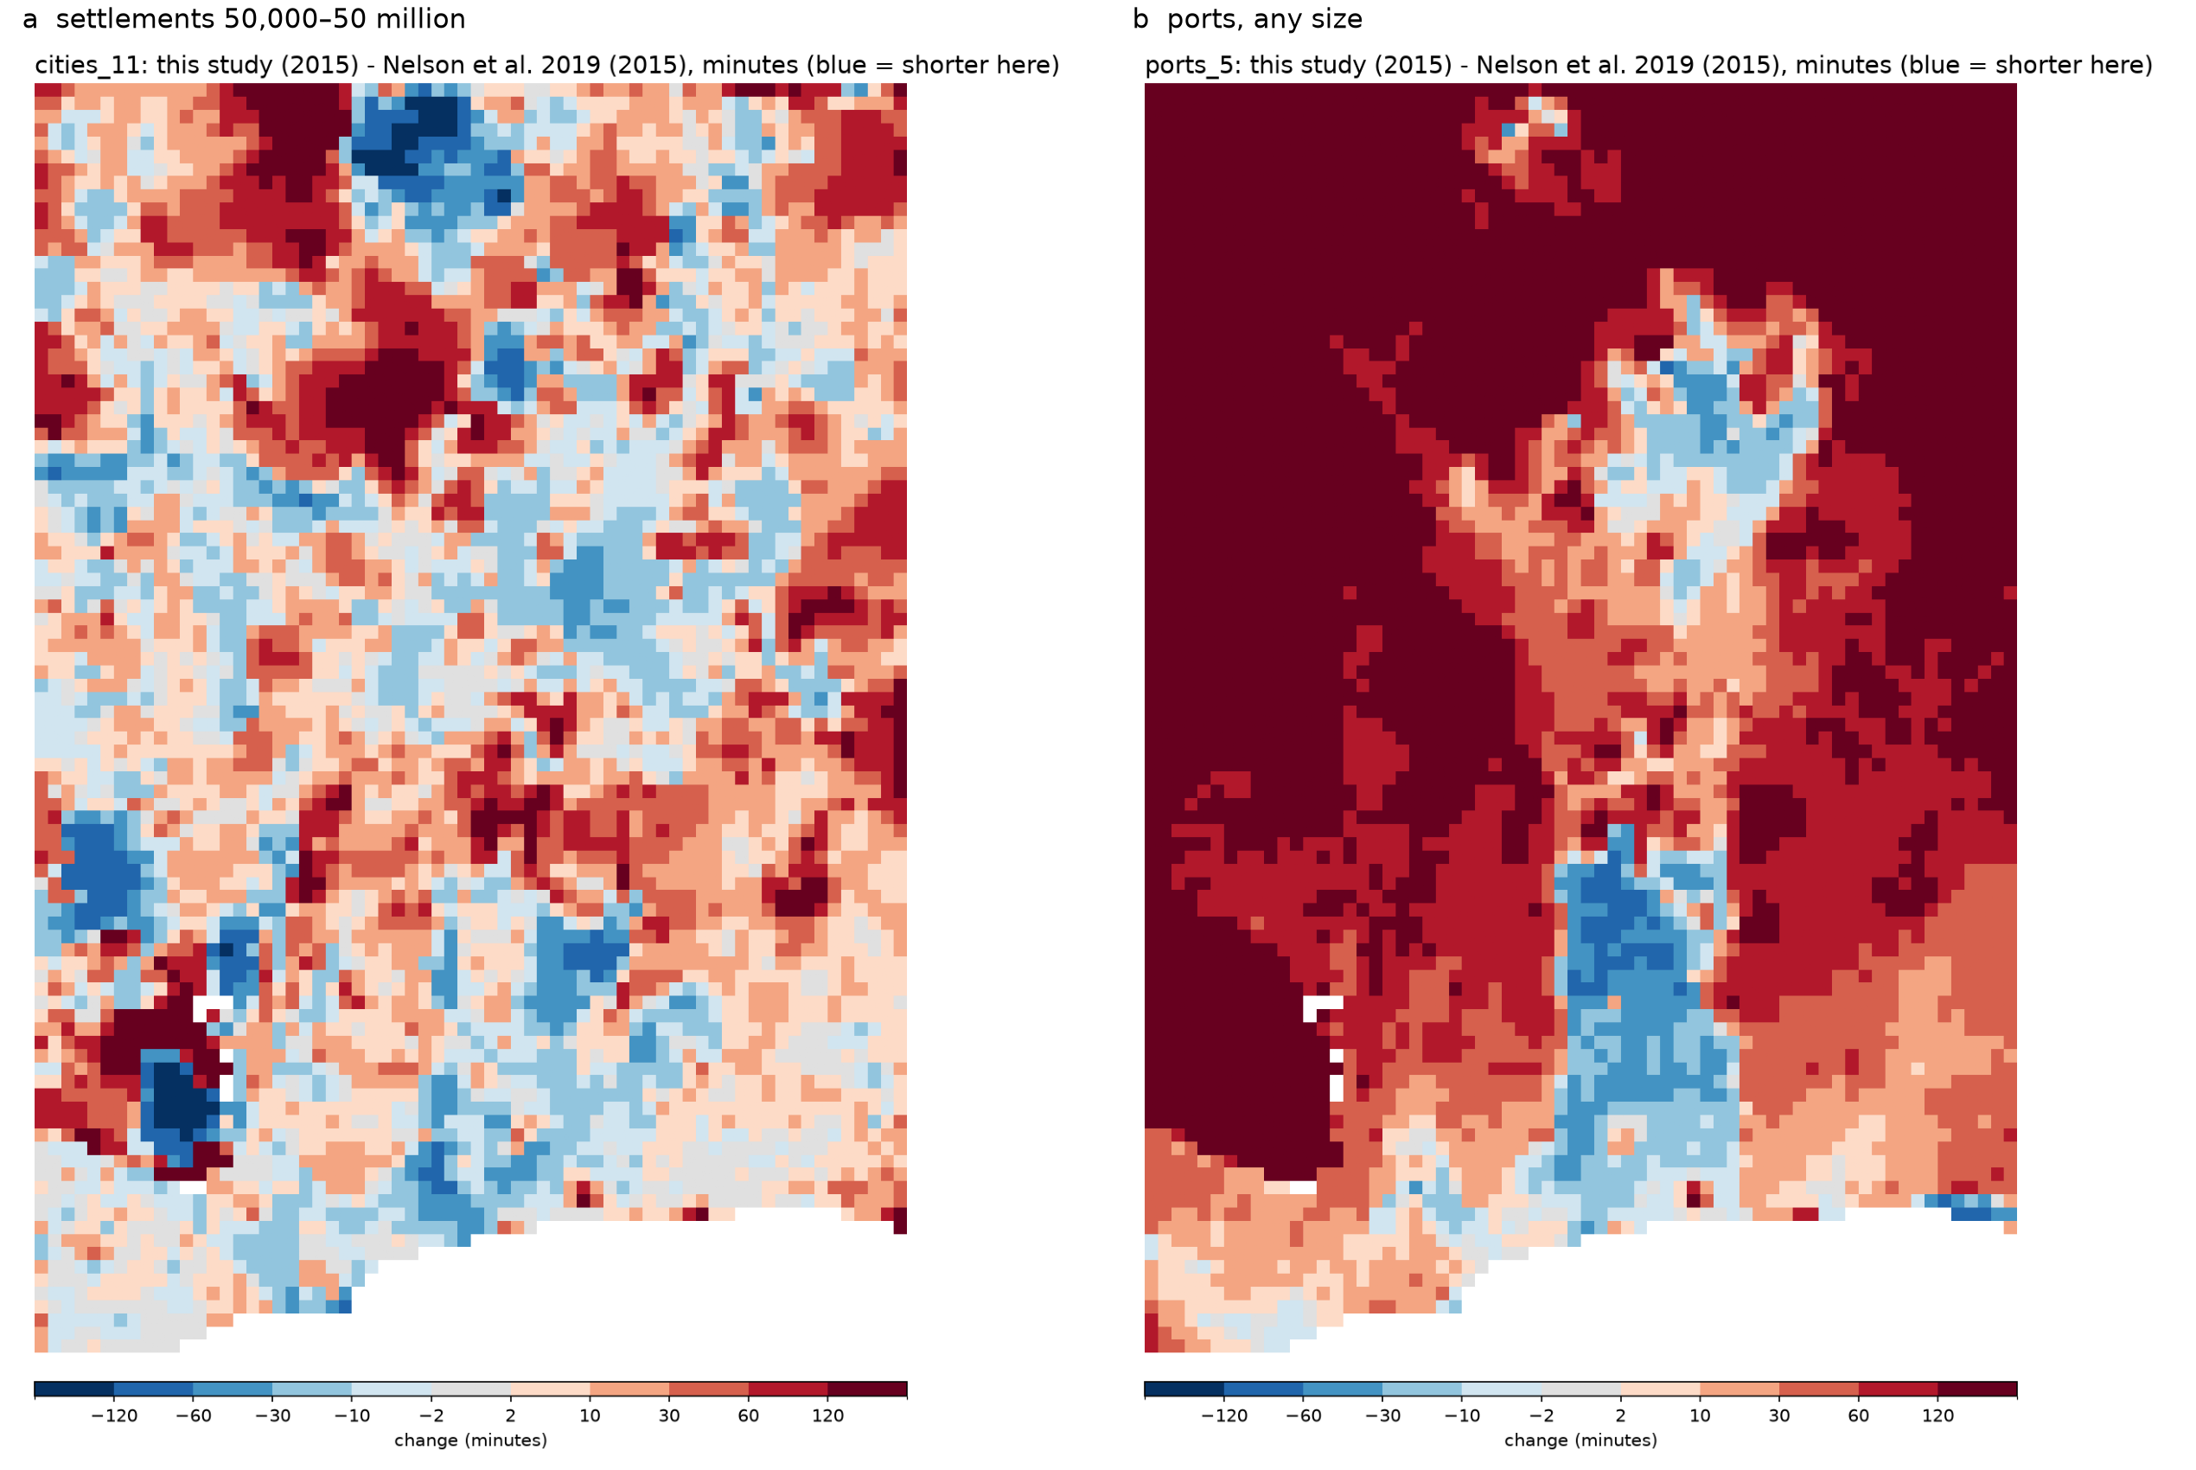
Figure 3. Difference between our 2015 estimates and Nelson et al. (2019), in minutes (blue = shorter in this study), for settlements of 50,000–50 million (left) and ports of any size (right), mean of 10 × 10 cells. Regional test domain [global].

3.5 Validation against OSRM
For the 12 settlements of ≥50,000 inhabitants sampled in the domain, 240 origin–settlement pairs were queried (great-circle distances 11.6–299.2 km; 20 origins per settlement, five per distance band). OSRM returned a route for all of them; 30 pairs were removed because a point was more than 1 km from the OSRM road network, leaving 210. Our 2026 travel times agreed closely with OSRM free-flow car times (Table 4; Figure 4): the median was 147.1 minutes in our estimates and 140.6 minutes in OSRM, the median ratio 1.00, the median difference −0.3 minutes and the mean absolute difference 20.7 minutes; 91.9% of pairs were within ±30% and the correlation of log travel times was 0.97 [global: results by continent and country]. Agreement increased with distance: within ±30% for 82% of the pairs of 10–50 km and for all pairs of 200–300 km, with median ratios between 0.99 and 1.01 in every band. Because both estimates rely on current OSM roads, this comparison validates the speed model and the least-cost computation rather than the completeness of the network.
Table 4. Validation of 2026 travel times against OSRM car routing (free flow) by great-circle distance between origin and settlement, regional test domain [global: by continent and country in routing_validation/].
Distance band | Pairs | Median, ours (min) | Median, OSRM (min) | Median ratio | Mean abs. diff. (min) | Within ±30% | r (log)
10-50 km | 51 | 54.0 | 58.2 | 0.99 | 24.7 | 82% | 0.82
50-100 km | 52 | 109.3 | 111.2 | 1.01 | 12.3 | 90% | 0.89
100-200 km | 53 | 194.7 | 194.3 | 0.99 | 23.3 | 94% | 0.95
200-300 km | 54 | 311.4 | 312.2 | 1.00 | 22.6 | 100% | 0.91
All | 210 | 147.1 | 140.6 | 1.00 | 20.7 | 91.9% | 0.97
Pairs with a snap distance above 1 km removed.
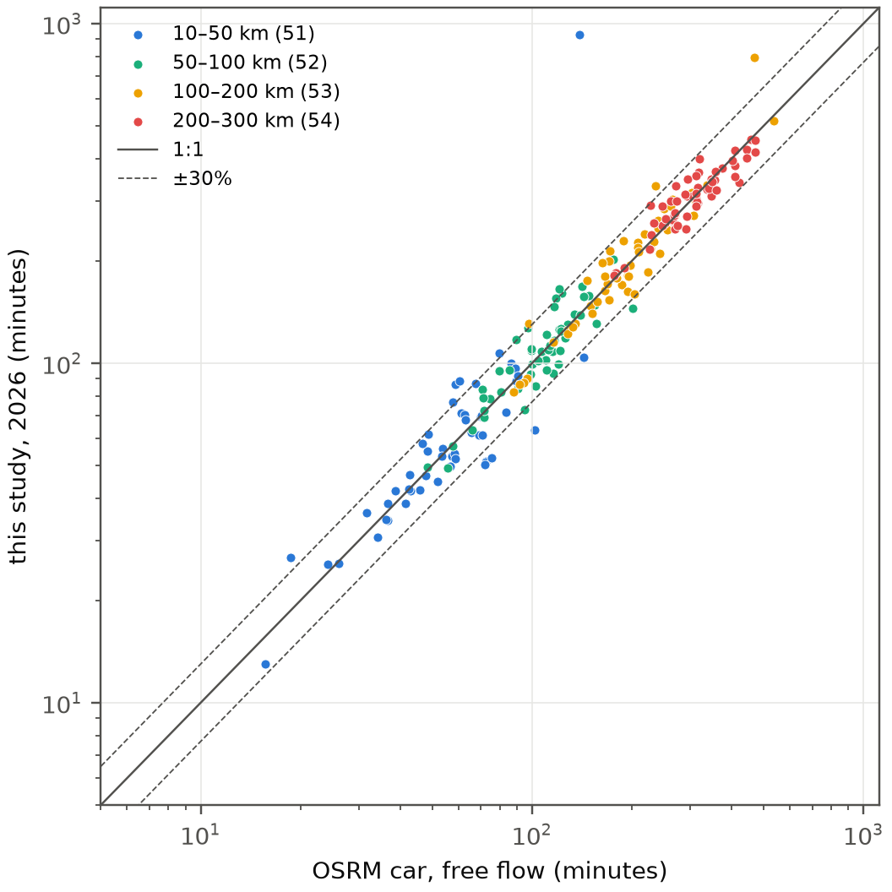
Figure 4. 2026 travel time from 210 origins to settlements of ≥50,000 inhabitants: this study against OSRM car routing (free flow), coloured by distance band. Solid line: 1:1; dashed lines: ±30%. Log scales. Regional test domain [global].

3.6 Sensitivity to the governance factor and the border delay
The governance factor changed the level of travel time but hardly its change between years (Table 5; Figure 5). For settlements of ≥50,000, the population-weighted mean in 2015 ranged from 20.90 minutes without the penalty (K = 0) to 23.31 minutes with K = 0.20 (−5% to +6% around the baseline of 22.03 minutes), while the 2015–2026 change stayed between −2.99 and −3.09 minutes. Travel times to ports, which involve long road journeys, were more sensitive (244.8 to 280.7 minutes in 2015, −6% to +7%), and their 2015–2026 change ranged from −16.3 to −20.5 minutes. The border delay had almost no effect at domain level: removing it shortened travel time to settlements of ≥50,000 by 0.13 minutes in 2015, and raising it from 15 to 60 minutes lengthened it by 0.03 minutes. Country results followed the same pattern (Table S11): in Benin the 2026 mean ranged from 19.3 minutes (K = 0) to 21.6 minutes (K = 0.20) and the 2015–2026 change from −2.4 to −2.6 minutes, and in the Nigerien part of the domain from 62.1 to 70.8 minutes, with a change of −12.3 to −13.6 minutes, while the border delay changed no country's 2026 mean by more than 0.3 minutes; its largest effect was in the Burkinabè part of the domain, where removing it shortened the 2015 mean by 1.3 minutes and changed the 2015–2026 change from −9.6 to −8.5 minutes (−9.9 with a delay of 30 or 60 minutes).
Table 5. Sensitivity of the population-weighted mean travel time (minutes) to the governance factor K and to the border-crossing delay, regional test domain [global]. Change = 2026 − 2015.
Scenario | Cities 11: 2015 | 2020 | 2026 | Change 2015–26 | Ports 5: 2015 | 2020 | 2026 | Change 2015–26
K = 0, delay 15 min | 20.90 | 20.69 | 17.92 | −2.99 | 244.8 | 233.5 | 228.5 | −16.3
K = 0.05, delay 15 min | 21.45 | 21.23 | 18.44 | −3.01 | 252.8 | 240.6 | 235.7 | −17.1
K = 0.10, delay 15 min (baseline) | 22.03 | 21.81 | 18.99 | −3.04 | 261.5 | 248.1 | 243.3 | −18.1
K = 0.20, delay 15 min | 23.31 | 23.08 | 20.22 | −3.09 | 280.7 | 264.6 | 260.2 | −20.5
K = 0.10, delay 0 min | 21.90 | 21.76 | 18.95 | −2.94 | 260.4 | 247.4 | 242.7 | −17.7
K = 0.10, delay 30 min | 22.05 | 21.81 | 18.99 | −3.06 | 261.6 | 248.1 | 243.4 | −18.2
K = 0.10, delay 60 min | 22.06 | 21.82 | 19.00 | −3.06 | 261.6 | 248.1 | 243.4 | −18.2
One-at-a-time design around the baseline; population weights as in Table 1.
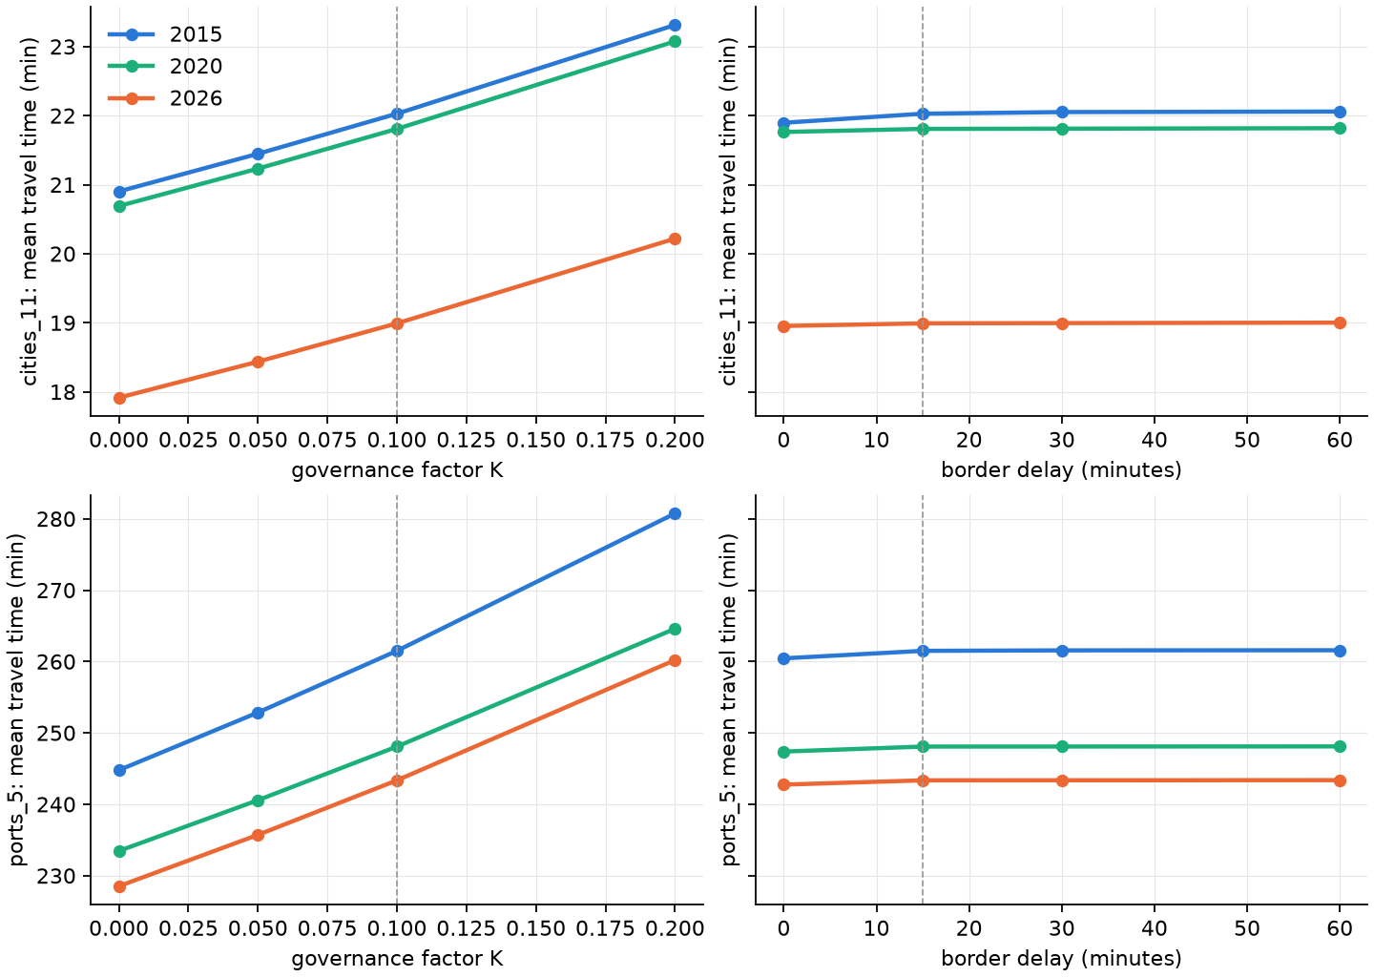
Figure 5. Population-weighted mean travel time to settlements of 50,000–50 million (top) and to ports of any size (bottom) in 2015, 2020 and 2026, as a function of the governance factor K (left, delay 15 minutes) and of the border delay (right, K = 0.10). Dashed lines: baseline. Rows share the same scale. Regional test domain [global].

4. Discussion
The discussion is written for the regional test; figures marked [global] and the scope of the claims should be revisited after the global run.

4.1 Principal findings
We present a reproducible way to update global travel-time accessibility for any set of years from open data, keeping the method fixed so that differences between years reflect the transport network and settlement growth. Applied to Benin, Togo and neighbouring areas for 2015, 2020 and 2026, it shows a reduction of the population-weighted travel time to the nearest settlement of ≥50,000 inhabitants from 22.0 minutes in 2015 to 21.8 minutes in 2020 and 19.0 minutes in 2026, with the largest gains in the rural, less connected parts of Burkina Faso and Niger and smaller gains in coastal areas that were already well connected. Our 2015 estimates reproduce the Nelson et al. (2019) indicators for settlements closely once the 2015 road network is completed, and our 2026 estimates agree with OSRM routing within ±30% for 92% of the origin–settlement pairs tested, across distances of 10–300 km.

4.2 Construction or mapping?
The main difficulty in dating accessibility change with OSM is that the growth of the map is not the growth of the network. In the test domain, OSM road length grew almost four-fold between 2015 and 2020 and by another 29% by 2026, mostly as unclassified, residential and track roads, which fits the pattern of humanitarian and corporate mapping campaigns better than that of construction; the decrease in primary roads alongside an increase in trunk roads points to reclassification. Using OSM 2015 as it was would attribute to later years many roads that already existed. Completing the 2015 network with the Weiss et al. (2018) surface, which drew on Google road data in addition to OSM, doubled the number of 2015 road cells and reduced the apparent 2015–2026 gain from about 15 minutes to 3 minutes for settlements of ≥50,000, while raising the agreement with Nelson et al. (2019) from r = 0.80 to 0.89. By 2020, OSM already contained 93–98% of the Weiss network in every tile, so the completion hardly changes 2020, and the 2015–2020 comparison mostly contrasts two different kinds of road data: a completed 2015 network and a nearly complete 2020 OSM. We consider the completed estimates the more credible ones, but the 2015–2026 change is still an upper bound on the effect of new roads: roads that exist in 2026 but were missing from both OSM 2015 and the 2015 Google data are counted as new. Separating construction from mapping more strictly would require dated road inventories or multi-temporal imagery.
A second, less visible effect of mapping is the editing of tags. Between 2015 and 2020, 15% of the 2015 road cells became slower, mostly because OSM contributors reclassified roads or added unpaved surfaces, and a smaller part because roads were removed or because completed 2015 cells took their speed from the 2026 map. This raised travel time between 2015 and 2020 in parts of the domain, notably in its north, although it is unlikely that the roads themselves deteriorated that much. Such edits usually improve the data, but they change speeds without any change on the ground. A stricter rule would be to never let a road become slower than in the previous reference year, or to cap completed speeds by the speed in the next year; both assume that roads do not deteriorate, which is not true everywhere. We report the unconstrained results and flag this as a choice to be made for the global run.

4.3 Comparison with previous global products
After completion, the settlement layers agree well with Nelson et al. (2019) in both level and pattern, despite differences in inputs: GHSL R2023A rather than the 2016 settlement layers, WorldCover rather than the earlier land cover, a different speed table and our governance and border penalties. The port layers agree in pattern (r = 0.97) but are about one hour longer in our estimates for 2015. In the regional test this is expected at least partly, because ports outside the domain, among them the larger ports of Lagos, Tema and Abidjan, cannot be reached; whether a difference remains in the global run is to be verified [global]. Differences in the World Port Index edition (current against the 26th edition used by Nelson et al.) may also contribute.

4.4 Validation
The agreement with OSRM (median ratio 1.00; 92% of pairs within ±30%) indicates that our speeds and least-cost computation reproduce routed car travel times on the current network, across distances from 10 to 300 km; agreement is weakest for short trips, where the walking segment from the origin and the 30″ resolution weigh most. It is not an independent validation of the network itself, since both rely on OSM, and OSRM free-flow times are a lower bound for real trips: they include no congestion, no stops and no border delays. Nelson et al. (2019), using Google journey times, found their estimates shorter than Google's in 72% of validation tiles (median difference −13.7 minutes), which suggests that routing-engine times are a more lenient benchmark than observed trips. The routing validation is available only for the last year, because free routing engines use current data; for 2015, the comparison with Nelson et al. (2019) is the closest available reference, and 2020 has no independent reference.

4.5 Governance and border penalties
The governance and border penalties are new relative to earlier global maps and rest on assumptions rather than measurements: we are not aware of empirical estimates that relate corruption scores to travel speed or crossing times for people. With K = 0.10 they slow roads by 5.2–7.5% in the test domain and add about one minute to the 15-minute delay at each official crossing. The sensitivity analysis (Section 3.6) shows that K shifts the level of travel time roughly in proportion to its size (about ±6% for settlements and ±7% for ports between K = 0 and 0.20) but leaves the changes between years almost unchanged, so conclusions about change do not depend on this assumption, whereas absolute travel times and comparisons between countries with different governance scores do.
The border delay, in contrast, had almost no effect, and increasing it beyond 15 minutes changed nothing. Two reasons are likely. First, for most people the nearest settlement of ≥50,000 inhabitants is in their own country, so few least-cost paths cross a border. Second, because the delay applies only at official crossings, as intended (including within ECOWAS, whose free-movement protocol does not remove border procedures in practice), a path can avoid a large delay by leaving the road and crossing the border on foot in an adjacent cell; at 30″ resolution such a detour costs roughly 15–30 minutes of walking, which caps the effective delay. We did not trace individual paths to confirm the second explanation. This behaviour is realistic for people on foot but not for vehicles and goods, which cannot leave the road; if the delay is meant to represent motorised crossings, it should be combined with a restriction that prevents vehicles from crossing a border elsewhere, which requires a mode-specific cost surface.

4.6 Limitations
- Speeds are not calibrated. Road speeds follow common practice and walking speeds are placeholders (Table S3); both affect absolute travel times more than any other choice and should be calibrated, for example against the OSRM pairs, survey data or local knowledge.
- Fixed land cover and water. One land-cover map (2021) is used for all years, so land-cover change does not contribute to the change in accessibility. Ferries and navigable waterways are not modelled, which makes islands served only by ferry unreachable from the mainland.
- OSM edits. Reclassification and surface tags added between snapshots change speeds without a change on the ground (Section 4.2); speeds are not constrained to be non-decreasing over time.
- Settlements. Destinations come from GHSL epochs (2015, 2020, 2025); the 2025 epoch is a projection [check], and single-class layers can change because settlements move between population classes rather than because access changes (Section 3.2).
- Microsoft road detections are undated and are used for the last year only; their contribution is therefore attributed entirely to 2020–2026.
- Resolution and mode. At 30″, all roads in a cell take the fastest speed, and travel is modelled as a single fastest mode without seasonality, congestion or vehicle availability.
- Regional test. The domain boundary truncates destinations outside it and parts of the neighbouring countries; country values for Ghana, Nigeria, Burkina Faso and Niger are not representative of those countries [global].

4.7 Outlook
Because the workflow is a single script with the reference years as parameters and one OSM source for all years, the maps can be updated as new OSM history files and GHSL epochs become available, and every grid is kept for further analysis. Priorities for the global application are to decide how OSM tag edits between years should be treated (Section 4.2), to report the comparison with Nelson et al. (2019) for tiles where OSM 2015 was complete, to run the sensitivity analyses of the governance and border parameters, and to calibrate the speed tables against the routing validation pairs, which will number about 2,000 per continent [global].

Supplementary Material
Values are from the regional test domain (1°W–4.5°E, 5.5–13.5°N; reference years 2015, 2020, 2026) unless stated; tables marked [global] will be regenerated from the global run (files in the results folder: methods/, tables/, nelson_comparison/, routing_validation/, sensitivity/ and store/).

Text S1. Implementation and reproducibility
The workflow is implemented in one Python file (global_accessibility_v3.py, version 3.0), configured in a block at the top of the file (reference years, OSM source, folders, speed tables, penalties, destination layers, validation settings); a few settings can be overridden on the command line (e.g. --years 2015 2020 2026, --bbox, --osm-source). On start, the script installs any missing Python package into a local folder (no administrator rights needed), checks that the PROJ coordinate database works, and, before downloading, contacts every data server so that a machine without access to one of them stops with a list rather than after long retries. It then runs ten resumable stages: download, grids, roads, friction, travel time, outputs, store, comparison, validation, sensitivity and clean-up; completed stages are skipped when the script is restarted, and the work folder is deleted only when every stage has succeeded.
- OSM history. The newest dated full-history planet file is downloaded (resumable; MD5 checked). osmium-tool is taken from the system or installed automatically from conda-forge (with mamba, conda or a downloaded micromamba) into the work folder. The years are cut side by side (time-filter at 1 January, tags-filter w/highway, extract into 10° land tiles with complete ways, 16 tiles per pass to bound memory); each year is resumable. Estimated peak scratch disk for three years: ≈530 GB.
- Parallelism. The script reads the number of usable cores and the available memory, including container (cgroup) limits, and plans each parallel stage from a per-task memory estimate plus ≈0.35 GB of process overhead, within 75% of the available memory. OSM tiles are processed in parallel (estimated 1.5 GB + 7 × file size per tile, largest first); the 51 travel-time layers (3 years × 17) are computed in parallel (≈10 bytes per grid cell, ≈7.8 GB for the global 30″ grid; e.g. 44 at a time with 485 GB of memory), with the friction surfaces shared through memory-mapped files. Remote reads of WorldCover and Copernicus tiles and the writing of the store use threads.
- Least-cost algorithm. Multi-source Dijkstra with an indexed binary heap, compiled with Numba; 32-bit indices (up to 2.1 billion cells). One layer on a 32-million-cell grid takes ≈40 s on one core.
- Outputs. Cloud Optimized GeoTIFFs (DEFLATE, internal overviews) at 30″ and 300″: traveltime_<year> (17 bands, uint16 minutes, nodata 65535, band descriptions and units), traveltime_change_<later>_minus_<earlier> for 2020−2015, 2026−2020 and 2026−2015 (int16 minutes, nodata −32768), friction_<year> (float32, minutes per metre); PNG maps of every layer, year and change; population-weighted tables by country, continent and domain; the comparison with Nelson et al. (2019) for all layers and years and the routing validation.
- Store. Every grid of the run as a COG on the 30″ grid, with a manifest (year, layer, units, data type, nodata): land cover, water share, slope, off-road speed, countries, Weiss 2015 speeds, Microsoft roads, population and settlements per GHSL epoch, and per year the OSM road speed, the final road speed, road crossings, friction and the 17 travel-time layers in full precision (float32 minutes); plus the countries, settlements, governance, checkpoint and OSM tables. A function load_store(results, name, year, layer, bbox) reads any of them (numpy and rasterio only).
- Methods folder. Configuration (all parameters as run), speed and land-cover tables, governance scores and factors per country and year, border crossings with their delays, African border lines, settlements per epoch, destinations per layer, OSM files used per year, road length by class and extract, OSM completeness tiles for 2015 and 2020, input manifest (URL, size, date, Last-Modified), figshare record and MD5 checksums of the Nelson et al. layers, software versions, run times and log.
- Sensitivity stage. For each scenario of K and border delay, friction is rebuilt from the saved road speeds (before the governance factor) and off-road speeds, so the baseline scenario reproduces the main run exactly; the headline layers are recomputed for all years in parallel and summarised; scenario grids are deleted afterwards. Default: one-at-a-time design, 7 scenarios, 36 extra travel-time runs for three years.
- Tests. 52 automated tests run in the test workflow (25 for version 3, 21 for version 2 and 6 for the least-cost module), on synthetic data; those of version 3 cover the grid, the least-cost algorithm (against scikit-image and analytical distances), road speeds and lengths, border and checkpoint detection, the governance factor and delay, the open-water rule, the completion for 2015 and 2020 and completeness, settlements, COG writing and aggregation, the memory-budgeted scheduler, port snapping, the routing validation by distance band (with a mocked server, including resumption), the OSM history cut per year and tiling with a real osmium-tool on a synthetic history file, downloads, network checks and clean-up, the store and its loader, and an integration of all stages from friction to the sensitivity analysis for three years.

Supplementary tables
Table S1. Input data.
Input | Source and version | Use
Roads | OpenStreetMap full-history planet (history-YYMMDD.osm.pbf) cut at 1 January 2015, 2020, 2026 with osmium-tool [global]; regional test: Geofabrik extracts (africa-150101; country extracts -200101 and -260101) | Road network and speeds
Roads (last year) | Microsoft Global ML Road Detections, release 2025-04-28 (Western_Africa.zip in the test; World.zip globally) | Gap filling, 2026
2015 network | Weiss et al. (2018) global friction surface 2015, MAP WCS (CC BY 4.0) | Completion of 2015 and 2020 roads; completeness
Land cover | ESA WorldCover 2021 v200, 10 m (2,651 tiles; 12 in the test) | Walking speed; water share
Elevation | Copernicus DEM GLO-90 (26,475 tiles; 52 in the test) | Slope (Tobler)
Settlements, population | GHSL R2023A GHS-SMOD and GHS-POP, 1 km, epochs 2015, 2020 and 2025 | Destinations; population weights
Ports | World Port Index, NGA Pub. 150 (current edition; 3,807 ports) | Port destinations
Countries, borders | Natural Earth Admin 0, 1:10 m | Governance factor; African borders
Governance | World Bank WGI, Control of Corruption score (GOV_WGI_CC.SC), 1996–2025 | Road-speed and border penalties
Reference layers | Nelson et al. (2019), figshare 7638134 v4 (= v3 rasters) | Comparison, all years
Reference routing | OSRM, car profile (router.project-osrm.org; routing.openstreetmap.de) | Validation, 2026

Table S2. Road speeds by OSM class before the governance factor. Unpaved speed = speed × 0.7, applied when the surface is tagged unpaved (unpaved, dirt, gravel, ground, earth, sand, compacted, mud, fine_gravel, grass, laterite) or, for classes marked no, when the surface is not tagged.
OSM highway class | Speed (km/h) | Paved if surface missing | Unpaved speed (km/h)
motorway | 100 | yes | 70
trunk | 80 | yes | 56
primary | 70 | yes | 49
secondary | 55 | yes | 38.5
tertiary | 40 | no | 28
unclassified | 30 | no | 21
residential | 25 | no | 17.5
motorway_link | 60 | yes | 42
trunk_link | 50 | yes | 35
primary_link | 45 | yes | 31.5
secondary_link | 40 | yes | 28
tertiary_link | 30 | no | 21
service | 20 | no | 14
track | 15 | no | 10.5
living_street | 15 | no | 10.5
Microsoft ML road (2026 only) | 15 | – | –

Table S3. Off-road walking speeds on flat ground, multiplied by exp(−3.5 tan θ). Values are placeholders within the 1–5 km/h range and should be calibrated.
WorldCover 2021 class | Code | Walking speed on flat ground (km/h)
Tree cover | 10 | 2.5
Shrubland | 20 | 3.0
Grassland | 30 | 4.0
Cropland | 40 | 4.0
Built-up | 50 | 5.0
Bare / sparse vegetation | 60 | 3.0
Snow and ice | 70 | 1.0
Permanent water bodies | 80 | 0 (impassable)
Herbaceous wetland | 90 | 1.5
Mangroves | 95 | 1.0
Moss and lichen | 100 | 3.0

Table S4. Destination layers, as defined by Nelson et al. (2019). Layers 1–9 and ports 1–4 are single classes; cities 10–12 and ports 5 are cumulative.
Layer | Destinations | Nelson et al. (2019) file
cities 1 | settlements 5,000,000 – <50,000,000 | travel_time_to_cities_1
cities 2 | 1,000,000 – <5,000,000 | …_cities_2
cities 3 | 500,000 – <1,000,000 | …_cities_3
cities 4 | 200,000 – <500,000 | …_cities_4
cities 5 | 100,000 – <200,000 | …_cities_5
cities 6 | 50,000 – <100,000 | …_cities_6
cities 7 | 20,000 – <50,000 | …_cities_7
cities 8 | 10,000 – <20,000 | …_cities_8
cities 9 | 5,000 – <10,000 | …_cities_9
cities 10 | 20,000 – <110,000,000 | …_cities_10
cities 11 (headline) | 50,000 – <50,000,000 | …_cities_11
cities 12 | 5,000 – <110,000,000 | …_cities_12
ports 1 | Large | travel_time_to_ports_1
ports 2 | Medium | …_ports_2
ports 3 | Small | …_ports_3
ports 4 | Very small | …_ports_4
ports 5 | Any size (incl. unclassified) | …_ports_5

Table S5. Governance (WGI Control of Corruption score, 0–100; latest year not later than the reference year) and resulting road-speed factor 1 − 0.1 (1 − score/100), countries of the test domain [global: all countries in methods/corruption_<year>.csv].
Country | 2015: WGI year | score | road factor | 2020: WGI year | score | road factor | 2026: WGI year | score | road factor
Benin | 2015 | 38.1 | 0.938 | 2020 | 47.5 | 0.948 | 2025 | 43.8 | 0.944
Togo | 2015 | 35.0 | 0.935 | 2020 | 35.0 | 0.935 | 2025 | 33.8 | 0.934
Ghana | 2015 | 42.6 | 0.943 | 2020 | 46.1 | 0.946 | 2025 | 45.8 | 0.946
Nigeria | 2015 | 24.8 | 0.925 | 2020 | 25.4 | 0.925 | 2025 | 26.5 | 0.927
Burkina Faso | 2015 | 41.5 | 0.942 | 2020 | 44.1 | 0.944 | 2025 | 43.5 | 0.944
Niger | 2015 | 39.3 | 0.939 | 2020 | 37.2 | 0.937 | 2025 | 33.2 | 0.933

Table S6. Official border crossings (major roads crossing an African land border) in the test domain, 2026. Delay per crossing after governance scaling: 15.9–16.1 min (mean 16.0).
Border | Official crossings, 2026
Benin – Togo | 25
Togo – Ghana | 25
Nigeria – Benin | 17
Burkina Faso – Togo | 8
Nigeria – Niger | 4
Burkina Faso – Ghana | 3
Niger – Burkina Faso | 3
Benin – Burkina Faso | 1
Benin – Niger | 1
Total (2015: 65; 2020: 73) | 87

Table S7. Completeness of OSM in 2015 and 2020 per 2° tile, before completion with the Weiss et al. (2018) surface. Threshold for complete: ≥80%.
Tile (west, north) | Weiss network cells that are OSM roads in 2026 | …in OSM 2015 | Completeness 2015 | …in OSM 2020 | Completeness 2020
1°W, 13.5°N | 8,347 | 5,176 | 62% | 8,197 | 98%
1°E, 13.5°N | 5,480 | 2,776 | 51% | 5,100 | 93%
3°E, 13.5°N | 7,497 | 3,062 | 41% | 7,208 | 96%
1°W, 11.5°N | 15,485 | 9,446 | 61% | 15,156 | 98%
1°E, 11.5°N | 13,091 | 4,808 | 37% | 12,848 | 98%
3°E, 11.5°N | 9,945 | 2,371 | 24% | 9,749 | 98%
1°W, 9.5°N | 11,692 | 7,829 | 67% | 11,340 | 97%
1°E, 9.5°N | 14,382 | 4,047 | 28% | 13,833 | 96%
3°E, 9.5°N | 12,608 | 1,777 | 14% | 11,810 | 94%
1°W, 7.5°N | 15,237 | 11,188 | 73% | 14,869 | 98%
1°E, 7.5°N | 16,212 | 5,363 | 33% | 15,785 | 97%
3°E, 7.5°N | 10,886 | 3,786 | 35% | 10,442 | 96%

Table S8. Length of OSM roads intersecting the test domain, by class. Great-circle lengths of whole segments, summed over the extracts used (adjacent country extracts in 2020 and 2026 share the ways that cross their borders); roads added by the completion (raster cells) are not included.
OSM highway class | 2015 (km) | 2020 (km) | 2026 (km)
unclassified | 10,435 | 114,269 | 148,256
residential | 17,954 | 92,972 | 118,193
track | 5,502 | 25,643 | 43,482
tertiary | 17,336 | 29,063 | 31,640
secondary | 11,238 | 13,490 | 14,799
primary | 13,479 | 9,729 | 10,836
service | 934 | 3,163 | 7,101
trunk | 1,472 | 6,231 | 6,731
motorway | 480 | 564 | 719
links and living streets | 268 | 210 | 271
Total | 79,098 | 295,335 | 382,029

Table S9. All 17 layers: destinations inside the test domain, population-weighted mean travel time and share of population within 60 minutes [global].
Layer | Dest. 2015 | 2020 | 2026 | Mean 2015 (min) | 2020 | 2026 | ≤60 min 2015 | 2020 | 2026
cities 1 | 1 | 2 | 2 | 331.3 | 245.6 | 239.7 | 28.0% | 38.4% | 38.2%
cities 2 | 6 | 7 | 9 | 160.1 | 166.3 | 155.7 | 34.1% | 37.2% | 40.8%
cities 3 | 6 | 9 | 8 | 301.3 | 210.2 | 204.2 | 28.1% | 27.1% | 31.4%
cities 4 | 21 | 22 | 24 | 107.5 | 110.4 | 91.1 | 31.3% | 32.9% | 39.4%
cities 5 | 48 | 50 | 57 | 71.5 | 67.2 | 62.5 | 68.1% | 70.2% | 71.4%
cities 6 | 104 | 101 | 98 | 53.6 | 55.2 | 62.3 | 73.5% | 68.3% | 47.5%
cities 7 | 187 | 197 | 215 | 49.0 | 43.0 | 40.1 | 73.2% | 82.2% | 85.1%
cities 8 | 331 | 343 | 359 | 40.3 | 38.2 | 34.2 | 87.1% | 88.2% | 90.9%
cities 9 | 505 | 539 | 580 | 37.1 | 35.4 | 34.0 | 89.9% | 90.8% | 92.8%
cities 10 | 373 | 388 | 413 | 14.9 | 13.5 | 11.4 | 92.1% | 92.7% | 94.2%
cities 11 | 186 | 191 | 198 | 22.0 | 21.8 | 19.0 | 87.1% | 87.1% | 88.7%
cities 12 | 1,209 | 1,270 | 1,352 | 8.7 | 8.1 | 6.4 | 95.8% | 96.2% | 97.6%
ports 1 | 1 | 1 | 1 | 383.6 | 360.5 | 348.0 | 18.4% | 18.3% | 18.1%
ports 2 | 3 | 3 | 3 | 314.6 | 288.6 | 279.7 | 9.3% | 10.6% | 11.5%
ports 3 | 2 | 2 | 2 | 291.1 | 278.2 | 272.1 | 26.7% | 26.7% | 26.3%
ports 4 | 1 | 1 | 1 | 391.7 | 364.0 | 358.6 | 3.6% | 4.1% | 4.2%
ports 5 | 7 | 7 | 7 | 261.5 | 248.1 | 243.3 | 36.2% | 37.2% | 37.4%

Table S10. Software and run time of the regional test.
Item | Value
Script | global_accessibility_v3.py, version 3.0.1
Python | 3.13.15
GDAL | 3.12.4
osmium-tool | 1.19.1 (installed by the script from conda-forge; history cut tested on synthetic data)
numpy / pandas / geopandas | 2.5.3 / 3.0.6 / 1.1.4
rasterio / pyogrio / shapely / pyproj | 1.5.1 / 0.13.0 / 2.1.2 / 3.8.0
numba / scipy | 0.67.0 / 1.18.1
Test run: grid | 660 × 960 cells (30″), 577,709 passable in 2026
Test run: cores / memory | 2 / 4.7 GB available
Test run: time | download 2.6 min; roads 2.4 min (Microsoft roads 0.9 min); 51 travel-time layers 10.5 s; outputs 23 s; store 5 s; validation 13 s; sensitivity (7 scenarios, 36 runs) 9 s

Table S11. Sensitivity by country: population-weighted mean travel time in 2026 to settlements of 50,000–50 million (minutes), with the 2015–2026 change in brackets, test domain [global: all countries and years in sensitivity/sensitivity_country.csv]. K scenarios with a 15-minute delay; delay scenarios with K = 0.10.
Scenario | Benin | Togo | Ghana (part) | Nigeria (part) | Burkina Faso (part) | Niger (part)
K = 0 | 19.3 (−2.4) | 14.8 (−4.9) | 13.0 (−3.1) | 6.3 (−1.2) | 76.0 (−9.5) | 62.1 (−13.6)
K = 0.05 | 19.8 (−2.4) | 15.3 (−5.0) | 13.3 (−3.1) | 6.5 (−1.3) | 78.0 (−9.6) | 64.1 (−13.3)
K = 0.10 (baseline) | 20.4 (−2.5) | 15.8 (−5.1) | 13.7 (−3.2) | 6.8 (−1.3) | 80.2 (−9.6) | 66.2 (−13.0)
K = 0.20 | 21.6 (−2.6) | 16.9 (−5.4) | 14.5 (−3.3) | 7.3 (−1.3) | 84.9 (−9.7) | 70.8 (−12.3)
delay 0 min | 20.4 (−2.5) | 15.7 (−5.0) | 13.7 (−3.2) | 6.7 (−1.3) | 80.0 (−8.5) | 66.1 (−13.0)
delay 30 min | 20.4 (−2.5) | 15.8 (−5.1) | 13.7 (−3.2) | 6.8 (−1.3) | 80.2 (−9.9) | 66.2 (−13.0)
delay 60 min | 20.4 (−2.5) | 15.8 (−5.1) | 13.7 (−3.2) | 6.8 (−1.3) | 80.2 (−9.9) | 66.2 (−13.0)

Table S12. Comparison with Nelson et al. (2019) for ports of any size (ports 5); definitions as in Table 3. Ports outside the domain are not reachable in the regional run [global].
Layer and version | Cells | Bias, min (% of Nelson) | Mean abs. diff., min (% of Nelson) | Median cell diff. | Within ±30 min | r (log) | Pop.-weighted: ours / Nelson, min (bias)
Ports 5 (any), 2015, OSM only | 576,522 | +189.8 (+43%) | 192.1 (43%) | +38% | 12% | 0.92 | 281.1 / 203.0 (+39%)
Ports 5 (any), 2015, completed | 576,765 | +123.0 (+28%) | 128.3 (29%) | +29% | 20% | 0.97 | 262.0 / 202.9 (+29%)
Ports 5 (any), 2020 | 577,071 | +82.5 (+19%) | 97.9 (22%) | +19% | 25% | 0.97 | 248.6 / 205.9 (+21%)
Ports 5 (any), 2026 | 577,215 | +63.0 (+14%) | 86.2 (19%) | +15% | 26% | 0.96 | 243.8 / 207.5 (+18%)

Table S13 (population-weighted travel time by country for all countries and years) will be taken from tables/pop_weighted_traveltime_by_country.csv of the global run [global].

Supplementary figures
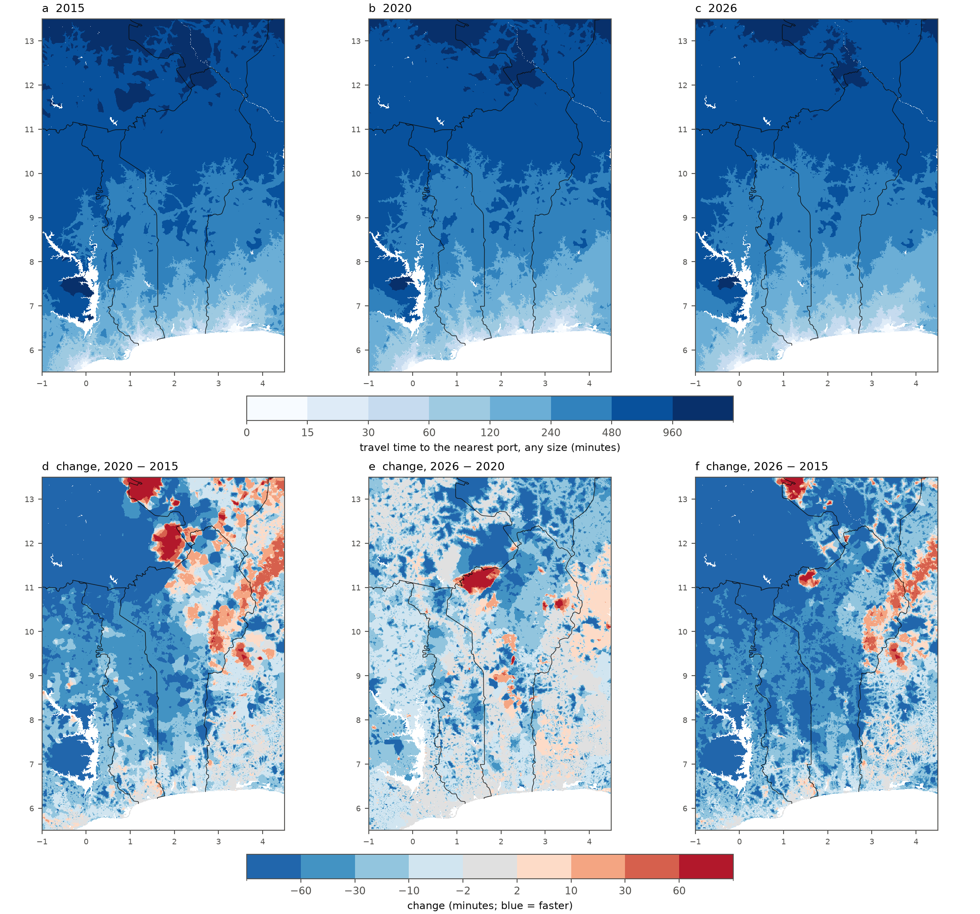
Figure S1. Travel time to the nearest port of any size (ports 5) in (a) 2015, (b) 2020 and (c) 2026, and the changes (d) 2020 − 2015, (e) 2026 − 2020 and (f) 2026 − 2015. Ports outside the domain (e.g. Lagos, Tema, Abidjan) are not reachable in the regional run [global].
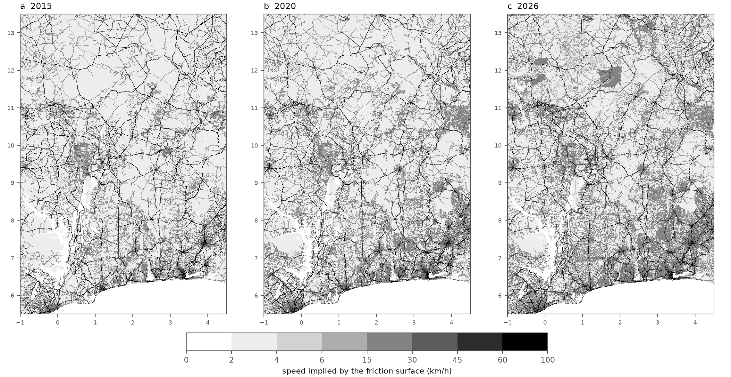
Figure S2. Speed implied by the friction surface (km/h) in (a) 2015 and (b) 2020, after completion with the Weiss et al. (2018) surface, and (c) 2026, including Microsoft road detections. Off-road cells are below 6 km/h.

References (main text and Supplementary Material)
Luxen, D., Vetter, C. (2011). Real-time routing with OpenStreetMap data. Proceedings of the 19th ACM SIGSPATIAL International Conference on Advances in Geographic Information Systems, 513–516. (OSRM; https://project-osrm.org)
Microsoft (2025). Global ML Road Detections, release 2025-04-28. https://github.com/microsoft/RoadDetections (ODbL).
Nelson, A. (2019). Travel time to cities and ports in the year 2015. figshare, dataset, version 4. https://doi.org/10.6084/m9.figshare.7638134.v4 (CC BY 4.0).
Nelson, A., Weiss, D. J., van Etten, J., Cattaneo, A., McMenomy, T. S., Koo, J. (2019). A suite of global accessibility indicators. Scientific Data 6, 266. https://www.nature.com/articles/s41597-019-0265-5
NGA – National Geospatial-Intelligence Agency. World Port Index, Publication 150 (current edition). https://msi.nga.mil/Publications/WPI
OpenStreetMap contributors. Full-history planet file (ODbL). https://planet.openstreetmap.org/pbf/full-history/; regional yearly snapshots by Geofabrik GmbH, https://download.geofabrik.de
Topf, J. et al. osmium-tool: command line tool for working with OpenStreetMap data (version 1.19). https://osmcode.org/osmium-tool/ (GPL-3.0).
Natural Earth. Admin 0 – Countries, 1:10 m. https://www.naturalearthdata.com (public domain).
European Commission, Joint Research Centre (2023). GHSL Data Package 2023: GHS-SMOD and GHS-POP, release R2023A. https://ghsl.jrc.ec.europa.eu
Tobler, W. (1993). Three presentations on geographical analysis and modeling. NCGIA Technical Report 93-1.
Weiss, D. J., Nelson, A., Gibson, H. S. et al. (2018). A global map of travel time to cities to assess inequalities in accessibility in 2015. Nature 553, 333–336. https://doi.org/10.1038/nature25181
Weiss, D. J. et al. (2018). Global friction surface 2015 (Accessibility__201501_Global_Travel_Speed_Friction_Surface). Malaria Atlas Project, CC BY 4.0. https://data.malariaatlas.org
World Bank. Worldwide Governance Indicators, Control of Corruption: score (GOV_WGI_CC.SC). https://www.worldbank.org/en/publication/worldwide-governance-indicators
Zanaga, D. et al. (2022). ESA WorldCover 10 m 2021 v200. European Space Agency. https://esa-worldcover.org (CC BY 4.0).
European Space Agency (2021). Copernicus Global Digital Elevation Model GLO-90. https://registry.opendata.aws/copernicus-dem/

