Updating global travel-time accessibility for new road developments: methods and results
Draft Methods and Results sections, with Supplementary Material in a separate file
Status of the results. The Methods describe the full global workflow (script global_accessibility.py). The Results reported here come from the complete end-to-end application of that workflow to a regional test domain (1°W–4.5°E, 5.5–13.5°N: Benin, Togo and neighbouring parts of Ghana, Burkina Faso, Niger and Nigeria) for 2015 and 2026. All numbers in brackets marked [global] must be replaced after the global run on the 30″ Nelson et al. (2019) extent; the structure, tables and figures are generated by the same code.

2. Methods

2.1 Study design
We estimated travel time from every location to the nearest settlement and port of a range of sizes for two reference years, a start year t₀ = 2015 and an end year t₁ = 2026, and attributed the change between them to new or newly mapped roads. The start year matches the reference year of the global accessibility indicators of Nelson et al. (2019), which we used for comparison. Both years were modelled with the same method, grid, speed tables and land cover, so that differences between them arise from the transport network and, where stated, from settlement growth. The workflow (Figure 1) builds a friction surface for each year (minutes needed to cross one metre), computes least-cost travel time to 17 sets of destinations, and compares the results with Nelson et al. (2019) for 2015 and with an independent routing engine for 2026.
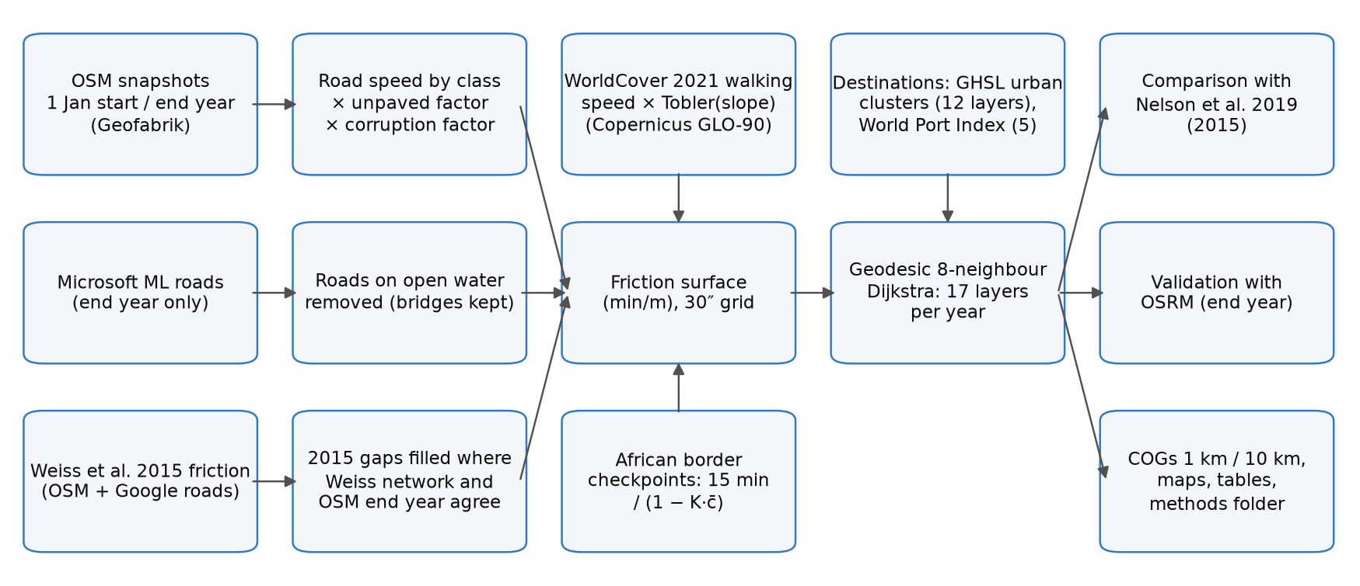
Figure 1. Workflow. Inputs (left) are combined into one friction surface per reference year, from which travel time to 12 settlement and 5 port layers is computed; outputs are compared with Nelson et al. (2019) and validated against OSRM. The 2015 completion step uses the Weiss et al. (2018) friction surface only for the start year.

2.2 Computational grid
All layers were computed on a regular geographic grid (WGS84) with a cell size of 30 arc-seconds (≈0.93 km at the equator), aligned with and covering the same extent as Nelson et al. (2019): 180°W–180°E and 60°S–85°N (43,200 × 17,400 cells). The grid wraps across the antimeridian. Cell areas and step lengths account for the convergence of meridians (Section 2.9). A light version at 300 arc-seconds (≈10 km) was derived by averaging valid 30″ cells in blocks of 10 × 10.

2.3 Road network

OpenStreetMap snapshots
Roads for each year were taken from OpenStreetMap (OSM) snapshots of 1 January of that year, distributed as regional extracts by Geofabrik. For each year we used, for every part of the domain, the smallest Geofabrik region for which a snapshot of that date exists; where a region did not yet exist (regions have been subdivided over time), its parent region was used, and nested duplicates were removed. For the current year the latest extract was used if the 1 January snapshot was not yet published. All ways tagged highway with a class listed in Table S2 were read; ways of other classes (paths, footways, cycleways), waterways and ferry routes were not used as travel links.

Speeds
Each road class was assigned a free-flow speed (Table S2), from 100 km/h for motorways to 15 km/h for tracks. Speeds were multiplied by 0.7 when the way was tagged with an unpaved surface, or when the surface was not tagged and the class is usually unpaved (tertiary and lower). Roads were burned into the grid with every touched cell receiving the speed of the fastest road crossing it.

Governance penalty
Travel on roads was slowed in proportion to perceived corruption, which we used as a proxy for delays from informal checkpoints and poorly maintained infrastructure. We used the World Bank Worldwide Governance Indicators Control of Corruption score (0–100, higher = better control; indicator GOV_WGI_CC.SC) for the latest year not later than the reference year, and the continental median for countries without a score. With S the score of the country containing a cell and c = 1 − S/100, road speeds were multiplied by
f_{corr} = 1 − K · c (1)
with K = 0.10, so that the road speeds of a country with the lowest score are reduced by at most 10%. Off-road walking was not penalised. Because K has no empirical basis, it is treated as a scenario parameter; values per country and year are given in Table S5.

Microsoft road detections
For the end year only, roads detected by Microsoft from satellite imagery (Global ML Road Detections, release of 28 April 2025) were added in cells without any OSM road, at 15 km/h. They were not used for the start year because their imagery date is not known.

Roads on open water
To exclude mapping errors and false detections, a road cell was removed when at least 90% of its area is permanent water (share computed from WorldCover 2021 at ≈185 m within each 30″ cell), unless the OSM way is tagged as a bridge, causeway, ford or embankment. Microsoft roads on such cells were always removed. Using the water share rather than the dominant class keeps roads along lake shores and coasts.

Completion of the 2015 network
OSM was much less complete in 2015 than today in many low- and middle-income countries. The friction surface of Weiss et al. (2018), which underlies the Nelson et al. (2019) indicators, combined OSM with Google road data for 2015; the Google data are not public, but the friction surface is (Malaria Atlas Project, CC BY 4.0). We converted it to speed (v = 60 / (1000 f), km/h) and, before any travel-time calculation, added a 2015 road to every cell where (i) OSM 2015 has no road, (ii) the Weiss surface implies a transport network (v ≥ 10 km/h), (iii) OSM of the end year has a road, and (iv) the cell is not open water. Condition (iii) restricts the completion to roads that exist today and removes the rivers, sea lanes and railways that are also present in the Weiss surface. The added cells received the lower of the Weiss speed and the end-year OSM speed, so that no road is faster in 2015 than in the end year.

Completeness of OSM 2015
To identify areas where OSM 2015 alone was already informative, we computed, for 2° × 2° tiles (the tile size used by Weiss et al., 2018, for validation), the share of Weiss 2015 network cells that are end-year OSM roads and were already OSM roads in 2015, before completion. Tiles with ≥80% completeness and ≥50 such cells were classed as OSM 2015 complete and used as a separate subset in the comparison with Nelson et al. (2019).

2.4 Off-road travel
Off-road cells were assigned a walking speed on flat ground according to their dominant ESA WorldCover 2021 class (Table S3), multiplied by Tobler's hiking factor for the mean slope of the cell:
v_{off} = v_{lc} · exp(−3.5 · tan θ) (2)
where tan θ is the mean of the slope computed from the Copernicus GLO-90 digital elevation model at 6″ (≈185 m) within each 30″ cell. Using one land-cover map (2021) for both years ensures that the change in travel time is not driven by differences between the WorldCover 2020 (v100) and 2021 (v200) products, which were produced with different algorithm versions. Permanent water is impassable (speed 0) unless crossed by a road.

2.5 Border crossings
Crossing an international land border between two African countries (Natural Earth, 1:10 m) added a delay at official crossing points only, defined as the intersections of motorways, trunk, primary and secondary roads (and their links) with such borders. The delay applies to all travellers using these crossings. Borders elsewhere in the world, and informal crossings away from major roads, were not penalised. The delay was scaled by the mean governance score of the two countries, c̄:
D = 15 min / (1 − K · c̄) (3)
and added to the friction of the grid cell containing the crossing as D / L, where L is the cell's mean step length, so that a path through the cell accumulates approximately D.

2.6 Friction surface
The speed of each cell was the larger of the road speed (after the governance factor) and the off-road speed; friction was expressed in minutes per metre:
F = 60 / (1000 · max(v_{road} · f_{corr}, v_{off})) (4)
Cells with speed 0 (open water, no data) were impassable.

2.7 Destinations

Settlements
Settlements were delineated for each reference year from the Global Human Settlement Layer (GHSL, release R2023A) at 1 km: contiguous (8-connected) cells classified by the degree-of-urbanisation model (GHS-SMOD) as urban centre, dense or semi-dense urban cluster, or suburban cell (classes 30, 23, 22 and 21), with population summed from GHS-POP. Urban clusters have at least 5,000 inhabitants by definition. The GHSL epoch nearest to each reference year was used (2015 for 2015, 2025 for 2026); GHSL epochs after 2020 are projections [check against the GHSL documentation]. Settlement cells were transferred to the 30″ grid by nearest-neighbour resampling.

Ports
Ports were taken from the current edition of the World Port Index (NGA Publication 150) and classified by harbour size. Ports falling on impassable cells were moved to the nearest passable cell within 5 km.

Layers
We reproduced the 17 layers of Nelson et al. (2019) (Table S4): travel time to settlements of each of nine population classes (layers 1–9, from 5–50 million to 5,000–10,000), to settlements of ≥20,000 (layer 10), 50,000–50 million (layer 11, the headline indicator used here) and ≥5,000 (layer 12), and to ports of each size (layers 1–4) and of any size (layer 5).

2.8 Least-cost travel time
Travel time from every cell to the nearest destination cell was computed with a multi-source Dijkstra algorithm over the 8-neighbour graph of the grid. The cost of a step between two adjacent cells i and j is
C_{ij} = ½ (F_{i} + F_{j}) · d_{ij} (5)
where d_{ij} is the great-circle step length on a sphere of radius 6,371,007 m: R Δφ north–south, R cos φ Δλ east–west at the latitude φ of the row, and the hypotenuse of the two (east–west length at the mean latitude of the two rows) for diagonal steps. All cells of a destination settlement are sources with time zero. Results are in minutes and were stored as 16-bit integers (nodata 65535), as in Nelson et al. (2019). The implementation was verified against scikit-image (MCP_Geometric) near the equator (agreement within 0.02%) and against analytical distances at 60°N.

2.9 Summary indicators
Travel times were summarised as population-weighted means and as the share of population within 60 minutes, using GHS-POP of the same epoch as the settlements, re-projected to the 30″ grid while conserving population (mean density × cell area). Population in cells from which no destination can be reached was reported separately. Summaries are given for each country, continent and the whole domain; in the regional test, country values refer only to the part of each country inside the domain.

2.10 Comparison with Nelson et al. (2019)
Our 2015 and end-year layers were compared cell by cell with the corresponding 2015 layers of Nelson et al. (2019) (figshare 10.6084/m9.figshare.7638134, version 4; the rasters are identical to version 3 cited by the R package geodata, verified by MD5 checksum). For each layer we report the mean and mean absolute difference, the share of cells within ±30 minutes, the Pearson correlation of log(1 + minutes), and population-weighted means, for all cells and for the OSM 2015 complete tiles (Section 2.3).

2.11 Validation against a routing engine
End-year travel times were validated against the free Open Source Routing Machine (OSRM; car profile on current OSM data, public servers of the OSRM project and FOSSGIS), queried at no more than one request per second in line with the servers' usage policies. We drew a sample of settlements of ≥50,000 inhabitants stratified by continent (in proportion to the square root of their number, at least five per continent; 250 globally [global], 12 in the regional test) and, for each, up to ten origins between 10 and 150 km (great-circle) sampled from populated cells with probability proportional to population. Our time was obtained from a single-source least-cost run from the settlement over the end-year friction surface; the reference was the OSRM table duration between the same points. Pairs for which OSRM moved an origin or the settlement point by more than 1 km to reach its road network were discarded. OSRM gives free-flow car times without walking segments or border delays and is therefore a lower-bound reference rather than an observed journey time.

2.12 Implementation
The workflow is a single Python script (Python 3.11–3.13) that installs missing packages, downloads all inputs, runs the stages above and writes Cloud Optimized GeoTIFFs at 30″ and 300″ (one 17-band file per year, a change file, and the friction surface), global maps, summary tables and a folder with all parameters, input versions, checksums and run logs (Text S1). The least-cost algorithm is compiled with Numba; OSM extracts and travel-time layers are processed in parallel with a scheduler that limits the number of concurrent tasks by their estimated memory. Stages are resumable. The regional test ran on a GitHub-hosted runner (2 cores available) in about 6 minutes; software versions are listed in Table S10.

3. Results
Regional test domain (1°W–4.5°E, 5.5–13.5°N). Replace with the global run where marked [global].

3.1 Road network and friction
For 2015 no country-level Geofabrik snapshots exist for the domain, so the Africa extract of 1 January 2015 was used; for 2026, the six country extracts (Benin, Burkina Faso, Ghana, Niger, Nigeria, Togo). The length of OSM roads in the domain grew almost five-fold, from 79,100 km in 2015 to 382,000 km in 2026 (Table S8). Growth was concentrated in unclassified (10,400 → 148,300 km), residential (18,000 → 118,200 km) and track (5,500 → 43,500 km) roads, whereas the length of primary roads decreased (13,500 → 10,800 km) while trunk roads increased (1,500 → 6,700 km), consistent with reclassification. On the grid, OSM 2015 roads occupied 66,886 cells; the completion with the Weiss et al. (2018) surface added 79,233 cells, giving 146,119 road cells in 2015. In 2026 there were 252,709 road cells, of which 29,882 were contributed by Microsoft road detections (1.08 million segments, 220,000 km in the domain). The open-water rule removed 35 (2015) and 111 (2026) OSM road cells and 29 Microsoft cells, and kept 9 and 12 cells tagged as bridges or causeways.
None of the twelve 2° tiles assessed reached the 80% completeness threshold: OSM 2015 contained between 14% and 73% (median 39%) of the Weiss network cells that are roads today (Table S7). Completeness was highest in the west of the domain (Ghana, 61–73%) and lowest in southern and central Nigeria and Benin (14–35%).
The governance factor reduced road speeds by 5.6–7.5% (Table S5; Nigeria 7.5%, Benin 5.7%, Togo 6.6% in 2026). Sixty-five official border crossings were identified in 2015 and 87 in 2026, mostly on the Togo–Ghana (25) and Benin–Togo (25) borders and the Benin–Nigeria border (17) (Table S6); their delays ranged from 15.9 to 16.1 minutes after the governance scaling.

3.2 Accessibility in 2015 and 2026
The number of settlements rose from 1,219 in 2015 to 1,369 in 2025, and those of ≥50,000 inhabitants from 186 to 198 (Table S9). The population-weighted mean travel time to the nearest settlement of ≥50,000 inhabitants fell from 22.0 minutes in 2015 to 19.0 minutes in 2026, and the share of the population within 60 minutes rose from 87.1% to 88.7% (Table 1; Figure 2). Travel time to the nearest settlement of ≥5,000 fell from 8.7 to 6.4 minutes (97.6% of people within 60 minutes in 2026), and to the nearest port of any size from 262 to 244 minutes. About 0.3% of the population (0.23–0.25 million) lived in cells from which no destination could be reached, mostly on land enclosed by water.
Table 1. Population-weighted mean travel time and share of population within 60 minutes, regional test domain [global]. Population: GHS-POP 2015 (67.1 million) and 2025 (84.4 million). Destinations are counted within the domain. All 17 layers are in Table S9.
Layer | Destinations 2015 | Destinations 2026 | Mean 2015 (min) | Mean 2026 (min) | ≤60 min 2015 | ≤60 min 2026
Settlements ≥ 5,000 (cities 12) | 1,209 | 1,352 | 8.7 | 6.4 | 95.8% | 97.6%
Settlements ≥ 20,000 (cities 10) | 373 | 413 | 14.9 | 11.4 | 92.1% | 94.2%
Settlements 50,000–50 M (cities 11) | 186 | 198 | 22.0 | 19.0 | 87.1% | 88.7%
Settlements 100,000–200,000 (cities 5) | 48 | 57 | 71.5 | 62.5 | 68.1% | 71.3%
Settlements 1–5 M (cities 2) | 6 | 9 | 160.2 | 155.8 | 34.1% | 40.7%
Any port (ports 5) | 7 | 7 | 261.6 | 243.5 | 36.2% | 37.4%
Mean and share are weighted by GHS-POP of the epoch used for the settlements.
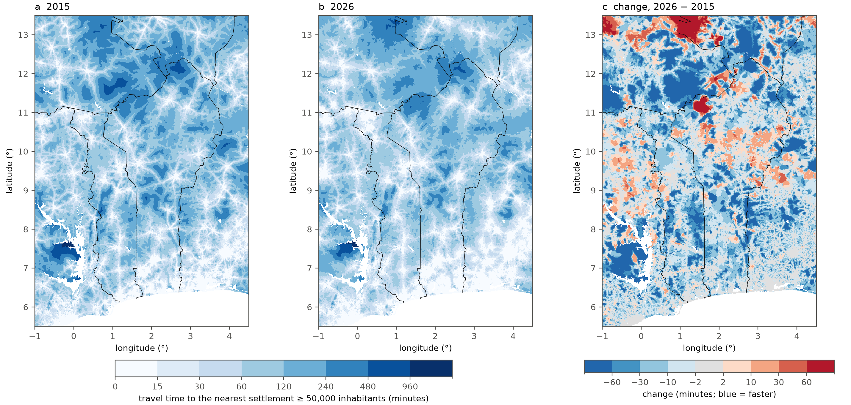
Figure 2. Travel time to the nearest settlement of 50,000–50 million inhabitants (layer cities 11) in (a) 2015 and (b) 2026, and (c) the change 2026 − 2015 (negative = faster). Lines: African land borders. White: water or no data. Regional test domain [global].
The improvement was widespread but uneven (Figure 2c). The largest reductions, often more than 60 minutes, occurred in rural areas, notably in Burkina Faso, Niger and west of Lake Volta in Ghana; most new OSM roads in the domain are unclassified roads and tracks (Table S8). In a few areas travel time increased, in places by more than 60 minutes (e.g. north of 11°N between 1° and 2°E, near the Benin–Burkina Faso–Niger borders); these are cells whose 2015 road (from OSM or from the completion) has no counterpart, or a slower class, in the 2026 network, and increases can also arise where GHSL 2025 no longer contains a settlement that was a destination in 2015. For layers restricted to one population class, growth can move settlements out of the class: the number of settlements of 50,000–100,000 inhabitants fell from 104 to 98 and the mean travel time to that class rose from 53.6 to 62.4 minutes, whereas it fell for the cumulative layers.

3.3 Differences between countries
Within the domain, mean travel time to settlements of ≥50,000 in 2026 ranged from 6.8 minutes in the Nigerian part to 80.2 minutes in the Burkinabè part (Table 2). The largest absolute reductions were in Niger (−13.2 minutes) and Burkina Faso (−9.6 minutes) and the largest relative reduction in Togo (−24%, from 20.9 to 15.8 minutes); in Benin the mean fell from 22.9 to 20.4 minutes and the share of people within 60 minutes rose from 85.5% to 86.6%.
Table 2. Population-weighted travel time to settlements of 50,000–50 million inhabitants (cities 11) and to any port, by country, regional test domain [global: all countries in Table S11].
Country (part in domain) | Population 2025 (M) | Cities 11, 2015 (min) | Cities 11, 2026 (min) | ≤60 min 2015 | ≤60 min 2026 | Ports 5, 2026 (min)
Benin | 14.4 | 22.9 | 20.4 | 85.5% | 86.6% | 222
Togo | 9.4 | 20.9 | 15.8 | 86.7% | 91.4% | 189
Ghana (part) | 16.8 | 16.9 | 13.7 | 92.7% | 94.0% | 192
Nigeria (part) | 34.1 | 8.0 | 6.8 | 95.5% | 96.2% | 146
Burkina Faso (part) | 5.7 | 89.8 | 80.2 | 46.3% | 52.4% | 740
Niger (part) | 3.6 | 79.2 | 66.0 | 47.7% | 52.5% | 866
Only the part of each country inside the domain is included; for Ghana, Nigeria, Burkina Faso and Niger this is a small, non-representative part of the country, and destinations outside the domain (e.g. ports of Lagos, Tema and Abidjan) are not reachable.

3.4 Comparison with Nelson et al. (2019)
After completion of the 2015 network, our 2015 estimates agreed closely with Nelson et al. (2019) for settlements (Table 3). For settlements of ≥50,000, the population-weighted mean was 22.0 minutes against 23.1 minutes in Nelson et al.; 67% of cells were within ±30 minutes and the correlation of log travel times was 0.89. Without the completion step, i.e. with OSM 2015 roads only, the same indicators were 33.8 minutes, 44% and 0.80. For settlements of ≥5,000, the means were 8.7 and 7.9 minutes (r = 0.87). Travel time to ports was spatially consistent (r = 0.97) but on average longer in our estimates (262 against 203 minutes), which we attribute, at least in part, to the domain boundary: Nelson et al. can reach ports outside the domain, such as Lagos, Tema and Abidjan, which our regional run cannot [global: to be verified]. No tile of the domain reached the completeness threshold, so the comparison restricted to OSM 2015 complete areas could not be made here [global]. Our 2026 estimates were shorter than the 2015 values of Nelson et al. for settlements (19.0 against 24.4 minutes for ≥50,000; population weights of 2025), consistent with the network growth described above.
Table 3. Comparison with the 2015 layers of Nelson et al. (2019), regional test domain [global]. Differences are ours − Nelson. OSM only: run without the 2015 completion step; completed: final method. Population weights: GHS-POP of our settlement epoch (2015 or 2025).
Layer and version | Cells | Mean diff. (min) | Mean abs. diff. (min) | Within ±30 min | r (log) | Pop.-weighted: ours / Nelson (min)
Cities 11, 2015, OSM only | 576,291 | 72.1 | 84.0 | 44% | 0.80 | 33.8 / 23.1
Cities 11, 2015, completed | 576,822 | 16.2 | 33.1 | 67% | 0.89 | 22.0 / 23.1
Cities 11, 2026 | 577,282 | −6.6 | 33.7 | 64% | 0.85 | 19.0 / 24.4
Cities 12, 2015, OSM only | 576,383 | 68.1 | 73.7 | 49% | 0.77 | 15.8 / 7.9
Cities 12, 2015, completed | 576,917 | 19.9 | 27.5 | 74% | 0.87 | 8.7 / 7.9
Cities 12, 2026 | 577,401 | −3.8 | 25.4 | 74% | 0.82 | 6.4 / 9.1
Ports 5, 2015, OSM only | 576,251 | 190.4 | 192.6 | 12% | 0.92 | 281.6 / 203.0
Ports 5, 2015, completed | 576,765 | 123.1 | 128.5 | 20% | 0.97 | 262.1 / 202.9
Ports 5, 2026 | 577,215 | 63.3 | 86.4 | 26% | 0.96 | 244.0 / 207.5
The OSM-only rows come from an earlier run of the same code without the completion step (identical inputs otherwise).
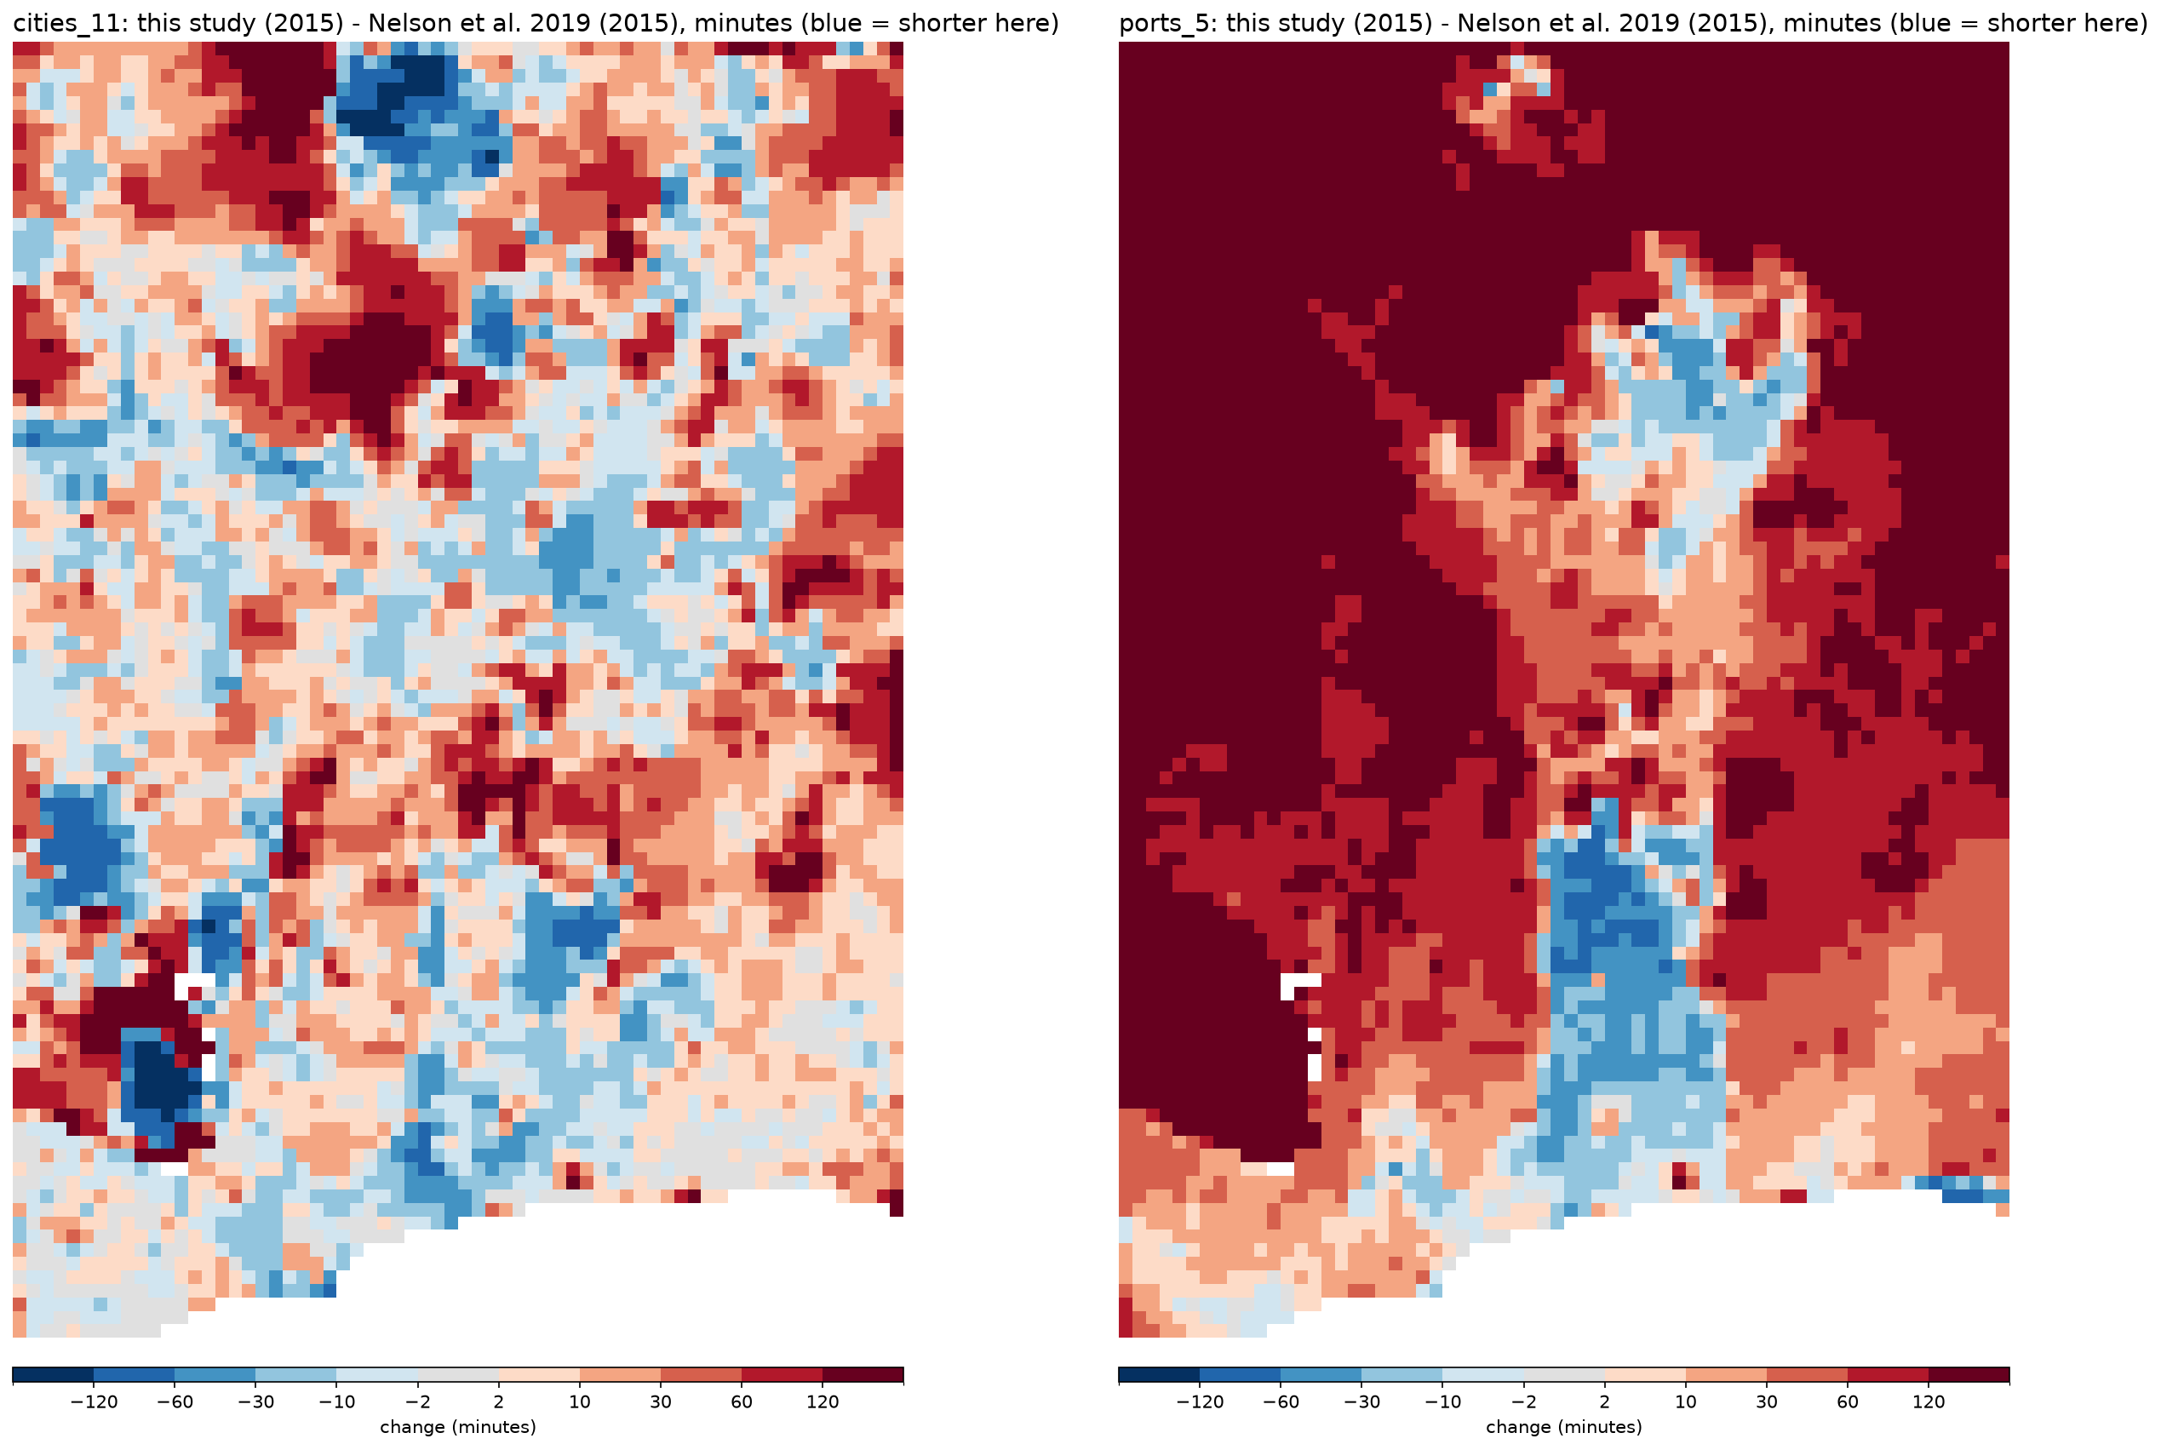
Figure 3. Difference between our 2015 estimates and Nelson et al. (2019), in minutes (blue = shorter in this study), for settlements of 50,000–50 million (left) and ports of any size (right), mean of 10 × 10 cells. Regional test domain [global].

3.5 Validation against OSRM
For 12 sampled settlements of ≥50,000 inhabitants, 120 origin–settlement pairs were queried (great-circle distances 12–149 km); 105 remained after removing pairs with a road snap distance above 1 km. Our 2026 travel times agreed closely with OSRM free-flow car times (Figure 4): the median was 118.7 minutes in our estimates and 113.5 minutes in OSRM, the median ratio 0.98, the median difference −1.6 minutes and the mean absolute difference 14.2 minutes; 90.5% of pairs were within ±30% and the correlation of log travel times was 0.94 [global: 250 settlements, results by continent]. Because both estimates rely on current OSM roads, this comparison validates the speed model and the least-cost computation rather than the completeness of the network.
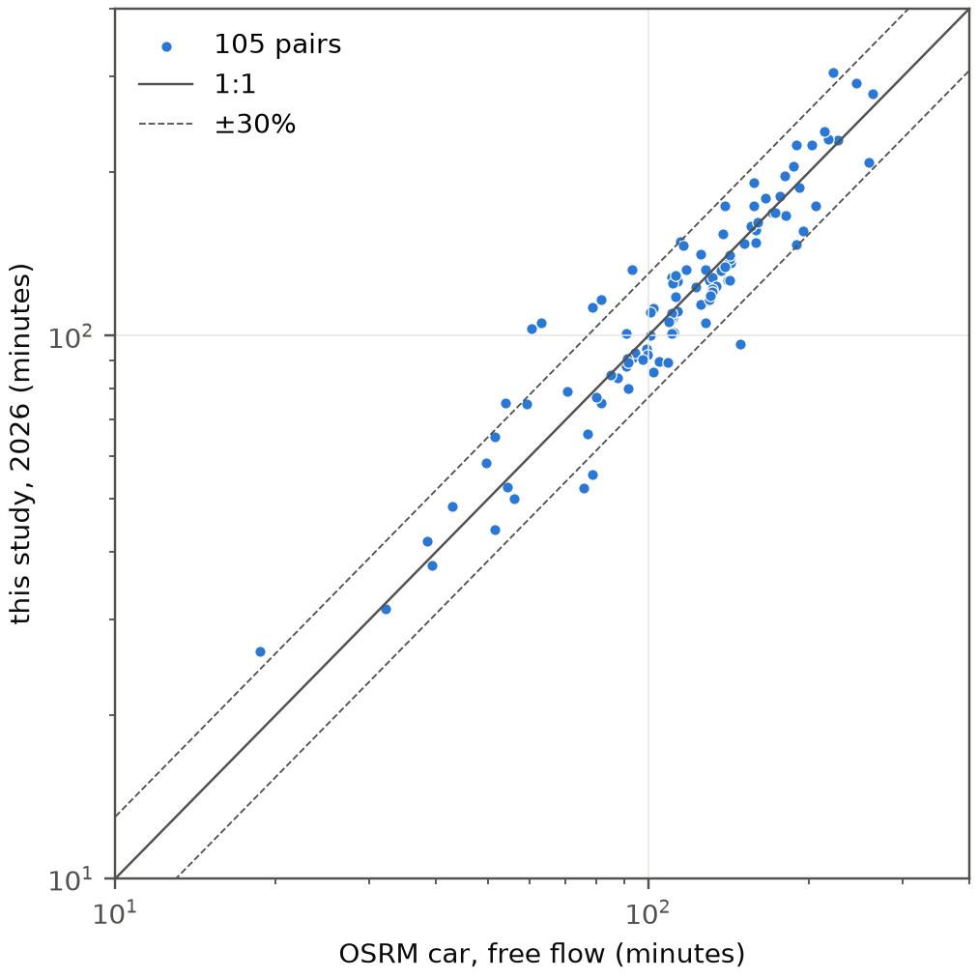
Figure 4. End-year (2026) travel time from 105 origins to settlements of ≥50,000 inhabitants: this study against OSRM car routing (free flow). Solid line: 1:1; dashed lines: ±30%. Log scales. Regional test domain [global].

References
Luxen, D., Vetter, C. (2011). Real-time routing with OpenStreetMap data. Proceedings of the 19th ACM SIGSPATIAL International Conference on Advances in Geographic Information Systems, 513–516. (OSRM; https://project-osrm.org)
Microsoft (2025). Global ML Road Detections, release 2025-04-28. https://github.com/microsoft/RoadDetections (ODbL).
Nelson, A. (2019). Travel time to cities and ports in the year 2015. figshare, dataset, version 4. https://doi.org/10.6084/m9.figshare.7638134.v4 (CC BY 4.0).
Nelson, A., Weiss, D. J., van Etten, J., Cattaneo, A., McMenomy, T. S., Koo, J. (2019). A suite of global accessibility indicators. Scientific Data 6, 266. https://www.nature.com/articles/s41597-019-0265-5
NGA – National Geospatial-Intelligence Agency. World Port Index, Publication 150 (current edition). https://msi.nga.mil/Publications/WPI
OpenStreetMap contributors. Planet data (ODbL), regional extracts and yearly snapshots by Geofabrik GmbH. https://download.geofabrik.de
Natural Earth. Admin 0 – Countries, 1:10 m. https://www.naturalearthdata.com (public domain).
European Commission, Joint Research Centre (2023). GHSL Data Package 2023: GHS-SMOD and GHS-POP, release R2023A. https://ghsl.jrc.ec.europa.eu
Tobler, W. (1993). Three presentations on geographical analysis and modeling. NCGIA Technical Report 93-1.
Weiss, D. J., Nelson, A., Gibson, H. S. et al. (2018). A global map of travel time to cities to assess inequalities in accessibility in 2015. Nature 553, 333–336. https://doi.org/10.1038/nature25181
Weiss, D. J. et al. (2018). Global friction surface 2015 (Accessibility__201501_Global_Travel_Speed_Friction_Surface). Malaria Atlas Project, CC BY 4.0. https://data.malariaatlas.org
World Bank. Worldwide Governance Indicators, Control of Corruption: score (GOV_WGI_CC.SC). https://www.worldbank.org/en/publication/worldwide-governance-indicators
Zanaga, D. et al. (2022). ESA WorldCover 10 m 2021 v200. European Space Agency. https://esa-worldcover.org (CC BY 4.0).
European Space Agency (2021). Copernicus Global Digital Elevation Model GLO-90. https://registry.opendata.aws/copernicus-dem/

