Supplementary Material
Updating global travel-time accessibility for new road developments
Values are from the regional test domain (1°W–4.5°E, 5.5–13.5°N) unless stated; tables marked [global] will be regenerated from the global run (files in the results folder: methods/ and tables/).

Text S1. Implementation and reproducibility
The workflow is implemented in one Python file (global_accessibility.py), configured in a block at the top of the file (reference years, folders, speed tables, penalties, destination layers, validation settings). On start, the script installs any missing package into a local folder (no administrator rights needed). It then runs eight resumable stages: download, grids, roads, friction, travel time, outputs, comparison, validation and clean-up; completed stages are skipped when the script is restarted.
- Parallelism. The script reads the number of usable cores and the available memory, including container (cgroup) limits, and plans each parallel stage from a per-task memory estimate plus ≈0.35 GB of process overhead, within 75% of the available memory. OSM extracts are processed in parallel (estimated 1.5 GB + 7 × file size per extract, largest first); the 34 travel-time layers (2 years × 17) are computed in parallel (≈10 bytes per grid cell, ≈7.8 GB for the global 30″ grid), with the friction surface shared through memory-mapped files. Remote reads of WorldCover and Copernicus tiles use threads.
- Least-cost algorithm. Multi-source Dijkstra with an indexed binary heap, compiled with Numba; 32-bit indices (up to 2.1 billion cells). One layer on a 32-million-cell grid takes ≈40 s on one core.
- Outputs. Cloud Optimized GeoTIFFs (DEFLATE, internal overviews) at 30″ and 300″: traveltime_<year> (17 bands, uint16 minutes, nodata 65535, band descriptions and units), traveltime_change_<end>_minus_<start> (int16 minutes, nodata −32768), friction_<year> (float32, minutes per metre); PNG maps of every layer, year and change; population-weighted tables by country, continent and domain; the comparison with Nelson et al. (2019) and the routing validation.
- Methods folder. Configuration (all parameters as run), speed and land-cover tables, governance scores and factors per country and year, border crossings with their delays, African border lines, settlements per epoch (population and centroid), destinations per layer, OSM extracts used per year, road length by class and extract, OSM 2015 completeness tiles, input manifest (URL, size, date, Last-Modified), figshare record and MD5 checksums of the Nelson et al. layers, software versions, run times and log.
- Tests. 21 automated tests on synthetic data cover the grid, the least-cost algorithm (against scikit-image and analytical distances), road speeds and lengths, border and checkpoint detection, the governance factor and delay, the open-water rule, the 2015 completion and completeness, settlements, COG writing and aggregation, the memory-budgeted scheduler, port snapping, the routing validation (with a mocked server) and an integration of all stages from friction to comparison.

Supplementary tables
Table S1. Input data.
Input | Source and version | Use
Roads | OpenStreetMap, Geofabrik extracts of 1 January of each year (africa-150101 for 2015; country extracts -260101 for 2026) | Road network and speeds
Roads (end year) | Microsoft Global ML Road Detections, release 2025-04-28 (Western_Africa.zip in the test; World.zip globally) | Gap filling, end year
2015 network | Weiss et al. (2018) global friction surface 2015, MAP WCS (CC BY 4.0) | Completion of 2015 roads; completeness
Land cover | ESA WorldCover 2021 v200, 10 m (2,651 tiles; 12 in the test) | Walking speed; water share
Elevation | Copernicus DEM GLO-90 (26,475 tiles; 52 in the test) | Slope (Tobler)
Settlements, population | GHSL R2023A GHS-SMOD and GHS-POP, 1 km, epochs 2015 and 2025 | Destinations; population weights
Ports | World Port Index, NGA Pub. 150 (current edition; 3,807 ports) | Port destinations
Countries, borders | Natural Earth Admin 0, 1:10 m | Governance factor; African borders
Governance | World Bank WGI, Control of Corruption score (GOV_WGI_CC.SC), 1996–2024 | Road-speed and border penalties
Reference layers | Nelson et al. (2019), figshare 7638134 v4 (= v3 rasters) | Comparison, 2015
Reference routing | OSRM, car profile (router.project-osrm.org; routing.openstreetmap.de) | Validation, end year

Table S2. Road speeds by OSM class before the governance factor. Unpaved speed = speed × 0.7, applied when the surface is tagged unpaved (unpaved, dirt, gravel, ground, earth, sand, compacted, mud, fine_gravel, grass, laterite) or, for classes marked no, when the surface is not tagged.
OSM highway class | Speed (km/h) | Paved if surface missing | Unpaved speed (km/h)
motorway | 100 | yes | 70
trunk | 80 | yes | 56
primary | 70 | yes | 49
secondary | 55 | yes | 38.5
tertiary | 40 | no | 28
unclassified | 30 | no | 21
residential | 25 | no | 17.5
motorway_link | 60 | yes | 42
trunk_link | 50 | yes | 35
primary_link | 45 | yes | 31.5
secondary_link | 40 | yes | 28
tertiary_link | 30 | no | 21
service | 20 | no | 14
track | 15 | no | 10.5
living_street | 15 | no | 10.5
Microsoft ML road (end year) | 15 | – | –

Table S3. Off-road walking speeds on flat ground, multiplied by exp(−3.5 tan θ). Values are placeholders within the 1–5 km/h range and should be calibrated.
WorldCover 2021 class | Code | Walking speed on flat ground (km/h)
Tree cover | 10 | 2.5
Shrubland | 20 | 3.0
Grassland | 30 | 4.0
Cropland | 40 | 4.0
Built-up | 50 | 5.0
Bare / sparse vegetation | 60 | 3.0
Snow and ice | 70 | 1.0
Permanent water bodies | 80 | 0 (impassable)
Herbaceous wetland | 90 | 1.5
Mangroves | 95 | 1.0
Moss and lichen | 100 | 3.0

Table S4. Destination layers, as defined by Nelson et al. (2019). Layers 1–9 and ports 1–4 are single classes; cities 10–12 and ports 5 are cumulative.
Layer | Destinations | Nelson et al. (2019) file
cities 1 | settlements 5,000,000 – <50,000,000 | travel_time_to_cities_1
cities 2 | 1,000,000 – <5,000,000 | …_cities_2
cities 3 | 500,000 – <1,000,000 | …_cities_3
cities 4 | 200,000 – <500,000 | …_cities_4
cities 5 | 100,000 – <200,000 | …_cities_5
cities 6 | 50,000 – <100,000 | …_cities_6
cities 7 | 20,000 – <50,000 | …_cities_7
cities 8 | 10,000 – <20,000 | …_cities_8
cities 9 | 5,000 – <10,000 | …_cities_9
cities 10 | 20,000 – <110,000,000 | …_cities_10
cities 11 (headline) | 50,000 – <50,000,000 | …_cities_11
cities 12 | 5,000 – <110,000,000 | …_cities_12
ports 1 | Large | travel_time_to_ports_1
ports 2 | Medium | …_ports_2
ports 3 | Small | …_ports_3
ports 4 | Very small | …_ports_4
ports 5 | Any size (incl. unclassified) | …_ports_5

Table S5. Governance (WGI Control of Corruption score, 0–100) and resulting road-speed factor 1 − 0.1 (1 − score/100), countries of the test domain [global: all countries in methods/corruption_<year>.csv].
Country | 2015: WGI year | 2015: score | 2015: road factor | 2026: WGI year | 2026: score | 2026: road factor
Benin | 2015 | 37.6 | 0.938 | 2024 | 43.0 | 0.943
Togo | 2015 | 35.1 | 0.935 | 2024 | 34.4 | 0.934
Ghana | 2015 | 42.3 | 0.942 | 2024 | 43.9 | 0.944
Nigeria | 2015 | 24.3 | 0.924 | 2024 | 25.3 | 0.925
Burkina Faso | 2015 | 41.2 | 0.941 | 2024 | 42.7 | 0.943
Niger | 2015 | 39.1 | 0.939 | 2024 | 35.4 | 0.935

Table S6. Official border crossings (major roads crossing an African land border) in the test domain, 2026. Delay per crossing after governance scaling: 15.9–16.1 min (mean 16.0).
Border | Official crossings, 2026
Benin – Togo | 25
Togo – Ghana | 25
Nigeria – Benin | 17
Burkina Faso – Togo | 8
Nigeria – Niger | 4
Burkina Faso – Ghana | 3
Niger – Burkina Faso | 3
Benin – Burkina Faso | 1
Benin – Niger | 1
Total (2015: 65) | 87

Table S7. Completeness of OSM 2015 per 2° tile, before completion with the Weiss et al. (2018) surface. Threshold for OSM 2015 complete: ≥80%.
Tile (west, north) | Weiss network cells that are OSM roads in 2026 | …of which in OSM 2015 | Completeness
1°W, 13.5°N | 8,347 | 5,176 | 62%
1°E, 13.5°N | 5,480 | 2,776 | 51%
3°E, 13.5°N | 7,497 | 3,062 | 41%
1°W, 11.5°N | 15,485 | 9,446 | 61%
1°E, 11.5°N | 13,091 | 4,808 | 37%
3°E, 11.5°N | 9,945 | 2,371 | 24%
1°W, 9.5°N | 11,692 | 7,829 | 67%
1°E, 9.5°N | 14,382 | 4,047 | 28%
3°E, 9.5°N | 12,608 | 1,777 | 14%
1°W, 7.5°N | 15,237 | 11,188 | 73%
1°E, 7.5°N | 16,212 | 5,363 | 33%
3°E, 7.5°N | 10,886 | 3,786 | 35%

Table S8. Length of OSM roads intersecting the test domain, by class. Great-circle lengths of whole segments; roads added by the 2015 completion (raster cells) are not included.
OSM highway class | 2015 (km) | 2026 (km)
unclassified | 10,435 | 148,256
residential | 17,954 | 118,193
track | 5,502 | 43,482
tertiary | 17,336 | 31,640
secondary | 11,238 | 14,799
primary | 13,479 | 10,836
service | 934 | 7,101
trunk | 1,472 | 6,731
motorway | 480 | 719
links and living streets | 268 | 271
Total | 79,098 | 382,028

Table S9. All 17 layers: destinations inside the test domain, population-weighted mean travel time and share of population within 60 minutes [global].
Layer | Destinations 2015 | 2026 | Mean 2015 (min) | 2026 | ≤60 min 2015 | 2026
cities 1 | 1 | 2 | 331.4 | 239.9 | 28.0% | 38.1%
cities 2 | 6 | 9 | 160.2 | 155.8 | 34.1% | 40.7%
cities 3 | 6 | 8 | 301.4 | 204.4 | 28.1% | 31.2%
cities 4 | 21 | 24 | 107.5 | 91.2 | 31.3% | 39.4%
cities 5 | 48 | 57 | 71.5 | 62.5 | 68.1% | 71.3%
cities 6 | 104 | 98 | 53.6 | 62.4 | 73.5% | 47.4%
cities 7 | 187 | 215 | 49.0 | 40.1 | 73.2% | 85.1%
cities 8 | 331 | 359 | 40.3 | 34.3 | 87.1% | 90.9%
cities 9 | 505 | 580 | 37.2 | 34.1 | 89.9% | 92.8%
cities 10 | 373 | 413 | 14.9 | 11.4 | 92.1% | 94.2%
cities 11 | 186 | 198 | 22.0 | 19.0 | 87.1% | 88.7%
cities 12 | 1,209 | 1,352 | 8.7 | 6.4 | 95.8% | 97.6%
ports 1 | 1 | 1 | 383.8 | 348.3 | 18.4% | 18.1%
ports 2 | 3 | 3 | 314.7 | 279.9 | 9.3% | 11.5%
ports 3 | 2 | 2 | 291.2 | 272.5 | 26.7% | 26.3%
ports 4 | 1 | 1 | 391.8 | 358.8 | 3.7% | 4.2%
ports 5 | 7 | 7 | 261.6 | 243.5 | 36.2% | 37.4%

Table S10. Software and run time of the regional test.
Item | Value
Python | 3.13.15
GDAL | 3.12.4
numpy / pandas / geopandas | 2.5.3 / 3.0.6 / 1.1.4
rasterio / pyogrio / shapely / pyproj | 1.5.1 / 0.13.0 / 2.1.2 / 3.8.0
numba / scipy | 0.67.0 / 1.18.1
Test run: grid | 660 × 960 cells (30″), 577,709 passable in 2026
Test run: cores / memory | 2 / 4.8 GB available
Test run: time | download 1.5 min; roads 3.5 min (Microsoft roads 1.8 min); 34 travel-time layers 10.5 s; outputs 23.5 s; validation 13 s

Table S11 (population-weighted travel time by country for all countries) will be taken from tables/pop_weighted_traveltime_by_country.csv of the global run [global].

Supplementary figures
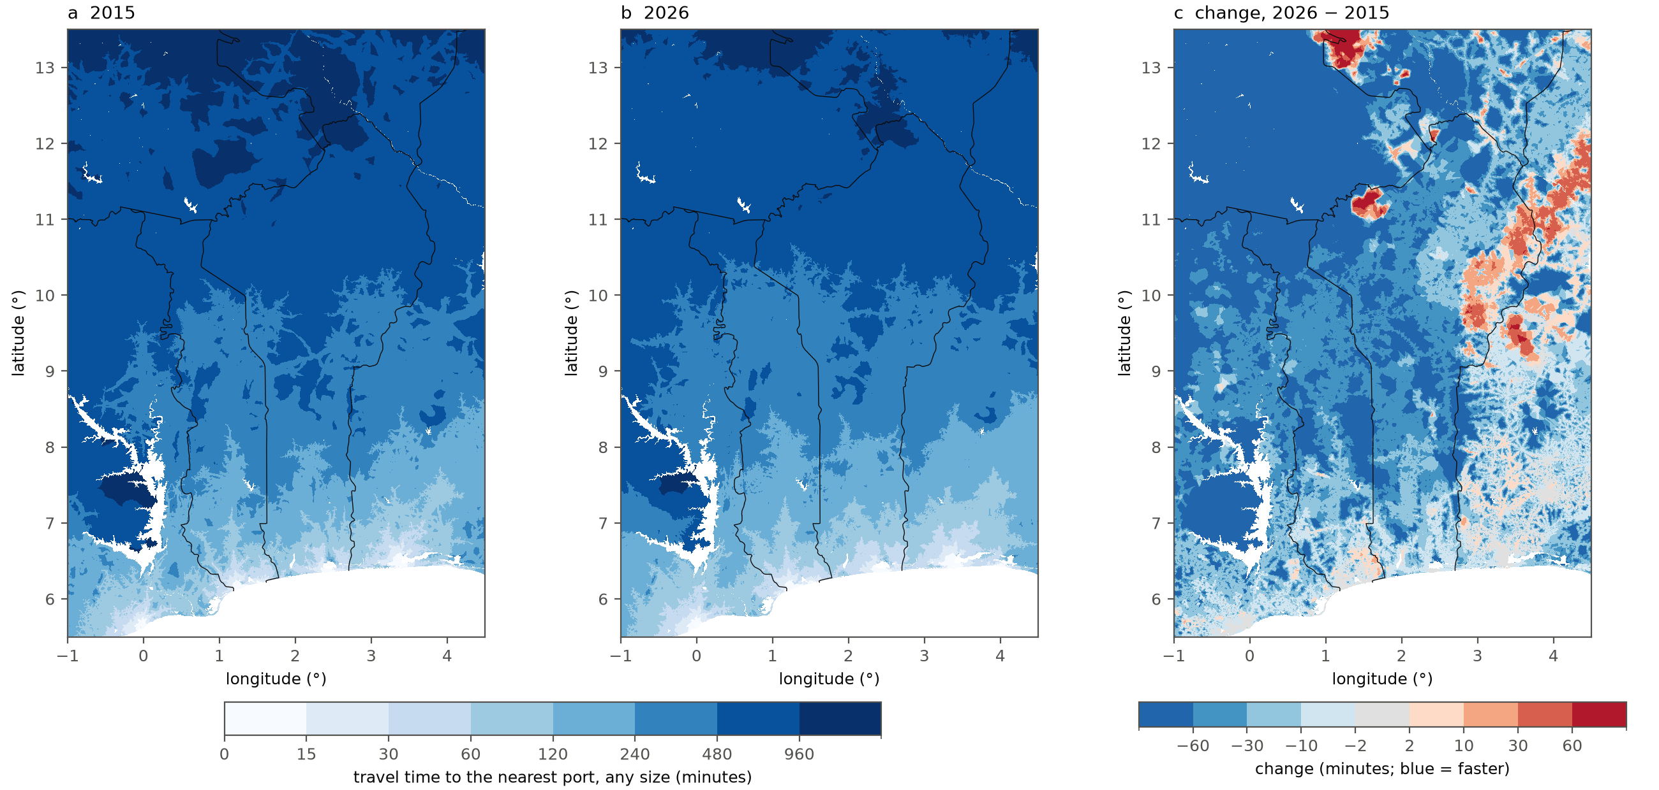
Figure S1. Travel time to the nearest port of any size (ports 5) in (a) 2015 and (b) 2026, and (c) the change 2026 − 2015. Ports outside the domain (e.g. Lagos, Tema, Abidjan) are not reachable in the regional run [global].
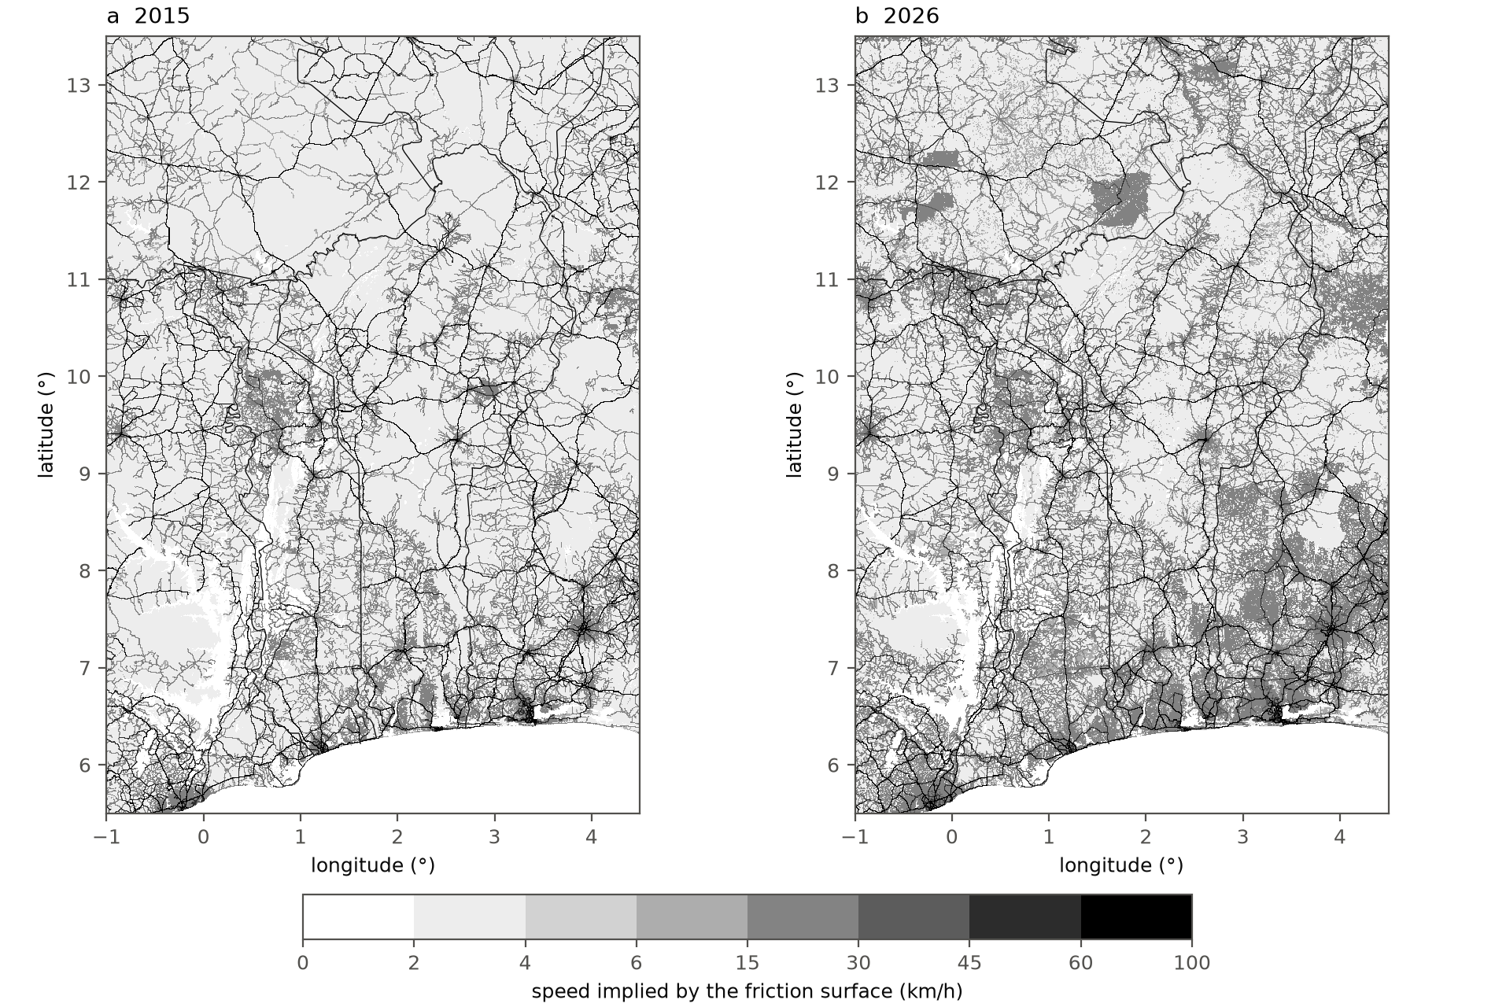
Figure S2. Speed implied by the friction surface (km/h) in (a) 2015, after completion with the Weiss et al. (2018) surface, and (b) 2026, including Microsoft road detections. Off-road cells are below 6 km/h.

