**ML LAB ASSIGNMENT 1**

**Name :** Abhay Vijay Jagtap

**Class** : BE-B

**Problem Statement :**

Predict the price of the Uber ride from a given pickup point to the agreed drop-off location. Perform following tasks:

1. Pre-process the dataset.

2. Identify outliers.

3. Check the correlation.

4. Implement linear regression and random forest regression models.

5. Evaluate the models and compare their respective scores like R2, RMSE, etc.

Dataset link: <https://www.kaggle.com/datasets/yasserh/uber-fares-dataset>

import pandas as pd

import numpy as np

import seaborn as sns

import matplotlib.pyplot as plt

!pip install haversine

df = pd.read_csv("/content/uber.csv")

df.head()

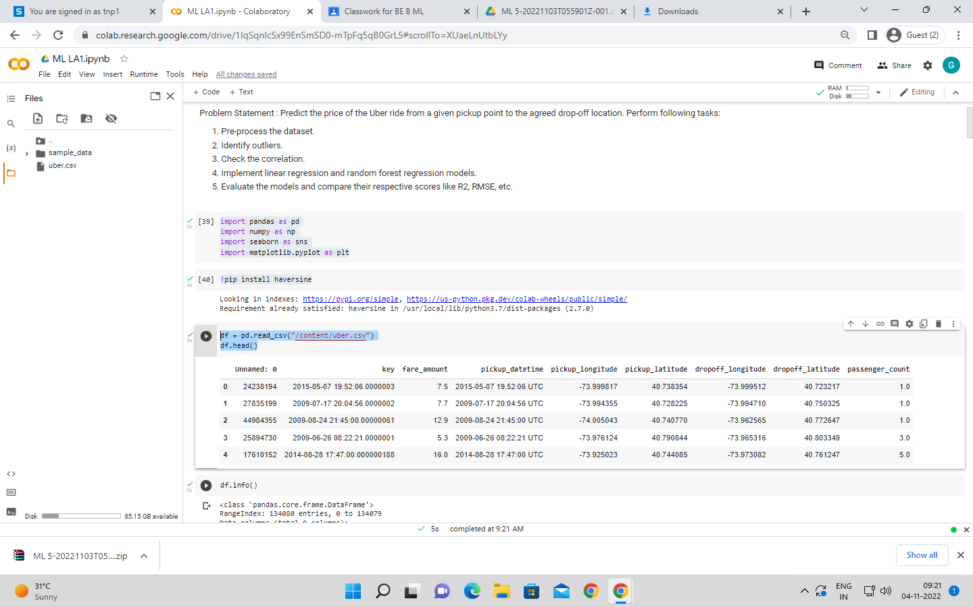

df.info()

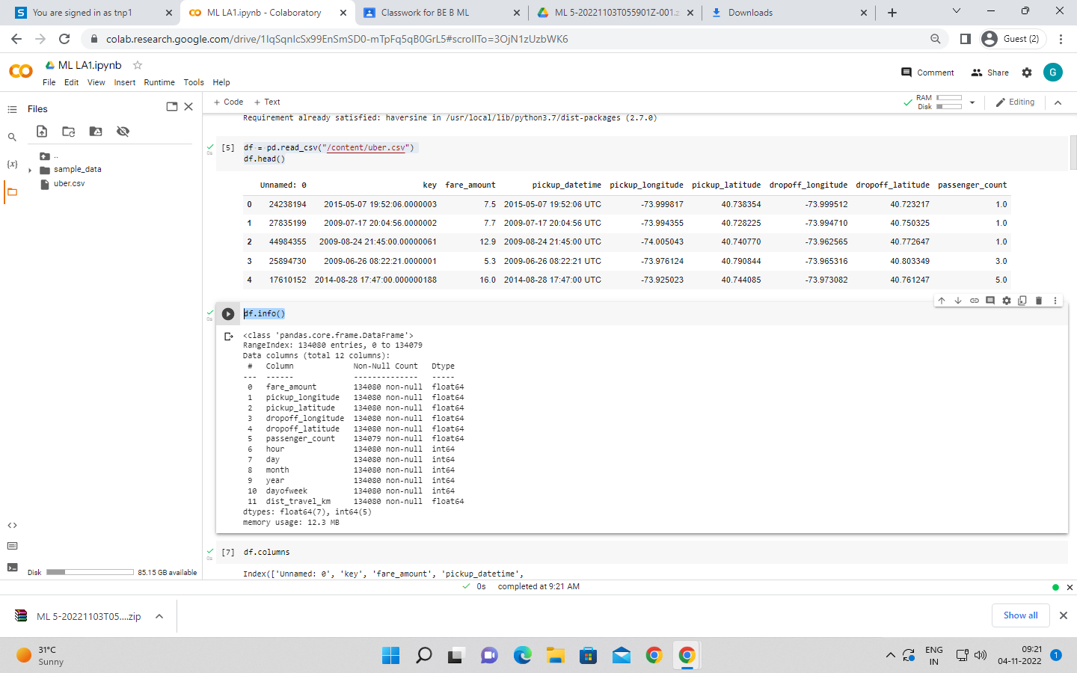

df.columns

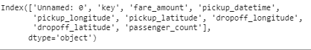

df.drop(['Unnamed: 0','key'],axis = 1,inplace = True)

df.head()

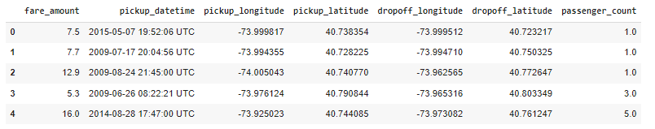

df.shape



df.pickup_datetime = pd.to_datetime(df.pickup_datetime, errors='coerce')

Df.dtypes

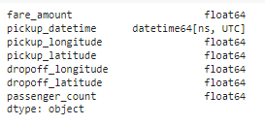

df = df.assign(hour = df.pickup_datetime.dt.hour,

day= df.pickup_datetime.dt.day,

month = df.pickup_datetime.dt.month,

year = df.pickup_datetime.dt.year,

dayofweek = df.pickup_datetime.dt.dayofweek)

df.drop('pickup_datetime',axis = 1,inplace = True)

df.head()

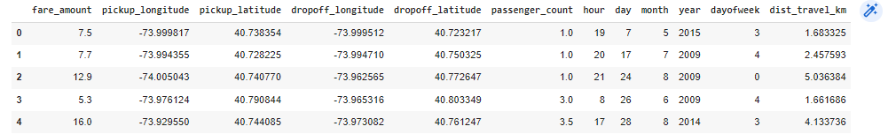

df.isnull().sum()

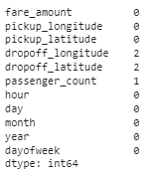

df['dropoff_latitude'].fillna(value=df['dropoff_latitude'].mean(),inplace = True)

df['dropoff_longitude'].fillna(value=df['dropoff_longitude'].median(),inplace = True)

df.isnull().sum()

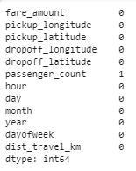

df.plot(kind = "box",subplots = True,layout = (7,2),figsize=(15,20))

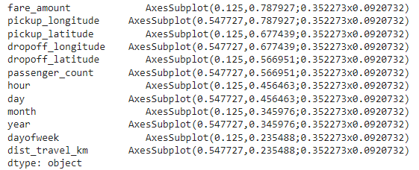

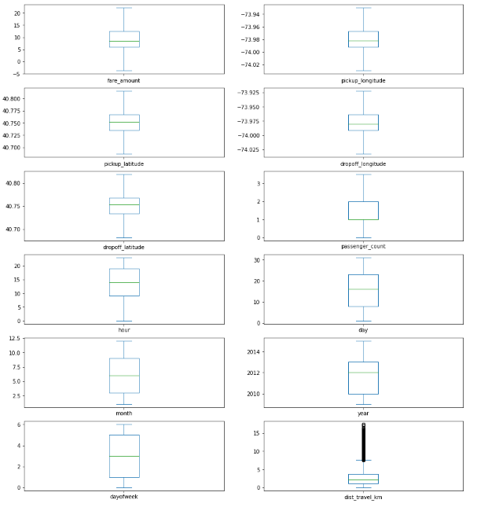

def remove_outlier(df1 , col):

Q1 = df1[col].quantile(0.25)

Q3 = df1[col].quantile(0.75)

IQR = Q3 - Q1

lower_whisker = Q1-1.5*IQR

upper_whisker = Q3+1.5*IQR

df[col] = np.clip(df1[col] , lower_whisker , upper_whisker)

return df1

def treat_outliers_all(df1 , col_list):

for c in col_list:

df1 = remove_outlier(df , c)

return df1

df = treat_outliers_all(df , df.iloc[: , 0::])

df.plot(kind = "box",subplots = True,layout = (7,2),figsize=(15,20))

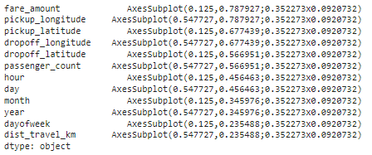

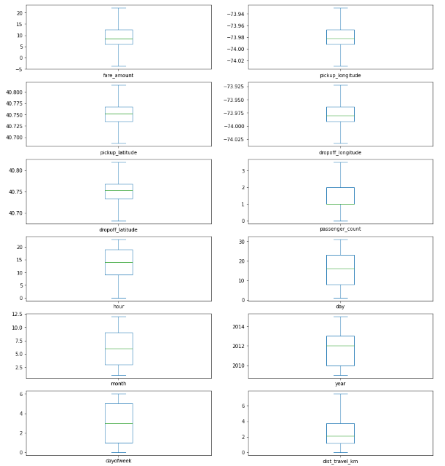

import haversine as hs

travel_dist = []

for pos in range(len(df['pickup_longitude'])):

long1,lati1,long2,lati2 = [df['pickup_longitude'][pos],df['pickup_latitude'][pos],df['dropoff_longitude'][pos],df['dropoff_latitude'][pos]]

loc1=(lati1,long1)

loc2=(lati2,long2)

c = hs.haversine(loc1,loc2)

travel_dist.append(c)

print(travel_dist)

df['dist_travel_km'] = travel_dist

df.head()

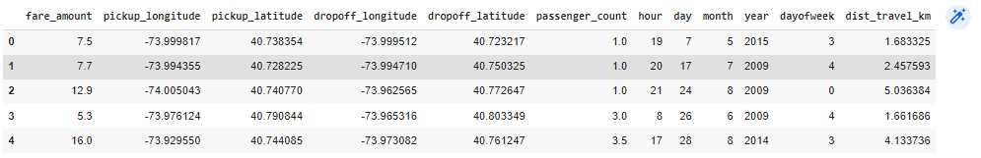

corr = df.corr()

corr

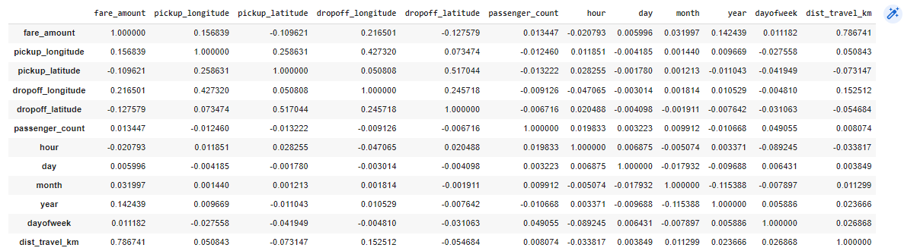

fig,axis = plt.subplots(figsize = (10,6))

sns.heatmap(df.corr(),annot = True)

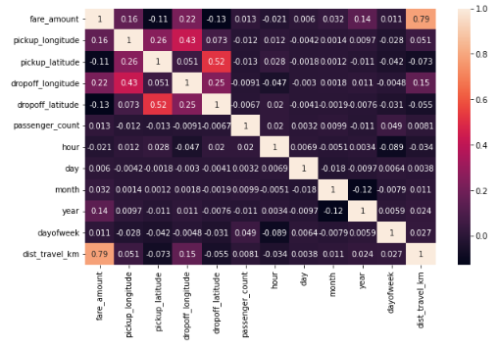

### Dividing the dataset into feature and target values

x = df[['pickup_longitude','pickup_latitude','dropoff_longitude','dropoff_latitude','passenger_count','hour','day','month','year','dayofweek','dist_travel_km']]

y = df['fare_amount']

### Dividing the dataset into training and testing dataset

from sklearn.model_selection import train_test_split

X_train,X_test,y_train,y_test = train_test_split(x,y,test_size = 0.33)

### Linear Regression

from sklearn.linear_model import LinearRegression

regression = LinearRegression()

regression.fit(X_train,y_train)



regression.intercept_ #To find the linear intercept



regression.coef_ #To find the linear coeeficient



prediction = regression.predict(X_test) #To predict the target values

print(prediction)



y_test

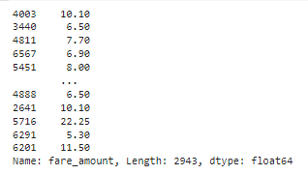

### Metrics Evaluation using R2, Mean Squared Error, Root Mean Squared Error

from sklearn.metrics import r2_score

r2_score(y_test,prediction)



from sklearn.metrics import mean_squared_error

MSE = mean_squared_error(y_test,prediction)

MSE



RMSE = np.sqrt(MSE)

RMSE



### Random Forest Regression

from sklearn.ensemble import RandomForestRegressor

rf = RandomForestRegressor(n_estimators=100) #Here n_estimators means number of trees you want to build before making the prediction

rf.fit(X_train,y_train)



y_pred = rf.predict(X_test)

y_pred



### Metrics evaluating for Random Forest

R2_Random = r2_score(y_test,y_pred)

R2_Random



MSE_Random = mean_squared_error(y_test,y_pred)

MSE_Random



RMSE_Random = np.sqrt(MSE_Random)

RMSE_Random

