**ML LAB ASSIGNMENT 2**

**Name:** Abhay Vijay Jagtap

**Class:** BE-B

**Problem Statement:**

Classify the email using the binary classification method. Email Spam detection has two states:

a) Normal State – Not Spam,

b) Abnormal State – Spam. Use K-Nearest Neighbors and Support Vector Machine for classification. Analyze their performance. Dataset link: The emails.csv dataset on the Kaggle <https://www.kaggle.com/datasets/balaka18/email-spam-classification-dataset-csv>

import pandas as pd

import numpy as np

import seaborn as sns

import matplotlib.pyplot as plt

%matplotlib inline

import warnings

warnings.filterwarnings('ignore')

from sklearn.model_selection import train_test_split

from sklearn.svm import SVC

from sklearn import metrics

df=pd.read_csv('/content/emails.csv')

df.head()

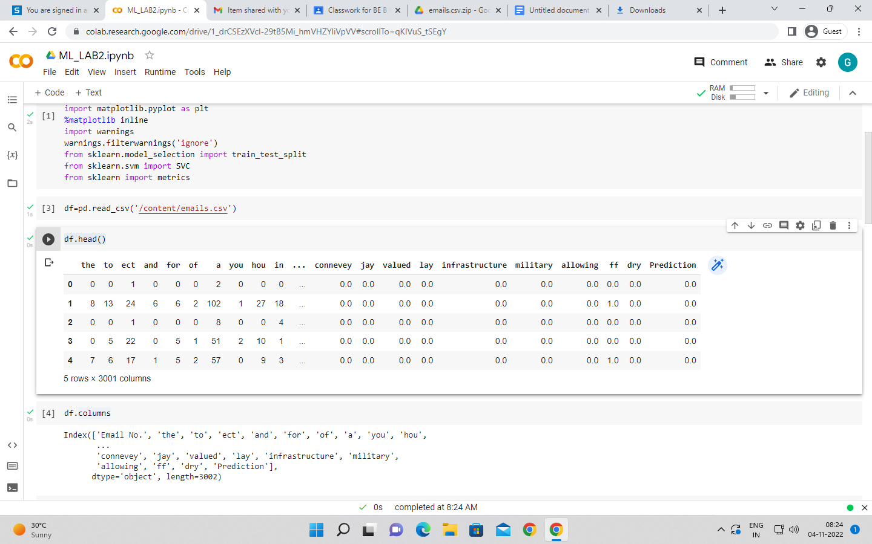

df.columns

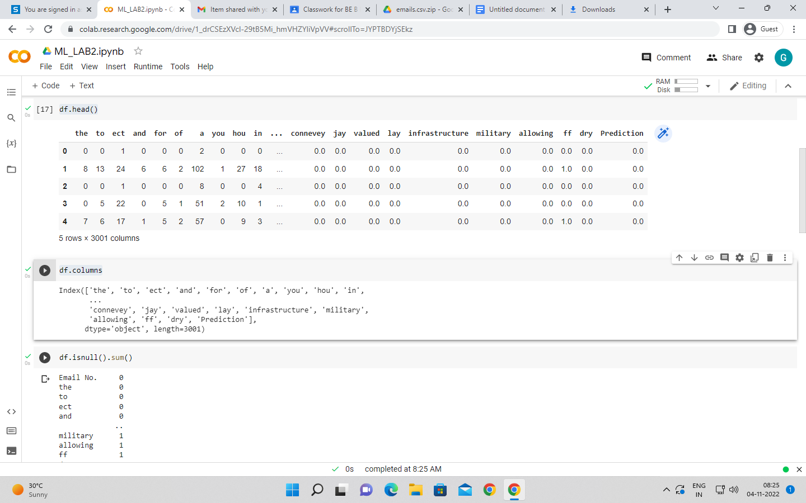

df.isnull().sum()

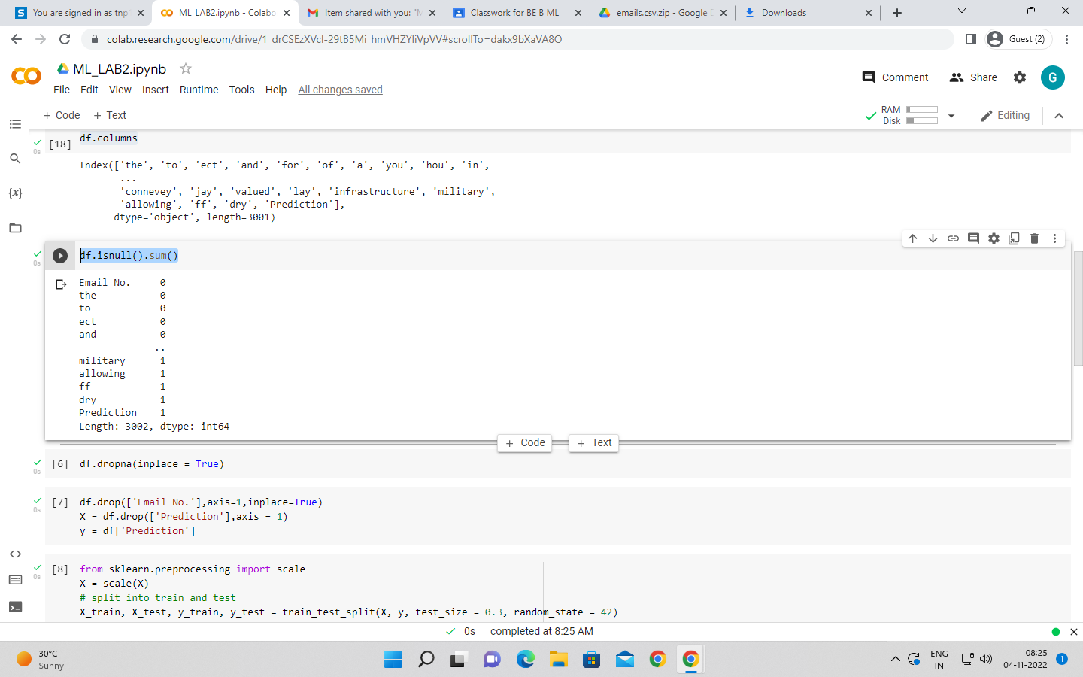

df.dropna(inplace = True)

df.drop(['Email No.'],axis=1,inplace=True)

X = df.drop(['Prediction'],axis = 1)

y = df['Prediction']

from sklearn.preprocessing import scale

X = scale(X)

# split into train and test

X_train, X_test, y_train, y_test = train_test_split(X, y, test_size = 0.3, random_state = 42)

## KNN classifier

from sklearn.neighbors import KNeighborsClassifier

knn = KNeighborsClassifier(n_neighbors=7)

knn.fit(X_train, y_train)

y_pred = knn.predict(X_test)

print("Prediction",y_pred)

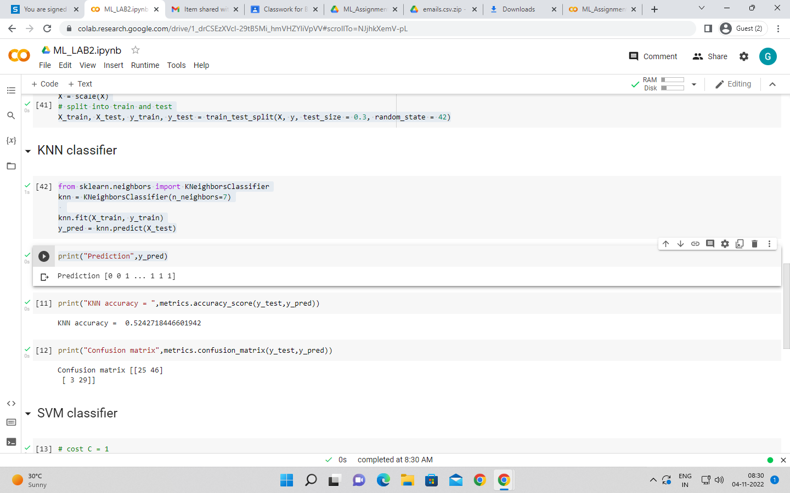

print("KNN accuracy = ",metrics.accuracy_score(y_test,y_pred))

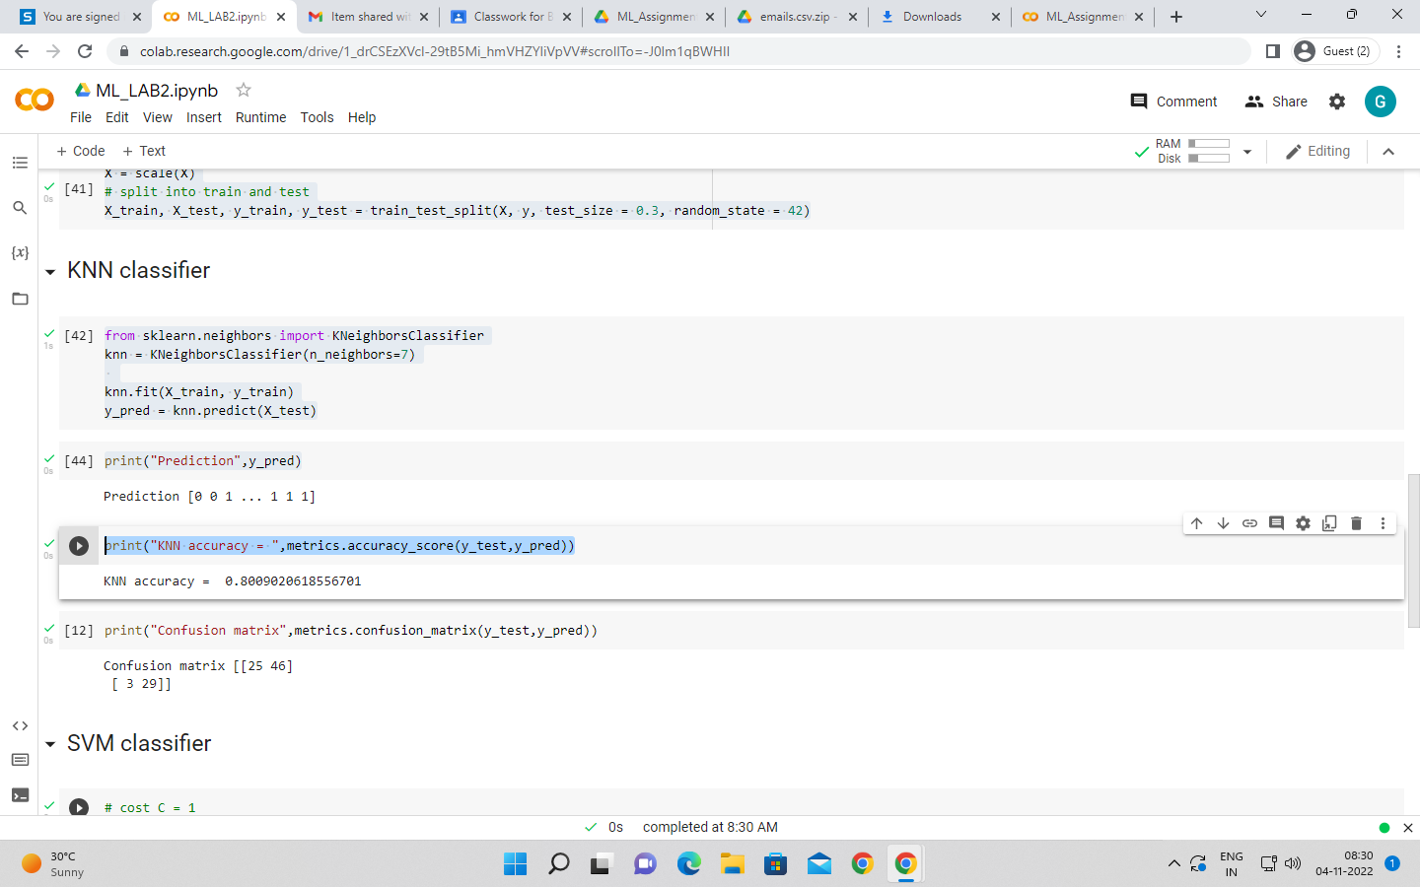

print("Confusion matrix",metrics.confusion_matrix(y_test,y_pred))

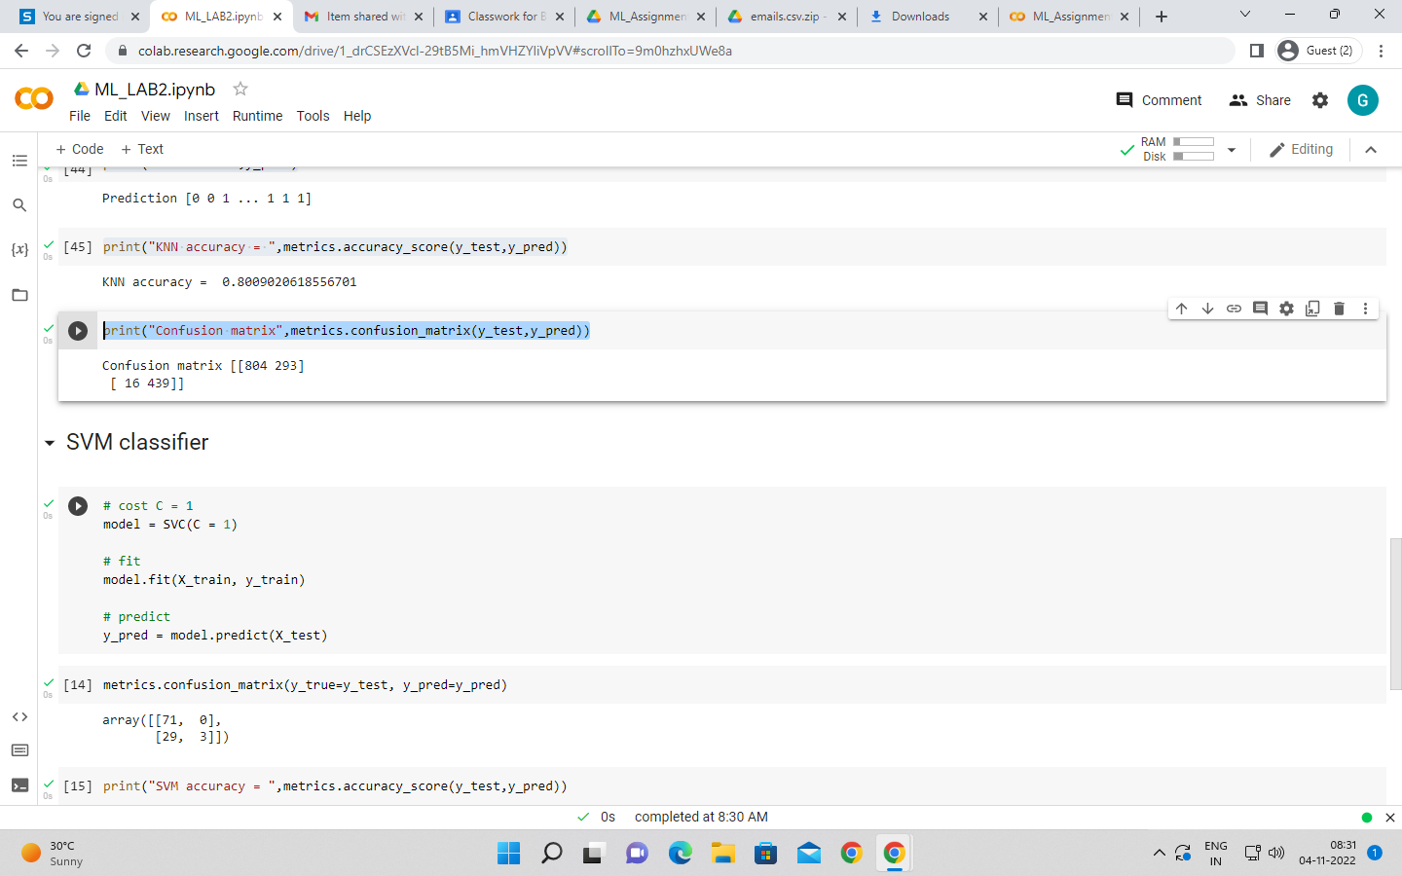

## SVM classifier

# cost C = 1

model = SVC(C = 1)

# fit

model.fit(X_train, y_train)

# predict

y_pred = model.predict(X_test)

metrics.confusion_matrix(y_true=y_test, y_pred=y_pred)

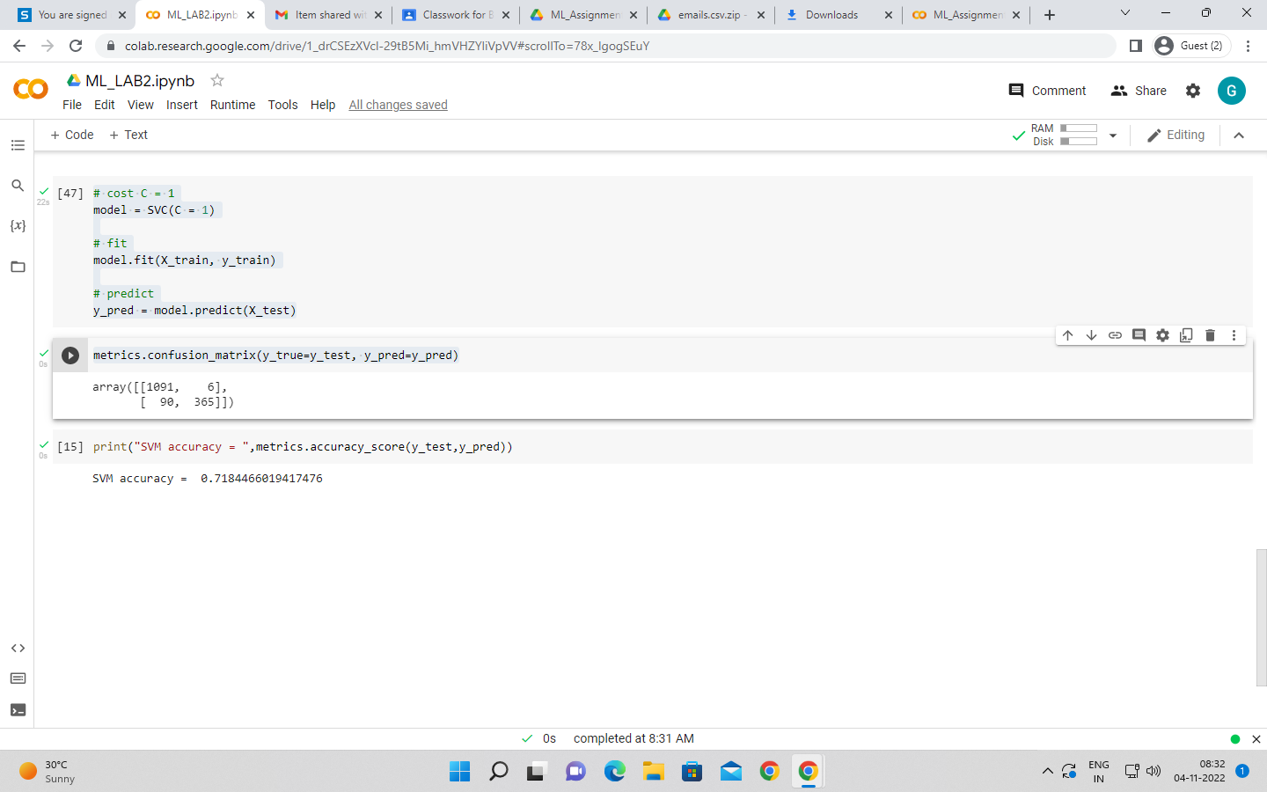

print("SVM accuracy = ",metrics.accuracy_score(y_test,y_pred))

