**ML LAB ASSIGNMENT 4**

**Name:** Abhay Vijay Jagtap

**Class:** BE-B

**Problem Statement:**

Implement Gradient Descent Algorithm to find the local minima of a function. For example, find the local minima of the function y=(x+3)² starting from the point x=2.

**Step 1 : Initialize parameters**

cur_x = 2 # The algorithm starts at x=3

rate = 0.01 # Learning rate

precision = 0.000001 #This tells us when to stop the algorithm

previous_step_size = 1 #

max_iters = 10000 # maximum number of iterations

iters = 0 #iteration counter

df = lambda x: 2*(x+3) #Gradient of our function

Step 2 : Run a loop to perform gradient descent

1. Stop loop when difference between x values from 2 consecutive iterations is less than 0.000001 or when number of iterations exceeds 10,000

while previous_step_size > precision and iters < max_iters:

prev_x = cur_x #Store current x value in prev_x

cur_x = cur_x - rate * df(prev_x) #Grad descent

previous_step_size = abs(cur_x - prev_x) #Change in x

iters = iters+1 #iteration count

print("Iteration ",iters,"\n X value is ",cur_x) #Print iterations

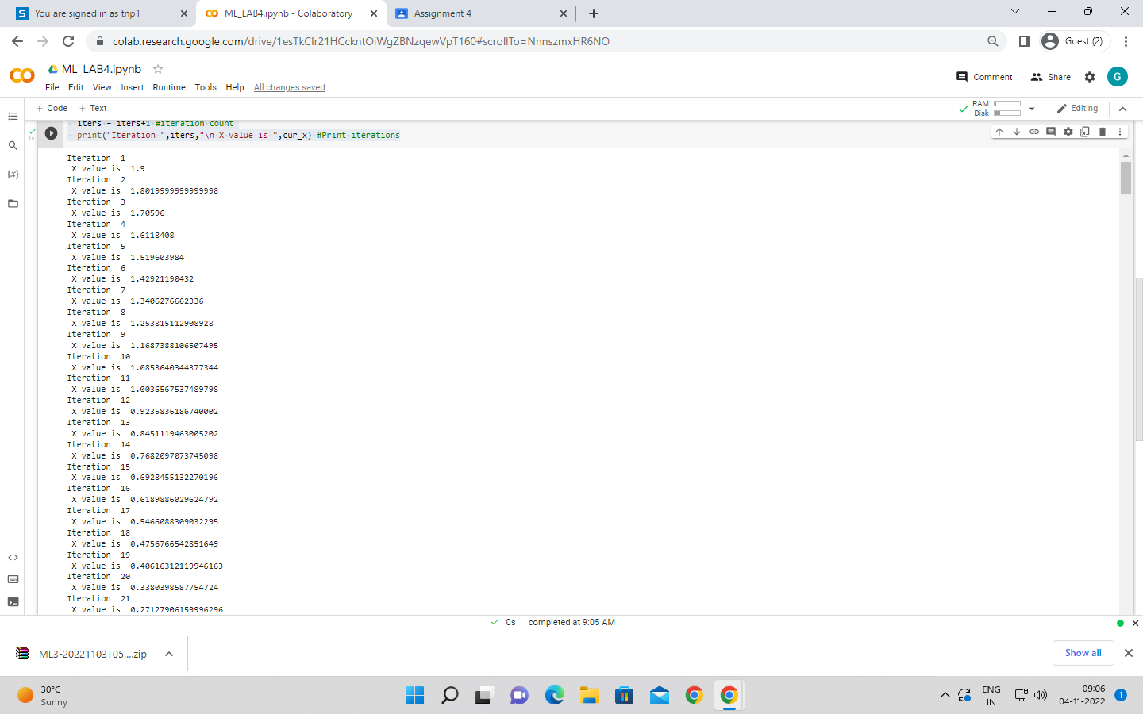

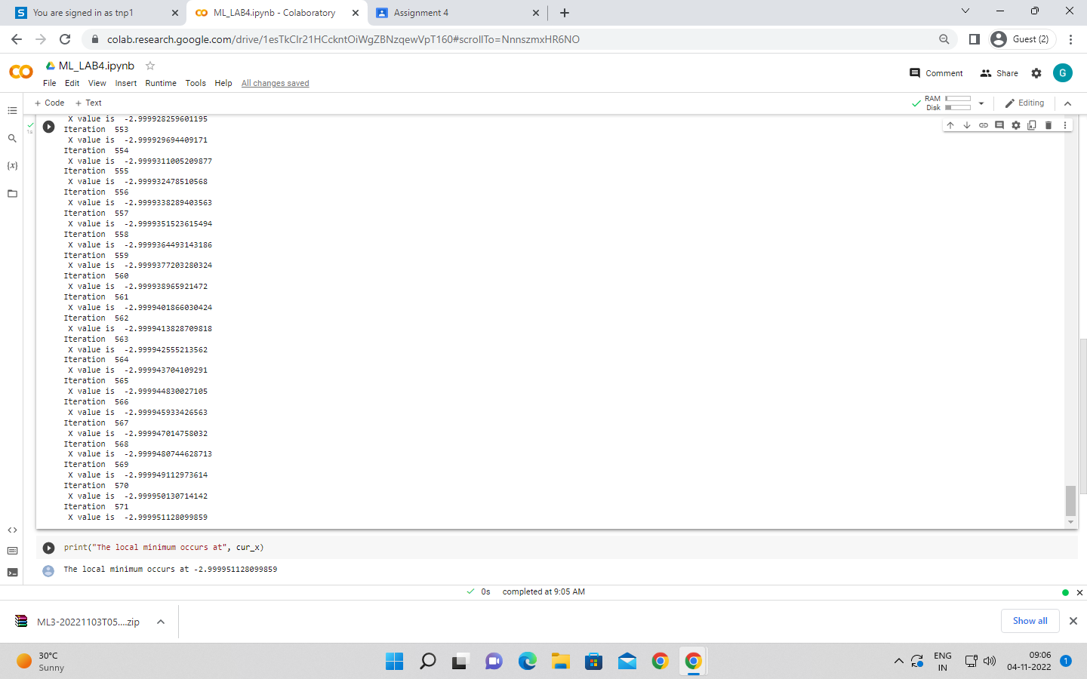

print("The local minimum occurs at", cur_x)

