**ML LAB ASSIGNMENT 5**

**Name:** Abhay Vijay Jagtap

**Class:** BE-B

**Problem Statement:**

Implement K-Nearest Neighbors algorithm on diabetes.csv dataset. Compute confusion matrix, accuracy, error rate, precision and recall on the given dataset.

Dataset link : <https://www.kaggle.com/datasets/abdallamahgoub/diabetes>

import pandas as pd

import numpy as np

import seaborn as sns

import matplotlib.pyplot as plt

%matplotlib inline

import warnings

warnings.filterwarnings('ignore')

from sklearn.model_selection import train_test_split

from sklearn.svm import SVC

from sklearn import metrics

df=pd.read_csv('/content/diabetes.csv')

df.columns

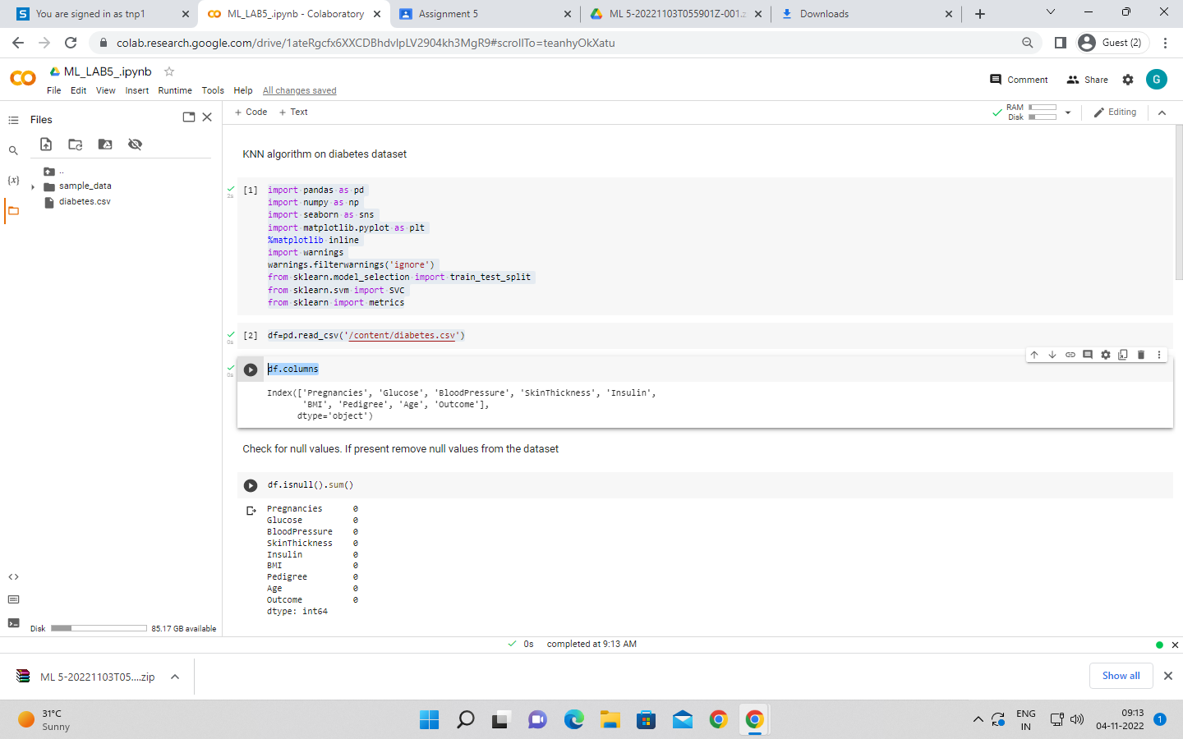

Check for null values. If present remove null values from the dataset

df.isnull().sum()

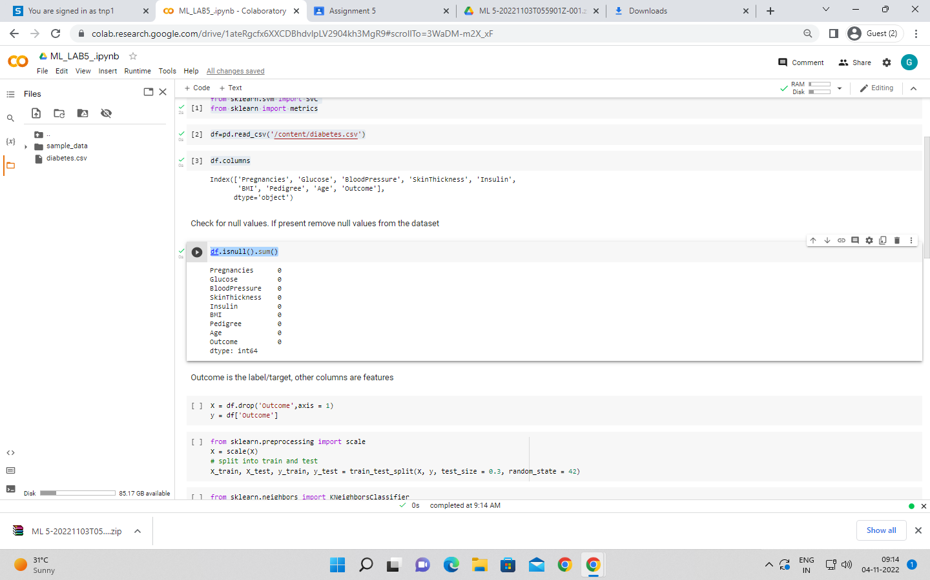

Outcome is the label/target, other columns are features

X = df.drop('Outcome',axis = 1)

y = df['Outcome']

from sklearn.preprocessing import scale

X = scale(X)

# split into train and test

X_train, X_test, y_train, y_test = train_test_split(X, y, test_size = 0.3, random_state = 42)

from sklearn.neighbors import KNeighborsClassifier

knn = KNeighborsClassifier(n_neighbors=7)

knn.fit(X_train, y_train)

y_pred = knn.predict(X_test)

print("Confusion matrix: ")

cs = metrics.confusion_matrix(y_test,y_pred)

print(cs)

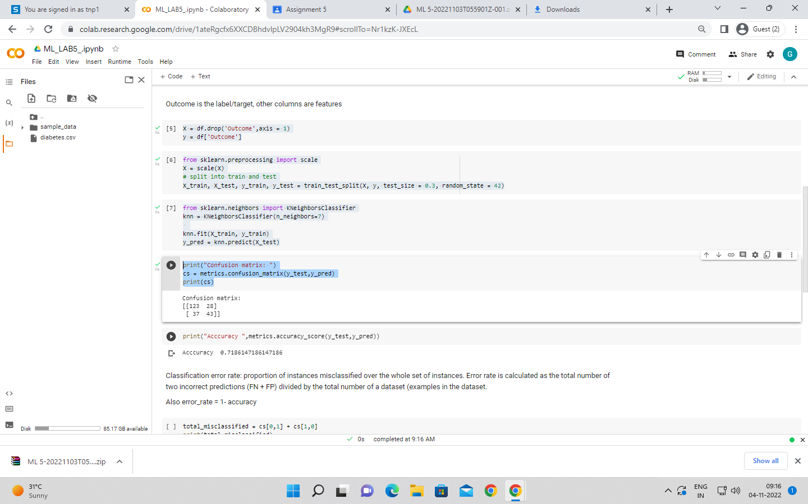

print("Acccuracy ",metrics.accuracy_score(y_test,y_pred))

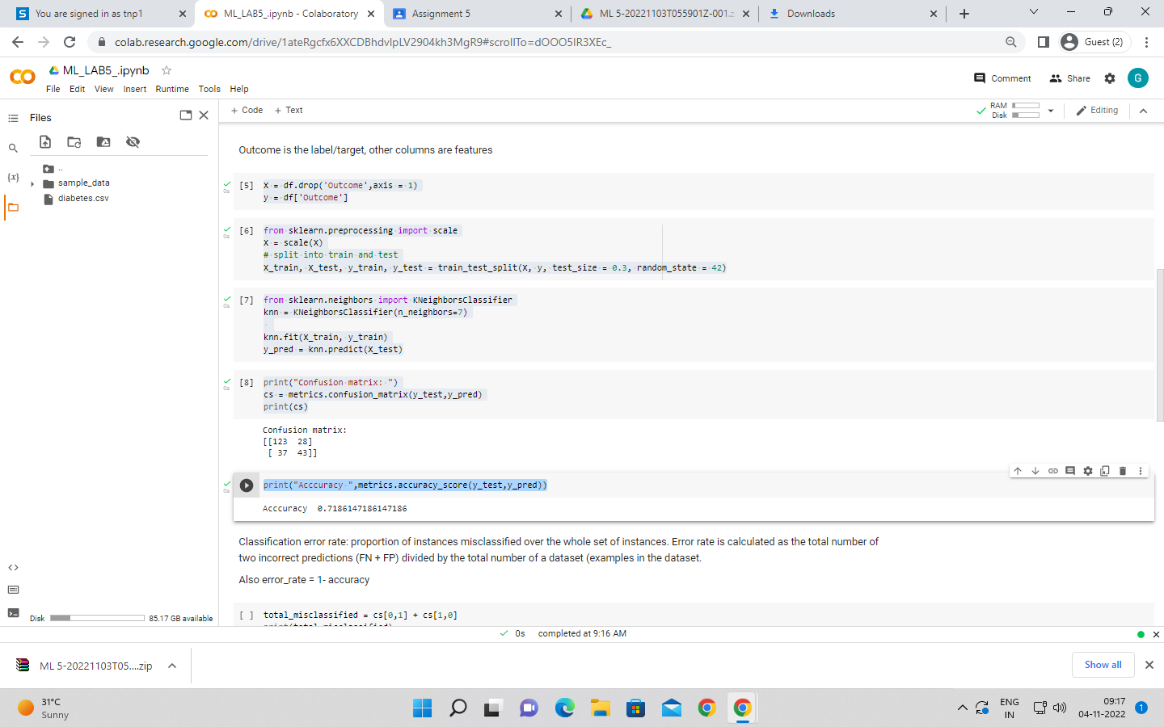

total_misclassified = cs[0,1] + cs[1,0]

print(total_misclassified)

total_examples = cs[0,0]+cs[0,1]+cs[1,0]+cs[1,1]

print(total_examples)

print("Error rate",total_misclassified/total_examples)

print("Error rate ",1-metrics.accuracy_score(y_test,y_pred))

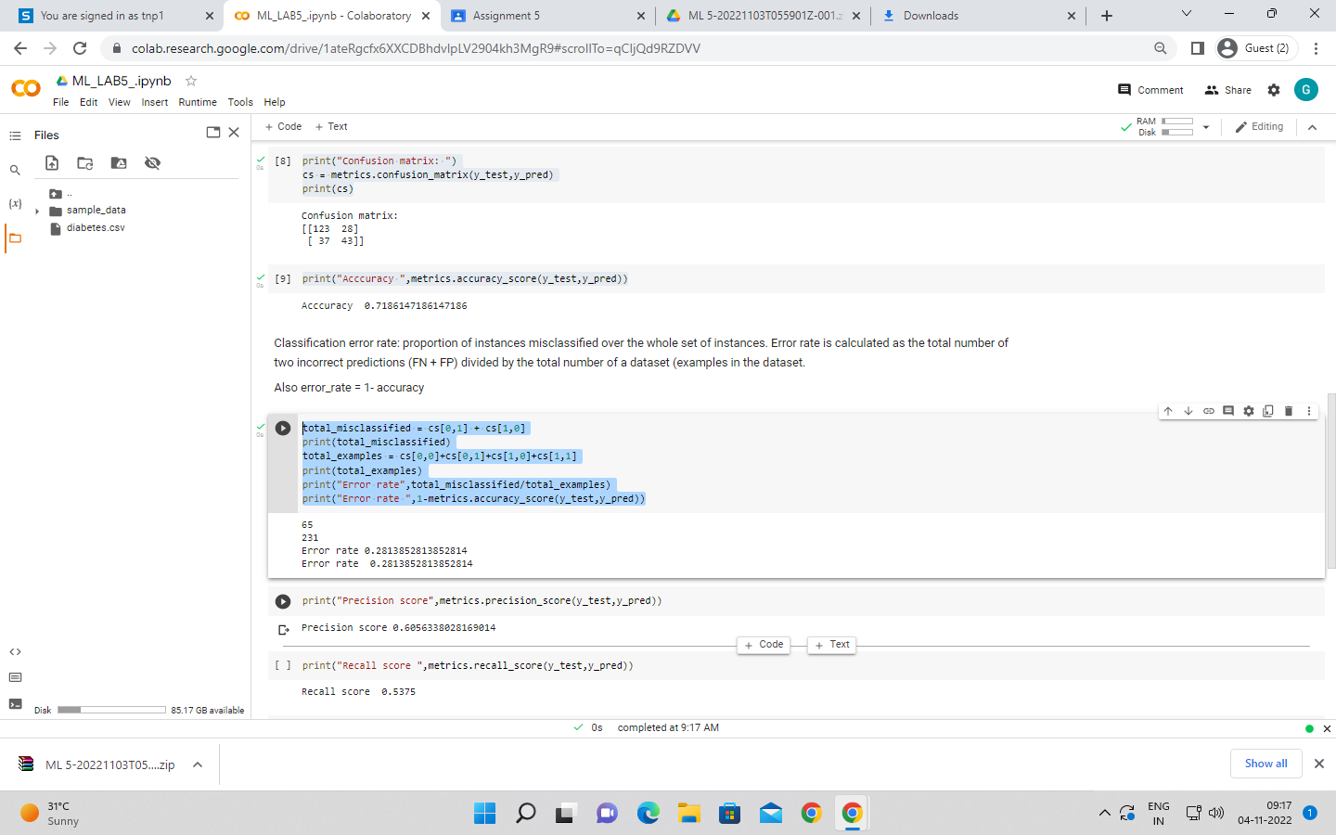

print("Precision score",metrics.precision_score(y_test,y_pred))

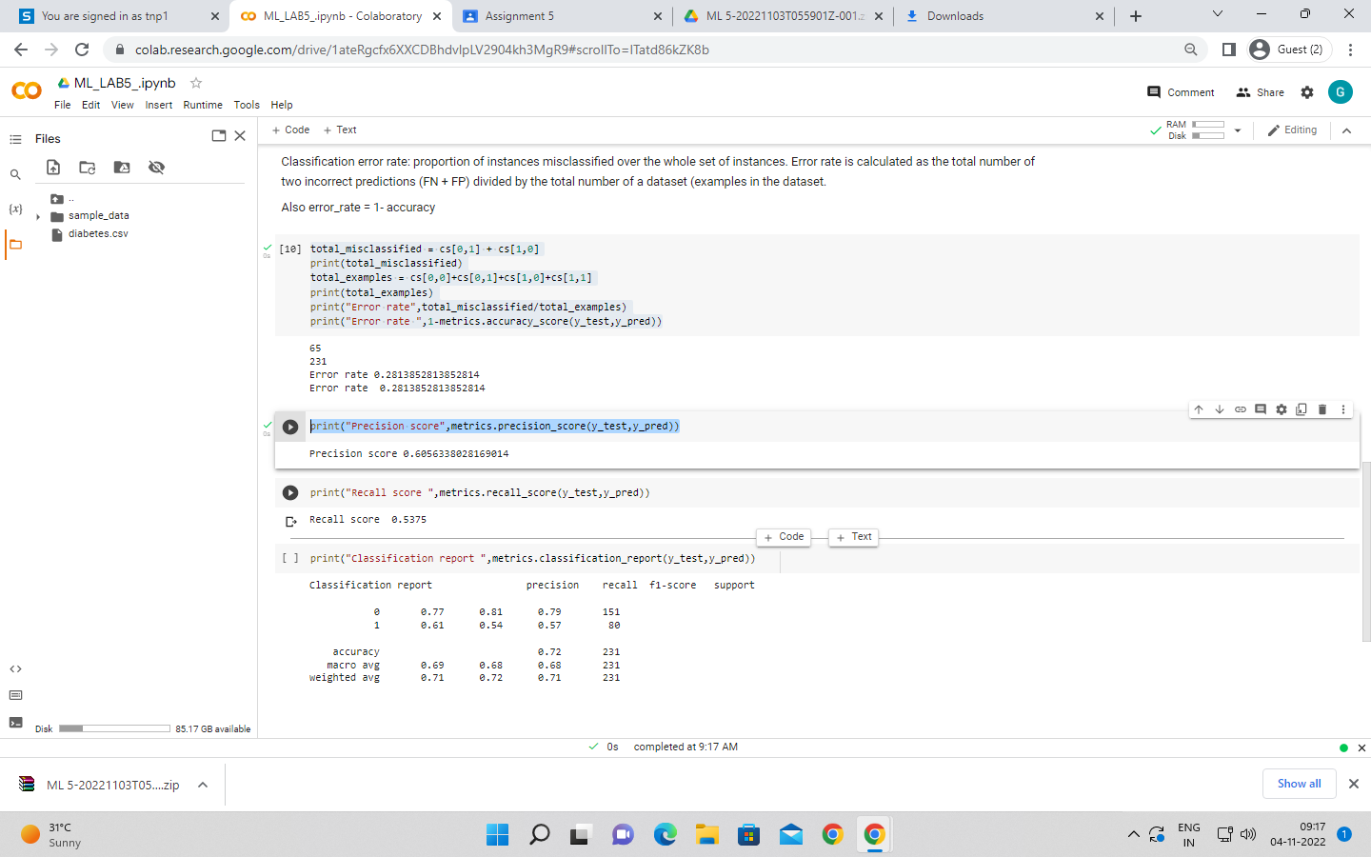

print("Recall score ",metrics.recall_score(y_test,y_pred))

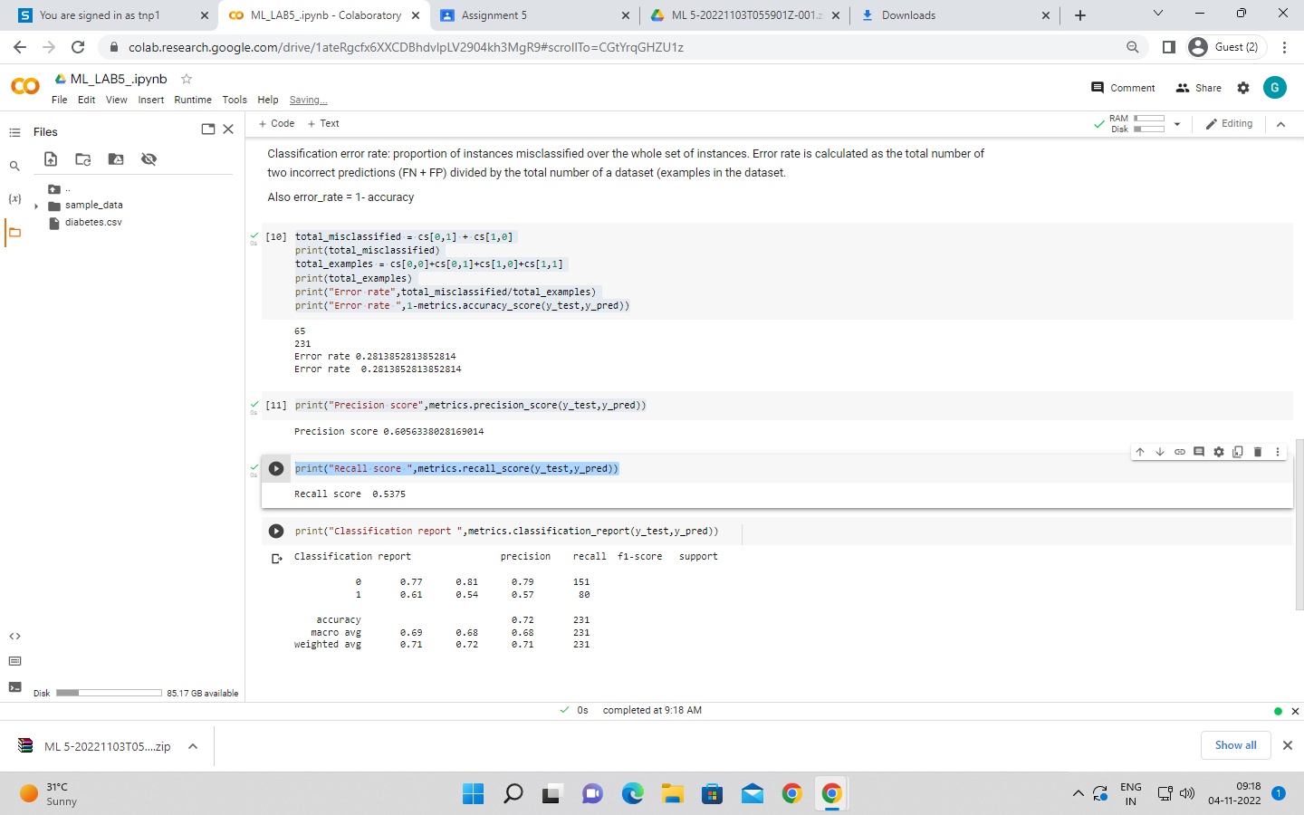

print("Classification report ",metrics.classification_report(y_test,y_pred))

