

**Electronic Signature of Documents using OTP via Email and SMS**

Summary

1. Introduction
2. Proposed Solution
3. Design and Architecture
4. Implementation Plan
5. Use Case
6. Benefits and Advantages
7. Conclusion

Introduction

The current document signing process is slow, inconvenient, and environmentally damaging. Physical documents require printing, scanning, and transportation, wasting time, resources, and contributing to deforestation. Additionally, paper-based systems are prone to loss, damage, and lack audit trails for compliance purposes.

A solution is to use electronic signature that eliminates the need for paper and streamlines the document signing process. Utilizing one-time passwords (OTPs) delivered via email and SMS, this system provides a secure and convenient way to sign documents electronically, regardless of location.

Proposed Solution

Electronic Signature System is a user-friendly electronic signature system that leverages OTP verification via email and SMS.

* Features and Functionalities:
* Intuitive User Interface: Upload documents, add recipients, manage signing workflows, and view audit trails with ease.
* Multiple Signature Capture Methods: Choose from typing, drawing, or uploading scanned images for a personalized signing experience.
* Secure OTP Authentication: Email and SMS verification ensures only authorized individuals can access and sign documents.
* Real-Time Tracking: Stay informed with instant updates on document status and completion progress.

- Comprehensive Audit Trail: Maintain a detailed record of all document activity for enhanced transparency and compliance.

- Cloud-Based Accessibility: Access and sign documents from any device, anywhere in the world.

Design and Architecture: A Robust and Secure Foundation

This electronic signature system will be built on a modern, robust infrastructure, providing a smooth experience and unparalleled security.

• Frontend:

- Built with a user-friendly JavaScript framework like React or Angular, which provides a responsive and intuitive user interface.

- Provides seamless communication for posting documents, adding recipients, managing signature workflows, and viewing audit trails.

• Backend:

- Powered by Node.js and Express framework, it provides a scalable and efficient backend infrastructure.

- Uses the flexible MongoDB database to store documents, user accounts, OTPs, and simple accounting methods.

- Uses Mongoose for smooth integration with MongoDB, simplifying data management and recovery.

• Security:

- Uses secure communication protocols such as HTTPS and JWT authentication to ensure data privacy and integrity.

- Integrates email and SMS functionality for OTP delivery with security and user authentication.

- Implements strong security measures such as encryption and access control to protect sensitive information.

• Signature capture:

- Use libraries such as Signature Pad to capture signatures electronically using a variety of methods, including typing, downloading and uploading scanned images

- Seamlessly integrates handwriting capture into the document signing process for a smooth user experience.

• Other Technologies:

- Use manipulation libraries like pdf-lib for PDF and docx for Microsoft DOCX to easily merge charts in documents

- Uses cloud-based infrastructure for scalability and global accessibility.

Implementation Plan

- Phase 1 : UI development focusing on document uploading, recipient management, signature processing, audit trail management.

- Phase 2 : Create backend API and integrate MongoDB database. Create API endpoints for basic functionality.

- Phase 3 : Implement OTP services via email and SMS, integrate secure communication protocols, and implement user access.

- Phase 4 : Securely integrate signatures and documents by joining signatures using libraries such as Signature Pad.

- Phase 5: Develop and implement detailed audit procedures. Conduct comprehensive tests for functionality, safety, and performance.

- Phase 6 : Deploy the application to the cloud platform, configure email and SMS services, create user guides, and launch the solution.

Use Case

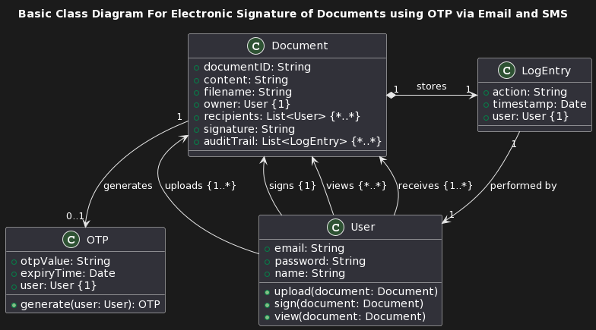

Benefits and Advantages

• Improved performance:

- Sign documents instantly regardless of location, eliminating time-consuming delays.

- Improve workflow by eliminating manual control for increased productivity.

- Strengthen responsiveness and decision-making through faster document completion times.

• Also Inadequate Security:

- Secure OTP authentication ensures that only authorized individuals can access and sign documents.

- Strong encryption protects sensitive information and maintains data integrity.

- Accurate accounting methods will provide insight and accurate accountability.

• Cost efficiency:

- Eliminates printing, scanning and courier costs associated with paper signatures.

- Reduce storage requirements and operating costs.

- Increase operational efficiency by improving resource utilization.

• Environmental Sustainability:

- Eliminates paper waste and contributes to a greener planet.

- Reduce carbon footprint by eliminating unnecessary transportation and mail transport.

- Encourage environmentally friendly practices in your organization.

Conclusion

The proposed electronic signature system provides a solution to the inefficiencies and security concerns of the old document signature system. This new platform provides an easy, secure and efficient way to manage your documents and speed up the signing process.