Copyright (C) 2016 Sebastian Samaruga.  
 Permission is granted to copy, distribute and/or modify this document under the terms of the GNU Free Documentation License Version 1.3 or any later version published by the Free Software Foundation; with no Invariant Sections, no Front-Cover Texts, and no Back-Cover Texts.  
 A copy of the license is included in the section entitled "GNU Free Documentation License".

## Abstract:

As far as I know, RDF / RDF(S) or OWL are not currently widely adopted in the enterprise, at least in the pervasive manner I think they should, in favor of more traditional methods of information storage and retrieval such as RDBMSs and, also, NoSQL datastores. This seems like the benefits of 'semantic' datastores are only visible to a selected group, seen like kind of 'gurus' by ‘relational’ guys, and that no mortal will be able, or even needing, to take advantage of SW at all. This is sad because I consider SW as *the* ideal platform for Big / Linked Data business and integration endeavors.

There must be a better way than an 'all or nothing' approach where one paradigm takes over another. Simple CRUD/ERP, BI and even Enterprise Application Integration (ESB) problems currently lack of 'ontologies' in favor of 'schemas' or interfaces when the former could be of great help when managed from the governance perspective of an organization.

Having a 'kind' of semantic repository, which is aware of all 'triples' the integrated systems 'produce' (Adapters), has previous knowledge of the 'world' (augmented/loaded with domain ontologies), performs type inference, ontology merge and alignment, resolves inferred links from new knowledge and aggregates this knowledge into layers: from raw data to symbolic statements to (inferred) behavior statements, may be the foundation (via a functional API) of a Master Data Management (MDM) like 'semantic' component.

Component that has a Protocol to which Adapters (datasource drivers) and Ports (application endpoints) communicate through enterprise integration mechanisms (ESB) and provides ‘seamless’ MDM and governance through its interfaces easily augmenting ‘semantically’ an organization processes.

Proposed implementation details of the component discussed below involve many low level concepts which are specific to this attempt of data integration and are not necessary 'orthodox' SW practices. In the end, the component offers a set of adapters/datasources, ports/endpoints for different protocols/services with similar semantics so it can be used by many clients as possible as a 'MDM Hub'.

Alignment to an ‘upper’ ontology which could map our knowledge with well known vocabularies (i.e.: ISO15926) is a possibility by the means of a ‘OWL Runtime’ and a little bit of extra API to make it available to popular semantic tools. One of the features introduced in this implementation is the notion of a resource having many types as it occur in different places so this runtime shall allow for a ‘standard’ view of the knowledge stored.

## Scope

Build an elemental repository component of semantically augmented data, information and knowledge for business applications data backend. Includes temporal analysis features for BI like applications.

RDF Backed: multiple data sources/formats translated to Triples by Adapters (Drivers for RDF import/sync). Knowledge database features.

Distributed 'peers' support for instances sharing of knowledge. Data coming from different sources in the form of raw triples without a schema will be classified, linked and merged (if they refer to the same subjects).

Type inference. Alignment & merge of different (imported) ontologies. Relationships & link discovery (reasoning). Augmentation of source knowledge.

Raw categorized data to be aggregated into facts, information (semiotically) and knowledge (behavior) metamodel levels. Rules (productions), Events and Flows (state) inference for declarative building of application logic at behavior level.

Set oriented metamodel layers abstraction for resource aggregation. Temporal contexts for statements. Eventual & logical order. Functional programming interface for models. 'Ports' for interfacing via known protocols with the knowledge base.

BI and Linked Data enabled platform at semantic knowledge backend level: The above mentioned features could make the concepts of the framework a solid backend for this kind of applications, suitable for flexible, platform independent, middle and presentation tiers implementations. This solution and the ability to merge diverse datasources/formats and to provide uniform interfaces are advantageous at the time to decide for a specific backend or narrow to a RDF only solution.

Introduction

The framework proposed here is not a ‘pure’ semantic web application framework in its strict sense but is more a workaround for implementing a functional programming / protocol frontend backed with set theory reasoning for type inference and ontology alignment and merge of diverse knowledge bases. It also attempts to provide a unified interface for data (facts), information (signs) and knowledge (behavior) SPO metamodels for load, query and manipulation of those entities in a functional and declarative fashion.

This is to be accomplished with the development of a component, named ‘MDM Hub’ with features akin to a relational database ones, in the sense that it is a ‘low level’ storage component but with the semantics and reasoning perspective of the Semantic Web (and its corresponding interfaces).

## Resources, Sets

For the sake of our attempt in modelling semantic/semiotic structures (semantics are a branch of semiotics that deals with signs and the objects they refer), all three layers of (meta)models which deal with triples are represented with instances of Resource(s) which are arranged in a pseudo (multi)set structure.

The first level: data (facts) deals with ‘pure’ source RDF CSPO statements. It corresponds with the management of ‘signs’ (SPOs URIs) and the semiotics branch of ‘syntax’ (the study of signs and their relationships).

The second level: information (objects, signs and concepts) adds a ‘meaning’ layer to previous pure signs, treating them all (SPOs of the previous level) as a single statement triple (here named Topic) part, its Object. It also treats previous level Triples and Kinds as its Subject and Predicate, respectively, in its Topic triples (more on Kinds and how to use them below). This resembles more accurately what ‘semantic’ means in a semiotic context.

The third level: knowledge (behavior) aggregates the previous level in the same manner than information level did with data level. Roughly this level will correspond with semiotics branch ‘pragmatics’. The intention here is to infer as much as possible ‘state’ knowledge regarding the occurrence of events, the application of some rule or the conditions of some workflow.

The Sets section depicts graphically in pseudo multiset diagram what has been told here. The following diagram shows the Resource hierachy in pseudo UML for graphical purposes.

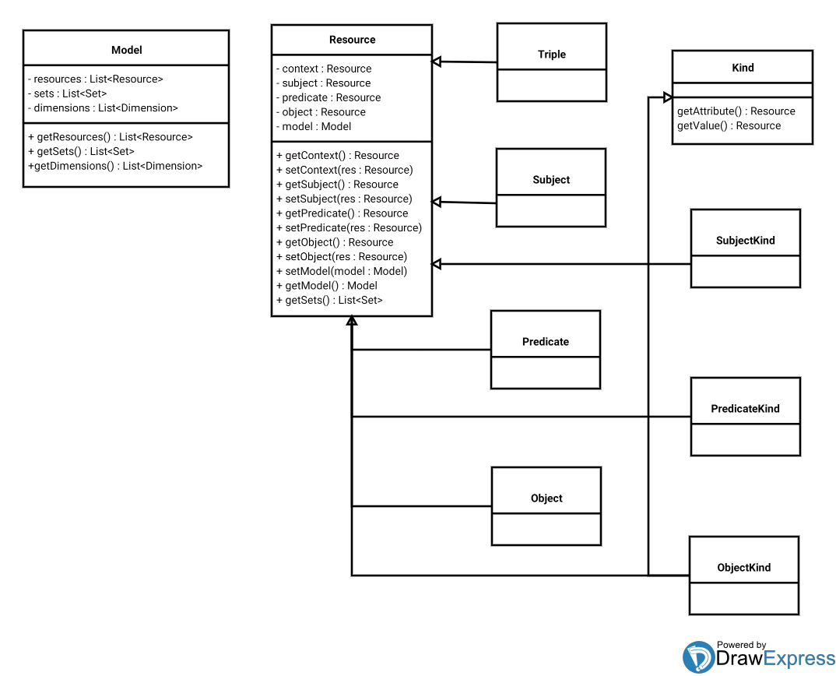

A Resource has an URI and this URI may play multiple occurrences in multiple Resource(s). A Resource may play many roles. It reifies another Resource(s) as its own CSPOs (it’s a quad). The roles a Resource may play are: Triple, Subject, Predicate, Object and their corresponding Kind(s).

Kind(s) are the ‘type information’ collected from the triples an SPO occurs in. A Kind have ‘attribute’ and ‘value’ fields corresponding to which part of a statement they classify. For example, a SubjectKind aggregates grouping by same Predicate attributes and then by same Object values to group the Kind instance into a ‘class’ (same Predicates) and a ‘metaclass’ (same class, same Object(s)). The same is for Predicate and Object Kind(s), changing their corresponding attributes and values from the statements they occur.

Classes and metaclasses, Kinds, are (reified) Resources (Set predicates: TBD) and have their own URIs (hierarchical: set/superset attrs/vals). For example, the SubjectKind for employees have a Subject reifying itself (and all the Employee set). Same Kind (class and metaclass) have multiple occurrence elements in its Kind set corresponding to the attributes/values they aggregates. To obtain a, for example, SubjectKind for a Subject in a given triple look for the corresponding attributes and values of the Subject’s Triple in the kinds set.

Encode Kind metadata in SPOs. TBD.

In sets sense, a SubjectKind can be considered as being in the intersection of the Predicate and Object sets because it has the corresponding attribute and value fields populated. TBD.

Kind’s Resource encoding allows to reify all its metadata, attributes and values using the context for the metaclass URI (more on contexts and triples: TBD) and the SPO part that would be, ie.: S for a SubjectKind, for the class URI. For being able to look for Kind information: retrieve attributes and values from triples with Resource occurring and then look up for corresponding matching Kind(s).

Metamodel layers: aggregated sets (ie.: SPO) into one level set (ie.: Signs): reify SPOs in Object part of Sign's Resource. Idem for Kinds/Concepts (Predicate) and Triples/Objects (Subject). TBD.

**Resource instantiation:**

When a (meta)model layer receives a set of triples it instantiates the corresponding triple Resource(s), it then de-aggregates the corresponding Kind(s) attribute/value instantiating Resource(s): PO Resources for SubjectKind, SO Resources for PredicateKind, SP Resources for ObjectKind. So, Kind(s) may be seen as the ‘intersection’ of the two complementary sets of a given one. Then it instantiates Resources for; Subject, Predicate and Object sets.

Evaluation of the Resources by the Sets API determines which Set each belongs to. In any level of the three models layers the behavior is the same. Sets in each level are given a different name to differentiate its purpose, meaning or usage. Another level(s) of model(s) could be added below or on top the ones here and those names will be ‘relative’ (SPO, OCS, TSP).

Name resolution API: An API should be provided that resolves entity names (identifiers) in namespaces or contexts maybe resolving such name as a property or relative to another entity. Infer Kind names (Employee). Align and merge (if two names resolve to the same, recursively?) TBD.

ResourceIDs (introduced later) are a mean of constructing ‘semantically rich’ hash codes, basically for lookup optimization in the Services API mappings and grammars and Sets. They should allow to build (LISP like) expressions which addresses in simple or complex forms a Resource or set of Resources.

ResourceIDs will be the ‘selector’ syntax for functional operations discussed below. The Services mappings and grammars will be the (persistence-able) model and represents the same Resource data as the Set model.

## Sets

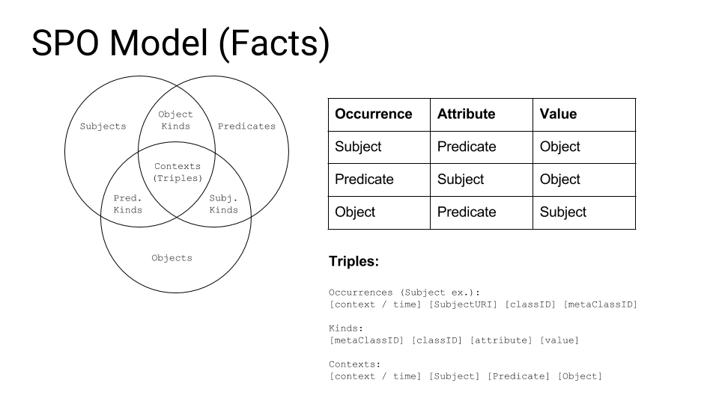

As discussed above, here is the data layer metamodel, with just sign triples (CSPO URIs). A sample statement could be:

(someNewsArticle, subject, climateChange)

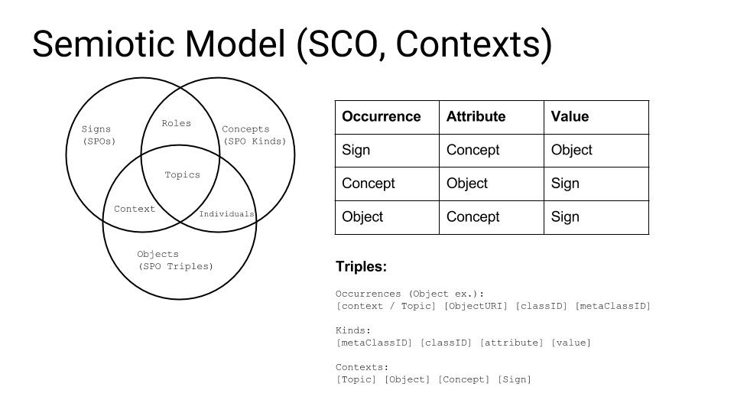

Here is the information layer metamodel. It adds a semantic (semiotic) refinement to previous triples. Aggregating data we could infer this information (Topic triple):

(someMedia, names, ecology)

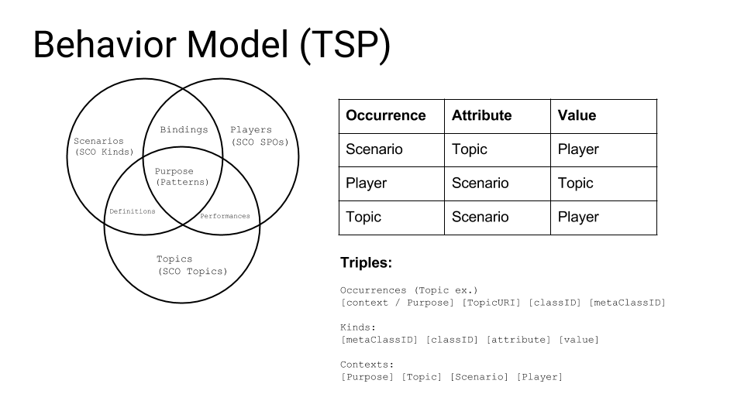

And the knowledge (behavior/pragmatics) model should show which state changes (or interactions) are taking place in our dataset. A sample triple (Purpose) would be:

(mention, mentions, mentionable)

**Events, Flows and Rules:**

According the type of predicate (Scenario) of a triple at this knowledge level there are three kind of possible Bindings:

For a SCO Role: Event Binding.

For a SCO Context: Rule Binding.

For a SCO Individual: Flow Binding.

Definition holds for possible Bindings state transition kinds. Performance holds for instances of given state transition executions.

Rule: A & B : C. C & D : cause(D, C).

(Fever & Cold : Flu. Flu & lowTemperature : cause(lowTemperature, aFlu).

Flow: A : B, C... according condition.

Given some Kind possible next Kinds.

Event: Employee : Promotion (good emp.). Identify / reify event and kind of event.

TSP Purpose statement contexts aggregates / sorts Rule's, Event's and Flow's instance triples temporally / logically.

**Service / Information Discovery**

Along as modelling typed kinds of behavior (classes and instances of such behaviors) encoded triples of this metamodel layer may provide information and services metadata and model the execution semantics of processes via retrieve-able invokable URIs (model resources, external services). For an internal process template triples for Protocol interaction are provided. Adapters keep in sync external resources.

**Metamodel layers Triple Kinds:**

Each level of metamodels have a Triple as the intersection of their SPOs. This Triple (quad) conveys a context which characterizes the Triple according its level purpose. For example a context/context instance for the three levels could be:

SPO: Organization / XYZ Corp (facts)

OCS: Department / Sales (info)

TSP: Buys / John Doe (knowledge)

The way of aggregating Triple Kinds is:

(Context) (SubjectKind / ‘metaclass1’) (PredicateKind / ‘class’) (ObjectKind / ‘metaclass2’)

Triples should be annotated with their corresponding Context(s), according their parts Kinds. Contexts are aggregated grouping by their classes, by metaclass1 and then by meteclass2.

To state Context Kind instances a statement should be like (for a Subject):

(Ctx) (S) (PredicateKind) (ObjectKind)

aggregated for a Subject, ie.: ‘XYZ Corp’, by P and then O.

A Subject statement should have in its context temporal information related to the occurrence of the statement.

For inter metamodel level context correlation aggregation should be made of the form:

(Ctx) (SPOCtx) (OCSCtx) (TSPCtx)

being contexts grouped by S, P, and O of this statement matching the contexts hierarchically.

**Ordering of triples and events:**

Temporal context of a given Subject occurrence (with its class and metaclass encoded as attribute / value for each Subject occurrence holds three aggregated temporal context with past, present and future temporal contexts. Subjects (and P, Os) have multiple occurrences in their sets according its kind information for a given (temporal) context.

In most example statements (quads) contexts are omitted. Quad contexts encode metaclass metadata for Kinds / SPOs and temporal metadata for Triples. The metaclass of a given resource occurs at a given point in time.

Time metadata should be encoded such as comparisons may shield an octal value as a result. Regarding an octal digit it can be represented by 3 binary digits, each one representing the comparison result for past, present, future and overlapping values of one statement respect to another.

Kinds reification as Resources. Bind any Kind type to any SPO type.

## Sets API

An uniform API should exist enabling sets definitions, population and manipulation for all three metamodel layer levels. Each set will be defined by a Predicate which determines if a Resource belongs or not to him. Previously, all types of Resource(s) must be de-aggregated from the level input triples.

Level(s) input triples shall be meaningfully aggregated/created from previous level entities. Operations over (inter) level sets will be those of traditional set operations, plus operations enabling to ‘join’ or navigate related set elements (Subject - Triples - SubjectKinds).

## Services / OWL Runtime

Services API is the core component for model persistence and provides mappings and grammars for ease of Functional API implementation, along with Sets API and ResourceIDs.

The mappings provided are: Index, Naming and Registry. They resemble functions (maps) which returns an entity given two other entities of the other types. The types mapped are: URIs, Kind(s) and Triples. There is how the functions look like:

Index(URI, Triple) : Kind

Naming(Triple, Kind) : URI

Registry(Kind, URI) : Triple(s).

A grammar is a description of a (set of) Resource(s). It will be implemented with ResourceIDs ‘selectors’ and will be populated with ‘automata’ like inferencing.

Equivalent grammars should represent equivalent resources so they should be merged if name resolution (discussed above) yields equivalent names for equivalent relationships.

Peers Hubs may perform distributed resolution and merge. Selectors (ResourceIDs) may have a textual syntax and a forms-like serialization. The can be used as (dynamic) dataflow placeholders (Protocol dialog) if implemented as Resources.

An OWL upper ontology will be developed for alignment with existing/new vocabularies and ontologies (for example ISO15926). An endpoint (Port) shall be provided for interaction with this view of the store.

## Functional API

Listeners for behavior (Events, Rules, Flows). TBD.

Selectors: Map, iterate, aggregate, query, traversal. TBD.

Bound functions. Monads. CoSQL. TBD.

Monads: Element<Resource> (for each Resource type).

Bound functions (query): (Element<Resource>) :

list(ctx). previous(ctxt). current(ctx). next(ctx). parent(ctx). child(ctx). kind(ctx). triples(ctx). subjects(ctx). predicates(ctx). objects(ctx).

Bound functions (transform):

Apply Data layer bindings.

Apply Information layer bindings.

Apply Behavior layer bindings.

Function contexts: Parameters, Element(s), selectors (ResourceIDs).

Monad components:

Type ctor<T> : public M<T> : M<T>.

Unit cun<T>(val : T) : M<T>.

Val fun<T>(v : M<T>) : T

Bind<T, U>(inst : M<T>, transform(val : T) : M<U>) : M<U> (bound functions).

## ResourceIDs (TBD)

TBD: Use functional expressions as mask / selector.

Example ResourceID:

(Context, SubjectKind, PredicateKind, ObjectKind).

Kinds: class / metaclass: attribute / value are recursive Kinds (a SK and a OK for a PK, equiv for SKs & PKs).

Context: Grammars metamodels (contexts, topics, purposes).

Dataflow: (ordered sets of)

SKs: Flows.

PKs: Rules.

OKs: Events.

Resources have URIs as their textual/retrieveable identifiers. But, internally, they should have an encoded (binary) string as a ‘semantic’ identifier which holds their occurrences, kinds and other information about the Resource in a parse-able manner. The identifier is ‘dynamic’ in the sense that is calculated from Resource’s context and members.

This identifiers will be used by ResourceIDs (masks for the binary string, ‘selectors’) for matching of given Resources. They also will provide for inter metamodel levels expressions, traversal. Encoding of binary string: TBD.

A ResourceID is a ‘semantically rich’ hash code. It serves as a ‘selector’ for Resources and have a LISP like form of declaration.

ResourceID form: TBD

ResourceID : ([TripleID, ResourceID pattern | TripleID mask])*;

The right part of the expression is a (variable) input and the TripleID is the context in which to evaluate the output of the expression. Forms can be complex with sub forms at the tail of the expression.

The intention is to use the statements component identifiers (CSPO, in binary form) to create a binary mask that will hold true for the desired output applying it as a filter for model resources.

**ResourceID expressions**

A resource can match to one or more resource expressions concatenated in the form:

(ResultAggregate, SourceAggregate) (LHSJoinMask, RHSJoinMask) (Mask, InputMask)

(ie.: for mapred like tasks. TBD.)

where each of the expression parts are ResourceIDs having their input on its right and their outputs on their left sides. The intention here is to define an aggregation task only by using selectors. TBD.

Grammars, of Services component, are implemented through ResourceIDs. The IDs are inferred from existing resources and similar resources will hold for selection of this given grammar.

TripleIDs and patterns/mask are composed together using the binary OR of its parts and the resulting mask applied to an (ordered) set of IDs resulting in the selection of matching instances.

## Align and merge / Inference

Relationship (links) inference example: X coworker Y (same employer). Develop discover algorithms. Infer link types (grammars). Use Kinds, classes, metaclasses (Kinds) relations. TBD.

Infer attributes / rels from class (emp, sal, dept, manager) from links. Mgr. is emp's dept. leader. TBD.

Infer type by contents: Occurrence having other Kinds in other contexts. Grammar (abstract) occurrences of subject, context merge. Sort Kinds: Grammar hiers (parent). Adult - CanDrive. Employee must be Person & Student. ResourceIDs. Phone number has area code. Infer keys. TBD.

## Search

The component basic job is to reply a request with content in the response relevant to the request contents by exact match or by similarity (search by example). It persists all queries as such and the client is allowed to repost a refined request based on the initial/successive responses.

Temporal relationships. Construct expression (diagnose, cause). Kinds, wildcards. Blocks (subgraphs, rel graphs and boolean expressions). Example. TBD.

## Protocol

Based on search. Submission of triples returns relevant triples (reified Kinds). The main purpose of this framework is to provide a low level lightweight knowledge database component. If submitted triples implies a state change or behavior corresponding data triples for such update are sent in the response and the client customizes this update ‘template’ and submits the update information.

Protocol modes:

Submission of

(foreignProducts, increaseTax, 5%)

triple as request input produces and returns the TSP generated triples (‘fires’ rules, events, flows) as the response for the next request that, when submitted, materializes / updates definitions and triples into sets and services models. Also a ‘priceIncrease’ event may be fired if two correlated (by purpose context) occurs and there exist a performance and roles kinds for the scenario and player parts of the TSP triple.

Definitions: Materialize SCO, TSP .(Reified Kinds) into SPO. Query for ‘priceIncrease’ events, rules and flows matching given criteria. TBD.

## Deployment (TBD)

Peers:

Component MDM Hub / Protocol.Datasources / Adapters (over Protocol). Load / Align.

Ports (over Protocol).

Deploy:

Listeners (Behavior).

Activation. DOM/ORM.

Client Proxy:

Uniform object service interface. Aggregated object features/relationships. Navigation: drill, browse.

Platform specific implementations. UI/Services generic declarative components.

**Ports:**

REST / HATEOAS

RDF(S) / OWL

SPARQL

OData

SOAP

Solid

## Application

Dashboard. TBD. See Metamodels layers Triple Kinds.

a) Show aggregated SPO Triple Kinds (tiles).

b) Show aggregated SPO Triple Kinds Instances (slider).

Show aggregated SPO Kinds / SPOs for a). Nested lists. Filters: text, rels selecton, facets.

c) Show aggregated OCS Triple Kinds (tiles) for a).

d) Show aggregated OCS Triple Kinds Instances (slider).

Show aggregated OCS Kinds / OCSs for c). Nested lists. Filters: text, rels selecton, facets.

e) Show aggregated TSP Triple Kinds (tiles).

f) Show aggregated TSP Triple Kinds Instances (slider).

Show aggregated TSP Kinds / TSPs for e). Nested lists. Filters: text, rels selecton, facets.

## SOM (Semantics-Object Mapping)

The lack of seamless interoperability with triple stores and imperative languages has been much of an impedance mismatch preventing more pervasive adoption of semantics in the enterprise. This is a proposed solution inspired in ORM techniques.

**Templates**

Templates are the objects (class) definitions for which semantic structures apply. They could be declared / stated or inferred from current data.

**Forms**

Forms are Template’s instances (an object instance of a class) for which a Proxy exists which synchronizes its state with the one on the triple store. Proxies are language specific as the instances of the Forms they represent. They implement some kind of remote mechanism to keep sync.

**Query, navigation, drill**

Some simple APIs, subset of the core ones would allow to perform this operations.

**Behavior layer operations**

An uniform API would allow to retrieve and manipulate / perform behavior operations (Events, Rules, Flows).

## Lab

Encoding: Devices. AlphaRGB, IPv4 address ResourceID hash encoding / algebra. ActiveMQ / Camel routes.

Google Drive, Document Adapters / Ports. Content type templates (CMS JCR Port). Apps / Google APIs integration. Dashboard browsing selects template placeholders contents / rels.

## GNU Free Documentation License

GNU Free Documentation License  
 Version 1.3, 3 November 2008  
  
 Copyright (C) 2000, 2001, 2002, 2007, 2008 Free Software Foundation, Inc.  
 <http://fsf.org/>  
 Everyone is permitted to copy and distribute verbatim copies  
 of this license document, but changing it is not allowed.  
  
0. PREAMBLE  
  
The purpose of this License is to make a manual, textbook, or other  
functional and useful document "free" in the sense of freedom: to  
assure everyone the effective freedom to copy and redistribute it,  
with or without modifying it, either commercially or noncommercially.  
Secondarily, this License preserves for the author and publisher a way  
to get credit for their work, while not being considered responsible  
for modifications made by others.  
  
This License is a kind of "copyleft", which means that derivative  
works of the document must themselves be free in the same sense. It  
complements the GNU General Public License, which is a copyleft  
license designed for free software.  
  
We have designed this License in order to use it for manuals for free  
software, because free software needs free documentation: a free  
program should come with manuals providing the same freedoms that the  
software does. But this License is not limited to software manuals;  
it can be used for any textual work, regardless of subject matter or  
whether it is published as a printed book. We recommend this License  
principally for works whose purpose is instruction or reference.  
  
  
1. APPLICABILITY AND DEFINITIONS  
  
This License applies to any manual or other work, in any medium, that  
contains a notice placed by the copyright holder saying it can be  
distributed under the terms of this License. Such a notice grants a  
world-wide, royalty-free license, unlimited in duration, to use that  
work under the conditions stated herein. The "Document", below,  
refers to any such manual or work. Any member of the public is a  
licensee, and is addressed as "you". You accept the license if you  
copy, modify or distribute the work in a way requiring permission  
under copyright law.  
  
A "Modified Version" of the Document means any work containing the  
Document or a portion of it, either copied verbatim, or with  
modifications and/or translated into another language.  
  
A "Secondary Section" is a named appendix or a front-matter section of  
the Document that deals exclusively with the relationship of the  
publishers or authors of the Document to the Document's overall  
subject (or to related matters) and contains nothing that could fall  
directly within that overall subject. (Thus, if the Document is in  
part a textbook of mathematics, a Secondary Section may not explain  
any mathematics.) The relationship could be a matter of historical  
connection with the subject or with related matters, or of legal,  
commercial, philosophical, ethical or political position regarding  
them.  
  
The "Invariant Sections" are certain Secondary Sections whose titles  
are designated, as being those of Invariant Sections, in the notice  
that says that the Document is released under this License. If a  
section does not fit the above definition of Secondary then it is not  
allowed to be designated as Invariant. The Document may contain zero  
Invariant Sections. If the Document does not identify any Invariant  
Sections then there are none.  
  
The "Cover Texts" are certain short passages of text that are listed,  
as Front-Cover Texts or Back-Cover Texts, in the notice that says that  
the Document is released under this License. A Front-Cover Text may  
be at most 5 words, and a Back-Cover Text may be at most 25 words.  
  
A "Transparent" copy of the Document means a machine-readable copy,  
represented in a format whose specification is available to the  
general public, that is suitable for revising the document  
straightforwardly with generic text editors or (for images composed of  
pixels) generic paint programs or (for drawings) some widely available  
drawing editor, and that is suitable for input to text formatters or  
for automatic translation to a variety of formats suitable for input  
to text formatters. A copy made in an otherwise Transparent file  
format whose markup, or absence of markup, has been arranged to thwart  
or discourage subsequent modification by readers is not Transparent.  
An image format is not Transparent if used for any substantial amount  
of text. A copy that is not "Transparent" is called "Opaque".  
  
Examples of suitable formats for Transparent copies include plain  
ASCII without markup, Texinfo input format, LaTeX input format, SGML  
or XML using a publicly available DTD, and standard-conforming simple  
HTML, PostScript or PDF designed for human modification. Examples of  
transparent image formats include PNG, XCF and JPG. Opaque formats  
include proprietary formats that can be read and edited only by  
proprietary word processors, SGML or XML for which the DTD and/or  
processing tools are not generally available, and the  
machine-generated HTML, PostScript or PDF produced by some word  
processors for output purposes only.  
  
The "Title Page" means, for a printed book, the title page itself,  
plus such following pages as are needed to hold, legibly, the material  
this License requires to appear in the title page. For works in  
formats which do not have any title page as such, "Title Page" means  
the text near the most prominent appearance of the work's title,  
preceding the beginning of the body of the text.  
  
The "publisher" means any person or entity that distributes copies of  
the Document to the public.  
  
A section "Entitled XYZ" means a named subunit of the Document whose  
title either is precisely XYZ or contains XYZ in parentheses following  
text that translates XYZ in another language. (Here XYZ stands for a  
specific section name mentioned below, such as "Acknowledgements",  
"Dedications", "Endorsements", or "History".) To "Preserve the Title"  
of such a section when you modify the Document means that it remains a  
section "Entitled XYZ" according to this definition.  
  
The Document may include Warranty Disclaimers next to the notice which  
states that this License applies to the Document. These Warranty  
Disclaimers are considered to be included by reference in this  
License, but only as regards disclaiming warranties: any other  
implication that these Warranty Disclaimers may have is void and has  
no effect on the meaning of this License.  
  
2. VERBATIM COPYING  
  
You may copy and distribute the Document in any medium, either  
commercially or noncommercially, provided that this License, the  
copyright notices, and the license notice saying this License applies  
to the Document are reproduced in all copies, and that you add no  
other conditions whatsoever to those of this License. You may not use  
technical measures to obstruct or control the reading or further  
copying of the copies you make or distribute. However, you may accept  
compensation in exchange for copies. If you distribute a large enough  
number of copies you must also follow the conditions in section 3.  
  
You may also lend copies, under the same conditions stated above, and  
you may publicly display copies.  
  
  
3. COPYING IN QUANTITY  
  
If you publish printed copies (or copies in media that commonly have  
printed covers) of the Document, numbering more than 100, and the  
Document's license notice requires Cover Texts, you must enclose the  
copies in covers that carry, clearly and legibly, all these Cover  
Texts: Front-Cover Texts on the front cover, and Back-Cover Texts on  
the back cover. Both covers must also clearly and legibly identify  
you as the publisher of these copies. The front cover must present  
the full title with all words of the title equally prominent and  
visible. You may add other material on the covers in addition.  
Copying with changes limited to the covers, as long as they preserve  
the title of the Document and satisfy these conditions, can be treated  
as verbatim copying in other respects.  
  
If the required texts for either cover are too voluminous to fit  
legibly, you should put the first ones listed (as many as fit  
reasonably) on the actual cover, and continue the rest onto adjacent  
pages.  
  
If you publish or distribute Opaque copies of the Document numbering  
more than 100, you must either include a machine-readable Transparent  
copy along with each Opaque copy, or state in or with each Opaque copy  
a computer-network location from which the general network-using  
public has access to download using public-standard network protocols  
a complete Transparent copy of the Document, free of added material.  
If you use the latter option, you must take reasonably prudent steps,  
when you begin distribution of Opaque copies in quantity, to ensure  
that this Transparent copy will remain thus accessible at the stated  
location until at least one year after the last time you distribute an  
Opaque copy (directly or through your agents or retailers) of that  
edition to the public.  
  
It is requested, but not required, that you contact the authors of the  
Document well before redistributing any large number of copies, to  
give them a chance to provide you with an updated version of the  
Document.  
  
  
4. MODIFICATIONS  
  
You may copy and distribute a Modified Version of the Document under  
the conditions of sections 2 and 3 above, provided that you release  
the Modified Version under precisely this License, with the Modified  
Version filling the role of the Document, thus licensing distribution  
and modification of the Modified Version to whoever possesses a copy  
of it. In addition, you must do these things in the Modified Version:  
  
A. Use in the Title Page (and on the covers, if any) a title distinct  
 from that of the Document, and from those of previous versions  
 (which should, if there were any, be listed in the History section  
 of the Document). You may use the same title as a previous version  
 if the original publisher of that version gives permission.  
B. List on the Title Page, as authors, one or more persons or entities  
 responsible for authorship of the modifications in the Modified  
 Version, together with at least five of the principal authors of the  
 Document (all of its principal authors, if it has fewer than five),  
 unless they release you from this requirement.  
C. State on the Title page the name of the publisher of the  
 Modified Version, as the publisher.  
D. Preserve all the copyright notices of the Document.  
E. Add an appropriate copyright notice for your modifications  
 adjacent to the other copyright notices.  
F. Include, immediately after the copyright notices, a license notice  
 giving the public permission to use the Modified Version under the  
 terms of this License, in the form shown in the Addendum below.  
G. Preserve in that license notice the full lists of Invariant Sections  
 and required Cover Texts given in the Document's license notice.  
H. Include an unaltered copy of this License.  
I. Preserve the section Entitled "History", Preserve its Title, and add  
 to it an item stating at least the title, year, new authors, and  
 publisher of the Modified Version as given on the Title Page. If  
 there is no section Entitled "History" in the Document, create one  
 stating the title, year, authors, and publisher of the Document as  
 given on its Title Page, then add an item describing the Modified  
 Version as stated in the previous sentence.  
J. Preserve the network location, if any, given in the Document for  
 public access to a Transparent copy of the Document, and likewise  
 the network locations given in the Document for previous versions  
 it was based on. These may be placed in the "History" section.  
 You may omit a network location for a work that was published at  
 least four years before the Document itself, or if the original  
 publisher of the version it refers to gives permission.  
K. For any section Entitled "Acknowledgements" or "Dedications",  
 Preserve the Title of the section, and preserve in the section all  
 the substance and tone of each of the contributor acknowledgements  
 and/or dedications given therein.  
L. Preserve all the Invariant Sections of the Document,  
 unaltered in their text and in their titles. Section numbers  
 or the equivalent are not considered part of the section titles.  
M. Delete any section Entitled "Endorsements". Such a section  
 may not be included in the Modified Version.  
N. Do not retitle any existing section to be Entitled "Endorsements"  
 or to conflict in title with any Invariant Section.  
O. Preserve any Warranty Disclaimers.  
  
If the Modified Version includes new front-matter sections or  
appendices that qualify as Secondary Sections and contain no material  
copied from the Document, you may at your option designate some or all  
of these sections as invariant. To do this, add their titles to the  
list of Invariant Sections in the Modified Version's license notice.  
These titles must be distinct from any other section titles.  
  
You may add a section Entitled "Endorsements", provided it contains  
nothing but endorsements of your Modified Version by various  
parties--for example, statements of peer review or that the text has  
been approved by an organization as the authoritative definition of a  
standard.  
  
You may add a passage of up to five words as a Front-Cover Text, and a  
passage of up to 25 words as a Back-Cover Text, to the end of the list  
of Cover Texts in the Modified Version. Only one passage of  
Front-Cover Text and one of Back-Cover Text may be added by (or  
through arrangements made by) any one entity. If the Document already  
includes a cover text for the same cover, previously added by you or  
by arrangement made by the same entity you are acting on behalf of,  
you may not add another; but you may replace the old one, on explicit  
permission from the previous publisher that added the old one.  
  
The author(s) and publisher(s) of the Document do not by this License  
give permission to use their names for publicity for or to assert or  
imply endorsement of any Modified Version.  
  
  
5. COMBINING DOCUMENTS  
  
You may combine the Document with other documents released under this  
License, under the terms defined in section 4 above for modified  
versions, provided that you include in the combination all of the  
Invariant Sections of all of the original documents, unmodified, and  
list them all as Invariant Sections of your combined work in its  
license notice, and that you preserve all their Warranty Disclaimers.  
  
The combined work need only contain one copy of this License, and  
multiple identical Invariant Sections may be replaced with a single  
copy. If there are multiple Invariant Sections with the same name but  
different contents, make the title of each such section unique by  
adding at the end of it, in parentheses, the name of the original  
author or publisher of that section if known, or else a unique number.  
Make the same adjustment to the section titles in the list of  
Invariant Sections in the license notice of the combined work.  
  
In the combination, you must combine any sections Entitled "History"  
in the various original documents, forming one section Entitled  
"History"; likewise combine any sections Entitled "Acknowledgements",  
and any sections Entitled "Dedications". You must delete all sections  
Entitled "Endorsements".  
  
  
6. COLLECTIONS OF DOCUMENTS  
  
You may make a collection consisting of the Document and other  
documents released under this License, and replace the individual  
copies of this License in the various documents with a single copy  
that is included in the collection, provided that you follow the rules  
of this License for verbatim copying of each of the documents in all  
other respects.  
  
You may extract a single document from such a collection, and  
distribute it individually under this License, provided you insert a  
copy of this License into the extracted document, and follow this  
License in all other respects regarding verbatim copying of that  
document.  
  
  
7. AGGREGATION WITH INDEPENDENT WORKS  
  
A compilation of the Document or its derivatives with other separate  
and independent documents or works, in or on a volume of a storage or  
distribution medium, is called an "aggregate" if the copyright  
resulting from the compilation is not used to limit the legal rights  
of the compilation's users beyond what the individual works permit.  
When the Document is included in an aggregate, this License does not  
apply to the other works in the aggregate which are not themselves  
derivative works of the Document.  
  
If the Cover Text requirement of section 3 is applicable to these  
copies of the Document, then if the Document is less than one half of  
the entire aggregate, the Document's Cover Texts may be placed on  
covers that bracket the Document within the aggregate, or the  
electronic equivalent of covers if the Document is in electronic form.  
Otherwise they must appear on printed covers that bracket the whole  
aggregate.  
  
  
8. TRANSLATION  
  
Translation is considered a kind of modification, so you may  
distribute translations of the Document under the terms of section 4.  
Replacing Invariant Sections with translations requires special  
permission from their copyright holders, but you may include  
translations of some or all Invariant Sections in addition to the  
original versions of these Invariant Sections. You may include a  
translation of this License, and all the license notices in the  
Document, and any Warranty Disclaimers, provided that you also include  
the original English version of this License and the original versions  
of those notices and disclaimers. In case of a disagreement between  
the translation and the original version of this License or a notice  
or disclaimer, the original version will prevail.  
  
If a section in the Document is Entitled "Acknowledgements",  
"Dedications", or "History", the requirement (section 4) to Preserve  
its Title (section 1) will typically require changing the actual  
title.  
  
  
9. TERMINATION  
  
You may not copy, modify, sublicense, or distribute the Document  
except as expressly provided under this License. Any attempt  
otherwise to copy, modify, sublicense, or distribute it is void, and  
will automatically terminate your rights under this License.  
  
However, if you cease all violation of this License, then your license  
from a particular copyright holder is reinstated (a) provisionally,  
unless and until the copyright holder explicitly and finally  
terminates your license, and (b) permanently, if the copyright holder  
fails to notify you of the violation by some reasonable means prior to  
60 days after the cessation.  
  
Moreover, your license from a particular copyright holder is  
reinstated permanently if the copyright holder notifies you of the  
violation by some reasonable means, this is the first time you have  
received notice of violation of this License (for any work) from that  
copyright holder, and you cure the violation prior to 30 days after  
your receipt of the notice.  
  
Termination of your rights under this section does not terminate the  
licenses of parties who have received copies or rights from you under  
this License. If your rights have been terminated and not permanently  
reinstated, receipt of a copy of some or all of the same material does  
not give you any rights to use it.  
  
  
10. FUTURE REVISIONS OF THIS LICENSE  
  
The Free Software Foundation may publish new, revised versions of the  
GNU Free Documentation License from time to time. Such new versions  
will be similar in spirit to the present version, but may differ in  
detail to address new problems or concerns. See  
http://www.gnu.org/copyleft/.  
  
Each version of the License is given a distinguishing version number.  
If the Document specifies that a particular numbered version of this  
License "or any later version" applies to it, you have the option of  
following the terms and conditions either of that specified version or  
of any later version that has been published (not as a draft) by the  
Free Software Foundation. If the Document does not specify a version  
number of this License, you may choose any version ever published (not  
as a draft) by the Free Software Foundation. If the Document  
specifies that a proxy can decide which future versions of this  
License can be used, that proxy's public statement of acceptance of a  
version permanently authorizes you to choose that version for the  
Document.  
  
11. RELICENSING  
  
"Massive Multiauthor Collaboration Site" (or "MMC Site") means any  
World Wide Web server that publishes copyrightable works and also  
provides prominent facilities for anybody to edit those works. A  
public wiki that anybody can edit is an example of such a server. A  
"Massive Multiauthor Collaboration" (or "MMC") contained in the site  
means any set of copyrightable works thus published on the MMC site.  
  
"CC-BY-SA" means the Creative Commons Attribution-Share Alike 3.0   
license published by Creative Commons Corporation, a not-for-profit   
corporation with a principal place of business in San Francisco,   
California, as well as future copyleft versions of that license   
published by that same organization.  
  
"Incorporate" means to publish or republish a Document, in whole or in   
part, as part of another Document.  
  
An MMC is "eligible for relicensing" if it is licensed under this   
License, and if all works that were first published under this License   
somewhere other than this MMC, and subsequently incorporated in whole or   
in part into the MMC, (1) had no cover texts or invariant sections, and   
(2) were thus incorporated prior to November 1, 2008.  
  
The operator of an MMC Site may republish an MMC contained in the site  
under CC-BY-SA on the same site at any time before August 1, 2009,  
provided the MMC is eligible for relicensing.  
  
  
ADDENDUM: How to use this License for your documents  
  
To use this License in a document you have written, include a copy of  
the License in the document and put the following copyright and  
license notices just after the title page:  
  
 Copyright (c) YEAR YOUR NAME.  
 Permission is granted to copy, distribute and/or modify this document  
 under the terms of the GNU Free Documentation License, Version 1.3  
 or any later version published by the Free Software Foundation;  
 with no Invariant Sections, no Front-Cover Texts, and no Back-Cover Texts.  
 A copy of the license is included in the section entitled "GNU  
 Free Documentation License".  
  
If you have Invariant Sections, Front-Cover Texts and Back-Cover Texts,  
replace the "with...Texts." line with this:  
  
 with the Invariant Sections being LIST THEIR TITLES, with the  
 Front-Cover Texts being LIST, and with the Back-Cover Texts being LIST.  
  
If you have Invariant Sections without Cover Texts, or some other  
combination of the three, merge those two alternatives to suit the  
situation.  
  
If your document contains nontrivial examples of program code, we  
recommend releasing these examples in parallel under your choice of  
free software license, such as the GNU General Public License,  
to permit their use in free software.