**Introduction**

Basically everything is modelled as RDF Quads. Classes in the diagram below (and Resources in general) have their instances represented as a Context (in the Quad) in which Resources have ‘occurrences’ or ‘parents’ (Quad’s Subjects) in which they play a role having ‘attributes’ (Quad’s Predicates) and ‘values’ (Quad’s Objects).

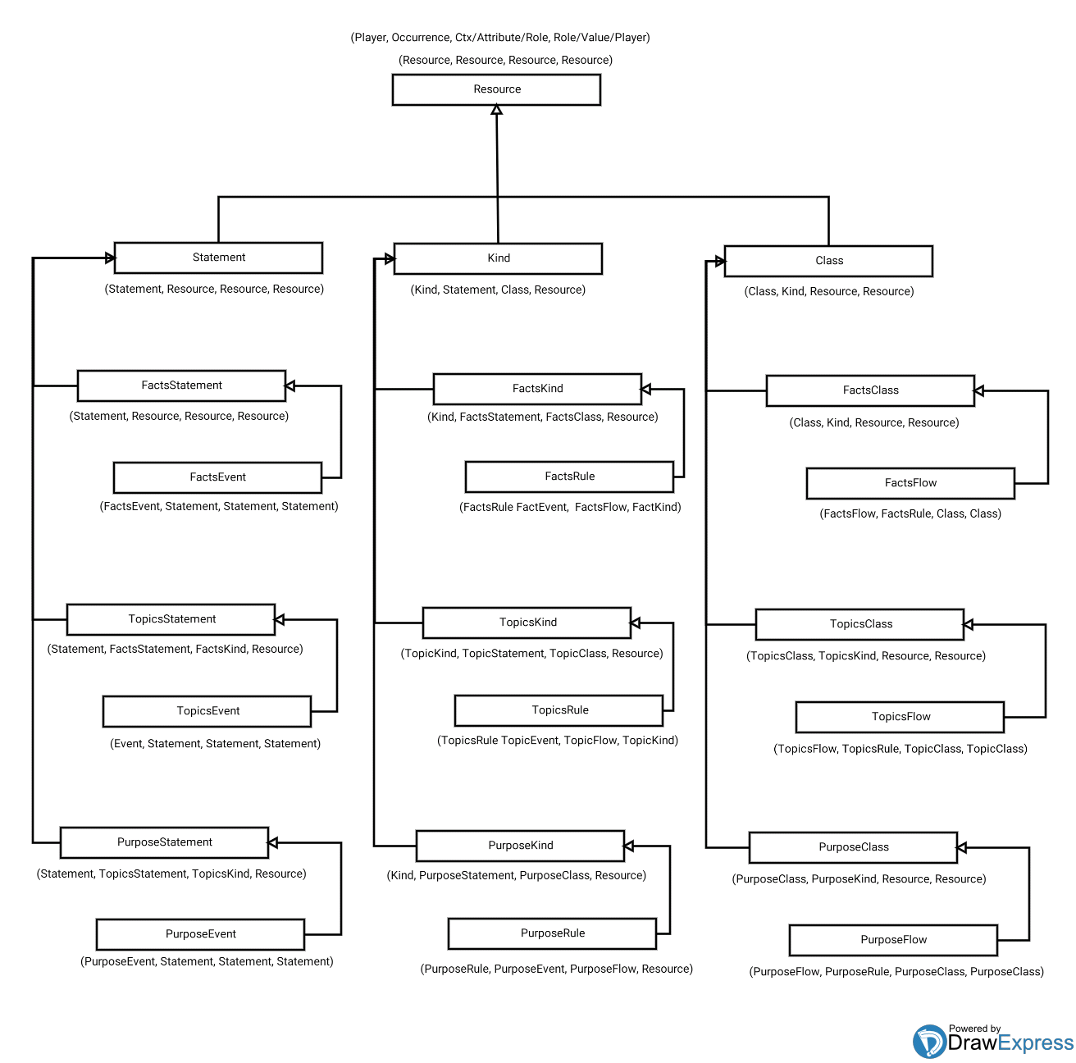

**Resources, Statements and Kinds**

Resources (SPOs) with an occurrence into an Statement have a Kind (type) corresponding to the Resource’s attribute and value (other SPOs of the Resource).

For example, a Subject ‘John Doe’ has a Subject Kind of ‘Employee’ in the Statement:

‘John Doe’, ‘worksAt’, ‘someCompany’.

Kinds aggregate Classes and may represent compound types (many attributes sharing their values.

Predicates and Objects are classified the same way than Subjects.

**Model / Facades (for Containers)**

Model : (Model, FactStatement, TopicStatement, PurposeStatement);

Aggregated Resource types (metamodel levels).

**Profiles**

Profile : (Profile, ?);

**Templates**

Template : (Template, ?); (Mapping).

Variables, expressions, wildcards. Patterns. Selectors.

**Adapters / Ports**

Adapter : (Adapter, Model, Profile, Model); (src, filter, dest).

Port : (Port, Adapter, Template, Adapter); (src, transform, dest).

[srcModelType][destModelType]Adapter class.

JenaModel; InMemoryModel; RDBMSModel

**Events, Rules and Flows**

Events: Order metadata / knowledge. Contextual registry functionality. Inference.

Event : (Event, Statement, Statement, Statement);

Rules: Identity, equivalence knowledge.Grammars. Alignment and merge inference. Patterns. Selectors. Naming resolution functionality.

Rule : (Rule, Event, Flow, Kind);

Flows: Attributes / links knowledge and inference. State graph resolution service (Index).

Flow : (Flow, Rule, Class, Class);

Example:

Event : (evt1, (anEmp, sal, lowSal), (anEmp, perf, goodPerf), (anEmp, sal, highSal));

Rule : (raiseSal, evt1, raiseSalFlow, empKind);

Flow : (raiseSalFlow, raiseSal, (lowSal, ‘salAttr’, 5000), (highSal, ‘salAttr’, 10000));

**Containers**

Container : (Container, Event, Rule, Flow); (data, context, interaction).

**Messages**

Algorithms. Message SPO: Data, Context, Interaction (Map, Filter, Reduce).

Encoding of ‘reactive’ expressions: event listeners / triggers. Routing / patterns.

Message : (Message, Container, Container, Container);

Subject Container apply(ied) to target Model (Map / actors).

Resulting Container is apply(ied) with Predicate Container (Filter / contexts).

Then, Object Container is applied to this result (Reduce / interaction). This interaction collects / returns into Object container, having ‘wildcards’ to be fulfilled from sender and then Message(d) back to resolve all patterns / selectors.

Resource matching:

Resource - Statement - Event.

Resource - Kind - Rule.

Resource - Class - Flow.

Map (align, rules) / Filter/Sort (events) / Reduce (links, attrs, classes).

**Resources**

Resource (Containers). Static factory / APIs.

Aggregators:

Resource’s static class singleton (for each Resource type).

Abstract factory.

Parent / child of aggregated Resource types (metamodel levels).

Quad classes (C, S, P, O) parameterized (Java generics).

Tracks instances: hierarchical aggregated lists: (C(S(P(O)))).

Instantiation of children hierarchies.

Factory / CRUD / Functional methods.

Dispatch Message(s).

Query / browse (Classes / instances navigable graph, contexts).

Services implementation / facade.

Handle Model’s backends (via Mapping specs).

**Mappings (specs)**

Mappings conforms the specifications to which a Model implementation relies in respect to its interaction with persistence or other IO mechanisms.

A Mapping is later leveraged by a Peer’s services who handles the actual protocols and connections needed to realize it.

RESTMapping: Mapping which provides (given Peer’s services) with the needed conceptualization to implement such interface:

URIs, Resources, Content Types, Representations, Verbs. HATEOAS Principles. DCI - JAF like. OData impl.

ObjectMapping: ORM like for RDF graphs. Clients (stubs, VM Activation).

**Protocol (Container, Resources, Messages)**

Container.apply(cont : Container) : Container;

Schema less protocol / storage. Dialog. Client sends Container and receives Container. Referer (context). ‘One method’ bi-di CRUD (metadata and semantics just in Container).

Mappings (other) implemented / interact with this abstraction (also schema-able / relational Mappings).

**Model Backends**

Mappings.

Peer services.

Deployment.

**ETL / Dashboard**

UX. Streaming CRUD. Planning (Rule, Flow, Event management. Process designer).

Data preparation / Refine. Reports, indicators. Document templates (forms, gestures, DAV). Design. Server. Client.

Interactions. Process (schema), Flows (instance) visualization. MDM, Governance, Traceability. BRMS, CEP. BPM. Workflow.

Alignment. Graph based schema merge / sync: Container protocol metadata. ISO / WebOWL Tools (export, endpoints).

**Peers (services)**

Binds Mappings / Models with specific protocols (persistence / communication mechanisms).

HTTP (REST, WebDAV), JMS, RDBMS (JDBC), JCR, SPARQL (RDF, OWL, ISO) services (interface implementation for each Model / Mapping type).

**ISO Alignment**

Align core model (Resource hierarchy classes) with an ISO OWL upper ontology. Backend metamodel.

**Lab**

Octal. Quad. Addressing encoding. URNs, Naming. Deep Learning. Cube. Algorithms facade. Functional Providers. Data addressable dataflow behaviors. Index, Registry. Clustering, Classification, Regression. Weka.

Order, Align: Opposite, inverse, complement.

Peer 'public html' folder (DAV / REST).

Naming (of Classes and Kinds). Resource type metadata (any SPO). Primitives (enumerable, operations) types. Naming (URNs) of Resources in context/occurrence with attributes and values.