Analysis Situs compilation on Linux

## Preface

This guide describes the building process as it is now. The compilation procedure is not perfect and may require significant refinement to become more user-friendly and straightforward. Anyway, this document is intended to be a reference guide, so if you encounter a problem or have suggestions for improvement, please contact us via our contact form (http://quaoar.su/blog/contact).



This procedure assumes you have a "clean" installation of Linux. As a result, it goes through all of the steps to install the required third-party dependencies, some of which your system may already have installed. If this is the case, you may skip the corresponding steps.

## Step-by-step instruction

The following guide describes the building process for Analysis Situs on Linux OS. In what follows, Linux Ubuntu 18.04.3 LTS and 20.04.1 LTS were used.

1. Install cmake-gui.

**sudo apt install cmake-qt-gui**

Alternatively, CMake can be installed from the Ubuntu Software application.

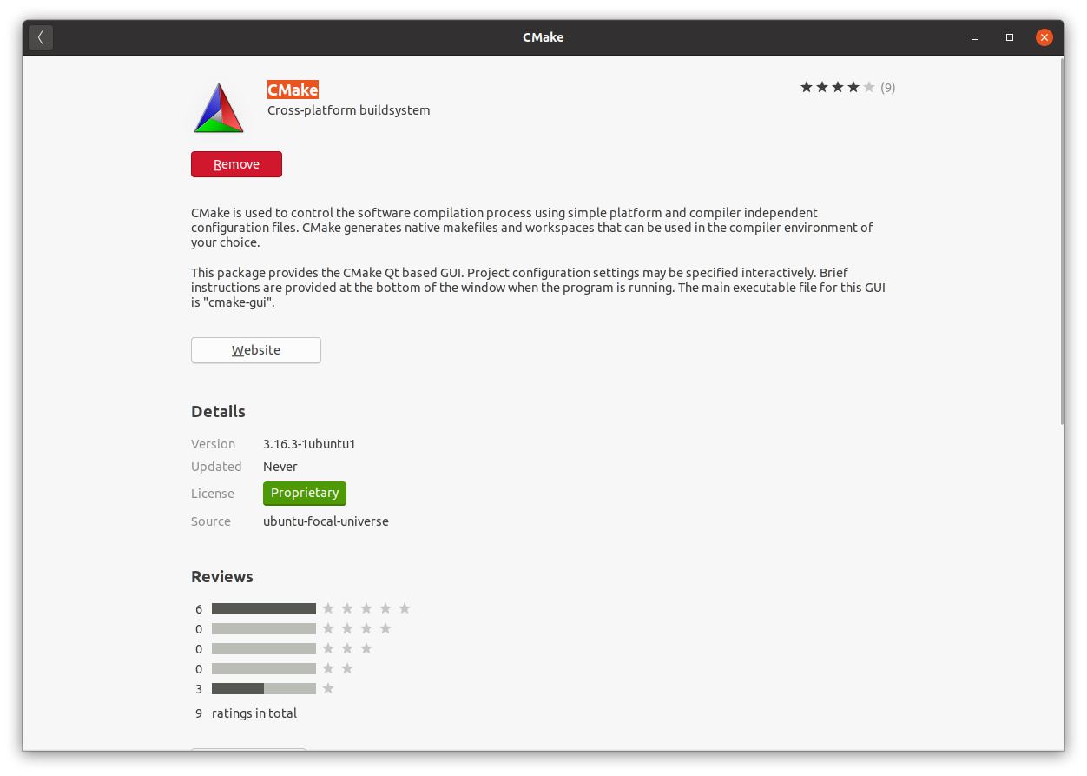

1. Install Qt asset.

**sudo apt install build-essential**

sudo apt install qtcreator

sudo apt install qt5-default

**sudo apt-get install libqt5x11extras5-dev**

**sudo apt-get install qttools5-dev**

1. Go to your working directory where you’d like to have Analysis Situs sources.

**cd /home/quaoar**

**mkdir work**

**cd work**

1. Install git.

**sudo apt install git**

1. Clone the repo.

**git clone https://gitlab.com/ssv/AnalysisSitus.git**

1. Run cmake-gui and specify the source directory for Analysis Situs. You also have to specify the build directory.

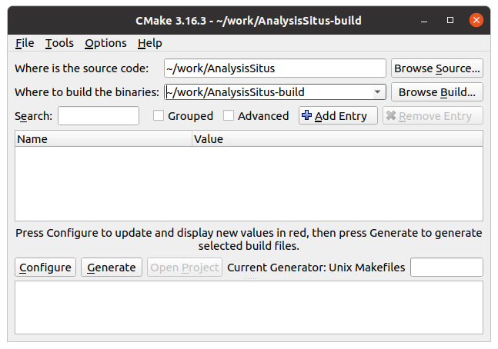

Source: /home/quaoar/work/AnalysisSitus

Build: /home/quaoar/work/AnalysisSitus-build

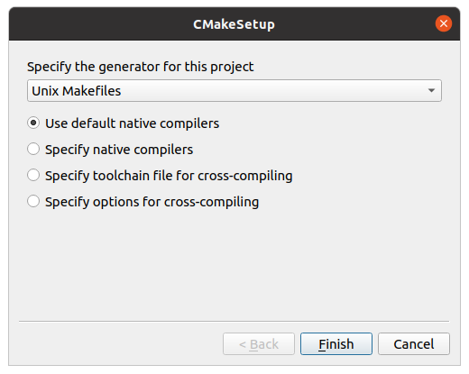

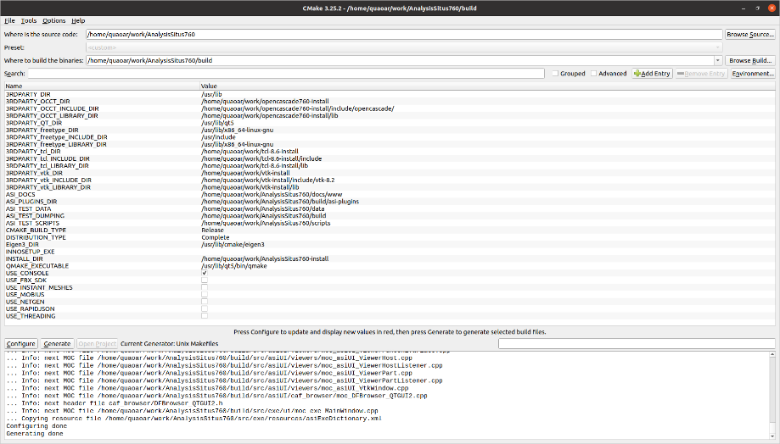

1. Try to configure. The process will end up with errors, saying that 3-rd parties are not found. You can specify the following values for the cmake variables at this stage:

**3RDPARTY_DIR** = /usr/lib

**INSTALL_DIR** = /home/quaoar/work/AnalysisSitus-install  
**CMAKE_BUILD_TYPE** = Release

At this stage, the configuration process cannot be completed as the essential 3-rd parties are missing.

1. Get VTK by cloning its repo and checkout the corresponding version.

**git clone** [**https://gitlab.kitware.com/vtk/vtk.git**](https://gitlab.kitware.com/vtk/vtk.git)

**git checkout v8.2.0**

**Caution:** make sure that VTK8.2.0 is exactly the version you are going to use. Analysis Situs won’t compile (or run) on any other versions.

1. Install libxt-dev (X Toolkit).

**sudo apt-get install libxt-dev**

1. Run cmake-gui and configure it to build VTK.

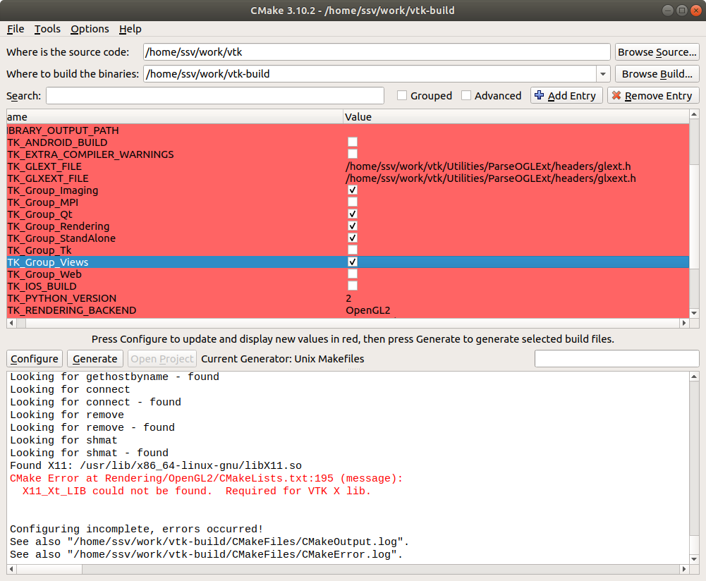

Pay attention to setting up some specific VTK props:

**VTK_Group_Imaging** = YES

**VTK_Group_Qt** = YES

**VTK_Group_Views** = YES

1. Set CMAKE_INSTALL_PREFIX to the directory where VTK will be installed.

**CMAKE_INSTALL_PREFIX** = /home/quaoar/work/vtk-install

1. Configure and Generate in cmake. Then make and install while in the VTK build directory.

**make**

**make install**

1. Install the development package of freetype.

Ubuntu 18_04: <https://packages.ubuntu.com/bionic/libfreetype6-dev>  
Ubuntu 20_04: <https://www.ubuntuupdates.org/package/core/focal/main/base/libfreetype6-dev>

Or use Ubuntu Software to install this package.

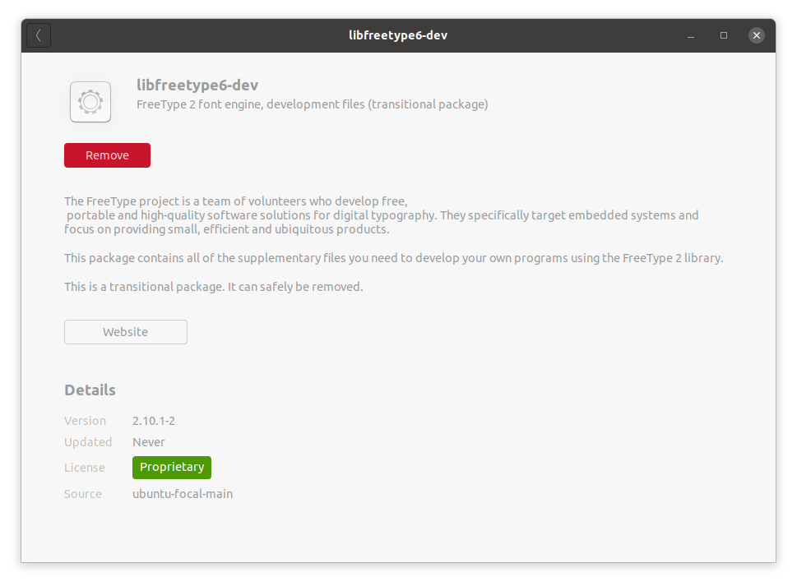

1. Download tcl 8.6 from the official website.

<https://www.tcl.tk/software/tcltk/download.html>

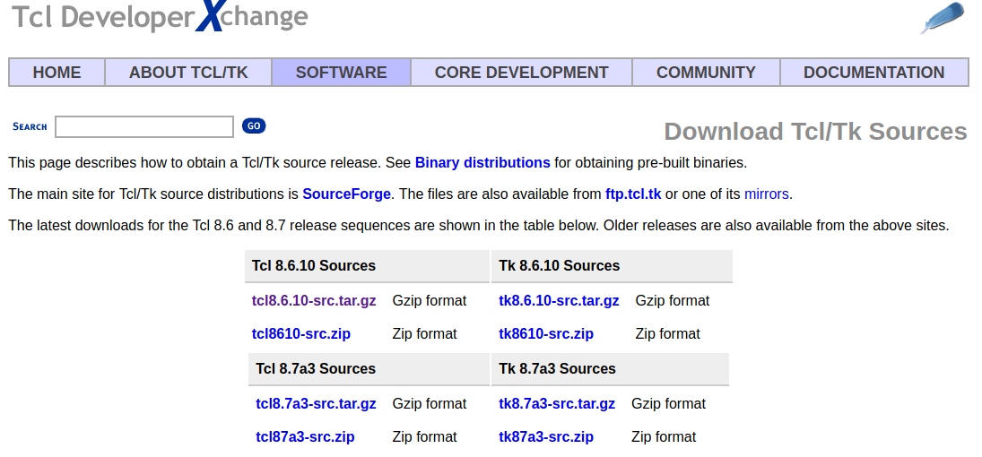

1. Build tcl.

**cd <TCL_SRC_DIR>/unix**

**./configure --enable-gcc --enable-shared --enable-threads --prefix=/home/quaoar/work/tcl-8.6-install --enable-64bit**

**make**

**make install**

1. Do the same with tk 8.6 (not necessary for Analysis Situs, do this only if you want to have Tk to run DRAW application of OpenCascade kernel).

**cd <TK_SRC_DIR>/unix**

**./configure --enable-gcc --enable-shared --enable-threads --with-tcl=/home/quaoar/work/tcl-8.6-install/lib --prefix=/home/quaoar/work/tk-8.6-install**

**make**

**make install**

1. Get the sources of OpenCascade library.

**git clone** [**https://git.dev.opencascade.org/repos/occt.git**](https://git.dev.opencascade.org/repos/occt.git)

Make sure the appropriate version of OpenCascade is used. Stick to the release ver7.4.

git checkout V7_4_0p1

**Note:** Analysis Situs has development branches for more recent releases of OpenCascade, including 7.7 and 7.6.ы

1. Run cmake-gui and set 3RDPARTY_DIR to the directory where your tcl and tk libs are installed.

**NOTE:** if some errors regarding Tcl/Tk appear on configuration, switch to the advanced mode of cmake and specify the corresponding Tcl/Tk libs manually.

1. Make sure to specify the INSTALL_DIR for OpenCascade.

**INSTALL_DIR** = ~/work/occt-install

1. Run make and make install in the build directory of OpenCascade.

**cd /home/quaoar/work/occt-build**

**make**

**make install**

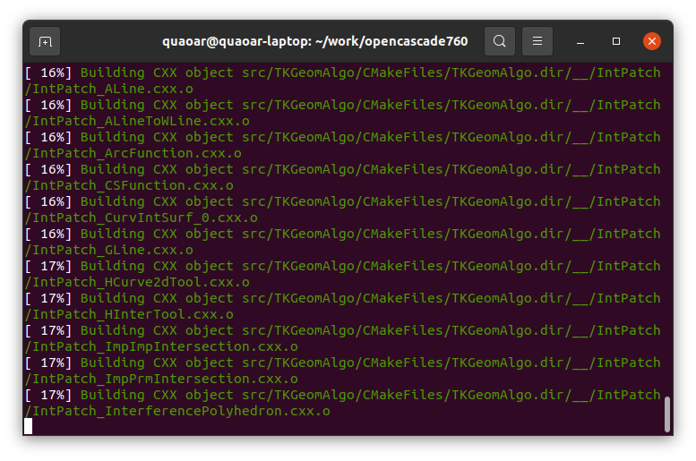

**NOTE:** When building OpenCascade, you might encounter compilation errors, which should be resolved by adding some extra missing packages to your OS.

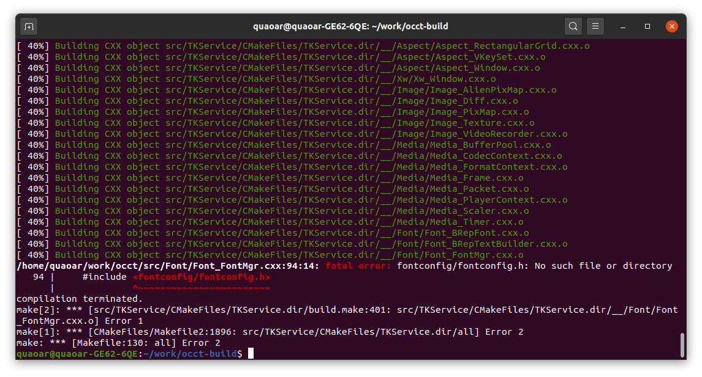

According to the picture above, the following packages happened to be missing:

**sudo apt-get install libfontconfig1-dev**

**sudo apt-get install libxmu-dev libxi-dev**

1. Get the sources of Eigen. There is no need to configure or build anything for Eigen as this library is implemented entirely in C++ header files.

<http://eigen.tuxfamily.org/>

1. Run cmake-gui for Analysis Situs. The list of primary dependencies appears at the first configuration attempt.

CMake Error at CMakeLists.txt:124 (message):

3RDPARTY_vtk_LIBRARY_DIR

3RDPARTY_OCCT_INCLUDE_DIR

3RDPARTY_OCCT_LIBRARY_DIR

3RDPARTY_tcl_LIBRARY_DIR

3RDPARTY_tk_LIBRARY_DIR

3RDPARTY_freetype_INCLUDE_DIR  
3RDPARTY_freetype_LIBRARY_DIR

1. Make sure to disable USE_MOBIUS, USE_INSTANT_MESHES, USE_THREADING cmake flags.
2. From the build directory of Analysis Situs, run

**make  
make install**

# Headless rendering

**NOTE:** It is advised to use dedicated build/install directories for the offscreen versions of VTK and Analysis Situs. E.g.:

/home/quaoar/work/AnalysisSitus-build  
/home/quaoar/work/**AnalysisSitus-offscreen-build**  
/home/quaoar/work/vtk-build  
/home/quaoar/work/**vtk-offscreen-build**

Install OSMESA (will be required to build VTK): sudo apt-get install libosmesa6-dev

* Enable **VTK_OPENGL_HAS_OSMESA** cmake flag when configuring VTK.
* Enable **VTK_DEFAULT_RENDER_WINDOW_HEADLESS**.

The following example demonstrating the offscreen rendering should work with VTK8.2.

#include <vtkAutoInit.h>

#include <vtkPolyDataMapper.h>

#include <vtkActor.h>

#include <vtkRenderWindow.h>

#include <vtkRenderer.h>

#include <vtkPolyData.h>

#include <vtkSmartPointer.h>

#include <vtkSphereSource.h>

#include <vtkWindowToImageFilter.h>

#include <vtkPNGWriter.h>

VTK_MODULE_INIT(vtkRenderingOpenGL2); // VTK was built with vtkRenderingOpenGL2

VTK_MODULE_INIT(vtkInteractionStyle);

int main(int, char *[])

{

std::cout << "Hello, offscreen rendering!" << std::endl;

// Create a sphere

vtkSmartPointer<vtkSphereSource> sphereSource =

vtkSmartPointer<vtkSphereSource>::New();

// Create a mapper and actor

vtkSmartPointer<vtkPolyDataMapper> mapper =

vtkSmartPointer<vtkPolyDataMapper>::New();

mapper->SetInputConnection(sphereSource->GetOutputPort());

vtkSmartPointer<vtkActor> actor =

vtkSmartPointer<vtkActor>::New();

actor->SetMapper(mapper);

// A renderer and render window

vtkSmartPointer<vtkRenderer> renderer =

vtkSmartPointer<vtkRenderer>::New();

vtkSmartPointer<vtkRenderWindow> renderWindow =

vtkSmartPointer<vtkRenderWindow>::New();

renderWindow->SetOffScreenRendering( 1 );

renderWindow->AddRenderer(renderer);

// Add the actors to the scene

renderer->AddActor(actor);

renderer->SetBackground(1,1,1); // Background color white

renderWindow->Render();

vtkSmartPointer<vtkWindowToImageFilter> windowToImageFilter =

vtkSmartPointer<vtkWindowToImageFilter>::New();

windowToImageFilter->SetInput(renderWindow);

windowToImageFilter->Update();

vtkSmartPointer<vtkPNGWriter> writer =

vtkSmartPointer<vtkPNGWriter>::New();

writer->SetFileName("screenshot.png");

writer->SetInputConnection(windowToImageFilter->GetOutputPort());

writer->Write();

return 0;

}

# Discussion

See FreeCAD topic here: <https://forum.freecadweb.org/viewtopic.php?f=8&t=23620>