Index:

> 9/23/16 My first time commit

> 9/24/16 Add Eureka Cluster,HA

>10/10/16 Add ELK

1. start eureka as service regisitry at port:8761

you can run the main class or mvn spring-boot:run ！

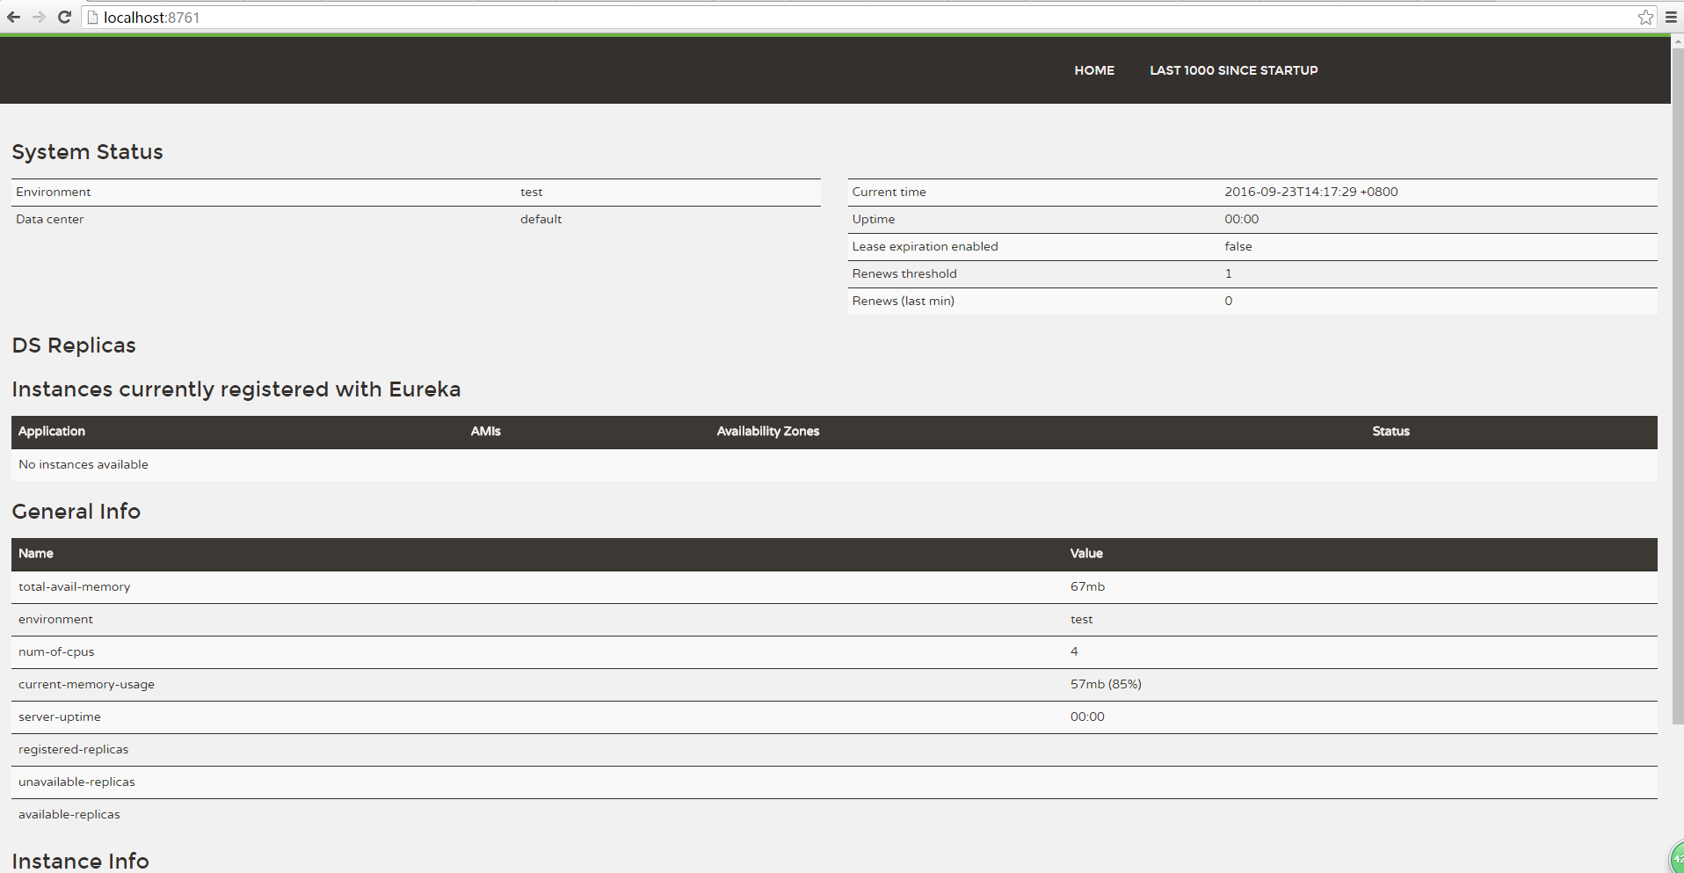

There is service at all,but itself.

1. Start config-center
2. Start 3 weather module,weather is as gatway. weather-service, weather-service-repetion are 2 available service.
3. And you can see this
4. 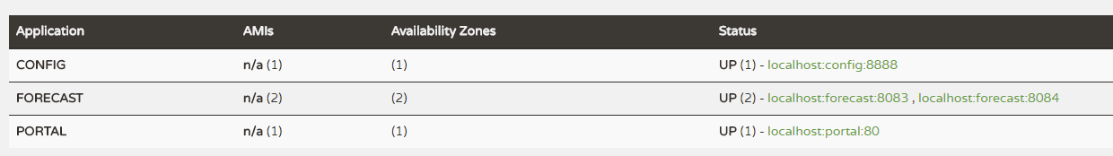
5. I use Feign as restApi and loadbalance
6. You can start visit the portal at localhost or localhost:80
7. 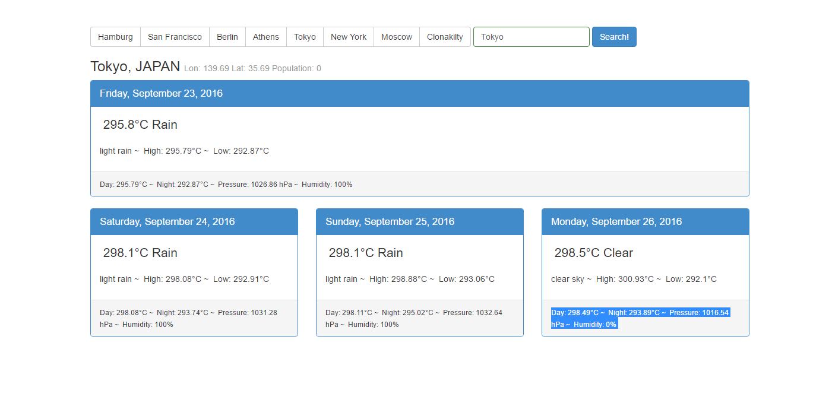
8. If you look weather-service and weather-service-repetion’s console, and you send several request,You can analyze the loadbalance is really worked!
9. Addtion ,the portal module is partly fork from https://github.com/atufkas/angular-openweather-app!!