Design justifications

First thought
after first reading the brief I believe my audience is for the younger audience they are likely to be more aware of the importance of a strong password compared to older generations so I’m going to use bright colours and more modern wording and its highly accessible and easy to navigate for young people as navigation should be straight forward

Page 1
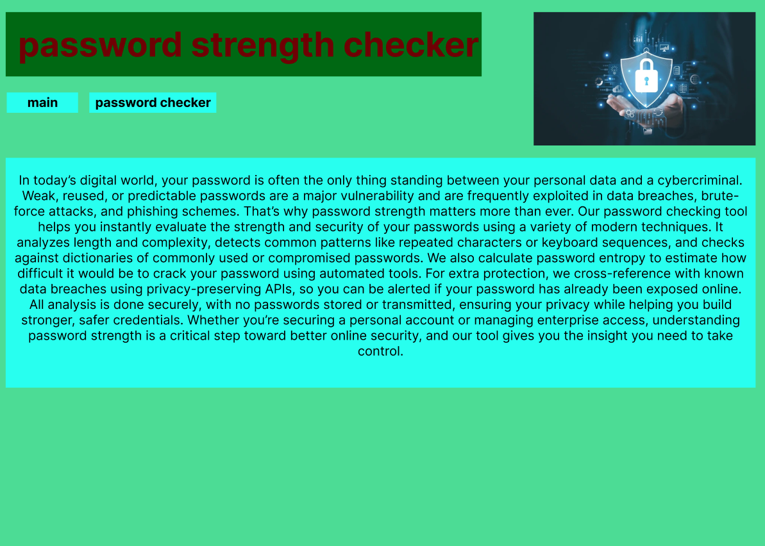
I used a weak lime for the background to ensure safety cyan for the things that require more attention as cyan is seen as a strong security colour a darker green for the header to make it pop out and font colour of red to symbolise danger I added text on the importance of password security and a logo in the top right depicting a lock to show security so they will more likely trust the checkers accuracy so we will be more reliable and more likely for them to share with others which would increase traffic to the website.
page 2

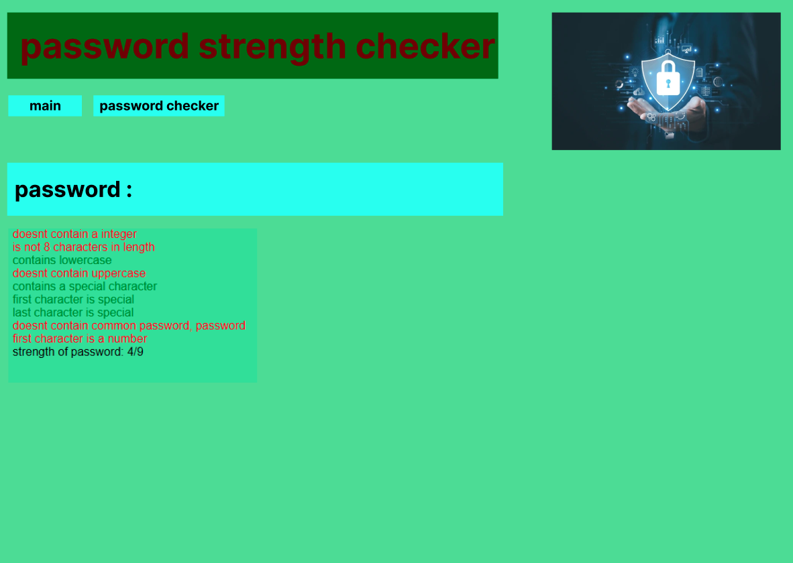
this page follows the previous formatting but contains a password box which is large and hard to miss with bold wording and colours to make it obvious to the user it also shows the password rating below the input box with colours and words to display the strength of the password

psuedocode-php
pseudocode for the password checker with each individual check being a separate function and a outward strength variable to count how many functions returned a good for password
I seperated functions for each check so I can call them individually in index aloowing for easier movement of checks I used many if and elseif statements to check conditions to check the values then I created a message which I returned to the calling function I added robust check around each function to ensure a pswd is set before doing any checks and else ill return a blank string I also incrment a value if it returns a true value then the final form

<?php // starts php
function num_check(){ // declaring function
if (isset($_SESSION["password"])) { // checks variable has been set
$_SESSION["strength"] = 0; // setting count variable
if (preg_match('/[0-9]/',$_SESSION["password"])){ //if condition is met
$numcheck = "<div id='good'>contains a integer</div>"; // creating a message to be returned
$_SESSION["strength"]+=1; // increments value
return $numcheck; // return value to calling function
} else{ // if no other conditions are met
$numcheck = "<div id='bad'>doesnt contain a integer</div>"; // creating a message to be returned
return $numcheck; // return value to calling function
}
}
else { // if no other conditions are met
return ""; // return value to calling function
}
}
function len_check(){ // declaring function
if (isset($_SESSION["password"])) { // checks variable has been set
$length = strlen($_SESSION["password"]);
if ($length>=8){ //if condition is met
$lencheck = "<div id='good'>is at least 8 characters</div>"; // creating a message to be returned
$_SESSION["strength"]+=1; // increments value
return $lencheck; // return value to calling function
} else{ // if no other conditions are met
$lencheck = "<div id='bad'>is not 8 characters in length</div>"; // creating a message to be returned
return $lencheck; // return value to calling function
}
}
else { // if no other conditions are met
return ""; // return value to calling function
}
}
function upper_check(){ // declaring function
if (isset($_SESSION["password"])) { // checks variable has been set
if (preg_match('/[A-Z]/',$_SESSION["password"])){ //if condition is met
$upper_check = "<div id='good'>contains uppercase</div>"; // creating a message to be returned
$_SESSION["strength"]+=1; // increments value
return $upper_check; // return value to calling function
} else{ // if no other conditions are met
$upper_check = "<div id='bad'>doesnt contain uppercase</div>"; // creating a message to be returned
return $upper_check; // return value to calling function
}
}
else { // if no other conditions are met
return ""; // return value to calling function
}
}
function lower_check(){ // declaring function
if (isset($_SESSION["password"])) { // checks variable has been set
if (preg_match('/[a-z]/',$_SESSION["password"])){ //if condition is met
$lower_check = "<div id='good'>contains lowercase</div>"; // creating a message to be returned
$_SESSION["strength"]+=1; // increments value
return $lower_check; // return value to calling function
} else{ // if no other conditions are met
$lower_check = "<div id='bad'>doesnt contain lowercase</div>"; // creating a message to be returned
return $lower_check; // return value to calling function
}
}
else { // if no other conditions are met
return ""; // return value to calling function
}
}
function special_check(){ // declaring function
if (isset($_SESSION["password"])) { // checks variable has been set
if (preg_match('/[^a-zA-Z0-9_]/', $_SESSION["password"])) { //if condition is met
$special_check = "<div id='good'>contains a special character</div>"; // creating a message to be returned
$_SESSION["strength"] += 1; // increments value
return $special_check; // return value to calling function
} else { // if no other conditions are met
$special_check = "<div id='bad'>doesn’t contain a special character</div>"; // creating a message to be returned
return $special_check; // return value to calling function
}
} else { // if no other conditions are met
return ""; // return value to calling function
}
}
function first_special_check(){ // declaring function
if (isset($_SESSION["password"])) { // checks variable has been set
if (!preg_match('/[a-zA-Z0-9_]/',$_SESSION["password"][0])) { //if condition is met
$first_special_check = "<div id='bad'>first character is special</div>"; // creating a message to be returned
return $first_special_check; // return value to calling function
} else{ // if no other conditions are met
$first_special_check = "<div id='good'>first character isn't special</div>"; // creating a message to be returned
$_SESSION["strength"]+=1; // increments value
return $first_special_check; // return value to calling function
}
}
else { // if no other conditions are met
return ""; // return value to calling function
}
}
function last_special_check(){ // declaring function
if (isset($_SESSION["password"])) { // checks variable has been set
if (!preg_match('/[a-zA-Z0-9_]/',$_SESSION["password"][strlen($_SESSION["password"])-1])){ //if condition is met
$last_special_check = "<div id='bad'>last character is special</div>"; // creating a message to be returned
return $last_special_check; // return value to calling function
} else{ // if no other conditions are met
$last_special_check = "<div id='good'>last character isn't special</div>"; // creating a message to be returned
$_SESSION["strength"]+=1; // increments value
return $last_special_check; // return value to calling function
}
}
else { // if no other conditions are met
return ""; // return value to calling function
}
}
function common_check(){ // declaring function
$common_words=["password","qwerty"]; // list of common passwords
if (isset($_SESSION["password"])) { // checks variable has been set //if condition is met
foreach ($common_words as $word) { // iterates through all items in the list
if (str_contains($_SESSION["password"], $word) ) { //if condition is met
$common_check = "<div id='bad'>contains common password, ".$word."</div>"; // creating a message to be returned
return $common_check; // return value to calling function
}
}
$common_check = "<div id='good'>doesnt contain a common password</div>"; // creating a message to be returned
$_SESSION["strength"] += 1; // increments value
return $common_check; // return value to calling function
}
else { // if no other conditions are met
return ""; // return value to calling function
}
}
function first_num_check(){ // declaring function
if (isset($_SESSION["password"])) { // checks variable has been set
if (!preg_match('/[0-9]/',$_SESSION["password"][0])){ //if condition is met
$first_num_check = "<div id='good'>first character isn't a number</div>"; // creating a message to be returned
$_SESSION["strength"]+=1; // increments value
return $first_num_check; // return value to calling function
} else{ // if no other conditions are met
$first_num_check = "<div id='bad'>first character is a number</div>"; // creating a message to be returned
return $first_num_check; // return value to calling function
}
}
else { // if no other conditions are met
return ""; // return value to calling function
}
}
function strength_check(){ // declaring function
if (isset($_SESSION["password"])) { //if condition is met
$_SESSION["password"] = ""; // blanks value
unset($_SESSION["password"]); // unsets value
if ($_SESSION["strength"] >=8){ //if condition is met
$strength="<div id= 'good'> strength of password: ".$_SESSION["strength"]. "/9</div> "; // creating a message to be returned
}
elseif($_SESSION["strength"] >=4){ // if other condition isn't met but this condition is met
$strength="<div id= 'medium'> strength of password: ".$_SESSION["strength"]. "/9</div> "; // creating a message to be returned
}
else{ // if no other conditions are met
$strength="<div id= 'bad'> strength of password: ".$_SESSION["strength"]. "/9</div> "; // creating a message to be returned
}
return $strength; // return value to calling function
}
else{ // if no other conditions are met
return ""; // return value to calling function
}
}
?>

