Design justifications

First thought
after first reading the brief I believe my audience is for the younger audience they are likely to be more aware of the importance of a strong password compared to older generations so I’m going to use bright colours and more modern wording and its highly accessible and easy to navigate for young people as navigation should be straight forward

Page 1
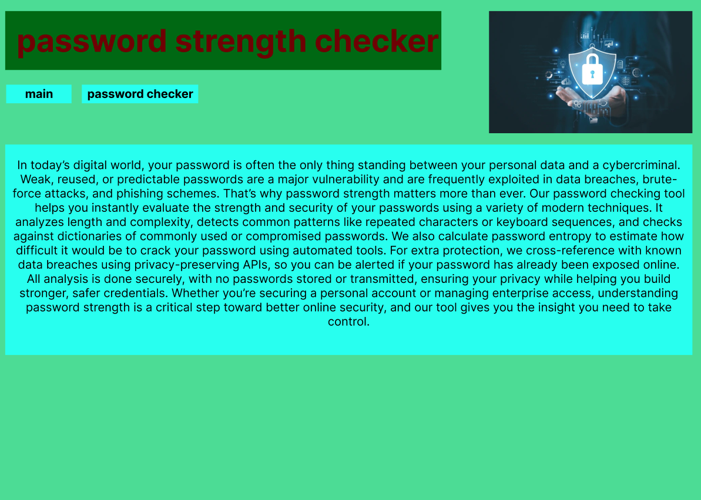
I used a weak lime for the background to ensure safety cyan for the things that require more attention as cyan is seen as a strong security colour a darker green for the header to make it pop out and font colour of red to symbolise danger I added text on the importance of password security and a logo in the top right depicting a lock to show security so they will more likely trust the checkers accuracy so we will be more reliable and more likely for them to share with others which would increase traffic to the website.
page 2

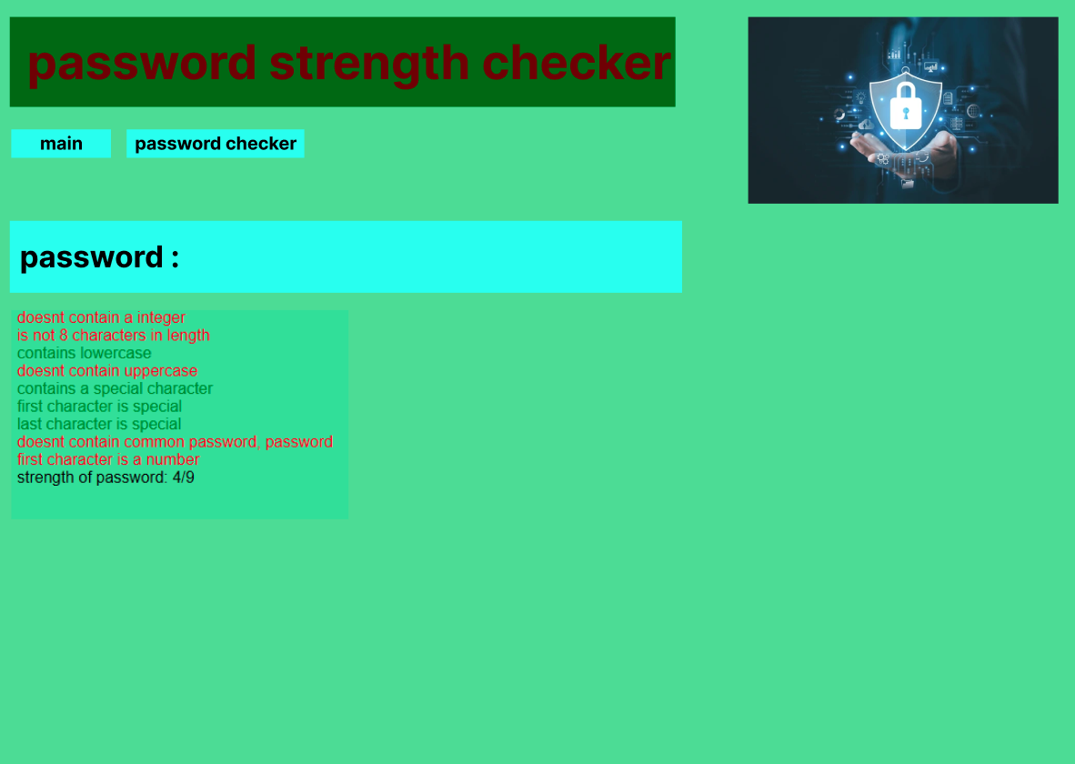
this page follows the previous formatting but contains a password box which is large and hard to miss with bold wording and colours to make it obvious to the user it also shows the password rating below the input box with colours and words to display the strength of the password

psuedocode-php
pseudocode for the password checker with each individual check being a separate function and a outward strength variable to count how many functions returned a good for password

<?php
$strength=0;
function num_check(){
if (isset($_SESSION["password"])) { // checks variable has been set
if (preg_match('/[0-9]/',$_SESSION["password"])){
$numcheck = "<div id='good'>contains a integer</div>"; // stored
$GLOBALS['strength']+=1;
return $numcheck;
} else{
$numcheck = "<div id='bad'>doesnt contain a integer</div>"; // stored
return $numcheck;
}
}
else {
return "";
}
}
function len_check(){
if (isset($_SESSION["password"])) { // checks variable has been set
$length = strlen($_SESSION["password"]);
if ($length>=8){
$lencheck = "<div id='good'>is at least 8 characters</div>"; // stored
$GLOBALS['strength']+=1;
return $lencheck;
} else{
$lencheck = "<div id='bad'>is not 8 characters in length</div>"; // stored
return $lencheck;
}
}
else {
return "";
}
}
function upper_check(){
if (isset($_SESSION["password"])) { // checks variable has been set
if (preg_match('/[A-Z]/',$_SESSION["password"])){
$upper_check = "<div id='good'>contains uppercase</div>"; // stored
$GLOBALS['strength']+=1;
return $upper_check;
} else{
$upper_check = "<div id='bad'>doesnt contain uppercase</div>"; // stored
return $upper_check;
}
}
else {
return "";
}
}
function lower_check(){
if (isset($_SESSION["password"])) { // checks variable has been set
if (preg_match('/[a-z]/',$_SESSION["password"])){
$lower_check = "<div id='good'>contains lowercase</div>"; // stored
$GLOBALS['strength']+=1;
return $lower_check;
} else{
$lower_check = "<div id='bad'>doesnt contain lowercase</div>"; // stored
return $lower_check;
}
}
else {
return "";
}
}
function special_check(){
if (isset($_SESSION["password"])) { // checks variable has been set
if (!preg_match('/[a-zA-Z0-9_]/',$_SESSION["password"])){
$special_check = "<div id='good'>contains a special character</div>"; // stored
$GLOBALS['strength']+=1;
return $special_check;
} else{
$special_check = "<div id='bad'>doesnt contain a special character</div>"; // stored
return $special_check;
}
}
else {
return "";
}
}
function first_special_check(){
if (isset($_SESSION["password"])) { // checks variable has been set
if (!preg_match('/[a-zA-Z0-9_]/',$_SESSION["password"][0])) {
$first_special_check = "<div id='bad'>first character is special</div>"; // stored
return $first_special_check;
} else{
$first_special_check = "<div id='good'>first character isn't special</div>"; // stored
$GLOBALS['strength']+=1;
return $first_special_check;
}
}
else {
return "";
}
}
function last_special_check(){
if (isset($_SESSION["password"])) { // checks variable has been set
if (!preg_match('/[a-zA-Z0-9_]/',$_SESSION["password"][strlen($_SESSION["password"])-1])){
$last_special_check = "<div id='bad'>last character is special</div>"; // stored
return $last_special_check;
} else{
$last_special_check = "<div id='good'>last character isn't special</div>"; // stored
$GLOBALS['strength']+=1;
return $last_special_check;
}
}
else {
return "";
}
}
function common_check(){
$common_words=["password","qwerty"];
if (isset($_SESSION["password"])) { // checks variable has been set
foreach ($common_words as $word) {
if (str_contains($_SESSION["password"], $word) ) {
$common_check = "<div id='bad'>contains common password, ".$word."</div>"; // stored
return $common_check;
}
}
$common_check = "<div id='good'>doesnt contains common password, ".$word."</div>"; // stored
$GLOBALS['strength'] += 1;
return $common_check;
}
else {
return "";
}
}
function first_num_check(){
if (isset($_SESSION["password"])) { // checks variable has been set
if (!preg_match('/[0-9]/',$_SESSION["password"][0])){
$first_num_check = "<div id='good'>first character isn't a number</div>"; // stored
$GLOBALS['strength']+=1;
return $first_num_check;
} else{
$first_num_check = "<div id='bad'>first character is a number</div>"; // stored
return $first_num_check;
}
}
else {
return "";
}
}
function strength_check(){
if (isset($_SESSION["password"])) {
$_SESSION["password"] = "";
unset($_SESSION["password"]);
if ($GLOBALS['strength'] >=6){
$strength="<div id= 'good'> strength of password: ".$GLOBALS['strength']. "/9</div> ";
}
elseif($GLOBALS['strength'] >=3){
$strength="<div id= 'medium'> strength of password: ".$GLOBALS['strength']. "/9</div> ";
}
else{
$strength="<div id= 'bad'> strength of password: ".$GLOBALS['strength']. "/9</div> ";
}
return $strength;
}
}
?>

pseudocode html/php
html and php to display to web screen

<?php //this opens the php code section
session_start();
require_once "assets/common.php";
if ($_SERVER["REQUEST_METHOD"] === 'POST') {
$_SESSION["password"] = $_POST["password"];
}
echo "<!DOCTYPE html>"; // desired tag to declare what type of page it is
echo "<html>"; // opening html
echo "<head>"; // opening head
echo "<title>page title</title>"; // creating title
echo "<link rel='stylesheet' type='text/css' href='css\styles.css'>";// getting css formatting for website from external
echo "</head>";
echo "<body>"; // opening body
echo "<div class ='container'>"; // class container to give all items a default to reduce need for styling later
require_once "assets/topbar.php"; // presenting header
require_once "assets/nav.php";// presenting navigation bar
echo "<div class ='content'>"; // class context to give all items that give information an overall css to reduce need for styling later and standardise formatting
echo "<form method='post' action=''>";
echo "<input type='password' name='password' placeholder='password: '>";
echo "</form>";
echo num_check();
echo len_check();
echo lower_check();
echo upper_check();
echo special_check();
echo first_special_check();
echo last_special_check();
echo common_check();
echo first_num_check();
echo strength_check();
echo "</div>";
echo "</div>";
echo "</body>";
echo "</html>";
?>

