Propsal for primary oaks

by tyler hooley

37710

my student id

Contents
organisation overview 3
Problem overview 3
scope 4
User groups 4
Patients 4
doctors 4
admin staff 4
user/stories 5
Empathy maps 6
patients 6
Doctors 7
Admin 7
Laws/guidance/legislation 8
General Medical Services (GMS) regulations 8
Data Protection Act (DPA) 2018 / UK GDPR: 8
Common Law Duty of Confidentiality (CLDC): 8
Health and Social Care Act 2008: 8
NHS Codes of Confidentiality and Information Security: 8
WCAG in a Doctor’s Surgery 9
Alternative systems 9
NHS 9
SIXT 10
pharmacy plus 10
Risks 11
Inputs/outputs 11
targetted malicious attacks 11
Decomposition 11
Inputs/outputs 11
targetted malicious attacks 11
user acceptance criteria 11
Patients 11
doctors 12
admins 12
Functional and non-functional requirements 12
functional 12
non-functional 12
Key performance indicators 13
Description of proposed solution 13
key features and benefits 14

organisation overview

Primary oaks is a local surgery providing essential NHS healthcare services to a diverse and growing patient base the surgery delivers a wide range of primary care services including general consultations, chronic condition management, vaccines and health promotion. The increasing demand of the growing patient customer base the appointments primarily managed over the phone has become harder to keep up with patients needs. To increase efficiency and reduce burden on surgery staff the surgery is looking to implement a booking system which allows patients to book and manage their own appointments online. Allowing doctors to view which patient appointments they have for that day and allowing admin staff to manage bookings and patients registered to the surgeries system.

Problem overview

The main problem they have is that they need a registration system for patients to book and manage their appointments so a database storing user details will be needed because data for the users and appointments will need to be stored. A login system and registering system will be needed as users will need a way of identifying their accounts so they can see their active bookings so they don’t miss appointments and allow us to identify which patient wants to book or cancel appointments reducing time wasted on unneeded verifying. a navigation for the system will be needed so users can easily navigate the website causing less customer support issues reducing time spent on solving problems allowing staff to focus on more important issues. they want a strong password checker so we will need input cleansing so there is no SQL injection and making users set a strong password reduces the chance of malicious people getting access to accounts which could cause legal issues which could result in fines and maybe even disallowing the surgery.

scope
- for this empathy map I am focusing only on tech-savvy individuals who want to book for themselves.

User groups

Patients
-catering for the ages between 18-65 as parents will book appointments for anyone below 18 and anybody above 65 will rarely be able to use technology to book appointments and will most likely call or somebody else will book the appointment for them.
- want to see their booked appointments
- want to cancel booked appointments
- want to book appointments
-want to reschedule appointments

doctors
Doctors between early 40’s and late 50’s because most doctors retire around late 50’s and most doctors are in training before age 40.
- want to see which patients they have appointments with

admin staff
Early 30’s to late 50’s as most technological people are from the younger generation so somebody who would manage the system will probably be in their early 30’s and most people above 50 ‘s are not familiar with tech as it wasn’t around during their time.
-want to add doctors
-want to add patients
-want to remove/add appointments
-see all patient appointments

user/stories

-As a patient, i want to be able to book appointments for myself without needing to call the surgery during working hours.

-As a doctor, I want to spend more time helping patients than answering calls for bookings.

-As an admin, I want to be able to control and manage everything without needing to contact patient or doctors to remove them from the record.

Empathy maps

patients
says | thinks
I can never get through when I call in the morning.  The phone lines are always busy.  I have to take time off work just to make an appointment.  Why isn’t there an easier way to book? | Will I be able to see the doctor soon?  I hope I don’t have to wait weeks.  I wish I could book from my phone or computer.  It’s frustrating that I can’t manage my appointments myself.
does | feels
Calls the surgery early in the morning and often gets a busy tone.  Tries to call repeatedly during breaks or lunchtime.  Writes down appointment details on a paper calendar.  Occasionally visits the surgery in person to book or reschedule. | Frustrated with the difficulty of booking.  Anxious about missing out on timely appointments.  Stressed balancing work, family, and making calls.  Helpless because they can’t control the booking process.

Doctors
says | thinks
I often don’t know if patients will show up or cancel last minute  I need better control over my appointment schedule  Phone bookings can be chaotic and lead to double bookings  Sometimes I have to squeeze urgent patients in | Will I have enough time for each patient today?  I hope the receptionist booked that patient in the correct slot  I want to avoid being overbooked or running late  It would be great to block out time for admin or emergencies easily
does | feels
Relies on reception staff to manage appointment bookings  Manages daily schedule on paper or basic electronic calendar  Often adjusts or extends appointments to handle urgent cases  Reviews patient files just before appointments | Frustrated by unpredictable appointment flow  Stressed when running behind schedule  Concerned about quality of care when rushed  Eager for a system that supports smoother scheduling

Admin
says | thinks
The phone lines are constantly busy especially during peak hours  It’s stressful handling appointment requests while assisting patients in person  I wish patients could book appointments without having to call all the time  Double bookings and last-minute cancellations cause a lot of confusion | How can I reduce the number of phone calls I get every day?  I hope I don’t make mistakes when booking appointments manually  It would be helpful to have a system that alerts me about cancellations or changes  I want to make sure urgent patients get appointments quickly
does | feels
Answers dozens of phone calls daily, often dealing with frustrated patients  Manages appointments using a manual or basic scheduling system  Coordinates with doctors to adjust their availability or block time  Tries to follow up with patients who miss or cancel appointments | Overwhelmed during busy periods with constant interruptions  Frustrated by manual processes that are time-consuming and error-prone  Anxious about making scheduling errors that impact patient care  Wants a smoother, more efficient way to manage bookings and reduce stress

Laws/guidance/legislation

General Medical Services (GMS) regulations
All GP practices in England must offer online appointment booking systems from 8 am to 6:30 pm, Monday to Friday

Data Protection Act (DPA) 2018 / UK GDPR:
This legislation sets out principles for data handling, including the need for a lawful basis to collect and process personal data. Health data falls under "special category data" with stricter rules for its use.

Common Law Duty of Confidentiality (CLDC):
This requires that patient data be handled with care, and its disclosure is only permissible under specific circumstances, such as by law or with consent.

Health and Social Care Act 2008:
Regulation 17 of this act, and subsequent CQC (Care Quality Commission) guidance, mandates that health providers must securely maintain accurate and complete patient records.

NHS Codes of Confidentiality and Information Security:
Practices are also subject to these NHS-specific codes.

WCAG in a Doctor’s Surgery
Ensuring digital accessibility in a doctor’s surgery is essential for inclusive patient care. Following WCAG (Web Content Accessibility Guidelines) means that all patients—including those with disabilities—can access services like online booking, health information, and contact forms. A WCAG-compliant system ensures content is perceivable, operable, understandable, and robust, meeting legal requirements (like the Equality Act 2010) while improving the experience for all users.

Alternative systems

NHS
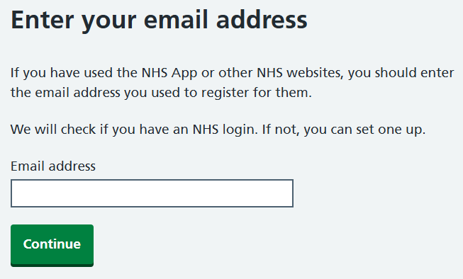

NHS uses an email verification system to identify users instead of having an username and password they use this to check if you have an account they follow visibility guidelines very well as they are in public sector so its navigation design is very accessible for most users

SIXT
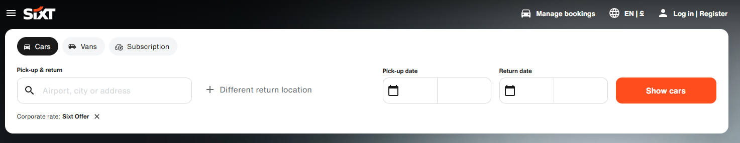
Sixt uses a search bar to search for available cars to rent uses a black white and orange colour scheme allowing for clear visual indicators since the monotone colour pallet will make the orange highlights pop out a lot more but the small letter sizing does not make it accessible for older users and those who are visually impaired its clearly marketed to those of the younger generation and those without a car because most elderly people will already have a car

pharmacy plus
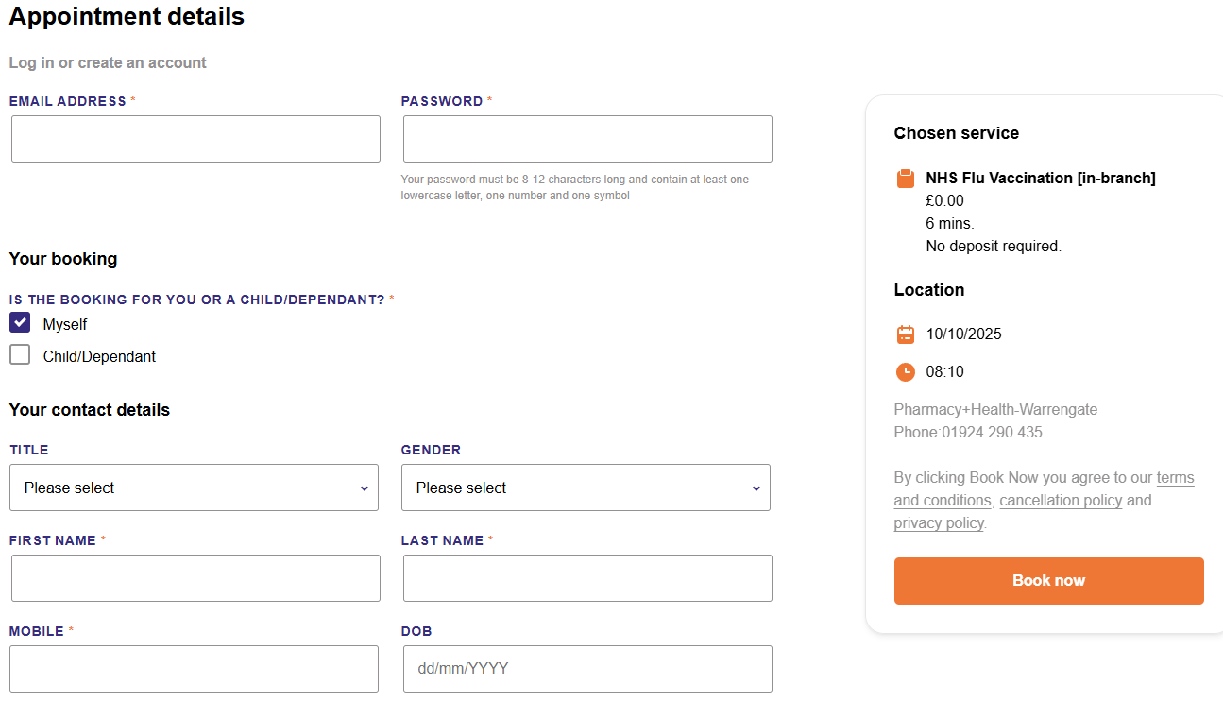
This uses a purple white and orange colour scheme with a more focus on displaying how they are a healthy company also matching the colours of their company logo also using a red asterisk to display required boxes for booking.

Risks

Inputs/outputs
Malicious person using targetted inputs such as trying to inject SQL into input boxes the ways we could prevent this is be cleansing the input using inbuilt php function which will clear certain characters if it senses a SQL statement

targetted malicious attacks
Targetted attacks such as botnet and ddos attacks to try and slow down or even crash the website by overloading the back end system with requests we could reduce this chance by using syn cookies but with the time given during the exam its unrealistic to add it in the time given.

Decomposition

Inputs/outputs
User will input a sql statement which will execute some sql for malicious activities after its input using inbuilt php function I will cleanse the statement of sql before following through with further processing.

targetted malicious attacks
N/A

user acceptance criteria

Patients
Clear and obvious navigation system
I can book an appointment online 24/7 using my phone or computer.
I can see available time slots and choose based on my preferences.
I receive a confirmation and reminder by SMS or email.
I can cancel or reschedule my appointment online.
The booking system is easy to use and accessible for all needs (e.g. WCAG compliant).
My personal information is secure and protected during the process.

doctors
fast loading time so doctors don’t need to wait for information between consultations
I can view my up-to-date appointment schedule in real time.
I can see the reason for a patient’s visit before the appointment.
I can block out time for breaks, admin, or emergencies.
I am notified of any changes or cancellations to my schedule.
I can access appointment details securely from my device.

admins
clear intractable buttons so they don’t miss-click and remove someone from system
I can view, book, cancel, or reschedule appointments for any patient.
I receive alerts for cancellations, urgent appointments, or booking conflicts.
I can search for available slots by clinician, time, or appointment type.
I can override or manually adjust bookings when needed.
The system reduces incoming phone traffic by offering self-service options.
I can access reports on appointment usage and patient attendance.

Functional and non-functional requirements

functional
Patients can book/view/cancel/reschedule appointments
doctors can view appointments
admins can remove/add patients/doctors

non-functional
Efficient code base responds to inputs in 2-5 seconds
encrypts and forces strong passwords
follow security law requirements
follow wcag conventions

Key performance indicators
I will know if the new system worked using these indicators:
Improved reviews
higher satisfaction rate for users
number of regular users
page load time
traffic from all sources
number of phone calls

Description of proposed solution

In the above paragraphs I was decomposing, analysing, and setting the requirements for the new booking system. In this section I will be summarising the proposal and its main benefits to the clients – primary oaks surgery

key features and benefits
-accessible
the website is going to be accessible to most users allowing users to navigate through all its functionalities with little to no issues.

-simple booking
the website will allow the user to easily book appointments without the need of doctor

-easier patient management
website will allow doctors to manage the patients they have appointments with

- simple booking management
allow the patients to manage which appointments they have and cancel and reschedule them if they need to

-easy registration
allows patients to easily register or login

