Page 1
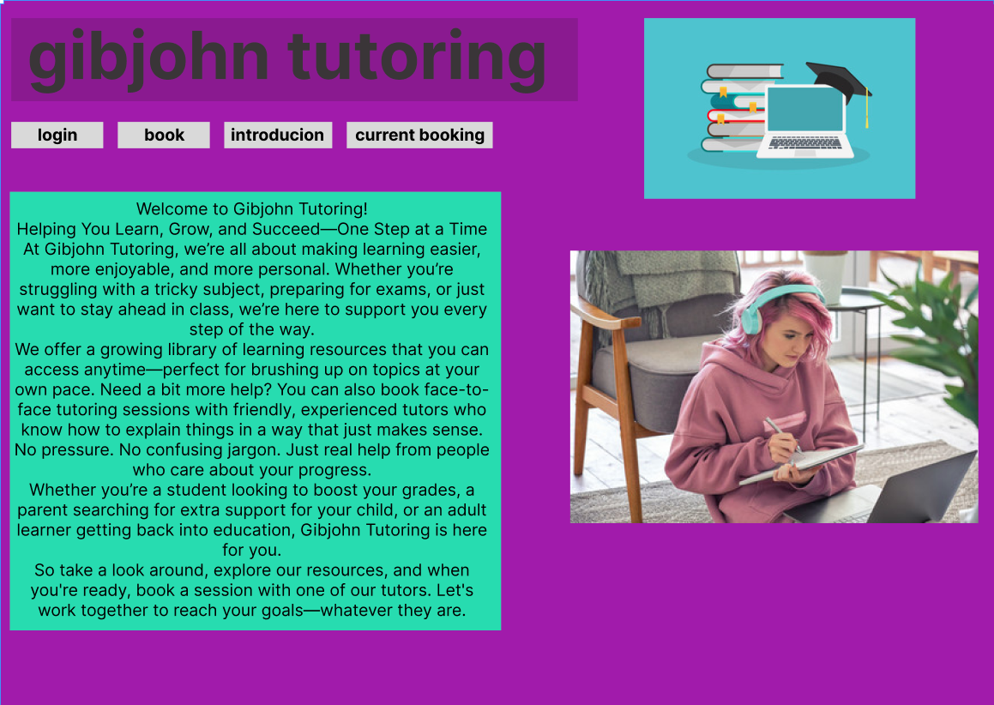
I chose purple for the background as purple represents aristocracy back in the day and is related to wealth knowledge and fortune. I centred all my text to the left and images to the right for a better visual feel and easier readability. I used simple blocks with short words for my nav bar to make it simple to understand I contrasted it with a white background to make it pop out more
for the introduction block I used cyan as it contrats well with the cyan.i used a pink haired woman to show we support diversity and our logo a book a laptop and graduate cap to show we are experts in the field.
Page 2
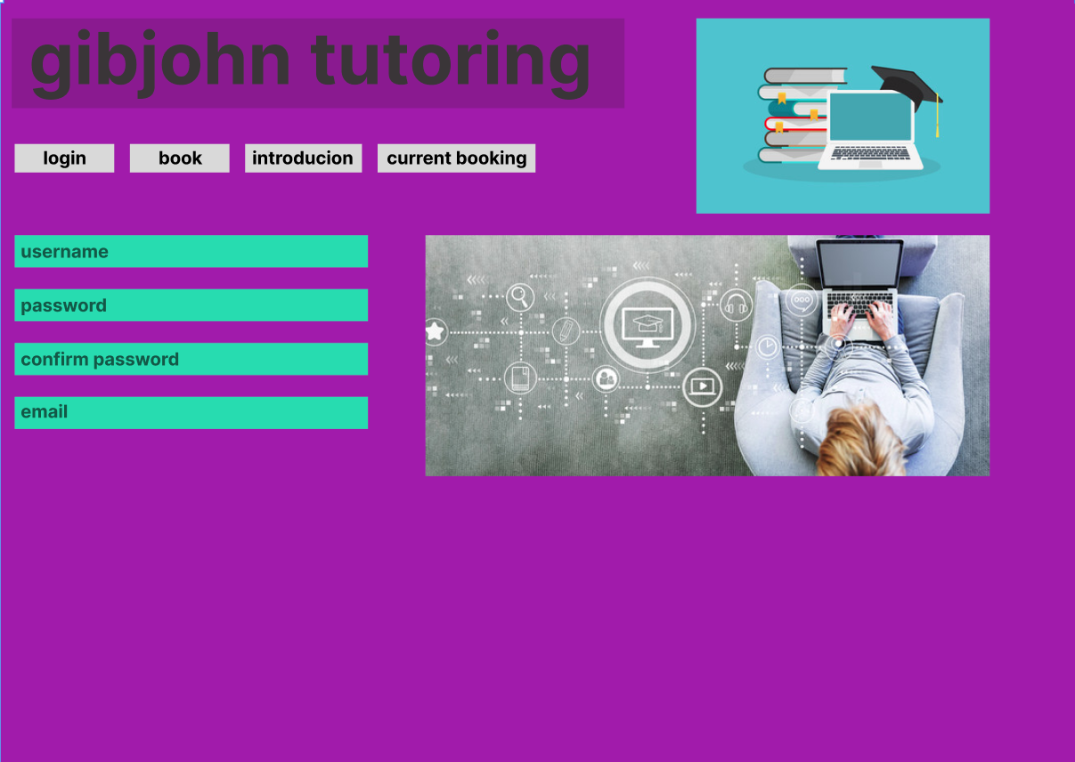
similar to previous except I have input boxes with opaque lettering for easier understand that you can write in the box I left room at the bottom for outputting after logging in and a image on the right to show your meant to enter into the boxes.
Page 3
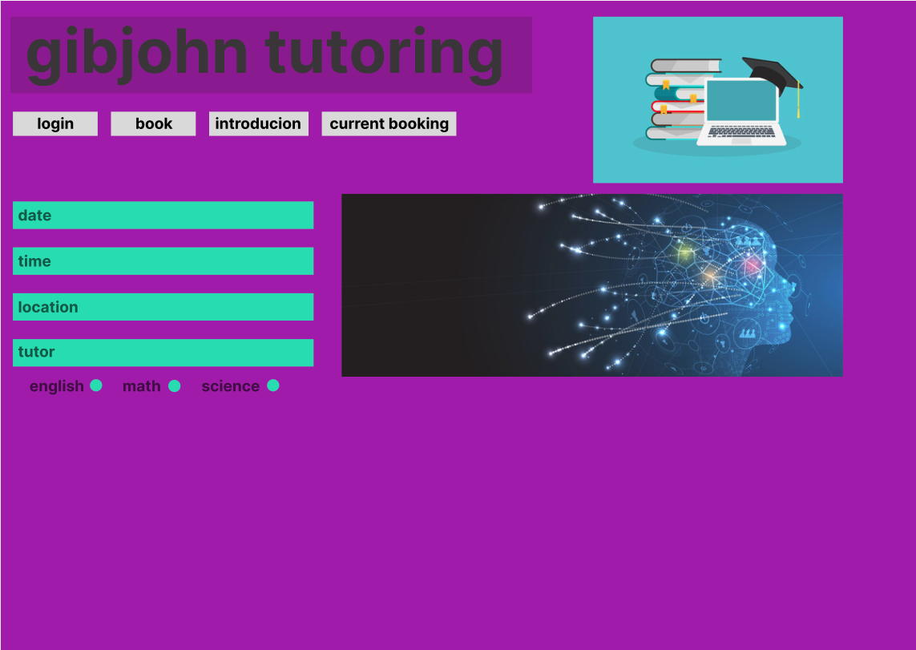
similar to previous except I have added a check box for selecting subjects so its easier for them to know the options we offer and I changed the image to a neural network to show intellect.
Page 4
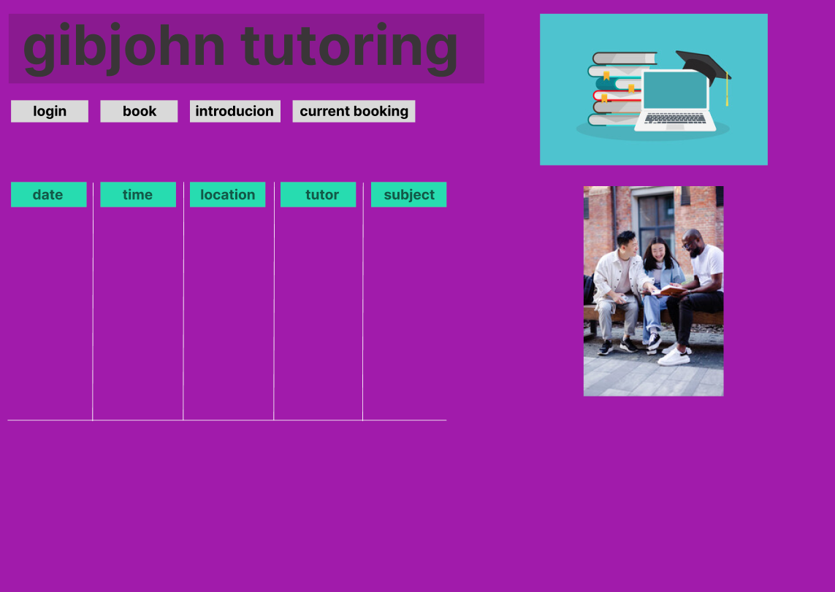
same as previous but added a table to sow bookings with clear white lines to show where information should be and an image on the right to inspire collaboration between tutors and learners.

